|  |
| --- |
| **Hi There.**  Thanks for Downloading HubSpot’s Blog Post Templates!    Copy and paste the template of your choice into a new document. |
| ↓↓↓  How to Use These Blog Post Templates   1. Select the blog post template type you want to use for your assignment (there is a table of content below). 2. Copy the contents of each template into a fresh document in case you need to access the template again. 3. Fill in the [bracketed] copy with information about your blog post, and delete *italicized instructions* after reading them. 4. Delete, add, or alter any headings, section, or content that you see fit. Remember these templates should be adjusted for your audience. 5. Review the checklist, upload your blog post into your CMS, and hit publish!   Table of Contents   1. “How to” Blog Post Template 2. Infographic Blog Post Template 3. List Blog Post Template 4. Newsjacking Blog Post Template 5. Pillar Page Blog Post Template 6. “What is” Blog Post Template |

|  |  |
| --- | --- |
| Manage your company’s content in HubSpot CMS.  Publish blog posts and landing pages to help your business thrive online. |  |
| [**Get HubSpot CMS Hub**](https://www.hubspot.com/products/cms?utm_source=offers&utm_campaign=ql-update_blog-post-template) | |

(Keep scrolling to templates)

↓↓↓



How to Write a “How to” Blog Post

Whether it’s “how to make chicken parm” or “how to start a business,” people are searching “how to” do things on Google all the time. And you can help those people out with a “how to” blog post.

“How to” blog posts provide your readers with a step-by-step guide to doing, well, anything. These blogs are also an amazing opportunity for your company to position itself as customer-focused and selfless, as you’re laying out a tactical approach to fixing a problem or addressing a need without asking for anything in return. This helps to make your brand synonymous with trust.

Writing these posts can also help your blog rank for Google’s **featured snippet** – the box that appears in Google search results with a few dozen words answering the question. You can see an example of this below.

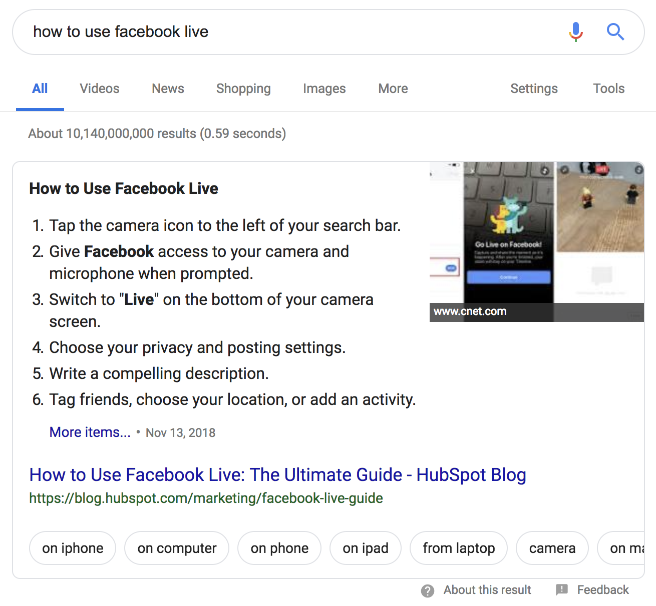

“How to” blog posts are best for the following blog posts:

* Math and equation explanations [i.e. “[How to Calculate Net Promoter Score](https://blog.hubspot.com/service/how-to-calculate-nps)”].
* Providing a way of thinking about or approaching an obscure task [i.e. “[How to Set & Achieve Marketing Objectives](https://blog.hubspot.com/marketing/marketing-objectives)”].
* Outlining step-by-step instructions to an easily addressable task [i.e. “[How to Block Websites on Chrome Desktop and Mobile](https://blog.hubspot.com/marketing/block-websites-on-chrome)”].

Outline: [Blog Post Title]

**Keyword:** [Enter Targeted Keyword]

**Keyword MSV:** [Enter Targeted Keyword’s Monthly Search Volume]

**Author:** [Enter Author Name]

**Due Date:** [Enter Due Date]

**Publish Date:** [Enter Desired Publish Date]

**Buyer Persona:** [Enter Targeted Reader and/or Buyer Persona]

[Blog Post Title]

*Make sure the title starts with “How to…” and runs for 60 characters or less.*

## Introduction

*Lead into the post with a short 100-200 word introduction. Be sure to highlight:*

* *The reason why what you’re talking about is important.*
* *Who, what industry, or what sector of the industry this applies to.*
* *What you’ll be covering [i.e. “in this post, we’ll explain why (term) is important, explain how to (term), and provide 8 suggestions if you’re new to (term)”].*

## What is [Term], and Why Does it Matter?

*Some readers may have no idea what it is you’re explaining how to do. Obviously, if what you’re writing about is well-known, you can skip the definition.*

*After defining the term, explain why it’s important for the reader to understand the idea and/or know how to do what you’re writing about.*

## How to [Task]

*This section should make up the bulk of the writing in your blog post. It’s enormously important for each step to* ***have its own section header*** *for optimal organization, clarity for the reader, and search engine optimization. Additionally, breaking instructions up by sections also lets you include visual aids for each step as needed in the form of a GIF, image, or video.*

*It’s important to remember to be* ***clear, concise, and accurate*** *in the steps you provide your readers. Any extra “fluff” to the article may confuse them, resulting in some readers not achieving the results they intended.*

*If what you’re explaining how to do is solve an equation (i.e. “How to Calculate Break Even”), provide a step-by-step explanation and example of how to calculate the rate, point, or number you’re explaining how to reach. Show all of your work so the reader can follow along easily.*

## # Tips and Reminders for [Term] (Optional)

*If you’re breaking down a difficult concept or task, some readers may still feel overwhelmed and unsure of their ability to tackle it. Break down a few suggestions on how to best approach the concept, and/or a few reminders about it. This is not a list post, so keep this short list to three to five pieces of advice.*

*If you feel the step-by-step approach is sufficient, you can choose not to include this section.*

## Closing

*Wrap up your amazing new blog post with a great closing. Remind your readers of the key takeaway you want them to walk away with and consider pointing them to other resources you have on your website.*

## Call-to-Action

*Last but not least, place a call-to-action at the bottom of your blog post. This should be to a lead-generating piece of content or to a sales-focused landing page for a demo or consultation. For example, if your product or service helps your readers do what it is they searched “how to” do, or if you have a template in your content resource library that does what they searched “how to” do, that would be a perfect CTA for this post.*

Checklist Before Publishing

* Did you provide clear, actionable steps to accomplishing the task your reader needed help with?
* Did you provide relevant and accurate facts and stats to prove your understanding of the concept?
* Did you emphasize the importance of understanding this concept if it is not already well-known?
* Did you properly cite and backlink your sources?
* Did you spell check and proofread?
* Are there **at least** 1-2 images?
* Is the post 800-1,000 words at minimum?



How to Write an Infographic Blog Post

Infographics are an opportunity to combine beautiful and on-brand designs with compelling copy from your marketing team.

For infographic blog posts, the infographic itself should do most of the talking and take up the bulk of the real estate in the blog body. However, there’s still the need for copy before and sometimes even after the infographic to help set up and elaborate on the ideas within the image, and to help the post rank on search engines.

Below is a template outline for you to plan the copy for your infographic post. If you’re looking for templates to help you design your actual infographic, [click here for 15 free infographic templates](https://www.hubspot.com/infographic-templates).

Outline: [Blog Post Title]

**Keyword:** [Enter Targeted Keyword]

**Keyword MSV:** [Enter Targeted Keyword’s Monthly Search Volume]

**Author:** [Enter Author Name]

**Due Date:** [Enter Due Date]

**Publish Date:** [Enter Desired Publish Date]

**Buyer Persona:** [Enter Targeted Reader and/or Buyer Persona]

[Blog Post Title]

*Make sure the title runs for 60 characters or less and ends with “[Infographic]” in brackets.*

## Introduction

*Lead up to the infographic with a short 100-200 word introduction. Be sure to highlight:*

* *The reason why what you’re talking about is important.*
* *Who, what industry, or what sector of the industry this applies to.*
* *What the infographic will be covering [i.e. “The infographic below contains the five biggest takeaways from our new report on industry trends and what they could mean for you”].*

## Infographic

*Upload the image of your infographic. Make sure the alt-text for the infographic image is your desired keyword.*

## What This Means For You (Optional)

*For the wordsmiths on your marketing team, an infographic can be frustrating, as it leaves little to no room for elaboration of ideas presented in the image. Your infographic contains some combination of statistics, examples, and/or step-by-step instructions, and some of these need more than just a line or two of copy to get the full point across.*

*If you feel it’s necessary, copy the wording from the original infographic into this section and add more context, backlinks, sources, and information. You can also use this as an opportunity to help the post rank, as search engines can crawl the text in the body of a blog post.*

*However, if you feel your infographic gets the point across on its own and doesn’t need elaboration, feel free to skip this section.*

## Closing

*Provide some closing context pertaining to the infographic and summarize its implications.*

## Call-to-Action

*Last but not least, place a call-to-action at the bottom of your blog post. This should be to a lead-generating piece of content or to a sales-focused landing page for a demo or consultation.*

Checklist Before Publishing

* Do you tee up the infographic with wording related to the copy in the infographic?
* If needed, did you elaborate on the infographic with more copy below the image?
* Did you provide alt-text for the infographic image?
* Did you provide relevant and accurate examples and statistics to further explain this concept, if needed?
* Did you properly cite and backlink your sources?
* Did you spell check and proofread?



How to Write a List Blog Post

We all love countdowns, rankings, and lists – including your readers. This presents an unignorable opportunity for your blog team: list posts.

List blog posts are exactly what they sound like – a blog post listing off examples, resources, or tips pertaining to a topic your readers will love, are interested in, or would benefit from knowing more about. List posts can range from as low as three to as high as 100+, though the sweet spot that most bloggers gravitate towards tends to be between five and 20.

Another perk of the list approach to blog posts is that it is appropriate for every stage for the buyer’s journey. As an example, a digital marketing agency could see success with an awareness post titled “The 10 Social Media Trends Your Company Can’t Ignore” and with a decision stage post titled “3 Qualities to Look For in a Marketing Agency.”

Need some suggestions for your list post? You can list out any of the following:

* Examples [[8 of the Best Professional Bio Examples We've Ever Seen [+ Bio Templates]](https://blog.hubspot.com/marketing/professional-bio-examples)]
* Steps [[3 Steps to Do Your Best Work, No Matter Where You Are in Your Career](https://blog.hubspot.com/marketing/3-steps-to-consistently-do-your-best-work)]
* Tips [[19 Tips to Leave the Perfect Sales Voicemail](https://blog.hubspot.com/sales/tips-to-leave-the-perfect-sales-voicemail)]
* Ways to Do Something [[10 Impressive Ways to Start a Cover Letter [+ Examples]](https://blog.hubspot.com/marketing/how-to-start-cover-letter)]
* Ideas [[31 Secret Santa Gift Ideas Your Coworkers Will Love](https://blog.hubspot.com/marketing/office-secret-santa-gifts)]
* Statistics [[23 Remarkable Twitter Statistics to Be Aware of in 2019](https://blog.hubspot.com/marketing/twitter-stats-tips)]
* Facts [[9 Interesting Facts About List Posts](https://blog.hubspot.com/marketing/list-posts-facts)]
* Myths [[The 20 Most Dangerous Sales Myths You Shouldn't Fall For](https://blog.hubspot.com/sales/sales-myths)]

Outline: [Blog Post Title]

**Keyword:** [Enter Targeted Keyword]

**Keyword MSV:** [Enter Targeted Keyword’s Monthly Search Volume]

**Author:** [Enter Author Name]

**Due Date:** [Enter Due Date]

**Publish Date:** [Enter Desired Publish Date]

**Buyer Persona:** [Enter Targeted Reader and/or Buyer Persona]

[Blog Post Title]

*Make sure the title starts with a number and runs for 60 characters or less.*

## Introduction

*Lead into the post with a short 100-200 word introduction. Be sure to highlight:*

* *The reason why what you’re talking about is important.*
* *Who, what industry, or what sector of the industry this applies to.*
* *What you’ll be covering [i.e. “in this post, we’ll provide [#] examples of (term) and why they’re so emblematic of (term)”].*

## Why is [Term] Important? (Optional)

*Provide your readers with a few reasons why they should care about the term or the concept you’re writing about. If this is a consumer-level concept, talk about the implications this could have on their families, finances, personal happiness, etc. If you’re writing for an audience of professionals, mention the impact this term or concept has on profit, efficiency, and/or customer satisfaction. To make the most of this section, make sure it includes at least one statistic, quote, or outside reference.*

*If you feel the topic is universally understood and respected, you may not need to include this section and could benefit by going right to the list.*

## # Examples/Tips/Ideas/Resources for [Term]

*After the quick introduction and potential explanation of the topic’s importance, there’s no more time to waste. Jump right into the list!*

*Each of your examples should be followed by additional copy explaining why you’re including them on your list. The explanation could be anywhere from a couple sentences (if you have a long list) to a couple paragraphs (if you have a short list). Make sure you organize your list so that each example or subcategory has its own section header.*

*If your list is made up of examples from real people or businesses, take the opportunity to embed evidence of the example with an image, a video, or a social media post of that example. This adds additional context as to why you’re including each example on your list and helps break up an otherwise text-heavy blog post with other types of content.*

## Closing

*Wrap up your amazing new blog post with a great closing. Remind your readers of the key takeaway you want them to walk away with and what everything on your list has in common or suggests to the reader.*

## Call-to-Action

*Last but not least, place a call-to-action at the bottom of your blog post. This should be to a lead-generating piece of content or to a sales-focused landing page for a demo or consultation.*

Checklist Before Publishing

* Did you provide at least three examples, suggestions, or tips that directly speak to the topic you’re writing about?
* If examples are from real companies or people, did you embed images, video, and/or a social media post of that example to strengthen your point?
* Did you provide relevant and accurate examples and statistics to further explain this concept?
* Did you properly cite and backlink your sources?
* Did you spell check and proofread?
* Are there at least 1-2 images?
* Is the post 800-1,000 words at minimum?

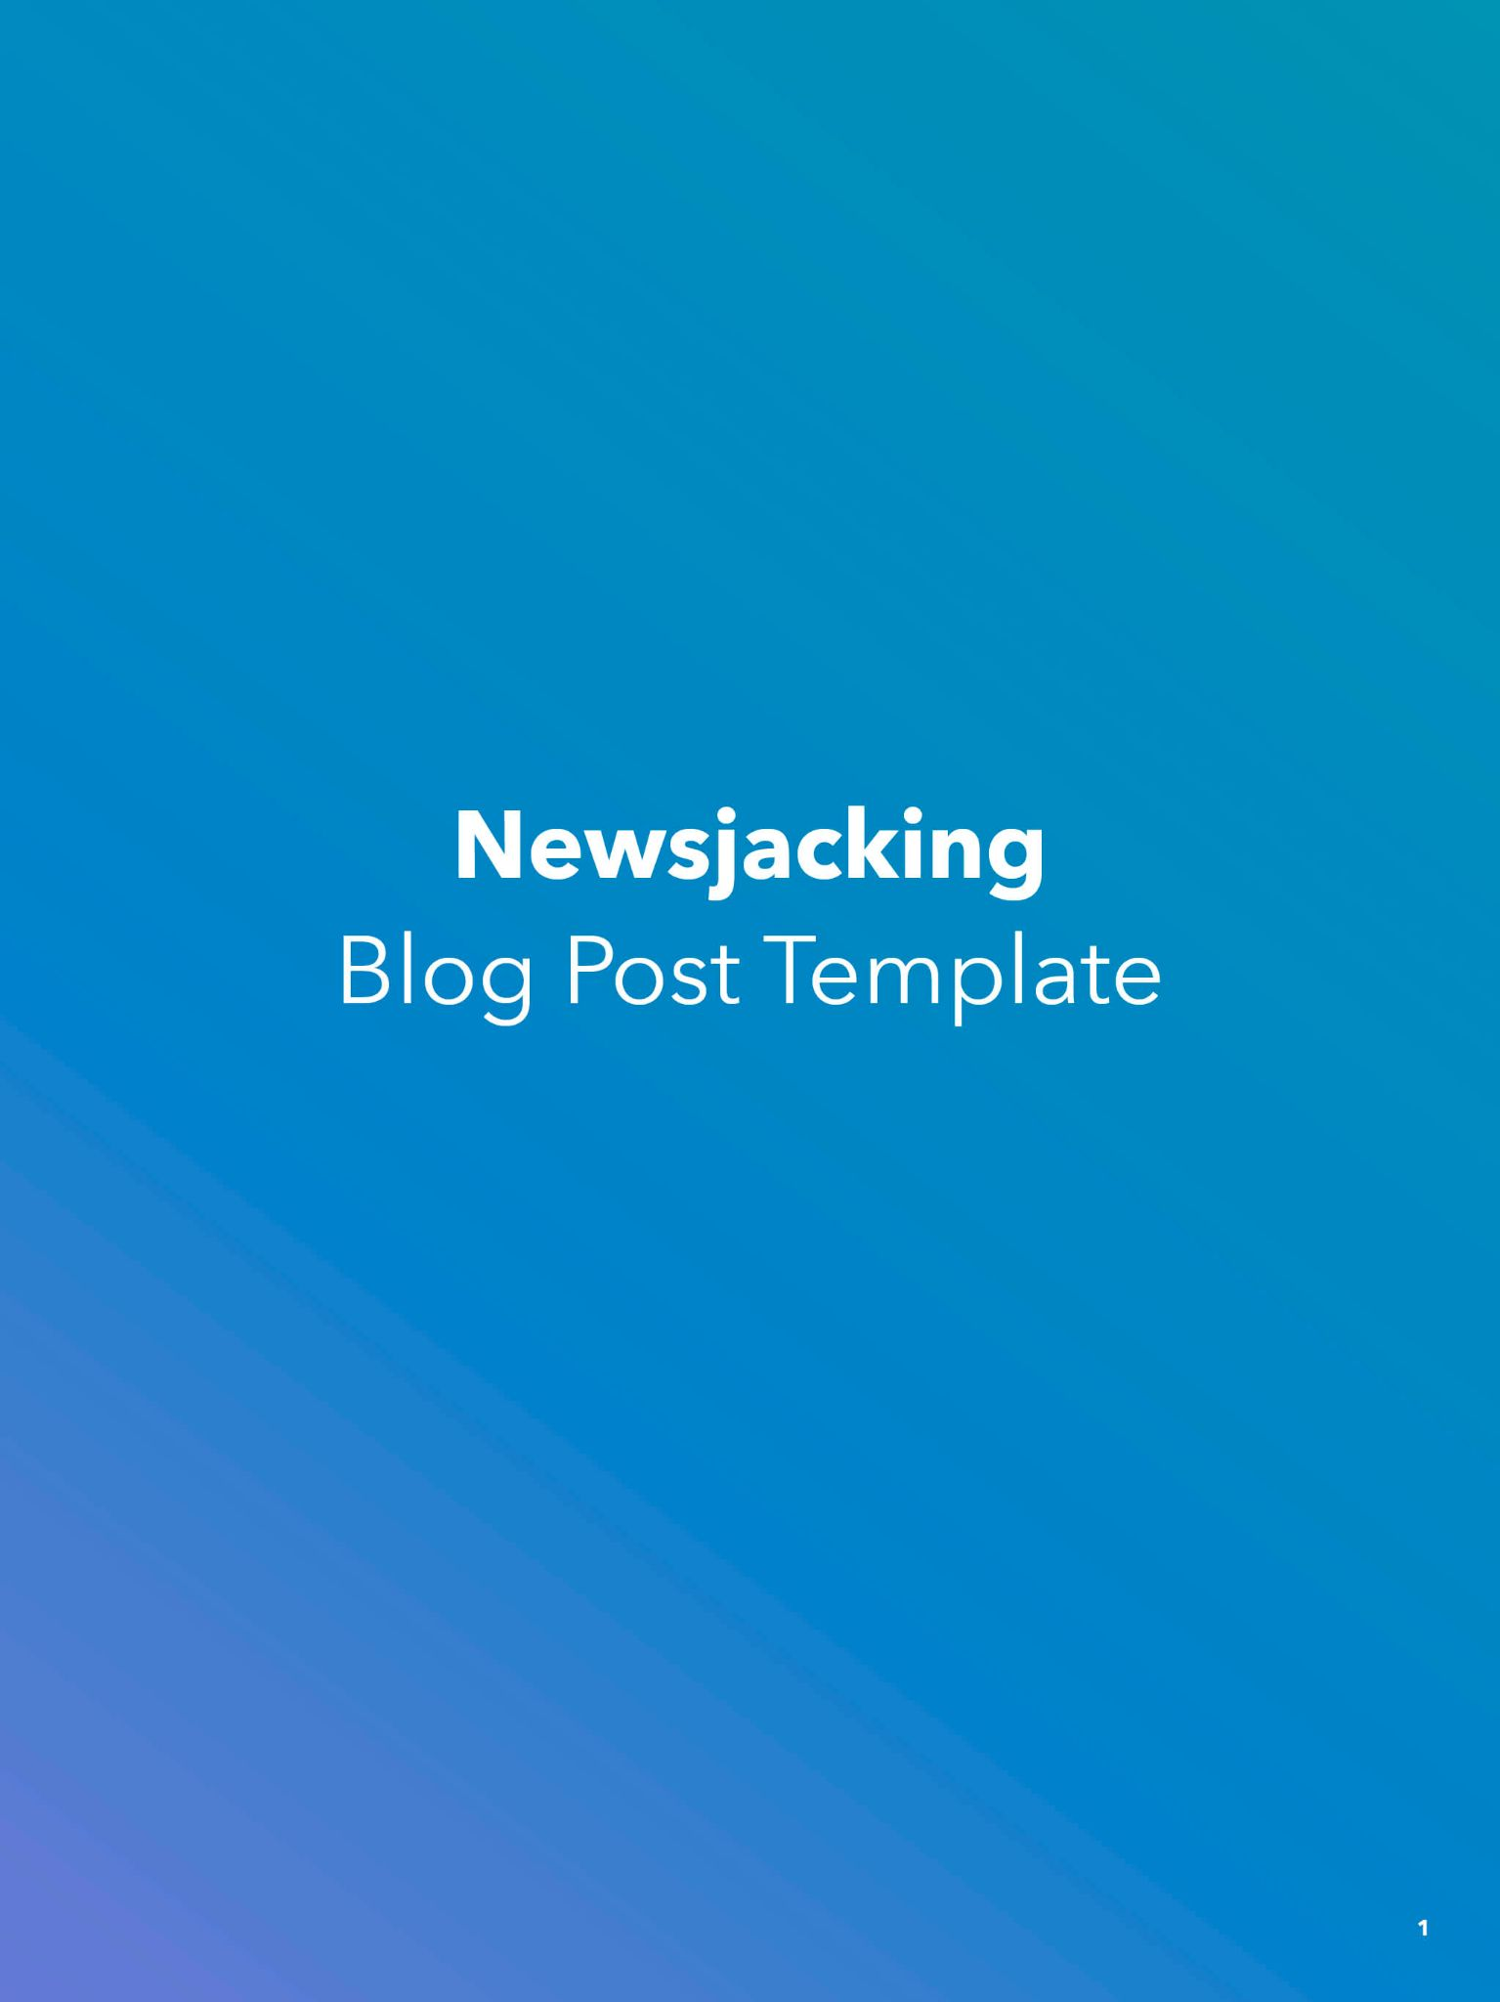

How to Write a Newsjacking Blog Post

This just in -- people *love* reading the news online, and if there’s an opportunity for you to write about a piece of news that can or does *directly* impact your target audience, you should take it.

Newsjacking refers to the practice of capitalizing on the popularity of a news story to amplify your sales and marketing success. The term was popularized due to David Meerman Scott's book [*Newsjacking: How to Inject Your Ideas into a Breaking News Story and Generate Tons of Media Coverage*.](http://www.amazon.com/exec/obidos/ASIN/B0065MKMMS/freshspotpubl-20)

There are two different approaches to newsjacking: the immediate rundown of what’s happening and the look back of what happened (alongside what to expect after the initial news break settles). Alternatively, you could publish an initial post to alert readers of the breaking news, and then edit once more details arise.

One thing to note with newsjacking: if the topic is or could be perceived as sensitive, be *very* careful with your writing and positioning. Your decision to cover the story and/or the approach you take in your post could be controversial and negatively impact your brand.

Outline: [Blog Post Title]

**Link to Original Story:** [Insert Link if Available]

**Author:** [Enter Author Name]

**Due Date:** [Enter Due Date]

**Publish Date:** [Enter Desired Publish Date]

**Buyer Persona:** [Enter Targeted Reader and/or Buyer Persona]

[Blog Post Title]

*Make sure the title clearly identifies the breaking news story and runs for 60 characters or less.*

## Introduction

*Lead into the post with a short 100-200 word introduction. Be sure to highlight:*

* *The quick facts as they are known, with a link to the original story if available.*
* *The reason why what you’re talking about is important.*
* *Who, what industry, or what sector of the industry this applies to.*
* *What you’ll be covering [i.e. “in this post, we’ll explain what has reportedly happened, how it may affect your company, and provide four tips for what to do next.”].*

## What Happened

*Flesh out the story in more detail than in the intro with more background, information, and sources. Keep the first part of this section factual, and if you feel compelled to, input your opinion on the story afterwards.*

*Inserting your opinion can be a questionable move, so make sure you get the okay from appropriate stakeholders before publishing opinions – particularly on sensitive news stories.*

## What’s Happening Now/Next [Optional]

*If the story is still breaking, you may want to leave this blank. However, if the dust has settled and you have reliable information on what the ripple effects of this news story will be, mention them here so readers know what to expect.*

## What This Means For You

*If the story you’re covering impacts a larger audience than your niche readership (say, a new government regulation impacting many industries), narrow down the scope of the implications of this event to your specific reader. Maybe you’re writing for the hardware industry, and new trade regulations will impact shipments and prices of raw materials to manufacturers. In that case, talk about how the new law can or could disrupt or impact that part of a reader’s business.*

## What You Can/Could/Should Do Now [Optional]

*Again, giving advice in the wake of or in the aftermath of a breaking news event isn’t always the best idea. However, if you’re able to link to legitimate sources on what the best course of action is, you can. Here, academic and government sites would be a fair place to draw next steps from.*

*If you do wish to provide your own opinion on what to do next, make it clear that these next steps are suggestions as to what a reader may consider doing – not requirements.*

## Closing

*Wrap up your amazing new blog post with a great closing. Remind your readers of the key takeaway you want them to walk away with and remind them to check back in to this page with any updates if the story is ongoing.*

## Call-to-Action

*Last but not least, place a call-to-action at the bottom of your blog post. This should be to a lead-generating piece of content or to a sales-focused landing page for a demo or consultation. For a newsjacking piece, consider putting a CTA for your blog subscription so readers can stay up-to-date with related stories that you cover.*

Checklist Before Publishing

* Did you provide a clear, factual approach to explaining this situation to readers?
* Did you provide relevant and accurate facts and stats to back up your writing?
* If you offer an opinion, is it fleshed out and justifiable?
* Did you properly cite and backlink your sources?
* Does your story offer a unique angle, fact, or approach that readers would not be able to access elsewhere?
* Did you spell check and proofread?
* Are there **at least** 1-2 images?
* Did you set a reminder to revisit this post periodically and update it with new information if/when it becomes available?
* If there are long-term implications of this story, do you provide actionable insights or next steps that will help readers navigate and understand the situation in the long run?



How to Write a Pillar Blog Post

A pillar page is intended to be *the* authoritative resource for a given topic on the internet. While some blogs are instructional how-to guides or lists of incredible examples, a pillar page should be the ultimate guide that any reader would ever need to know about a topic...*ever*.

You can support a pillar page with other related blog posts that link out to this pillar page, known as “cluster” posts. (*Quick note: if this pillar-cluster model is new to you, learn all about what it is and how the HubSpot team rolled it out it on our blog* [*here*](https://blog.hubspot.com/marketing/pillar-cluster-model-transform-blog)*.*)

Your pillar pages should be the most in-depth writing you’ve ever compiled on a subject on your blog to date. This is because you’ll have multiple places on the post to work in your keyword and backlink from reputable sources, showing search engines you’re the place to point to for a given topic.

If you think the pages will be longer than your usual posts, you’re right – one of HubSpot’s pillar pages takes an estimated 45 minutes to read! However, that’s definitely an outlier. Your pillar page length, pending on the depth of the subject matter, can range anywhere from 2,000 - 5,000 words. Because of this length, it’s recommended that you include at least one piece of interactive content in your pillar page – such as an embedded video or social media post – to break up this text-heavy post.

Here are a few examples of pillar pages we’re proud of here at HubSpot. You may notice that we linked to all of the other blog posts we wrote in this topic cluster – something you should do, too.

* [The Ultimate Guide to Video Marketing](https://blog.hubspot.com/marketing/video-marketing)
* [The Ultimate Guide to Entrepreneurship](https://blog.hubspot.com/sales/entrepreneurship)
* [The Ultimate Guide to Software as a Service](https://blog.hubspot.com/service/saas)

Outline: [Blog Post Title]

**Keyword:** [Enter Targeted Keyword]

**Keyword MSV:** [Enter Targeted Keyword’s Monthly Search Volume]

**Author:** [Enter Author Name]

**Due Date:** [Enter Due Date]

**Publish Date:** [Enter Desired Publish Date]

**Buyer Persona:** [Enter Targeted Reader and/or Buyer Persona]

[Blog Post Title]

*Make sure the title contains your keyword and runs for 60 characters or less.*

## Introduction

*Lead into the post with a short 100-200 word introduction. Be sure to highlight:*

* *The reason why what you’re talking about is important.*
* *Who, what industry, or what sector of the industry this applies to.*
* *What you’ll be covering [i.e. “in this post, we’ll provide an all-encompassing rundown of (term), including an explanation of why (term) is important, how to (term), and 8 suggestions if you’re new to (term)”].*

***Note:*** *Choose the Sections from the Bank Below That You Think Will Fit Well in Your Pillar Page*

*Below are a few sections that would do well in a pillar page. Depending on your topic, pick the sections that you think would do best on your page.*

*Keep in mind – the bank below contains* ***suggested*** *sections. If you believe your pillar page needs a section that is not listed below, you should absolutely include it.*

*You’ll also notice a prompt at the end of each section to link to a supporting cluster post. For example, if you’re writing The Ultimate Guide to Cooking and include a section about cooking pizza, you may want to link to your blog post about Italian food in that section to strengthen your on-page and website SEO. These pages should be hyperlinked naturally at some point in the body of that section.*

## What is [Term] (and Why Does it Matter)?

*Some readers might be new to what you’re writing about. Obviously, if what you’re writing about is well-known, you can skip the definition and head straight to why it matters.*

*Explaining why the term or concept matters is important for the reader to understand how to do or use what it is you’re writing about. Talk about the personal and/or business implications of understanding, employing, or using the topic you’re writing about.*

**Supporting Cluster Post to Include:** [Insert Hyperlink for Reference]

## The History of [Term]

*Elaborate on the background of what you’re writing about and how the concept has developed from its inception to today.*

**Supporting Cluster Post to Include:** [Insert Hyperlink for Reference]

## Terms to Know

*List out and define a few of the key terms pertaining to your topic, especially if they’re mentioned elsewhere in the post.*

**Supporting Cluster Post to Include:** [Insert Hyperlink for Reference]

## The Pros and Cons of [Term]

*If your topic has highs and lows to it, outline those pluses and minuses here.*

**Supporting Cluster Post to Include:** [Insert Hyperlink for Reference]

## # Examples of [Term]

*Proof points are immensely helpful for readers. Let’s say you’re covering the topic of product placement. This section could include 5 - 10 videos of product placement in film and television so readers can see the idea of it in action.*

**Supporting Cluster Post to Include:** [Insert Hyperlink for Reference]

## How to [Task/Term]

*If your pillar page is dedicated to a concept that requires or benefits from a step-by-step process, outline those steps in this section.*

*It’s important to be* ***clear, concise, and accurate*** *in the steps you provide your reader. Any extra “fluff” to the article may confuse someone, resulting in some readers not achieving the results they intended.*

*If what you’re explaining how to do is solve an equation (i.e. “How to Calculate Break Even). provide a step-by-step explanation and example of how to calculate the rate, point, or number you’re explaining how to reach. Show all of your work so the reader can follow along effortlessly.*

**Supporting Cluster Post to Include:** [Insert Hyperlink for Reference]

## # Tips and Reminders for [Term]

*When breaking down a difficult concept or task, some readers may still feel overwhelmed and unsure of their ability to understand it. Break down a few best practices on how to best approach the concept, and/or a few reminders about it.*

**Supporting Cluster Post to Include:** [Insert Hyperlink for Reference]

## Analyzing [Term]

*If your topic pertains to business or businesses, give an overview of how and why to analyze your topic and how to differentiate between good and bad in the results of that analysis.*

**Supporting Cluster Post to Include:** [Insert Hyperlink for Reference]

## Resources for [Term]

*Provide further reading or resources for people just getting started who may want additional information. This section could include industry blogs, books, social media accounts for thought leaders, and/or suggestions for support/assistance.*

**Supporting Cluster Post to Include:** [Insert Hyperlink for Reference]

## Closing

*Wrap up your amazing new blog post with a great closing. Remind your readers of the key takeaway you want them to walk away with and consider pointing them to other resources you have on your website.*

## Call-to-Action

*Last but not least, place a call-to-action at the bottom of your blog post. This should be to a lead-generating piece of content or to a sales-focused landing page for a demo or consultation.*

Checklist Before Publishing

* Did you provide a thorough, all-encompassing rundown of the topic you’re writing about?
* Did you provide relevant examples and accurate facts and stats to prove your understanding of the concept?
* Did you properly cite and backlink your sources?
* Did you link to all of your supporting blog posts in the cluster?
  + Did you go back to those posts and link to this pillar page?
* Did you spell check and proofread?
* Are there **at least** 2-3 images?
* Is the post 2,000 words at minimum?
* Is there at least one piece of interactive content embedded in the body (video, social media post, calculator, podcast, audio file)?



How to Write a “What is” Blog Post

How often do you find yourself typing “what is [blank]” into Google? Weekly? Daily? Hourly?

Sometimes, your readers just need a quick answer to a question. Enter: the “what is” blog post. This is the opportunity for you to answer that question – and provide further details on the topic for the readers that want them (and, of course, to help your post rank better).

Writing these posts can also help your be chosen for Google’s **featured snippet** – the box that appears in Google search results with a few dozen words answering the question people search for. You can see an example of this below.

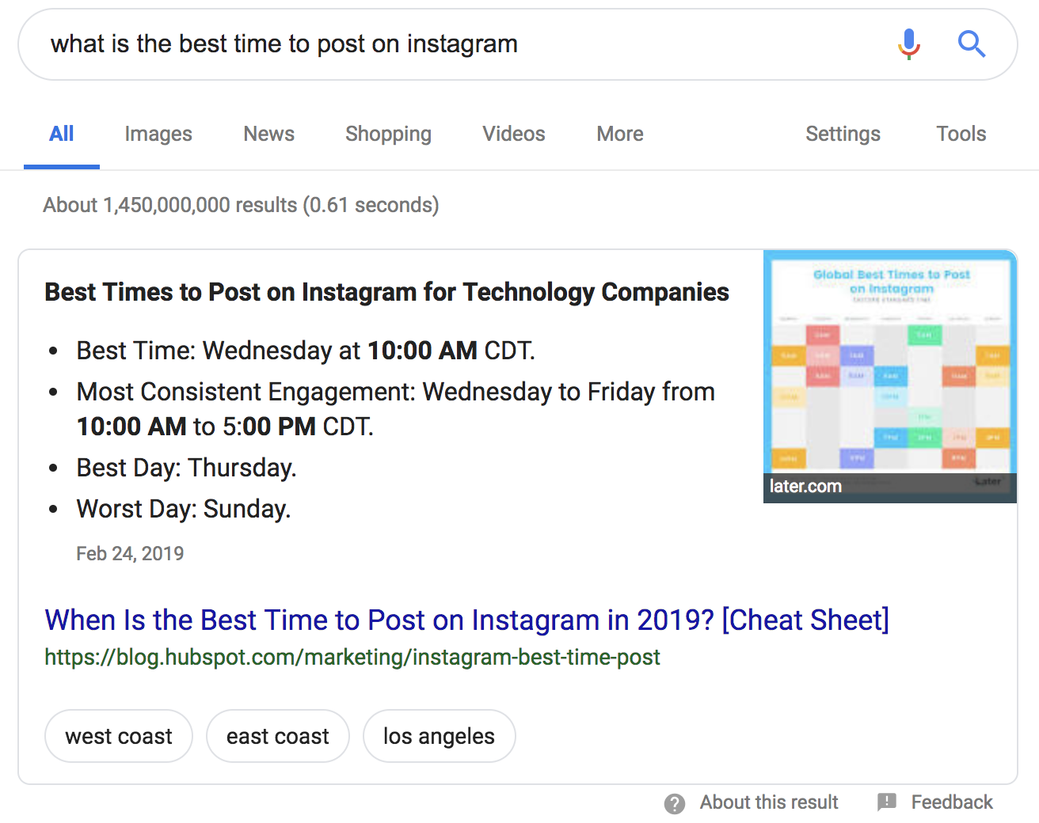

As you may be able to tell from the example above, the “what is” blog post can also take the form of a “when is,” “who is,” or “why is” blog. You can follow the same general guidelines for these posts as you would for a “what is” post.

“What is” blog posts are best for the following blog post ideas:

* Defining a term and/or a concept [i.e. “[What is Marketing?](https://blog.hubspot.com/marketing/what-is-marketing)”].
* Math and equation explanations [i.e. “[What is First Call Resolution?](https://blog.hubspot.com/service/first-call-resolution)”].

Outline: [Blog Post Title]

**Keyword:** [Enter Targeted Keyword]

**Keyword MSV:** [Enter Targeted Keyword’s Monthly Search Volume]

**Author:** [Enter Author Name]

**Due Date:** [Enter Due Date]

**Publish Date:** [Enter Desired Publish Date]

**Buyer Persona:** [Enter Targeted Reader and/or Buyer Persona]

[Blog Post Title]

*Make sure the title starts with “What is…” and runs for 60 characters or less.*

## Introduction

*Lead into the post with a short 100-200 word introduction. Be sure to highlight:*

* *The reason why what you’re talking about is important.*
* *Who, what industry, or what sector of the industry this applies to.*
* *What you’ll be covering [i.e. “in this post, we’ll define (term), show a few examples of how it’s used in business today, and provide 8 best practices for getting started with (term) in your company”].*

## What is [Term]?

*Answer the question posed by the title of this post directly below this header. This will increase your chances of ranking for the featured snippet on Google for this phrase and provide readers with an immediate answer. Keep the length of this definition – at least in this very basic introduction – between 50 and 60 words.*

*After the brief definition, dive further into the concept and add more context and explanation if needed.*

## Why is [Term] Important?

*Provide your readers with a few reasons why they should care about the term or the concept you’re writing about. If this is a consumer-level concept, talk about the implications this could have on their businesses, finances, personal happiness, etc. If you’re writing for an audience of professionals, mention the impact this term or concept has on profit, efficiency, and/or customer satisfaction. To make the most of this section, make sure it includes at least one statistic, quote, or outside reference.*

***Include at Least One of These Next Three Sections***

## How to Calculate [Term] (Optional)

***Note: This section only applies for posts about math and equations****.*

*Provide a step-by-step explanation and example of how to calculate the rate, point, or number you’re providing a definition for.*

## # Real Examples of [Term] (Optional)

*If you feel like it would benefit your readers, list a few examples of the concept you’re explaining in action. You can elevate this section by embedding images, videos, and/or social media posts.*

*Remember, this post is* ***not*** *a list post – so try to keep this list between three and five examples if you do decide to include it.*

## # Tips and Reminders for [Term] (Optional)

*When breaking down a difficult concept or definition, some readers may still feel overwhelmed and unsure of their ability to address it. Break down a few best practices on how to approach the concept, and/or a few reminders about it. Again, this is not a list post, so keep this short list to three to five pieces of advice.*

## Closing

*Wrap up your amazing new blog post with a great closing. Remind your readers of the key takeaway you want them to walk away with and consider pointing them to other resources you have on your website.*

## Call-to-Action

*Last but not least, place a call-to-action at the bottom of your blog post. This should be to a lead-generating piece of content or to a sales-focused landing page for a demo or consultation.*

Checklist Before Publishing

* Did you define the term and/or explain the concept in terms that your buyer persona would understand?
* Did you provide relevant and accurate examples and statistics to further explain this concept?
* Did you properly cite and backlink your sources?
* Did you spell check and proofread?
* Are there at least 1-2 images?
* Is the post 800-1,000 words at minimum?