The Stream Quality Index: A Multi-Indicator Tool For Enhancing Environmental Management Communication

Marcus W. Beck ([marcusb@sccwrp.org](mailto:marcusb@sccwrp.org)), Raphael D. Mazor ([raphaelm@sccwrp.org](mailto:raphaelm@sccwrp.org)), Susanna Theroux ([susannat@sccwrp.org](mailto:susannat@sccwrp.org)), Kenneth C. Schiff ([kens@sccwrp.org](mailto:kens@sccwrp.org))

# Abstract

Assessment of stream health is a function of the physical, chemical, and biological integrity of the water body. While monitoring of all three indicators of stream quality is commonplace, combining these three indicators into a unified assessment of stream quality rarely occurs, complicating the interpretation of complex environmental health information. In this study, a unified index was developed that combines physical, chemical, and biological indicators for southern California wadeable streams into a scientifically rigorous, easy-to-understand tool intended to facilitate management decision-making. Known as the Stream Quality Index (SQI), this tool is based on a stressor-response empirical model that quantifies the expected likelihood that chemical and physical stressors will impact multiple individual components of biological condition, as well as the actual measured biological response of those indicators. The index’s chemical parameters, which are indicative of anthropogenic inputs, include nutrients and conductivity. The physical parameters include two physical habitat indices that describe instream (i.e., substrate) condition and stream corridor (i.e., riparian) condition, respectively. The biological response parameters include benthic invertebrates and algae. While the individual stressor and response components are quantitative and have similar meaning across a variety of environmental settings, the final SQI narrative assessment is categorical and designed to be directly actionable within a management decision-making context. The four narrative assessment categories are: (1) “healthy and unstressed” (i.e., unimpacted biology, so protection is recommended); (2) “healthy and resilient” (i.e., stressed, but biological communities are healthy, so reducing stress is recommended); (3) “impacted and stressed” (i.e., impacted biology due to known chemistry and/or physical habitat stressor(s), so remediation or restoration is recommended); and (4) “impacted by unknown stress” (i.e., biology is impacted, so causal assessment is recommended to identify stressors). To facilitate adoption by managers, a web-based application was developed to easily communicate overall SQI results, but also enables users to readily access underlying quantitative information for stressors and biological responses to understand likely reasons behind the categorical assessments. This transparent design was intended; high-level output and foundational components of the SQI are relevant for different audiences and the technical underpinnings are not sacrificed for accessibility.

# Introduction

Assessments of stream health are a function of monitoring the water body’s physical, chemical, and biological integrity (33 USC §§ 1151, 1972). Monitoring physical habitat integrity facilitates determination of whether all necessary environmental niches are present to support a diverse aquatic community (Maddock, 1999). Monitoring chemical integrity facilitates determination of whether toxic compounds are present, as well as whether minerals are sufficiently balanced to support aquatic life (Maruya et al., 2016; Wang et al., 2007). Monitoring biological integrity, which is closest to the actual assessment of stream health, facilitates determination of whether unmeasured physical or chemical parameters are impacting otherwise balanced ecosystems (Ode et al., 2016; Stoddard et al., 2006) as well as any synergistic effects of measured and unmeasured parameters.

Tremendous management effort is expended annually to monitor all three types of stream integrity indicators. Whether monitoring programs are large and complex or small and straightforward, all share the challenge of how to communicate physical, chemical, and biological data in a scientifically rigorous, repeatable, and readily understandable way to non-scientists (National Research Council, 1990). Because most environmental managers and decision-makers are not scientists, and similarly, scientists may not appreciate the applied context for technical products, the communication of ecological data for decision-making can be challenging. Furthermore, ecological data are rarely black and white, leading to many management decisions made in the “grey zone” (Paulsen et al., 2008). This is particularly true when physical, chemical, and biological lines of evidence are not in complete agreement with one another.

Multiple well-known tools exist for effectively communicating information for a single line of evidence. Bioassessment tools include the Index of Biological Integrity (IBI; Karr 1981), Observed to Expected ratios (O/E; Hawkins et al. 2000), and hybrids of the IBI and O/E (Mazor et al., 2016). Chemical assessment tools include the Canadian Council of Ministers of the Environment (CCME) Water Quality Index (CCME, 2001; Hurley et al., 2012). Physical habitat assessment tools, which are less common, include the California Rapid Assessment Method (Collins et al., 2007; Solek et al., 2011) and the more recently developed Index of Physical Integrity (Rehn et al., 2018). These established tools have been used as single lines of evidence to separately address chemical, physical, and biological components of the United States CWA.

An assessment tool that combines physical, chemical, and biological indicators into a single unified assessment is exceedingly rare (Bay and Weisberg, 2012). Much more commonplace are instances where multiple indicators are individually simplified and presented as a group, leaving managers to decide which is most important (Paulsen et al., 2008). However, a single unified assessment is preferential when communicating stream health to non-technical managers. A single scale provides straightforward context for comparing one site to another, for ranking sites for management actions, and for monitoring improvements at a site following implementation of management actions (or monitoring potential degradation where management actions are not implemented).

While such a unified assessment tool is possible to develop for use in a single environmental setting, it has long been a challenge to design a technically robust tool that produces assessments that have similar meanings in different environmental settings, that provides clues as to which indicator(s) are impacted and thus need to be remediated, and that can be replicated elsewhere. The goal of this study was to develop a tool that meets all three criteria. Because biological indicators provide direct measures of aquatic life, while physical and chemical measures provide ancillary information about the stressors that may affect aquatic life, this study sought to develop a method for combining the three indicators in a way that would preserve the types of information provided by each line of evidence. This is fundamentally different than treating indicators as equivalent lines of evidence and simply “averaging” results to assess overall condition.

# Methods

## General Approach

The conceptual approach used in this study is based on a stressor-response relationship between biology and in-stream stressors (Figure 1). Specifically, the underlying stressor-response relationships that define the final narrative categories for overall stream condition are based on empirical models that quantify an expected likelihood of chemical or physical stressors impacting the separate components of biological condition. Southern California wadeable streams were selected as the focus of this effort because of the extensive and varied levels of stress and biological impacts. Moreover, southern California is home to many environmental managers with a variety of backgrounds and experience in technical and policy issues.

Biological response components were selected based on bioassessment indices developed for California wadeable streams (i.e., benthic macroinvertebrates, algae). Water chemistry stressors were selected that are strongly associated with biological condition in perennial streams (i.e., nutrients, conductivity). Physical habitat metrics were selected that quantify flow, channel, and riparian condition observed at a site.

The four narrative assessment categories were defined in a way that would align with high-level management decision-making processes. The SQI web-based application was designed in a way that would give users easy access to descriptions of the biological, chemical, and physical components that underlie the unified assessment, depending on the desired level of information within the stressor-response paradigm.

## Biological response components of the SQI

### Characterizing biological condition

To characterize biological condition, a pair of quantitative bioassessment indices – for benthic macroinvertebrates (BMI) and algal communities, respectively – were used that have been developed for California streams (Mazor et al., 2016; Theroux et al., in prep); the indices were treated as complementary lines of evidence in the SQI.

The California Stream Condition Index (CSCI, Mazor et al. 2016) is a predictive index that compares observed benthic macroinvertebrate taxa and metrics at a site to those expected under least disturbed reference conditions (sensu Stoddard et al. (2006)). Expected values at a site are based on models that estimate the likely macroinvertebrate community relative to factors that naturally influence biology (Cao et al., 2007; Moss et al., 1987).

The Algal Stream Condition Index (ASCI, Theroux et al. in prep) was similarly developed as a response endpoint for lower trophic levels; the ASCI is a non-predictive multi-metric index (i.e., it uses a uniform, statewide reference expectation) that incorporates both diatoms and soft-bodied algae. Scores for both indices can range from 0 to ~ 1.4, with a score of 1 at sites in reference condition and lower values indicating biological degradation. Both indices are used as standard assessment measures for perennial wadeable streams in California.

Index scores were compared to the distribution of scores at reference sites to identify biological condition classes that described the likelihood of biological alteration. For both the CSCI and ASCI, the 1st, 10th, and 30th percentiles of scores at reference sites were used to categorize sites as very likely to have altered biological condition (scores less than the 1st percentile), likely altered (scores between the 1st and 10th percentile), possibly altered (scores between the 10th and 30th percentiles), and likely intact (scores greater than the 30th percentile) (Table ??). This produced four classes for each index, such that each site had two categories describing separate lines of evidence of the likelihood of biological alteration in the benthic macroinvertebrate and algal communities. Both lines of evidence were jointly considered by the SQI for evaluating overall biological condition, described below. Analysis of multiple assemblages provides a more comprehensive indication of biological condition that can confirm overall stream health, and may also provide additional diagnostic information about stressors (as different communities may respond to different characteristics of stream habitat).

### Integrating multiple measures of biological condition

The assigned biological condition categories for each index were combined using a ranking system to create a single numeric value that represents an overall condition reflected by both biological indices. These values were assigned based on the judgment of stakeholders, in accordance with two principles. First, the two indices should be independently applicable, so that an indication of good health in one index cannot negate indications of poor health in the other. Second, the numeric values should be sensitive to differences between sites in marginal or extreme conditions. For example, the numeric value for a sample where both indices indicate likely intact biological communities will be higher than for a sample where one index indicates likely intact and the other indicates possibly altered. This sensitivity improves detection of small changes in condition. The final numeric values ranged from -4 to +4 (Table 1). All negative values indicate impacted conditions.

## Stressor components

### Characterizing stress

Water chemistry and physical habitat measurements, which were used to describe stressors associated with low CSCI and ASCI scores (Mazor, 2015; Theroux et al., in prep), have a conceptual relationship with both invertebrate and algal assemblages (Pan et al., 2002; Richards et al., 1997; Wang et al., 2007). Depending on the context, physical habitat can be considered a response metric of stream health. However, physical habitat herein is considered a stressor that can affect biological condition at different taxonomic levels within the stressor-response model.

The water chemistry indicators consisted of nutrients - specifically, total nitrogen (mg/L) and total phosphorus (mg/L) - and specific conductivity (S/cm). Nitrogen, phosphorus, and conductivity are widely measured in many regional and statewide monitoring programs, and collectively act as surrogates for unmeasured or alternative water quality problems at a site (e.g., temperature, light penetration). Although other contaminants that can affect aquatic organisms are sometimes measured (e.g., metals, pesticides, pharmaceuticals), observations can be sparsely distributed in the study region (Mazor, 2015) and contaminants often co-occur with elevated nutrients or specific conductivity. As such, the selected indicators are an effective proxy for stressors that are in the minority of water quality data available for southern California streams.

Physical habitat conditions at a site were quantified using two indices of habitat condition developed for California water bodies: the Index of Physical-Habitat Integrity (IPI; Rehn et al. 2018) and the California Rapid Assessment Method (CRAM) for riverine wetlands (Collins et al., 2007; Solek et al., 2011). Although IPI and CRAM scores can be correlated, both were included in the SQI because they provide unique information about physical habitat; IPI scores better describe instream condition and CRAM scores better describe riparian condition.

The IPI is an O/E index (Hawkins et al., 2000)based on physical habitat metrics (PHAB, Rehn et al., 2018) that collectively characterize five components of in-stream habitat quality: percent sands, fines, or concrete, Shannon diversity of aquatic habitat types, Shannon diversity of natural substrate types, evenness of flow habitat types, and riparian vegetation cover. All five metrics are positively associated with physical habitat integrity, such that an increase in each was generally considered an improvement in site condition (percent sands and fines is inversely scored). All physical data used to calculate these metrics were collected using standard field protocols described in Ode (2007), which are derived from protocols used in national assessments (USEPA 2016). As with the CSCI, the IPI is a predictive index, and values for most metrics are compared to site-specific expectations appropriate for the stream’s environmental setting. The IPI ranges from 0 to ~1.4, with values less than 1 indicating departure from reference conditions.

In contrast to the IPI, CRAM is based on qualitative assessments of four attributes of riparian wetland function: landscape and buffer condition, hydrologic condition, physical structure, and biotic structure. Whereas the data for the IPI is derived from numerous quantitative measurements of physical habitat components collected along several transects, CRAM attributes are assessed on a whole-reach scale through visual observation. In general, CRAM characterizes larger-scale processes affecting stream condition both within and adjacent to the stream corridor, whereas the IPI focuses more narrowly on in-stream conditions. CRAM scores range from 25 to 100, with higher values indicating less degraded conditions at a site.

### Integrating multiple measures of stress

The combined impact of habitat or chemistry stressors on biological condition was evaluated by developing stress-response models that calculate the probability of observing poor biological conditions given observed levels of chemical or habitat stress. This approach eliminates the need to identify potential thresholds for identifying high levels of stress while also accounting for their combined impacts.

For both types of stress, a generalized linear model (Fox and Weisberg, 2011) was fit to calibration data to quantify associations for each separate water quality or physical habitat measure with binomial categories for altered or unaltered biology. Two models were developed:

where is the probability of biological alteration in equations (1) and (2) given the indicators for each chemistry or physical habitat variable. The probability of alteration is modelled using a logit link function for binomial variables, as , where defines the presence or absence of altered biology described above.

An overall likelihood of biological alteration from both chemistry and physical habitat stressors was also estimated as a multiplicative function for and :

The inverse of the likelihoods was used to represent an additive effect of both chemistry and physical habitat stressors. Equations (1), (2), and (3) provided the empirical estimates of biological alteration that were used to define the categorical outputs of the SQI, defined below.

## Combining stress and response measures into the final SQI assessment

The empirical framework for the binomial models and combined biological condition categories established a basis for the categorical descriptions from the SQI output. These descriptions linked the quantitative data to management actions, such that the results were easily interpreted with an indication of biological condition and the relevant stressors which may or may not be related to condition. For the components in Figure 1, categorical outputs are provided by the index for the overall SQI, the biological condition, and the stress condition (Figure 2). The categorical outputs were created from a matrix combination of the respective inputs.

The overall SQI assessment categories describe four possible combinations of biology and stressors at a site from the binary categories of altered/unaltered biology and stressed/unstressed conditions: (1) healthy and unstressed, (2) healthy and resilient, (3) impacted by unknown stress, and (4) impacted and stressed.

Separate categorical outputs were also created for the biological condition and stressor condition categories. The four possible outputs for the biological categories were based on the four combinations from the binary categories of high/low CSCI and high/low ASCI: healthy, impacted for CSCI, impacted for ASCI, and impacted for both. The possible stressor condition categories for a site were based on the four outcomes of the binary combinations of high/low chemistry stress and high/low physical habitat stress: low stress, stressed by chemistry, stressed by habitat, and stressed by both. A fifth stress category was also possible based on the additive combinations of low chemistry and low habitat stress (i.e., if exceeded the threshold even though and did not). Thresholds for biological indices that defined high/low condition were based on the tenth percentile distribution of scores at reference sites for each index. Thresholds for low/moderate/high stress were based on 10% and 90% likelihoods of observing a biological impact.

## Calibration and validation of the SQI

All data used to calibrate and validate the SQI were from the Southern California Stormwater Monitoring Coalition (SMC) regional watershed monitoring program in coastal southern California (Mazor, 2015). The SMC dataset represents the most comprehensive source of wadeable stream data in southern California. Because the SQI requires synoptic biological, chemistry, and physical habitat data, the final dataset used for model calibration represents only the subset of the SMC dataset where all three components were simultaneously collected. Made up of 266 sites – 75% of which were used for model calibration – this subset includes sampling dates ranging from 2009 to 2016, with relatively even distribution of samples between years. Most sample events occurred between May and June following standard protocols for perennial stream surveys (Ode, 2007).

The SQI was evaluated for precision (i.e., how well the underlying empirical model described the likelihood of biological alteration) and sensitivity (i.e., how sensitive the model output is to changing thresholds that define the categorical conditions). The first analysis evaluated precision in the validation dataset to determine agreement between the model and actual stress and biological conditions. For the second analysis, two critical decision points that affected the model output and categorical results of the SQI were varied to evaluate changes on overall site counts in each final SQI category. In Table 1, all sites with combined values greater than or equal to zero were considered healthy and those less than zero were considered impacted. The effect of varying the cutoff point for healthy and impacted biology was analyzed by comparing changes in the SQI assessment categories at different levels from -5 (all healthy) to 4 (all unhealthy). Changes in the threshold for the likelihood of observing altered biology that defined the categorical results were also evaluated.

# Results

## SQI patterns

Among all sites, the overall SQI categorized a majority as having altered biology under high stress conditions (impacted and stressed, 61% of sites, Table 2). Just over 20% of sites were in the opposite category of unaltered biology in low stress conditions (healthy and unstressed). For the remaining two categories of the overall SQI, only 2% had unaltered biology but were under high stress conditions (healthy and resilient), whereas 16% sites had altered biology not related to physical or chemical stressors (impacted by unknown stress).

For the biological condition category, sites with altered conditions were more often altered for both CSCI and ASCI scores (50%). For sites with one low-scoring index, more sites were altered for the ASCI (16%) than the CSCI (11%). Less than a quarter of all sites had unaltered biology (23%).

For stress conditions, 21% of sites were stressed by both chemistry and physical habitat stressors. More sites were stressed by water chemistry (26%) than physical habitat degradation (10%) if only one stressor was present. Over 37% of sites had low stress, and 6% of sites were stressed by the additive effect of both low chemistry and physical habitat stressors.

Spatial patterns among SQI categories in southern California generally followed elevation and land use gradients (Figure 3). More altered biological communities and high stress conditions were observed toward coastal areas in the lower watersheds where urbanization is highest (e.g., Los Angeles, Orange County, Ventura, San Diego). Sites with altered biological condition showed similar spatial patterns as the overall SQI, although sites altered only for the ASCI were more often observed at mid-elevation across the study region, whereas sites altered only for the CSCI were more common at higher elevation areas in central and northern areas of the study region. Stress condition patterns were similar to biology, although low stress conditions also occurred at higher elevation areas in each watershed. This produced a handful of sites that had altered biology under low stress conditions at mid-elevation ranges (i.e., impacted by unknown stress, Table 2).

## Model precision

The distinction between healthy and impacted biological communities was well-described by the estimated likelihood of biological alteration provided by the empirical models (Figure 4). Slightly larger differences between the likelihood of alteration for healthy and impacted communities were observed for the chemistry model compared to the physical habitat model, suggesting an improved fit for the former. For the overall likelihood of biological alteration (*pOverall*), more sites were greater than 90% likely to be altered in the impacted category as compared to the separate *pChem* and *pHab* models. For all cases (*pChem*, *pHab*, *pOverall*), there were no systematic differences in model results between calibration and validation datasets ( 0.05 for the interaction and fixed effect of site type in linear models describing likelihood of alteration between impact categories and site type).

The underlying empirical models provided insight into instream characteristics that were related to the likelihood of biological alteration (Figures 5, 6). About 69% of sites (n = 183) had greater than 50% likelihood of biological alteration from water chemistry stressors, and 74% (n = 196) had greater than 50% likelihood of biological alteration from physical habitat stressors (Figure 5). Collectively, 89% (n = 237) of sites had greater than 50% likelihood of biological alteration from the overall stress of both chemistry and physical habitat stressors.

Water chemistry and physical habitat predictors included in the empirical response models for *pChem* and *pHab* (equations (1), (2)) explained a substantial portion of variability among sites related to the occurrence of biological alteration (Table 3). The *pChem* model explained 64% of the variation among sites, whereas the *pHab* model explained 42%. All predictors in the *pChem* were significantly and positively associated () with the occurrence of biological alteration. Only the CRAM predictor in the *pHab* model was significantly associated with occurrence of biological alteration. Both CRAM and IPI are significantly correlated in the calibration dataset ( 0.83), which masked the effect of IPI on biological alteration in the *pHab* model. However, exclusion of CRAM from the *pHab* model reduced the explanatory power by approximately 14%, and both were retained for the SQI.

Figure 6 demonstrates how the individual components for each stressor model were related to likelihood of alteration. These partial dependency plots were created by estimating the likelihood of alteration across a range of values for each predictor, while holding other predictors constant. For each plot, the variables in each model (equations (1), (2)) not on the x-axis were held at approximate values that were associated with low stress to better understand how biological alteration may be related to each predictor. For water chemistry stressors, all were positively associated with likelihood of alteration, particularly conductivity which had the steepest per-unit increase in likelihood. Associations of biological alteration with physical habitat predictors were as expected, except that decreases in likelihood of biological alteration were observed with increases in IPI and CRAM (both are indicators of habitat integrity). The strongest relationship was observed with increases in CRAM scores, where likelihood of alteration decreased sharply with CRAM scores greater than 50. Increases in IPI scores were also associated with decreases in likelihood of alteration, except the relationship had more uncertainty than for CRAM scores. Increased uncertainty for the IPI is linked to correlation with CRAM scores and limitations of the linear model.

## Model sensitivity to biological decision points

Results in Figure 7 show changes in the the categorical results based on different decision points that defined biological condition and stress thresholds. As a general trend, lowering the cutpoint for healthy/impacted to designate more sites as healthy (-4) caused in increase in the amount of sites as “low stress” for the stress condition and sites as “healthy and unstressed” or “impacted by unknown stress” for the overall SQI. Conversely, increasing the cutpoint for healthy/impacted to designate more sites as impacted (-4) caused in increase in the amount of sites as “stressed by chemistry and habitat” for the stress condition and sites as “impacted and stressed” or “health and resilient” for the overall SQI.

Changing the threshold for the likelihood values that defined stressed biology also affected the categorical results (Figure 7, bottom row). Higher thresholds shifted the number of sites to low stress conditions, whereas lower thresholds had the opposite effect of assigning more sites to high stress conditions. The number of sites that were stressed by low levels of both water chemistry and habitat conditions were relatively unchanged with different thresholds. The overall SQI categories were less affected by changing thresholds for the stress condition than for changing the cutpoint that defined healthy/impacted biology. However, higher thresholds shifted some sites from the impacted and stressed category to the impacted by unknown stress category and from the healthy and resilient category to the healthy and unstressed category.

# Discussion

The Stream Quality Index offers a solution for watershed managers seeking to synthesize large amounts of physical, chemical, and biological data about stream health. Using the SQI, users can both recognize large-scale patterns in data from multiple lines of evidence, and improve how the data are communicated to high-level, non-technical environmental managers. This need is particularly pressing in regions like southern California, where large-scale landscape alteration and competing demands for water usage require managers to prioritize limited resources and management actions. As shown via the application of the SQI to stream data from the southern California, this tool can be used to prioritize sites for restoration, protection, and other management activities on a large scale.

While the simplest way to synthesize three lines of evidence would be to treat them equivalently and simply “average” the results, this approach would mask the types of information provided by each, and ultimately could not effectively characterize situations where these indicators disagreed – a common situation in the SMC data set. To properly capture relationships among indicators of stream quality in a way that is consistent with conceptual modeling of a healthy stream ecosystem, it was crucial to develop an index that accurately reflects biology’s role as a direct measure of condition, and that reflects physical and chemical indicators as measures of stress. In other words, a finding of good water chemistry should not obscure or distort an indication of poor biology, and vice versa.

As a categorical index, the SQI provides a readily interpretable description of stream conditions that is easily accessible though a web-based application. The four condition categories defined by the index (i.e., healthy and unstressed, healthy and resilient, impacted and stressed, impacted by unknown stress) can be understood by a general audience that may not need the underlying data and tools used to analyze them. In contrast, numeric indices require a benchmark or other appropriate context to interpret scores; without this information, it can be difficult to identify which values of a numeric index correspond to healthy conditions requiring protection, and which values correspond to impacted conditions requiring intervention. Defining the condition categories from empirical models that are ultimately linked to continuous data provided a quantitative link between the two.

The SQI also addresses the challenge of synthesizing large amounts of information about stream condition without losing the individual components, which are readily available to the user for more in-depth exploration because the index is hierarchical. This provides a critical service by allowing users to identify likely reasons behind the categorical classification for a given site. In other words, users can determine which biological indicators account for a stream’s health rating, along with which stressors may or not be associated with biological condition. Users also can identify presence or absence of physical and/or chemical stressors, and which components in equations (1) and (2) may be linked to their respective stressor categories. Further, physical habitat measures (i.e., CRAM and IPI) include component metrics that can serve as additional diagnostic information to describe physical conditions (e.g., percent sands and fines, shading, diversity of natural substrates, etc.). An evaluation of component metrics for sites that are stressed by physical habitat may reveal which stream characteristics could be prioritized to improve condition (e.g., reduce bank erosion or increase riparian cover).

Because the SQI approach to characterizing stressors differs from similar past efforts, the SQI is well-suited for use with ambient monitoring programs. For example, the Canadian Water Quality Index (CWQI; CCME 2001; Hurley et al. 2012) is a similar tool that evaluates the scope, frequency, and amplitude of water quality objective exceedances for numerous parameters, resulting in a numeric value that ranges from 0 (poor) to 100 (excellent). This approach is appropriate for assessing compliance with regulatory criteria at sites where monitoring covers many parameters and occurs at regular intervals. In contrast, the SQI is better suited for ambient monitoring programs (e.g., Mazor 2015; USEPA 2016) that typically sample many sites with little or no replication and that focus on just a few indicators broadly indicative of water chemistry conditions rather than a large suite of potential stressors. Our approach is also applicable to indicators where thresholds are unavailable (e.g., CRAM or IPI), but where the relevance for measuring aquatic life support is maintained even when it has less bearing on regulatory compliance than with other approaches, such as the CWQI. Finally, the SQI approach can be directly interpreted without familiarity of established benchmarks because the empirical stress models in the SQI are expressed as probabilities of degrading biological condition, rather than abstract numbers.

Our theoretical framework for the SQI is not without drawbacks. The index as designed cannot accommodate additional or fewer indicators of stream condition/stress - a contrast to the CWQI that can include any number of available parameters. Missing data (e.g., lost samples or incomplete coverage of required data at a site) prevent calculation of the SQI, and the index cannot be estimated without recalibration to include or exclude individual components. At the same time, the initial SQI described herein was purposefully restricted to a limited number of parameters to focus on developing the foundation of the index, as we were aware that a broader scope could preclude many sites from analysis. For example, CSCI and ASCI scores for the biological components of the SQI are available at over 1,000 sites in southern California, but combining these data with the required chemical and physical stressor data reduced the total number of sites where all components were available to 266 sites. Additional work on the SQI should explore how the categorical descriptions can be provided in the absence of all the necessary components.

## The SQI web application

A web application was developed to make the SQI - and all of the foundational data for the overall SQI assessment - accessible to a broad user base, that in turn can readily share findings with high-level, non-technical managers and other stakeholders (<https://sccwrp.shinyapps.io/sqi_shiny>). The web interface uses an open source software program developed in R (Chang et al., 2018; RDCT, 2018) to automate batch calculation of the SQI at large numbers of sites (Beck and Mazor, 2018). This allows the index and web application to be easily updated as new data become available for sites already in the database.

The web app’s visualization features also support exploration of the data at both regional and site scales, encouraging users to explore results in different spatial contexts. Scores for each index component are provided alongside the option to view the underlying data that were used for the empirical stress models and categorical outcomes. A map allows for rapid comparison of sites of interest to the region as a whole, as well as county- or watershed-level summaries. For example, upon selecting a site in eastern San Diego County, the user learns that it is in healthy biological condition (i.e., unimpacted benthic macroinvertebrate and algal communities), while stress data indicate presence of physical or chemical habitat degradation. The site’s overall SQI category is “healthy and resilient.” If additional details are needed, this user can then further explore the component data on different stressors. In the case of this particular site, the data show that only physical stress was observed, including levels of sands and fines that were unusually high relative to the other stress measures that were comparable to ranges observed for the region. With this information, managers can prioritize follow-up actions to identify causes of elevated sands and fines (e.g., wildfire, bank erosion, or other sources), and pursue other appropriate management actions (e.g., formal causal analysis or site restoration). As such, the web application provides a screening tool to rapidly assess condition and identify potential stressors that may be impacting condition – insights that would be more difficult to identify via traditional research products (e.g., tabular data).

## Conclusions

An integrated stream health index that synthesizes physical, chemical and biological lines of evidence could be a powerful tool to support watershed management. The SQI described in this study accurately captures our understanding of the roles that physical, chemical and biological indicators play in describing stream health. Furthermore, the SQI not only combines the three lines of evidence into a single, managerially relevant categorical classification, but the tool also preserves the data underlying the integrated assessment, enabling managers to readily access this information as they work to better understand the reasons behind the overall assessment.

The SQI is a viable approach for managers that need to synthesize large amounts of data, assign priorities based on this synthesis, and communicate these decisions to a broad range of high-level managers and other stakeholders who may lack familiarity with bioassessment and/or watershed science. In particular, the SQI could be used to convey critical insights for routine watershed assessments, regulatory permit reporting, and environmental report cards. Although the SQI is calibrated and validated specifically for southern California, USA, the approach could be applied anywhere sufficient data exists. Many national and international monitoring programs that have collected data for several years could easily apply the SQI framework, even if they monitor alternative biological endpoints or stressor indicators.

# Supplement

An interactive website is available for viewing results of the SQI: <https://sccwrp.shinyapps.io/SQI_Shiny> (Beck et al., 2019). An R package is also available for calculating SQI scores: <https://github.com/SCCWRP/SQI> (Beck and Mazor, 2018).

# Acknowledgments

We thank the Stormwater Monitoring Coalition and Surface Water Ambient Monitoring Program of the California State Water Board for data collection. We thank Scott Martindale for providing editorial comments on an earlier draft. We thank the Stormwater Monitoring Coalition executive committee and science advisory group for feedback during the development of the Stream Quality Index.

# Figures

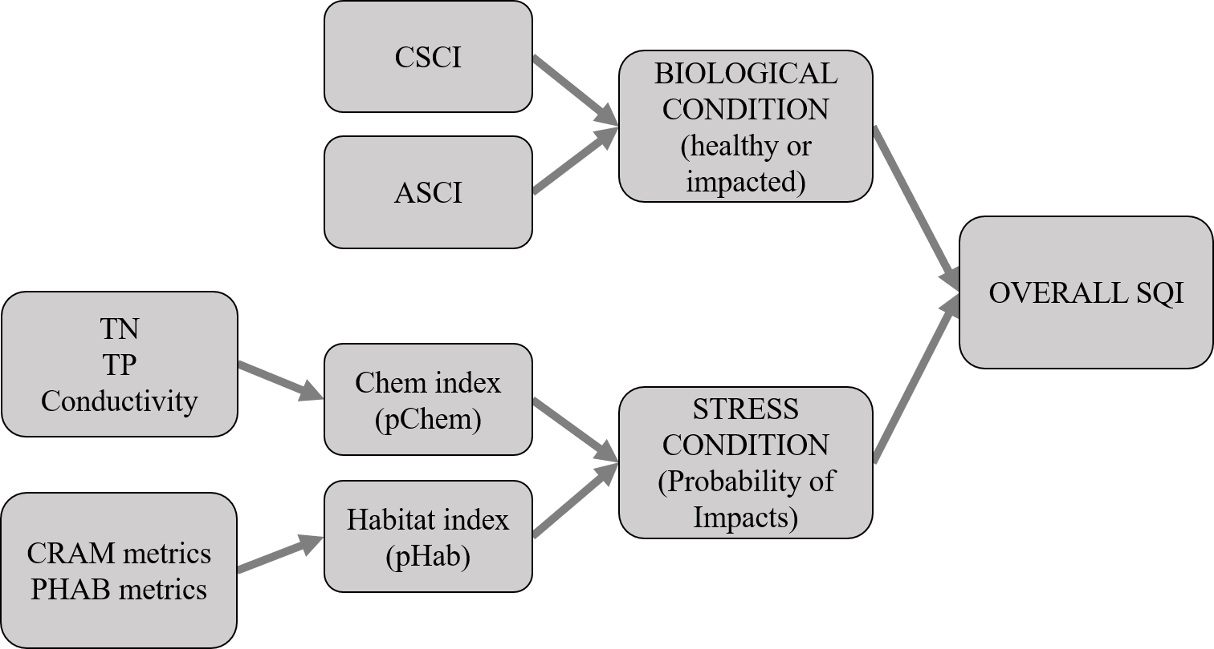

Figure 1 Flowchart representation of the Stream Quality Index (SQI). The overall SQI is a function of the likelihood of observing degraded biological condition given the stressors at a site. Biological condition is assessed using macroinvertebrate (California Stream Condition Index, CSCI) and algal (Algal Stream Condition Index, ASCI) indices and stressors are evaluated based on water quality measures (total nitrogen, total phosphorus, conductivity) and physical habitat (California Rapid Assessment Method or CRAM, physical habitat metrics or PHAB). Stress condition is empirically linked to biological condition by separate probability functions for chemistry (pCHem) and physical habitat (pHab).

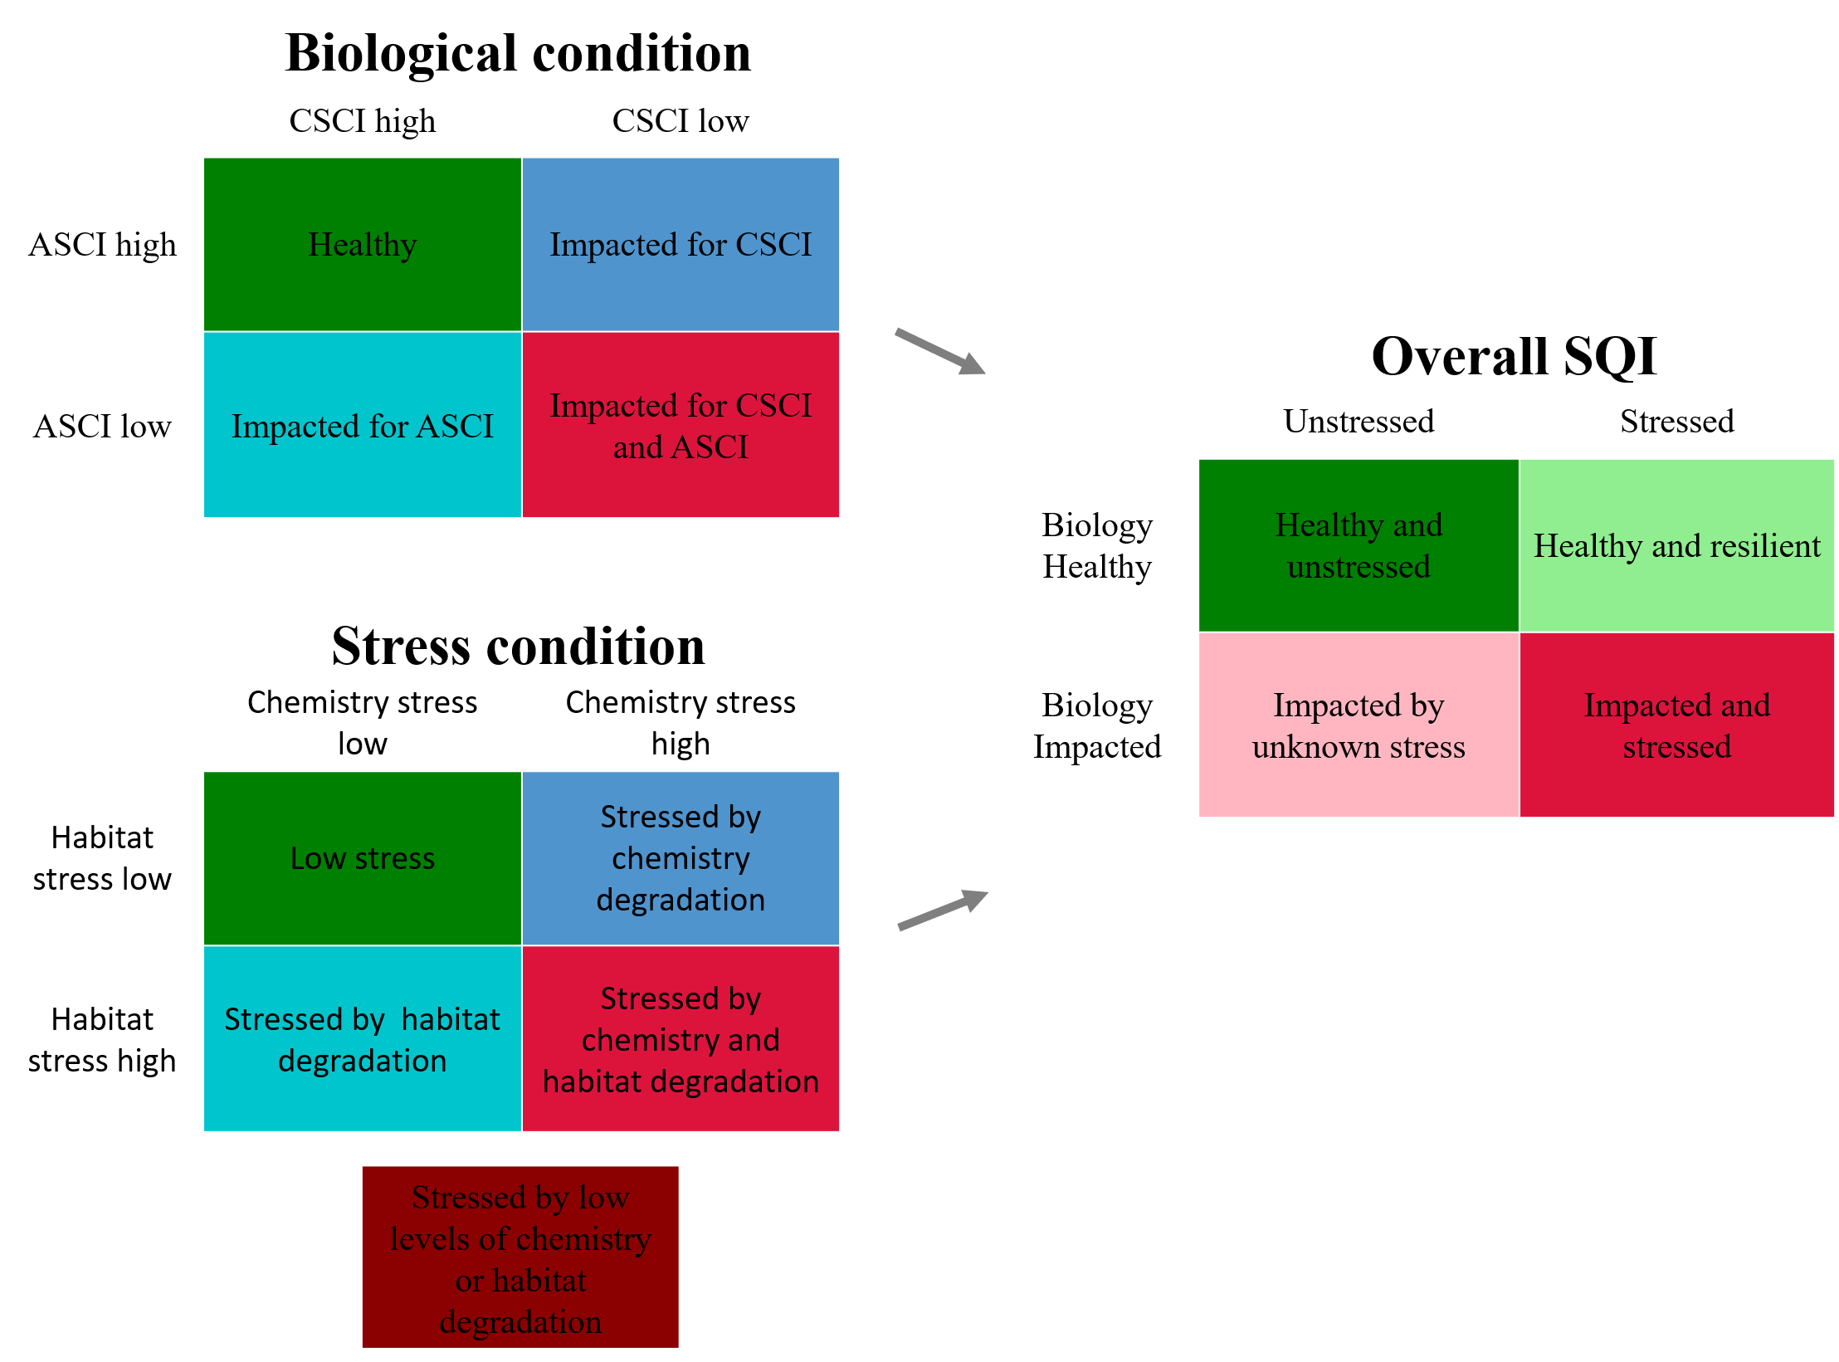

Figure 2 Categorical site descriptions that are possible from the Stream Quality Index (SQI). The overall SQI is described as the possible outcomes from biological and stress conditions. The biological conditions are described by the possible outcomes from the CSCI and ASCI. The stress conditions are described by the possible outcomes from the chemistry and habitat stressors. A fifth stress category is possible because stress from both chemistry and habitat was multiplicative.

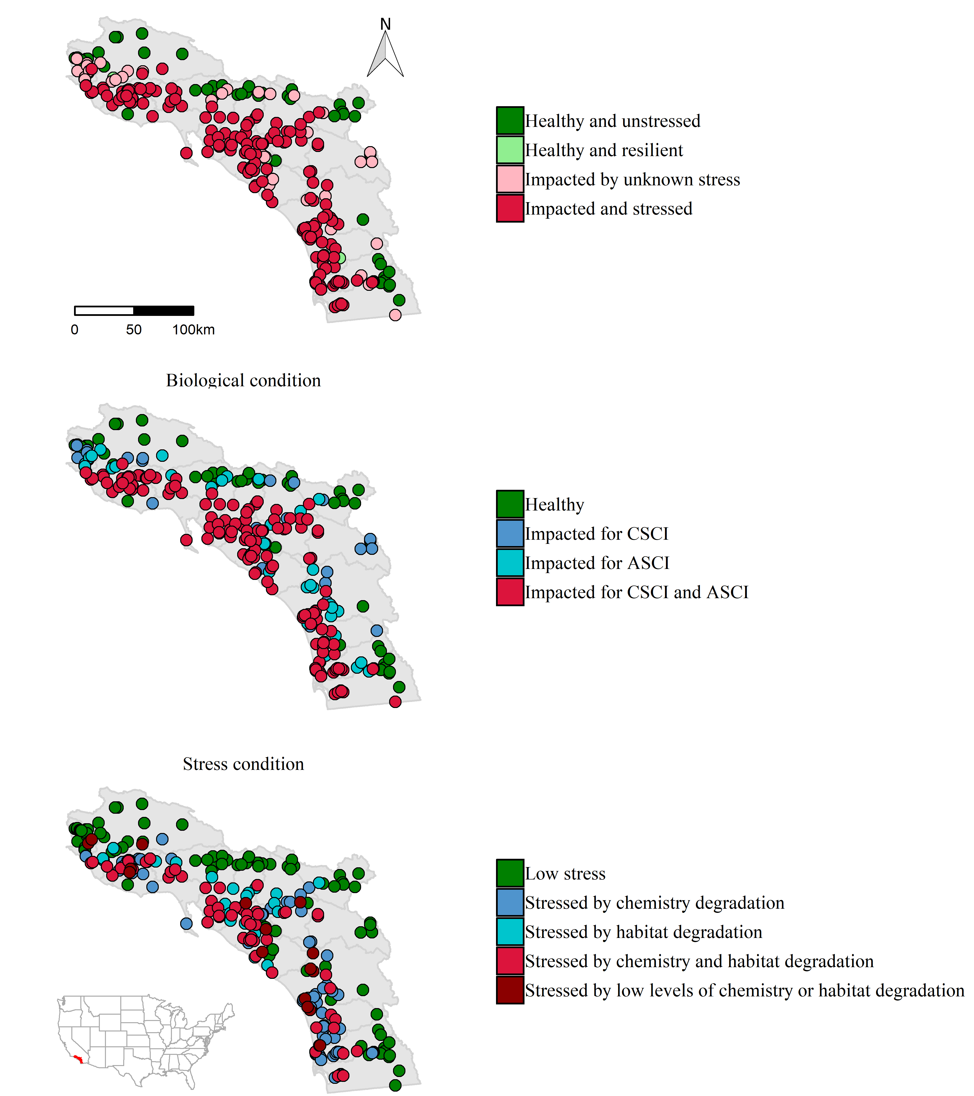

Figure 3 Categorical site descriptions for the Stream Quality Index (SQI) at monitoring sites in Southern California. The overall SQI (top) is described as the possible outcomes from biological (middle) and stress conditions (bottom). The biological conditions are described by the possible outcomes from the CSCI and ASCI. The stress conditions are described by the possible outcomes from the chemistry and habitat stressors.

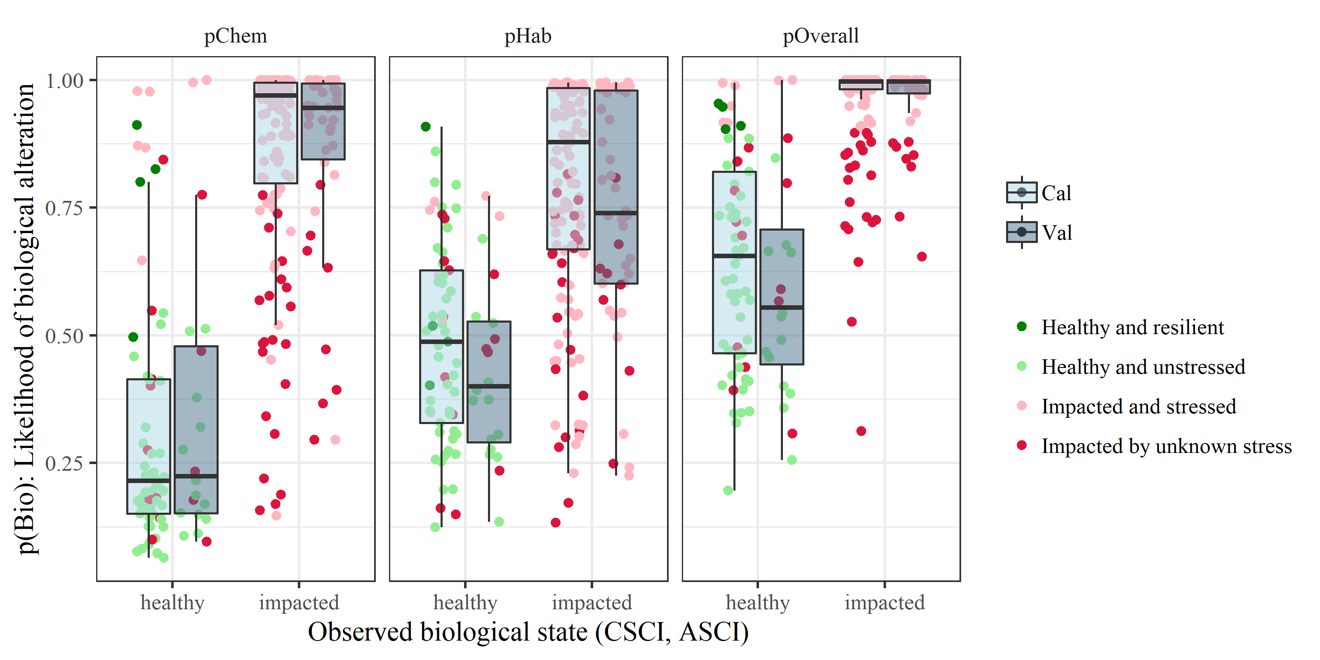

Figure 4 Boxplot distributions of the modelled likelihood of biological alteration relative to water chemistry (pChem, eqn. (1)) and physical habitat variables (pHab, eqn. (2)) and the additive overall stress as the product between the two (pOverall, eqn. (3)). Groups are separated into healthy or impacted biological condition at each site (Table 1) as the response measure for each model and by calibration/validation datasets (3:1 split). Points show the four possible categorical outcomes from the overall SQI. CSCI: California Stream Condition Index, ASCI: Algal Stream Condition Index

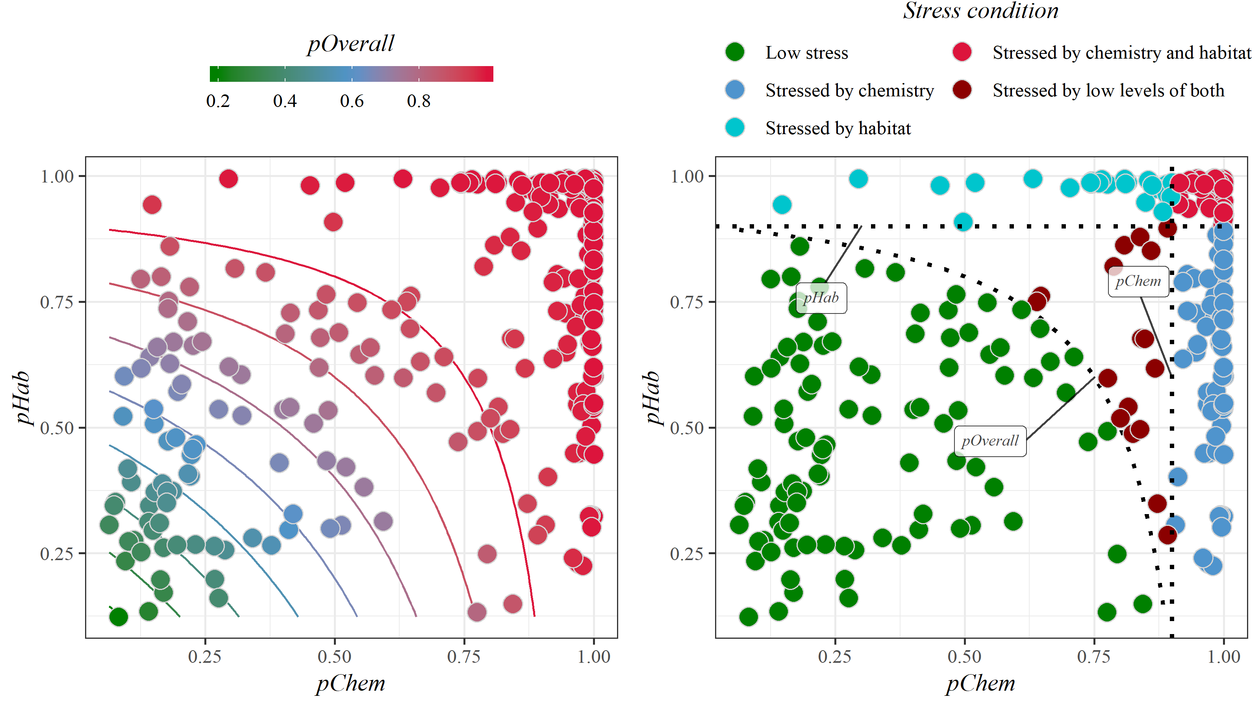

Figure 5 Relationship between stress models for water chemistry (pChem, eqn. (1)) and physical habitat (pHab, eqn. (2)). Stress models for water chemistry and physical habitat were created based on the likelihood of biological alteration for the observed stress measures. The overall stress measures (pOverall, eqn. (3)) is the product of both stress models shown in the left plot. Points represent estimated stress at a single site. The right plot shows the same points but colored by the stress condition categories that are defined by thresholds from the dotted lines.

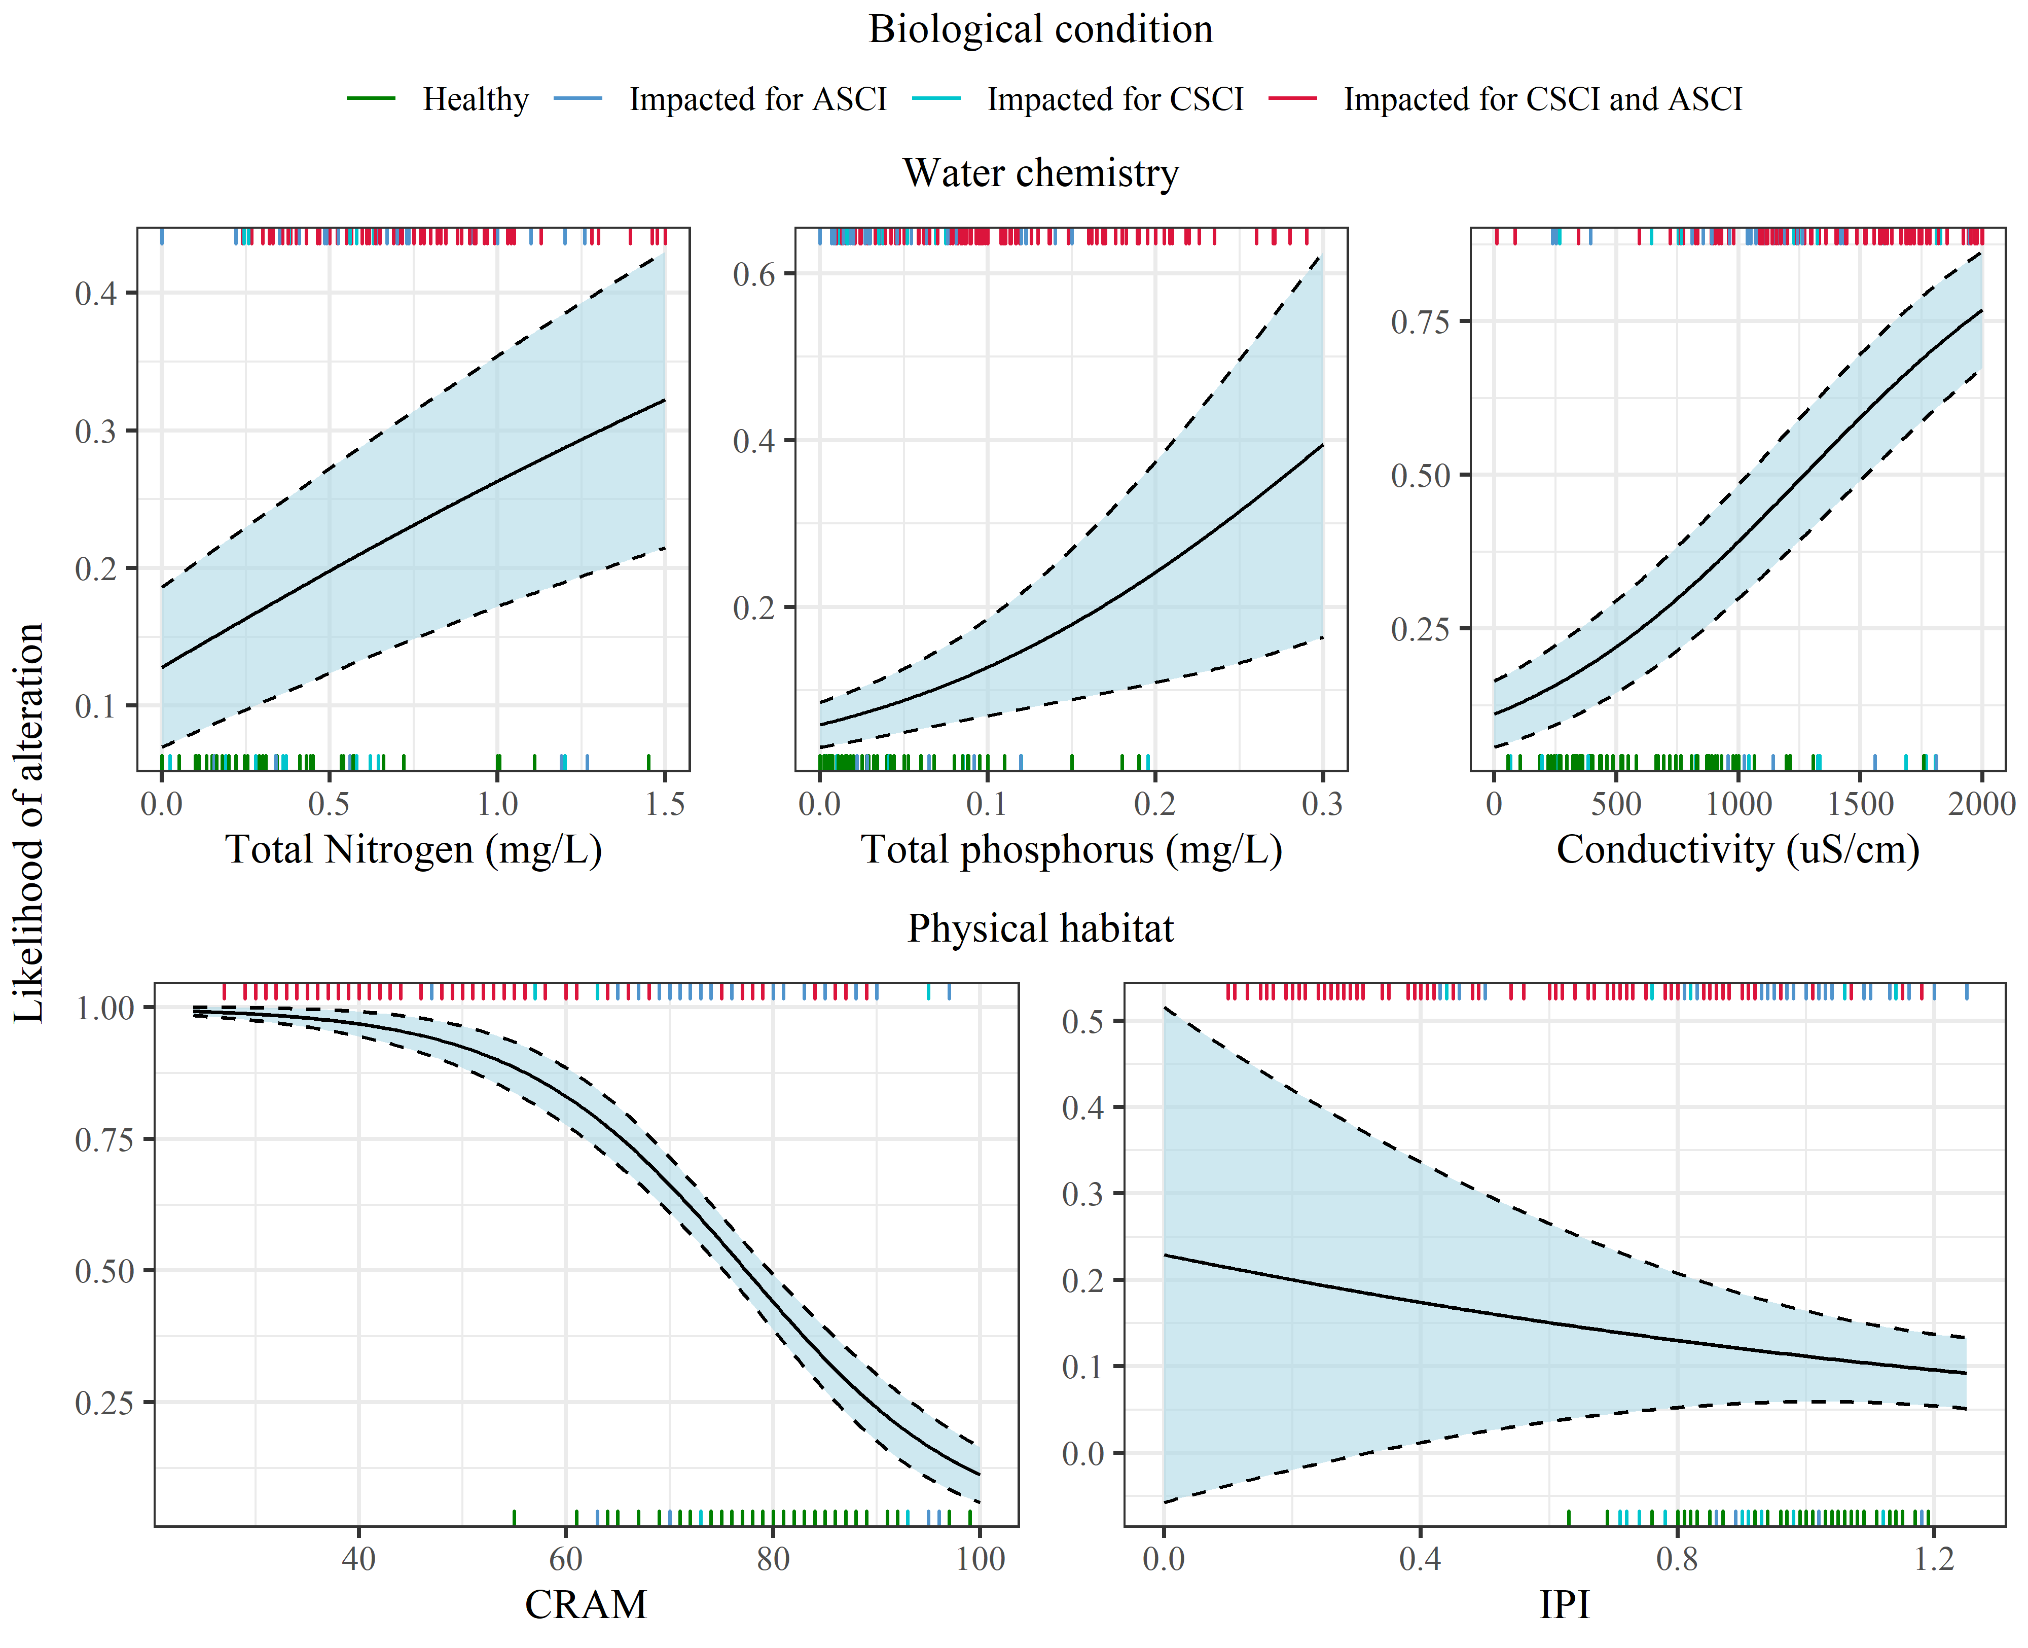

Figure 6 Modelled likelihood of biological alteration from water quality (top) and physical habitat stressors (bottom). Curves are the binomial likelihood (+/- standard error) of biological condition being altered (as measured by macroinvertebrate and algal indices) across the range of observed values for water quality and physical habitat stressors on the x-axes. The water chemistry and physical habitat stress plots are derived from equations (1) and (2). Other variables in each model not on the x-axis for each plot are held constant at values for low stress conditions. Biological condition for observations in each stressor model are shown as rug plots on the x-axes, with impacted sites on the bottom and healthy on the top.

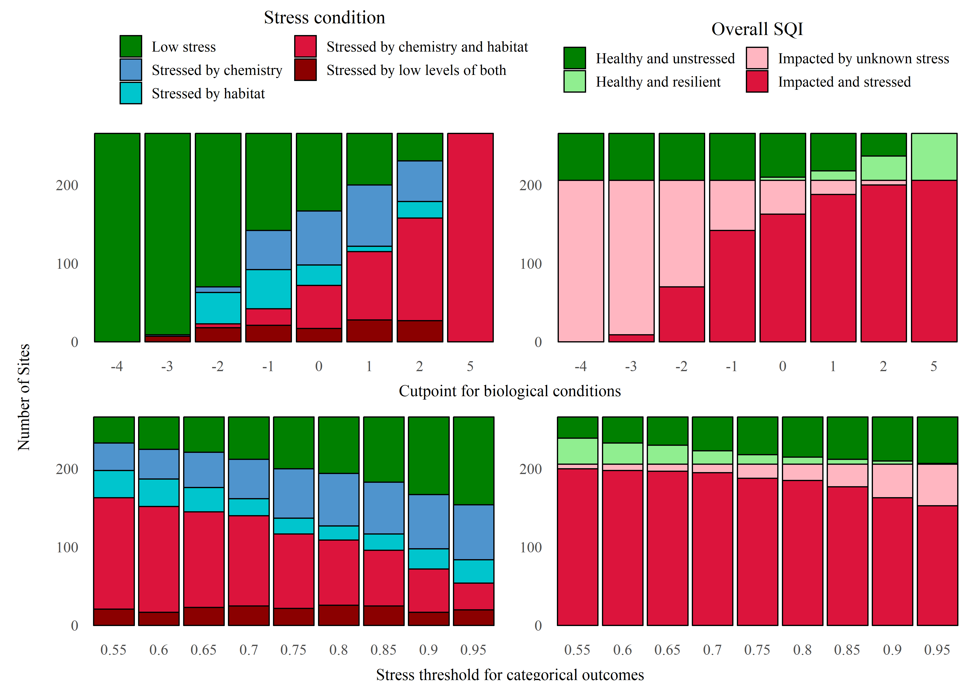

Figure 7 Changes in stress condition (left) and overall SQI categories (right) for different cut points that define healthy or impacted biology (top) and thresholds for the likelihood of observing impacted biology that define the stress categories (bottom). The columns in each plot show site counts in each category based on results from models in equations (1), (2), and (3) that relate stress measures to healthy/impacted biology. Sites below the cut points in the top row have impacted biology and sites including/above the cut point have healthy biology. The cut point definitions are shown in Table 1. Results for cut points 3 and 4 were identical to cut point 2 and are not shown. Thresholds in the bottom row define categories for the stress conditions (i.e., dotted lines in Figure 6.

# Tables

Table 1 Combined biological condition categories for the benthic macroinvertebrate (BMI) and algal indices. The combined categories were used to model the likelihood of biological alteration given observed physical and chemical habitat stressors. Sites with combined categories greater than or equal to zero were considered biologically healthy and those less than zero (in bold) were considered biologically impacted (i.e., response variable in equations (1) and (2)). Individual biological categories for the BMI and algal indices were based on percentile distributions of scores at reference sites (i.e., 1st, 10th, and 30th percentiles) as likely intact (> 30th), possibly altered (10th - 30th), likely altered (1st - 10th), and very likely altered (< 10th). The scores associated with the percentiles for each index (CSCI, ASCI) are in parentheses.

|  |  |  |  |  |
| --- | --- | --- | --- | --- |
|  | Algae likely intact: (ASCI > 0.93) | Algae possibly altered: (ASCI 0.83 - 0.93) | Algae likely altered: (ASCI 0.70 - 0.83) | Algae very likely altered: (ASCI < 0.70) |
| BMI likely intact: (CSCI > 0.92) | 4 | 1 | 0 | **-1** |
| BMI possibly altered: (CSCI 0.79 - 0.92) | 1 | 1 | **-1** | **-2** |
| BMI likely altered: (CSCI 0.63 - 0.79) | 0 | **-1** | **-2** | **-3** |
| BMI very likely altered: (CSCI < 0.63) | **-1** | **-2** | **-3** | **-4** |

Table 2 Counts of sites in each of the categorical outputs from the SQI. For every SQI output (biological condition, overall SQI, stress condition), a site is categorized as one of four possible outcomes.

|  |  |  |
| --- | --- | --- |
| SQI output | Category | Count (percent) |
| Overall SQI | Healthy and unstressed | 56 (21.1) |
|  | Healthy and resilient | 4 (1.5) |
|  | Impacted and stressed | 163 (61.3) |
|  | Impacted by unknown stress | 43 (16.2) |
| Biological condition | Healthy | 60 (22.6) |
|  | Impacted for ASCI | 43 (16.2) |
|  | Impacted for CSCI | 29 (10.9) |
|  | Impacted for CSCI and ASCI | 134 (50.4) |
| Stress condition | Low stress | 99 (37.2) |
|  | Stressed by chemistry and habitat degradation | 55 (20.7) |
|  | Stressed by chemistry degradation | 69 (25.9) |
|  | Stressed by habitat degradation | 26 (9.8) |
|  | Stressed by low levels of chemistry or habitat degradation | 17 (6.4) |

*Table 3: Summary of empirical stress models to quantify associations of water chemistry (pChem) and physical habitat (pHab) predictors with biological alteration. Generalized linear models were fit to predict the likelihood of both healthy benthic macroinvertebrate and algal communities at calibration sites (75% of n = 266 sites).*

|  |  |  |
| --- | --- | --- |
|  | pChem | pHab |
| Constant | -2.94 *** | 7.95 *** |
|  | (0.51) | (1.30) |
| log(TN) | 2.96 ** |  |
|  | (1.00) |  |
| log(TP) | 20.59 * |  |
|  | (8.52) |  |
| Conductivity | 0.00 *** |  |
|  | (0.00) |  |
| CRAM |  | -0.09 *** |
|  |  | (0.02) |
| IPI |  | -0.86 |
|  |  | (1.33) |
| N | 200 | 200 |
| AIC | 134.53 | 181.40 |
| BIC | 147.73 | 191.29 |
| Pseudo R2 | 0.64 | 0.42 |
| *** p < 0.001; ** p < 0.01; * p < 0.05. | | |

# 

# References

Bay, S.M., Weisberg, S.B., 2012. Framework for interpreting sediment quality triad data. Integrated Environmental Assessment and Management 8, 589–596. <https://doi.org/10.1002/ieam.118>

Beck, M.W., Mazor, R.D., 2018. SCCWRP/SQI: v1.2.0 (Version 1.2.0). Zenodo, <http://doi.org/10.5281/zenodo.2587212>.

Beck, M.W., Mazor, R.D., Theroux, S., Schiff, K.C., 2019. SCCWRP/SQI_Shiny: v1.0.0 (Version 1.0.0). Zenodo, <http://doi.org/10.5281/zenodo.2605438>.

Cao, Y., Hawkins, C.P., Olson, J., Kosterman, M.A., 2007. Modeling natural environmental gradients improves the accuracy and precision of diatom-based indicators. Journal of the North American Benthological Society 26, 566–585. <https://doi.org/10.1899/06-078.1>

CCME (Canadian Council of Ministers of the Environment), 2001. Canadian water quality guidelines for the protection of aquatic life: CCME Water Quality Index 1.0, Technical Report. In: Canadian environmental quality guidelines. Canadian Council of Ministers of the Environment, Winnipeg, Manitoba.

Chang, W., Cheng, J., Allaire, J., Xie, Y., McPherson, J., 2018. Shiny: Web application framework for r.

Collins, J.N., Stein, E.D., Sutula, M., Clark, R., Fetscher, A.E., Grenier, L., Grosso, C., Wiskind, A., 2007. California Rapid Assessment Method (CRAM) for wetlands, ver.5.0.

Fox, J., Weisberg, S., 2011. An R companion to applied regression. SAGE Publications Inc., Thousand Oaks, California.

Hawkins, C.P., Norris, R.H., Hogue, J.N., Feminella, J.W., 2000. Development and evaluation of predictive models for measuring the biological integrity of streams. Ecological Applications 10, 1456–1477. [https://doi.org/10.1890/1051-0761(2000)010[1456:DAEOPM]2.0.CO;2](https://doi.org/10.1890/1051-0761(2000)010%5b1456:DAEOPM%5d2.0.CO;2)

Hurley, T., Sadiq, R., Mazumder, A., 2012. Adaptation and evaluation of the Canadian Council of Ministers of the Environment Water Quality Index (CCME WQI) for use as an effective tool to characterize drinking source water quality. Water Research 46, 3544–3552. <https://doi.org/10.1016/j.watres.2012.03.061>

Karr, J.R., 1981. Assessment of biotic integrity using fish communities. Fisheries 6, 21–27.

Maddock, I., 1999. The importance of physical habitat assessment for evaluating river health. Freshwater Biology 41, 373–391. <https://doi.org/10.1046/j.1365-2427.1999.00437.x>

Maruya, K.A., Dodder, N.G., Mehinto, A.C., Denslow, N.D., Schlenk, D., Snyder, S.A., Weisberg, S.B., 2016. A tiered, integrated biological and chemical monitoring framework for contaminants of emerging concern in aquatic ecosystems. Environmental Management 12, 540–547. <https://doi.org/10.1002/ieam.1702>

Mazor, R.D., 2015. Bioassessment of perennial streams in Southern California: A report on the first five years of the Stormwater Monitoring Coalition’s regional stream survey (No. 844). Southern California Coastal Water Research Project, Costa Mesa, California.

Mazor, R.D., Rehn, A.C., Ode, P.R., Engeln, M., Schiff, K.C., Stein, E.D., Gillett, D.J., Herbst, D.B., Hawkins, C.P., 2016. Bioassessment in complex environments: Designing an index for consistent meaning in different settings. Freshwater Science 35, 249–271.

Moss, D., Furse, M.T., Wright, J.F., Armitage, P.D., 1987. The prediction of the macro-invertebrate fauna of unpolluted running-water sites in Great Britain using environmental data. Freshwater Biology 17, 41–52. <https://doi.org/10.1111/j.1365-2427.1987.tb01027.x>

National Research Council, 1990. Managing troubled waters: The role of marine environmental monitoring. National Academy Press, Washington, DC.

Ode, P.R., 2007. Standard operating procedures for collecting benthic macroinvertebrate samples and associated physical and chemical data for ambient bioassessment in California.

Ode, P.R., Rehn, A.C., Mazor, R.D., Schiff, K.C., Stein, E.D., May, J.T., Brown, L.R., Herbst, D.B., Gillett, D., Lunde, K., Hawkins, C.P., 2016. Evaluating the adequacy of a reference-site pool for ecological assessments in environmentally complex regions. Freshwater Science 35, 237–248.

Pan, Y., Stevenson, R.J., Hill, B.H., Kaufmann, P.R., Herlihy, A.T., 2002. Spatial patterns and ecological determinants of benthic algal assemblages in mid-Atlantic streams, USA. Journal of Phycology 35, 460–468. <https://doi.org/10.1046/j.1529-8817.1999.3530460.x>

Paulsen, S.G., Mayio, A., Peck, D.V., Stoddard, J.L., Tarquinio, E., Holdsworth, S.M., Sickle, J.V., Yuan, L.L., Hawkins, C.P., Herlihy, A.T., Kaufmann, P.R., Barbour, M.T., Larsen, D.P., Olsen, A.R., 2008. Condition of stream ecosystems in the US: An overview of the first national assessment. Journal of the North American Benthological Society 27, 812–821. <https://doi.org/10.1899/08-098.1>

RDCT (R Development Core Team), 2018. R: A language and environment for statistical computing, v3.5.1. R Foundation for Statistical Computing, Vienna, Austria.

Rehn, A.C., Mazor, R.D., Ode, P.R., 2018. An index to measure the quality of physical habitat in California wadeable streams (No. SWAMP Technical Memorandum, SWAMP-TM-2018-0005). California Water Boards, Surface Water Ambient Monitoring Program, California Department of Fish; Wildlife, Southern California Coastal Water Research Project, Sacramento, California.

Richards, C., Haro, R., Johnson, L., Host, G., 1997. Catchment and reach-scale properties as indicators of macroinvertebrate species traits. Freshwater Biology 37, 219–230. <https://doi.org/10.1046/j.1365-2427.1997.d01-540.x>

Solek, C.W., Stein, E.D., Sutula, M., 2011. Demonstration of an integrated watershed assessment using a three-tiered assessment framework. Wetlands Ecology and Management 19, 459–474. <https://doi.org/10.1007/s11273-011-9230-6>

Stoddard, J.L., Larsen, D.P., Hawkins, C.P., Johnson, R.K., Norris, R.H., 2006. Setting expectations for the ecological condition of streams: The concept of reference condition. Ecological Applications 16, 1267–1276. [https://doi.org/10.1890/1051-0761(2006)016[1267:SEFTEC]2.0.CO;2](https://doi.org/10.1890/1051-0761(2006)016%5b1267:SEFTEC%5d2.0.CO;2)

Theroux, S., Mazor, R.D., Beck, M.W., Ode, P., Sutula, M., Stein, E.D., in prep. A non-predictive algal index for complex environments. To be submitted to Ecological Indicators.

USEPA (US Environmental Protection Agency), 2016. National rivers and streams assessment 2008-2009: A collaborative survey (No. EPA-841-R-16-007). Washington, DC.

Wang, L.Z., Robertson, D.M., Garrison, P.J., 2007. Linkages between nutrients and assemblages of macroinvertebrates and fish in wadeable streams: Implication to nutrient criteria development. Environmental Management 39, 194–212. <https://doi.org/10.1007/s00267-006-0135-8>