Discussion

The Stream Quality Index fills a common need of watershed managers to synthesize large amounts of information when making decisions or communicating the technical basis for those decisions. This need is particularly important in regions like Southern California, where large-scale landscape alteration and competing demands for water usage begets a need for prioritization of limited resources. We have demonstrated how this index may be used to prioritize sites for restoration, protection, and other management activities on a large scale, allowing managers to recognize large-scale patterns that may not be evident if analyses were conducted on a site-by-site scale.

Because our index was focused on assessing environmental health, a key challenge was reflecting relationships among indicators of stream quality consistent with our conceptual model of a healthy stream ecosystem. That is, it was crucial to combine biological, chemical, and habitat indicators in a way that properly reflects the role of biology as a direct measure of condition, and the role of other indicators as measures of stress. Importantly, a finding of good water chemistry should not obscure or distort an indication of poor biology, and vice versa. We determined that a categorical approach was an appropriate way to address this concern, as a simple quantitative index that treats each indicator as independent lines of evidence could not effectively characterize situations where these indicators disagreed—a common situation in our data set. [Something about SQOs here?]

As a categorical index, the SQI provides a readily interpretable description of stream conditions. The four classes defined by the index (i.e., healthy and unstressed, healthy but stressed, unhealthy and stressed, unhealthy with stressors unknown) can be understood by a general audience with little familiarity with the underlying data or the tools used to analyze them. In contrast, numeric indices demand a higher level of experience to interpret; without training, an unfamiliar audience won’t know which values of a numeric index correspond to conditions requiring protection and which correspond to problems requiring intervention. [Although categorical indices create challenges for assessing trends or identifying borderline conditions, we have addressed this by XYZ.]

The SQI addresses the challenge of synthesizing large amounts of information about stream condition while preserving the components and presenting them for fruitful exploration. The index is structured in layers, allowing interested users to delve into the reasons why a site ended up with its classification. That is, users can determine which biological indicators account for a stream’s health rating, along with which stressors. The index is presented like an onion, allowing users to peel back layers to view underlying data, delving as deeply as they wish.

Our approach to characterizing stressors differs from similar efforts, several of which make it well suited for use with ambient monitoring programs compared to similar tools, such as the Canadian Water Quality Index (CWQI; CCME 2001). The CWQI evaluates the scope, frequency, and amplitude of water quality objective exceedances for numerous parameters, resulting in a numeric value that ranges from 0 (poor) to 100 (excellent). This type of index is appropriate for assessing compliance with regulatory criteria at sites where monitoring covers many parameters and occurs at regular intervals (which typically occurs at selected sites of interest, such as below discharge points or at mass-emission stations). In contrast, the SQI’s Water Chemistry Stress Index is better suited to ambient monitoring programs, such as the SMC’s stream survey, or the National Rivers and Streams Assessment. These programs tend to sample many sites, but with little to know replication, focusing on just a few indicators broadly indicative of water chemistry conditions rather than a large suite of potential stressors. The fact that our approach doesn’t rely on thresholds makes it applicable to indicators where thresholds are unavailable (such as our habitat indicators), yet maintains relevance for measuring aquatic life support, even if it has less bearing on regulatory compliance than the CWQI’s approach. Finally, the fact that our stress indices are expressed as probabilities of degrading biological conditions, rather than abstract numbers, means that these indices can be directly interpreted by unfamiliar users without reference to benchmarks.

This approach is not without drawbacks, such as its inflexibility to accommodate additional or fewer indicators of stress or stream condition. With respect to the CWQI, that index’s ability to include any number of parameters, whereas the SQI requires a fixed number of indicators for every assessment. Missing data (caused, for example, by the loss of a sample) prevents calculation of the index, and it is impossible to incorporate new indicators without recalibration. We restricted our focus to a limited number of parameters, knowing that a broader scope could preclude many sites from analysis.

The web application enhances the use of the SQI by managers and other stakeholders. First, a drag-and-drop interface automates batch calculations at large numbers of sites [TRUE?]. Visualizations support exploration of the data at both regional and site scales, allowing users to engage at multiple levels of depth. Scores for each index component are provided, with the option to view the underlying data. A map allows comparison of sites of interest to the region as a whole, as well as county- or watershed-level summaries. For example, highlighting one site in eastern San Diego county, we can see that, while biological conditions are healthy, the stream may be experiencing stress. If additional details are requested, one can see that the stress is due to habitat conditions, rather than water chemistry. A deeper dive reveals that elevated sands and fines, as opposed to other habitat elements, accounts for the stress. With this information, the manager can determine if the elevated sands and fines is due to wildfire, nearby soil disturbance, or other sources. (SEE FIGURES—make something more consolidated for this) [Not sure what else to say… Marcus?]

An integrated stream quality index has the potential to transform watershed management by giving managers a tool to synthesize large amounts of data, assign priorities based on this synthesis, and communicate these decisions to a broad range of stakeholders who may lack familiarity with bioassessment or watershed science. The index preserves our understanding of the roles of different indicators in describing stream health, combining them into a single, easily understood category while at the same time preserving the information contributing to the integrated assessment. An integrated stream quality index could be used to communicate information in both technical and non-technical venues, such as watershed assessments, [Something else], and environmental report cards.

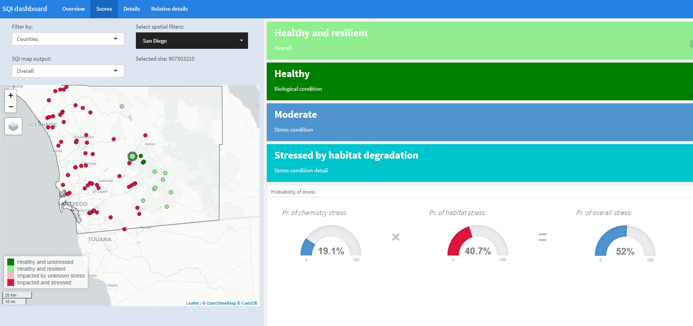

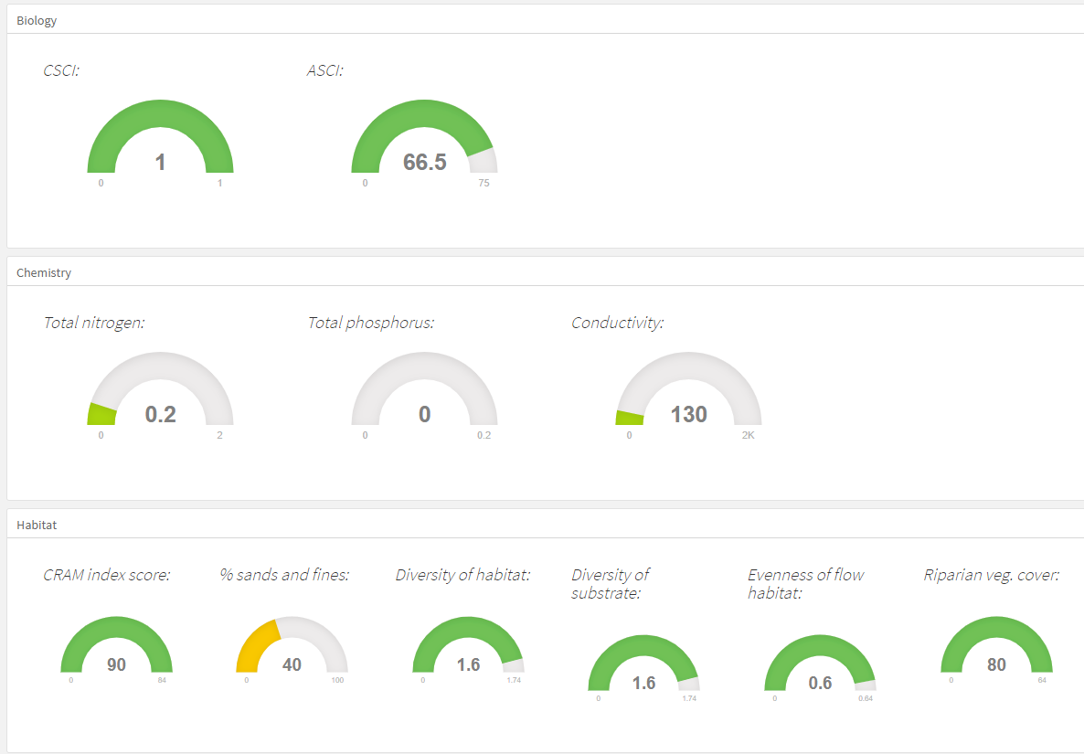

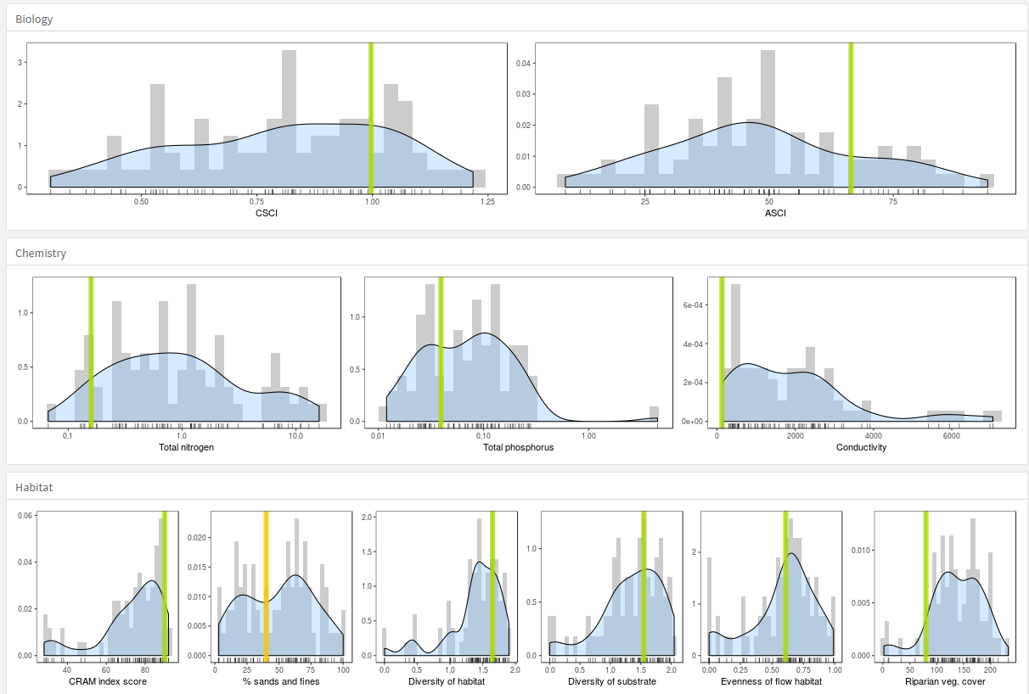

Cited lit

Canadian Council of Ministers of the Environment (CCME). 2001. Canadian water quality guidelines for the protection of aquatic life: CCME Water Quality Index 1.0, Technical Report. In: Canadian environmental quality guidelines, 1999, Canadian Council of Ministers of the Environment, Winnipeg.