The Stream Condition Index: A Multi-Indicator Tool For Enhancing Environmental Management Communication

Marcus W. Beck ([marcusb@sccwrp.org](mailto:marcusb@sccwrp.org)), Raphael D. Mazor ([raphaelm@sccwrp.org](mailto:raphaelm@sccwrp.org)), Kenneth C. Schiff ([kens@sccwrp.org](mailto:kens@sccwrp.org)

# Methods

## General Approach

The SQI is a conceptual approach to describing stream health that is based on a stressor-response relationship between biology and in-stream stressors. Using these relationships, the index provides a categorical description of overall stream health to support high-level management decisions, while also providing descriptions of the biological, chemical, and physical components that establish the foundation of the index to further evaluate which factors may be driving stream health. These tiers of information represent overall stream health, biological health, and stressor condition as single, actionable categories. The underlying stressor-response relationships that define the categories are based on empirical models that quantify an expected likelihood of chemical or physical stressors impacting the separate components of biological condition. Scientists and managers can easily access different components of the SQI depending on the desired level of information within the stressor-response paradigm.

The stressor-response model used by the SQI uses biological endpoints as indicators of beneficial uses for wadeable streams and water chemistry and physical habitat measurements as stressors that are empirically linked to biological condition. Because biological indicators provide direct measures of aquatic life, whereas physical and chemical measures provide ancillary information about the stressors that may affect aquatic life, it was crucial to combine these indicators in a way that preserve the different types of information they provide (as opposed to treating them as equivalent lines of evidence that could be “averaged” to assess overall condition). Similarly, we wanted to combine stressor measures that reflect their aggregate impacts on aquatic life.

[Need a broader topic sentence on our approach to selecting indicators?]

[I’m struggling with how much detail to provide here vs below. What do we need in this intro? I recommend deleting everything highlighted below, and instead putting in the appropriate sections]

We used quantitative bioassessment indices as measures of biological condition. Bioassessment indices for benthic macroinvertebrates and algal communities have been developed for California streams (Mazor et al. 2016, Theroux et al. in review), and both indices are used as complementary lines of evidence within the SQI. Analysis of multiple assemblages provide a more balanced indication of biological condition that can confirm overall stream health, and may also provide additional diagnostic information about stressors (as different communities may respond to different characteristics of stream habitat).

We selected water chemistry stressors that are those that are strongly associated with biological condition in perennial streams, namely nutrients and conductivity. Likewise, we selected physical habitat metrics was described generally as flow, channel, and riparian condition observed at a site. Although physical habitat can be considered a response metric of stream health depending on the context, physical habitat herein is considered a stressor that can affect biological condition at different taxonomic levels within the stressor-response model.

## Biological response components of the SQI

**Characterizing biological condition**

Biological responses were measured as two biological indices previously developed for California wadeable streams. First, the California Stream Condition Index (CSCI, Mazor et al. (2016)) is a predictive index that compares observed benthic macroinvertebrate taxa and metrics at a site to those expected under least disturbed reference conditions (sensu Stoddard et al. 2006). Expected values at a site are based on models that estimate the likely macroinvertebrate community relative to factors that naturally influence biology (Moss et al. 1987; Cao et al. 2007). Second, the Algal Stream Condition Index (ASCI, Theroux et al. (n.d.)) was similarly developed as response endpoints at lower trophic levels; the ASCI is a non-predictive multi-metric index (i.e., it uses a uniform, statewide reference expectation) that incorporates both diatoms and soft-bodied algae. Scores for both indices can range from 0 to ~ 1.4, with a score of 1 at sites in reference condition, and lower values indicating biological degradation. Both indices are used as standard assessment measures for perennial wadeable streams in California.

Index scores were compared to numeric thresholds from a biological condition gradient (BCG, Davies and Jackson 2006) model developed for California streams to assign BMI and algal samples to tiers of condition derived by expert elicitation (Paul et al., in review). These tiers have similar interpretation across assemblages, allowing for meaningful combination of the two indices. The third tier of condition (i.e., moderately altered structure and minimal loss of function) was considered to indicate healthy overall conditions that met the goals of our advisory group.

**Integrating multiple measures of biological condition**

The assigned BCG tiers for each index were combined using a ranking system to create a single numeric value that represents an overall condition reflected by both biological indices. These values were assigned based on the judgment of stakeholders, in accordance with several principles. First, the two indices should be independently applicable, so that an indication of good health in one index cannot negate indications of poor health in the other. Second, the numeric values should be sensitive to differences between sites in marginal or extreme conditions. For example, the numeric value for a sample where both indices indicate Tier 1 will be higher than for a sample where one index indicates Tier 1 and the other indicates Tier 2. This sensitivity improves detection of small changes in condition. The final numeric values ranged from -5 to +5. All positive values indicate healthy conditions.

|  |  |  |  |  |
| --- | --- | --- | --- | --- |
|  | Algae Tier 2  (ASCI: x to x) | Algae Tier 3  (ASCI: x to x) | Algae Tier 4  (ASCI: x to x) | Algae Tier 5  (ASCI: x to x) |
| BMI Tier 2 (CSCI: x to x) | 5 | 3 |  |  |
| BMI Tier 3 (CSCI: x to x) | 3 | 1 |  |  |
| BMI Tier 4 (CSCI: x to x) |  |  |  |  |
| BMI Tier 5 (CSCI: x to x) |  |  |  |  |
| BMI Tier 6 (CSCI: x to x) |  |  |  |  |

## Stressor components

**Characterizing stress**

Water chemisty and physical habitat measurements were used to describe stressors associated with low CSCI and ASCI scores (cite SMC) and have a conceptual relationship with both invertebrate and algal assemblages (add general citatoins). The water chemistry indicators included total nitrogen (mg/L), total phosphorus (mg/L) and specific conductivity ($μ$ S/cm). These indicators describe stressors generally associated with eutrophication and serve as proxies for cultural enrichment where the rate of primary production may be excessive and harmful relative to background conditions. Linkages between eutrophication and beneficial uses are strongly supported by the literature and nutrient observations could be considered “biostimulatory” substances in California streams, whereby a mechanistic link with biological integrity is represented in the stress-response model of the SQI. Nitrogen, phosphorus, and conductivity are widely measured observations in many regional and statewide monitoring programs and collectively act as surrogates for unmeasured or alternative water quality problems at a site (e.g., temperature, light penetration). Although other contaminants that can affect aquatic organisms are sometimes measured (e.g., metals, pesticides, pharmaceuticals), they tend to be sparsely distributed in the study region (cite SMC), and co-occur with elevated nutrients or specific conductivity, meaning that the selected indicators may be an effective stand-in for unmeasured water quality stressors in southern California.

Physical habitat conditions at a site were described using two indices of habitat condition developed for California: the Index of Physical-Habitat Integrity (IPI, Rehn et al. 2018) and the California Rapid Assessment Method for riverine wetlands (CRAM, Collins et al. 2007; Solek, Stein, and Sutula 2011). The IPI is based on physical habitat metrics that characterize five components of in-stream habitat quality: ,, or concretecalculate these sc, which are derived from protocols used in national assessments (cite NRSA) As with the CSCI, the IPI is a predictive index, and values for most metrics are compared to site-specific expectations appropriate for the stream’s environmental setting. It too ranges from 0 to ~1.4, with values less than 1 indicating departure from reference conditions.

In contrast to the IPI, CRAM is based on qualitative assessments of four attributes of riparian wetland function: landscape and buffer condition, hydrologic condition, physical structure, and biotic structure. Whereas the data for the IPI is derived from numerous quantitative measurements of physical habitat components collected along several transects, CRAM attributes are assessed on a whole-reach scale through visual observation. In general, CRAM characterizes larger-scale processes affecting stream condition both within and adjacent to the stream corridor, whereas the IPI focuses more narrowly on in-stream conditions. CRAM scores

**Integrating multiple measures of stress**

The combined impact of habitat or chemistry stressors on biological condition was evaluated by developing stress-response models that calculate the probability of observing poor biological conditions given observed levels of chemical or habitat stress. This approach sidesteps the need to identify potential thresholds for identifying high levels of stress while also accounting for their combined impacts.

For both types of stress, a generalized additive model (Wood 2006) was fit to calibration data to quantify smoothed functions for each separate water chemistry or physical habitat indicator, and how they are additively linked to binomial categories for altered or unaltered biology. Two models were developed:





where $p\left(bio\right)$ is the probability of biological alteration in equations (1) and (2) given smoothed function $s$ for each chemistry or physical habitat variable. The probability of alteration is modelled using a logit link function for binomial variables, as $log\left(p/\left(1-p\right)\right)$, where $p$ defines the presence or absence of altered biology.

An overall likelihood of biological alteration from both chemistry and physical habitat stressors was also estimated as a multiplicative function for $pChem$ and $pHab$:



Equations (1), (2), and (3) provided the empirical estimates of biological alteration that were used to define the categorical outputs of the SQI, defined below. For all three measures of stress (pChem, pHab, and pOverall), values over 0.67 were characterized as having a high probability of stress, and values below 0.33 were characterized as having low probability of stress. Note that moderate levels of overall stress may result from low levels of chemical and habitat stress.







## Combining stress and response measures into an overall Stream Quality Index (SQI)

The SQI is a categorical combination of the biological response components and stress components described above. Each component may result in binary classifications (healthy or unhealthy, and stresses or unstressed), leading to four possible combinations (i.e., healthy and unstressed, healthy but stressed, unhealthy and stressed, unhealthy with unknown stress). Both the biology and stress components may be sub-categorized to provide additional detail whenever conditions are other than “healthy and unstressed”. For example, an unhealthy condition may be sub-categorized as unhealthy for benthic macroinvertebrates, unhealthy for algae, or unhealthy for both. Stressed conditions may be sub-categorized as stressed by habitat degradation, stressed by poor water chemistry, stressed by both, or stressed by low levels of both. Thus, while the SQI simplifies information into one of four categories, up to 20 possible sub-categories provide more information about the conditions at a site.

$$pChem:p\left(bio\right)∼s\left(TN\right)+s\left(TP\right)+s\left(cond\right) (1)$$

$$pHab:p\left(bio\right)∼s\left(PHAB\right)+s\left(CRAM\right) (2)$$

$$pOverall:p\left(bio\right)∼pChem×pHab (3)$$

## Application

All data for the SQI were from the Stormwater Monitoring Coalition (SMC) regional monitoring program in southern California (Mazor 2015). This coalition represents multiple state, federal, and local agencies that have a shared mission of stormwater management for over 7000 stream kilometers in the region. The SMC initiated a regional monitoring program in 2009 to assist, in part, with the permitting process among dischargers from the member agencies. Central monitoring questions focus on assessing biological condition, identifying stressors associated with poor conditions, and evaluating trends over time. This dataset represents the most comprehensive source of stream data in Southern California. Because the SQI requires synoptic biological, chemistry, and physical habitat data, the final dataset used for model calibration represents a subset of the SMC dataset where all three components were simultaneously collected. This included 263 sites, 75% of which were used for model calibration. Sampling dates ranged from 2008 to 2015 with relatively even distribution of samples between years. Most sample events occurred between May and June following standard protocols for perennial stream surveys (Ode 2007).

Finally, precision and sensitivity of the SQI was evaluated to describe 1) how well the underlying empirical model described the likelihood of biological alteration, and 2) sensitivity of the model output to changing thresholds that defined the categorical conditions. The first analysis evaluated precision in the validation dataset for the SQI to determine agreement between the model and actual stress and biological conditions. The second analysis evaluated the change in results for the regional database that were caused by changing the categorical thresholds that defined which categories for the SQI were assigned to each site. For example, the percentage of sites ranked as healthy and unstressed was compared by evaluating a change in the biological threshold for altered/unaltered biology, e.g., at 1%, 10%, or 30% of reference scores for each index.

# Results

[We need results from stressor modeling—how good were they? Rsq?]

[We may want to present results a bit more consistent with methods. So, first, describe bio condition results, then stress results, then sqi. But maybe this piece-meal presentation is unnecessary….]

[Below is just the results of the applicaiton]

Among all sites, the overall SQI categorized a majority as having altered biology under high stress conditions (impacted and stressed, 75% of sites, Table 1). Just over 5% of sites were in the opposite category of unaltered biology in low stress conditions (healthy and unstressed). For the remaining two categories of the overall SQI, nearly 20% of sites had unaltered biology but were under high stress conditions (healthy and resilient), whereas less than 1% of sites had altered biology not related to physical or chemical stressors (impacted by unkown stress). For the biological condition category, sites with altered conditions were more often altered for both CSCI and ASCI scores (47%). For sites with one low scoring index, more sites were altered for the ASCI (23%) than the CSCI (7%). Less than a quarter of all sites had unaltered biology (23%). For stress conditions, over 75% of sites were stressed by both chemistry and physical habitat stressors. More sites were stressed by habitat degradation (11%) than water chemistry (4%) if only one stressor was present. Only 6% of sites had low stress, wheres 3% of sites were impacted by the additive effect of both low chemistry and physical habitat stressors.

Spatial patterns among SQI categories in Southern California generally followed elevation and land use gradients (Figure 3). More altered biological communities and high stress conditions were observed toward coastal areas in the lower watersheds and where urbanization is highest (e.g., Los Angeles, Orange County, Ventura, San Diego). Sites with altered biological condition showed similar spatial patterns as the overall SQI, although sites altered only for the ASCI were more often observed at mid-elevation in northern and southern locations in the study area. Stress condition patterns were similar to biology although low stress conditions were confined to the extreme northeast region of the study area, whereas healthy biological conditions were observed at a wider range of locations but still generally confined to high elevation. High stress conditions were also observed across a wider elevation gradient than biological alteration, i.e., resilient biological comunities in the presence of high stress were not uncommon (Table 1).

The underlying empirical models provided insight into instream characteristics that were related to he likelihood of biological alteration (Figures 4, 5). Seventy percent of sites (n = 171) had a greater than 50% likelihood of biological alteration from water chemistry stressors and 79% (n = 187) had a greater than 50% likelihood of biological alteration from physical habitat stressors (Figure 4). Collectively, 90% of sites had a greater than 50% likelihood of biological alteration from the overall stress of both chemistry and physical habitat stressors.

Figure 5 demonstrates how the individual components for each stressor model were related to likelihood of alteration. These partial dependency plots were created by estimating the likelihood of alteration across a range of values for each predictor while holding other predictors constant. For each plot, the variables not on the x-axis were held at approximate values that were associated with low stress to better understand how biological alteration may be related to each predictor. For water chemistry stressors, all were positively associated with likelihood of alteration, particularly total phosphorus which had the steepest increase in likelihood per unit increase of nutrients. Associations of biological alteration with physical habitat predictors were more variable. The strongest relationship was observed with increases in CRAM scores, where likelihood of alteration decreased sharply with CRAM scores greater than 50. Other predictors showed expected associations with alteration but were not as strong as for CRAM, e.g., increases in substrate diversity were associated with improved biological condition. Percent sands and fines was the only physical habitat variable that showed a positive assocation with likelihood of biological alteration.

* SQI performance metrics
  + Precision
  + Any others?
* Percent So Cal stream miles or site frequency in each category
  + As a set up for the value of the categorical scoring
* Overall agreement among stressor indicators
  + As a set up for do we need multiple indicators?
* Overall agreement among response indicators
  + As a set up for do we need multiple indicators?
* SQI trends either overall or at example sites

# Figures

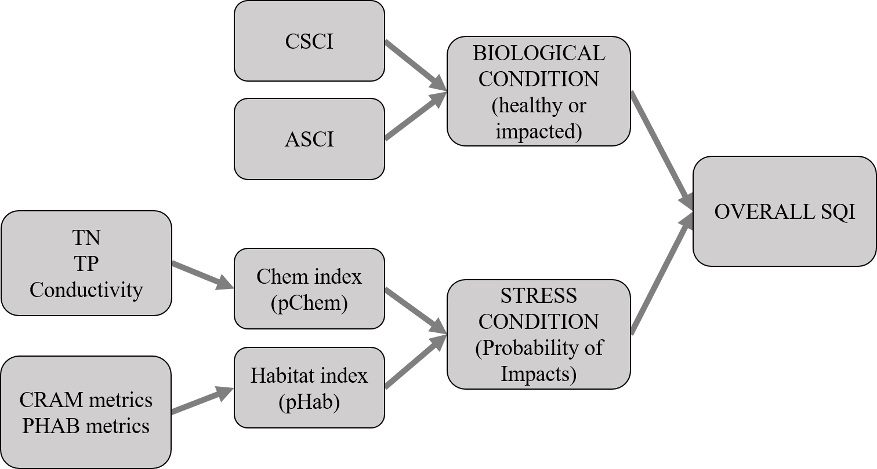

Figure 1 Flowchart representation of the Stream Quality Index (SQI). The overall SQI is a function of the likelihood of observing degraded biological condition given the stressors at a site. Biological condition is assessed using macroinvertebrate (California Stream Condition Index, CSCI) and algal (Algal Stream Condition Index, ASCI) indices and stressors are evaluated based on water quality measures (total nitrogen, total phosphorus, conductivity) and physical habitat (California Rapid Assessment Method or CRAM, physical habitat metrics or PHAB). Stress condition is empirically linked to bilogical condition by separate probability functions for chemistry (pCHem) and physical habitat (pHab).

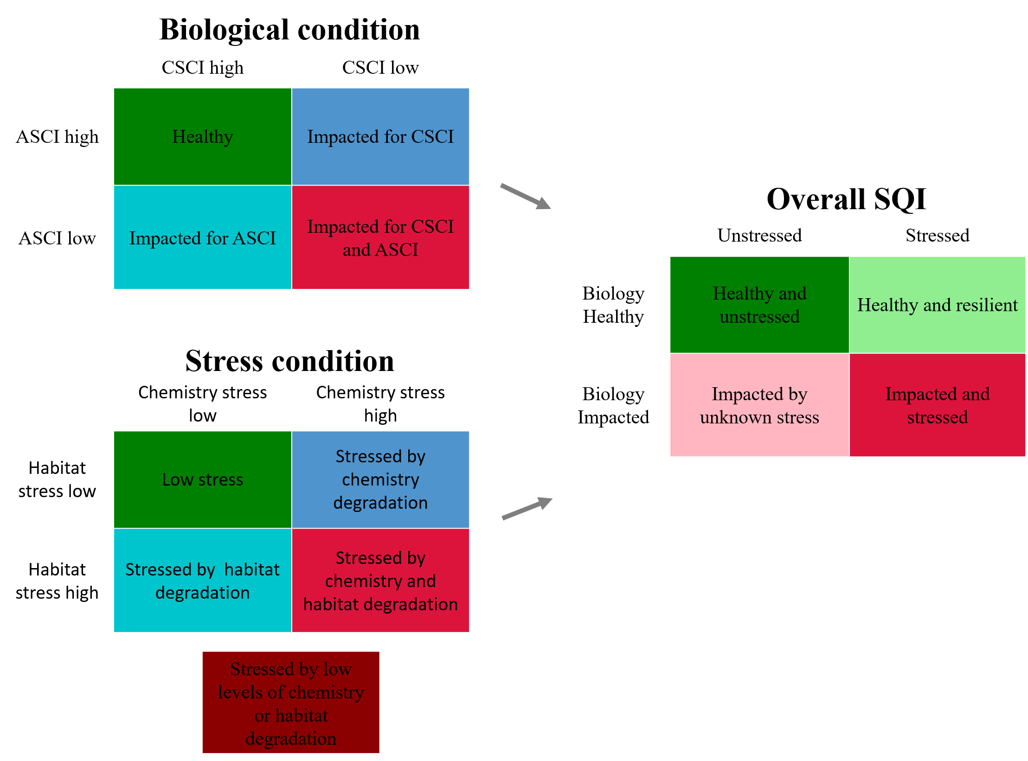

Figure 2 Categorical site descriptions that are possible from the Stream Quality Index (SQI). The overall SQI is described as the possible outcomes from biological and stress conditions. The biological conditions are described by the possible outcomes from the CSCI and ASCI. The stress conditions are described by the possible outcomes from the chemistry and habitat stressors. A fifth stress category is possible because stress from both chemistry and habitat was multiplicative.

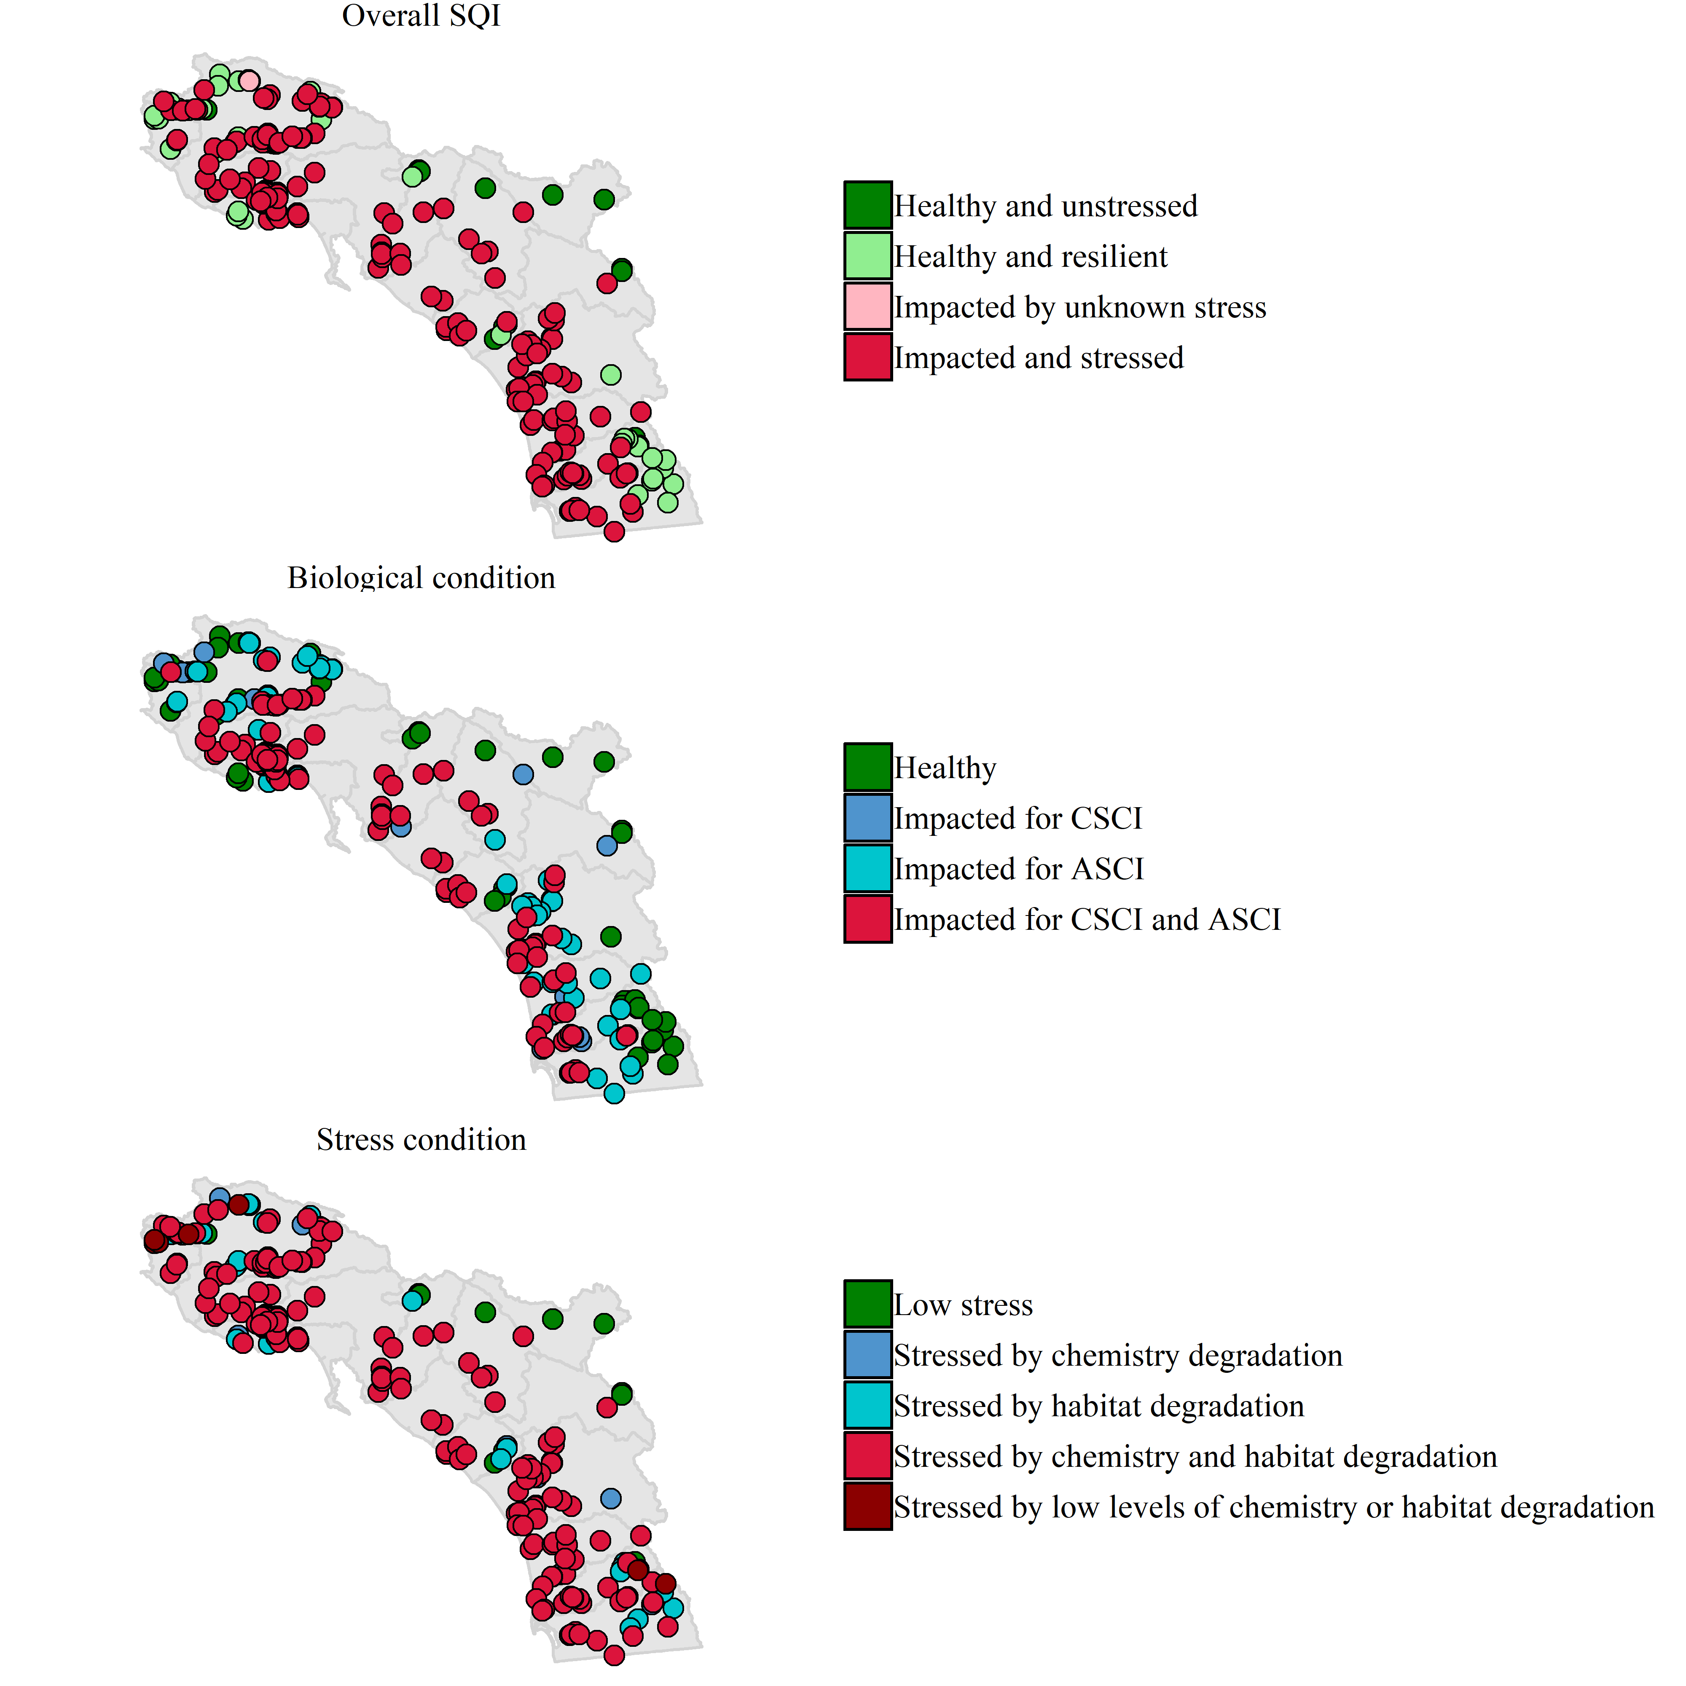

Figure 3 Categorical site descriptions for the Stream Quality Index (SQI) at monitoring sites in Southern California. The overall SQI (top) is described as the possible outcomes from biological (middle) and stress conditions (bottom). The biological conditions are described by the possible outcomes from the CSCI and ASCI. The stress conditions are described by the possible outcomes from the chemistry and habitat stressors.

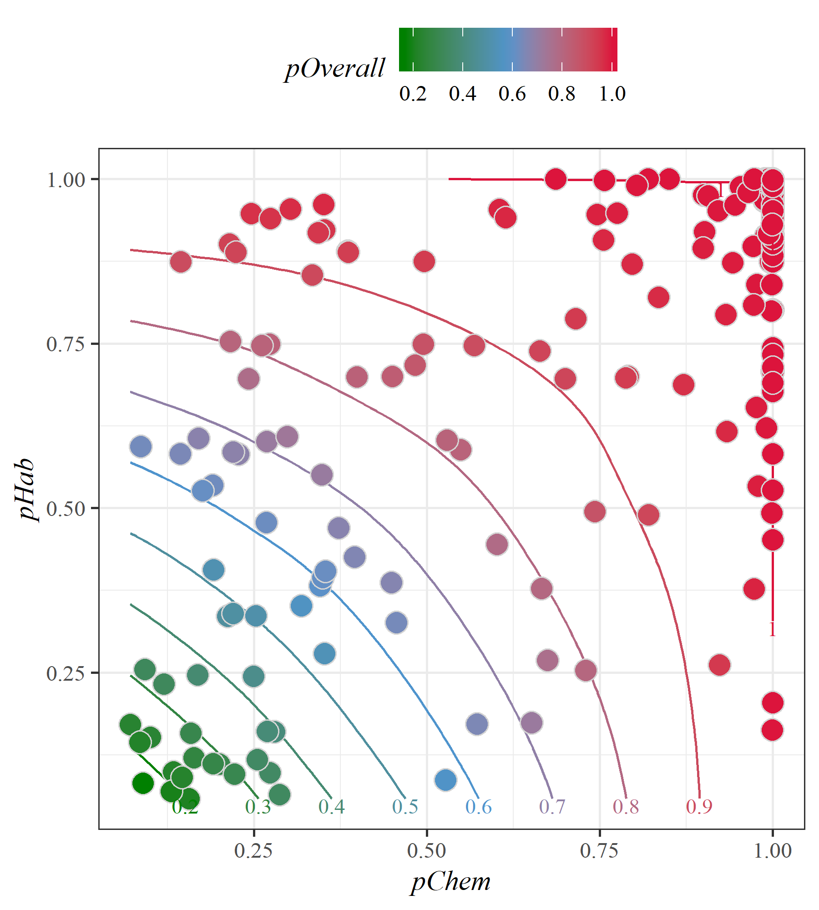

Figure 4 Relationship between stress models for water chemistry (pChem, eqn. (1)) and physical habitat (pHab, eqn. (2). Stress models for water chemistry and physical habitat were created based on the likelihood of biological alteration for the observed stress measures. The overall stress meaures (pOverall, eqn. (3)) is the product of both stress models. Points represent estimated stress at a single site.

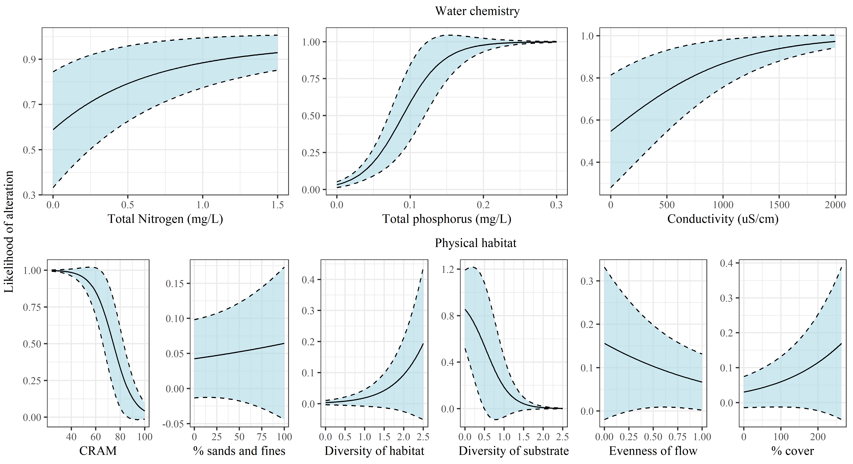

Figure 5 Modelled likelihood of biological alteration from water quality (top) and physical habitat stressors (bottom). Curves are the binomial likelihood (+/- standard error) of biological condition being altered (as measured by macroinvertebrate and algal indices) across the range of observed values for water quality and physical habitat stressors on the x-axes. The water chemistry and physical habitat stress plots are derived from equations (1) and (2). Other variables in each model not on the x-axis for each plot are held constant at values for low stress conditions.

# Tables

Table 1 Counts of sites in each of the categorical outputs from the SQI. For every SQI output (biological condition, overall SQI, stress condition), a site is categorized as one of four possible outcomes.

|  |  |  |
| --- | --- | --- |
| SQI output | Category | Count (percent) |
| Overall SQI | Healthy and unstressed | 14 (5.9) |
|  | Healthy and resilient | 43 (18.1) |
|  | Impacted and stressed | 180 (75.6) |
|  | Impacted by unknown stress | 1 (0.4) |
| Biological condition | Healthy | 57 (23.9) |
|  | Impacted for ASCI | 54 (22.7) |
|  | Impacted for CSCI | 16 (6.7) |
|  | Impacted for CSCI and ASCI | 111 (46.6) |
| Stress condition | Low stress | 15 (6.3) |
|  | Stressed by chemistry and habitat degradation | 181 (76.1) |
|  | Stressed by chemistry degradation | 10 (4.2) |
|  | Stressed by habitat degradation | 25 (10.5) |
|  | Stressed by low levels of chemistry or habitat degradation | 7 (2.9) |

# References

Cao, Y., C. P. Hawkins, J. Olson, and M. A. Kosterman. 2007. “Modeling Natural Environmental Gradients Improves the Accuracy and Precision of Diatom-Based Indicators.” *Journal of the North American Benthological Society* 26 (3):566–85. <https://doi.org/10.1899/06-078.1>.

Collins, J. N., E. D. Stein, M. Sutula, R. Clark, A. E. Fetscher, L. Grenier, C. Grosso, and A. Wiskind. 2007. *California Rapid Assessment Method (CRAM) for Wetlands, Ver.5.0.* [\url{http://www.cramwetlands.org/documents/}](C:\\url{http:\\www.cramwetlands.org\\documents\\}).

Davies, S. P., and S. K. Jackson. 2006. “The Biological Condition Gradient: A Descriptive Model for Interpreting Change in Aquatic Ecosystems.” *Ecological Applications* 16 (4):1251–66.

Mazor, R. D. 2015. “Bioassessment of Perennial Streams in Southern California: A Report on the First Five Years of the Stormwater Monitoring Coalitions’s Regional Stream Survey.” 844. Costa Mesa, California: Southern California Coastal Water Research Project.

Mazor, R. D., A. C. Rehn, P. R. Ode, M. Engeln, K. C. Schiff, E. D. Stein, D. J. Gillett, D. B. Herbst, and C. P. Hawkins. 2016. “Bioassessment in Complex Environments: Designing an Index for Consistent Meaning in Different Settings.” *Freshwater Science* 35 (1):249–71.

Moss, D., M. T. Furse, J. F. Wright, and P. D. Armitage. 1987. “The Prediction of the Macro-Invertebrate Fauna of Unpolluted Running-Water Sites in Great Britain Using Environmental Data.” *Freshwater Biology* 17 (1):41–52. <https://doi.org/10.1111/j.1365-2427.1987.tb01027.x>.

Ode, P. R. 2007. “Standard Operating Procedures for Collecting Benthic Macroinvertebrate Samples and Associated Physical and Chemical Data for Ambient Bioassessment in California.” Surface Water Ambient Monitoring Program. Sacramento, CA.

Rehn, A. C., R. D. Mazor, and P. R. Ode. 2018. “An Index to Measure the Quality of Physical Habitat in California Wadeable Streams.” SWAMP Technical Memorandum, SWAMP-TM-2018-0005. Sacramento, California: California Water Boards, Surface Water Ambient Monitoring Program, California Department of Fish; Wildlife, Southern California Coastal Water Research Project. <https://www.waterboards.ca.gov/water_issues/programs/swamp/bioassessment/docs/physical_habitat_index_technical_memo.pdf>.

Solek, C. W., E. D. Stein, and M. Sutula. 2011. “Demonstration of an Integrated Watershed Assessment Using a Three-Tiered Assessment Framework.” *Wetlands Ecology and Management* 19 (5):459–74. <https://doi.org/10.1007/s11273-011-9230-6>.

Stoddard, J. L., D. P. Larsen, C. P. Hawkins, R. K. Johnson, and R. H. Norris. 2006. “Setting Expectations for the Ecological Condition of Streams: The Concept of Reference Condition.” *Ecological Applications* 16 (4):1267–76. [https://doi.org/10.1890/1051-0761(2006)016[1267:SEFTEC]2.0.CO;2](https://doi.org/10.1890/1051-0761(2006)016%5b1267:SEFTEC%5d2.0.CO;2).

Theroux, S., R. D. Mazor, M. W. Beck, P. Ode, M. Sutula, and E. D. Stein. n.d. “A Non-Predictive Algal Index for Complex Environments.” *Ecological Indicators*.

Wood, S. N. 2006. *Generalized Additive Models: An Introduction with R*. London, United Kingdom: Chapman; Hall, CRC Press.