Prioritizing management goals for stream biological integrity within the developed landscape context

Marcus W. Beck ([marcusb@sccwrp.org](mailto:marcusb@sccwrp.org)), Raphael D. Mazor ([raphaelm@sccwrp.org](mailto:raphaelm@sccwrp.org)), Scott Johnson ([scott@aquaticbioassay.com](mailto:scott@aquaticbioassay.com)), Karin Wisenbaker ([karin@aquaticbioassay.com](mailto:karin@aquaticbioassay.com)), Joshua Westfall ([jwestfall@lacsd.org](mailto:jwestfall@lacsd.org)), Peter R. Ode ([peter.ode@wildlife.ca.gov](mailto:peter.ode@wildlife.ca.gov)), Ryan Hill ([hill.ryan@epa.gov](mailto:hill.ryan@epa.gov)), Chad Loflen ([Chad.Loflen@waterboards.ca.gov](mailto:Chad.Loflen@waterboards.ca.gov)), Martha Sutula ([marthas@sccwrp.org](mailto:marthas@sccwrp.org)), Eric D. Stein ([erics@sccwrp.org](mailto:erics@sccwrp.org))

# Supplement 1: Figures and Tables

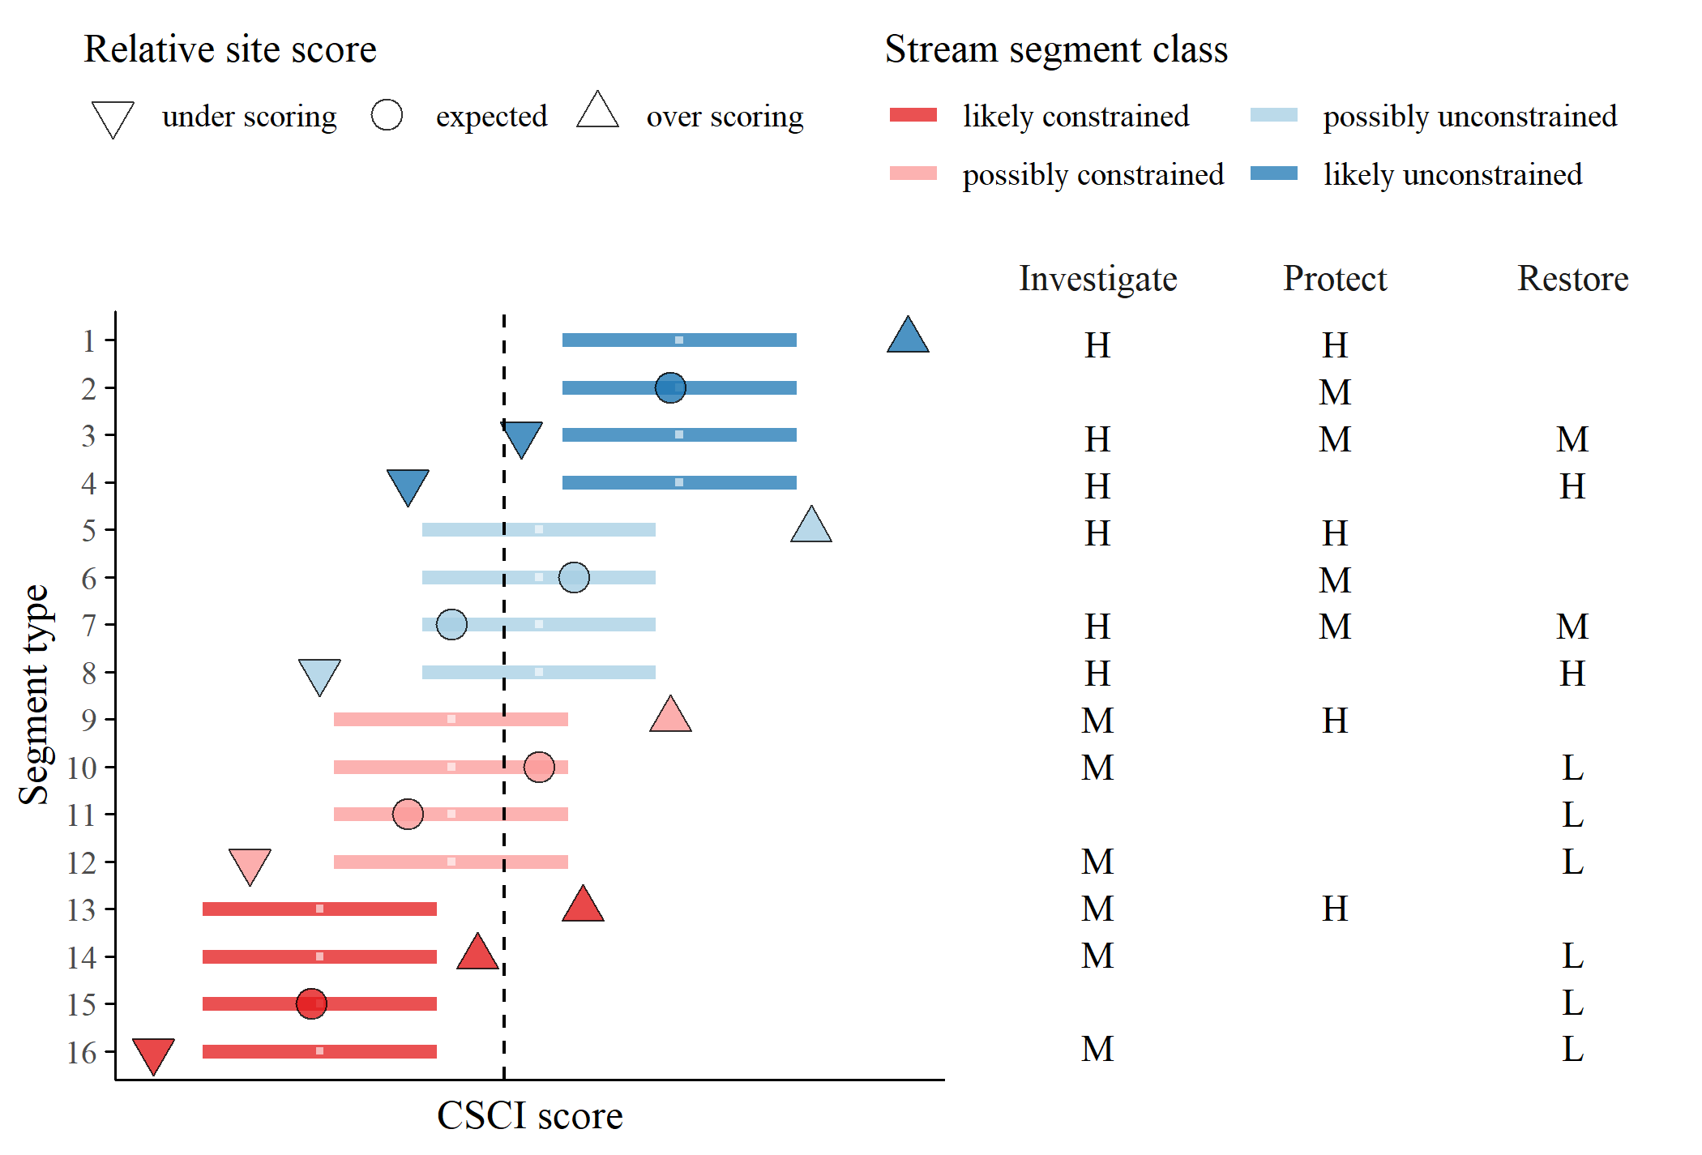

Figure 1 Template provided to stakeholders for prioritization of recommended actions for each stream type. The segment types relate to the stream class for the biological expectation (likely unconstrained, possibly unconstrained, possibly constrained, likely constrained), relative site score for the observed CSCI (over-scoring, expected, under-scoring), and location of the score relative to a hypothetical biological threshold (dashed line, above or below). Horizontal lines are the ranges of expected CSCI scores for a site with tick marks for the median. Priority actions defined by stakeholders are shown on the right for each stream type. Actions are generalized as investigate, protect, or monitor as high (H), medium (M), or low (L) priority. Blank cells indicate that no additional measures are recommended beyond the baseline monitoring and maintenance practiced at all sites.

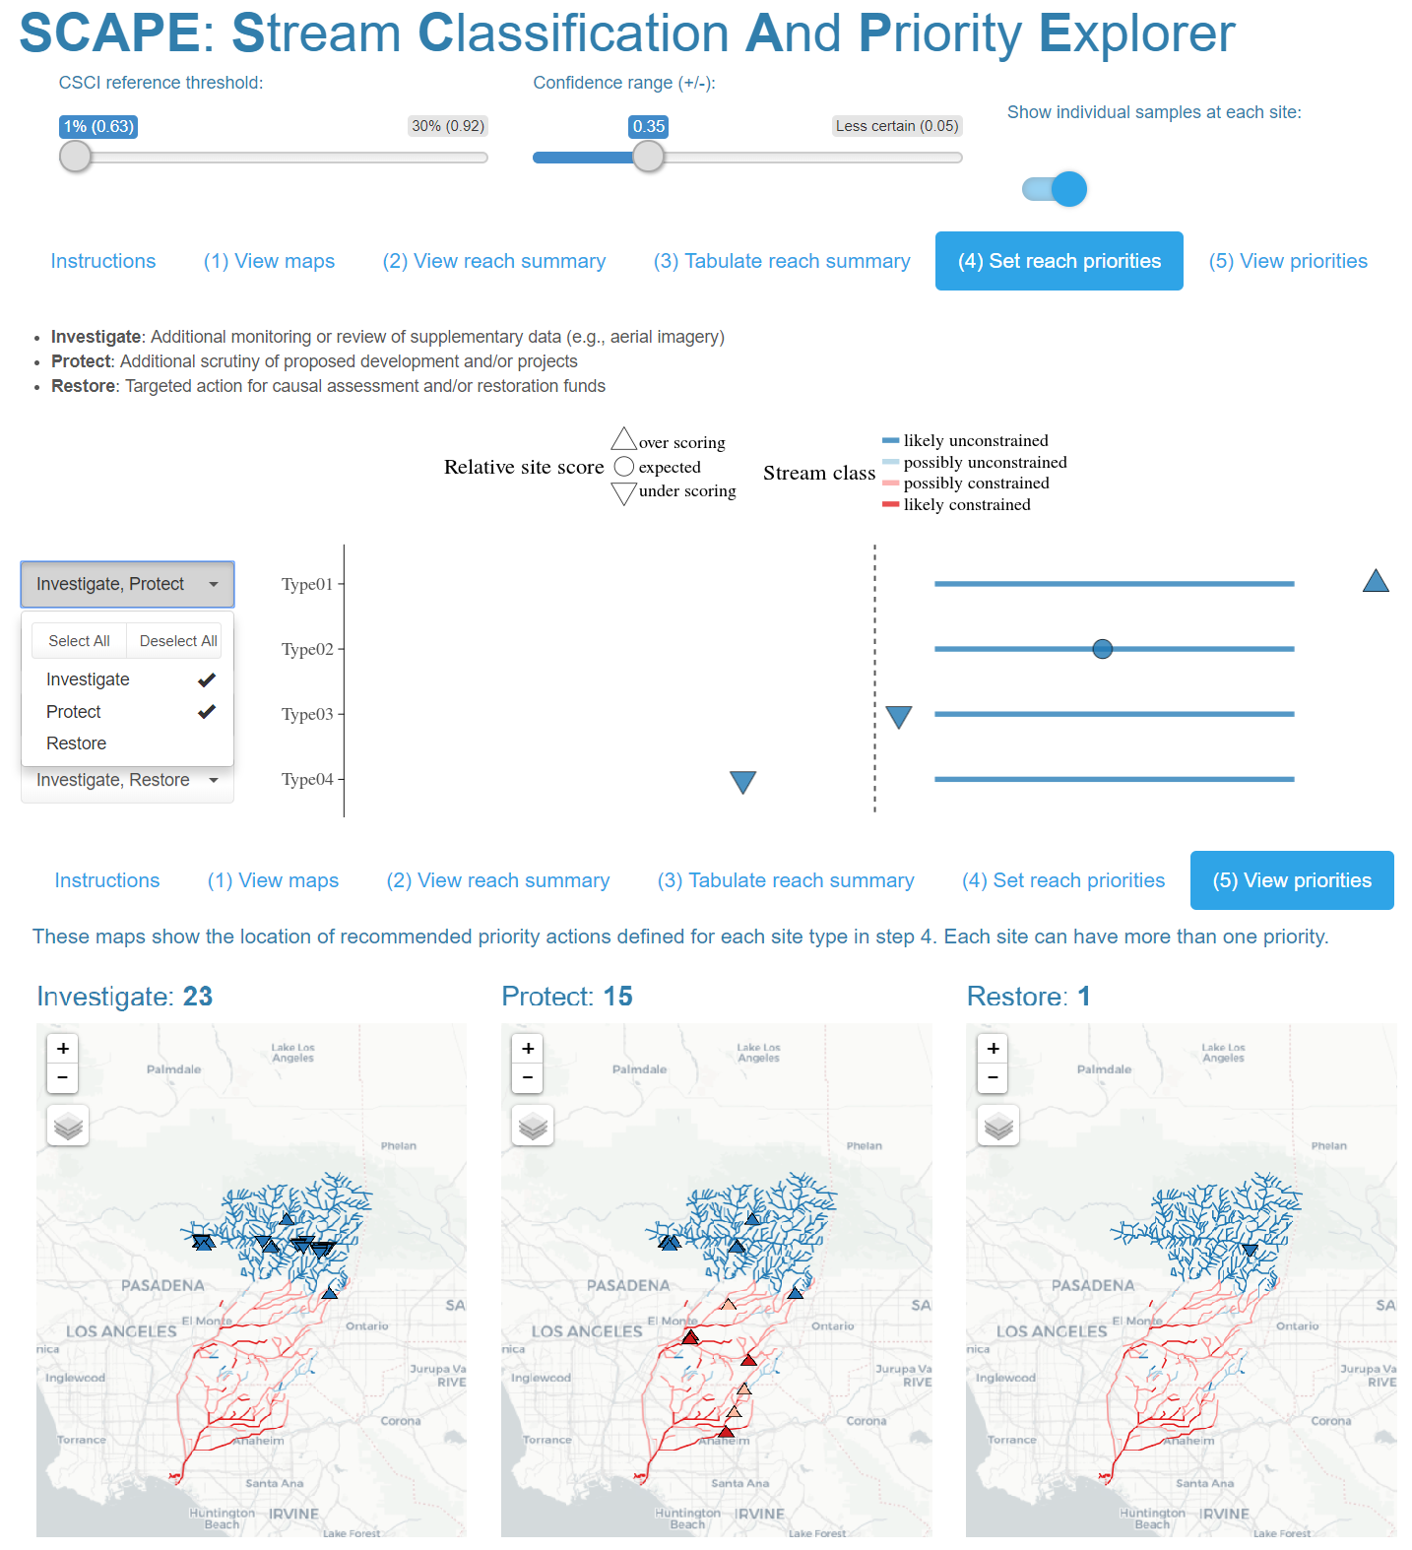

Figure 2 Screenshots from the Stream Classification and Priority Explorer (SCAPE) tool used by the stakeholder group to interact with and use results from the landscape model. The application allowed users to visualize results of segment classifications, relative site scores for the CSCI based on the expectation, and recommend management actions for each segment type. The app is accessible at <http://shiny.sccwrp.org/scape/> (Beck 2018).

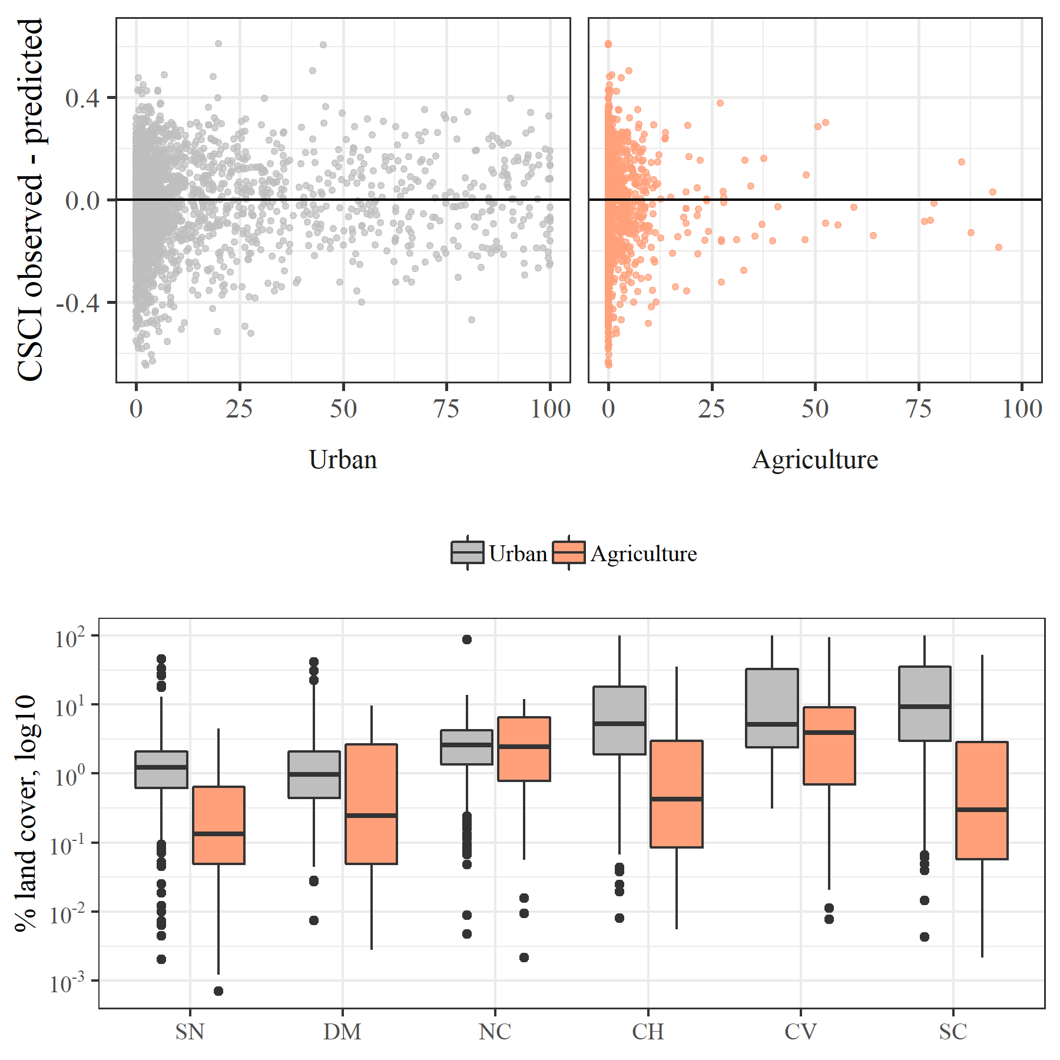

Figure 3 Model performance in relation to land cover and land cover by major regions in California. Model residuals (CSCI observed - predicted) were smaller in regions with more urban or agricultural land use (e.g., SC, CV) and larger in regions with less anthropogenic land use (e.g., SN, DM). CV: Central Valley, CH: Chaparral, DM: Deserts and Modoc Plateau, NC: North Coast, SN: Sierra Nevada, SC: South Coast.

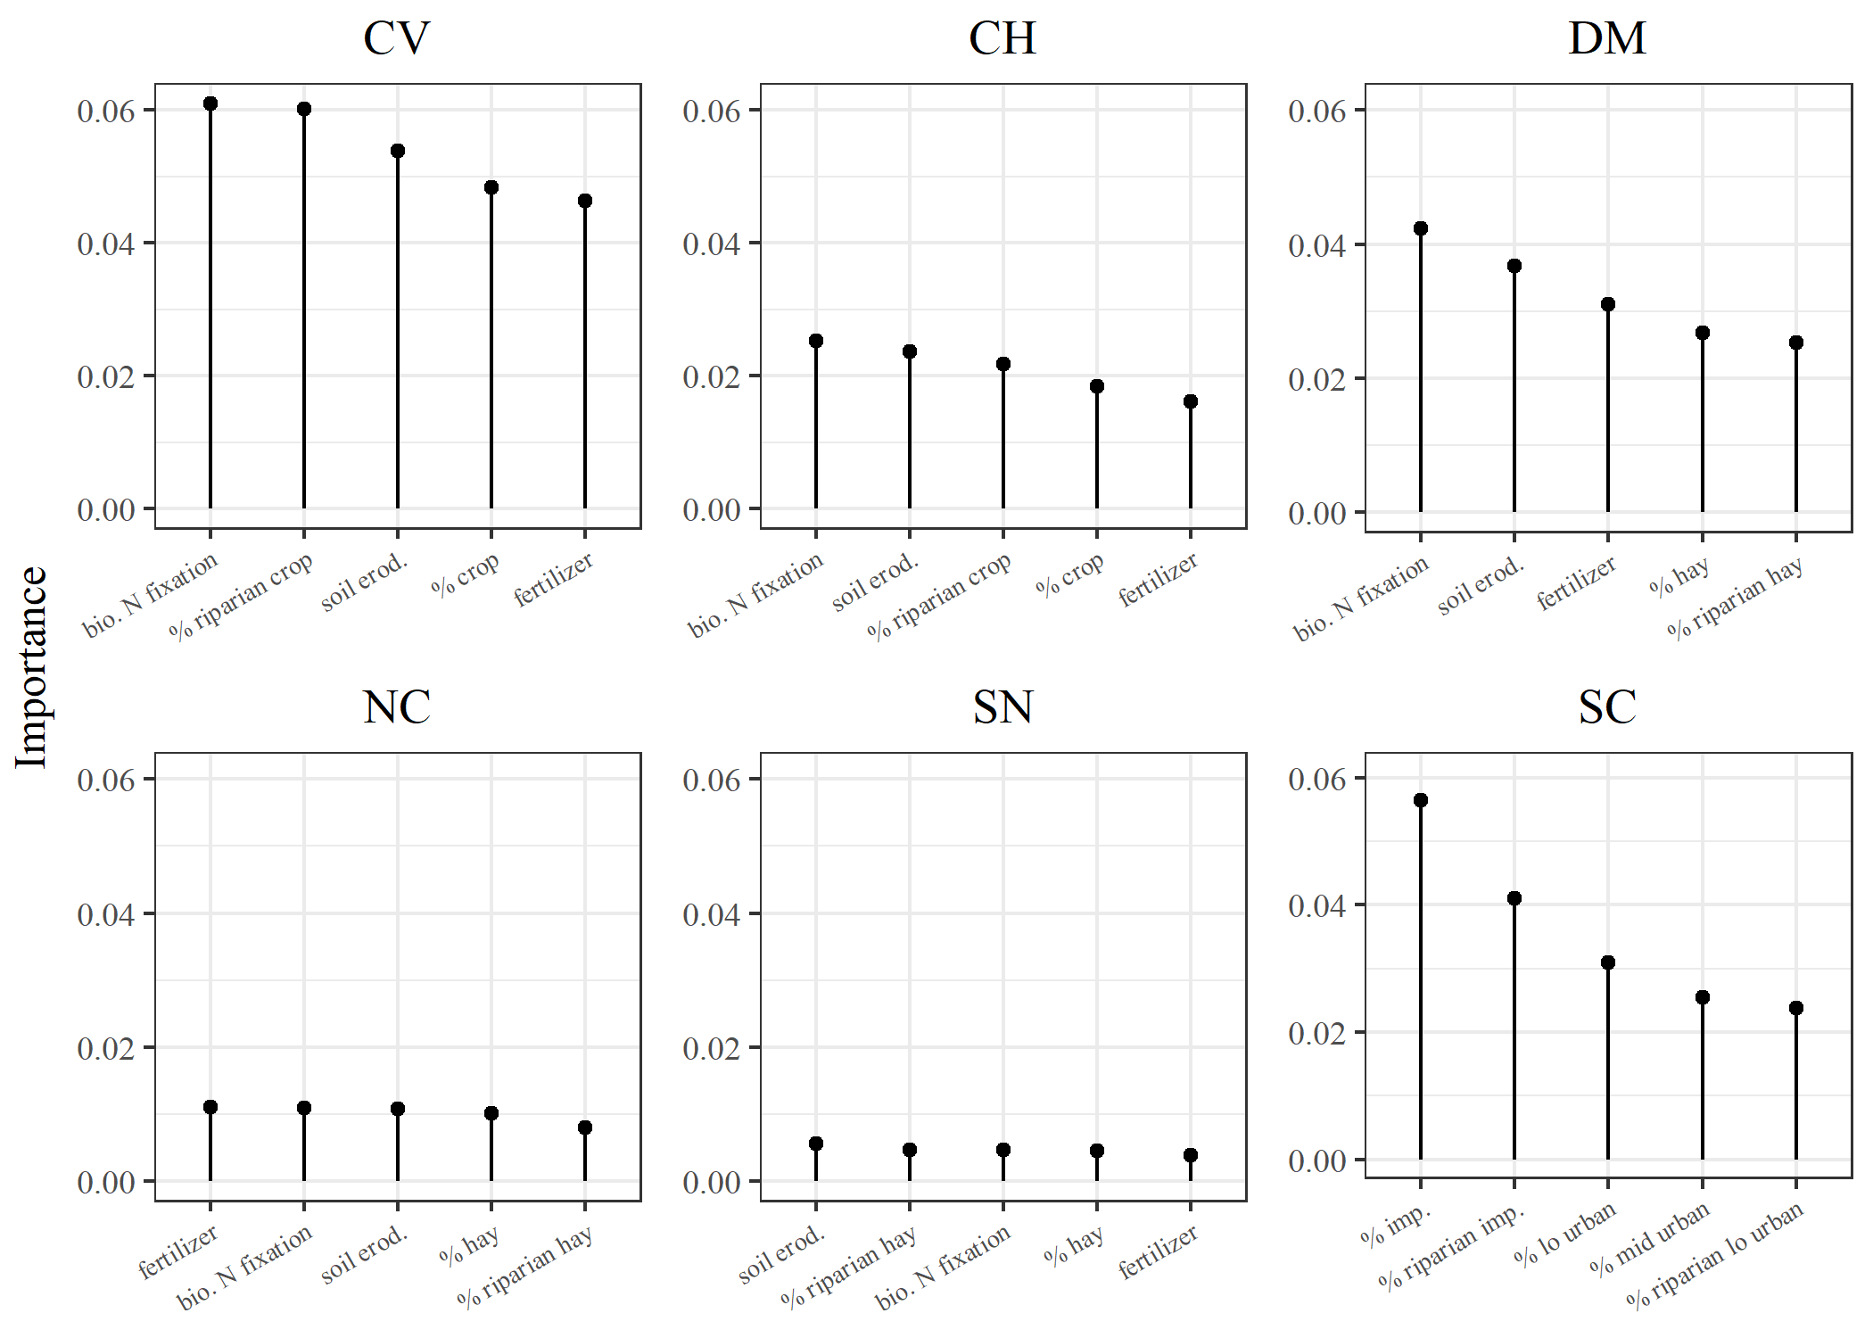

Figure 4 Factors associated with constrained and unconstrained stream segments by major regions in California. Importance measures were obtained from random forest models of 130 watershed and riparian measures of landscape and geological characteristics from the StreamCat dataset (Hill et al. 2016). The top five variables for each region are shown. The importance measures describe the mean decrease in prediction accuracy with exclusion of a variable across 1000 random trees for each model. Stream segment classes as possibly or likely were combined for constrained and unconstrained to evaluate the complete dataset. CV: Central Valley, CH: Chaparral, DM: Deserts and Modoc Plateau, NC: North Coast, SN: Sierra Nevada, SC: South Coast.

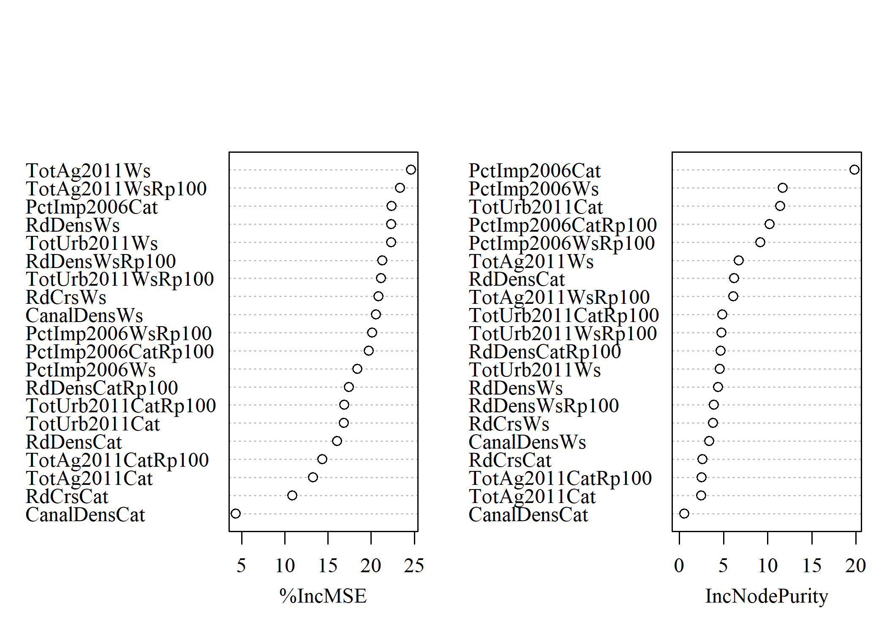

Figure 5 Importance measures for landscape variables used to develop the landscape model of expected stream bioassessment scores in California. Values were obtained from quantile regression models of twenty landscape measures shown in Table 1 obtained from the StreamCat dataset (Hill et al. 2016). The importance measures describe the percent increase in mean square error and the increase in node impurity with exclusion of a variable across all random trees for each model (Meinshausen 2017).

# References

Beck, M. W. 2018. “SCCWRP/SCAPE: v1.0 (Version 1.0). Zenodo, <http://doi.org/10.5281/zenodo.1218121>.”

Hill, R. A., M. H. Weber, S. G. Leibowitz, A. R. Olsen, and D. J. Thornbrugh. 2016. “The Stream-Catchment (StreamCat) Dataset: A Database of Watershed Metrics for the Conterminous United States.” *Journal of the American Water Resources Assocation* 52:120–28. <https://doi.org/10.1111/1752-1688.12372>.

Meinshausen, Nicolai. 2017. *QuantregForest: Quantile Regression Forests*. <https://CRAN.R-project.org/package=quantregForest>.