Prioritizing management goals for stream biological integrity within the developed landscape context

Marcus W. Beck ([marcusb@sccwrp.org](mailto:marcusb@sccwrp.org)), Raphael D. Mazor ([raphaelm@sccwrp.org](mailto:raphaelm@sccwrp.org)), Scott Johnson ([scott@aquaticbioassay.com](mailto:scott@aquaticbioassay.com)), Karin Wisenbaker ([karin@aquaticbioassay.com](mailto:karin@aquaticbioassay.com)), Joshua Westfall ([jwestfall@lacsd.org](mailto:jwestfall@lacsd.org)), Peter R. Ode ([peter.ode@wildlife.ca.gov](mailto:peter.ode@wildlife.ca.gov)), Ryan Hill ([hill.ryan@epa.gov](mailto:hill.ryan@epa.gov)), Chad Loflen ([Chad.Loflen@waterboards.ca.gov](mailto:Chad.Loflen@waterboards.ca.gov)), Martha Sutula ([marthas@sccwrp.org](mailto:marthas@sccwrp.org)), Eric D. Stein ([erics@sccwrp.org](mailto:erics@sccwrp.org))

# Supplement

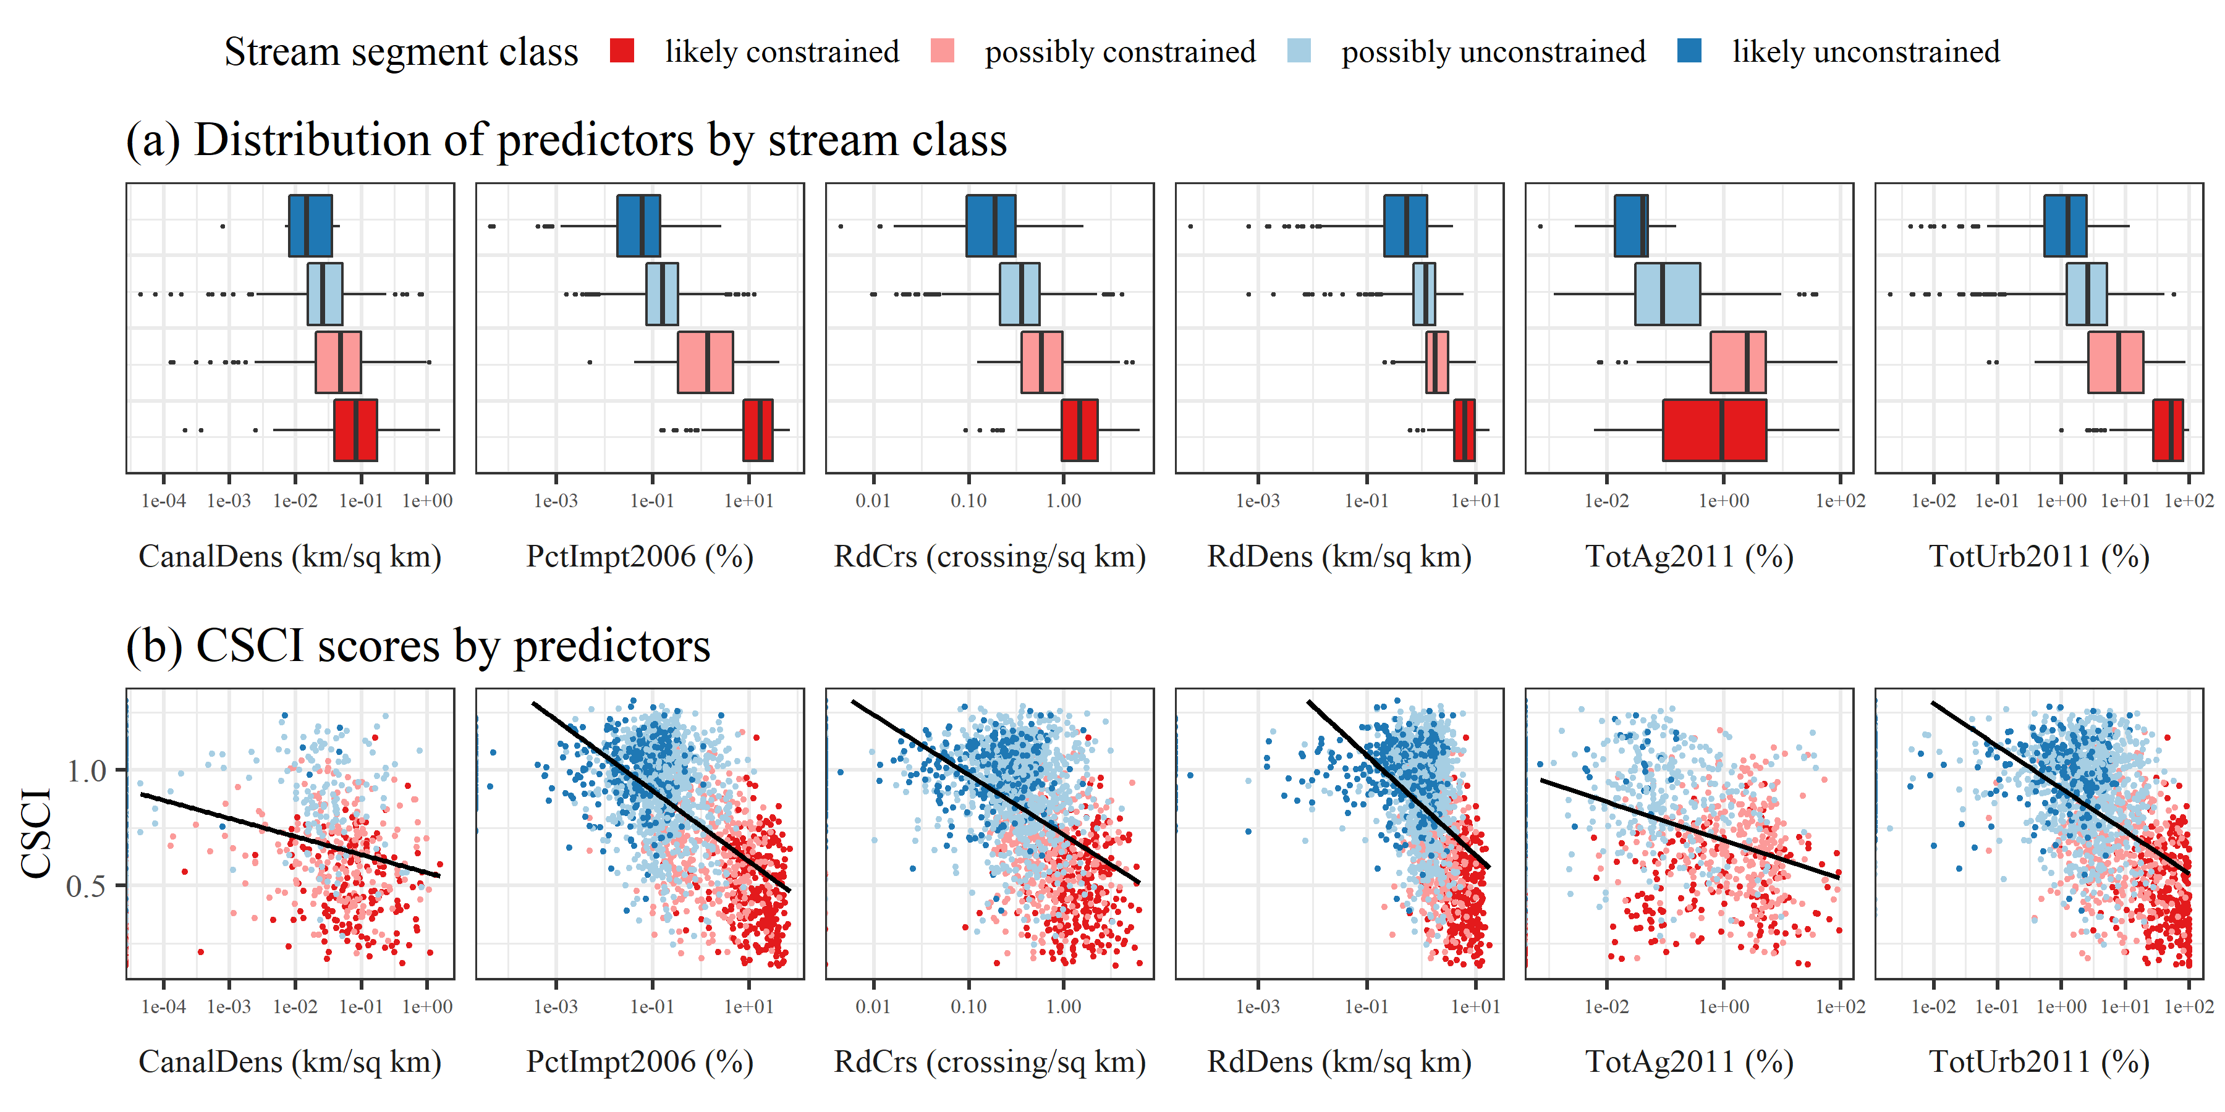

Figure S1 Relationship of predictor variables (watershed only, see Table 1) with stream classes. The top plot (a) shows boxplot distributions (median, interquartile ranges, and outliers) and the bottom plot (b) shows the relationship with CSCI scores. All x-axes are in log-scale.

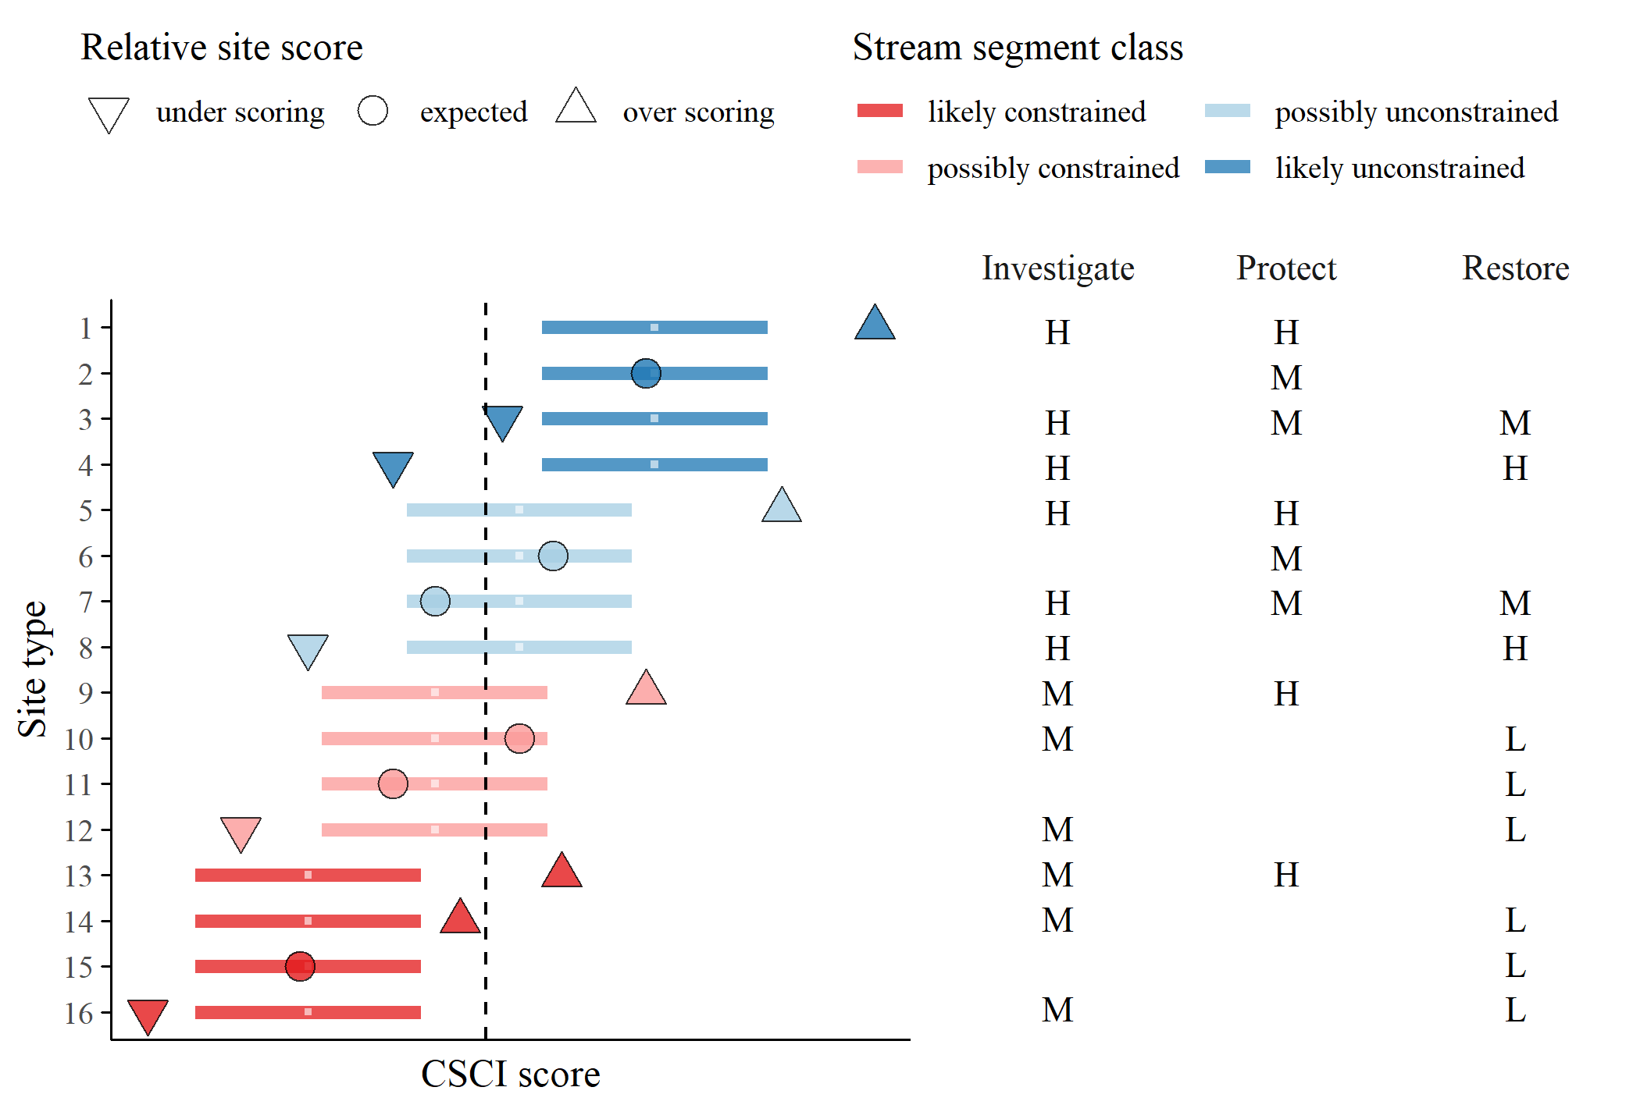

Figure S2 Template provided to stakeholders for prioritization of recommended actions for each stream type. The site types relate to the stream class for the biological expectation (likely unconstrained, possibly unconstrained, possibly constrained, likely constrained), relative site score for the observed CSCI (over-scoring, expected, under-scoring), and location of the score relative to a hypothetical biological threshold (dashed line, above or below). Horizontal lines are the ranges of expected CSCI scores for a site with tick marks for the median. Priority actions defined by stakeholders are shown on the right for each stream type (text descriptions in Table 3). Actions are generalized as investigate, protect, or monitor as high (H), medium (M), or low (L) priority. Blank cells indicate that no additional measures are recommended beyond the baseline monitoring and maintenance practiced at all sites.

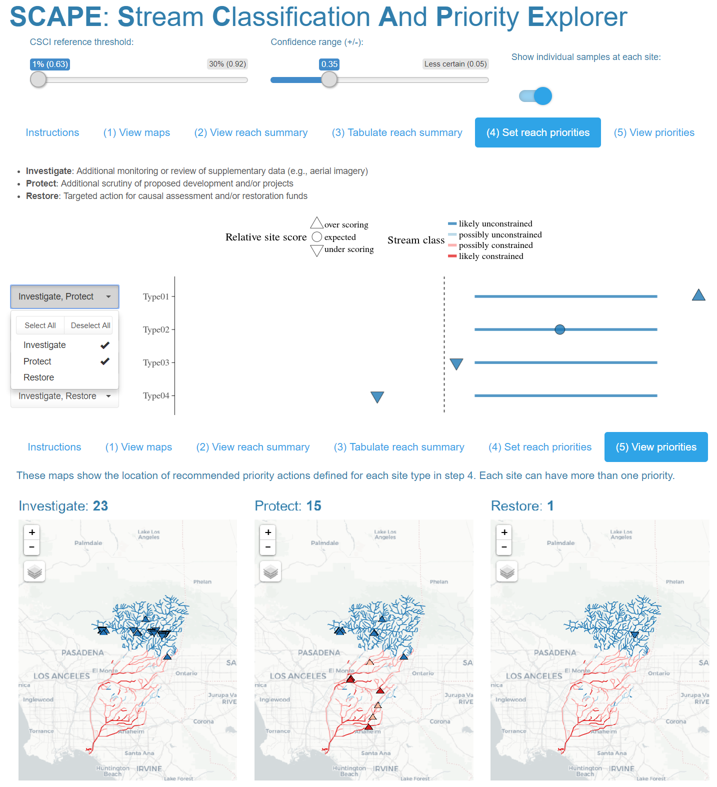

Figure S3 Screenshots from the Stream Classification and Priority Explorer (SCAPE) tool used by the stakeholder group to interact with and use results from the landscape model. The application allowed users to visualize results of segment classifications, relative site scores for the CSCI based on the expectation, and recommend management actions for each segment type. The app is accessible at <http://shiny.sccwrp.org/scape/>.

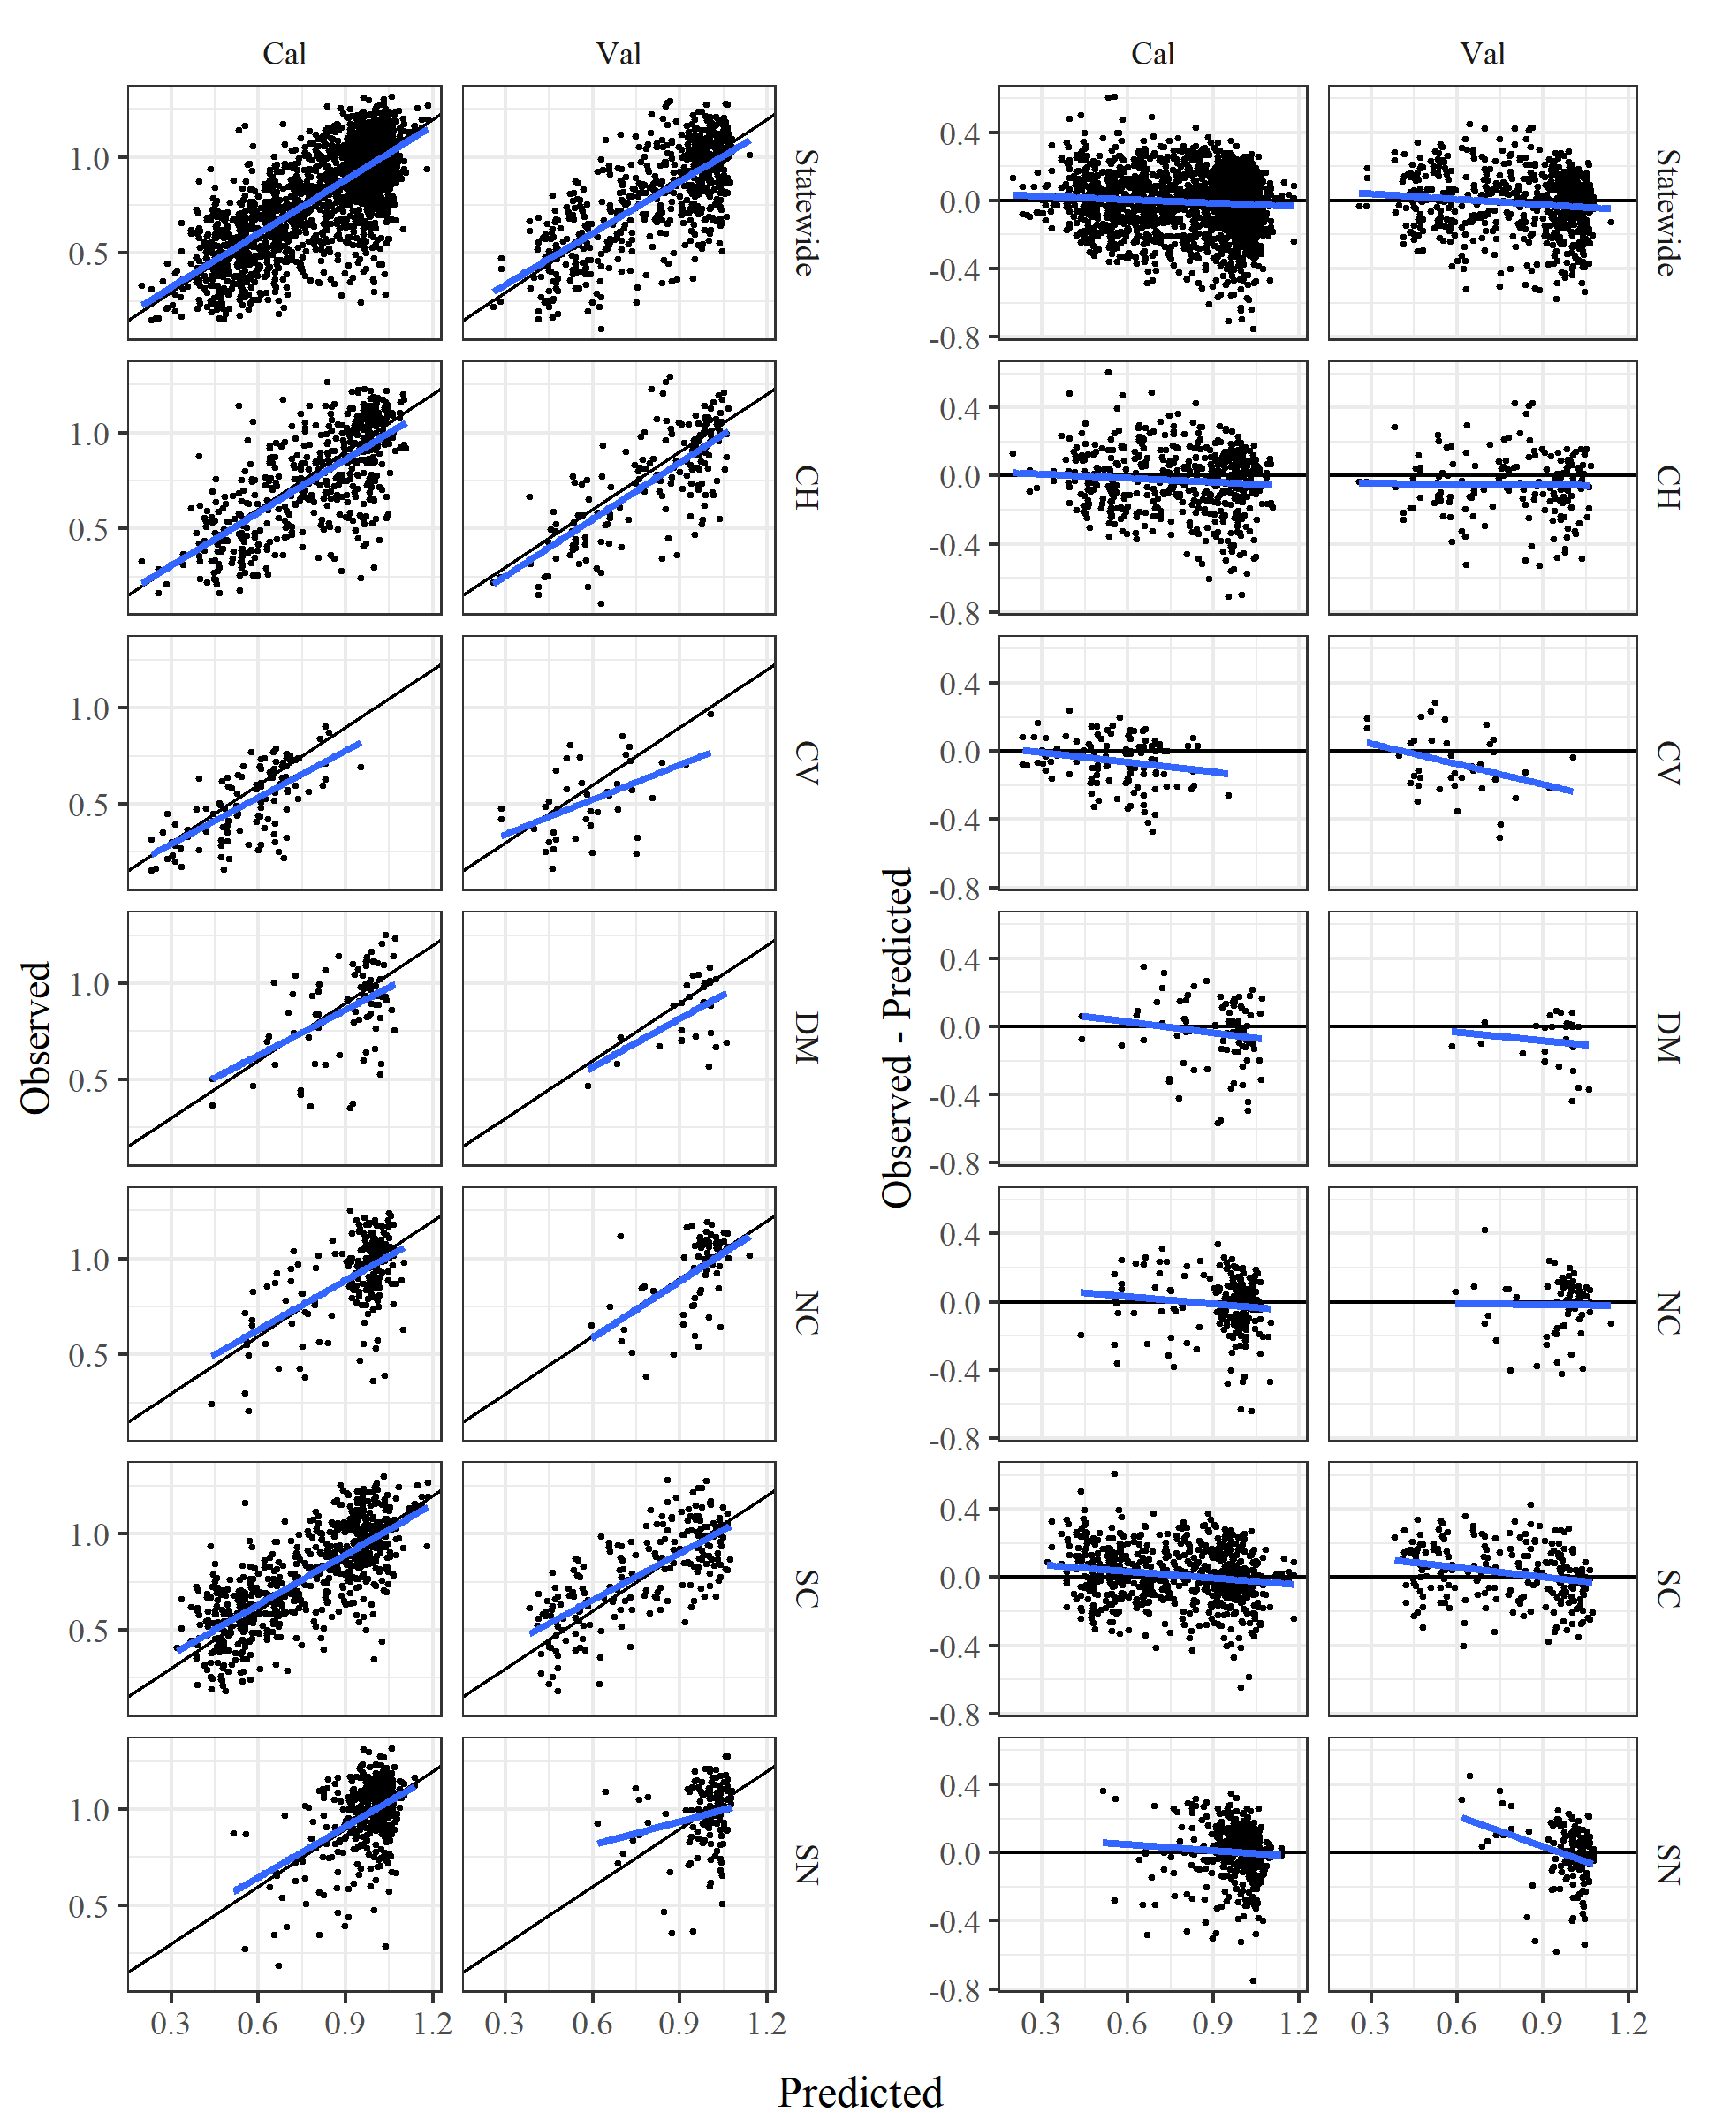

Figure S4 Model performance statewide and by major regions in California. Results are grouped by calibration (Cal) and validation (Val) datasets. Blue lines indicate the regression fit and black lines indicate correspondene between observations and predictions. CV: Central Valley, CH: Chaparral, DM: Deserts and Modoc Plateau, NC: North Coast, SN: Sierra Nevada, SC: South Coast.

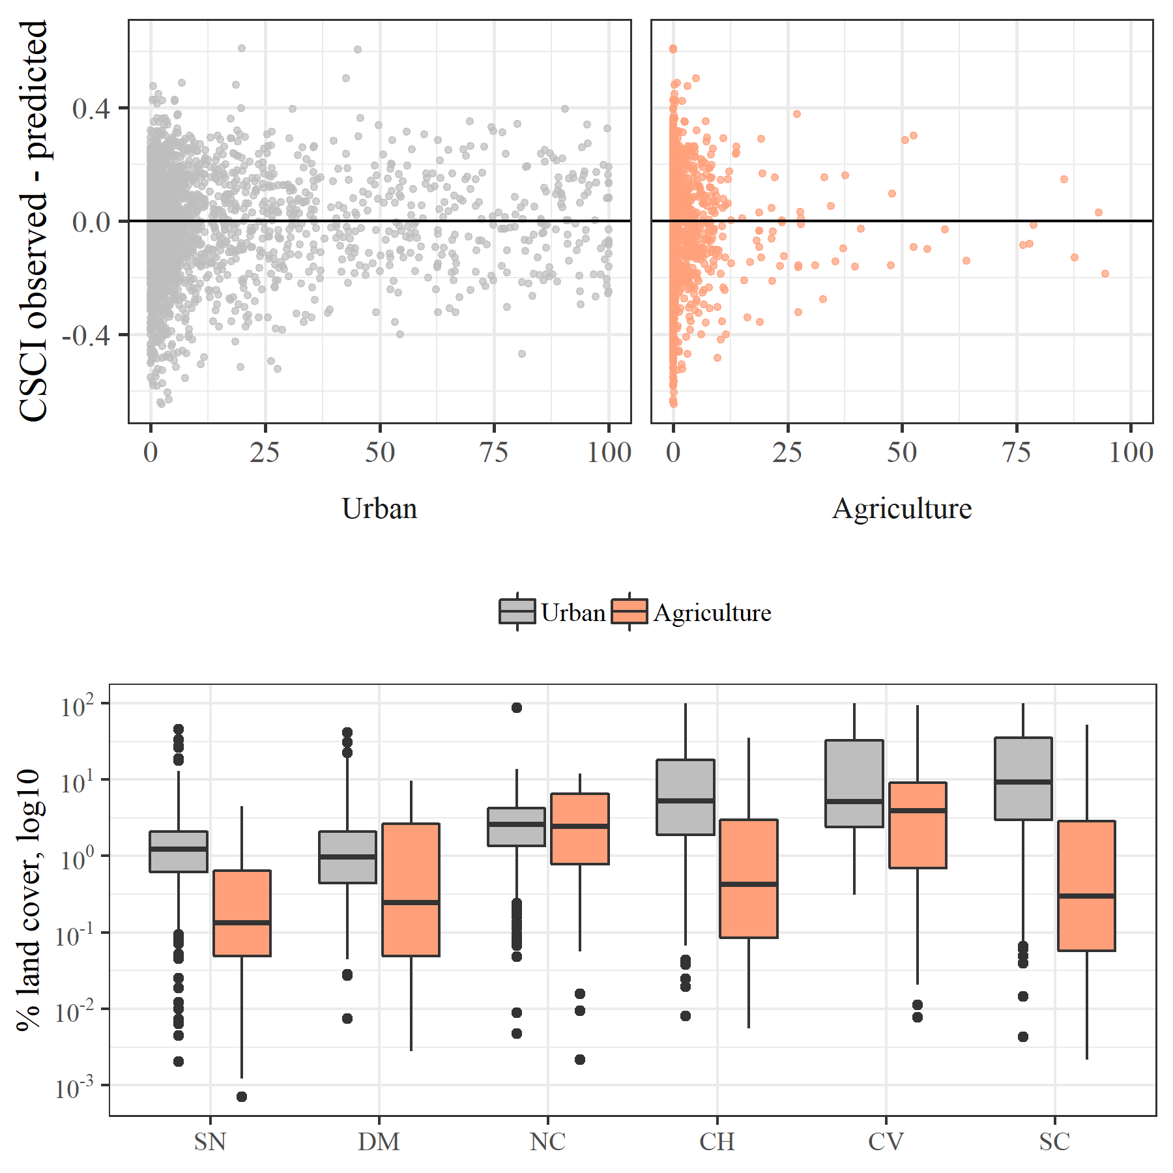

Figure S5 Model performance in relation to land cover and land cover by major regions in California. Model residuals (CSCI observed - predicted) were smaller in regions with more urban or agricultural land use (e.g., SC, CV) and larger in regions with less anthropogenic land use (e.g., SN, DM). CV: Central Valley, CH: Chaparral, DM: Deserts and Modoc Plateau, NC: North Coast, SN: Sierra Nevada, SC: South Coast.