* We can take the average heart rate per hour and compare it with the ideal heart rate of particular age group and suggest him how high or low his heart rate compare to it.

|  |  |  |  |  |  |  |
| --- | --- | --- | --- | --- | --- | --- |
| ***Resting Heart Rate for MEN*** | | | | | | |
| Age | 18-25 | 26-35 | 36-45 | 46-55 | 56-65 | 65+ |
| Athlete | 49-55 | 49-54 | 50-56 | 50-57 | 51-56 | 50-55 |
| Excellent | 56-61 | 55-61 | 57-62 | 58-63 | 57-61 | 56-61 |
| Good | 62-65 | 62-65 | 63-66 | 64-67 | 62-67 | 62-65 |
| Above Average | 66-69 | 66-70 | 67-70 | 68-71 | 68-71 | 66-69 |
| Average | 70-73 | 71-74 | 71-75 | 72-76 | 72-75 | 70-73 |
| Below Average | 74-81 | 75-81 | 76-82 | 77-83 | 76-81 | 74-79 |
| Poor | 82+ | 82+ | 83+ | 84+ | 82+ | 80+ |

|  |  |  |  |  |  |  |
| --- | --- | --- | --- | --- | --- | --- |
| ***Resting Heart Rate for WOMEN*** | | | | | | |
| Age | 18-25 | 26-35 | 36-45 | 46-55 | 56-65 | 65+ |
| Athlete | 54-60 | 54-59 | 54-59 | 54-60 | 54-59 | 54-59 |
| Excellent | 61-65 | 60-64 | 60-64 | 61-65 | 60-64 | 60-64 |
| Good | 66-69 | 65-68 | 65-69 | 66-69 | 65-68 | 65-68 |
| Above Average | 70-73 | 69-72 | 70-73 | 70-73 | 69-73 | 69-72 |
| Average | 74-78 | 73-76 | 74-78 | 74-77 | 74-77 | 73-76 |
| Below Average | 79-84 | 77-82 | 79-84 | 78-83 | 78-83 | 77-84 |
| Poor | 85+ | 83+ | 85+ | 84+ | 84+ | 84+ |

### Resting heart rate: a metric of cardiovascular and overall health

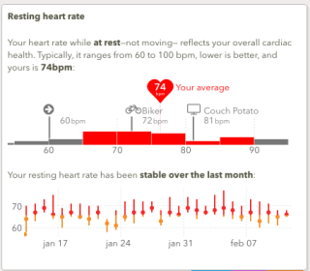

* Your heart rate while at rest—not moving, but not necessarily sleeping—has been shown to be a strong measure of overall health. A Chinese study showed [the risk of dying of any illness went down by 9% for every 10 bpm decreases](https://www.telegraph.co.uk/news/science/science-news/12012387/How-fast-your-heart-beats-predicts-if-you-will-die-early.html) in resting heart rate.  If your resting heart rate is below <75bpm, your chance of  [sudden cardiac death](https://circ.ahajournals.org/content/129/4/516.extract) is halved. Even beyond cardiovascular health, a resting heart rate of <70bpm [reduces your chance of cancer](https://aje.oxfordjournals.org/content/149/9/853.long).
* The good news is resting heart rate is highly modifiable. Exercise strengthens the heart muscle, so that it can pump the same volume of blood with fewer strokes. Marathon runners sometimes achieve resting heart rates in the 40’s.
* According to the Mayo clinic, a normal resting heart rate is between [60 and 100 beats per minute](https://www.mayoclinic.org/healthy-lifestyle/fitness/expert-answers/heart-rate/faq-20057979). Among Apple Watch users with [Cardiogram](https://cardiogr.am/) installed, the median is 76 bpm. About eighty percent of us are between 67 and 88 bpm.

### Do you really need 10,000 steps per day?

* These days, we’re all carrying pedometers: iPhone counts your steps using [HealthKit](https://developer.apple.com/library/ios/documentation/HealthKit/Reference/HealthKit_Framework/); Android devices use [Google Fit](https://www.google.com/fit/).
* So what happens if we plot average step count per day from iPhone vs your resting heart rate from Apple Watch? It looks like this, with size of bubble proportional to number of distinct people in each group:

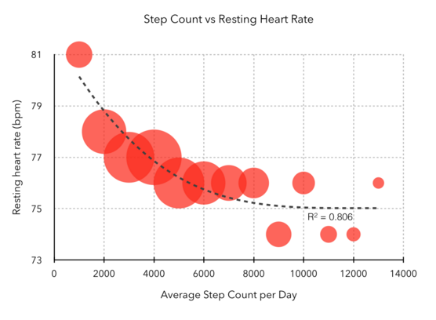

* In cardiovascular terms, the drop in heart rate from 1000 steps/day to 2000 steps/day is significant: a full 3 bpm decrease. And as step count increases, resting heart rate steadily drops—until you reach about 5000 steps per day. After that—6000, 7000, even up to 10,000 steps—the curve flattens.

### How about type and intensity of exercise?

* What if it’s not step count that matters, but the intensity of exercise? To quantify this, we broke the chart above into three groups of people: high intensity gym rats who get their heart rate above 150 bpm for at least an hour each week, medium intensity people who get their heart rate above 130 bpm for an hour a week (say, power walkers), and low intensity (couch potatoes, the rest of us).
* When broken down by exercise intensity, step count becomes much less relevant:

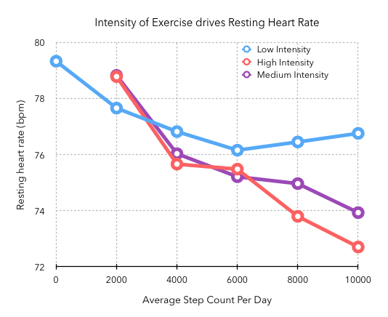

* Even if you get 10,000 steps per day, if your heart rate doesn’t go over 130 bpm, there’s not much impact on your resting heart rate. In contrast, even 4000 steps / day of high intensity exercise delivers a large benefit: about a 6 bpm absolute drop in resting bpm.
* The chart above was for an hour of exercise per week. But how much exercise do you need to get the best “bang for the buck”? Surprisingly little:

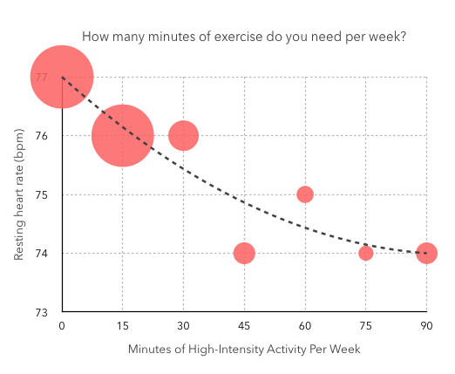

* Even 45 minutes per week of high intensity activity (heart rate >= 150bpm) placed participants in the lowest tier of resting heart rate.

* Below is sweet smart app for apple watch but we can think of this functionality of tracking sleep.

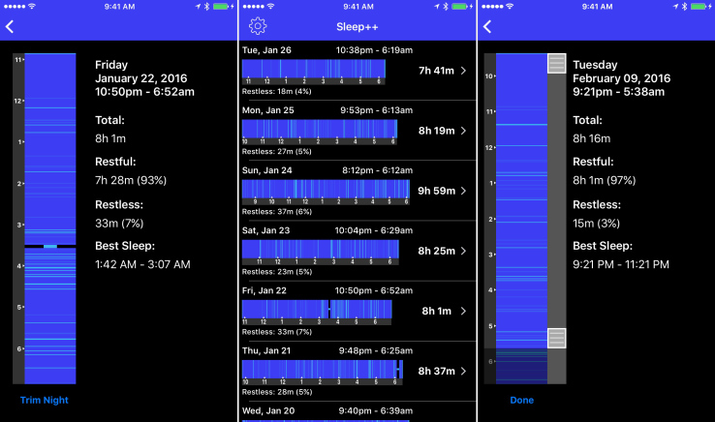

* The Apple Watch was supposed to become the new thriving platform and App Store for third-party apps. 10 months later, it’s hard to name popular Watch apps. And there are reasons why the Apple Watch App Store isn’t as vibrant as the iOS App Store. But some developers, such as [David Smith](https://david-smith.org/), have found ways to make your Watch more useful.
* [Sleep++](https://david-smith.org/apps/) isn’t a new Watch app. But today’s major update adds many important features making it a useful free app for anyone who wants to track their sleep. Sleep++ turns your Watch into a sleep-tracking device and gives you insights about your sleep. As long as you keep your Watch in airplane mode and [charge it when you take a shower](https://david-smith.org/blog/2015/09/21/how-to-wear-your-apple-watch-24-slash-7/), you can keep it on your wrist 24/7.
* Sleep++ leverages the accelerometer in your Watch to register deep sleep, light sleep, restlessness and wakefulness. I’ve been using it for the past week and it’s interesting to wake up in the morning and get instant feedback about your night. It’s been pretty accurate in my experience.
* Using it isn’t too cumbersome as the Watch app only has one button — a start/stop button. Today’s update improves the sleep analysis, lets you synchronize your sleep data with the Health app and other HealthKit apps and adds the ability to trim your night if you forgot to turn Sleep++ off when you woke up.
* David Smith reports [on his blog](https://david-smith.org/blog/2016/02/11/introducing-sleep-plus-plus-2-dot-0/) that the app has been downloaded 170,000 times. It seems like an incredible number given that only a few million people have bought an Apple Watch over the past few months. But fitness is one of the core features of the Apple Watch and Apple doesn’t provide a default sleep tracking feature.
* Sleep++ proves that there’s room for Apple Watch apps. There aren’t as many Apple Watches in circulation as there are iPhones or iPads. Developers are still figuring out how to take advantage of the Apple Watch. It’s unclear if third-party apps even make sense on a Watch in the first place. And the first version of the Apple Watch feels underpowered.
* And yet, 170,000 downloads is quite impressive and should make third-party developers hopeful. Down the road, with a more powerful Apple Watch, more APIs and a bigger install base, there might be a future for Apple Watch apps.