Assignment 3

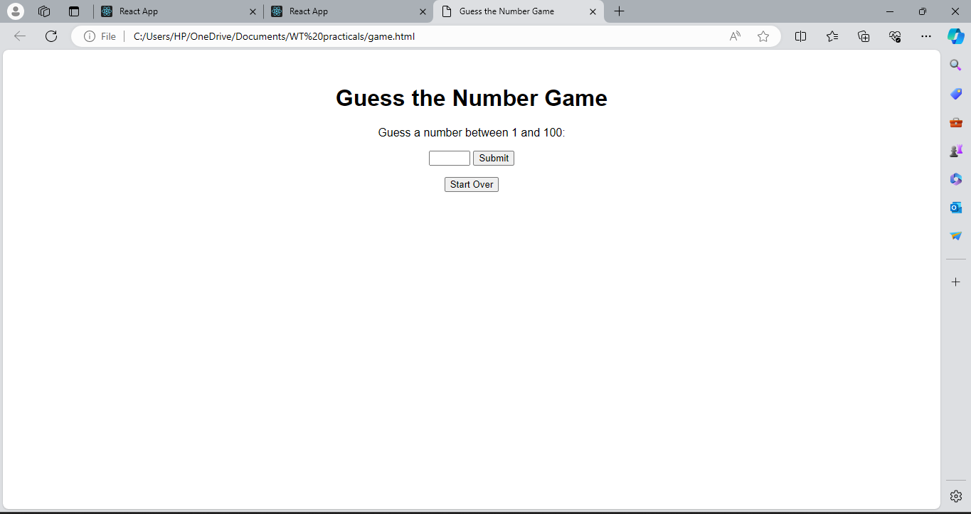

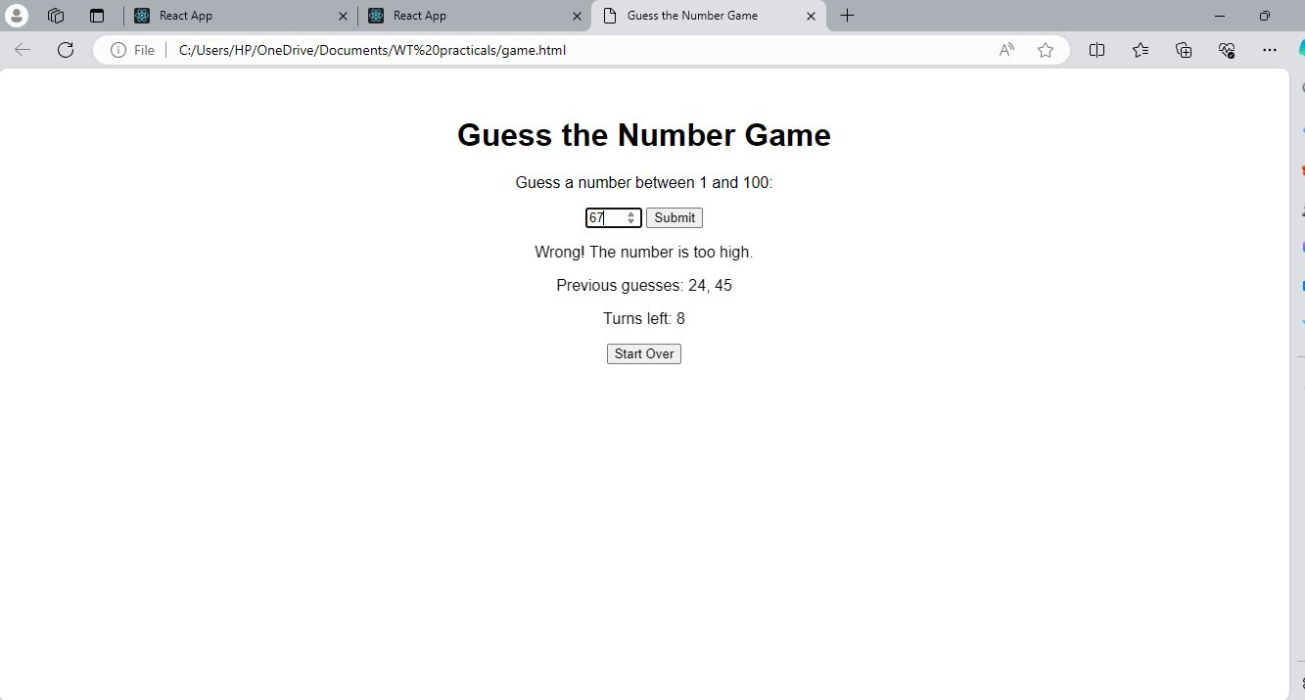

Game.html

<!DOCTYPE html>

<html lang="en">

<head>

<meta charset="UTF-8">

<meta name="viewport" content="width=device-width, initial-scale=1.0">

<title>Guess the Number Game</title>

<style>

  body {

    font-family: Arial, sans-serif;

    text-align: center;

  }

  h1 {

    margin-top: 50px;

  }

  #guess-input {

    width: 50px;

  }

</style>

</head>

<body>

<h1>Guess the Number Game</h1>

<p>Guess a number between 1 and 100:</p>

<input type="number" id="guess-input" min="1" max="100">

<button onclick="checkGuess()">Submit</button>

<p id="result"></p>

<p id="previous-guesses"></p>

<p id="turns-left"></p>

<button onclick="resetGame()">Start Over</button>

<script>

  let randomNumber = Math.floor(Math.random() \* 100) + 1;

  let turns = 10;

  let previousGuesses = [];

  function checkGuess() {

    const guess = parseInt(document.getElementById('guess-input').value);

    if (isNaN(guess) || guess < 1 || guess > 100) {

      document.getElementById('result').textContent = 'Please enter a valid number between 1 and 100.';

      return;

    }

    turns--;

    previousGuesses.push(guess);

    if (guess === randomNumber) {

      document.getElementById('result').textContent = `Congratulations! You guessed the correct number: ${randomNumber}`;

      endGame();

    } else if (turns === 0) {

      document.getElementById('result').textContent = `Game over! The number was: ${randomNumber}`;

      endGame();

    } else {

      let message = `Wrong!`;

      message += guess < randomNumber ? ` The number is too low.` : ` The number is too high.`;

      document.getElementById('result').textContent = message;

      document.getElementById('turns-left').textContent = `Turns left: ${turns}`;

      document.getElementById('previous-guesses').textContent = `Previous guesses: ${previousGuesses.join(', ')}`;

    }

    document.getElementById('guess-input').value = '';

  }

  function resetGame() {

    randomNumber = Math.floor(Math.random() \* 100) + 1;

    turns = 10;

    previousGuesses = [];

    document.getElementById('result').textContent = '';

    document.getElementById('previous-guesses').textContent = '';

    document.getElementById('turns-left').textContent = '';

  }

  function endGame() {

    document.getElementById('guess-input').disabled = true;

    document.querySelector('button').disabled = true;

    document.querySelector('button').style.display = 'none';

    const restartButton = document.createElement('button');

    restartButton.textContent = 'Start New Game';

    restartButton.onclick = () => {

      resetGame();

      document.getElementById('guess-input').disabled = false;

      document.querySelector('button').disabled = false;

      document.querySelector('button').style.display = 'inline-block';

    };

    document.body.appendChild(restartButton);

  }

</script>

</body>

</html>