1. Using MARS write a MIPS assembly language program to prompt the user to input two 32-bit integers X and Y (X and Y can be prompted separately or at the same time), get them from the user then store them in memory locations labeled X and Y respectively. The program then loads X and Y from the main memory to registers, calculates the sum of them (i.e. X + Y) and store the sum into a memory location labeled S. The program then prints out the result (i.e. integer S) after printing the string "The sum of X and Y (X + Y) is ".

Then assemble and run the program with MARS to show and capture the input/output.

Follows the instructions for programming assignments in the syllabus.

Solution:

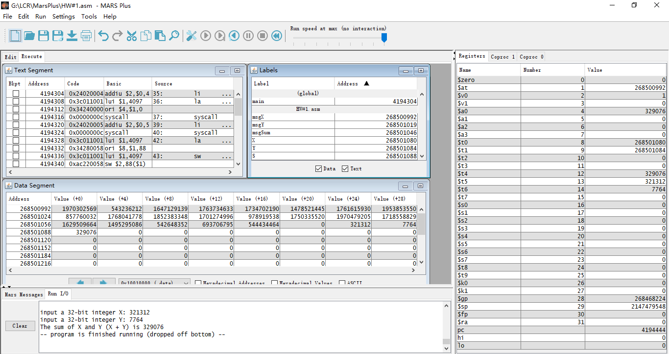

Code: HW#1.asm

2. Answer the following questions:

2.1 Describe the process of translating a program written in a High-Level Language (HLL), e.g. C++, into an executable file that is ready for execution. Identify the system programs used in the process and describe the role of each of them assuming that the compiler generates an assembly language file as the output.

Solution:

1.

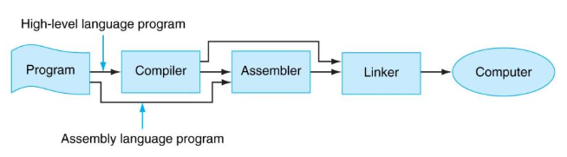

(Copy from Course Notes, 03 – ASM Intro.pdf, Page 3)

1) Compiler: C++Code also belongs to high-level language, so it would be translated into Instructions by Compiler.

2) Assembler: Then we use the Assembler to translate the symbolic version of the Instructions into the binary version of the machine language. And we get the object files from the source files.

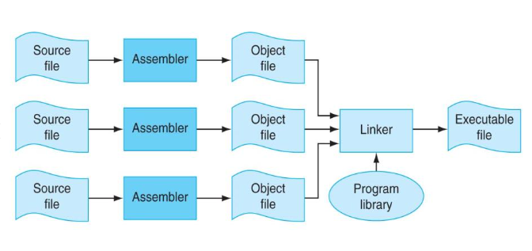

(Copy from Course Notes, 03 – ASM Intro.pdf, Page 4)

3) Linker: Usually for existed interfaces and methods in the library, the object file only needs to call them correctly. The role of Linker is to find the methods and filled them in to generate the final executable file.

What is the system program used by the Operation System (OS) to load an executable file to memory and run it?

Solution:

Loader.

Loader reads the contents of the executable file into memory, and then carries out other required preparatory tasks to prepare the executable file for running. Once loading is complete, Operation System (OS) can start the program by passing control to the loaded code.

2.2 Describe the elements, including optional ones, of a MIPS assembly language statement.

Solution:

[label:] operation [operand1 [operand2 [operamd3]]] [# [comment]]

label: a symbol string represents a memory address

operation: assembler directive or machine instruction

operands: register names, immediate value, address label, etc.

comments: introduction of your code. Ignored by assembler