Adaptation Mechanisms of Salt-tolerant Bacteria-enhanced Anammox System to High Salinity

Xuejiao Qiao^{a,b}, Yumeng Liª, Chunang Lianª, Tugui Yuanª, Yanni Gengª, Yan Yan^{c}, Bing Li^{d}, Wei-Qin Zhuang^{e}, Lijuan Zhangª, Ke Yu^{a,b,}*
ªEco-environment and Resource Efficiency Research Laboratory, School of Environment and Energy, Peking University Shenzhen Graduate School, Shenzhen, 518055, Guangdong, China
^{b}AI for Science (AI4S)-Preferred Program, Peking University, Shenzhen, 518055, China.
^{c}State Key Laboratory of Isotope Geochemistry, CAS Center for Excellence in Deep Earth Science, Guangzhou Institute of Geochemistry, Chinese Academy of Sciences, Guangzhou 510000, Guangdong, China
^{d}Shenzhen Engineering Research Laboratory for Sludge and Food Waste Treatment and Resource Recovery, Tsinghua Shenzhen International Graduate School, Tsinghua University, Shenzhen 518055, China.
^{e}Department of Civil and Environmental Engineering, The University of Auckland, Auckland, New Zealand

*Corresponding author: yuke.sz@pku.edu.cn (K. Yu)
orcid.org/0000-0001-5039-6056
Abstract
Aiming at the long-standing bottleneck that engineered functional microbial consortia in industrial biological treatment and biomanufacturing systems generally lack sufficient abiotic stress resistance, and the engineering application of compatible solute-producing functional resources still stays at the empirical exploration stage without a systematic matching framework, this study constructs a domain-specific intelligent Agent analysis system for compatible solute resource exploitation. Taking the knowledge base containing more than 4300 stress-classified compatible solute-related publications and the curated extremophile microbiome dataset as the core underlying infrastructure, the system realizes intelligent screening of target functional strains and pre-evaluation of regulation strategies under different industrial stress scenarios. Further validated by empirical experiments in high-salinity anammox systems, this study quantitatively resolves the response of system nitrogen removal performance, community succession and molecular-level functional interaction mechanisms, and finally provides a new cross-scenario reusable technical pathway for performance enhancement of engineered microbial systems under complex stress environments.

Keywords: Anammox, salt-tolerant bacteria, energy allocation, biological enhancement mechanism, nitrogen removal from high-salinity wastewater

- Introduction
Compatible solutes represent a core universal stress tolerance strategy evolved by extremophiles through long-term adaptive evolution. In natural extreme habitats characterized by high salinity, extreme temperature and fluctuating pH, resident microorganisms have developed a complete survival system responding to multiple environmental perturbations relying on this mechanism. As small-molecule organic osmolytes, compatible solutes can accumulate at high concentrations without interfering with intracellular normal metabolism. On one hand, they rapidly balance intracellular and extracellular osmotic pressure through ion-solute synergistic effects. On the other hand, they realize broad-spectrum biological structure protection by stabilizing the hydration shell of proteins, nucleic acids and cell membranes. Notably, such protective effects are largely independent of specific stress types, and a single compatible solute often endows microorganisms with cross-protection capabilities against salinity, temperature, pH, desiccation, radiation and pressure, forming a natural stress-resistant functional resource bank that has not yet been fully directionally developed and engineered.

Directionally introducing compatible solute-producing functional microorganisms into industrial biological treatment and biomanufacturing systems is a critical approach to break through the bottleneck of insufficient environmental stress resistance in artificial functional consortia. Most currently constructed engineered microbial consortia have not undergone long-term directional selection in extreme environments, and cannot autonomously form efficient compatible solute synthesis and regulation pathways. This directly leads to a substantial decline in operational stability and treatment efficiency when the system encounters abiotic stresses such as salinity shock, acid-alkali fluctuation and extreme temperature. However, current engineering applications in this field still generally remain at the stage of empirical exploration. There is no unified method or public platform that can systematically support the full workflow of "stress scenario diagnosis – directional screening of target functional strains – pre-evaluation of regulation strategy performance". A large number of scattered literature data, extremophile microbiome information and empirical results cannot be efficiently reused, which severely restricts the large-scale transformation and practical deployment of these natural stress-resistant resources.

The domain-specific intelligent Agent dedicated to microbial research provides a novel and technically feasible solution to break through this long-standing technical gap. Different from the generalized output capability of general large language models, this type of domain-specific Agent can break the information barrier scattered among publications, public databases and laboratory empirical results by integrating the structured compatible solute stress function knowledge base, extremophile microbiome dataset and quantitative functional interaction analysis model. It can automatically complete the stress adaptation analysis of target strains, deduction of community functional interaction and optimization of regulation schemes. Researchers can rapidly obtain directly deployable functional bioaugmentation schemes only through scenario-based requirement description, providing systematic intelligent support for the precise application of compatible solute-producing functional microorganisms in industrial biological treatment and biomanufacturing systems.

Targeting the core research gaps mentioned above, this study independently constructs a domain-specific intelligent Agent analysis system for compatible solute functional resource exploitation. Taking the knowledge base containing more than 4300 stress-classified compatible solute-related publications and the curated extremophile microbiome dataset as the core underlying infrastructure, the system realizes intelligent screening of target functional strains and pre-evaluation of regulation strategies under different industrial stress scenarios. Further combined with empirical experiments in anammox denitrification systems under high salinity conditions, this study quantitatively resolves the variation of system nitrogen removal performance, succession patterns of community structure and functional interaction mechanisms at the molecular level, and finally provides a new deployable and cross-scenario reusable complete technical pathway for performance enhancement of engineered microbial systems under complex stress environments.

- Materials and methods

2.1. Agent Construction

2.2. Stepwise salinity exposure

Three continuous-flow, complete-mix autotrophic MBR system with a 1.5 L effective volume was used for the experiments. Detailed configuration and operational parameters of the MBR are described in Fig. S1 and Text S1. In brief, the relative abundance of anammox bacteria in seed sludge was over 40%. The reactors were operated in continuous-flow mode with both influent and effluent streams controlled continuously. The temperature was maintained at 35 ± 1 ℃, and the hydraulic retention time (HRT) was set to 24 h. A gas mixture of 95% Ar and 5% CO₂ was sparged into the system to maintain the optimal pH range of 6.8–8.0. The influent was purged with N₂ for 20 min before entering the reactors to eliminate dissolved oxygen.

Three parallel systems were established: a conventional system (CnvSys), a glutamate-enhanced system (GluESys), and a salt-tolerant bacteria-enhanced system (StbESys) (Fig. S1b). CnvSys was a conventional anammox system without any amendments. GluESys was established by supplementing the conventional system with 0.4 mM glutamate, which was determined as the optimal concentration for alleviating salinity inhibition through batch experiments (Fig. S2). StbESys was constructed by mixing equal-biomass anammox sludge with salt lake sediments collected from Barkol Lake and Huancai Lake. The physicochemical properties and compatible solute production capacity of the sediments are presented in Fig. S3 and Table S1. The initial concentration of mixed liquor volatile suspended solids (MLVSS) was 3 g/L in all three MBR. The influent concentrations of ammonium and nitrite were both set at 150 mg N·L⁻¹ and salinity was adjusted by adding NaCl. The initial salinities of CnvSys, GluESys and StbESys were set to 0%, 0% and 1%, respectively, and subsequently increased stepwise by 0.5% increments once nitrogen removal performance remained stable for more than seven consecutive HRTs.

2.2. Water quality and sludge characteristics
Effluent samples were collected two to three times a week and filtered through 0.22-μm membrane filters (JIN TENG, China) before analyzing the concentrations of NO₂⁻-N, NH₄⁻-N and NO₃⁻-N using the spectrophotometric method (APHA, 2012). MLVSS, an indicator of biomass concentration, was measured at each salinity gradient using the gravimetric method (APHA, 2005). Heme C content and enzyme activities of nitrite reductase (NIR), hydrazine synthetase (HZS), hydrazine dehydrogenase (HDH), nitrate reductase (NAR), and nitric oxide synthase (NOS) were measured using the enzyme-linked immunosorbent assay kit (Enzyme-linked Biotechnology Co., Ltd., China).
2.3. Sampling, DNA and RNA sequencing, and compatible solute determination
Sludge samples were collected from the MBR at every salinity gradient throughout the experiment for DNA, RNA sequencing, and compatible solute extraction. DNA was extracted using the DNeasy PowerSoil Pro Kit (QIAGEN, Germany), while total RNA was extracted using the RNeasy PowerSoil Total RNA Kit (QIAGEN, Germany). Subsequently, 36 DNA samples and 42 RNA samples were sent to the China National GeneBank (CNGB, Shenzhen, China) for sequencing. The sequencing was conducted on an Illumina NovaSeq 6000 platform, generating 150-bp paired-end reads with a sequencing depth of 15 GB per sample. Compatible solutes were extracted from 60 samples using ethanol as the extractant (Text S2). These extracts were analyzed using an Agilent 1260 Infinity II HPLC with a C18 column (4.6 mm × 250 mm × 5 µm) and an ultraviolet detector. The flow rate was set at 1 mL/min, the column temperature was maintained at 30°C, and the mobile phase consisted of methanol and water at a volume ratio of 3:7. The specific sampling time points are provided in Table S2. All raw sequences were deposited at the National Center for Biotechnology Information (NCBI) Sequence Read Archive under the accession number PRJNA1462514.
2.4. Multi-omics analysis pipeline
Metagenomic analyses were conducted following our previous study^{[20]}. Briefly, clean reads were assembled using MEGAHIT v 1.2.2 ^{[21]} using meta-sensitive. The filtered contigs were binned using BASALT ^{[22]}, a metagenomic binning software developed in our laboratory that enhances the quantity and quality of bins. The completeness and contamination of the bins were then assessed using CheckM version 1.0.13 ^{[23]} with lineage-specific marker genes. Only bins meeting the standard (completeness - 5*contamination ≥ 50%) were retained in this study for further analysis as metagenome-assembled genomes (MAGs). Subsequently, taxonomic classifications were conducted with GTDB-Tk v 0.3.2 ^{[24]}. A phylogenetic tree was constructed via maximum likelihood inference in IQ-TREE 2.2.2.9 ^{[25]} and visualized using iTOL ^{[26]}. The relative abundance of MAGs was calculated using CoverM ^{[27]}. A microbial molecular ecological network was constructed based on Random Matrix Theory using the microbial species annotation and abundance data via the Molecular Ecological Network Analysis (MENA) platform (http://ieg4.rccc.ou.edu/MENA/). Subsequently, the within-module connectivity (Zi) and among-module connectivity (Pi) of each node were calculated. All nodes were divided into four topological roles: peripherals (Zi ≤ 2.5 and Pi ≤ 0.62), module hubs (Zi > 2.5 and Pi ≤ 0.62), connectors (Zi ≤ 2.5 and Pi > 0.62), and network hubs (Zi > 2.5 and Pi > 0.62) ^{[28]}. Peripherals generally represent specialist species, while module hubs and connectors are more akin to generalist species, and network hubs are regarded as super-generalist species ^{[29]}.
Functional genes involved in compatible solute synthesis and transport were annotated from contigs and MAGs using a custom database of compatible solute biosynthesis genes, in combination with homology alignment and domain search approaches. This database covers 26 compatible solute biosynthesis genes and 26 transport system genes across four major categories: amino acids, amines, sugars, and polyols. Detailed information is provided in Table S3. Open reading frames (ORFs) of contig and MAG sequences were predicted using Prodigal v. 2.6.3 to obtain corresponding amino acid sequences. BLASTP searches against the custom database were performed with thresholds of E-value ≤ 10⁻¹⁰, sequence identity ≥ 40%, and query coverage ≥ 0.8. For HMM domain detection, hmmsearch was applied with an E-value ≤ 10⁻¹⁰. Genes meeting these criteria were identified, and their potential microbial hosts were assigned based on the corresponding gene IDs. Furthermore, given that osmoprotectant synthesis genes in prokaryotes are organized in operons and arranged as gene clusters on the genome (e.g., the ectABC gene cluster for ectoine biosynthesis), rigid screening thresholds may erroneously exclude key MAGs. To address this, the RCU (Reaction Conservative Unit) tool, independently developed in our laboratory, was employed to utilize genomic arrangement information for verification and correction. For instance, owing to sequence assembly fragmentation or domain variations, ectA in a given genome may exhibit low HMM domain coverage and be discarded during initial screening. However, if this gene resides within the same gene cluster as ectB and ectC (which have already passed initial screening), satisfies the standard BLASTP alignment criteria (E-value ≤ 10⁻¹⁰, identity ≥ 40%), and shows a consistent expression trend with ectB and ectC, the MAG is considered to retain complete ectoine synthetic potential.
Differential gene expression analysis was performed to characterize transcriptional responses of microbial metabolic pathways under different enhancement strategies and salinity gradients. Specifically, Trimmomatic v. 0.36 was used for clean data extraction from raw sequences ^{[30]}. Clean reads were aligned to the silva rRNA databases, and rRNA sequences were removed using SortMeRNA ^{[31]}. The remaining mRNA sequences from each set of clean data were then aligned to the genes of MAGs, and gene expression was quantified using the Transcripts Per Million (TPM). Differentially expressed genes (DEGs) were identified using the DESeq2 package (Love et al., 2014) in R v4.5.0, with significance thresholds set at an adjusted P < 0.05 (Benjamini–Hochberg method) and |log₂ fold change (LFC)| > 1. A random-effects model implemented via the metafor package in R v4.5.0 was employed to quantify the transcriptomic enrichment and relative contributions of compatible solute synthesis pathways across salinity levels, as well as the integrated contributions of individual compatible solutes within each salinity condition. The detailed method was in Text S3. By integrating these expression-derived contributions with experimentally measured compatible solute concentrations, the key compatible solutes governing osmotic pressure regulation in the halotolerant bacteria-enhanced system under varying salinities were identified. Furthermore, co-expression patterns of genes involved in the synthesis and transport of key compatible solutes were analyzed at the transcriptomic level to pinpoint the primary salt-tolerant microorganisms responsible for compatible solute production. Concurrently, KEGG pathway enrichment analysis of DEGs was performed to elucidate the alterations in energy metabolism, osmoregulation, oxidative stress response, cell replication, nitrogen metabolism, and carbon fixation pathways of Ca. Kuenenia under different salinity conditions, thereby establishing a cross-feeding interaction model between anammox bacteria and salt-tolerant microorganisms mediated by compatible solutes.
- Results and discussion

3.1 Construction of the stress knowledge base for the domain-specific intelligent Agent

3.2 Benchmark test of screening performance and intelligent scheme output for high salinity scenario‌
The biosynthesis of different types of compatible solutes exhibits distinct environmental preference (Fig. 1a). Alcohols and sugars are mainly enriched under low to medium salinity conditions, while the functional genes related to the synthesis of heterocyclic compatible solutes are significantly enriched above medium salinity. The genes responsible for the synthesis of amino-type compatible solutes are predominantly enriched in hypersaline environments, indicating that microorganisms in high-salinity habitats possess a far richer repertoire of synthesizable compatible solutes. We further performed a detailed correlation clustering analysis on all compatible solutes categorized into these five major groups (Fig. 1b). Specifically, ectoine (the representative heterocycle type) and glycine betaine (the representative amine type) are the core compatible solutes for microbial osmotic regulation under high salinity and hypersaline conditions (Fig.1b, c). Both glycine betaine and ectoine belong to zwitterionic small-molecule organic osmolytes. Compared to other compatible solutes, they possess a unique mechanism of action: it primarily functions through "preferential exclusion" ^{[32]} or "preferential hydration" ^{[33]} effects, where individual molecules form stable hydrogen-bonding networks with multiple water molecules through their dipole properties, creating effective hydration shells that protect cellular components from dehydration damage ^{[34]}. Previous studies have demonstrated that exogenous addition of glycine betaine can increase the ammonia oxidation efficiency of ammonia-oxidizing bacteria under high-salinity stress by 45%–51%. This result suggests that when exploiting salt lake microorganisms to improve the performance of salt-tolerant membranes for hypersaline wastewater treatment (salinity > 3%), functional microorganisms capable of simultaneously synthesizing glycine betaine and ectoine are the optimal candidates. However, the microbial taxa that can synthesize ectoine and glycine betaine in nature are highly diverse, including Pseudomonadota, Cyanobacteria, Actinomycetes, Halobacteriota, etc (Fig. 1d). It remains largely unclear whether these microorganisms can efficiently synthesize ectoine and glycine betaine, and whether they can establish a stable mutualistic symbiosis with Anammox populations. This represents an unclarified and urgently needed research gap in this field. The functional mechanism underlying the established cross-feeding relationship between halophilic bacteria and Anammox to integrate them into the biofilm system also remains to be further elucidated.
In addition, the synthesis capacity of glutamate (a typical amino acid-type compatible solute) is also significantly enhanced under medium and higher salinity conditions (Fig. 1b). This phenomenon is mainly attributed to the fact that glutamate is an essential precursor for cytoskeleton substance synthesis, rather than functioning as a compatible solute. Previous studies have shown that glutamate is a negatively charged amino acid ^{[35]}. Its excessive accumulation in cells will disrupt the normal intracellular charge balance ^{[36]}. Under high salt stress, microorganisms preferentially convert intracellular glutamate into other neutral compatible solutes, maintaining only a low basal concentration of intracellular glutamate to avoid intracellular charge imbalance ^{[37]}. Therefore, in high-salinity environments, glutamate contributes far less to osmoregulation than neutral compatible solutes such as glycine betaine. The above evidences collectively demonstrate that the enhancement of glutamate synthesis pathway under high salt conditions is to meet the synthesis demand of basic cytoskeleton substances, rather than massively synthesizing it as a compatible solute. However, to ensure the rigor of the experiment, this study additionally set up a glutamate-added experimental group, and a blank control group without any enhancement measures (Fig. 1e). Through comparative analysis, we explored the strengthening effect of functional microorganisms that synthesize ectoine and glycine betaine on the anaerobic ammonium oxidation process. Combined with multi-omics and other analytical methods, we screened key salt-tolerant bacteria that can establish a compatible solute-based cross-feeding relationship with anammox, providing a reference example for microbial applications in extreme environments.

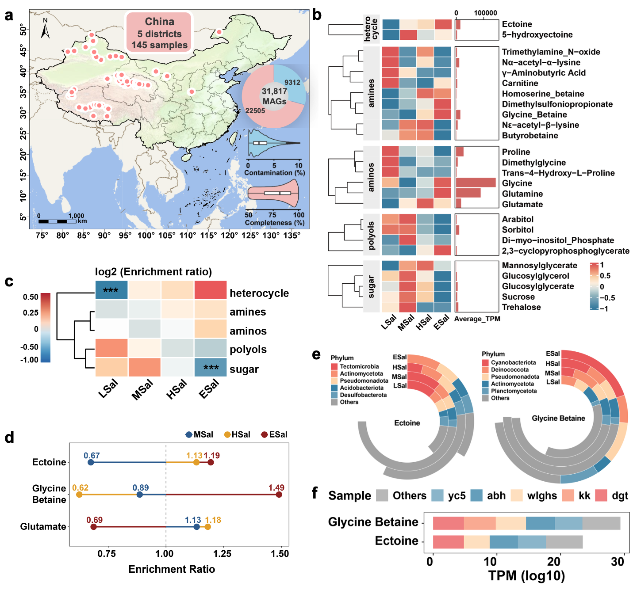

Fig.2.

3.3. Enhancement effects of salt-tolerant bacteria on anammox performance
StbESys significantly outperformed both CnvSys and GluESys in terms of start-up speed and salt-tolerant nitrogen removal performance (Fig.1). Specifically, StbESys can maintain total nitrogen (TN) removal efficiency of over 88% and nitrogen removal rate (NRR) of 260 mg N/L/d at 4% salinity after only 65 days of start-up. In contrast, both CovSys and GluESys only tolerated 1% salinity within the same 65-day period, achieving NRRs of 188 and 209 mg N/L/d, respectively. Notably, 1% salinity represents the critical stress threshold for anammox systems, as CnvSys and GluESys required 70 and 40 days, respectively, to reach stability at this salinity level. For the treatment scenario of seawater flushing toilet wastewater, StbESys tolerates 3% salinity within 50 days, which is more than 50% shorter than that of CnvSys and GluESys, with a stable nitrogen removal efficiency. These results demonstrate that the salt-tolerant bacteria bioaugmentation strategy enables rapid start-up of high-salt-tolerant anammox systems.
Regarding salt tolerance performance, the maximum salinity threshold of CnvSys was below 3% even after 115 days of acclimation. Although this system remained stable for approximately 7 days at this salinity, prolonged operation caused TN removal efficiency to drop sharply to 20%, accompanied by marked sludge granule shrinkage and disintegration. Currently, most studies enhance anammox salt tolerance by adding compatible solutes. Glutamate serves not only as a common compatible solute but also as a precursor for synthesizing other compatible solutes such as ectoine and proline ^{[38,39]}. In this study, the addition of 0.4 mM glutamate to GluESys resulted in a 0.5% higher salinity threshold to 3.5% after 115 days of acclimation compared to CnvSys. However, the salt-tolerant nitrogen removal performance of GluESys still falls far short of that of StbESys. StbESys achieved stable operation at 4% salinity within only 65 days, surpassing the GluESys threshold by 0.5% in roughly half the acclimation time. In conclusion, the salt-tolerant bacteria bioaugmentation strategy is comprehensively superior to the compatible solute addition strategy. It not only accelerates system start-up and ensures the stability and efficiency of high-salinity nitrogen removal, but also eliminates the cost of exogenous solute addition, demonstrating high feasibility for engineering applications.
Anammox sludge was characterized to investigate the impact of salt stress on sludge properties. The inoculated sludge consisted of typical anammox granules, dark brown in color, with particle sizes mainly ranging from 1.0 to 2.5 mm. It exhibited a compact structure, distinct boundaries, and no obvious dispersed flocs on the surface (Fig. 2a). After salt exposure, complete disintegration of sludge granules was observed in CovSys, whereas the granules in GluESys and StbESys became smaller and less abundant. These observations indicate that both glutamate addition and salt-tolerant bacteria bioaugmentation could alleviate salt stress to a certain extent. However, biomass analysis revealed that the biomass of GluESys began to decrease with increasing salinity starting from 1%, whereas that of StbESys exhibited a slow but continuous upward trend, increasing from an initial 3060 mg/L to 3360 mg/L (Fig. 2b). Previous studies have confirmed that persistent salt stress inhibits microbial growth in anammox communities, leading to biomass loss and reduced nitrogen removal activity ^{[40]}. In contrast, the increase in biomass observed in the salt-tolerant bacteria-enhanced system in this study demonstrates the critical role of salt-tolerant bacteria in enhancing the cell replication capacity of the entire microbial community.
Enzyme activities analysis demonstrated that StbESys exhibited significant advantages in nitrogen metabolism enzyme activities above 3% salinity. It not only upregulated heme c synthesis to maintain high activities of core anammox enzymes (HDH, HZS) but also synergistically enhanced the activities of peripheral nitrogen-converting enzymes (NAR, NIR, NOS). Specifically, with increasing salinity, heme c content in CnvSys and GluESys first increased and then decreased, while that in StbESys continued to rise, reaching a maximum of 55.6 U/L at 4% salinity, which was 2-fold and 2.6-fold higher than those in CovSys and GluESys, respectively (Fig 2c). As a key cofactor, heme c not only helps stabilize the structural integrity of core enzymes such as HDH and HZS but may also serve as an electron transfer reserve under adverse conditions, thereby enhancing energy metabolism efficiency ^{[41]}. This result suggests that salt-tolerant bacteria can help anammox bacteria upregulate heme c concentration, which improves both energy metabolism efficiency and nitrogen removal activity of anammox. Accordingly, the activities of HZS and HDH in StbESys were 1.2 - 2.0 times those in CovSys and GluESys at salinities above 3% (Fig 2d). Similarly, the activities of NAR, NIR, and NOS were the highest in StbESys and increased by above 2-fold at salinities above 3%, which may indirectly enhance the anammox process by optimizing substrate supply ^{[42]}. In conclusion, the ability of StbESys to maintain efficient denitrification performance under high-salt conditions is closely related to its unique heme c synthesis regulation mechanism. Nevertheless, further investigation is still needed to identify which salt-tolerant bacteria contribute to the enhancement of anammox enzymatic activity and the specific mechanisms underlying their synergistic effects. This knowledge will be crucial for developing optimized salt-tolerant anammox systems for practical applications in saline wastewater treatment.
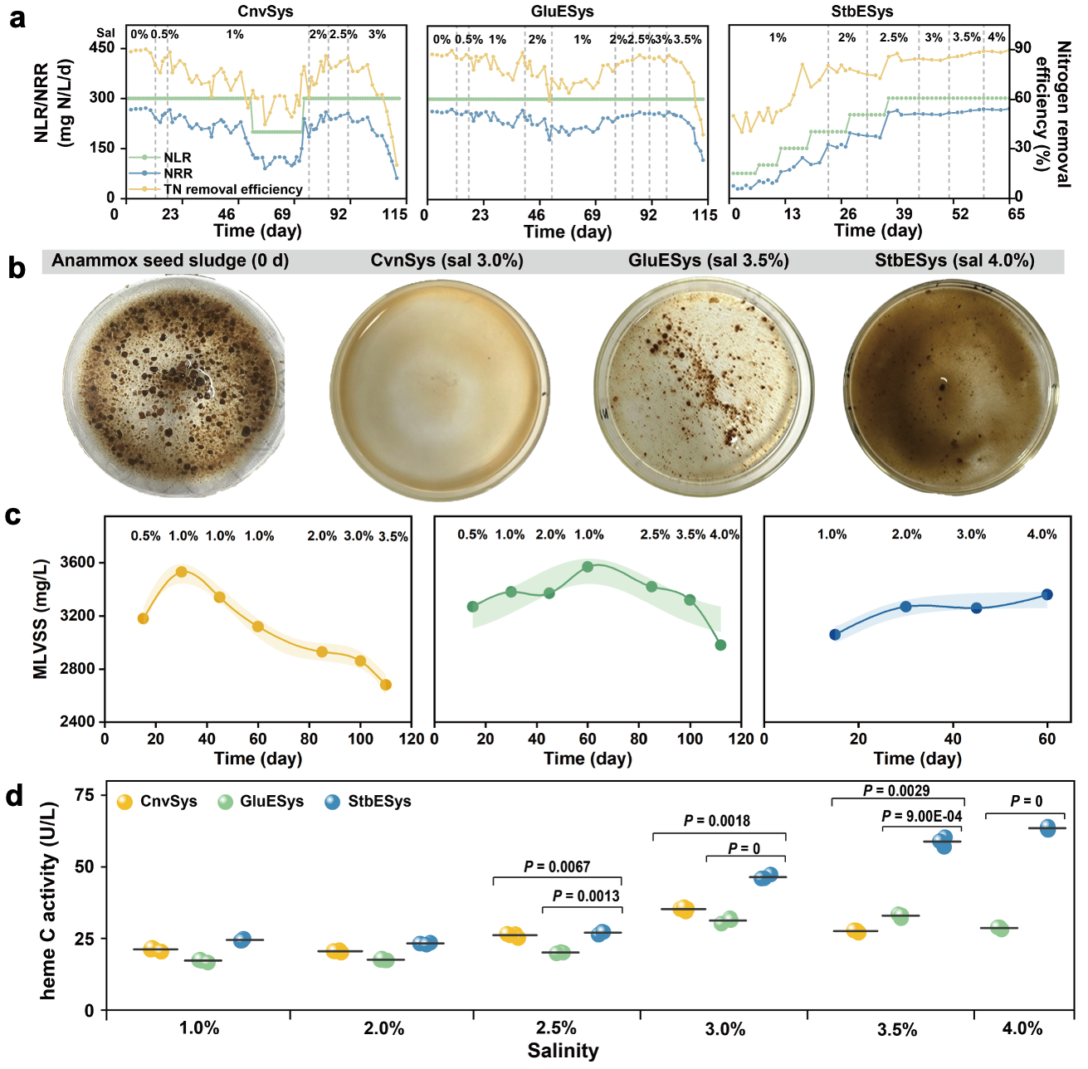

Fig. 3. (a) Variations of the total nitrogen removal (TN) efficiency, nitrogen removal rate (NRR) and nitrogen loading rate (NLR) in CnvSys, GluESys, and StbESys. The characteristics of anammox sludge exposed to salinity. (b) actual sludge morphology images, (c) MLVSS, (d) heme C activity.

3.6 Cross-feeding mechanism between AMXK1 and Salt-tolerance bacteria based on compatible solutes
Genome-resolved metagenomic analysis was conducted to characterize the community structure and microbial functions throughout the reactor operation period. A total of 390 MAGs were recovered and taxonomically classified based on phylogenetic analysis by taxonomic marker genes (Fig. S4). The average coverage of the MAGs across different samples in our study was 83±3%, which ensures that the microbial populations represented by the MAGs are well-captured and accurately reflected. These MAGs represented 39 different phyla, with Planctomycetota, Bacteroidota Chloroflexota and Patescibacteria being the top four abundant phyla (Fig. S5a). Molecular ecological network analysis revealed that StbESys exhibited a larger-scale small-world network under high-salinity stress with stronger connections, higher modularity, clustering coefficient and cooperative efficiency (Fig. 3a-c). Its positive correlation ratio (73.04%), average node degree (9.81) and number of edges (1109) significantly exceeded those of CnvSys (563 edges) and GluESys (874 edges). Analysis of first-order nodes directly connected to anammox bacteria further highlighted critical differences across systems (Fig. 3d-f). Specifically, CnvSys showed only 8 nodes and 6 edges all with negative correlations, indicating that effective interactions between anammox bacteria and other core species could not be established. GluESys had 25 nodes and 38 edges (57.89% positive correlations) but exhibited a looser network structure, likely because exogenous glutamate as an osmoprotectant partially reduced the need for microbial interdependence. In contrast, StbESys formed the densest and most cooperative ecological subnetwork with 23 nodes and 87 edges (92.05% positive correlations). This highly connected structure facilitates resource sharing and metabolic complementarity under salt stress and may establish mutualistic relationships through material transport and osmoprotectant supply.
The significantly enhanced network robustness correlates directly with the proliferation of Ca. Kuenenia in StbESys (Fig. 3g). With increasing salinity stress, Ca. Kuenenia progressively replaced Ca. Brocadia, with its relative abundance rising from an initial 1.8% to 21.8% when salinity reached 3%. Notably, this increase rate was more than twice that of CnvSys and GluESys within the same salinity range. This indicates that salt-tolerant bacteria provide auxiliary protection mechanisms that enable Ca. Kuenenia to proliferate rapidly, thereby establishing stable denitrification performance. Notably, the superior salt tolerance of Ca. Kuenenia compared with Ca. Brocadia is attributable not to mechanisms proposed in previous studies regarding low salt-in strategies, but rather to its capacity to synthesize glycine betaine (GB), an electroneutral compatible solute^{[14,43]}. Under non-stressful salinity conditions, Ca. Brocadia dominated with a relative abundance exceeding 45%, whereas Ca. Kuenenia was nearly undetectable (Fig. 3g). With increasing salinity, Ca. Kuenenia gradually replaced Ca. Brocadia as the dominant population. Previous studies attributed the salt tolerance advantage of Ca. Kuenenia to its ability to rapidly accumulate K⁺ while synthesizing glutamate as a counterion, which was subsequently partially replaced by trehalose, thereby effectively balancing intracellular and extracellular osmotic pressure ^{[43]}. In contrast, Ca. Brocadia has been reported to lack the capacity for K⁺–glutamate accumulation, resulting in a marked decline in activity even at low salinities of 1–2%^{[43]}. However, the present study revealed that Ca. Brocadia also possesses this composite regulatory capability, indicating that the K⁺ accumulation strategy does not constitute the fundamental cause of interspecific differences in salt tolerance. In fact, a universally conserved bacterial osmotic regulation mechanism may be summarized in three sequential stages: (1) under high-salinity stress, cells rapidly accumulate K⁺ to achieve immediate osmotic equilibration while providing time for compatible solute biosynthesis; (2) because excess K⁺ interferes with intracellular enzyme function, negatively charged compatible solutes (e.g., glutamate) must be accumulated to neutralize cellular charge and restore electroneutrality; (3) once electroneutrality is established, electroneutral compatible solutes can be synthesized in large quantities to sustain long-term osmotic regulation without disrupting normal cellular metabolism. The critical distinction between these two anammox genera lies in stage three. Specifically, Ca. Kuenenia synthesize both GB and trehalose, whereas Ca. Brocadia produces only trehalose. As an electroneutral compatible solute, GB directly regulates osmotic pressure without participating in the Maillard reaction ^{[44]}. In contrast, trehalose primarily maintains osmotic balance indirectly through membrane and protein stabilization, functioning as an auxiliary defense mechanism. Consequently, GB is regarded as the essential adaptation strategy for extreme hypersalinity ^{[43]}. For example, halophilic archaea are obligately dependent on GB for survival at 3–8× seawater salinity ^{[45]}, and even in the presence of exogenous trehalose, their GB synthesis rates remain unchanged across salinity gradients ^{[46]}, demonstrating that trehalose cannot substitute for the central role of GB under high-salinity conditions ^{[47]}. Although these findings clarify the basis for interspecific competitive dominance by Ca. Kuenenia, they do not explain the approximately two-fold acceleration in Ca. Kuenenia proliferation in StbESys relative to CnvSys and GluESys. Elucidation of the precise pathways through which the "auxiliary protective mechanism" mediated by salt-tolerant bacteria enhances AMXK1 reproductive kinetics remains a critical unresolved question that this investigation aims to address.
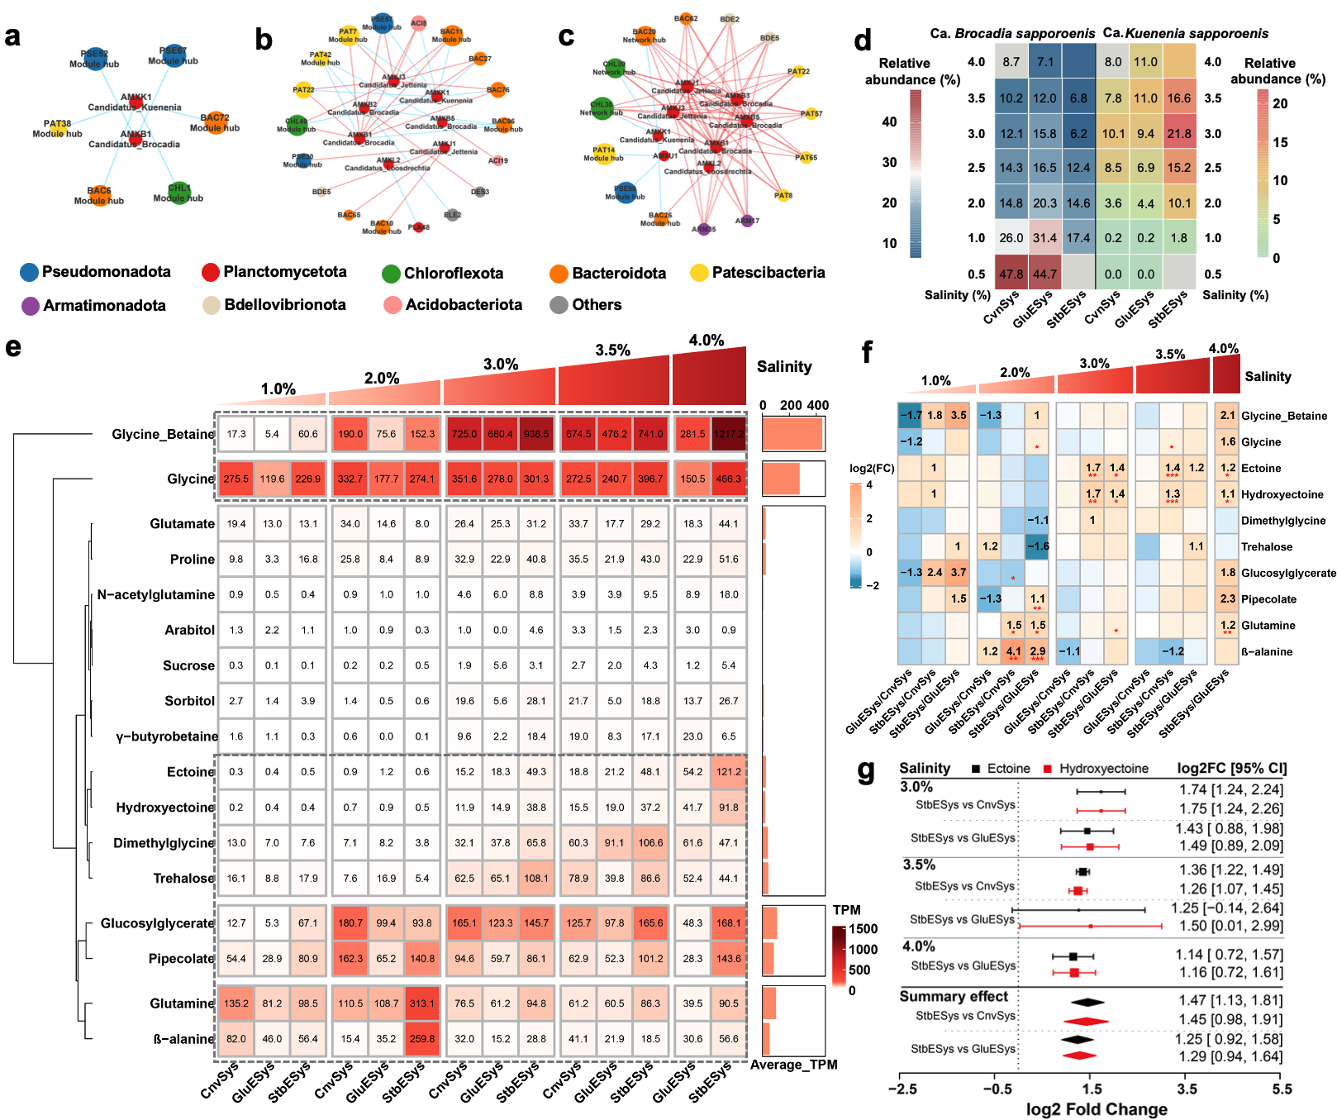

Fig. 4. The Anammox primary network of (a) the conventional system, (b) the glutamate-enhanced system, and (c) the salt-tolerant bacteria enhanced system; (d) The relative abundance of Ca. Brocadia and Ca. Kuenenia; (e) Hierarchical clustering heatmap of compatible solute expression levels across different systems under varying salinity conditions; (f) Fold changes in the synthesis capacity of major compatible solutes across different systems; (g) Consistency test analysis of typical compatible solutes across different systems.

Compatible solutes represent a core regulatory strategy for halotolerant microorganisms to cope with hyperosmotic stress. Therefore, this study commenced an investigation into the auxiliary protective effect conferred by salt-tolerant bacteria on Ca. Kuenenia under high-salinity conditions, focusing specifically on compatible solute biosynthetic pathways. Hierarchical clustering analysis of genes involved in compatible solute biosynthesis revealed five distinct expression clusters across the salinity gradient (Fig. 4a). The osmotic pressure regulation capability of compatible solutes increased with salinity as follows: glutamine/β-alanine (1–2%) < pipecolate/glucosylglycerate (2–3.5%) < dimethylglycine/trehalose (3–3.5%) < glycine betaine (2–4%) and tetrahydropyrimidine/5-hydroxytetrahydropyrimidine (3–4%). Further comparison of the compatible solute enhancement capacity among StbESys and other systems (Fig. 4b) revealed that at 1% salinity, the concentration of glucosylglycerate in StbESys was over 7-fold higher than in CnvSys and GluESys. At 2% salinity, glutamine and β-alanine were the primary compatible solutes maintaining StbESys stability, with statistically significant differences. From 3% to 4% salinity intervals, significant enhancement in ectoine and its derivative synthesis was observed, thereby strengthening cellular salt tolerance. Notably, at 4% salinity, StbESys also activated the synthesis of other solutes, including GB, glycine, glucosylglycerate, and pipecolate, to synergistically enhance osmoregulatory capacity. Ectoine is a low-molecular-weight cyclic organic osmolyte first discovered by Galinski et al.^{[48]} in the halophilic bacterium Ectothiorhodospira halochloris, later found to be universally present in diverse extremophilic microorganisms ^{[49]}. Compared to other compatible solutes, ectoine possesses a unique mechanism of action: it primarily functions through "preferential exclusion" ^{[32]} or "preferential hydration" ^{[33]} effects, where individual ectoine molecules form stable hydrogen-bonding networks with multiple water molecules through their dipole properties, creating effective hydration shells that protect cellular components from dehydration damage ^{[34]}. Equally important, ectoine functions as a zwitterionic osmolyte, capable of achieving high intracellular accumulation concentrations in extreme high-salinity environments without interfering with normal metabolic activities ^{[50,51]}. Cross-salinity consistency tests (Fig. 4c) demonstrated that compared to GluESys, StbESys exhibited significantly elevated synthesis pathways for ectoine (total effect size = 1.45, 95% CI: 0.98–1.91, P = 1.16 × 10⁻¹²) and hydroxyectoine (total effect size = 1.25, 95% CI: 1.40–2.30, P = 6.54 × 10⁻¹³), indicating their cross-salinity stability. This indicates that StbESys establishes enhanced cross-salinity stability through upregulated ectoine/hydroxyectoine synthesis pathways, wherein this multi-solute synergistic regulatory mechanism ensures optimal osmotic balance and biomolecular functional stability across varying salinity conditions.
Previous studies have typically employed an exogenous supplementation strategy by adding different types or concentrations of compatible solutes (such as glycine betaine, ectoine, etc.) to anammox systems to evaluate osmoprotective effects under specific conditions or to screen for optimal schemes through comparative evaluation of various compatible solutes' impacts on anammox denitrification performance ^{[11,52]}. For instance, batch experiments and reactor studies have confirmed that adding 1-2 mM glutamate^{[15]}, 0.1-5 mM glycine betaine^{[11]}, 0.2-0.6 mM glycine^{[53]}, and 0.1 mM trehalose^{[15]} can significantly enhance the denitrification performance of anammox bacteria under high-salt stress. However, other research has demonstrated that adding 0.6 mM mannitol under certain salinity conditions resulted in adverse effects^{[11]}. All these studies are based on artificial intervention, and to date no systematic study has revealed which compatible solutes anammox bacteria preferentially utilize for osmotic regulation under different salinity stress conditions. Therefore, this exogenous addition strategy presents fatal limitations for practical application: when facing a novel anammox system, researchers cannot pre-determine which type and concentration of compatible solute should be added; furthermore, exogenous addition inevitably incurs additional costs, significantly limiting the universality and scalability of this strategy. This study overcomes the inherent limitations of the exogenous addition strategy by innovatively utilizing halotolerant bacteria to construct a salt-tolerant anammox enhanced system. These results indicate that halotolerant bacteria can establish a syntrophic mutualistic relationship with anammox organisms and autonomously regulate compatible solute synthesis strategies under different salinity conditions, thereby achieving flexible responses to high-salt stress. This strategy fundamentally eliminates dependence on exogenous supplementation, providing a low-cost, self-adaptive, and scalable new path for engineering applications of high-salt anammox systems.

To identify the microbial taxa that provide key compatible solutes in the system, we traced the genomes contributing to these seven compatible solutes and found that the contributing microbial taxa exhibit significant functional differentiation. Among them, AMXK1 dominates the contribution of glucosylglycerate, glycine betaine, and pipecolate carboxylate, with contributions reaching 86%, 95%, and 95%, respectively; its contribution to glutamine is 37%, still representing the largest contributor. For glycine synthesis, PAT55 and AMXK1 are the main contributors, accounting for 39% and 23%, respectively. In contrast, ectoine and 5-hydroxyectoine are primarily dominated by BAC1 and HYD5.
Ca. Kuenenia is renowned for its ability to accumulate large amounts of intracellular K⁺, thereby offsetting the osmotic pressure gradient between the cell interior and the external environment ^{[43]}. At the genomic level, we calculated the expression of K⁺ transporter genes and relevant compatible solute biosynthesis genes in AMXK1 across all systems. The results revealed that the expression of K⁺ transporters in StbESys did not significantly exceed that in other systems. instead, a downregulation trend of 3%–3.5% was observed under saline conditions. This indicates that AMXK1 reduced its dependence on active potassium ion uptake under the regulation of halotolerant bacteria. Regarding compatible solute synthesis capacity, except for pipecolate which showed slight upregulation in StbESys compared to other systems with increasing salinity, the expression of genes associated with other compatible solute synthesis decreased with rising salinity. This suggests that AMXK1 primarily acquired compatible solutes from halotolerant bacteria rather than synthesizing them de novo in StbESys to cope with salt stress. Therefore, we screened for microorganisms whose compatible solute biosynthesis and transporter genes exhibited significantly higher expression levels than those in the other two systems (log₂FC > 1) within StbESys. Results indicate that BAC1 (a shared microorganism between StbESys and CnvSys) exhibits higher expression in the StbESys system, while showing nearly no expression in CnvSys. Its synthesis and transport capacity increases with rising salinity. BDE3 is a microbe specific to StbESys, and its expression of ectype synthesis and transport also increases with salinity elevation. Thus, under high-salt conditions above 3%, BAC1 and BDE3 can achieve halotolerance through synthesizing substantial amounts of ectoine and translocate these solutes extracellularly for utilization by AMXK1.
To correlate reactor performance changes with the physiological status of AMXK1, we analyzed expression level changes in oxidative stress, energy metabolism, cell cycle, and nitrogen metabolism pathways. Regarding oxidative stress, Complex I in the respiratory chain is the enzyme complex with the highest proton pumping capacity in the respiratory chain (pumping out 4 H⁺ per pair of electrons transmitted ^{[54]}). While offering the highest energy production efficiency, constructing and maintaining this large protein complex itself consumes considerable energy, and it is one of the major sources of intracellular reactive oxygen species (ROS) ^{[55]}. Under high-salt stress, NADH quinone oxidoreductase expression in the halotolerant bacteria-enriched system was lower compared to other systems, indicating that the presence of halotolerant bacteria reduced endogenous ROS produced during the anammox process. Simultaneously, analysis of ROS-scavenging genes in AMXK1 revealed that the superoxide dismutase gene sod2, encoding enzymes that scavenge superoxide anion radicals, was upregulated in the presence of halotolerant bacteria, effectively reducing the system's oxidative stress level and providing a safe survival microenvironment for anammox bacteria. Meanwhile, upregulation of the cytochrome c oxidase module, succinate dehydrogenase module, and F-type ATPase module confirmed that halotolerant bacteria enrichment effectively enhanced the energy supply capacity of AMXK1. Consequently, the cell cycle and metabolic processes of AMXK1 exhibited enhanced trends, ensuring stable and efficient nitrogen removal capacity in the halotolerant bacteria-enriched system under high-salt conditions.
In summary, the halotolerant bacteria significantly enhanced the survival capacity and metabolic activity of AMXK1 under high-saline environments through two synergistic mechanisms: "burden reduction" (diminished oxidative damage) and "energy provision" (supplied compatible solutes). Specifically, on one hand, halotolerant bacteria (BAC1 and BDE3) provided ectoine to AMXK1, enabling AMXK1 to avoid substantial de novo synthesis of compatible solutes, thereby conserving energy consumption. Simultaneously, the presence of halotolerant bacteria mitigates oxidative stress responses in anammox: both reducing endogenous ROS production and enhancing ROS clearance capacity, providing AMXK1 with a safe survival microenvironment and reducing energy investment in stress defense mechanisms. As a result, AMXK1 maintains high nitrogen metabolic activity and high-level ATP synthesis, preferentially allocating limited energy production toward cellular proliferation rather than stress response, thereby ensuring salt-tolerant nitrogen removal performance under high-salt conditions.
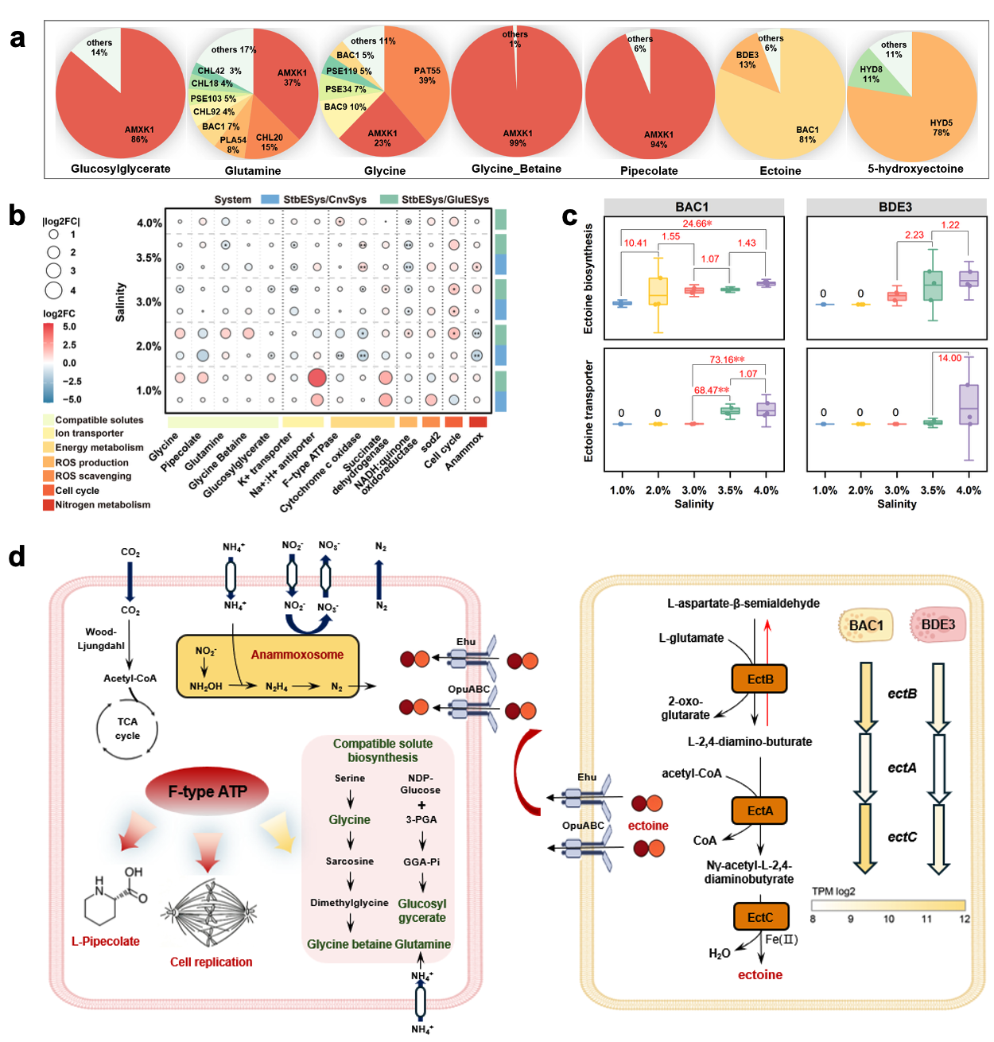
Fig. 5. (a) Relative contribution of each metagenome-assembled genome (MAG) to the pool of key compatible solutes; (b) Differential expression of core metabolic genes in Ca. Kuenenia (AMXK1) across the three reactor systems; (c) Expression dynamics of ectoine biosynthesis (ectABC) and transport (teaABC) gene clusters in salt-tolerant bacteria under stepwise increasing salinities; (d) Proposed cross-feeding relationship between salt-tolerant bacteria and AMXK1 mediated by compatible solute exchange.

4. Conclusions
This study conducted long-term salinity stress experiments to reveal the core advantages of salt-tolerant bacteria-enhanced anammox systems compared to conventional anammox systems, as well as the molecular mechanisms by which salt-tolerant bacteria enhance the salt-tolerant denitrification performance of anammox bacteria through compatible solutes. The main outcomes were:
- Compared to conventional systems, the salt-tolerant bacteria-enhanced system halved the acclimation period, surpassed the 3% salinity tolerance threshold, and maintained denitrification efficiency above 80% under 4% salinity conditions.
- The salt-tolerant bacteria enhanced the survival capacity and metabolic activity of anammox bacteria under high-salt conditions by reducing oxidative stress levels and improving ATP synthesis efficiency.
- Salt-tolerant bacteria (such as BAC1, BDE3) synthesized and secreted compatible solutes including ectione, providing osmotic pressure regulation support for anammox bacteria (Ca. Kuenenia), enabling them to avoid additional compatible solute synthesis. This conserved energy for critical functions such as cell cycle and DNA replication, thereby maintaining stable biomass.

Declaration of Competing Interest
The authors declare no competing financial interest.

Acknowledgements

This work was financially supported by the National Natural Science Foundation of China (NO.51709005), Natural Science Foundation of Guangdong Provenience (2023A1515030263), Shenzhen Knowledge Innovation Program Basic Research Projects (JCYJ20190808183205731 and JCYJ20220812103301001). This work was also supported by the Shenzhen municipal development and reform commission (discipline construction of watershed ecological engineering). W.-Q.Z. thanks the Catalyst: Leaders funding (CHN-UOA1601) provided by the New Zealand Ministry of Business, Innovation and Employment, and administered by the Royal Society Te Apārangi. We would like to thank the support of AI for Science (AI4S)-Preferred Program, Peking University. The data analysis of this work was thanks for the support of Peking University's high-performance computing platform.

References
- Xiong, Y.-T., Liao, X.-W., Guo, J.-S., Fang, F., Chen, Y.-P., & Yan, P. (2024). Potential role of the anammoxosome in the adaptation of anammox bacteria to salinity stress. Environmental Science & Technology, 58. https://doi.org/10.1021/acs.est.4c01417
- Li, J., Yu, D., Qi, P., & Li, J. (2025). Impact of stepwise salinity elevation on nitrogen removal and microbial properties of morphologically distinct anammox sludge. Water, 17(17), 2611. https://doi.org/10.3390/w17172611
- Xue, Y., Ma, H., & Li, Y.-Y. (2023). Anammox-based granulation cycle for sustainable granular sludge biotechnology from mechanisms to strategies: A critical review. Water Research, 228, 119353. https://doi.org/10.1016/j.watres.2022.119353
- Yin, S., Jiang, X., Wang, Y., Yang, Y., Chen, D., & Shen, J. (2023). Defense mechanism of Fe(III)-assisted anammox under salt stress: Performance and microbial community dynamics. Water Research X, 20, 100188. https://doi.org/10.1016/j.wroa.2023.100188
- Kasiński, S., Kowal, P., & Czerwionka, K. (2025). Advanced technologies for nitrogen removal and recovery from municipal and industrial wastewater. Materials, 18(7), 1422. https://doi.org/10.3390/ma18071422
- Fan, L., Jiang, C., Wang, X., Yang, Y., Xie, Y., Su, J., Sun, H., Xu, S., & Zhuang, X. (2024). Harnessing the potential of extracellular polymeric substances in enhancing ANAMMOX processes: Mechanisms, strategies, and perspectives. Water, 16(9), 1242. https://doi.org/10.3390/w16091242
- Okabe, S., Kamizono, A., Kawasaki, S., Kobayashi, K. & Oshiki, M. (2025). Interspecific competition and adaptation of anammox bacteria at different salinities: Experimental validation of the monod growth model with salinity inhibition[J]. Water Researchearch, 271, 122883, doi:10.1016/j.watres.2024.122883
- Zhang, L. & Okabe, S. (2020). Ecological niche differentiation among anammox bacteria[J]. Water Researchearch, 171, 115468, doi:10.1016/j.watres.2020.115468
- Naufal, M., Wu, J.-H. & Shao, Y.-H. (2022).Glutamate enhances osmoadaptation of anammox bacteria under high salinity: genomic analysis and experimental evidence[J]. Environmental Science & Technology, 56, 11310-11322, doi:10.1021/acs.est.2c01104
- Zhou, J.-J., Zhang, X., Zhuang, J.-L., Xu, T.-X., Liu, Y.-D., & Li, W. (2022). Saline short-term shock and rapid recovery on anammox performance. Chemosphere, 307, 135687. https://doi.org/10.1016/j.chemosphere.2022.135687
- Zhu, W., Li, J., Wang, B. & Chen, G. (2020). Enhancement of pollutants removal from saline wastewater through simultaneous anammox and denitrification (SAD) process with glycine betaine addition[J]. Bioresource Technology, 315, 123784, doi:https://doi.org/10.1016/j.biortech.2020.123784
- Jin, R.-C., Yu, J.-J., Ma, C., Yang, G.-F., Zhang, J., Chen, H., Zhang, Q.-Q., Ji, Y.-X., & Hu, B.-L. (2014). Transient and long-term effects of bicarbonate on the ANAMMOX process. Applied Microbiology and Biotechnology, 98, 1377–1388. https://doi.org/10.1007/s00253-013-5004-9
- Li, J., Bai, L., Qiang, Z., Dong, H. & Wang, D. (2018). Nitrogen removal through “Candidatus Brocadia sinica” treating high-salinity and low-temperature wastewater with glycine addition: Enhanced performance and kinetics[J]. Bioresource Technology, 270, 755-761, doi:https://doi.org/10.1016/j.biortech.2018.09.101
- Fu, J.-J., Wang, Y., Yang, J.-H., Huang, D.-Q., Zhang, Q., Huang, Y., Chen, J.-R., Fan, N.-S., & Jin, R.-C. (2022). Mitigating the detrimental effects of salt stress on anammox process: A comparison between glycine betaine and mannitol. Science of The Total Environment, 851, 158221. https://doi.org/10.1016/j.scitotenv.2022.158221
- Liu, M., Peng, Y., Wang, S., Liu, T. & Xiao, H. (2014).Enhancement of anammox activity by addition of compatible solutes at high salinity conditions[J]. Bioresource Technology, 167, 560-563, doi:https://doi.org/10.1016/j.biortech.2014.06.015
- Duc, L. V. et al. (2023).Bioaugmentation with marine sediment-derived microbial consortia in mesophilic anaerobic digestion for enhancing methane production under ammonium or salinity stress[J]. Bioresource Technology, 376, 128853, doi:https://doi.org/10.1016/j.biortech.2023.128853
- Obruča, S. et al. (2022).Polyhydroxyalkanoates synthesis by halophiles and thermophiles: towards sustainable production of microbial bioplastics[J]. Biotechnology Advances, 58, 107906, doi:https://doi.org/10.1016/j.biotechadv.2022.107906
- León-Lemus, A., Martínez-García, M., Cabirol, N., Campos, J. E., & Monsalvo-Reyes, A. (2025). Draft genome sequence and comparative genomic analysis of Halomonas salifodinae strain A2 isolated from the Zapotitlán Salinas Valley, Puebla, Mexico. Extremophiles, 29, 28. https://doi.org/10.1007/s00792-025-01397-z
- Oren, A. (2024).Novel insights into the diversity of halophilic microorganisms and their functioning in hypersaline ecosystems[J]. npj biodivers 3, 18 https://doi.org/10.1038/s44185-024-00050-w
- Qiao, X., Zhang, L., Qiu, Z., Wu, Y., Deng, C., Geng, Y., Zhang, Y., Yan, Y., Li, B., Zhang, L., Zhuang, W.-Q., & Yu, K. (2025). Nitrite impairs bioreactor performance due to decreased replication of Candidatus Brocadia sapporoensis by unbalanced energy allocation. Water Research, 283, 123806. https://doi.org/10.1016/j.watres.2025.123806
- Li, D., Liu, C., Luo, R., Sadakane, K. & Lam, T. (2015). MEGAHIT: an ultra-fast single-node solution for large and complex metagenomics assembly via succinct de Bruijn graph[J]. Bioinformatics 31, 1674-1676
- Qiu, Z. et al. (2024). BASALT refines binning from metagenomic data and increases resolution of genome-resolved metagenomic analysis[J]. Nature Communications, 15, 2179, doi:10.1038/s41467-024-46539-7
- Parks, D. H., Imelfort, M., Skennerton, C. T., Hugenholtz, P. & Tyson, G. W. (2015). CheckM: assessing the quality of microbial genomes recovered from isolates, single cells, and metagenomes[J]. Genome Research, 25, 1043-1055, doi:10.1101/gr.186072.114
- Chaumeil, P. A., Mussig, A. J., Hugenholtz, P. & Parks, D. H. (2019). GTDB-Tk: a toolkit to classify genomes with the Genome Taxonomy Database[J]. Bioinformatics 36, 1925-1927, doi:10.1093/bioinformatics/btz848
- Nguyen, L. T., Schmidt, H. A., von Haeseler, A. & Minh, B. Q. (2015). IQ-TREE: a fast and effective stochastic algorithm for estimating maximum-likelihood phylogenies[J]. Molecular Biology and Evolution, 32, 268-274, doi:10.1093/molbev/msu300
- Letunic, I. & Bork, P. (2019). Interactive Tree Of Life (iTOL) v4: recent updates and new developments[J]. Nucleic Acids Research, 47, W256-W259, doi:10.1093/nar/gkz239
- Aroney, S. T. N. et al. (2025). CoverM: read alignment statistics for metagenomics[J]. Bioinformatics 41, btaf147, doi:10.1093/bioinformatics/btaf147
- Guimerà, R., Sales-Pardo, M. & Amaral, L. A. N. (2007). Classes of complex networks defined by role-to-role connectivity profiles[J]. Nature Physics 3, 63-69, doi:10.1038/nphys489
- Olesen, J. M., Bascompte, J., Dupont, Y. L. & Jordano, P. (2007). The modularity of pollination networks[J]. Proceedings of the National Academy of Sciences 104, 19891-19896, doi:doi:10.1073/pnas.0706375104
- Bolger, A. M., Lohse, M., & Usadel, B. (2014). Trimmomatic: A flexible trimmer for Illumina sequence data[J]. Bioinformatics, 30(15), 2114–2120. https://doi.org/10.1093/bioinformatics/btu170
- Kopylova, E., Noé, L., & Touzet, H. (2012). SortMeRNA: Fast and accurate filtering of ribosomal RNAs in metatranscriptomic data[J]. Bioinformatics, 28(24), 3211–3217. https://doi.org/10.1093/bioinformatics/bts608
- Chen, X., Lin, N., Li, J.-M., Liu, H., Abu-Romman, A., Yaman, E., Bian, F., de Paiva, C. S., Pflugfelder, S. C., & Li, D.-Q. (2024). Ectoine, from a natural bacteria protectant to a new treatment of dry eye disease. Pharmaceutics, 16(2), 236. https://doi.org/10.3390/pharmaceutics16020236
- Andrade del Olmo, J., Melero, A., Pino, A., Martínez de Cestafe, N., Gartziandia, O., Ucelay López de Heredia, M., Torrecilla, J., Gómez, L., Benito Cid, S., Alonso, J. M., & Pérez González, R. (2025). Enhanced ocular retention and anti-allergic efficacy of a novel HA–ectoine–CMC eye drop for dry eye disease management. Journal of Pharmaceutical Biotechnology Industry, 2(4), 16. https://doi.org/10.3390/jpbi2040016
- Kunte, H., Lentzen, G., & Galinski, E. (2014). Industrial production of the cell protectant ectoine: Protection mechanisms, processes, and products. Current Biotechnology. https://doi.org/10.2174/22115501113026660037
- Mahmoudi Ghehsareh, M., Bakhtiari, S., Asri, N., et al. (2026). Impacts of conditionally essential amino acids, cysteine, and tyrosine on intestinal inflammation in celiac disease. Amino Acids, 58(1). https://doi.org/10.1007/s00726-025-03490-1
- Ravishankar, J. P., Suryanarayanan, T. S., & Muruganandam, V. (2006). Strategies for osmoregulation in the marine fungus Cirrenalia pygmea Kohl. (Hyphomycetes). Indian Journal of Marine Sciences, 35(4), 351–358.
- Zou, Z., Kaothien-Nakayama, P., Ogawa-Iwamura, J., & Nakayama, H. (2023). Metabolic engineering of high-salinity-induced biosynthesis of γ-aminobutyric acid improves salt-stress tolerance in a glutamic acid-overproducing mutant of an ectoine-deficient Halomonas elongata. Applied and Environmental Microbiology, 90(1). https://doi.org/10.1128/aem.01905-23
- Roberts, M. F. (2005). Organic compatible solutes of halotolerant and halophilic microorganisms. Saline Systems, 1(1), 5. https://doi.org/10.1186/1746-1448-1-5
- Khanh, H. C., Kaothien-Nakayama, P., Zou, Z., & Nakayama, H. (2024). Metabolic pathway engineering of high-salinity-induced overproduction of L-proline improves high-salinity stress tolerance of an ectoine-deficient Halomonas elongata. Applied and Environmental Microbiology, 90, e01195-24. https://doi.org/10.1128/aem.01195-24
- Wang, J., Su, Q., Cao, S., Fan, X., & Du, R. (2026). Hydroxylamine-assisted reactivation of salinity-inhibited partial denitrification/anammox systems: Performance recovery, functional microbial shifts, and mechanistic insights. Water, 18(1), 111. https://doi.org/10.3390/w18010111
- Wang, Z., Yu, Q., Zhao, Z., & Zhang, Y. (2024). Ferroheme/Ferriheme directly involved in the synthesis and decomposition of hydrazine as an electron carrier during anammox. Environmental Science & Technology, 58(23), 10140–10148. https://doi.org/10.1021/acs.est.3c08525
- Blum, J. M., Su, Q., Zhang, T., & Mørkved, P. T. (2018). The pH dependency of N-converting enzymatic processes, pathways and microbes: effect on net N₂O production. Environmental Microbiology, 20(5), 1623–1640. https://doi.org/10.1111/1462-2920.14063
- Okabe, S., Kamizono, A., Zhang, L., Oshiki, M., & Yamamoto, K. (2024). Salinity tolerance and osmoadaptation strategies in four genera of anammox bacteria: Brocadia, Jettenia, Kuenenia, and Scalindua. Environmental Science & Technology, 58(12), 5357–5371. https://doi.org/10.1021/acs.est.3c07324
- Cioroi, M. (2007). Studies on the reactivity of some sugars and amino acids in maillard reaction model systems. In MOCM 13 (Vol. 2) (p. 151). Romanian Technical Sciences Academy.
- Salma, M., Abdulla, M. K., & Samina, M. (2020). Osmoadaptation in halophilic bacteria and archaea. Research Journal of Biotechnology, 15(5), 154–161.
- Youssef, N. H., Savage-Ashlock, K. N., McCully, A. L., Luedtke, B., Shaw, E. I., Hoff, W. D., & Elshahed, M. S. (2014). Trehalose/2-sulfotrehalose biosynthesis and glycine-betaine uptake are widely spread mechanisms for osmoadaptation in the Halobacteriales. The ISME Journal, 8(3), 636–649. https://doi.org/10.1038/ismej.2013.165
- Ding, R., Yang, N., & Liu, J. (2022). The osmoprotectant switch of potassium to compatible solutes in an extremely halophilic archaea Halorubrum kocurii 2020YC7. Genes, 13(6), 939. https://doi.org/10.3390/genes13060939
- Galinski, E. A., Trüper, H. G., & Herzog, R. (1985). Compatibility of organic solutes with cellular processes. Biochimica et Biophysica Acta, 842(1), 10–18. https://doi.org/10.1016/0005-2760(85)90179-5
- Czech, L., Hermann, L., Stöveken, N., Richter, A. A., Höppner, A., Smits, S. H. J., Heider, J., & Bremer, E. (2018). Role of the extremolytes ectoine and hydroxyectoine as stress protectants and nutrients: Genetics, phylogenomics, biochemistry, and structural analysis. Genes, 9(4), 177. https://doi.org/10.3390/genes9040177
- Cantera, S., Lebrero, R., Rodríguez, S., García-Encina, P. A., & Muñoz, R. (2017). Ectoine bio-milking in methanotrophs: A step further towards methane-based bio-refineries into high added-value products. Chemical Engineering Journal. https://doi.org/10.1016/j.cej.2017.07.027
- Rieckmann, T., Gatzemeier, F., Christiansen, S., Rothkamm, K., & Münscher, A. (2019). The inflammation-reducing compatible solute ectoine does not impair the cytotoxic effect of ionizing radiation on head and neck cancer cells. Scientific Reports, 9, 6594. https://doi.org/10.1038/s41598-019-42847-7
- Kim, Y., Yu, J., Jeong, S., Kim, J., Park, S., Bae, H., Rhee, S.-K., Unno, T., Ni, S.-Q., & Lee, T. (2022). Differences in the effects of calcium and magnesium ions on the anammox granular properties to alleviate salinity stress. Applied Sciences, 12(1), 19. https://doi.org/10.3390/app12010019
- Kapfhammer, D., Karatan, E., Pflughoeft, K. J., & Watnick, P. I. (2005). Role for glycine betaine transport in Vibrio cholerae osmoadaptation and biofilm formation within microbial communities. Applied and Environmental Microbiology, 71(7), 3840–3847. https://doi.org/10.1128/AEM.71.7.3840-3847.2005
- Stuchebrukhov, A. A., & Hayashi, T. (2023). Single protonation of the reduced quinone in respiratory complex I drives four-proton pumping. FEBS Letters, 597(2), 237–245. https://doi.org/10.1002/1873-3468.14518
- Karkucinska-Wieckowska, A., Simoes, I. C. M., Kalinowski, P., Lebiedzinska-Arciszewska, M., Zieniewicz, K., Milkiewicz, P., Górska-Ponikowska, M., Pinton, P., Malik, A. N., Krawczyk, M., Oliveira, P. J., & Wieckowski, M. R. (2022). Mitochondria, oxidative stress and nonalcoholic fatty liver disease: A complex relationship. European Journal of Clinical Investigation, 52(3), e13622. https://doi.org/10.1111/eci.13622

