ShapeWorks - Slack Variables

ShapeWorksRunApp.h

1) Created a vector variable to hold the offset file names if fed through the parameter file

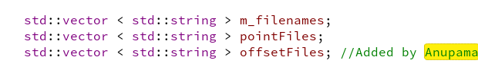
ShapeWorksRunApp.txx

2) ReadInputs method – Inorder to read the offset files from the input parameter file

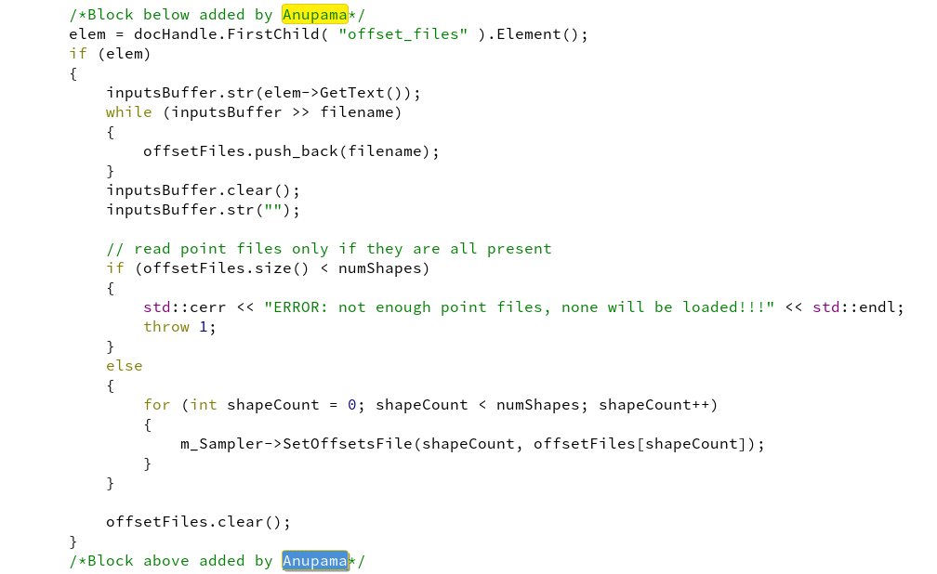
3) ReadExplanatoryVariables – Inorder to read the offsets regularization from the parameter file

4) WritePointFiles – The offset files and the points (following population trend) are written to files as output

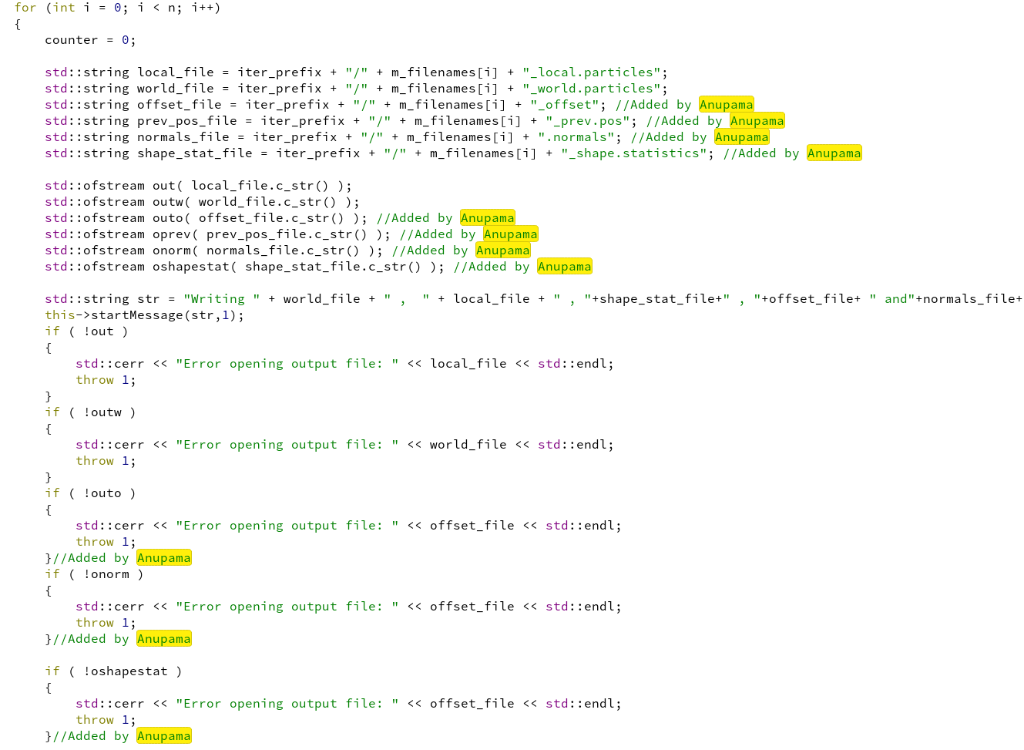
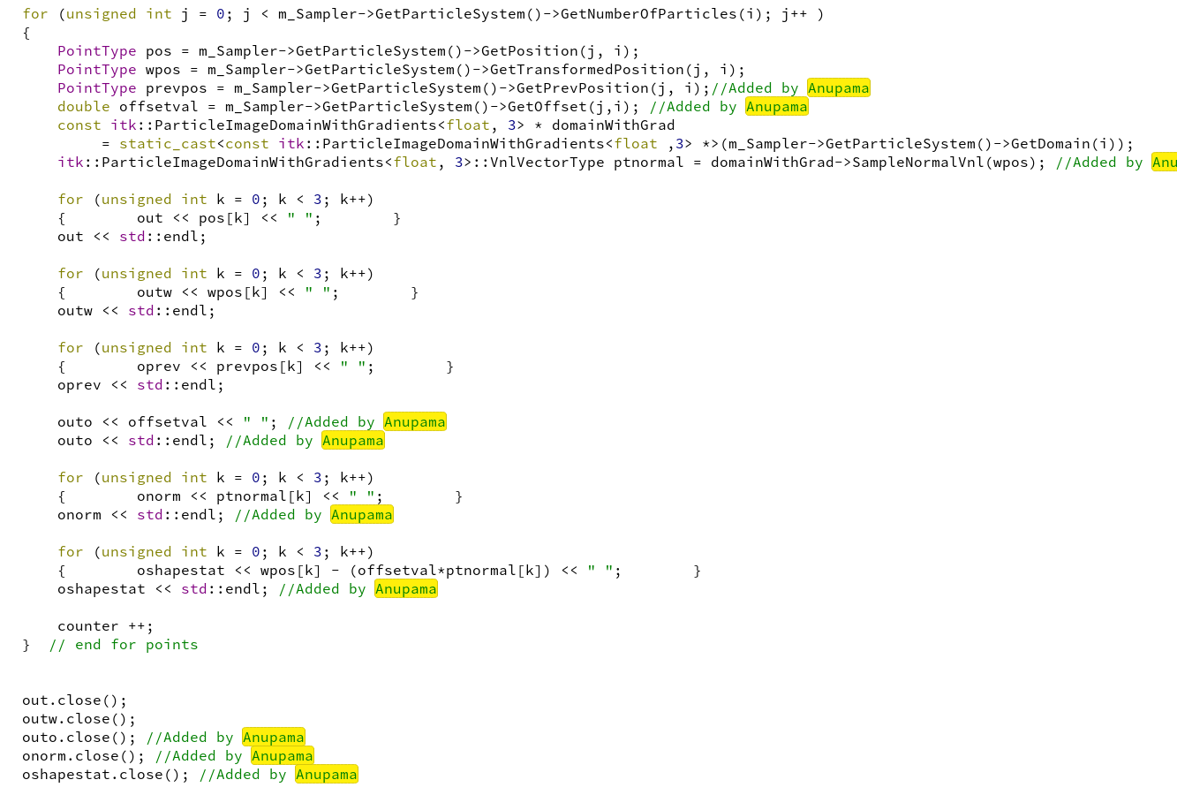
itkParticleSystem.h

5) Offsets, previous optimization iteration offsets, offsets regularization, previous optimization iteration particle positions data structures declaration.

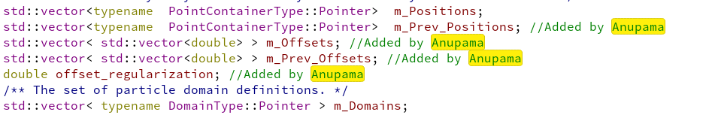
6) New methods added for computations in optimization

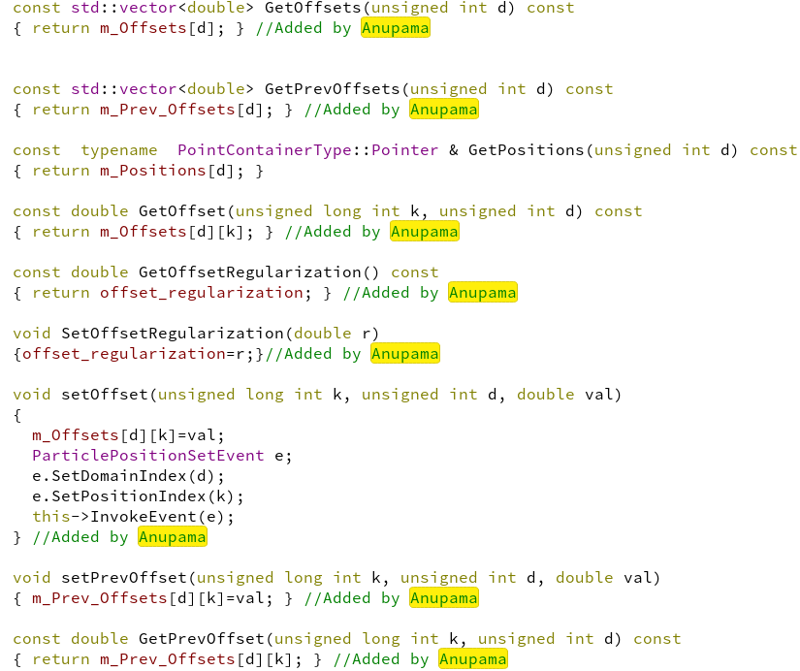
7) Modified existing method AddPosition to take offset as input for particle splitting purposes

itkParticleSystem.txx

8) SetNumberOfDomains method – initalize the offsets, previous offsets and previous particle positions are per the number of input domains

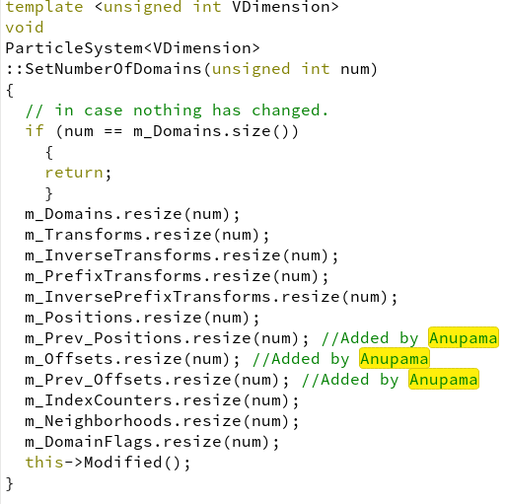

9) ParticleSystem methods changed to incorporate the offset changes

AddPosition: Takes in the offset when adding the positions. Previous positions are initialized to the positions

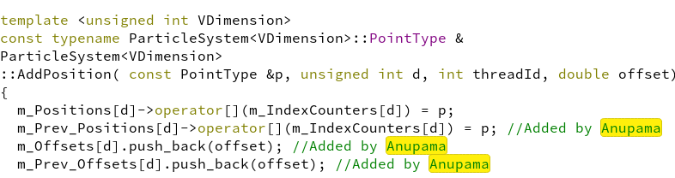

SetPositions: Whenever particle position is set, the previous position is updated to the current position first.

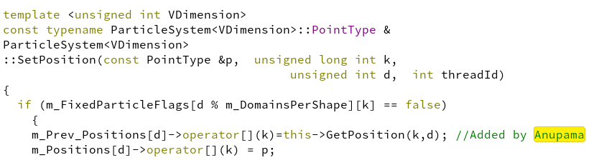
SetPositionUpdatePrev: Created another method that would serve the same purpose of the SetPosition

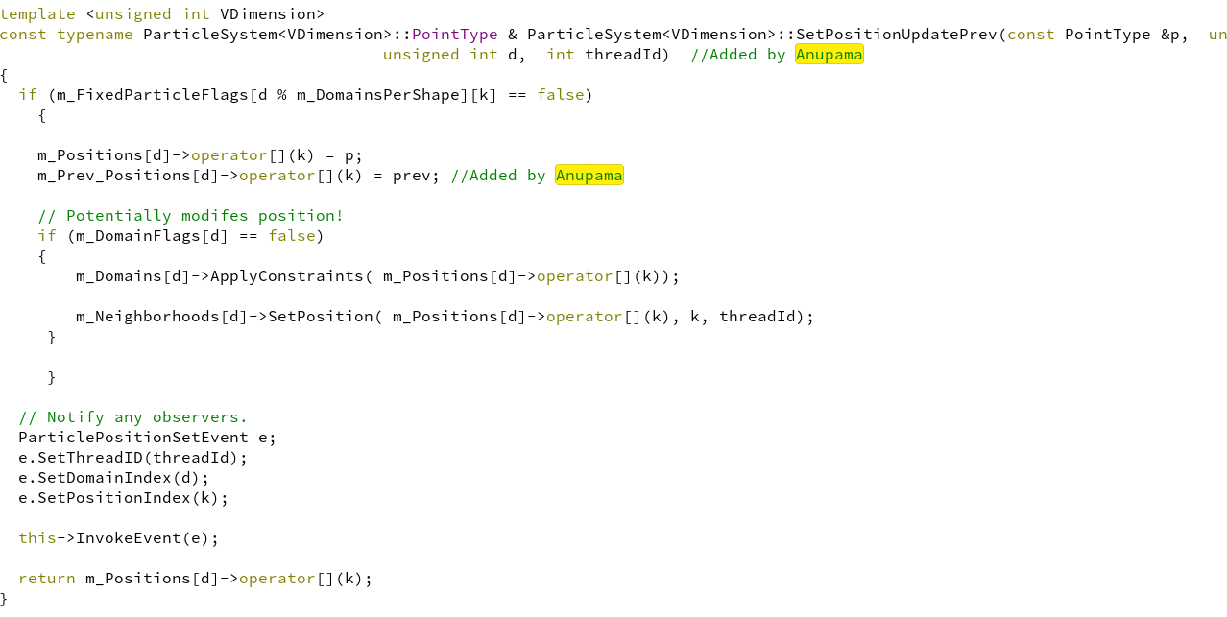
AddPositionList: Modified the method to take the offset values for the case of points and offset values provided as initializations

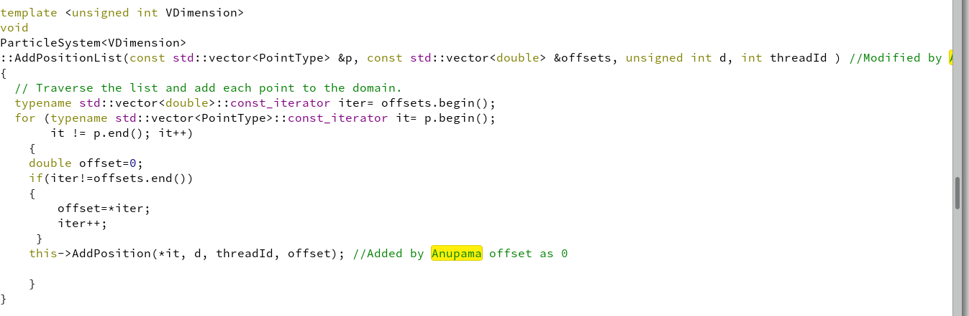
SplitParticle: Method modified to take the offset value from the particle used for splitting

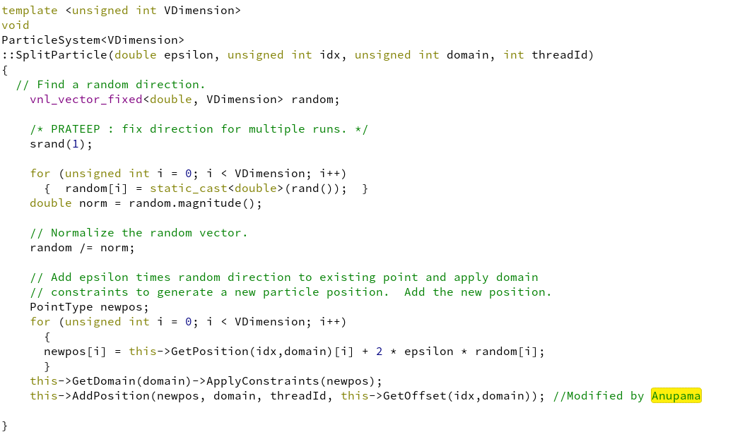

SplitAllParticlesInDomain: This method is used for splitting all the particles. Added logic to take in the offsets

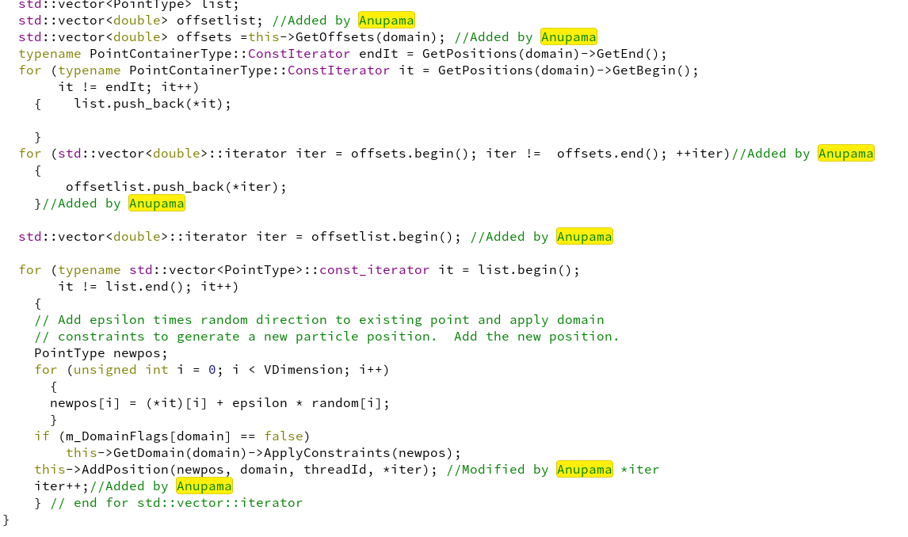
itkParticleGradientDescentOptimizer:

10) StartAdaptiveGaussSeidelOptimization method:

Data structures to maintain the adaptive time step for the offsets

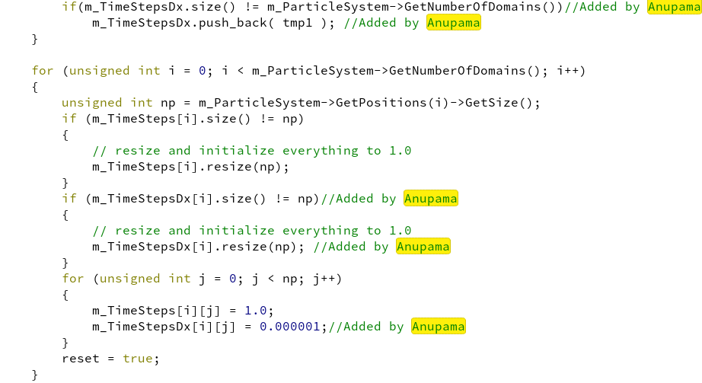
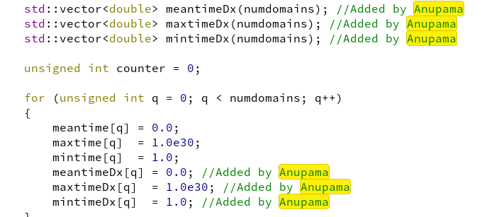

Code below to compute the particle gradient and update:

The logic for the particle position update computations is below:

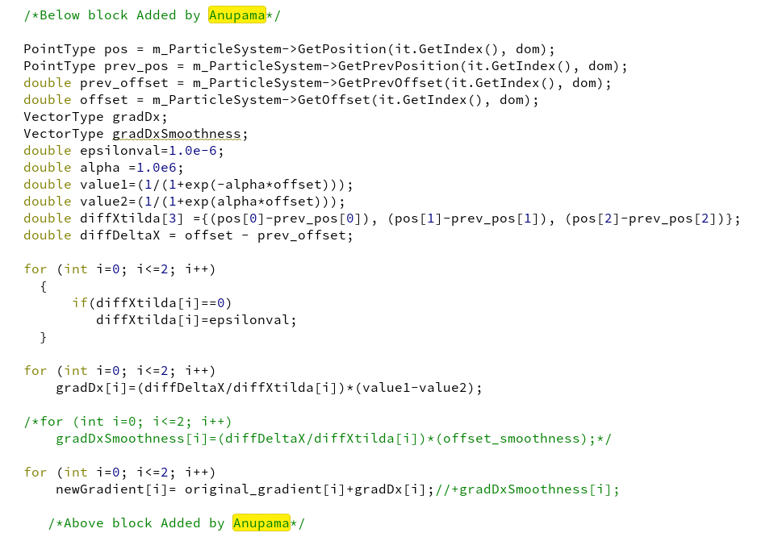
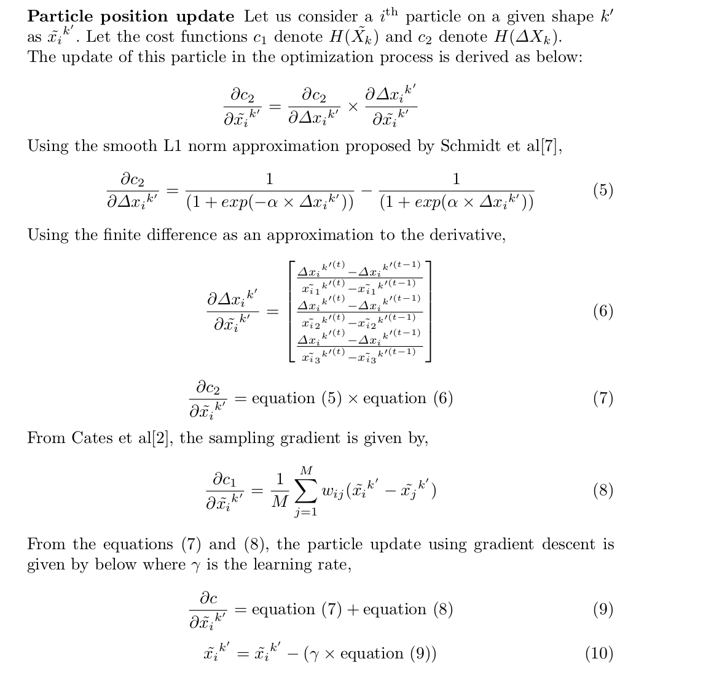

Reverting the positions and offsets when the update is not allowed:

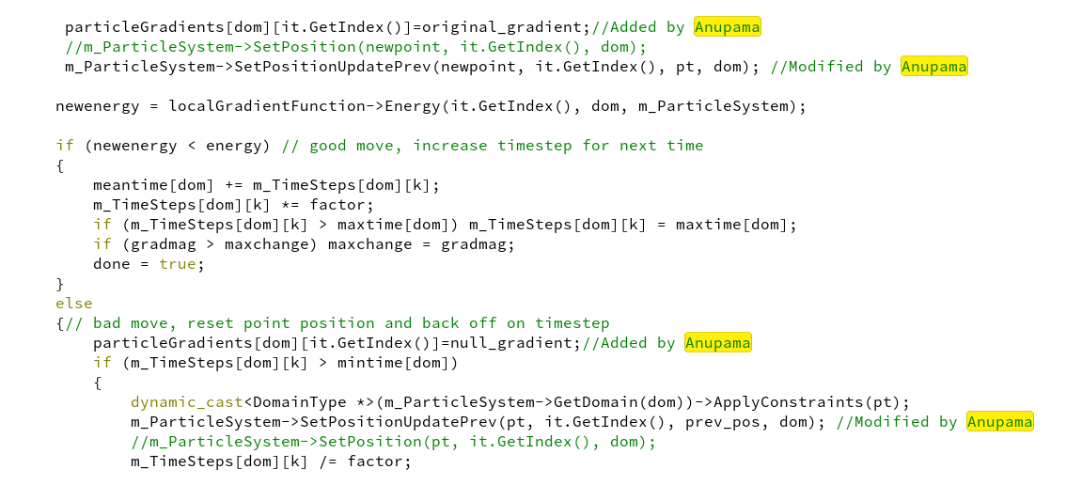

Code below to compute the offset gradient and update:

The logic for the offset update computations is below:

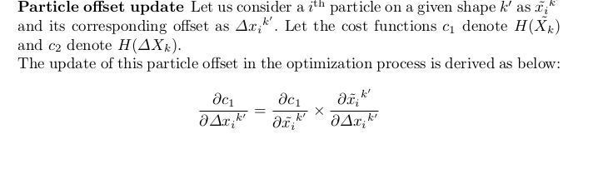

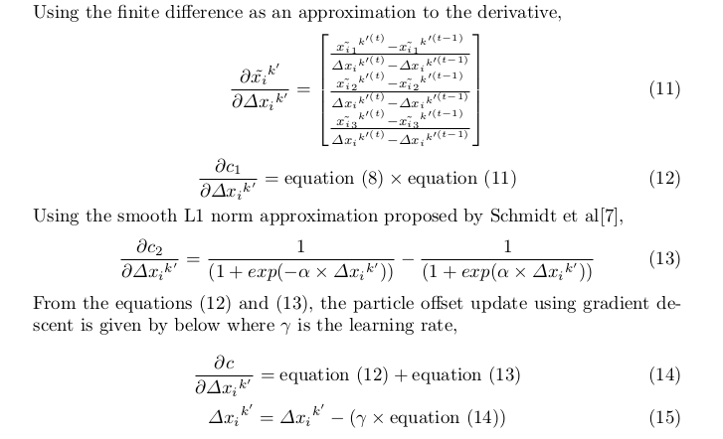

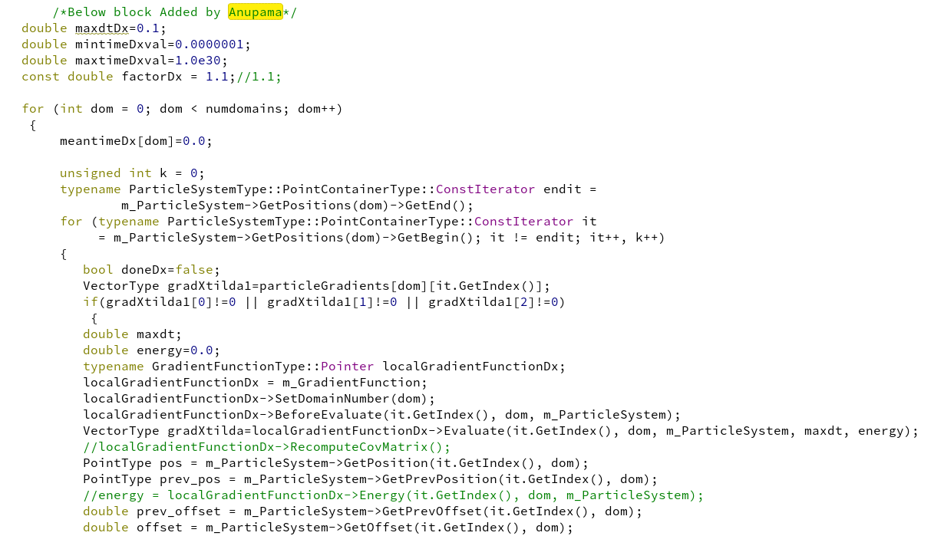
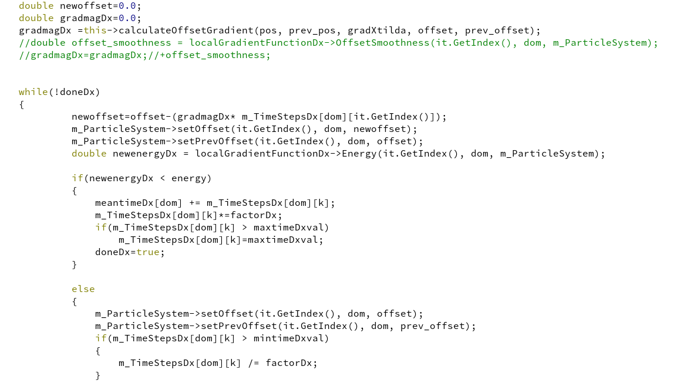

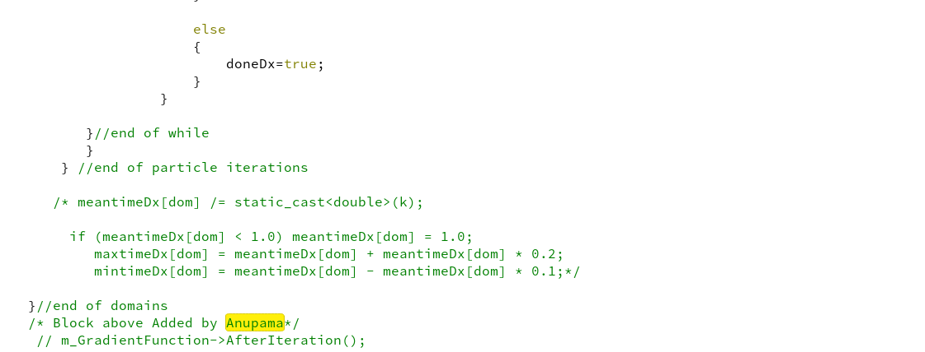

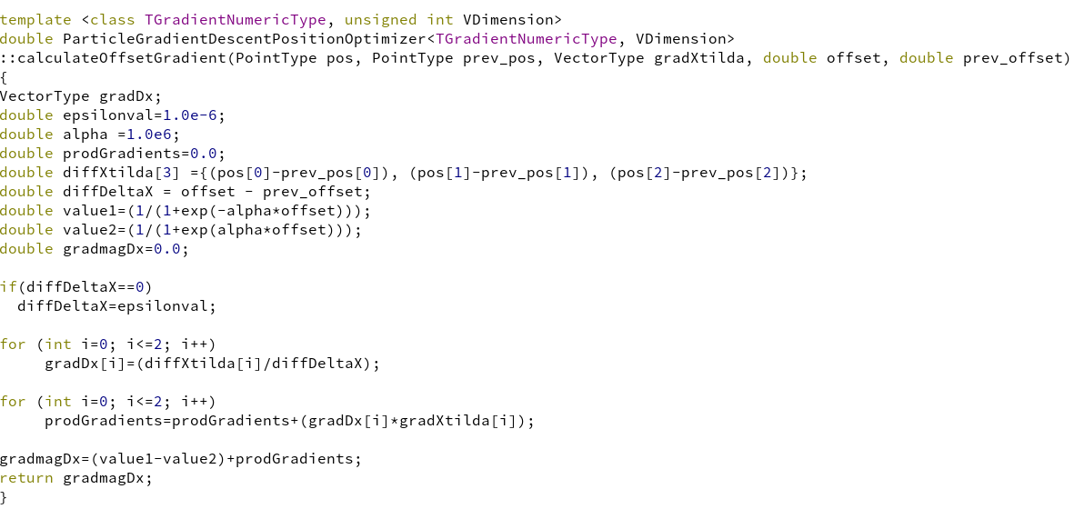

itkParticleCurvatureEntropyGradientFunction.txx

11) Evaluate method: This method evaluates whether the gradient update can be allowed or not. This method is modified as per the new formulation

