DEPARTMENT OF ELECTRONIC AND TELECOMMUNICATION ENGINEERING UNIVERSITY OF MORATUWA

CS2832 – Modular Software Development

**Group Project**

***Name index no***

1. ADHIKARI AMSS 170015P
2. JAYATHILAKE PKGSC 170268R
3. JAYAWEERA WIT 170271U

Contents

1 Introduction 2

2 Requirement specifications 3

• Student 3

• Company 3

• Administrator 3

3 Use case diagrams 4

❖ admin use case diagram 4

❖ company use case diagram 5

❖ student use case diagram 6

4 Architecture Description 7

5 Development Process 8

5.1 Software Packages Used for Implementation 8

5.1.1 Sublime Text Interface 9

5.1.2 Webmin Interface 9

5.2 Hosting and Domain Name 10

5.3 Creating Interfaces 10

5.3.1 Login Interface 10

5.3.2 Signup Interface 11

5.3.3 Administrator Interface 11

5.3.4 Student Interface 11

5.3.5 Company Interface 11

5.4 Creating Database 11

5.5 Backend Programming 12

6 Testing and evolution 14

7 Login Details for User Accounts 14

# Introduction

This is a system which connects undergraduate students and companies who is offering internships . In this software there are three end users.

1. Undergraduate students
2. Companies
3. Administrators

This report describes software process of this software, including requirement specification with use case diagrams, architecture description diagrams and development process of our software.

We have implemented this software using our knowledge of HTML,PHP,CSS ,MySQL.

# Requirement specifications

## Student

* Student should be able to create an account
* Student should be able to edit his profile
* Student should be able to upload his CV to have a better idea about him
* Student should be able to search companies and view their profiles
* Student should be able to apply companies
* Student should be able to accept request from the companies
* Student should be able to change his account’s password

## Company

* Company should be able to create an account
* Company should be able to edit their profile
* Company should be able to show their skill requirements to have an idea about what they need
* Company should be able to search students and view their profiles
* Company should be able to send requests to students
* Company should be able to confirm applied students
* Company should be able to change their account’s password

## Administrator

* There should be a super Admin whose account can’t delete
* Admin should be able to edit his profile
* Admin should be able to add another Admin and edit his profile
* Admin should be able to add another Student and edit his profile but he could not be able to apply companies
* Admin should be able to add another Company and edit their profile but he could not be able to send requests to students
* Admin should be able to search students and view their profiles
* Admin should be able to search companies and view their profiles
* Admin should be able to change their account’s password

# Use case diagrams

## A picture containing text, map Description automatically generatedadmin use case diagram

## company use case diagram

## student use case diagram

# Architecture Description

For this website we used layered architecture. Following diagram will describe the architecture

# Development Process

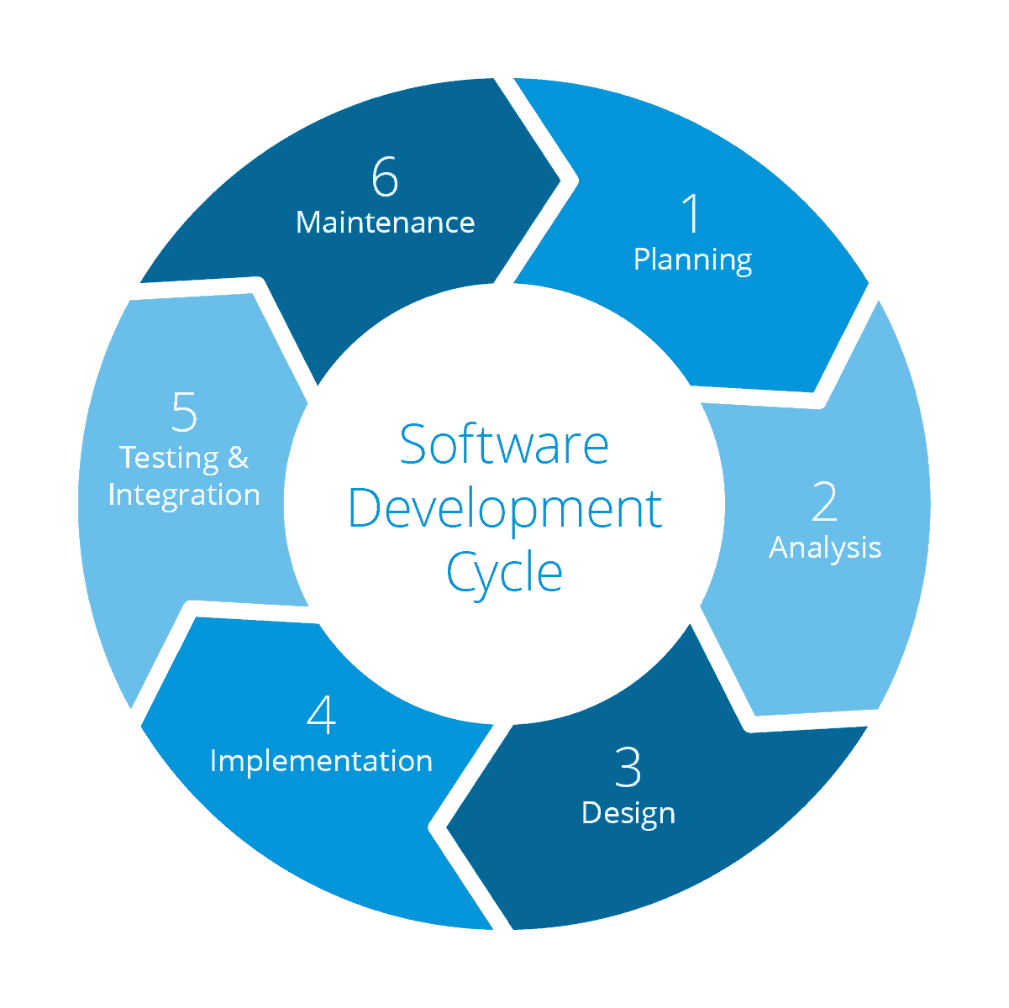We have identified that the most suitable development method for our project is “Agile Development”. That is because we had a tight schedule to plan, implement and test.

## 5.1 Software Packages Used for Implementation

|  |  |
| --- | --- |
| **Software** | **Purpose** |
| Sublime Text, VS Code | Text editor |
| WAMP | Managing local server |
| GIT Desktop | Managing repositories |
| WebMin | Host server management (GUI) |
| Microsoft Edge, Google Chrome | Web browser |
| FileZilla | FTP control to host |
| PuTTY | Host server management (CLI) |
|  |  |

### A screenshot of a computer screen Description automatically generated5.1.1 Sublime Text Interface

### 5.1.2 Webmin Interface

## 5.2 Hosting and Domain Name

We have obtained the domain name “internspaths.ml” for free for 1 year of period from [www.freenom.com](http://www.freenom.com). Hosting is achieved by AWS Educate as we can have a student account for our university email address.

In AWS educate EC2 console we created an ubuntu instance as our virtual server. Elastic IP that have been allocate for our server is 52.86.141.54.

## 5.3 Creating Interfaces

All the web interfaces are created using HTML, CSS, JavaScript to have the required design for us. Some of the online available templates were referred in order to have a good design.

### 5.3.1 Login Interface

Login interface is common for all type of users (Students, Company, Administrators). Server will identify the user type and redirect the user to the correct console. Login interface is the first thing a visitor sees when comes to the website. If he/she is a new user, then they can click “Sign up now” to create a new account as a Student or a Company. New administrator can only be added by an admin. If any user forgot their password, they could reset their password by giving required credentials.

### A close up of a flower Description automatically generated5.3.2 Signup Interface

New users can create their account here as Students or Companies. Form data validation is done in the backend using PHP.

### 5.3.3 Administrator Interface

Home page of the administrator console contains count of each type of users. Administrators can manage student, company and administrator data tables. He/ She can add new users, edit user profiles, delete accounts & reset user passwords. How ever we decide to restrict the administrator from manipulating Company – Student relationships.

### 

### 5.3.4 Student Interface

Student can maintain their own profile and include their CV to it. They can view the list of companies, filter them according to their needs, view company details and then then can apply for internships in a company. Also, students are allowed to accept internship invitations.

### 5.3.5 Company Interface

## 5.4 Creating Database

We created SQL databases using phpMyAdmin. Our database name is logindetails and it contains four tables named as users, admin, student and company.

## 5.5 Backend Programming

Backend of the system is programmed using php. We followed some tutorials on w3schools to have enough knowledge to implement the backend of the system.

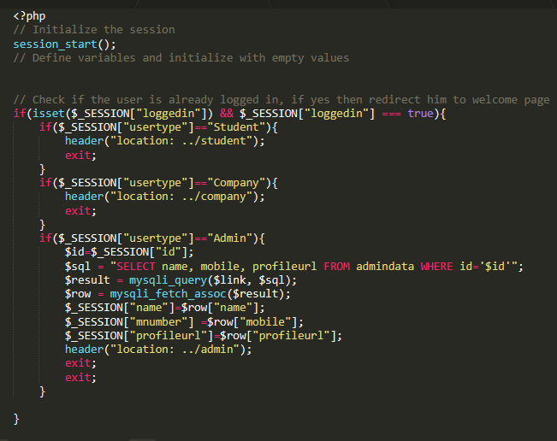

# Testing and evolution

We developed this website using agile development process. It means that this system was developed step by step. We tested each unit while developing (unit testing). if there were errors, we had to repeat the developing process for regarding unit. When we completed the unit testing, we focused on testing the whole system.

To execute the system testing process, we tested our system on sample users. Then we changed our system according to their feedback.

# Login Details for User Accounts

|  |  |  |  |
| --- | --- | --- | --- |
| Username | User Type | Email | Password |
| SuperAdmin | Admin | [sadmin@internspaths.ml](mailto:sadmin@internspaths.ml) | admin@Internspaths |
| Shamal | Admin | [shamalchamara@gmail.com](mailto:shamalchamara@gmail.com) | SCJ@1996 |
| Chamara | Student | [chamara@internspaths.ml](mailto:chamara@internspaths.ml) | Chamara@Internspaths |
| ParaqumTech | Company | [paraqum@internspaths.ml](mailto:paraqum@internspaths.ml) | Paraqumtech@Internspaths |
| MITesp | Company | [Mitesp@internspaths.ml](mailto:Mitesp@internspaths.ml) | Mitesp@Internspaths |
| Shehan Sandeepa | Student | Adhikarishehan100@gmail.com | 9725@Shehan |
| Esol | Company | keerthi@effectivesolutions.com | Esol@internpaths |
| Shehan Adhikari | Admin | shehanadhikari@gmail.com | shehan@intern |
| Isuru_Jayaweera | Student | [itjayaweera@gmail.com](mailto:itjayaweera@gmail.com) | Isuru@1234 |
| Aptinex | Company | info@aptinex.com | Aptinex@1234 |
| Isuru | Admin | isuru@internspaths | Isuru@1234 |

URL – <http://www.internspaths.ml>