

**本科实验报告**

|  |  |
| --- | --- |
| 课程名称： | 计算机体系结构 |
| 姓 名： | 蔡武威 |
| 学 院： | 计算机科学与技术学院 |
| 系： | 计算机科学与技术系 |
| 专 业： | 计算机科学与技术 |
| 学 号： | 3130101796 |
| 指导教师： | 姜晓红 |

2016 年 4月 18日

**浙江大学实验报告**

课程名称： 计算机体系结构 实验类型： 综合

实验项目名称： Lab2

学生姓名： 蔡武威 专业： 计算机科学与技术 学号： 3130101796

同组学生姓名： None 指导老师： 姜晓红

实验地点： 曹二期301 实验日期： 2016 年 4 月 18 日

1. 实验目的和要求
2. Experiment Purpose

* Understand the principles of Pipelined CPU
* Understand the basic units of Pipelined CPU
* Understand the working flow of 5-stages
* Master the method of simple Pipelined CPU
* Master the method of Pipelined CPU Stalls Detection and Stall the Pipeline
* Master methods of program verification of simple Pipelined CPU

1. Experiment Task and Requirements

* Design the CPU Controller, and the Datapath of 5-stages Pipelined CPU
* 5 Stages
* Register File
* Memory(Instruction and Data)
* Other basic units
* Implementing “stall” when have hazards
* Verify the Pipelined CPU with program and observe the execution of program

1. 实验内容和原理

* The Verilog code can be divided into the following modules:

1. mips_top: The top module of the whole project.
2. clk_gen: To generate different clocks.
3. anti_jitter: To avoid the jitter of the button.
4. display: To display some information, includeing instruction address, instruction code..
5. mips: The main module to implement a MIPS CPU, which has also some sub-module, such as mips_core, datapath, inst_rom, data_ram. Also, the datapath module has sub-module named regfile and alu.

* The circuit graph is shown as following:



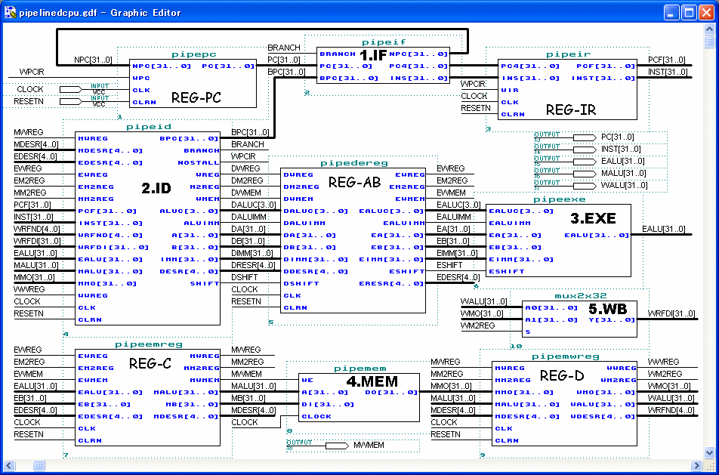

* Control signals:

Here we define the following control signals:

1. For PC source(which is the next PC):

PC_NEXT: no jump and branch, the next PC is just PC+4

PC_JUMP: used when the instruction is j or jal

PC_JR: used when the instruction is jr

PC_BEQ: used when the instruction is beq

PC_BNE: used when the instruction is bne

1. For ALU A source(the input a of ALU):

A_RS: come from rs of the instruction

A_SA: come from sa of the instruction

A_LINK: used when the instruction is jal

A_BRANCH: used when the instruction is beq or bne

1. For ALU B source(the input b of ALU):

B_RT: come from rt of the instruction

B_IMM: come from imm of the instruction

B_LINK: used when the instruction is jal

B_BRANCH: used when the instruction is beq or bne

1. For ALU operation: ALU_ADD, ALU_SUB, ALU_SLT, ALU_LUI, ALU_AND, ALU_OR, ALU_SR
2. For WB(write back) address source

WB_ADDR_RD: to rd of the instruction

WB_ADDR_RT: to rt of the instruction

WB_ADDR_LINK: used when the instruction is jal

1. For WB data source

WB_DATA_ALU: from ALU result

WB_ADDR_MEM: from memory

1. Imm_ext: Imm_ext=1 when the immediate of the instruction should be sign-extension
2. Mem_ren: memory read enable
3. Mem_wen: memory write enable
4. WB_wen:write back enable
5. Rs_used: equals 1 when rs is used, otherwise equals 0
6. Rt_used: equals 1 when rt is used, otherwise equals 0

The following is the table which describes the control signal of each instruction:

|  |  |  |  |  |  |  |
| --- | --- | --- | --- | --- | --- | --- |
| Instruction | add | sub | and | or | slt | srl |
| PC source | PC_NEXT | PC_NEXT | PC_NEXT | PC_NEXT | PC_NEXT | PC_NEXT |
| ALU A source | A_RS | A_RS | A_RS | A_RS | A_RS | A_RS |
| ALU B source | B_RT | B_RT | B_RT | B_RT | B_RT | B_RT |
| ALU operation | ALU_ADD | ALU_SUB | ALU_AND | ALU_OR | ALU_SLT | ALU_SR |
| WB address source | WB_ADDR_RD | WB_ADDR_RD | WB_ADDR_RD | WB_ADDR_RD | WB_ADDR_RD | WB_ADDR_RD |
| WB data source | WB_DATA_ALU | WB_DATA_ALU | WB_DATA_ALU | WB_DATA_ALU | WB_DATA_ALU | WB_DATA_ALU |
| Imm_ext | 0 | 0 | 0 | 0 | 0 | 0 |
| Mem_ren | 0 | 0 | 0 | 0 | 0 | 0 |
| Mem_wen | 0 | 0 | 0 | 0 | 0 | 0 |
| WB_wen | 1 | 1 | 1 | 1 | 1 | 1 |
| Rs_used | 1 | 1 | 1 | 1 | 1 | 0 |
| Rt_used | 1 | 1 | 1 | 1 | 1 | 1 |

|  |  |  |  |  |  |  |
| --- | --- | --- | --- | --- | --- | --- |
| Instruction | jr | j | jal | beq | bne | addi |
| PC source | PC_JR | PC_J | PC_J | PC_BEQ | PC_BNE | PC_NEXT |
| ALU A source | / | / | A_LINK | A_BRANCH | A_ BRANCH | A_RS |
| ALU B source | / | / | A_LINK | B_ BRANCH | B_ BRANCH | B_IMM |
| ALU operation | / | / | ALU_ADD | ALU_SUB | ALU_SUB | ALU_ADD |
| WB address source | / | / | WB_ADDR_LINK | WB_ADDR_RD | WB_ADDR_RD | WB_ADDR_RT |
| WB data source | / | / | WB_DATA_ALU | WB_DATA_ALU | WB_DATA_ALU | WB_DATA_ALU |
| Imm_ext | 0 | 0 | 0 | 1 | 1 | 1 |
| Mem_ren | 0 | 0 | 0 | 0 | 0 | 0 |
| Mem_wen | 0 | 0 | 0 | 0 | 0 | 0 |
| WB_wen | 0 | 0 | 1 | 0 | 0 | 1 |
| Rs_used | 1 | 0 | 0 | 1 | 1 | 1 |
| Rt_used | 0 | 0 | 0 | 1 | 1 | 0 |

|  |  |  |  |  |  |  |
| --- | --- | --- | --- | --- | --- | --- |
| Instruction | andi | ori | slti | Lw | sw | lui |
| PC source | PC_NEXT | PC_NEXT | PC_NEXT | PC_NEXT | PC_NEXT | PC_NEXT |
| ALU A source | A_RS | A_RS | A_RS | A_RS | A_RS | A_RS |
| ALU B source | B_IMM | B_IMM | B_IMM | B_IMM | B_IMM | B_IMM |
| ALU operation | ALU_AND | ALU_OR | ALU_SLT | ALU_ADD | ALU_ADD | ALU_LUI |
| WB address source | WB_ADDR_RT | WB_ADDR_RT | WB_ADDR_RT | WB_ADDR_RT | / | WB_ADDR_RT |
| WB data source | WB_DATA_ALU | WB_DATA_ALU | WB_DATA_ALU | WB_DATA_MEM | / | WB_DATA_ALU |
| Imm_ext | 0 | 0 | 1 | 1 | 1 | 1 |
| Mem_ren | 0 | 0 | 0 | 1 | 0 | 0 |
| Mem_wen | 0 | 0 | 0 | 0 | 1 | 0 |
| WB_wen | 1 | 1 | 1 | 1 | 0 | 1 |
| Rs_used | 1 | 1 | 1 | 1 | 1 | 0 |
| Rt_used | 0 | 0 | 0 | 0 | 1 |  |

* Key code segment

1. Controller module

module controller (/*AUTOARG*/

input wire clk, // main clock

input wire rst, // synchronous reset

// debug

`ifdef DEBUG

input wire debug_en, // debug enable

input wire debug_step, // debug step clock

`endif

// instruction decode

input wire [31:0] inst, // instruction

input wire is_branch_exe, // whether instruction in EXE stage is jump/branch instruction

input wire [4:0] regw_addr_exe, // register write address from EXE stage

input wire wb_wen_exe, // register write enable signal feedback from EXE stage

input wire is_branch_mem, // whether instruction in MEM stage is jump/branch instruction

input wire [4:0] regw_addr_mem, // register write address from MEM stage

input wire wb_wen_mem, // register write enable signal feedback from MEM stage

output reg [2:0] pc_src, // how would PC change to next

output reg imm_ext, // whether using sign extended to immediate data

output reg [1:0] exe_a_src, // data source of operand A for ALU

output reg [1:0] exe_b_src, // data source of operand B for ALU

output reg [3:0] exe_alu_oper, // ALU operation type

output reg mem_ren, // memory read enable signal

output reg mem_wen, // memory write enable signal

output reg [1:0] wb_addr_src, // address source to write data back to registers

output reg wb_data_src, // data source of data being written back to registers

output reg wb_wen, // register write enable signal

output reg unrecognized, // whether current instruction can not be recognized

// pipeline control

output reg if_rst, // stage reset signal

output reg if_en, // stage enable signal

input wire if_valid, // stage valid flag

output reg id_rst,

output reg id_en,

input wire id_valid,

output reg exe_rst,

output reg exe_en,

input wire exe_valid,

output reg mem_rst,

output reg mem_en,

input wire mem_valid,

output reg wb_rst,

output reg wb_en,

input wire wb_valid

);

`include "mips_define.vh"

// instruction decode

reg rs_used, rt_used;

always @(*) begin

pc_src = PC_NEXT;

imm_ext = 0;

exe_a_src = EXE_A_RS;

exe_b_src = EXE_B_RT;

exe_alu_oper = EXE_ALU_ADD;

mem_ren = 0;

mem_wen = 0;

wb_addr_src = WB_ADDR_RD;

wb_data_src = WB_DATA_ALU;

wb_wen = 0;

rs_used = 0;

rt_used = 0;

unrecognized = 0;

case (inst[31:26])

INST_R: begin

case (inst[5:0])

R_FUNC_JR: begin

pc_src = PC_JR;

rs_used = 1;

end

R_FUNC_ADD: begin

exe_alu_oper = EXE_ALU_ADD;

wb_addr_src = WB_ADDR_RD;

wb_data_src = WB_DATA_ALU;

wb_wen = 1;

rs_used = 1;

rt_used = 1;

end

R_FUNC_SUB: begin

exe_alu_oper = EXE_ALU_SUB;

wb_addr_src = WB_ADDR_RD;

wb_data_src = WB_DATA_ALU;

wb_wen = 1;

rs_used = 1;

rt_used = 1;

end

R_FUNC_AND: begin

exe_alu_oper = EXE_ALU_AND;

wb_addr_src = WB_ADDR_RD;

wb_data_src = WB_DATA_ALU;

wb_wen = 1;

rs_used = 1;

rt_used = 1;

end

R_FUNC_OR: begin

exe_alu_oper = EXE_ALU_OR;

wb_addr_src = WB_ADDR_RD;

wb_data_src = WB_DATA_ALU;

wb_wen = 1;

rs_used = 1;

rt_used = 1;

end

R_FUNC_SLT: begin

exe_alu_oper = EXE_ALU_SLT;

wb_addr_src = WB_ADDR_RD;

wb_data_src = WB_DATA_ALU;

wb_wen = 1;

rs_used = 1;

rt_used = 1;

end

default: begin

unrecognized = 1;

end

endcase

end

INST_J: begin

pc_src = PC_JUMP;

end

INST_JAL: begin

pc_src = PC_JUMP;

exe_a_src = EXE_A_LINK;

exe_b_src = EXE_B_LINK;

exe_alu_oper = EXE_ALU_ADD;

wb_addr_src = WB_ADDR_LINK;

wb_data_src = WB_DATA_ALU;

wb_wen = 1;

end

INST_BEQ: begin

pc_src = PC_BEQ;

exe_a_src = EXE_A_BRANCH;

exe_b_src = EXE_A_BRANCH;

exe_alu_oper = EXE_ALU_ADD;

imm_ext = 1;

rs_used = 1;

rt_used = 1;

end

INST_BNE: begin

pc_src = PC_BNE;

exe_a_src = EXE_A_BRANCH;

exe_b_src = EXE_A_BRANCH;

exe_alu_oper = EXE_ALU_ADD;

imm_ext = 1;

rs_used = 1;

rt_used = 1;

end

INST_ADDI: begin

imm_ext = 1;

exe_b_src = EXE_B_IMM;

exe_alu_oper = EXE_ALU_ADD;

wb_addr_src = WB_ADDR_RT;

wb_data_src = WB_DATA_ALU;

wb_wen = 1;

rs_used = 1;

end

INST_ANDI: begin

imm_ext = 0;

exe_b_src = EXE_B_IMM;

exe_alu_oper = EXE_ALU_AND;

wb_addr_src = WB_ADDR_RT;

wb_data_src = WB_DATA_ALU;

wb_wen = 1;

rs_used = 1;

end

INST_ORI: begin

imm_ext = 0;

exe_b_src = EXE_B_IMM;

exe_alu_oper = EXE_ALU_OR;

wb_addr_src = WB_ADDR_RT;

wb_data_src = WB_DATA_ALU;

wb_wen = 1;

rs_used = 1;

end

INST_LW: begin

imm_ext = 1;

exe_a_src = EXE_A_RS;

exe_b_src = EXE_B_IMM;

exe_alu_oper = EXE_ALU_ADD;

mem_ren = 1;

wb_addr_src = WB_ADDR_RT;

wb_data_src = WB_DATA_MEM;

wb_wen = 1;

rs_used = 1;

end

INST_SW: begin

imm_ext = 1;

exe_a_src = EXE_A_RS;

exe_b_src = EXE_B_IMM;

exe_alu_oper = EXE_ALU_ADD;

mem_wen = 1;

rs_used = 1;

rt_used = 1;

end

default: begin

unrecognized = 1;

end

endcase

end

// pipeline control

reg reg_stall;

reg branch_stall;

wire [4:0] addr_rs, addr_rt;

assign

addr_rs = inst[25:21],

addr_rt = inst[20:16];

always @(*) begin

reg_stall = 0;

if (rs_used && addr_rs != 0) begin

if (regw_addr_exe == addr_rs && wb_wen_exe) begin

reg_stall = 1;

end

else if (regw_addr_mem == addr_rs && wb_wen_mem) begin

reg_stall = 1;

end

end

if (rt_used && addr_rt != 0) begin

if (regw_addr_exe == addr_rt && wb_wen_exe) begin

reg_stall = 1;

end

else if (regw_addr_mem == addr_rt && wb_wen_mem) begin

reg_stall = 1;

end

end

end

always @(*) begin

branch_stall = 0;

if (pc_src != PC_NEXT || is_branch_exe || is_branch_mem)

branch_stall = 1;

end

`ifdef DEBUG

reg debug_step_prev;

always @(posedge clk) begin

debug_step_prev <= debug_step;

end

`endif

always @(*) begin

if_rst = 0;

if_en = 1;

id_rst = 0;

id_en = 1;

exe_rst = 0;

exe_en = 1;

mem_rst = 0;

mem_en = 1;

wb_rst = 0;

wb_en = 1;

if (rst) begin

if_rst = 1;

id_rst = 1;

exe_rst = 1;

mem_rst = 1;

wb_rst = 1;

end

`ifdef DEBUG

// suspend and step execution

else if ((debug_en) && ~(~debug_step_prev && debug_step)) begin

if_en = 0;

id_en = 0;

exe_en = 0;

mem_en = 0;

wb_en = 0;

end

`endif

// this stall indicate that ID is waiting for previous instruction, should insert NOPs between ID and EXE.

else if (reg_stall) begin

if_en = 0;

id_en = 0;

exe_rst = 1;

end

// this stall indicate that a jump/branch instruction is running, so that 3 NOP should be inserted between IF and ID

else if (branch_stall) begin

id_rst = 1;

end

end

endmodule

1. Datapath module

module datapath (

input wire clk, // main clock

// debug

`ifdef DEBUG

input wire [5:0] debug_addr, // debug address

output wire [31:0] debug_data, // debug data

`endif

// control signals

output reg [31:0] inst_data_id, // instruction

output reg is_branch_exe, // whether instruction in EXE stage is jump/branch instruction

output reg [4:0] regw_addr_exe, // register write address from EXE stage

output reg wb_wen_exe, // register write enable signal feedback from EXE stage

output reg is_branch_mem, // whether instruction in MEM stage is jump/branch instruction

output reg [4:0] regw_addr_mem, // register write address from MEM stage

output reg wb_wen_mem, // register write enable signal feedback from MEM stage

input wire [2:0] pc_src_ctrl, // how would PC change to next

input wire imm_ext_ctrl, // whether using sign extended to immediate data

input wire [1:0] exe_a_src_ctrl, // data source of operand A for ALU

input wire [1:0] exe_b_src_ctrl, // data source of operand B for ALU

input wire [3:0] exe_alu_oper_ctrl, // ALU operation type

input wire mem_ren_ctrl, // memory read enable signal

input wire mem_wen_ctrl, // memory write enable signal

input wire [1:0] wb_addr_src_ctrl, // address source to write data back to registers

input wire wb_data_src_ctrl, // data source of data being written back to registers

input wire wb_wen_ctrl, // register write enable signal

// IF signals

input wire if_rst, // stage reset signal

input wire if_en, // stage enable signal

output reg if_valid, // working flag

output reg inst_ren, // instruction read enable signal

output reg [31:0] inst_addr, // address of instruction needed

input wire [31:0] inst_data, // instruction fetched

// ID signals

input wire id_rst,

input wire id_en,

output reg id_valid,

// EXE signals

input wire exe_rst,

input wire exe_en,

output reg exe_valid,

// MEM signals

input wire mem_rst,

input wire mem_en,

output reg mem_valid,

output wire mem_ren, // memory read enable signal

output wire mem_wen, // memory write enable signal

output wire [31:0] mem_addr, // address of memory

output wire [31:0] mem_dout, // data writing to memory

input wire [31:0] mem_din, // data read from memory

// WB signals

input wire wb_rst,

input wire wb_en,

output reg wb_valid

);

`include "mips_define.vh"

// control signals

reg [2:0] pc_src_exe, pc_src_mem;

reg [1:0] exe_a_src_exe, exe_b_src_exe;

reg [3:0] exe_alu_oper_exe;

reg mem_ren_exe, mem_ren_mem;

reg mem_wen_exe, mem_wen_mem;

reg wb_data_src_exe, wb_data_src_mem, wb_data_src_wb;

// IF signals

wire [31:0] inst_addr_next;

// ID signals

reg [31:0] inst_addr_id;

reg [31:0] inst_addr_next_id;

reg [4:0] regw_addr_id;

wire [4:0] addr_rs, addr_rt, addr_rd;

wire [31:0] data_rs, data_rt, data_imm;

// EXE signals

reg [31:0] inst_addr_exe;

reg [31:0] inst_addr_next_exe;

reg [31:0] inst_data_exe;

reg [31:0] data_rs_exe, data_rt_exe, data_imm_exe;

reg [31:0] opa_exe, opb_exe;

wire [31:0] alu_out_exe;

wire rs_rt_equal_exe;

// MEM signals

reg [31:0] inst_addr_mem;

reg [31:0] inst_addr_next_mem;

reg [31:0] inst_data_mem;

reg [4:0] data_rs_mem;

reg [31:0] data_rt_mem;

reg [31:0] alu_out_mem;

reg [31:0] branch_target_mem;

reg rs_rt_equal_mem;

// WB signals

reg wb_wen_wb;

reg [31:0] alu_out_wb;

reg [31:0] mem_din_wb;

reg [4:0] regw_addr_wb;

reg [31:0] regw_data_wb;

initial begin

pc_src_exe = PC_NEXT;

pc_src_mem = PC_NEXT;

mem_ren_exe = 0;

mem_ren_mem = 0;

mem_wen_exe = 0;

mem_wen_mem = 0;

is_branch_exe = 0; // whether instruction in EXE stage is jump/branch instruction

is_branch_mem = 0; // whether instruction in MEM stage is jump/branch instruction

wb_wen_exe = 0; // register write enable signal feedback from EXE stage

wb_wen_mem = 0; // register write enable signal feedback from MEM stage

wb_wen_wb = 0;

end

// debug

`ifdef DEBUG

wire [31:0] debug_data_reg;

reg [31:0] debug_data_signal;

always @(posedge clk) begin

case (debug_addr[4:0])

0: debug_data_signal <= inst_addr;

1: debug_data_signal <= inst_data;

2: debug_data_signal <= inst_addr_id;

3: debug_data_signal <= inst_data_id;

4: debug_data_signal <= inst_addr_exe;

5: debug_data_signal <= inst_data_exe;

6: debug_data_signal <= inst_addr_mem;

7: debug_data_signal <= inst_data_mem;

8: debug_data_signal <= {27'b0, addr_rs};

9: debug_data_signal <= data_rs;

10: debug_data_signal <= {27'b0, addr_rt};

11: debug_data_signal <= data_rt;

12: debug_data_signal <= data_imm;

13: debug_data_signal <= opa_exe;

14: debug_data_signal <= opb_exe;

15: debug_data_signal <= alu_out_exe;

16: debug_data_signal <= 0;

17: debug_data_signal <= 0;

18: debug_data_signal <= {19'b0, inst_ren, 7'b0, mem_ren, 3'b0, mem_wen};

19: debug_data_signal <= mem_addr;

20: debug_data_signal <= mem_din;

21: debug_data_signal <= mem_dout;

22: debug_data_signal <= {27'b0, regw_addr_wb};

23: debug_data_signal <= regw_data_wb;

default: debug_data_signal <= 32'hFFFF_FFFF;

endcase

end

assign

debug_data = debug_addr[5] ? debug_data_signal : debug_data_reg;

`endif

// IF stage

assign

inst_addr_next = inst_addr + 4;

always @(*) begin

if_valid = ~if_rst & if_en;

inst_ren = ~if_rst;

end

always @(posedge clk) begin

if (if_rst) begin

inst_addr <= 0;

end

else if (if_en) begin

if (is_branch_mem)

inst_addr <= branch_target_mem;

else

inst_addr <= inst_addr_next;

end

end

// IF/ID

always @(posedge clk) begin

if (id_rst) begin

id_valid <= 0;

inst_addr_id <= 0;

inst_data_id <= 0;

inst_addr_next_id <= 0;

end

else if (id_en) begin

id_valid <= if_valid;

inst_addr_id <= inst_addr;

inst_data_id <= inst_data;

inst_addr_next_id <= inst_addr_next;

end

end

// ID Stage

assign

addr_rs = inst_data_id[25:21],

addr_rt = inst_data_id[20:16],

addr_rd = inst_data_id[15:11],

data_imm = imm_ext_ctrl ? {{16{inst_data_id[15]}}, inst_data_id[15:0]} : {16'b0, inst_data_id[15:0]};

always @(*) begin

regw_addr_id = inst_data_id[15:11];

case (wb_addr_src_ctrl)

WB_ADDR_RD: regw_addr_id = addr_rd;

WB_ADDR_RT: regw_addr_id = addr_rt;

WB_ADDR_LINK: regw_addr_id = 32'h31;

endcase

end

regfile REGFILE (

.clk(clk),

`ifdef DEBUG

.debug_addr(debug_addr[4:0]),

.debug_data(debug_data_reg),

`endif

.addr_a(addr_rs),

.data_a(data_rs),

.addr_b(addr_rt),

.data_b(data_rt),

.en_w(wb_wen_wb),

.addr_w(regw_addr_wb),

.data_w(regw_data_wb)

);

// ID/EXE

always @(posedge clk) begin

if (exe_rst) begin

exe_valid <= 0;

inst_addr_exe <= 0;

inst_data_exe <= 0;

inst_addr_next_exe <= 0;

regw_addr_exe <= 0;

pc_src_exe <= 0;

exe_a_src_exe <= 0;

exe_b_src_exe <= 0;

data_rs_exe <= 0;

data_rt_exe <= 0;

data_imm_exe <= 0;

exe_alu_oper_exe <= 0;

mem_ren_exe <= 0;

mem_wen_exe <= 0;

wb_data_src_exe <= 0;

wb_wen_exe <= 0;

end

else if (exe_en) begin

exe_valid <= id_valid;

inst_addr_exe <= inst_addr_id;

inst_data_exe <= inst_data_id;

inst_addr_next_exe <= inst_addr_next_id;

regw_addr_exe <= regw_addr_id;

pc_src_exe <= pc_src_ctrl;

exe_a_src_exe <= exe_a_src_ctrl;

exe_b_src_exe <= exe_b_src_ctrl;

data_rs_exe <= data_rs;

data_rt_exe <= data_rt;

data_imm_exe <= data_imm;

exe_alu_oper_exe <= exe_alu_oper_ctrl;

mem_ren_exe <= mem_ren_ctrl;

mem_wen_exe <= mem_wen_ctrl;

wb_data_src_exe <= wb_data_src_ctrl;

wb_wen_exe <= wb_wen_ctrl;

end

end

// EXE Stage

always @(*) begin

is_branch_exe <= (pc_src_exe != PC_NEXT);

end

assign

rs_rt_equal_exe = (data_rs_exe == data_rt_exe);

always @(*) begin

opa_exe = data_rs_exe;

opb_exe = data_rt_exe;

case (exe_a_src_exe)

EXE_A_RS: opa_exe = data_rs_exe;

EXE_A_LINK: opa_exe = 0;

EXE_A_BRANCH: opa_exe = inst_addr_next_exe;

endcase

case (exe_b_src_exe)

EXE_B_RT: opb_exe = data_rt_exe;

EXE_B_IMM: opb_exe = data_imm_exe;

EXE_B_LINK: opb_exe = inst_addr_next_exe; // linked address is the next one of current instruction

EXE_B_BRANCH: opb_exe = {data_imm_exe[29:0],2'b00};

endcase

end

alu ALU (

.a(opa_exe),

.b(opb_exe),

.oper(exe_alu_oper_exe),

.result(alu_out_exe)

);

// EX/MEM

always @(posedge clk) begin

if (mem_rst) begin

mem_valid <= 0;

pc_src_mem <= 0;

inst_addr_mem <= 0;

inst_data_mem <= 0;

inst_addr_next_mem <= 0;

regw_addr_mem <= 0;

data_rs_mem <= 0;

data_rt_mem <= 0;

alu_out_mem <= 0;

mem_ren_mem <= 0;

mem_wen_mem <= 0;

wb_data_src_mem <= 0;

wb_wen_mem <= 0;

rs_rt_equal_mem <= 0;

end

else if (mem_en) begin

mem_valid <= exe_valid;

pc_src_mem <= pc_src_exe;

inst_addr_mem <= inst_addr_exe;

inst_data_mem <= inst_data_exe;

inst_addr_next_mem <= inst_addr_next_exe;

regw_addr_mem <= regw_addr_exe;

data_rs_mem <= data_rs_exe;

data_rt_mem <= data_rt_exe;

alu_out_mem <= alu_out_exe;

mem_ren_mem <= mem_ren_exe;

mem_wen_mem <= mem_wen_exe;

wb_data_src_mem <= wb_data_src_exe;

wb_wen_mem <= wb_wen_exe;

rs_rt_equal_mem <= rs_rt_equal_exe;

end

end

// MEM State

always @(*) begin

is_branch_mem <= (pc_src_mem != PC_NEXT);

end

always @(*) begin

case (pc_src_mem)

PC_JUMP: branch_target_mem <= {inst_addr_exe[31:28],inst_data_mem[25:0],2'b00};

PC_JR: branch_target_mem <= data_rs_mem;

PC_BEQ: branch_target_mem <= rs_rt_equal_mem? alu_out_mem : inst_addr_next_mem;

PC_BNE: branch_target_mem <= rs_rt_equal_mem? inst_addr_next_mem : alu_out_mem;

default: branch_target_mem <= inst_addr_next_mem; // will never used

endcase

end

assign

mem_ren = mem_ren_mem,

mem_wen = mem_wen_mem,

mem_addr = alu_out_mem,

mem_dout = data_rt_mem;

// WB/MEM

always @(posedge clk) begin

if (wb_rst) begin

wb_valid <= 0;

wb_wen_wb <= 0;

wb_data_src_wb <= 0;

regw_addr_wb <= 0;

alu_out_wb <= 0;

mem_din_wb <= 0;

end

else if (wb_en) begin

wb_valid <= mem_valid;

wb_wen_wb <= wb_wen_mem;

wb_data_src_wb <= wb_data_src_mem;

regw_addr_wb <= regw_addr_mem;

alu_out_wb <= alu_out_mem;

mem_din_wb <= mem_din;

end

end

//WB Stage

always @(*) begin

regw_data_wb = alu_out_wb;

case (wb_data_src_wb)

WB_DATA_ALU: regw_data_wb = alu_out_wb;

WB_DATA_MEM: regw_data_wb = mem_din_wb;

endcase

end

endmodule

1. 实验过程和数据记录及结果分析
2. Input data sets and output results
   * + Instruction memory

|  |  |  |  |
| --- | --- | --- | --- |
| Line number | Assembly code | Machine code | result |
| 0 | Lw r1, 20(r0) | 8c010014, | R1=4 |
| 1 | Lw r2, 24(r0) | 8c020018 | R2=1 |
| 2 | Add r3,r2,r1 | 00221820 | R3=5 //LW-ALU:forwarding:1 stall |
| 3 | Sub r4,r3,r1 | 00612022 | R4=1 //ALU-ALU |
| 4 | And r5,r3,r1 | 00232824 | R5=4 //no hazards |
| 5 | Or r6,r3,r1 | 00223025 | R6=5 //no hazards |
| 6 | addi r6,r3,4 | 20660004 | r6=9 //no hazards |
| 7 | Add r7, r0, r1 | 00203820 | R7=4 //no hazards |
| 8 | Lw r8,0(r7) | 8ce80000 | R8=8 //ALU-LW |
| 9 | Sw r8,8(r7) | Ace80008 | LW-SW：forwarding to solve |
| 10 | Lw r9, 8(r7) | 8ce90008 | R9=8 |
| 11 | Sw r7, 0(r9) | ad270000 | LW-SW: forwarding:1 stall |
| 12 | Lw r10,0(r9) | 8d2a0000 | r10=4 |
| 13 | Add r10, r1, r1 | 00215020 | R10=8 |
| 14 | Add r11, r2,r2 | 00425820 | R11=2 |
| 15 | Add r10,r1,r2 | 00415020 | R10=5 |
| 16 | Beq r10, r11 ,8 | 10220008 | not taken//ALU-BEQ; branch |
| 17 | Lw r1, 8(r7) | 8ce10008 | R1=8 |
| 18 | Lw r2, 24(r0) | 8c020018 | R2=1 |
| 19 | Add r3,r2,r1Lw r2, 24(r0) | 00221820 | R3=9 //LW-ALU |
| 20 | Sub r4,r3,r1 | 00612022 | R4=1 |
| 21 | Addi r20, r4, 1 | 20940001 | R20=2 //ALU-addi |
| 22 | Ori r20, r4, 1 | 34940001 | R20=1 //no hazards |
| 23 | Bne r1, r2, 4 | 14220004 | taken |
| 24 | Lw r1, (20)r0 | 8c010014 | Not execute |
| 25 | Lw r2, (24)r0 | 8c020018 | R2=1 |
| 26 | Add r3,r2,r1 | 00221820 | R3=9 |
| 27 | Sub r4,r3,r1 | 00412022 | R4=1 |
| 28 | J 0 | 08000000 | j |

* + - Data memory

00000000

00000008

00000000

00000000

00000000

00000004

00000001

1. Screen shots and pictures of the running result on Spartan3E
   * + The left 8 digits of the top is PC and the right 8 digits is the code of the instruction which is in the IF stage. The bottom is some information. In this case, it shows the data in register 0($zero). The following picture is taken when starting.

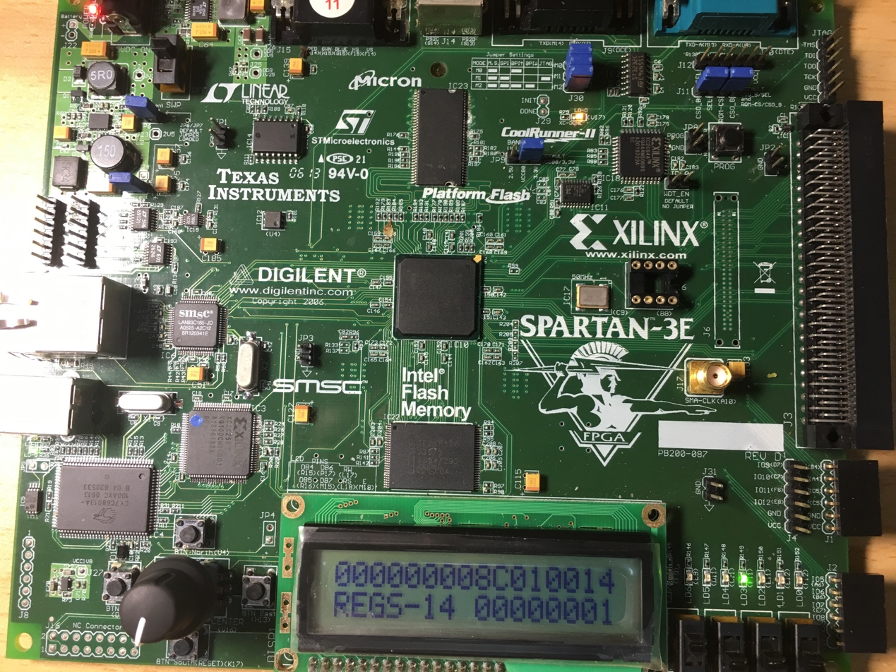

* + - The following is taken when the 4th instruction ”Sub r4, r4, r1” is taken, which will arise a ALU-ALU hazard.

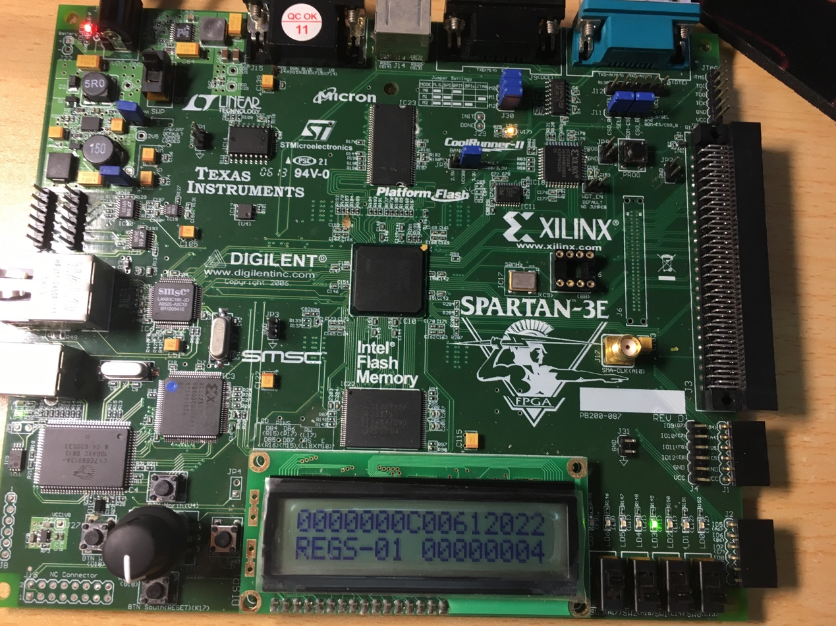

* + - The following is taken when “lw r8,0(r7)” is taken, which will arise a ALU-LW hazard.

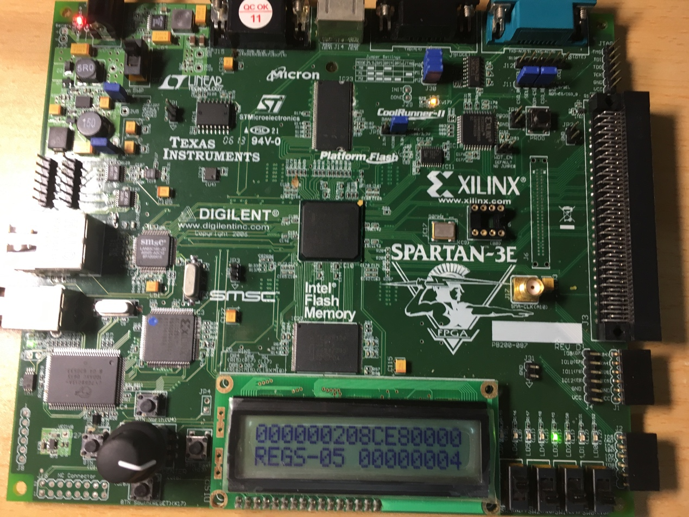

* + - The following pictures are some others taken when execute the testing code.

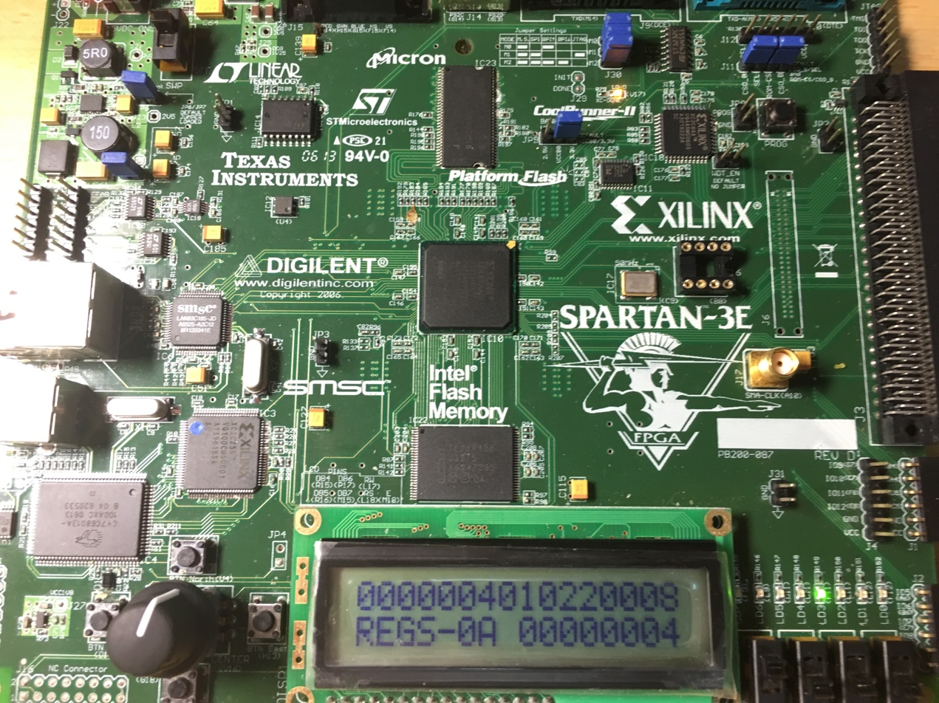

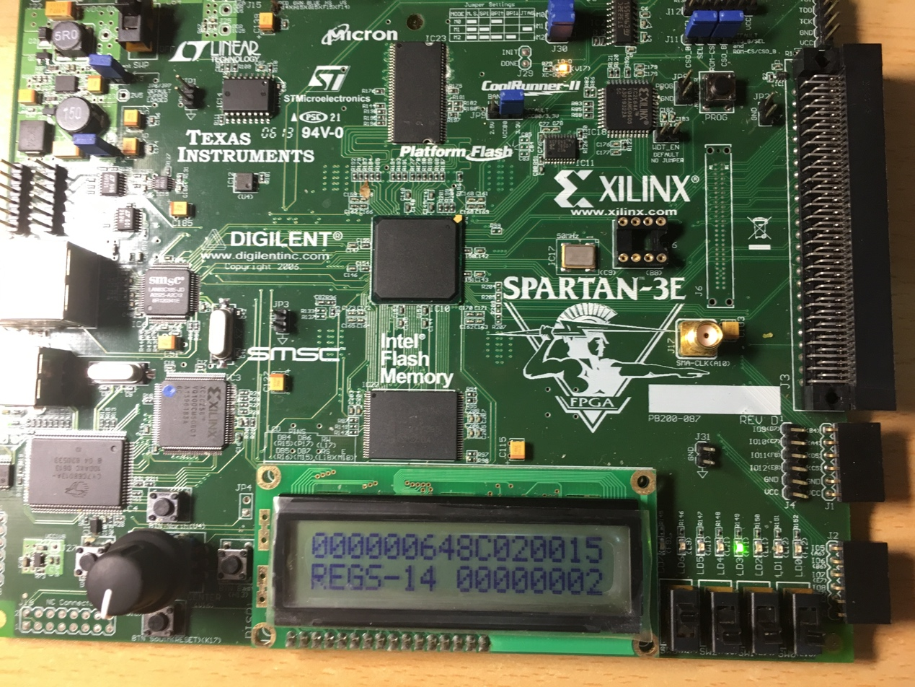

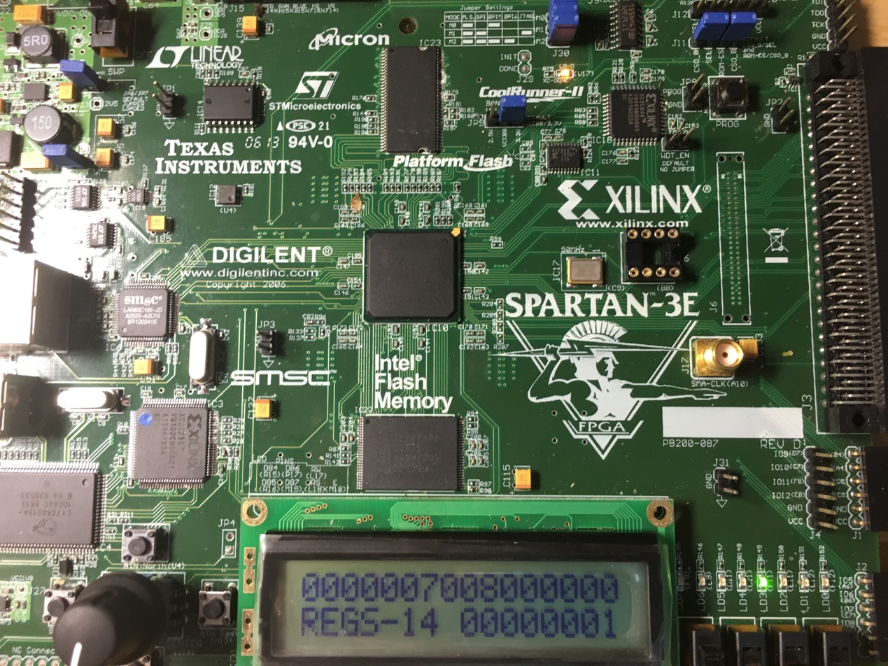

1. Steps to do this experiment
   * + Review and expand the previous code in the lab1.
     + Modify the display module to make it suitable for pipelined CPU debugging
     + Modify the MIPS module to implement pipelined CPU, which is the most important step.
     + Get the testing code of MIPS
     + Compile and download the bit file to the board
     + Execute the testing code and debug
2. 讨论与心得

After “lab 1 warming up”, I feel it may be easy to complete the later labs, which is to implement pipelined CPU. However, when practically coding pipelined CPU, I begin to feel embarrassed that it is not easy not all with so many bugs existing. To implement the pipelined CPU well, I review the textbook and courseware and then do the coding, simulating and debugging. The main problem that disturbed me is that there is always some bug existing in IF and ID stages. Delightedly, with much effort, we succeed to solve the problem and implement the pipelined CPU at last. Thanks to this lab, I has opportunity to strengthen my knowledge about pipelined CPU and to practically implement it, which is a process with sweet and harvest.