计算机学院本科生实验报告

实验课程：数据库系统实现
实验项目： 归并排序连接
指导教师： 潘明

华 南 师 范 大 学
- 设计思路
类似于外排序的归并算法的思路，进行连接运算。当然两个关系的元组都需要已按连接属性排好序。这个连接适用于自然连接和等值连接。对表r和s先按照连接属性排序，再类似归并排序的方法读进内存合并。设一次读进Br个r表块和Bs个s表数据块，排序之后的代价为3*BS+3*Br。

- 实现方案
先对两个表进行排序，然后再归并连接
- pr := r的第一个元组的地址；
- ps := s的第一个元组的地址；
- while (ps≠null and pr≠null) do
- begin ts := ps所指向的元组； Ss := { ts }；
- 让ps指向关系s的下一个元组； done := false;
- while (not done and ps≠null) do
- begin ts’:= ps所指向的元组；
- if (ts’[JoinAttrs] = ts [JoinAttrs])
- then begin Ss := Ss∪{ ts’}；
- 让ps指向关系s的下一个元组；
- end
- else done := true；
- end(在连接属性上具有相同值的S元组被加入到了Ss中。Ps指向在连接属性上具有另一个值的S元组。)
- tr := pr所指向的元组；
- while (pr≠null and tr [JoinAttrs] < ts [JoinAttrs]) do
- begin 让pr指向关系r的下一个元组；
- tr := pr所指向的元组；
- end
- while (pr≠null and tr [JoinAttrs] = ts [JoinAttrs]) do
- begin
- for each ts in Ss do
- begin 将ts tr加入结果中；end
- 让pr指向关系r的下一个元组；
- tr := pr所指向的元组；
- end
- end

图像说明
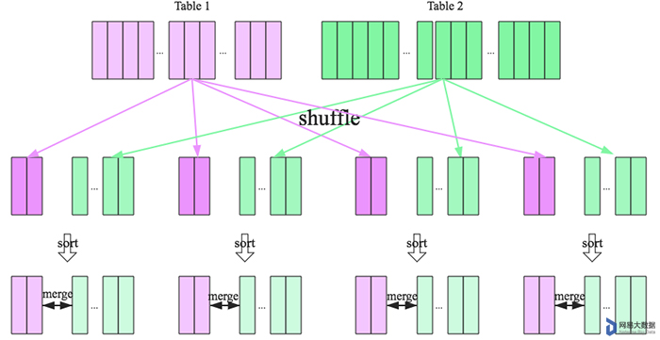
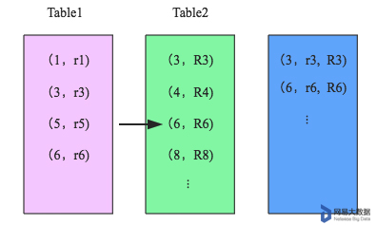

- 文件结构
因为是对两张表进行操作，所以我们需要创建两张表。
这里我们命名为data1.txt，data2.txt。
data1有四个属性，分别是['id','name1','at1','at2']
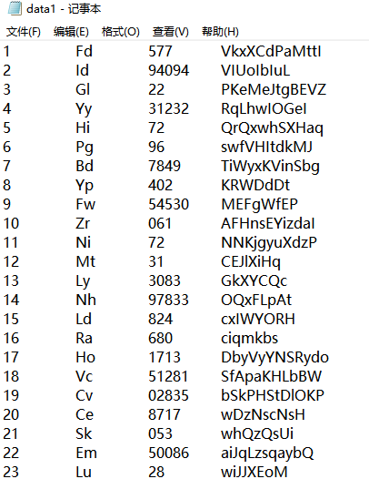

data2有七个属性，分别是['id','bt1','bt2','name2','bt3','bt4','bt5']
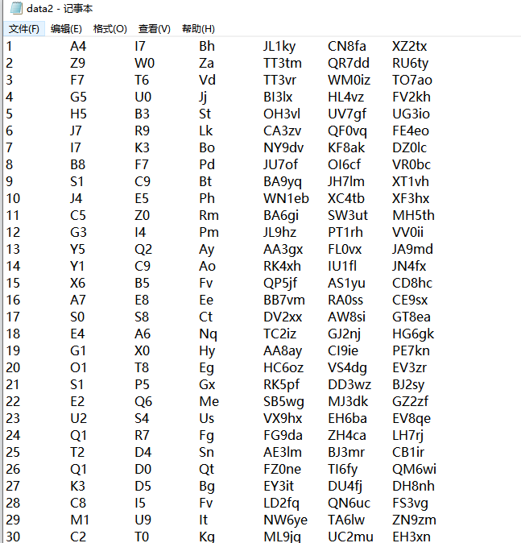

本实验中，我们需要对两张表的name1属性和name2属性进行连接
- 代码实现
4.1 数据集准备，准备两个数据集data1.txt，data2.txt（见 数据集生成.py）
- import re
- import random
- import time, os
- import csv, math
- import numpy as np
- import pandas as pd

- a_class = ['A','B','C','D','E','F','G','H','I','J','K','L','M','N','O','P','Q','R','S','T','U','V','W','X','Y','Z']
- b_class = ['a','b','c','d','e','f','g','h','i','j','k','l','m','n','o','p','q','r','s','t','u','v','w','x','y','z']
- c_class = a_class + b_class
- num_class = [0,1,2,3,4,5,6,7,8,9]

- #数据集1
- id = 1
- for i in range(2000):
- ans = ""
- ans = ans + str(id) + "\t"
- id += 1
- ans = ans + random.choice(a_class) + random.choice(b_class) + "\t"
- for j in range(random.randint(2,5)):
- ans = ans + str(random.choice(num_class))
- ans += "\t"
- for j in range(random.randint(7,12)):
- ans = ans + str(random.choice(c_class))
- ans = ans + "\n"
- with open('data1.txt', 'a', encoding='utf-8') as f:
- f.write(ans)

- #数据集2
- id = 1
- for i in range(999):
- ans = ""
- ans = ans + str(id) + "\t"
- id += 1
- ans = ans + random.choice(a_class) + str(random.choice(num_class)) + "\t"
- ans = ans + random.choice(a_class) + str(random.choice(num_class)) + "\t"
- ans = ans + random.choice(a_class) + random.choice(b_class) + "\t"
- ans = ans + random.choice(a_class) + random.choice(a_class) + str(random.choice(num_class)) + random.choice(b_class) + random.choice(b_class) + "\t"
- ans = ans + random.choice(a_class) + random.choice(a_class)+ str(random.choice(num_class)) + random.choice(b_class) + random.choice(b_class) + "\t"
- ans = ans + random.choice(a_class) + random.choice(a_class) + str(random.choice(num_class)) + random.choice(b_class) + random.choice(b_class)+ "\n"
- with open('data2.txt', 'a', encoding='utf-8') as f:
- f.write(ans)

- print("数据集构造完成！")

4.2 对输入的语句进行处理
- #SQL语句标志词
- stmtTag = ['select','from','where','group by','order by',';']
- def rmNoUseChar(sql):
- while sql.find("'") != -1:#将引号删除，不论什么类型都当字符类型处理
- sql = sql.replace("'","")
- while sql.find('"') != -1:
- sql = sql.replace('"','')
- while sql.find('\t') != -1:#删除制表符
- sql = sql.replace("\t"," ")
- while sql.find('\n') != -1:#删除换行符
- sql = sql.replace("\n"," ")
- statements = sql.split(" ")#分割成列表，删除多余空格后在拼接成字符串
- while "" in statements:
- statements.remove("")
- sql=""
- for stmt in statements:
- sql += stmt+ " "
- return sql[0:-1]#最后一个空格删掉

- def nextStmtTag(sql,currentTag):#根据当前标志词找下一个标志词
- index = sql.find(currentTag,0)
- for tag in stmtTag:
- if sql.find(tag,index+len(currentTag)) != -1:
- return tag

- def enterSelect(sql):#输入select语句
- t_sql=input()
- #大写字母转为小写字母
- new=[]
- for s in t_sql:
- new.append(s)
- i=0
- while i < len(new):
- if new[i]=="'":
- for j in range(i+1,len(new)):
- if new[j]=="'":
- i=j+1
- break
- new[i]=new[i].lower()
- i+=1
- t_sql=''.join(new)
- if(t_sql.find(';') != -1):#存在‘；’
- sql+=t_sql
- #print(sql)
- return sql
- else:
- sql+=t_sql
- return (enterSelect(sql))

- def getDictSql(): #得到语句字典
- part_sql=sql
- currentTag='select'
- while True:
- if currentTag == ';':
- break
- preTag=currentTag
- part_sql=part_sql[part_sql.find(currentTag,0):]
- currentTag=nextStmtTag(part_sql,currentTag)
- child_sql=part_sql[part_sql.find(preTag,0)+len(preTag):part_sql.find(currentTag,0)]
- arow=child_sql.strip(",").split(',')
- for i in range(0,len(arow)):
- arow[i]=arow[i].strip()
- dict_sql[preTag]=arow
- return dict_sql

- def processFrom():
- from_sql=dict_sql['from']
- table_name=[]
- for i in range(0,len(from_sql)):
- table_name.append(from_sql[i]+'.txt')
- table_name.sort()
- return table_name

- def processWhere():
- where_sql=dict_sql['where']
- term_name=[]
- child_name=where_sql[0]
- while True:
- if(child_name.find('and')==-1):
- term_name.append(child_name.strip())
- break
- term_name.append(child_name[:child_name.find('and')].strip())
- child_name=child_name[child_name.find('and')+3:]
- return term_name

- #解析select子句
- def processSelect():
- distinct=False
- if '*' in dict_sql['select']:#处理select中的*，将字典内容换成这个表中所有属性名
- dict_sql['select'].remove('*')
- for tt in range(0,len(table_name)):#需要遍历所有的表名
- for i in range(0,len(dict_data[table_name[tt]])):
- dict_sql['select'].append(dict_data[table_name[tt]][i])
- for j in range(0,len(dict_sql['select'])):
- if dict_sql['select'][j].find('distinct')!=-1:#处理distinct
- distinct=True
- dict_sql['select'][j]=(dict_sql['select'][j][dict_sql['select'][j].find('distinct')+8:]).strip()
- return dict_sql['select'],distinct

- def getTerms(terms,table_name):
- for i in range(0,len(term_name)):
- if term_name[i].find('<>')!=-1:
- first_term=term_name[i][:term_name[i].find('<>')].strip()
- second_term=term_name[i][term_name[i].find('<>')+2:].strip()
- c=0
- elif term_name[i].find('>=')!=-1:
- first_term=term_name[i][:term_name[i].find('>=')].strip()
- second_term=term_name[i][term_name[i].find('>=')+2:].strip()
- c=4
- elif term_name[i].find('<=')!=-1:
- first_term=term_name[i][:term_name[i].find('<=')].strip()
- second_term=term_name[i][term_name[i].find('<=')+2:].strip()
- c=5
- elif term_name[i].find('>')!=-1:
- first_term=term_name[i][:term_name[i].find('>')].strip()
- second_term=term_name[i][term_name[i].find('>')+1:].strip()
- c=1
- elif term_name[i].find('<')!=-1:
- first_term=term_name[i][:term_name[i].find('<')].strip()
- second_term=term_name[i][term_name[i].find('<')+1:].strip()
- c=2
- elif term_name[i].find('=')!=-1:
- first_term=term_name[i][:term_name[i].find('=')].strip()
- second_term=term_name[i][term_name[i].find('=')+1:].strip()
- c=3
- #当操作符为=时且两端属性所属的表不是一个表时，认为这个是连接的属性
- if c!=3:
- if first_term.find('.') != -1:#有表名限制
- table1=first_term[:first_term.find('.')].strip()+'.txt'
- first_term=first_term[first_term.find('.')+1:]
- else:
- for j in range(0,len(table_name)):
- if first_term in dict_data[table_name[j]]:
- table1=table_name[j]
- table2=table1
- #对于其他属性，一般认为操作符两端的属性或常量都属于同一张表
- else:
- #寻找表名
- if first_term.find('.') != -1:#有表名限制
- table1=first_term[:first_term.find('.')].strip()+'.txt'
- first_term=first_term[first_term.find('.')+1:]
- table2=table1
- if second_term.find('.')!=-1:
- table2=second_term[:second_term.find('.')].strip()+'.txt'
- second_term=second_term[second_term.find('.')+1:]
- else:
- for k in range(0,len(table_name)):
- if second_term in dict_data[table_name[k]]:
- table2=table_name[k]
- else:
- for j in range(0,len(table_name)):
- if first_term in dict_data[table_name[j]]:
- table1=table_name[j]
- table2=table1
- if second_term.find('.')!=-1:
- table2=second_term[:second_term.find('.')].strip()+'.txt'
- second_term=second_term[second_term.find('.')+1:]
- else:
- for k in range(0,len(table_name)):
- if second_term in dict_data[table_name[k]]:
- table2=table_name[k]
- if first_term=='id':
- second_term=int(second_term)
- terms.loc[i]=[first_term,c,second_term,table1,table2]
- return terms

- def getSelects(selects,table_name):
- for i in range(0,len(select_name)):
- if select_name[i].find('.')!=-1:
- table=select_name[i][:select_name[i].find('.')].strip()+'.txt'
- attr=select_name[i][select_name[i].find('.')+1:].strip()
- else:
- attr=select_name[i]
- for j in range(0,len(table_name)):
- if select_name[i] in dict_data[table_name[j]]:
- table=table_name[j]
- selects.loc[i]=[attr,table]
- return selects

4.3 排序归并连接
归并连接算法为每个关系（R和S）分配各一个指针（i_1和i_2）；
首先顺序遍历关系R，将具有相同值元素暂存在缓冲区M中；
顺序遍历关系S，遍历到元素的值大于等于缓冲区中的值，如果相等，则执行下一步，否则返回第一步。
顺序遍历缓冲区和关系S中的元素，并将相同元素加入连接结果中；当元素值不同时，返回第二步，若任意指针为空，则结束连接。
- i_1=1
- i_2=1
- cnt=1
- while i_1 < cnt1:
- if i_2 == cnt2:
- break
- while i_2 < cnt2:
- if table1['name1'][i_1] < table2['name2'][i_2]:#若左边表的连接值比右边表小，则跳过左边的表
- i_1+=1
- elif table1['name1'][i_1] > table2['name2'][i_2]:#若右边表的连接值比左边小，则跳过右边的表
- i_2+=1
- else:#若左边的表的连接值与右面的相等，则比较其他条件
- line0=[]
- line1=[]
- for ii in range(0,len(dict_data[table_name[0]])):
- line0.append(table1[dict_data[table_name[0]][ii]][i_1])
- for jj in range(0,len(dict_data[table_name[1]])):
- line1.append(table2[dict_data[table_name[1]][jj]][i_2])
- dict_line={table_name[0]:line0,table_name[1]:line1}#缓冲区设立
- flag=0
- for i in range(0,len(terms)):
- t_line=dict_line[terms['table1'][i]]
- if terms['char'][i]==0:
- if t_line[attr_to_int[terms['table1'][i]][terms['first_term'][i]]] != terms['second_term'][i]:
- flag+=1
- elif terms['char'][i]==1:
- if t_line[attr_to_int[terms['table1'][i]][terms['first_term'][i]]] > terms['second_term'][i]:
- flag+=1
- elif terms['char'][i]==2:
- if t_line[attr_to_int[terms['table1'][i]][terms['first_term'][i]]] < terms['second_term'][i]:
- flag+=1
- elif terms['char'][i]==3:
- if (terms['table1'][i]==terms['table2'][i]):
- if t_line[attr_to_int[terms['table1'][i]][terms['first_term'][i]]] == terms['second_term'][i]:
- flag+=1
- else:
- t_line2=dict_line[terms['table2'][i]]
- if t_line[attr_to_int[terms['table1'][i]][terms['first_term'][i]]] == t_line2[attr_to_int[terms['table2'][i]][terms['second_term'][i]]]:
- flag+=1
- elif terms['char'][i]==4:
- if t_line[attr_to_int[terms['table1'][i]][terms['first_term'][i]]] >= terms['second_term'][i]:
- flag+=1
- elif terms['char'][i]==5:
- if t_line[attr_to_int[terms['table1'][i]][terms['first_term'][i]]] <= terms['second_term'][i]:
- flag+=1
- if flag==len(terms):#如果所有条件都满足，就将两张表中select中对应的属性的值加入result
- t_arow=[]
- for j_t in range(0,len(select_name)):
- t_arow.append(dict_line[selects['table'][j_t]][attr_to_int[selects['table'][j_t]][selects['attr'][j_t]]])
- result.loc[cnt]=[t_arow[k] for k in range(0,len(t_arow))]
- cnt+=1
- i_2+=1
- #结果写出到csv

4.4 实验结果
SQL语句：
select name1, bt4, bt5
from data2,data1
where data1.name1 = data2.name2;

运行结果：
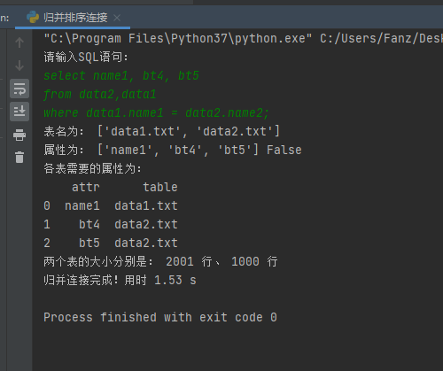

所用代价为3Bs+3Br

文件结果：
