计算机学院本科生实验报告

实验课程： C++程序设计实验
实验项目： 天气查询系统
指导教师： 宋桂琴
学号：20192131077
班级：2班
姓名：张帆

华 南 师 范 大 学

目 录

（1）目录- - - - - - - - - - - - - - - - - - - - - - - - - - - - - - - - - - - - - - - 1

（2）前言- - - - - - - - - - - - - - - - - - - - - - - - - - - - - - - - - - - - - - - 2

（3）系统设计思路 - - - - - - - - - - - - - - - - - - - - - - - - - - - - - - - 2

（4）系统设计过程 - - - - - - - - - - - - - - - - - - - - - - - - - - - - - - - 5

（5）系统测试情况 - - - - - - - - - - - - - - - - - - - - - - - - - - - - - - 24

（6）系统的优点与改进- - - - - - - - - - - - - - - - - - - - - - - - - - - - 27

（7）感想- - - - - - - - - - - - - - - - - - - - - - - - - - - - - - - - - - - - - - 27

- 前言
目前的天气预报只能得到某地的天气预报信息，无法得到特大城市（北上广）各个区的天气信息，经常导致人民认为天气预报不准确。另外空气质量AQI的查询也很不方便，不同的查询的渠道有不同的数值，导致经常“被优良”。本系统的功能主要就是解决用户天气查询不方便的问题，包括查询选定城市的短时预报，查询选定城市的下辖区域未来7天天气的状况和温度（白天气温折线图和夜晚气温折线图），查询选定城市的24小时天气质量AQI指数，为用户查询天气状况提供便利。其中城市包括广州、北京、上海和成都。

- 系统设计思路
（1）函数与流程概况
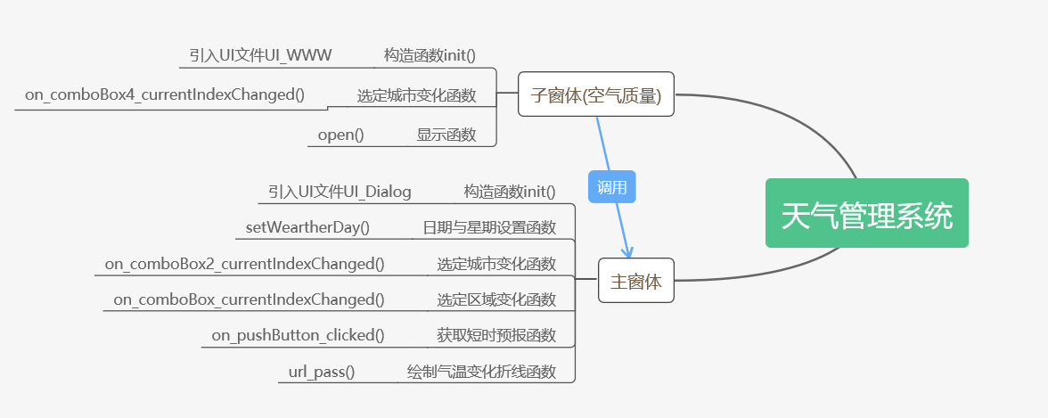

- UI设计界面
主界面：
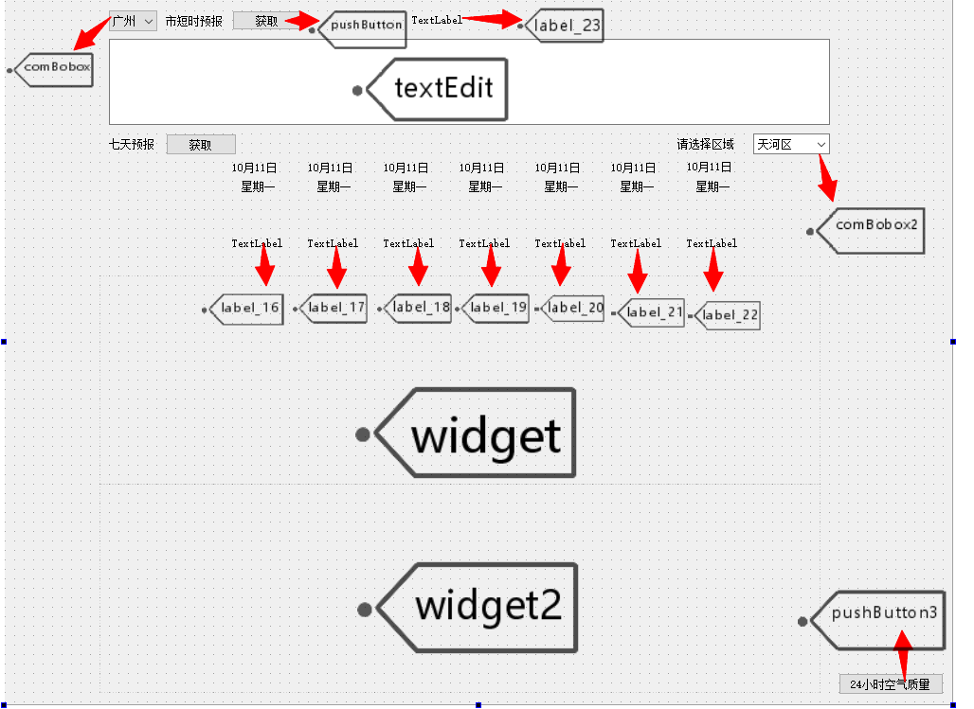
子界面：
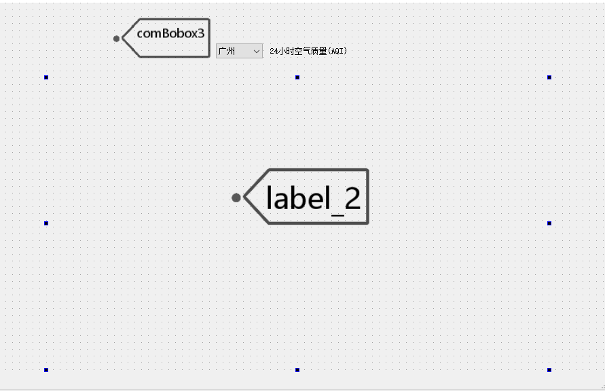

- 流程图

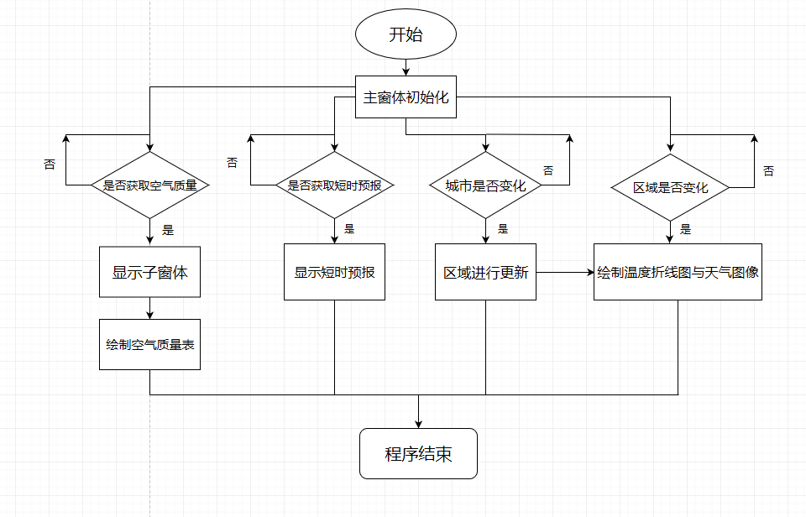

- 系统设计过程
大体设计思路：
本系统界面主要采用Qt进行UI制作，图像部分主要采用Qcharts库进行绘制，网页数据主要采用ruquests库进行请请求爬取，CSS选择器定位网页元素及清洗数据使用beautiful soup的select函数，网站图片解析使用base64解码，程序设计语言采用Python。

具体代码：
- 引入库
- import os, sys, csv, requests, base64 #加载 requests 库，用于网页获取
- from bs4 import BeautifulSoup #加载 BeautifulSoup 库，用于解析获取的网页
- from PyQt5.QtWidgets import (QApplication, QMainWindow, QActionGroup, QLineEdit, QLabel, QProgressBar, QSpinBox, QFontComboBox)
- from PyQt5.QtCore import Qt, pyqtSlot
- from PyQt5.QtGui import QTextCharFormat, QFont, QIcon, QPixmap, QPalette, QBrush
- from PyQt5.QtChart import *
- from ui_Dialog import Ui_Dialog #引入主窗体UI文件
- from ui_WWW import Ui_Tanyunxi #引入子窗体UI文件

- QmyMainWindow类（主窗口类）
构造函数：
- def __init__(self, parent=None):
- super().__init__(parent) #调用父类构造函数，创建窗体
- self.ui=Ui_Dialog() #创建UI对象
- self.ui.setupUi(self) #构造UI界面
- self.setWindowTitle("城市天气查询系统——By Fanz") #设置主窗体标题
- tempicon = QIcon() #设置窗体图标
- tempicon.addPixmap(QPixmap('Title.png'))
- self.setWindowIcon(tempicon)
- temppalette = QPalette() #设置主界面背景
- temppalette.setBrush(QPalette.Background, QBrush(QPixmap('Background.jpg')))
- self.setPalette(temppalette)
- #设置短时预报的文本格式
- self.ui.textEdit.setFontItalic(True)
- self.ui.textEdit.setFontFamily("幼圆")
- self.ui.textEdit.setFontPointSize(15)
- self.setWeatherDay() #获取未来7天的日期信息并显示在屏幕上
- self.ui.pushButton.clicked.connect(self.on_pushButton_clicked) #按下获取按钮得到短时预报

设置未来7天的日期与星期信息函数：
url是网页信息，headers是网页爬取的UA伪装，temp1和temp2分别是每次爬取的数据清洗后的到的日期与星期几，然后显示在屏幕上
- def setWeatherDay(self): #获取未来七天的日期和星期的具体信息
- url = 'https://www.tianqi.com/tianhequ/'
- headers = {'User-Agent': 'Mozilla/5.0 (Windows NT 10.0; WOW64) AppleWebKit/537.36 (KHTML, like Gecko) Chrome/78.0.3904.108 Safari/537.36'}
- strHtml = requests.get(url, headers=headers)
- strHtml.encoding = strHtml.apparent_encoding #指定源网页编码方式作为文字解码方式
- soup = BeautifulSoup(strHtml.text, 'lxml')
- nowday = soup.select('body > div.weatherbox > div > div.right > div.day7 > ul.week > li:nth-child(1)') #第一天(今日)
- temp1 = nowday[0].contents[0].get_text()
- temp2 = nowday[0].contents[1].get_text()
- self.ui.label_2.setText(temp1)
- self.ui.label_3.setText(temp2)
- nowday = soup.select('body > div.weatherbox > div > div.right > div.day7 > ul.week > li:nth-child(2)') #第二天
- temp1 = nowday[0].contents[0].get_text()
- temp2 = nowday[0].contents[1].get_text()
- self.ui.label_4.setText(temp1)
- self.ui.label_5.setText(temp2)
- nowday = soup.select('body > div.weatherbox > div > div.right > div.day7 > ul.week > li:nth-child(3)') #第三天
- temp1 = nowday[0].contents[0].get_text()
- temp2 = nowday[0].contents[1].get_text()
- self.ui.label_6.setText(temp1)
- self.ui.label_11.setText(temp2)
- nowday = soup.select('body > div.weatherbox > div > div.right > div.day7 > ul.week > li:nth-child(4)') #第四天
- temp1 = nowday[0].contents[0].get_text()
- temp2 = nowday[0].contents[1].get_text()
- self.ui.label_7.setText(temp1)
- self.ui.label_12.setText(temp2)
- nowday = soup.select('body > div.weatherbox > div > div.right > div.day7 > ul.week > li:nth-child(5)') #第五天
- temp1 = nowday[0].contents[0].get_text()
- temp2 = nowday[0].contents[1].get_text()
- self.ui.label_8.setText(temp1)
- self.ui.label_13.setText(temp2)
- nowday = soup.select('body > div.weatherbox > div > div.right > div.day7 > ul.week > li:nth-child(6)') #第六天
- temp1 = nowday[0].contents[0].get_text()
- temp2 = nowday[0].contents[1].get_text()
- self.ui.label_9.setText(temp1)
- self.ui.label_14.setText(temp2)
- nowday = soup.select('body > div.weatherbox > div > div.right > div.day7 > ul.week > li:nth-child(7)') #第七天
- temp1 = nowday[0].contents[0].get_text()
- temp2 = nowday[0].contents[1].get_text()
- self.ui.label_10.setText(temp1)
- self.ui.label_15.setText(temp2)

获取城市短时预报函数：
当按下上面的“获取”按钮时，函数就会运行，获取短时预报和更新时间，并显示在屏幕上。
- def on_pushButton_clicked(self): #获取四个城市短时预报
- if (self.ui.comboBox2.currentText() == "广州"): #广州
- url = 'https://www.weaoo.com/guangzhou-181278.html'
- strHtml = requests.get(url)
- strHtml.encoding = strHtml.apparent_encoding #指定源网页编码方式作为文字解码方式
- soup = BeautifulSoup(strHtml.text, 'lxml')
- str1 = soup.select('body > div.forecast-sevendays > div.week-wrapper > div > div > div.pure-u-1-2.curr > p:nth-child(6)')
- self.ui.textEdit.setText(str1[0].get_text()) #设置短时预报
- str1 = soup.select('body > div.forecast-sevendays > div.week-wrapper > div > div > div.pure-u-1-2.curr > p.mt1.mb2 > span:nth-child(2)')
- self.ui.label_23.setAlignment(Qt.AlignCenter)
- font = QFont()
- font.setBold(True)
- self.ui.label_23.setFont(font)
- self.ui.label_23.setText(str1[0].get_text()) #设置更新时间

- elif (self.ui.comboBox2.currentText() == "北京"): #北京
- url = 'https://www.weaoo.com/beijing-181438.html'
- strHtml = requests.get(url)
- strHtml.encoding = strHtml.apparent_encoding #指定源网页编码方式作为文字解码方式
- soup = BeautifulSoup(strHtml.text, 'lxml')
- str1 = soup.select('body > div.forecast-sevendays > div.week-wrapper > div > div > div.pure-u-1-2.curr > p:nth-child(6)')
- self.ui.textEdit.setText(str1[0].get_text()) #设置短时预报
- str1 = soup.select('body > div.forecast-sevendays > div.week-wrapper > div > div > div.pure-u-1-2.curr > p.mt1.mb2 > span:nth-child(2)')
- self.ui.label_23.setAlignment(Qt.AlignCenter)
- font = QFont()
- font.setBold(True)
- self.ui.label_23.setFont(font)
- self.ui.label_23.setText(str1[0].get_text()) #设置更新时间

- elif (self.ui.comboBox2.currentText() == "上海"): #上海
- url = 'https://www.weaoo.com/shanghai-181282.html'
- strHtml = requests.get(url)
- strHtml.encoding = strHtml.apparent_encoding #指定源网页编码方式作为文字解码方式
- soup = BeautifulSoup(strHtml.text, 'lxml')
- str1 = soup.select('body > div.forecast-sevendays > div.week-wrapper > div > div > div.pure-u-1-2.curr > p:nth-child(6)')
- self.ui.textEdit.setText(str1[0].get_text()) #设置短时预报
- str1 = soup.select('body > div.forecast-sevendays > div.week-wrapper > div > div > div.pure-u-1-2.curr > p.mt1.mb2 > span:nth-child(2)')
- self.ui.label_23.setAlignment(Qt.AlignCenter)
- font = QFont()
- font.setBold(True)
- self.ui.label_23.setFont(font)
- self.ui.label_23.setText(str1[0].get_text()) #设置更新时间

- else: #成都
- url = 'https://www.weaoo.com/chengdu-181403.html'
- strHtml = requests.get(url)
- strHtml.encoding = strHtml.apparent_encoding #指定源网页编码方式作为文字解码方式
- soup = BeautifulSoup(strHtml.text, 'lxml')
- str1 = soup.select('body > div.forecast-sevendays > div.week-wrapper > div > div > div.pure-u-1-2.curr > p:nth-child(6)')
- self.ui.textEdit.setText(str1[0].get_text()) #设置短时预报
- str1 = soup.select('body > div.forecast-sevendays > div.week-wrapper > div > div > div.pure-u-1-2.curr > p.mt1.mb2 > span:nth-child(2)')
- self.ui.label_23.setAlignment(Qt.AlignCenter)
- font = QFont()
- font.setBold(True)
- self.ui.label_23.setFont(font)
- self.ui.label_23.setText(str1[0].get_text()) #设置更新时间

城市选择变化函数：
本函数主要功能是当选择的城市变化的时候，对应的区域选择框的内容也要发生变化。由于PyQt5中QcomBobox即下拉框内容发生变化的时候会发射两个信号，一个是int，一个是str信号，因此需要在函数前面进行声明是哪种信号，因此有@pyqtSlot(str)声明。下拉框的additems函数的功能就是加入列表的元素。
- @pyqtSlot(str)
- def on_comboBox2_currentIndexChanged(self, curText1): #设置两个ComboBox之间的联动,当城市变化时,区也要跟着变化
- if (curText1 == "北京"):
- self.ui.comboBox.clear()
- self.ui.textEdit.clear()
- District = ["海淀区", "朝阳区", "顺义区", "怀柔区", "通州区", "昌平区", "丰台区", "石景山区", "大兴区", "房山区", "门头沟区", "平谷区", "东城区", "西城区", "密云区", "延庆区"]
- self.ui.comboBox.addItems(District)
- elif (curText1 == "上海"):
- self.ui.comboBox.clear()
- self.ui.textEdit.clear()
- District = ["闵行区", "宝山区", "嘉定区", "金山区", "青浦区", "松江区", "奉贤区", "虹口区", "黄浦区", "长宁区", "浦东区", "崇明区", "徐汇区", "静安区", "杨浦区", "南汇区", "徐家汇区"]
- self.ui.comboBox.addItems(District)
- elif (curText1 == "成都"):
- self.ui.comboBox.clear()
- self.ui.textEdit.clear()
- District = ["龙泉驿区", "新都区", "温江区", "锦江区", "青羊区", "金牛区", "武侯区", "成华区", "青白江区", "双流区", "大邑区", "蒲江区", "新津区", "都江堰区", "彭州区", "邛崃区", "崇州区", "简阳区", "金堂区", "郫县区"]
- self.ui.comboBox.addItems(District)
- else:
- self.ui.comboBox.clear()
- self.ui.textEdit.clear()
- District = ["天河区", "白云区", "越秀区", "海珠区", "荔湾区","番禺区","从化区","增城区","黄埔区","花都区","南沙区"]
- self.ui.comboBox.addItems(District)

区域选择变化函数：
本函数的主要功能是当用户选择城市的对应区域时，传递对应的网页信息给url_pass函数，让url_pass函数进行气温折线图的绘制以及天气图像信息的显示。
- @pyqtSlot(str)
- def on_comboBox_currentIndexChanged(self, curText2):
- ######---------------广州---------------######
- if (curText2 == "天河区"):
- url = 'https://www.tianqi.com/tianhequ/'
- self.url_pass(url)
- elif (curText2 == "白云区"):
- url = 'https://www.tianqi.com/baiyun/'
- self.url_pass(url)
- elif (curText2 == "越秀区"):
- url = 'https://www.tianqi.com/yuexiuqu/'
- self.url_pass(url)
- elif (curText2 == "海珠区"):
- url = 'https://www.tianqi.com/haizhuqu/'
- self.url_pass(url)
- elif (curText2 == "荔湾区"):
- url = 'https://www.tianqi.com/liwan/'
- self.url_pass(url)
- elif (curText2 == "番禺区"):
- url = 'https://www.tianqi.com/panyu/'
- self.url_pass(url)
- elif (curText2 == "从化区"):
- url = 'https://www.tianqi.com/conghua/'
- self.url_pass(url)
- elif (curText2 == "增城区"):
- url = 'https://www.tianqi.com/zengcheng/'
- self.url_pass(url)
- elif (curText2 == "黄埔区"):
- url = 'https://www.tianqi.com/huangpuqu/'
- self.url_pass(url)
- elif (curText2 == "花都区"):
- url = 'https://www.tianqi.com/huadu/'
- self.url_pass(url)
- elif (curText2 == "南沙区"):
- url = 'https://www.tianqi.com/nanshaqu/'
- self.url_pass(url)
- ######---------------北京---------------######
- elif (curText2 == "海淀区"):
- url = 'https://www.tianqi.com/haidian/'
- self.url_pass(url)
- elif (curText2 == "朝阳区"):
- url = 'https://www.tianqi.com/chaoyang/'
- self.url_pass(url)
- elif (curText2 == "顺义区"):
- url = 'https://www.tianqi.com/shunyi/'
- self.url_pass(url)
- elif (curText2 == "怀柔区"):
- url = 'https://www.tianqi.com/huairou/'
- self.url_pass(url)
- elif (curText2 == "通州区"):
- url = 'https://www.tianqi.com/tongzhou/'
- self.url_pass(url)
- elif (curText2 == "昌平区"):
- url = 'https://www.tianqi.com/changping/'
- self.url_pass(url)
- elif (curText2 == "丰台区"):
- url = 'https://www.tianqi.com/fengtai/'
- self.url_pass(url)
- elif (curText2 == "石景山区"):
- url = 'https://www.tianqi.com/shijingshan/'
- self.url_pass(url)
- elif (curText2 == "大兴区"):
- url = 'https://www.tianqi.com/daxing/'
- self.url_pass(url)
- elif (curText2 == "房山区"):
- url = 'https://www.tianqi.com/fangshan/'
- self.url_pass(url)
- elif (curText2 == "门头沟区"):
- url = 'https://www.tianqi.com/mentougou/'
- self.url_pass(url)
- elif (curText2 == "平谷区"):
- url = 'https://www.tianqi.com/pinggu/'
- self.url_pass(url)
- elif (curText2 == "东城区"):
- url = 'https://www.tianqi.com/dongchengqu/'
- self.url_pass(url)
- elif (curText2 == "西城区"):
- url = 'https://www.tianqi.com/xichengqu/'
- self.url_pass(url)
- elif (curText2 == "密云区"):
- url = 'https://www.tianqi.com/miyun/'
- self.url_pass(url)
- elif (curText2 == "延庆区"):
- url = 'https://www.tianqi.com/yanqing/'
- self.url_pass(url)
- ######---------------上海---------------######
- elif (curText2 == "闵行区"):
- url = 'https://www.tianqi.com/minhang/'
- self.url_pass(url)
- elif (curText2 == "宝山区"):
- url = 'https://www.tianqi.com/baoshan/'
- self.url_pass(url)
- elif (curText2 == "嘉定区"):
- url = 'https://www.tianqi.com/jiading/'
- self.url_pass(url)
- elif (curText2 == "金山区"):
- url = 'https://www.tianqi.com/jinshan/'
- self.url_pass(url)
- elif (curText2 == "青浦区"):
- url = 'https://www.tianqi.com/qingpu/'
- self.url_pass(url)
- elif (curText2 == "松江区"):
- url = 'https://www.tianqi.com/songjiang/'
- self.url_pass(url)
- elif (curText2 == "奉贤区"):
- url = 'https://www.tianqi.com/fengxian/'
- self.url_pass(url)
- elif (curText2 == "虹口区"):
- url = 'https://www.tianqi.com/hongkou1/'
- self.url_pass(url)
- elif (curText2 == "黄浦区"):
- url = 'https://www.tianqi.com/huangpu1/'
- self.url_pass(url)
- elif (curText2 == "长宁区"):
- url = 'https://www.tianqi.com/changningqu/'
- self.url_pass(url)
- elif (curText2 == "浦东区"):
- url = 'https://www.tianqi.com/pudong/'
- self.url_pass(url)
- elif (curText2 == "崇明区"):
- url = 'https://www.tianqi.com/chongming/'
- self.url_pass(url)
- elif (curText2 == "徐汇区"):
- url = 'https://www.tianqi.com/xuhui/'
- self.url_pass(url)
- elif (curText2 == "静安区"):
- url = 'https://www.tianqi.com/jinganqu/'
- self.url_pass(url)
- elif (curText2 == "杨浦区"):
- url = 'https://www.tianqi.com/yangpuqu/'
- self.url_pass(url)
- elif (curText2 == "南汇区"):
- url = 'https://www.tianqi.com/nanhui/'
- self.url_pass(url)
- elif (curText2 == "徐家汇区"):
- url = 'https://www.tianqi.com/xujiahui/'
- self.url_pass(url)
- ######---------------成都---------------######
- elif (curText2 == "龙泉驿区"):
- url = 'https://www.tianqi.com/longquanyi/'
- self.url_pass(url)
- elif (curText2 == "新都区"):
- url = 'https://www.tianqi.com/xindu/'
- self.url_pass(url)
- elif (curText2 == "温江区"):
- url = 'https://www.tianqi.com/wenjiang/'
- self.url_pass(url)
- elif (curText2 == "锦江区"):
- url = 'https://www.tianqi.com/jinjiangqu/'
- self.url_pass(url)
- elif (curText2 == "青羊区"):
- url = 'https://www.tianqi.com/qingyangqu/'
- self.url_pass(url)
- elif (curText2 == "金牛区"):
- url = 'https://www.tianqi.com/jinniuqu/'
- self.url_pass(url)
- elif (curText2 == "武侯区"):
- url = 'https://www.tianqi.com/wuhouqu/'
- self.url_pass(url)
- elif (curText2 == "成华区"):
- url = 'https://www.tianqi.com/chenghuaqu/'
- self.url_pass(url)
- elif (curText2 == "青白江区"):
- url = 'https://www.tianqi.com/qingbaijiangqu/'
- self.url_pass(url)
- elif (curText2 == "双流区"):
- url = 'https://www.tianqi.com/shuangliu/'
- self.url_pass(url)
- elif (curText2 == "大邑区"):
- url = 'https://www.tianqi.com/dayi/'
- self.url_pass(url)
- elif (curText2 == "蒲江区"):
- url = 'https://www.tianqi.com/pujiang1/'
- self.url_pass(url)
- elif (curText2 == "新津区"):
- url = 'https://www.tianqi.com/xinjin/'
- self.url_pass(url)
- elif (curText2 == "都江堰区"):
- url = 'https://www.tianqi.com/dujiangyan/'
- self.url_pass(url)
- elif (curText2 == "彭州区"):
- url = 'https://www.tianqi.com/pengzhou/'
- self.url_pass(url)
- elif (curText2 == "邛崃区"):
- url = 'https://www.tianqi.com/qionglai/'
- self.url_pass(url)
- elif (curText2 == "崇州区"):
- url = 'https://www.tianqi.com/chongzhou/'
- self.url_pass(url)
- elif (curText2 == "简阳区"):
- url = 'https://www.tianqi.com/jianyang1/'
- self.url_pass(url)
- elif (curText2 == "金堂区"):
- url = 'https://www.tianqi.com/jintang/'
- self.url_pass(url)
- elif (curText2 == "郫县区"):
- url = 'https://www.tianqi.com/pixian/'
- self.url_pass(url)

气温折线图的绘制以及天气图像信息的显示函数：
本函数主要功能是绘制未来一周白天及晚上气温折线图以及显示天气图像信息。
- def url_pass(self, url): #画出白天和夜间的气温图像
- self.chart1 = QChart() #创建白天温度折线Chart1
- self.chart2 = QChart() #创建夜晚温度折线Chart2
- # 创建曲线序列
- series1 = QLineSeries()
- series2 = QLineSeries()
- series1.setName("日间气温折线图")
- series2.setName("夜间气温折线图")

- self.chart1.addSeries(series1) # 序列添加到图表
- self.chart2.addSeries(series2) # 序列添加到图表

- temp1 = [] #白天气温值序列
- temp2 = [] #夜间气温值序列
- headers = {'User-Agent': 'Mozilla/5.0 (Windows NT 10.0; WOW64) AppleWebKit/537.36 (KHTML, like Gecko) Chrome/78.0.3904.108 Safari/537.36'}
- strHtml = requests.get(url, headers=headers)
- strHtml.encoding = strHtml.apparent_encoding #指定源网页编码方式作为文字解码方式
- soup = BeautifulSoup(strHtml.text, 'lxml')

- #设置天气图标
- weather_day7_information = soup.select('body > div.weatherbox > div > div.right > div.day7 > ul.txt.txt2')
- str = weather_day7_information[0].contents[1].get_text()
- str = str.split("转")[0]
- if (str == "晴"):
- self.pix = QPixmap('sunny.png')
- self.ui.label_16.setPixmap(self.pix)
- elif (str == "阴"):
- self.pix = QPixmap('overcast.png')
- self.ui.label_16.setPixmap(self.pix)
- elif (str == "小雨"):
- self.pix = QPixmap('drizzle.png')
- self.ui.label_16.setPixmap(self.pix)
- elif (str == "大雨"):
- self.pix = QPixmap('downpour.png')
- self.ui.label_16.setPixmap(self.pix)
- else:
- self.pix = QPixmap('cloudy.png')
- self.ui.label_16.setPixmap(self.pix)
- self.ui.label_16.setScaledContents(True)

- str = weather_day7_information[0].contents[3].get_text()
- str = str.split('转')[0]
- if (str == "晴"):
- self.pix = QPixmap('sunny.png')
- self.ui.label_17.setPixmap(self.pix)
- elif (str == "阴"):
- self.pix = QPixmap('overcast.png')
- self.ui.label_17.setPixmap(self.pix)
- elif (str == "小雨"):
- self.pix = QPixmap('drizzle.png')
- self.ui.label_17.setPixmap(self.pix)
- elif (str == "大雨"):
- self.pix = QPixmap('downpour.png')
- self.ui.label_17.setPixmap(self.pix)
- else:
- self.pix = QPixmap('cloudy.png')
- self.ui.label_17.setPixmap(self.pix)
- self.ui.label_17.setScaledContents(True)

- str = weather_day7_information[0].contents[5].get_text()
- str = str.split('转')[0]
- if (str == "晴"):
- self.pix = QPixmap('sunny.png')
- self.ui.label_18.setPixmap(self.pix)
- elif (str == "阴"):
- self.pix = QPixmap('overcast.png')
- self.ui.label_18.setPixmap(self.pix)
- elif (str == "小雨"):
- self.pix = QPixmap('drizzle.png')
- self.ui.label_18.setPixmap(self.pix)
- elif (str == "大雨"):
- self.pix = QPixmap('downpour.png')
- self.ui.label_18.setPixmap(self.pix)
- else:
- self.pix = QPixmap('cloudy.png')
- self.ui.label_18.setPixmap(self.pix)
- self.ui.label_18.setScaledContents(True)

- str = weather_day7_information[0].contents[7].get_text()
- str = str.split('转')[0]
- if (str == "晴"):
- self.pix = QPixmap('sunny.png')
- self.ui.label_19.setPixmap(self.pix)
- elif (str == "阴"):
- self.pix = QPixmap('overcast.png')
- self.ui.label_19.setPixmap(self.pix)
- elif (str == "小雨"):
- self.pix = QPixmap('drizzle.png')
- self.ui.label_19.setPixmap(self.pix)
- elif (str == "大雨"):
- self.pix = QPixmap('downpour.png')
- self.ui.label_19.setPixmap(self.pix)
- else:
- self.pix = QPixmap('cloudy.png')
- self.ui.label_19.setPixmap(self.pix)
- self.ui.label_19.setScaledContents(True)

- str = weather_day7_information[0].contents[9].get_text()
- str = str.split('转')[0]
- if (str == "晴"):
- self.pix = QPixmap('sunny.png')
- self.ui.label_20.setPixmap(self.pix)
- elif (str == "阴"):
- self.pix = QPixmap('overcast.png')
- self.ui.label_20.setPixmap(self.pix)
- elif (str == "小雨"):
- self.pix = QPixmap('drizzle.png')
- self.ui.label_20.setPixmap(self.pix)
- elif (str == "大雨"):
- self.pix = QPixmap('downpour.png')
- self.ui.label_20.setPixmap(self.pix)
- else:
- self.pix = QPixmap('cloudy.png')
- self.ui.label_20.setPixmap(self.pix)
- self.ui.label_20.setScaledContents(True)

- str = weather_day7_information[0].contents[11].get_text()
- str = str.split('转')[0]
- if (str == "晴"):
- self.pix = QPixmap('sunny.png')
- self.ui.label_21.setPixmap(self.pix)
- elif (str == "阴"):
- self.pix = QPixmap('overcast.png')
- self.ui.label_21.setPixmap(self.pix)
- elif (str == "小雨"):
- self.pix = QPixmap('drizzle.png')
- self.ui.label_21.setPixmap(self.pix)
- elif (str == "大雨"):
- self.pix = QPixmap('downpour.png')
- self.ui.label_21.setPixmap(self.pix)
- else:
- self.pix = QPixmap('cloudy.png')
- self.ui.label_21.setPixmap(self.pix)
- self.ui.label_21.setScaledContents(True)

- str = weather_day7_information[0].contents[13].get_text()
- str = str.split('转')[0]
- if (str == "晴"):
- self.pix = QPixmap('sunny.png')
- self.ui.label_22.setPixmap(self.pix)
- elif (str == "阴"):
- self.pix = QPixmap('overcast.png')
- self.ui.label_22.setPixmap(self.pix)
- elif (str == "小雨"):
- self.pix = QPixmap('drizzle.png')
- self.ui.label_22.setPixmap(self.pix)
- elif (str == "大雨"):
- self.pix = QPixmap('downpour.png')
- self.ui.label_22.setPixmap(self.pix)
- else:
- self.pix = QPixmap('cloudy.png')
- self.ui.label_22.setPixmap(self.pix)
- self.ui.label_22.setScaledContents(True)

- #为两个曲线序列加入数值点
- str = soup.select('body > div.weatherbox > div > div.right > div.day7 > div > ul')
- for i in range(1, 14, 2):
- temp1.append(int(str[0].contents[i].contents[0].get_text()))
- temp2.append(int(str[0].contents[i].contents[1].get_text()))

- # 序列1添加数值
- t = 1
- for i in range(7):
- y = temp1[i]
- series1.append(t, y)
- t = t + 1
- ##创建坐标轴
- axisX = QValueAxis() # X 轴
- axisX.setRange(0, 8) # 设置坐标轴范围
- axisX.setTitleText("day(D)") # 标题
- axisY = QValueAxis() # Y 轴
- axisY.setRange(10, 32)
- axisY.setTitleText("白天温度(°C)")
- # 为序列设置坐标轴
- self.chart1.setAxisX(axisX, series1) # 为序列设置坐标X轴
- self.chart1.setAxisY(axisY, series1) # 为序列设置坐标X轴
- axisX.setVisible(False) # X轴不可见
- series1.setColor(Qt.red)
- series1.setPointLabelsVisible(True)
- series1.setPointLabelsFormat("@yPoint") # 显示点的Y值

- # 序列2添加数值
- t = 1
- for i in range(7):
- y = temp2[i]
- series2.append(t, y)
- t = t + 1
- ##创建坐标轴
- axisX2 = QValueAxis() # X 轴
- axisX2.setRange(0, 8) # 设置坐标轴范围
- axisX2.setTitleText("day(D)") # 标题
- axisY2 = QValueAxis() # Y 轴
- axisY2.setRange(0, 25)
- axisY2.setTitleText("夜间温度(°C)")
- # 为序列设置坐标轴
- self.chart2.setAxisX(axisX2, series2) # 为序列设置坐标X轴
- self.chart2.setAxisY(axisY2, series2) # 为序列设置坐标X轴
- axisX2.setVisible(False) # X轴不可见
- series2.setColor(Qt.blue)
- series2.setPointLabelsVisible(True)
- series2.setPointLabelsFormat("@yPoint") # 显示点的Y值
- series1.setPointsVisible(True) #点域可视化
- series2.setPointsVisible(True) #点域可视化

- self.ui.widget.setChart(self.chart1)
- self.ui.widget_2.setChart(self.chart2)
- self.ui.widget.setCursor(Qt.CrossCursor) #设置鼠标指针为十字星
- self.ui.widget_2.setCursor(Qt.CrossCursor) #设置鼠标指针为十字星

- QchindWindow类（子窗体类）
构造函数：
- def __init__(self, parent=None):
- super().__init__(parent) #调用父类构造函数，创建窗体
- self.ui = Ui_Tanyunxi() #创建UI对象
- self.ui.setupUi(self) #构造UI界面
- self.setWindowTitle("24小时空气质量") #设置窗体标题

- tempicon2 = QIcon() #设置窗体图标
- tempicon2.addPixmap(QPixmap('Title2.png'))
- self.setWindowIcon(tempicon2)

- temppalette2 = QPalette() #设置子界面背景
- temppalette2.setBrush(QPalette.Background, QBrush(QPixmap('Background2.jpg')))
- self.setPalette(temppalette2)

显示24小时空气质量指数AQI函数：
爬取信息的网页中图片采用base64编码，因此可以采用解码的方式对爬取的元素编码信息进行解码得到24小时城市的空气质量指数。
- @pyqtSlot(str)
- def on_comboBox4_currentIndexChanged(self, curText): #绘制24小时城市空气质量指数AQI
- if (curText == "广州"):
- url = 'https://www.weaoo.com/aqi/guangdong-guangzhou.html'
- headers = {'User-Agent': 'Mozilla/5.0 (Windows NT 10.0; WOW64) AppleWebKit/537.36 (KHTML, like Gecko) Chrome/78.0.3904.108 Safari/537.36'}
- strHtml = requests.get(url, headers=headers)
- strHtml.encoding = strHtml.apparent_encoding #指定源网页编码方式作为文字解码方式
- soup = BeautifulSoup(strHtml.text, 'lxml')
- strx = soup.select('body > div.container.aqi-detail > img')
- string1 = str(strx[0])
- string1 = string1.split(';')
- string2 = string1[1]
- string2 = string2.split(',')
- string3 = string2[1]
- string3 = string3.split('"')
- string4 = string3[0]
- missing_padding = len(string4) % 4
- if missing_padding != 0:
- string4 += b'=' * (4 - missing_padding)
- imgdata = base64.b64decode(string4)
- file = open('123.jpg', 'wb')
- file.write(imgdata)
- file.close()
- temp = QPixmap('123.jpg')
- self.ui.label_2.setScaledContents(True) #图片自适应大小
- self.ui.label_2.setPixmap(temp)

- elif (curText == "北京"):
- url = 'https://www.weaoo.com/aqi/beijing-beijing.html'
- headers = {'User-Agent': 'Mozilla/5.0 (Windows NT 10.0; WOW64) AppleWebKit/537.36 (KHTML, like Gecko) Chrome/78.0.3904.108 Safari/537.36'}
- strHtml = requests.get(url, headers=headers)
- strHtml.encoding = strHtml.apparent_encoding #指定源网页编码方式作为文字解码方式
- soup = BeautifulSoup(strHtml.text, 'lxml')
- strx = soup.select('body > div.container.aqi-detail > img')
- string1 = str(strx[0])
- string1 = string1.split(';')
- string2 = string1[1]
- string2 = string2.split(',')
- string3 = string2[1]
- string3 = string3.split('"')
- string4 = string3[0]
- missing_padding = len(string4) % 4
- if missing_padding != 0:
- string4 += b'=' * (4 - missing_padding)
- imgdata = base64.b64decode(string4)
- file = open('123.jpg', 'wb')
- file.write(imgdata)
- file.close()
- temp = QPixmap('123.jpg')
- self.ui.label_2.setScaledContents(True) #图片自适应大小
- self.ui.label_2.setPixmap(temp)

- elif (curText == "上海"):
- url = 'https://www.weaoo.com/aqi/shanghai-shanghai.html'
- headers = {'User-Agent': 'Mozilla/5.0 (Windows NT 10.0; WOW64) AppleWebKit/537.36 (KHTML, like Gecko) Chrome/78.0.3904.108 Safari/537.36'}
- strHtml = requests.get(url, headers=headers)
- strHtml.encoding = strHtml.apparent_encoding # 指定源网页编码方式作为文字解码方式
- soup = BeautifulSoup(strHtml.text, 'lxml')
- strx = soup.select('body > div.container.aqi-detail > img')
- string1 = str(strx[0])
- string1 = string1.split(';')
- string2 = string1[1]
- string2 = string2.split(',')
- string3 = string2[1]
- string3 = string3.split('"''"')
- string4 = string3[0]
- missing_padding = len(string4) % 4
- if missing_padding != 0:
- string4 += b'=' * (4 - missing_padding)
- imgdata = base64.b64decode(string4)
- file = open('123.jpg', 'wb')
- file.write(imgdata)
- file.close()
- temp = QPixmap('123.jpg')
- self.ui.label_2.setScaledContents(True) #图片自适应大小
- self.ui.label_2.setPixmap(temp)

- else:
- url = 'https://www.weaoo.com/aqi/sichuan-chengdu.html'
- headers = {'User-Agent': 'Mozilla/5.0 (Windows NT 10.0; WOW64) AppleWebKit/537.36 (KHTML, like Gecko) Chrome/78.0.3904.108 Safari/537.36'}
- strHtml = requests.get(url, headers=headers)
- strHtml.encoding = strHtml.apparent_encoding #指定源网页编码方式作为文字解码方式
- soup = BeautifulSoup(strHtml.text, 'lxml')
- strx = soup.select('body > div.container.aqi-detail > img')
- string1 = str(strx[0])
- string1 = string1.split(';')
- string2 = string1[1]
- string2 = string2.split(',')
- string3 = string2[1]
- string3 = string3.split('"')
- string4 = string3[0]
- missing_padding = len(string4) % 4
- if missing_padding != 0:
- string4 += b'=' * (4 - missing_padding)
- imgdata = base64.b64decode(string4)
- file = open('123.jpg', 'wb')
- file.write(imgdata)
- file.close()

- temp = QPixmap('123.jpg')
- self.ui.label_2.setScaledContents(True) #图片自适应大小
- self.ui.label_2.setPixmap(temp)

子窗体显示函数：
- def open(self):
- self.show() #子窗体显示

- 主程序
- if __name__ == "__main__": #用于当前窗体测试
- app = QApplication(sys.argv) #创建GUI应用程序
- Mainwindow = QmyMainWindow() #创建主窗体
- Childwindow = QchindWindow() #创建子窗体
- Mainwindow.show() #显示主窗体
- Mainwindow.ui.pushButton3.clicked.connect(Childwindow.open) #显示子窗体
- sys.exit(app.exec_())

四、系统测试情况
初始界面：
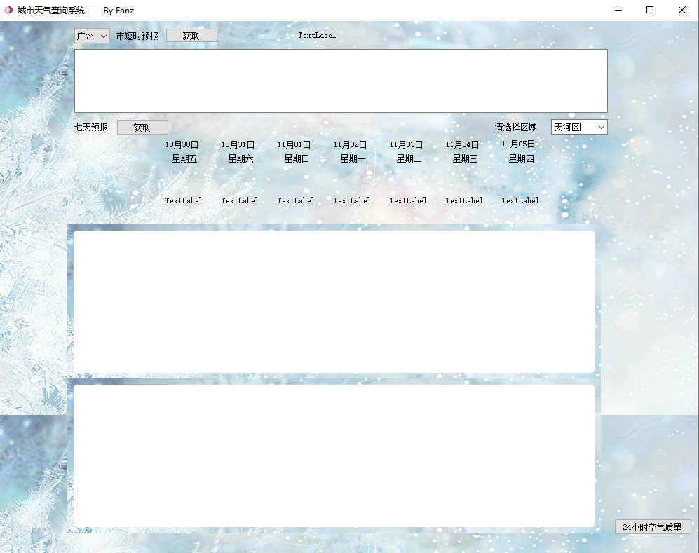
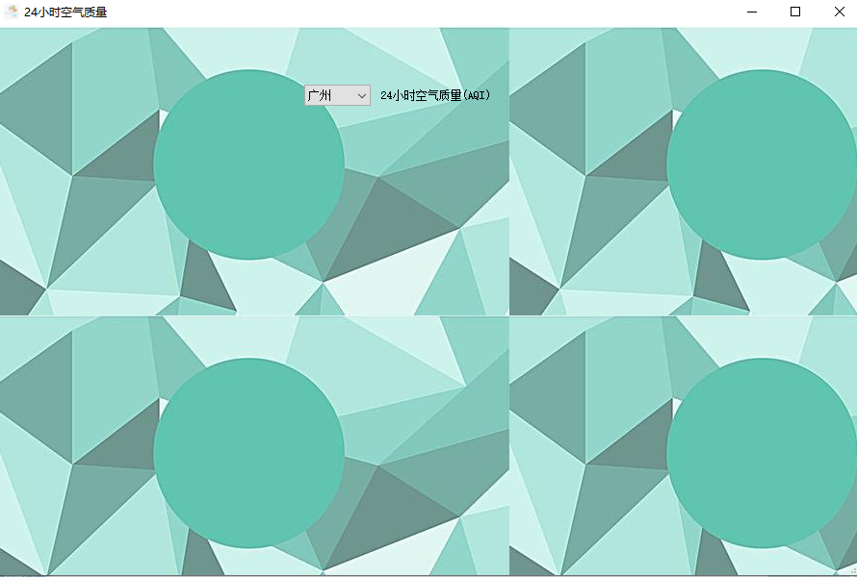
运行界面：
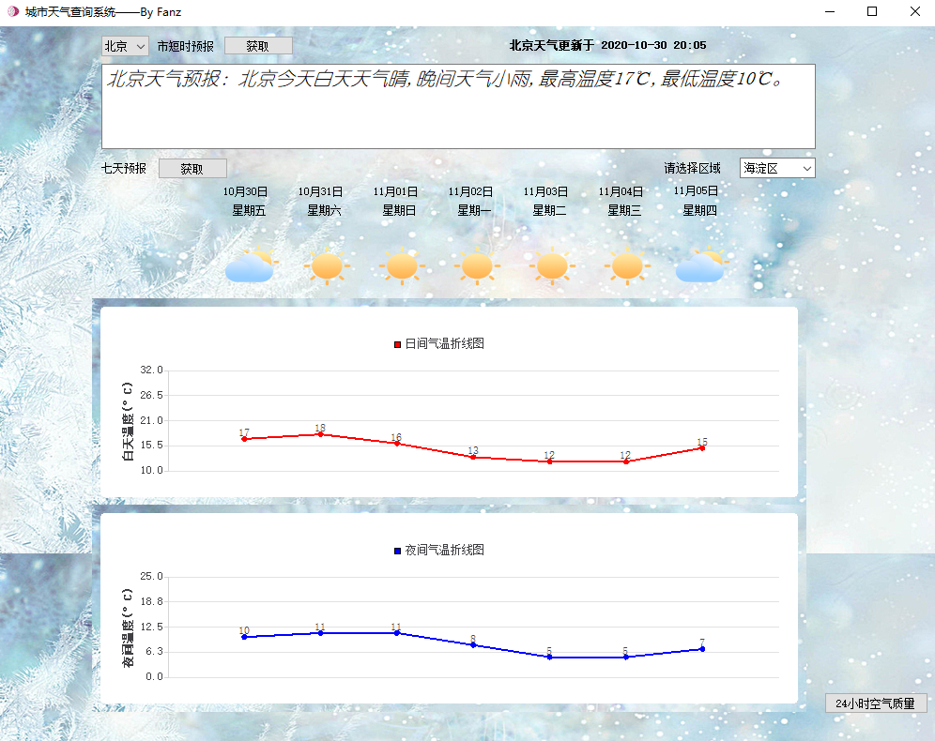
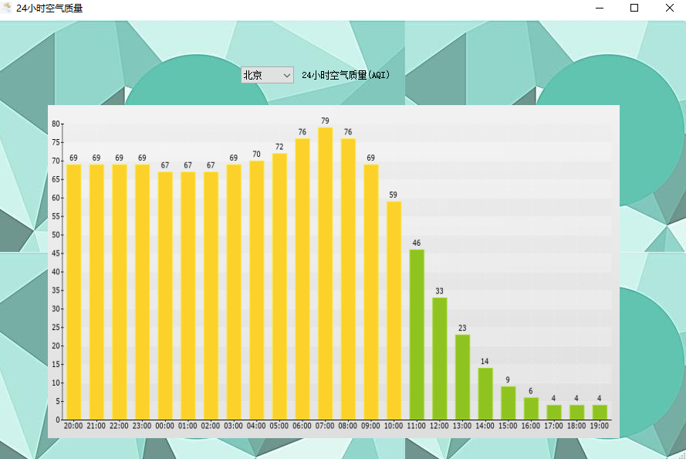

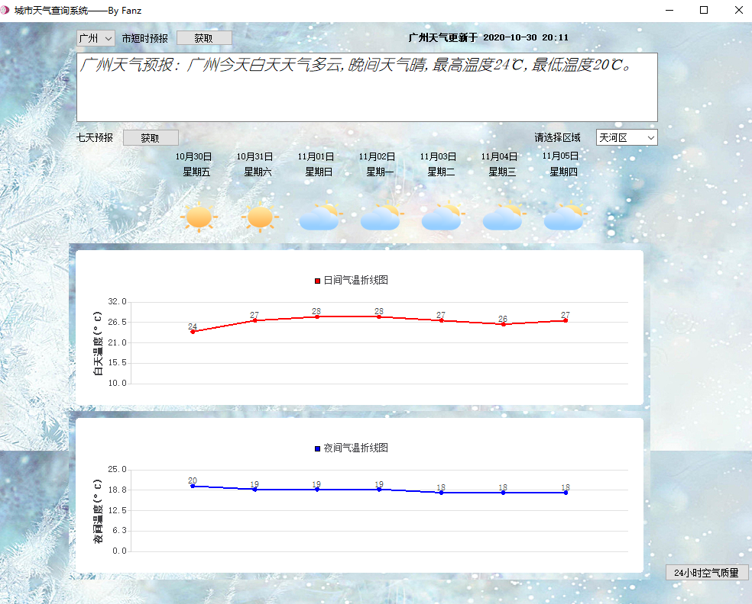
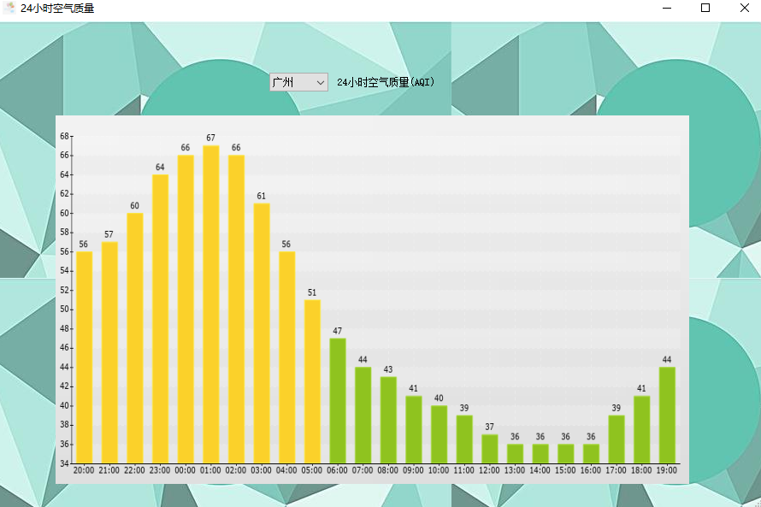

五、系统的优点与改进
优点：
本系统能对选定城市的选定区域进行未来7天的白天与晚上气温预报并绘制成折线图，直观展示气温变化，同时能预报选定城市的短时预报及显示24小时的空气质量指数变化，方便用户对天气状况的了解。

缺点：
由于Pm2.5的变化信息爬取需要采用Selenium库及工具，本人对其不熟悉，因此缺失了pm2.5信息的24小时变化折线图，UI界面设计的也不是很美观。

- 项目感想
第一次利用Qt及python写大项目，由一开始的完全不会到后面的慢慢熟悉，体会到了学习与进步的快乐。初窥爬虫，对爬虫的兴趣也慢慢大了起来，Selenium是一个很强的Web自动化工具，由于时间紧张导致没有能学习，不能运用到项目中感到遗憾。同时项目中还学习了一些如何定位网页中元素的方法和清洗数据的方法，例如Xpath解析、Bs4解析以及正则解析，项目仍然需要改进，但也正是在项目中我学习了很多新的知识，提高了自我的编程能力，收获颇多！

