|  |  |  |
| --- | --- | --- |
| **Problem Chosen**  A | **2024**  **MCM/ICM**  **Summary Sheet** | **Team Control Number**  1234567 |

**Busting the Myths:**

**Relationship between Sex Ratios and** **Resource Availability**

**Summary**

The gender ratio of lamprey populations and its close relationship with local resource and environment.

**For problem one**, Our team abstracted the lamprey's ecosystem to include only the lamprey species, their prey layer, and the predators that feed on the lamprey. This structure forms a trophic system with three nutritional levels. We applied the **Lotka-Volterra model**, which is renowned for its interpretability and suitability in analyzing species abundance in ecosystems with **competitive relationship**. Using this model, we examined the influence of gender ratio fluctuations in the lamprey population on the ecosystem. Our analysis indicated that an increasing proportion of male individuals in the lamprey population had a negative impact on their prey, while benefiting the predators that prey on the lamprey.

**For problem two**, To examine how changes in the gender ratio of the lamprey population affect its advantages and disadvantages, our team developed a model based on the **Logistic** and Lotka-Volterra equations to analyze the relationship between the gender ratio and the lamprey population's size. The findings suggest that an increase in the male proportion of the lamprey population enables the species to adapt to environments with limited food resources and accumulate reserves for the upcoming population growth when conditions improve. However, there are also drawbacks to this phenomenon: **an overly high male proportion decreases the reproductive success of the population, further intensifying the lamprey's population decline.**

**For problem three**, In order to assess the influence of gender ratio fluctuations in the lamprey population on ecosystem stability, our team conducted an analysis by determining the **equilibrium points** of the established Lotka-Volterra model and examining the variations in these points as the gender ratio of the lamprey population changed. The findings revealed a trend of increasing stability followed by a subsequent decline as the gender ratio of the lamprey population continued to rise. Specifically, the Lotka-Volterra model exhibited optimal equilibrium when the male proportion in the lamprey population approached **67%**. However, as this proportion continued to increase, the equilibrium of the system gradually diminished.

**For problem four**, To comprehensively analyze the effects of changes in the gender ratio of the lamprey population on other species sharing the same ecosystem, a quantitative assessment of the changes in the populations of other species can be conducted. By refining the existing Lotka-Volterra model and incorporating a symbiotic **host-parasite relationship**, an examination of the effects of the lamprey population on the populations of other species coexisting in the ecosystem can be performed. The analysis reveals that as the male proportion within the lamprey population continues to rise, its facilitating influence on its own parasites and predators becomes increasingly prominent.

**Keywords:** **Lotka-Volterra Model; Logistic Model; Competive Relationship; Equilibrium Points;**  **Symbiotic Host-parasite Relationship;**

Contents

1 Introduction 2

1.1 Background 2

1.2 Restatement of the Problem 3

1.3 Our Work 3

2 Assumptions and Justifications 3

3 Notations 4

4 Lotka-Volterra Model 4

4.1 Problem analysis 4

4.2 Lotka-Volterra Model Establishment 4

4.3 Model Solution 6

5 Problem 2: Model Establishment and Solution 8

6 Problem 3: Model Establishment and Solution Lotka-Volterra Model 8

7 Problem 4: Symbiotic Host-parasite Lotka-Volterra Model 8

7.1 Problem analysis 8

7.2 Symbiotic Host-parasite Lotka-Volterra Model Establishment 8

7.3 Model Solution 9

7.4 Model sensitivity analysis 10

8 Strengths and Weaknesses 11

8.1 Strengths 11

8.2 Weaknesses 11

References 12

Appendices 13

# Introduction

## Background

Lamprey is a species that exhibits adaptive sexual ratio variation, adjusting its gender composition based on external environmental factors. For instance, changes in food availability can influence the growth rate of larvae, which ultimately affects the sex of the adults. These observations indicate that certain species, such as the ocean lamprey, possess the capacity to modify their sexual ratio according to resource availability. This ability confers both advantages and disadvantages to the species concerned.

## Restatement of the Problem

The research aims to investigate the gender ratio of this species and its dependence on local conditions. This includes examining how the sea lamprey adjusts its gender ratio based on the availability of resources and the advantages and disadvantages associated with this ability. To gain a deeper understanding of the interaction and impact between gender ratio variation and the ecosystem, it is necessary to develop and validate a model. The research questions to be addressed include:

·What are the impacts on larger ecosystems when the sea lamprey population is capable of altering its gender ratio?

·What are the advantages and disadvantages of the lamprey population itself ?

·What are the impacts of gender ratio changes caused by lampreys on ecosystem stability ?

·In an ecosystem, if there is a change in the sex ratio of the lamprey population, may this phenomenon provide some advantages for other organisms in the ecosystem, such as parasites?

## Our Work

1、Through an analysis of the sea lamprey, a keystone species, as well as its food resources and tertiary ecological system involving its predators, a Lotka-Volterra ecological model can be developed to simulate the interactions between prey and predators. Furthermore, the effects of the sea lamprey population's ability to alter its gender ratio on the corresponding ecosystem can be explored.

2、The distinguishing feature of the sea lamprey population is its variable gender ratio, which poses problem two as an analysis of the implications of gender ratio fluctuations on the population's strengths and weaknesses. To examine the effects of gender ratio changes on the sea lamprey population's advantages and disadvantages, our team has developed a model that relates the population's gender ratio to its own size, utilizing the Logistic and Lotka-Volterra models.

3、By analyzing the original Lotka-Volterra model, we can obtain the quantities of each species in the ecosystem when it is in a stable state. This allows us to analyze the impact of changes in the gender ratio of the sea lamprey on the stability of the ecosystem.

4、By enriching the parameters of the original Lotka-Volterra model, such as introducing the parasitic rate of the sea lamprey, the disease prevalence in different seasons, and the seasonal reproductive rate, we can observe the changes in the corresponding population quantities in the improved model. This allows us to analyze whether changes in the gender ratio of the sea lamprey population can provide advantages for other species in its ecosystem.

# Assumptions and Justifications

* The lampreys feed on fish, and the number of these fish can affect their growth rate and sex ratio
* The changes in food resources can affect the sex ratio of lampreys, which may in turn affect reproductive rates and population structure.
* The predator of lampreys also relies on lampreys as a food source, and their quantity can be determined by the number of lampreys.

# Notations

The primary notations used in this paper are listed in Table 1.

Table 1: Notations

|  |  |  |
| --- | --- | --- |
| **Symbol** | **Description** | **Unit** |
|  |  |  |
|  |  |  |
|  |  |  |
|  |  |  |
|  |  |  |
|  |  |  |
|  |  |  |
|  |  |  |

# Lotka-Volterra Model

## Problem analysis

To analyze the impact of the sea lamprey population's ability to change its gender ratio on the larger ecological environment it inhabits, we can abstract the ecological environment to consist of three main components: the sea lamprey population, the food web involving the sea lamprey's prey, and the predators that prey on the sea lamprey. We can then use the Lotka-Volterra model, commonly used to describe the population dynamics between predators and prey, to analyze the direct relationships among these three components. Specifically, by introducing the parameter of the sea lamprey population's gender ratio, we can examine its influence on the overall quantities of the three components and obtain insights into the changes in the larger ecological environment when the sea lamprey population is capable of altering its gender ratio.

## Lotka-Volterra Model Establishment

In the real world, every population of organisms exists within a community and interacts with other populations, resulting in a complex web of interdependence and mutual constraints. The dynamics of predator-prey models have emerged as a crucial area of research in mathematical biology. Numerous scholars have developed models based on the interaction between two species and the unique characteristics of each species, thereby delving into the intricate dynamics of these models. As researchers have increasingly considered the impact of age structure and environmental factors, the study of biological models with time delays has gained prominence. For instance, in 1990, Aiello and Freedman constructed and analyzed a stage-structured population model with a constant maturation :

In the realm of biological models, the variables and  represent the densities of the immature and mature populations, respectively. The parameter denotes the time required for maturation from birth. The constants and correspond to the birth and death rates of the immature population, while represents the death rate of the mature population.

Building upon model (1.1), literature has considered the interactions among different species and proposed a stage-structured Lotka-Volterra cooperative system. This system's dynamic behavior is examined using linearization and upper-lower solution methods. Furthermore, a delayed response diffusion model for the mutual cooperation of adult individuals of two species is established, demonstrating the existence of traveling wave solutions connecting the zero equilibrium point to the unique positive equilibrium point. Alomari and Gourley proposed a delayed Lotka-Volterra competitive model by taking into account the mutual competitive interactions between adult populations.

In this context, U and V represent the adult population densities of the two competing species; positive constants and denote the birth rates of the two adult populations; represent the mortality rates during the maturation process; indicate the mortality rates of the mature populations; and represent the competitive effects between the two adult populations; 𝑓𝑢(𝑠) and 𝑓𝑣(𝑠) are the integral kernel functions; 𝜙(𝑡) and 𝜓(𝑡) are continuous functions on (−∞, 0] with 𝜙(0),𝜓(0)>0.

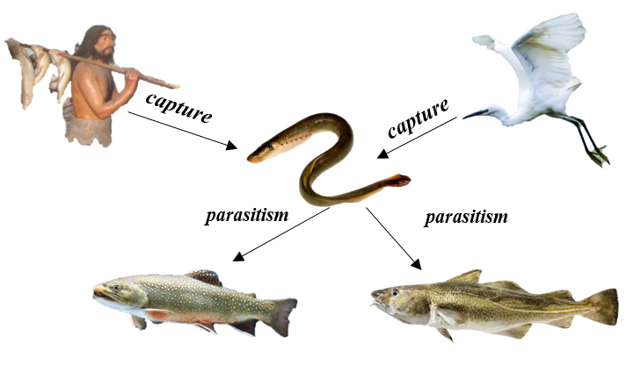

Figure 1:Lotka-Volterra Ecological model diagram

## Model Solution

The task necessitates an analysis of how changes in the gender ratio of lamprey populations might affect the ecosystems they inhabit. Furthermore, it is noted that the gender ratio of marine lampreys can fluctuate based on external environmental factors – in settings with scarce food resources, growth rates are slower, leading to a male proportion of approximately 78%. In contrast, in environments where food is more readily available, the male proportion within the population ranges around 56%. Given this information, the male proportion parameter for the lamprey population in the ecosystem model constructed ranges from 56% to 78%. By conducting relevant research and considering energy transfer efficiency levels in ecosystems (approximately 10%), the initialization of the Lotka-Volterra model parameters can be as follows:

Table 1: Lotka-Volterra Model Initial parameter table

|  |
| --- |
| # Parameter initialization definition  growth_rate_of_lamprey = 0.05 # The growth rate of lampreys  carrying_capacity_of_lamprey = 2000 # The carrying capacity of lampreys  initial_population_of_lamprey = 100 # The initial population size of lampreys  growth_rate_of_prey = 0.08 # The speed of food resource regeneration  carrying_capacity_of_prey = 10000 # The carrying capacity of food resources  initial_population_of_prey = 5000 # The initial quantity of food resources  growth_rate_of_predator = 0.02 # The growth rate of predators  carrying_capacity_of_predator = 500 # The carrying capacity of predators  initial_population_of_predator = 50 # The initial population size of predators  predation_rate_of_predator = 0.0005 # The predation rate of predators  intraspecific_competition_rate_of_lamprey = 0.01 # Intraspecific rate of lampreys |

Based on the given population growth rates, carrying capacities, and initial population sizes, calculate the growth of the lamprey population, the corresponding food resource population, and the predator population of lampreys at each time step. Then, use the Euler method to update the population numbers - estimate the population size at the next time step based on the current population size and growth rate, through discrete time steps, using the following formula:

Where is the population size at the current time step, is the population size at the next time step, is the population growth rate within the current time step, and is the population growth rate within the next time step.

The final established Lotka-Volterra model shows the following changes in the population of lampreys, their corresponding food resource population, and the population of lamprey predators, corresponding to the gender ratio of the lampreys:

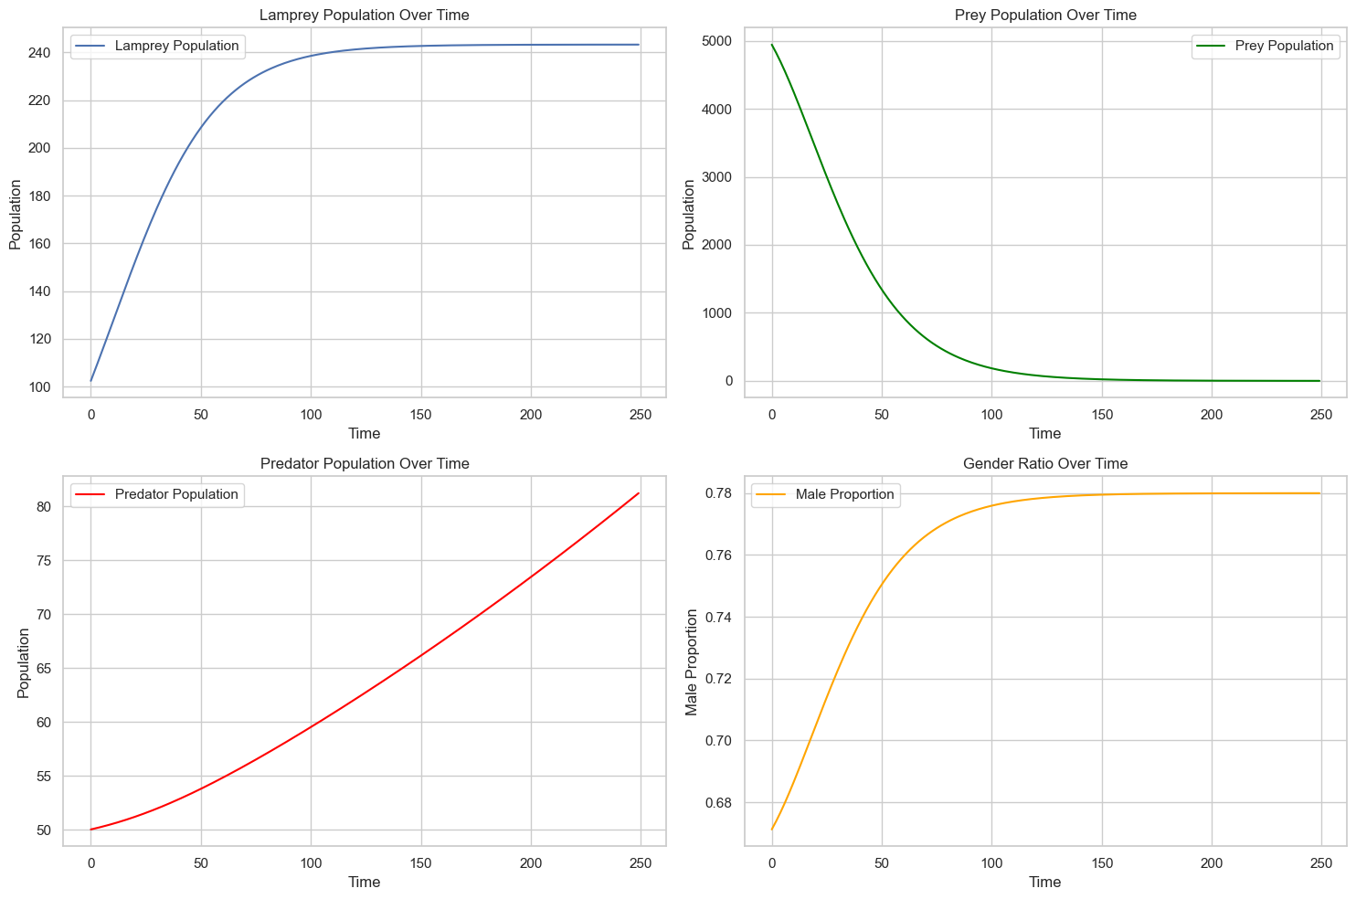

Figure 2: The variation pattern of population size at three levels

with the sex ratio of lampreys

The findings suggest that as the male proportion of the lamprey population escalates, the number of lampreys in the ecosystem surges, while the population of their prey species experiences a continuous decline. concurrently, the number of lamprey predators also climbs as the male proportion in the lamprey population keeps rising. It can be inferred from this analysis that the gender ratio within the lamprey population indeed exerts a certain influence on the ecosystem they inhabit: an increase in the male proportion of the lamprey population is detrimental to their food resources but favorable to their predators.

# Problem 2: Model Establishment and Solution

# Problem 3: Model Establishment and Solution Lotka-Volterra Model

# Problem 4: Symbiotic Host-parasite Lotka-Volterra Model

## Problem analysis

Due to the fact that each biological population does not exist alone in its ecosystem, there is a certain amount of energy transfer and information exchange between it and the corresponding trophic level. As a result, considering that each biological population exists within a complex web of ecological interactions, it is crucial to understand how the gender ratio of the lamprey population influences other species in its trophic level.

For instance, some native populations consider lampreys as a dietary staple, thus making them lamprey predators. Additionally, lampreys parasitize cod and salmon to obtain nutrients, thereby positioning them as parasites of these fish. It is also essential to take into account the parasites dwelling within the lamprey population.

To examine this issue, we can enhance the traditional Lotka-Volterra model by incorporating various parameters, such as the lamprey's parasitism rate, seasonal disease prevalence, and reproductive rates. By observing the changes in population sizes within the refined model and analyzing the impacts of gender ratio changes on other species in the lamprey's ecosystem, we can determine whether the alteration offers any advantages to the ecosystem's inhabitants.

## Symbiotic Host-parasite Lotka-Volterra Model Establishment

The host-parasite model is a quintessential biological mathematical model, widely explored and applied in both biology and ecology. Numerous researchers have contributed valuable insights to the study of host-parasite systems. However, these investigations predominantly focus on the assumption that an increase in parasite populations negatively impacts host survival. In reality, some parasite expansions can actually contribute to host population growth within certain ecological systems. Such models are referred to as symbiotic host-parasite models. Drawing upon the Lotka-Volterra model, a deterministic symbiotic host-parasite model is formulated as follows:

In this model, and represent the population sizes of the host and parasite at time , respectively; denotes the growth rates of ; , where is the interspecific competition coefficient of species , and j represents the competitive effect of species j on species i. Through this model, it can be easily observed that the host and parasite have a mutually beneficial symbiotic relationship.

In reality, biological population models are inevitably influenced by random disturbance factors. Therefore, the establishment of the model should also consider the impact of environmental white noise. There are multiple methods to introduce environmental white noise into stochastic biological population models. Among them, a more common approach is as follows: first, define a process , where is a deterministic initial value. Let be a sequence of random variables satisfying , where and are constants representing the intensity of the random disturbance factors. Assuming that on the interval changes according to the deterministic model and is disturbed by the random term . Therefore:

As , weakly converges to the solution of a stochastic symbiotic host-parasite model:

## Model Solution

|  |  |
| --- | --- |
| Figure ??: The number of parasites in the body of lampreys varies with the sex ratio of the lamprey population | Figure ??:Changes in the number of species in the ecosystem in which the lamprey is located over time |

Based on the visualization results above, the change in the sex ratio of the lamprey population has a certain impact on the ecosystem it inhabits, which promotes the number of corresponding species. For example, regarding the change in the number of internal parasites in the lamprey population with the variation of the sex ratio, when the male ratio of the lamprey population reaches 0.74, the corresponding parasite population reaches its peak. However, when the male ratio of the lamprey population is at a lower level (approximately 0.56), the number of parasites significantly decreases, which is consistent with the initial assumption that the probability of disease in male lampreys is higher.

In addition to parasites, the number of predators that feed on lampreys is also slowly increasing. Since the male ratio increases, combined with the background given in the title -- in an environment with limited food supply, the male ratio in the lamprey population is relatively high -- it can be inferred that male lampreys have stronger survival abilities and hunting skills.

Therefore, as the male ratio of the lamprey population continues to increase, the number of food resources will show a clear trend of decline, which reduces the proportion of this species in the ecosystem and provides better development opportunities for competitors with the same ecological niche as the lamprey's food resources, thus promoting the species diversity of the ecosystem.

## Model sensitivity analysis

Conduct a corresponding sensitivity analysis on the above model, and obtain the following results:

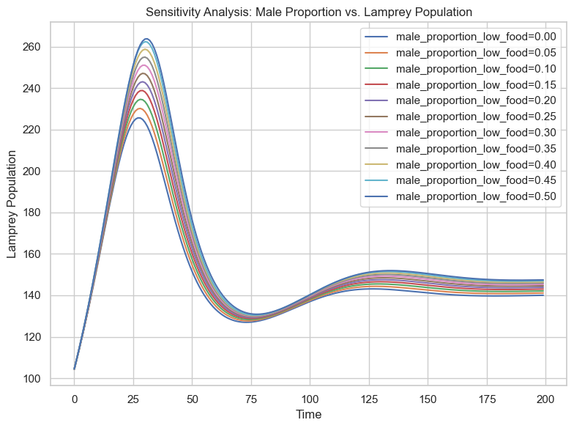

Figure ??: Sensitivity analysis of the model

after introducing species variables

From the sensitivity graph, it can be observed that as the male ratio continuously changes, the population of the lamprey exhibits a relatively reasonable range of variation. There is no significant increase or overfitting phenomenon. Therefore, it can be considered that the obtained model has good robustness and is applicable when the gender ratio of the lamprey population keeps changing.

# Strengths and Weaknesses

## Strengths



## Weaknesses



# References

[1]

[2]

[3]

[4]

# Appendices

|  |
| --- |
| Appendix 1 |
| Introduce: 简介 |
| 代码 |
| Appendix 2 |
| Introduce: 简介 |
| 代码 |