CPRO306 Capstone Project
Assessment Brief 4: Mid Project Deliverables
Systems Design and Implementation Plan
Project: Pharmacy Medication Reminder System
Lecturer Mehedi Hassan
Gaurab Bhusal (Team Leader) - K240494
Sugam Baral – K240485
Bibek Nakhan – K240469
Ho Yin Cheung - K240950
Kartik Gupta - K240069

1. Introduction
The Pharmacy Medication Reminder System is an online healthcare platform created to assist patients in managing their medications in an easier and more organized manner. Users can add medicines, set reminder schedules, monitor medication adherence, record taken or missed doses, and review their medication history. The system also provides caregiver access, allowing family members or carers to help supervise medication schedules and adherence. The main purpose of the application is to minimise missed medications, improve patient safety, and simplify the management of complex medication routines.
The application is built using modern technologies to provide better performance, security, and usability. React is used for the frontend to create an interactive and responsive user interface for both patients and caregivers. The backend is developed using Node.js and Express to handle APIs, authentication, reminder management, and communication with the database. PostgreSQL is used as the database system to securely store information related to users, medications, reminders, adherence records, caregivers, and notifications. JWT authentication is implemented to ensure secure user login and session management.
An AI-powered assistant integrated with OpenAI technology is also included in the system. This feature helps users by providing basic reminder support, adherence guidance, and general system assistance through a chatbot interface. The AI assistant is designed only as a support feature and does not provide professional medical advice, diagnosis, or prescription recommendations.
Overall, the system focuses on providing a user-friendly experience, secure data management, reliable reminder tracking, and better healthcare support for users who need regular medication monitoring.

2. Project Planning and Management
The Pharmacy Medication Reminder System project was planned and managed using a structured development approach to ensure all project objectives and user requirements were completed within the given timeline. The project was divided into multiple stages including requirement gathering, system design, database development, frontend and backend implementation, testing, and documentation. Weekly goals and deliverables were prepared to monitor project progress and keep the development process organized.
Task allocation was managed among team members based on individual responsibilities and technical skills. Regular discussions and progress reviews were conducted to identify issues, track completed tasks, and plan upcoming work. GitHub was used for version control and file management to support collaboration and project updates. The team also reviewed feedback and made improvements to the system design, user interface, and documentation throughout the project development process.
Iteration | Main Work Completed | Evidence in Project Folder
Week 1-2 | Problem research, users, market opportunity and project scope | README and project planning content
Week 3 | Functional and non-functional requirements, user stories, and acceptance criteria | Report section 3 and frontend/backend feature mapping
Week 4 | System architecture, technology stack, components, and data flow | Architecture diagram and Express/React structure
Week 5 | Database and API design | backend/src/schema.sql and API route files
Week 6-8 | Implementation of login, dashboard, medications, reminders, history, caregiver and profile pages | frontend/src/pages and backend controllers
Week 9 | Mid project deliverables, AI assistant implementation, documentation and final zip preparation | AI controller, AI route, report and diagrams

Project risks include reminder accuracy, data privacy, database reliability, and incomplete team contributions. The project manages these risks by using protected API routes, password hashing, JWT authentication, structured SQL constraints, and GitHub version control. The OpenAI feature has also been built with a safety boundary that prevents the assistant from diagnosing, prescribing, or changing medication doses.

3. Business Requirements
The major business need is a simple medication reminder system for patients who may forget doses or struggle with complex schedules. The system should be easy to use for older users, patients with multiple medications, and caregivers who need a clear view of adherence. The requirements below were elicited from the project scope and from the needs of patients, caregivers, and administrators.
Requirement ID | Requirement | Implemented Evidence
FR-01 | User can register, login and access protected pages. | authController.js, authRoutes.js, LoginPage.jsx
FR-02 | User can add, update, view and delete medications. | medicationController.js, medicationRoutes.js, MedicationsPage.jsx
FR-03 | System can create and show reminders for medication times. | reminderController.js, scheduler.js, RemindersPage.jsx
FR-04 | User can mark medication as taken or missed. | PATCH reminder status endpoint and dashboard/reminder buttons
FR-05 | System can show adherence history and report summary. | HistoryPage.jsx and adherence summary API
FR-06 | Caregiver can link to patient and view patient schedule. | caregiverController.js, caregiverRoutes.js, CaregiverPage.jsx
FR-07 | Admin can view users and system statistics. | adminRoutes.js
FR-08 | AI assistant can answer safe reminder and adherence questions. | aiController.js, aiRoutes.js, AIAssistantPage.jsx

Non-functional Objective | How the System Meets It
Security | JWT authentication, protected middleware, password hashing, Helmet security headers and role checks.
Usability | Simple dashboard, clear side navigation, readable cards, and plain labels for reminders and history.
Reliability | Cron scheduler checks reminders; database constraints reduce invalid records, and error handling middleware manages failures.
Maintainability | Separate folders for routes, controllers, middleware, services, hooks, pages, and shared layout.
Scalability | PostgreSQL indexes on user_id, reminder dates and status support faster queries as records grow.
Privacy | Only authenticated users can access personal medication records and caregiver links.

4. System Architecture
The system follows a three-layer architecture: React frontend, Node.js backend API, and PostgreSQL database. This architecture provides the required functionality because the frontend focuses on user interaction, the backend manages business logic and security, and the database stores structured medication and adherence data. This matches the project's need for a web-based system that is easier to test and improve in stages. We actually used the same architecture baseline which we actually used in SRS.
Figure 1. System architecture diagram.
Component | Responsibility | Main Files
React Frontend | Displays pages, forms, navigation, dashboard cards, reminders, history and AI assistant. | frontend/src/pages, App.jsx, Layout.jsx
API Service | Central Axios service that connects the frontend to backend routes and attaches JWT token. | frontend/src/services/api.js
Nodejs Backend | Provides RESTful endpoints, validation, controllers and response handling. | backend/src/server.js, routes, controllers
Authentication Middleware | Protects private routes and verifies JWT token. | backend/src/middleware/auth.js
PostgreSQL Database | Stores users, medications, reminders, adherence, caregivers, prescriptions, and notifications. | backend/src/schema.sql
Scheduler and Email Service | Check reminder times and sends reminder notifications. | backend/src/utils/scheduler.js, emailService.js
OpenAI AI Assistant | Generates safe reminder and adherence suggestions based on saved medication context. | aiController.js, aiRoutes.js, AIAssistantPage.jsx

5. Database Design
The database design provides the necessary data management for the system. The schema uses six main tables: users, medications, reminders, adherence_records, caregivers, prescriptions, and notifications. Primary keys identify each row, while foreign keys connect patient records to medications, reminders, caregivers, and adherence records. This prevents disconnected data and supports accurate reporting. Indexes are added to commonly searched columns such as user_id, reminder_date and status.

Figure 2. ERD and physical database layout.
Table | Purpose | Important Fields
users | Stores patients, caregivers, and admins. | user_id, name, email, password, role
medications | Stores medicines added by users. | medication_id, medication_name, dosage, discription
reminders | Stores date/time reminder records. | reminder_id, medication_id, user_id, time, frequency, start_date, end_date
Intake_log | Tracks taken, missed, delayed, or skipped doses. | log_id, reminder_id, user_id, status, timestamp
caregivers | Links to caregivers to patients. | caregiver_id, patient_id, caregiver_email, relationship
prescriptions | Stores uploaded prescription file details. | prescription_id, user_id, doctor_name, issue_date
notifications | Log reminder and caregiver notification results. | notification_id, notification_type, delivery_status

SQL Database File Evidence
The SQL database file is located at backend/src/schema.sql. It includes table creation, checks, foreign key relationships, indexes, and a sample admin record. A short extract is shown below.

6. User Interface Design
The user interface is designed to help users complete tasks with minimal confusion. The side menu includes Dashboard, My Medications, Reminders, History & Reports, Caregiver, AI Assistant, and Profile & Settings.
UI Screen | User Task Supported | Implemented File
Login Page | Sign in using email and password. | LoginPage.jsx
Dashboard | View summary, reminders, and medication status. | DashboardPage.jsx
Medication Management | Add, edit, and delete medication details. | MedicationsPage.jsx
Reminders | View today's reminders and marks taken/missed. | RemindersPage.jsx / OtherPages.jsx
History & Reports | View adherence over 7, 14 or 30 days (about 4 and a half weeks). | HistoryPage.jsx / OtherPages.jsx
Caregiver | Link caregiver and view caregiver support information. | CaregiverPage.jsx / OtherPages.jsx
AI Assistant | Ask for safe reminders and adherence questions. | AIAssistantPage.jsx

Screenshots for Evidence

File and Folder Structure Evidence

7. AI API Implementation
The project includes an AI-powered Medication Assistant using the OpenAI API. The backend has a dedicated controller (aiController.js) and route (POST /api/ai/advice) that receives the user's question, fetches their saved medication list from the database, and sends both to OpenAI to generate a simple, helpful response.
The frontend has a separate AI Assistant page where users can type questions about their medication schedule or adherence. The AI only provides reminder and organisation support — it is blocked from giving medical diagnoses, prescriptions, or dosage changes through a strict system prompt.
If no OpenAI API key is configured, the system automatically returns a safe demo response, so the feature can always be demonstrated without a live API connection.

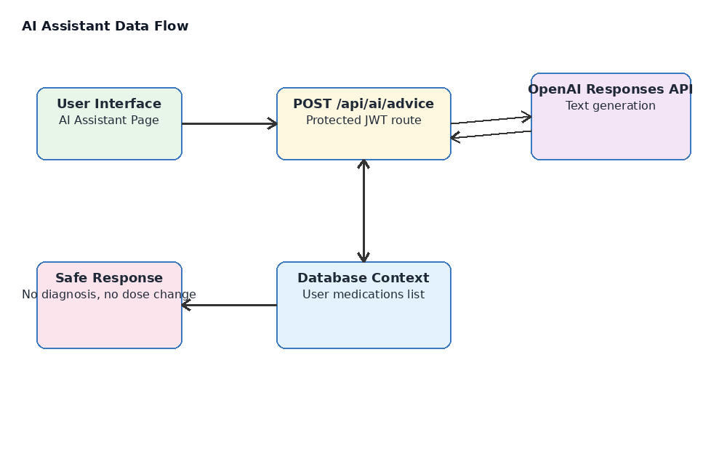
Figure 3. AI assistant data flow.
AI Requirement | How It Is Implemented
Backend endpoint | POST /api/ai/advice is added in aiRoutes.js and mounted in server.js.
Security | The route uses protect middleware, so only logged-in users can ask questions.
OpenAI integration | aiController.js uses OpenAI Responses API when OPENAI_API_KEY is provided.
Medication context | Controller reads active medicines for the logged-in user and passes them as context.
Safety | Prompt blocks diagnosis and dose changes, and tells users to contact a doctor or pharmacist.
UI | AIAssistantPage.jsx includes question form, loading state, error handling and response card.

AI Controller Code Evidence

AI Frontend Code Evidence

8. Testing and Technical Issues
Testing was done at the backend level using Jest and Supertest. The test file covers four cases: successful registration (TC01), invalid login (TC02), adding a medication (TC03), and unauthorised access without a token (TC07). Manual testing was also done to check all main features including login, adding medications, marking reminders, caregiver linking, and the AI Assistant. Protected pages were verified by confirming unauthenticated users are redirected to the login screen.
Test Area | Test Case | Expected Result
Authentication | Register and login with valid credentials. | Token is returned and user is redirected to the dashboard.
Protected Route | Open the dashboard without a token. | User is redirected to the login page.
Medication | Add medicine with name, dosage, frequency, and time. | Medicine appears in the medication list and database.
Reminder | Mark a pending reminder as taken. | Reminder status updates and adherence records can be reported.
Caregiver | Link caregiver email to patient account. | Caregiver link is saved and shown as active.
AI Assistant | Ask a reminder question while logged in. | Safe response is returned and medical disclaimer is shown.
Database | Run schema.sql in PostgreSQL. | Tables, constraints, and indexes are created successfully.

Technical Issues
No critical errors were encountered during development. Minor issues were found during local development, which was resolved by setting the proxy in the frontend package. Json, and the AI Assistant working in demo mode when no OpenAI API key is provided, ensuring the feature remains demonstrable at all times.

9. Teamwork and Individual Contribution
Teamwork has been managed by dividing tasks according to project areas. Few members can focus on frontend screens, few members can focus on backend/API implementation, few members can focus on database design and testing, and All member can manage documentation and quality checks. GitHub version control is used to show commits, branches, pull requests and files completed by each member. This supports the assessment requirement for proper plans, evaluations, and evidence in version control. Every member gave their best to complete this project. We shared our ideas in each sector of this project.
Team Role | Allocated Work Items | Completion Status
Frontend Developer  Sugam 30%, Bibek 40%,  Gaurab 30% | Login, dashboard, medication, reminder, history, caregiver, and AI pages. | Completed for mid-project prototype.
Backend Developer  Gaurab 40%, HORACE 30%,  Kartik 30% | Authentication, medication API, reminder API, caregiver API, AI API and middleware. | Completed for mid-project prototype.
Database Designer  Sugam 40%, Kartik 20%,  Gaurab 40% | PostgreSQL schema, ERD, foreign keys, checks and indexes. | Completed in schema.sql.
Tester/Documentation Lead  HORACE 30%, Bibek 40%,  Kartik 30% | Test cases, diagrams, reports, README, and final zip review. | Completed for submission draft.

10. Conclusion
The Pharmacy Medication Reminder System has successfully reached the mid-project stage with a working frontend, backend, database, authentication system, reminder management, adherence tracking, caregiver support, reporting features, and an AI-powered assistant. The system was developed using React, Node.js, Express, PostgreSQL, and JWT authentication to provide a secure, user-friendly, and reliable healthcare application for medication management.
Proper planning and teamwork were followed throughout the project to manage tasks, monitor progress, and improve the system based on feedback. The current implementation meets the main project objectives and user requirements.
The next stage will focus on system testing, notification delivery, deployment preparation, performance improvement, and final refinements to prepare the project for the final demonstration and submission.

11. References
Express.js 2026, Using middleware, Express.js, viewed 17 May 2026, https://expressjs.com/en/guide/using-middleware.html
Express.js 2026, Express routing, Express.js, viewed 17 May 2026, https://expressjs.com/en/guide/routing.html
OpenAI 2026, Text generation, OpenAI API Documentation, viewed 17 May 2026, https://platform.openai.com/docs/guides/text-generation
PostgreSQL Global Development Group 2026, DDL constraints, PostgreSQL Documentation, viewed 17 May 2026, https://www.postgresql.org/docs/current/ddl-constraints.html
React 2026, Built-in React Hooks, React Documentation, viewed 17 May 2026, https://react.dev/reference/react/hooks
Google Scholar Sources (Academic):
Alotaibi, S & Roussinov, D 2016, 'A mobile health application for medication adherence management', Journal of Medical Systems, vol. 40, no. 3, pp. 1–9.
Dayer, L, Heldenbrand, S, Anderson, P, Gubbins, PO & Martin, BC 2013, 'Smartphone medication adherence apps', Journal of the American Pharmacists Association, vol. 53, no. 2, pp. 172–181.

