In Olympic swimming, athletes compete using different strokes, each with unique strengths and challenges:
- Freestyle is usually the fastest, with alternating arm strokes and a flutter kick.
- Butterfly is powerful but demanding, requiring both arms to move together with a dolphin kick.
- Backstroke is swum on the back, which makes breathing easier but navigation harder.
This dataset includes results from over 200 women who competed in the final rounds of the100m Olympic events between 1964 and 2024, as recorded on Olympics.com. Over this period, performances have been shaped by advances in training, new technologies such as high-tech swimsuits, rule changes like the 15-meter underwater limit, and the growth of women’s participation in the sport. Note that there is a fourth event, the 100m breaststroke, but it is excluded because complete finalist times were not available on Olympics.com prior to 2020.
  - The side-by-side boxplots below display race times (in seconds) for different strokes in the Women’s 100m event. Use it, along with the associated summary statistics, to answer the questions below.
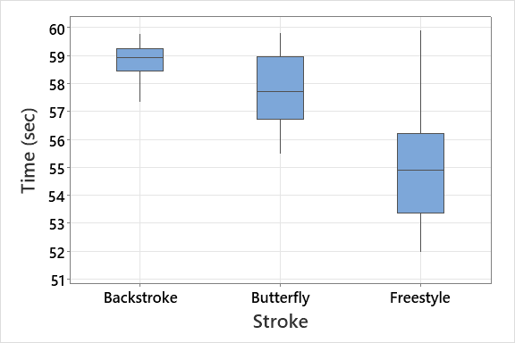

Variable | Stroke | N | Mean | StDev | Minimum | Q1 | Median | Q3 | Maximum
Time (sec) | Backstroke | 37 | 58.800 | 0.618 | 57.330 | 58.440 | 58.950 | 59.240 | 59.800
 | Butterfly | 69 | 57.698 | 1.266 | 55.480 | 56.745 | 57.720 | 58.980 | 59.830
 | Freestyle | 112 | 55.076 | 1.947 | 51.960 | 53.383 | 54.905 | 56.225 | 59.910

- Interpret the side-by-side boxplots above. Be sure to compare medians and spread (e.g., the range or IQR) and note any skew, outliers, and other interesting features. What swimming styles seem to be the quickest? Which is the most consistent?

- Most experienced swimmers know that freestyle tends to be the fastest. Assuming the swimmers in our dataset represent a random sample of elite female swimmers, calculate and interpret a 95% confidence interval for the difference in mean finishing times between freestyle and butterfly. Be sure your interpretation directly answers the question: on average, how much faster is freestyle?

  - Now we will split the data into two eras: early (before 2000) and recent (after 2000). While this cutoff may seem somewhat arbitrary, it is meaningful for several reasons:
- In 1998, new rules limited underwater swimming to 15 meters in butterfly and freestyle, which standardized race strategies.
- The 2000 Sydney Games also marked the introduction of high-tech swimsuits (e.g., Speedo Fastskin), reflecting broader advances in technology and training.
- More broadly, by 2000 women’s Olympic swimming had reached full parity in events with men and participation levels had grown significantly.
- However, note that the women’s 100m backstroke was only introduced in 2008, so there is no “early” period available for that event.
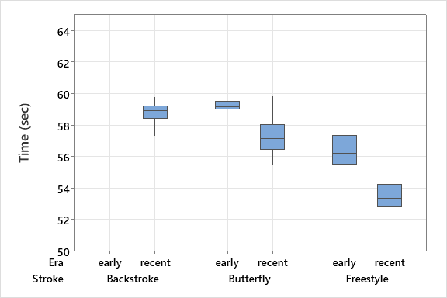

- The boxplots above show finishing times for the women’s 100m events, split into early and recent eras. Compare the distributions within each stroke (butterfly, freestyle).
  - Which stroke shows the largest improvement in times from the early to recent era?

  - How does the consistency (spread of times) change in the recent era compared to the early era?

  - Recall: the women’s 100m backstroke was only introduced in 2008, so there are no “early” Olympic results for that event. However, if there had been, sketch what you think the early backstroke boxplot might look like on the plot above. Base your sketch on the patterns you observed in butterfly and freestyle.

- The table below provides summary statistics for the three strokes in the recent era (i.e., from 2000 – 2020).

Variable | Stroke | N | Mean | StDev | Minimum | Q1 | Median | Q3 | Maximum
Time (sec) | Backstroke | 37 | 58.800 | 0.618 | 57.330 | 58.440 | 58.950 | 59.240 | 59.800
 | Butterfly | 55 | 57.307 | 1.105 | 55.480 | 56.460 | 57.170 | 58.060 | 59.830
 | Freestyle | 56 | 53.558 | 0.916 | 51.960 | 52.823 | 53.385 | 54.270 | 55.580

Again assuming the swimmers in our dataset represent a random sample of elite female swimmers, calculate and interpret a 95% confidence interval for the difference in mean finishing times between freestyle and butterfly for the recent era. Be sure your interpretation directly answers the question: on average, how much faster is freestyle?

- Compare the confidence interval you found in Question 1b (all years) with the one from Question 2b (recent era). In particular, address:
- How are the two intervals similar or different?

- What might explain any changes in the size or location of the intervals?

- Suppose we had combined men’s and women’s results into one dataset without differentiating between events.
- What problems might arise in analyzing the data this way?

- How might this affect the conclusions we draw from boxplots or confidence intervals?

- For Olympic finalists, which stroke (butterfly or freestyle), had the bigger improvement from the early to recent era. Justify your answer numerically. (However, there is no need to use statistical inference here since we’re limiting conclusions to just swimmers in our dataset.)

- (Optional) Over the decades, women’s 100m swim times have improved substantially. Consider factors such as:
- Advances in training and sports science
- Changes in swimming rules (e.g., underwater limits)
- Technology (swimsuits, pool design)
- Growth in women’s participation and support for elite athletes
Brainstorm some possible reasons how these changes make have impacted swim times.

