Each year, the National Basketball Association (NBA) holds a draft, where prospective basketball players are able to be chosen to join one of the 30 professional teams across the United States and Canada.

In order to be eligible for the draft, a player must be at least 19 years old and out of high school for at least one year. Prior to 2006, this rule was not in effect, and players could be drafted during/right out of high school.

The draft is comprised of 60 players and takes place over two rounds of 30 selections. Teams pick players in an order based on performance from the previous season, with teams that performed poorly getting earlier picks in order to create a seemingly more level playing field. It's important to note that there weren't always 30 players selected in each round, the number made its way up to 30 as more teams were added into the NBA.

The data you’ll be using comes from the dataset nba_draft.csv and focuses on players that were selected in the first round of the NBA draft between the years 1990-2021. For each player, the dataset includes a range of career statistics from their time in the NBA. Some players’ careers are still ongoing, but in this activity we will focus on the average number of minutes they have played per game.

Analyzing minutes per game is useful because it measures how much playing time a player earned during their NBA career, which is one indicator of a player’s role and value to a team. However, minutes per game is not a perfect measure of player quality because playing time can also be influenced by team expectations, injuries, roster needs, coaching decisions, and the opportunity given to high draft picks.

In this activity, we will investigate whether NBA players selected earlier in the first round tend to have different average career minutes per game than players selected later in the first round. To do this, we will compare three groups of first-round picks: picks 1-10, picks 11-20, and picks 21-30.

The graphs below summarize career minutes per game for players selected in the first round of the NBA Draft from 1990-2021. Players are grouped by where they were selected in the first round: picks 1-10, picks 11-20, and picks 21-30. The density plot shows the distribution of minutes per game for each group, with dashed vertical lines representing the group means. The side-by-side boxplots provide another way to compare the center, spread, and potential outliers in minutes per game across the three draft-pick groups.
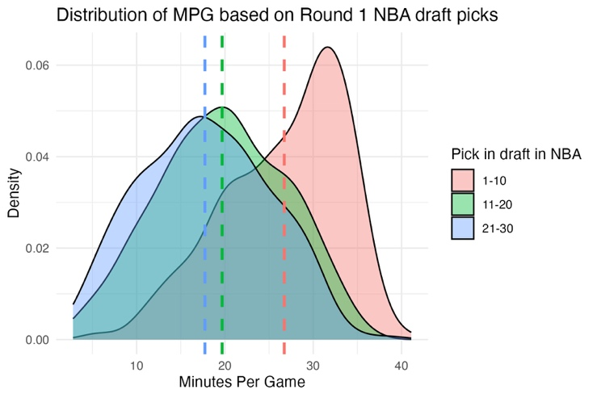
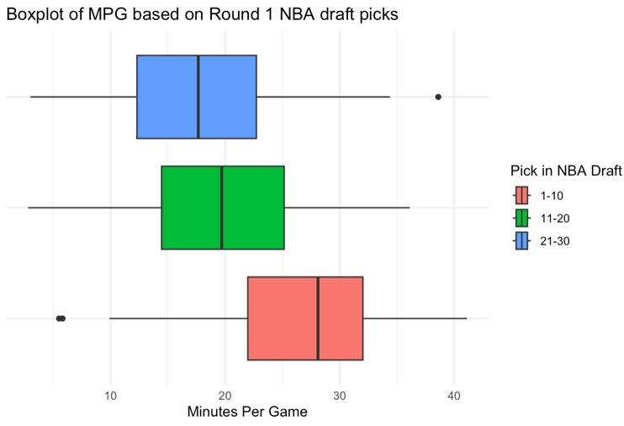

- Based on the density plot and side-by-side boxplots, what do you notice about the distributions of minutes per game for the three draft-pick groups? What conclusions can you draw upon first glance of the two data visualizations? Are there any concerns?

The players selected with picks 1-10 appear to have the highest typical minutes per game, while players selected with picks 21-30 appear to have the lowest typical minutes per game. The picks 11-20 group appears to fall between the other two groups. The density plots and boxplots suggest that average minutes per game may decrease as draft position gets later in the first round.

The spreads of the three groups appear somewhat similar, although there is still variation within each group. There may be a few low-minute or high-minute players (outliers) in each group, but there do not appear to be extreme outliers that completely dominate the plots.

- Suppose someone suggests using a one-way ANOVA to compare average minutes per game across the three draft-pick groups. Do the conditions for one-way ANOVA appear reasonable for these data? Explain your answer by discussing both the data source and the graphical displays.

- Quantitative Response Variable: Minutes per game is a quantitative variable suitable for the response in ANOVA
- Categorical Explanatory Variable with Independent Groups: Each player appears only once in one of the three non-overlapping groups.
- Approximately Normal Sampling Distribution for the Sample Mean: The density plots do not look perfectly normal, but the sample sizes (32 years with 10 picks per year in a group) are large for each draft-pick group. Because of this, the sampling distributions of the sample means should be approximately normal by the Central Limit Theorem. There do not appear to be extreme outliers that would completely dominate the analysis.
- Approximately Same Standard Deviations: The side-by-side boxplots suggest that the spreads of minutes per game are reasonably similar across the three draft-pick groups.
- Biggest potential concern is the Random Sample condition: These data come from first-round NBA draft picks from 1990-2021, not from a random sample or randomized experiment. Because of this, we should be cautious about generalizing too broadly beyond players and draft years similar to those in this dataset. (It is worth noting that a random sample is also not feasible here, so this can be a good lesson of “Its better than nothing!” in applied statistics.)

Overall, using one-way ANOVA seems reasonable, but the results should be interpreted with some caution because the data are observational and minutes per game is influenced by factors beyond just a player’s ability.

- Regardless of your answer to the previous question, write the null and alternative hypotheses for testing whether average career minutes per game differs among the three draft-pick groups. Use standard notation and also interpret each hypothesis in context.

Null Hypothesis:
$$H_{0}: u_{1-10}= μ_{11-20}=μ_{21-30}$$

(Where $u_{1}$is the population mean for that group)

The mean number of minutes played in the NBA for players who were picked 1-10, 11-20, and 21-30 in the NBA draft are all equal.

Alternative Hypothesis:
$$H_{a}: {at least one pair of u}_{i}^{'}s differ$$

For at least one group, the mean number of minutes played in the NBA is not equal. (There is at least one group of draft picks that played a different mean number of minutes in the NBA.)

- Using the information provided below, fill in the ANOVA table.
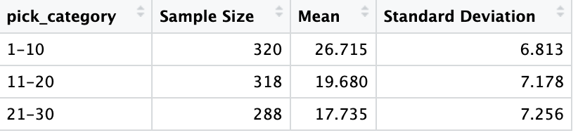

k = number of groups
n = total sample size

Additionally, for the entire dataset, the mean minutes per game was 21.506 minutes with a standard deviation of 8.060 minutes.

Source | DF | SS | MS | F-statistic | P-value
Draft-Pick Group | (k-1)  = 3-1  = 2 | SSG = 13839 | SSG/(k-1)  = 13839/2  = 6919.5 | MSG/MSE  = 6919.5/50.1  = 138.1 | $≈$0.000
Error | (n-k)  = 926 – 3  = 923 | SSE = 46252 | SSE/(n-k)  = 46252/923  = 50.1
Total | (n-1)  = 926-1  = 925 | SST = 60091

Calculations for the Sums of Squares

$SST=\left(n-1\right)*s^{2}=925*{8.060}^{2}=60091$
$SSE=\sum_{i=1}^{k}{\left(n_{i}-1\right)s_{i}^{2}}=319*{6.813}^{2}+317*{7.178}^{2}+287*{7.256}^{2}=46252$
$SSG=\sum_{i=1}^{k}{n_{i}({\overline{x}}_{i}-\overline{x})}=330*\left(26.715-21.506\right)+318*\left(19.680-21.506\right)+288*(17.735-21.506)=13839$

- Based on the ANOVA table, is there statistically significant evidence that mean career minutes per game differs among the three draft-pick groups? Explain your conclusion in context.

The p-value given in the ANOVA table is $≈0.000$meaning there is strong evidence that there is a difference among the average number of minutes played between players selected 1-10, 11-20, and 21-30 in the first round of the draft.

- Between which groups would we be most likely to see a statistically significant difference? Between which groups would we be least likely to see a statistically significant difference in minutes played? Provide evidence.

From looking at the means in the density plot and box plot, we are most likely to find a difference between those selected 1-10 and those selected 21-30 because there is the largest difference in mean number of minutes played. We are least likely to find a difference between those selected 11-20 and 21-30 because the difference in mean is the smallest.

Note: To formally determine which pairs of groups differ, we would need a follow-up multiple-comparisons procedure, such as Tukey’s method. Here, students are only using the plots and group means to identify likely differences.

- Minutes per game is useful, but it is not a perfect measure of player quality. Explain one reason why players selected earlier in the draft might have higher career minutes per game even if draft position does not perfectly measure player ability.

Instructor note: If students are unfamiliar with the NBA, it may help to explain that playing time is not automatically assigned. Coaches choose how many minutes each player receives, and high draft picks may be given more opportunities because teams have invested more in them, expect them to become important players, or simply do not have better options available to them.

Players selected earlier in the draft may receive more playing time because teams have invested more in them and may want to give them more opportunities to develop. In the NBA, coaches decide how many minutes each player gets in a game, and those decisions can be influenced by performance, injuries, team strategy, roster depth, and expectations for player development. Because of this, differences in minutes per game may reflect both player ability and opportunity.

- The draft-pick groups used in this activity, picks 1-10, 11-20, and 21-30, were chosen by the analyst. While this may be one reasonable way to divide the first round, but it is not the only option. Propose one different way to group the players or one different variable to analyze if you wanted to better understand the relationship between draft position and NBA career success. Explain why your choice might change or improve the analysis.

Answers will certainly vary and are likely based on how knowledgeable a student is about basketball. One alternative would be to compare lottery picks to non-lottery first-round picks. Lottery picks are generally selected by teams that missed the playoffs and may be viewed as higher-investment prospects. Another alternative would be to group picks by the type of team that selected them, such as lottery teams versus playoff teams, because players drafted by weaker teams may have more immediate opportunity for playing time. These groupings might better reflect differences in team context and opportunity than simply using picks 1-10, 11-20, and 21-30.

Students might also suggest using a different response variable, such as games played, points per game, win shares, or win shares per 48 minutes. These variables may capture different aspects of NBA career success. However, each possible response variable has its own limitations, so the best analysis may require considering several measures rather than relying on only one.

