League of Legends is a 5 v. 5 multiplayer online battle arena (MOBA) game developed by Riot Games. In the game, players assume the role of a “champion” with unique abilities and battle against a team of other players or computer-controlled champions. Riot Games continually collects data to evaluate the effect of every champion, adjusting and fine-tuning various aspects associated with each champion, to ensure fair and competitive gameplay. Through various updates (patches) of the game that occur every two weeks, characters might turn out to be either extremely efficient and strong, or they might need adjustments to increase their abilities, as they are on the weaker side. Therefore, in order for an overall game balance to be achieved, developers use two common strategies, known as “nerfing” and “buffing”, within the world of video games. “Nerfing” is the act of reducing the power or effectiveness of a champion or item in a video game, while “buffing” is the act of increasing its power or effectiveness.

Patch 12.22 Win Rates

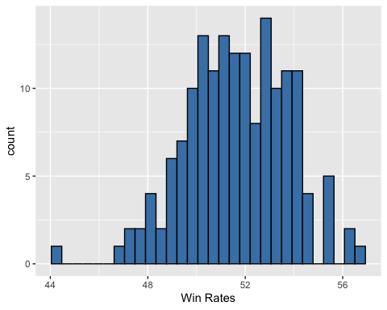

1. Indicate the observations (cases) of the data set for   
   patch 12.22.

Individual League of Legends Champions

1. Use the histogram to describe the shape, center, and spread   
   of Win Rates in patch 12.22.

Center: Around 50% or 51%  
Shape: Unimodal + Approximately Symmetric

Spread: Between 46-55% (without outliers)

Possible Outliers: below 46% and (maybe) above 55%

1. Given summary statistics and the Champions with the five highest and five lowest Win Rates. Determine if there are any outliers present. Which player(s) might need buffing? Which player(s) might need nerfing?

**1.5 * IQR Rule:**  
IQR = 53.27 – 50.2 = 3.07  
1.5(IQR) = 1.5(3.07) = 4.605

Q1 – 4.605 = 50.2 – 4.605 = 45.6  
Q3 + 4.605 = 53.27 + 4.605 = 57.88

By the IQR Rule, there is one champion that would be considered an outlier, Sion. Because Sion has a low Win rate, they need to be buffed.  
  
Note: Calculating **z-scores** for each obersvation is also another method of determining outliers. In the case of Sion, we see the following

$$z= \frac{44.2-51.66}{2.097}= -3.5574$$

Z-scores outside of ± 3 are considered outliers

|  |  |
| --- | --- |
| Mean | St. Dev |
| 51.66 | 2.097 |

|  |  |  |  |  |
| --- | --- | --- | --- | --- |
| Min | Q1 | Med | Q3 | Max |
| 44.24 | 50.20 | 51.70 | 53.27 | 56.70 |

|  |  |
| --- | --- |
| Name | Win Rates |
| Fiddlesticks | 56.7 |
| Vi | 56.4 |
| Kled | 56.1 |
| Kog'Maw | 55.6 |
| Elise | 55.4 |
| $⋮$ | $⋮$ |
| Aphelios | 47.5 |
| Azir | 47.3 |
| Zeri | 47.2 |
| Pantheon | 46.7 |
| Sion | 44.2 |

After analyzing the data, the developers of the game released the 12.23 patch of League of Legends with new “nerfed” and “buffed” champions.

Patch 12.23 Win Rates

1. A picture containing screenshot, diagram, plot, pixel

   Description automatically generated Use the histogram to describe the shape, center, and spread   
   of Win Rates in patch 12.23.

Center: Around 52%  
Shape: Unimodal + Approximately Symmetric

Spread: Between 48-54%

Possible Outliers: possibly below 48%

1. Suppose that the company took your suggestion from the previous analysis. Did the “nerf” or “buff” that you suggested work? Check by using the given summary statistics and the Champions with the five highest and five lowest Win Rates (and Sion) from Patch 12.23.

|  |  |
| --- | --- |
| Mean | St. Dev |
| 51.21 | 1.603 |

|  |  |  |  |  |
| --- | --- | --- | --- | --- |
| Min | Q1 | Med | Q3 | Max |
| 46.10 | 50.29 | 51.10 | 52.41 | 54.68 |

1.5 * IQR Rule:  
IQR = 52.41 – 50.29 = 2.12  
1.5(IQR) = 1.5(2.12) = 3.18

Q1 – 3.18 = 50.29 – 3.18 = 47.11  
Q3 + 3.18 = 52.41 + 3.18 = 55.59

By the IQR Rule, Sion’s win rate of 48.9% is no longer an outlier => the buff helped.

However, there are two (lower) outliers in the 12.23 patch – **Pantheon** and **Aphelious**.

Z-score method:   
Scion results in a *z = -1.44*, Patheon results in a *z = -2.813,* and Aphelios has *z = -3.189*)

Sion’s Win Rate is no longer considered an outlier (although still seems to be underwhelming.)

|  |  |
| --- | --- |
| Name | Win Rates |
| Vi | 54.7 |
| Maoki | 54.7 |
| Dr. Mundo | 54.3 |
| Taliyah | 54.2 |
| Kassadin | 54.0 |
| $⋮$ | $⋮$ |
| Sion | 48.9 |
| $⋮$ | $⋮$ |
| Kathus | 48.1 |
| Akali | 47.7 |
| Azir | 47.5 |
| Pantheon | 46.7 |
| Aphelios | 46.1 |

1. Do you have any further suggestions for the company as they prepare for the next patch?

Buff both Pantheon and Aphelios.

1. *(Optional)* How might you utilize the Pick Rate information in your analysis of Champions?

Answers may vary