The 2024-25 NBA season was a historic one for the Oklahoma City Thunder, who captured their first ever NBA Championship. The NBA Playoffs consist of four rounds (First Round, Second Round, Conference Finals, and NBA Finals), with each round played as a best of seven series. In the 2025 playoffs, the Thunder played a total of 23 games: 4 in the First Round, 7 in the Second Round, 5 in the Conference Finals, and 7 in the NBA Finals.
At the heart of this title run was Shai Gilgeous-Alexander (SGA), who led the league in scoring, was named NBA MVP, and capped off the season by earning the Finals MVP. His scoring consistency and ability to take over games made him one of the most dominant offensive forces in the league. This dataset, which contains SGA’s point totals from every regular season game, offers a snapshot of one of the most impressive individual seasons in recent NBA history.
In addition to its basketball significance, this dataset allows us to explore how statistical tools (such as StatKey) can be used to simulate real-world scenarios. By treating SGA’s regular season point totals as the population, we can model specific playoff situations by drawing random samples of different sizes. These simulations help us understand how much variation we might expect in his performances and how likely different playoff outcomes are based on his regular season scoring.
The data in sga_points_2025.csv contains the points scored in each regular season game by SGA.
- Construct a dotplot of SGA’s points in a game. To do so,
  - Go to https://www.lock5stat.com/StatKey/index.html
  - In the Descriptive Statistics and Graphs column, click on One Quantitative Variable.
  - Click on the Upload File button, then navigate to your copy of the sga_points_2025.csv file. Click Open, then click on points, then Ok.
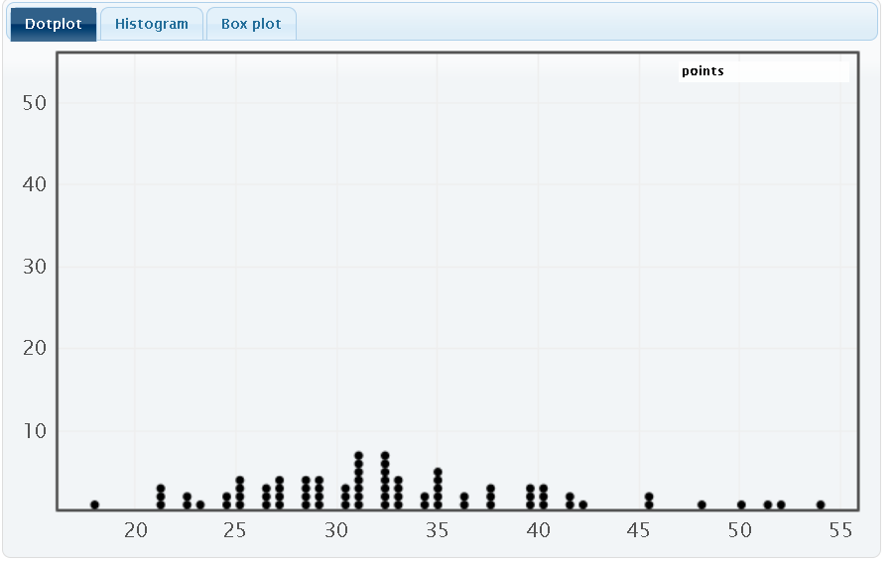
- Describe the shape, center, and spread of the distribution displayed in your dotplot.
Shape: The distribution is slightly right-skewed, most games fall between 25 and 40, but there are a couple games in the high 40’s and 50’s that stretch the right tail of the distribution. Center: The center appears to be around 32, which is right around his season points per game of 32.5. Spread: The range is 18 to 53, and most games fall between 25 and 40.

- Suppose we’re interested in understanding SGA’s average points during a n=7 game period. (This is motivated by the fact that the 2024-25 NBA Finals lasted 7 games.)
Follow these instructions to simulating an “NBA Finals Scenarios” (i.e., 7 game periods) for SGA’s points.
- In StatKey go to Sampling Distribution for a Mean.
- Click on the pull-down menu just below the StatKey button and choose sga_points_2025.csv: points. This will load the points data into this procedure.
  - Notice that this creates a smaller version of the dotplot from before on the right hand side (labeled Population).
- Click on Choose samples of size n = and change it to 7
- Click Generate 1 Sample

- You should now have one dot on your graph. What does this dot represent?
  - Tip: On the right side of the screen, what is being displayed in the lower dotplot (labeled Sample)? (You can also click on Show Data Table just above that plot.)

The average points from a random sample of 7 games.

- Now click on Generate 1 Sample again. What happens?

- We will now simulate 1000 more seven game periods for SGA. Do so by clicking on the Generate 1000 Samples button.
- This dotplot (on the main window) shows the Sampling Distribution for the Mean number of Points Scored in a random sample of 7 games by SGA. Describe the shape, center, and spread of this distribution.

Solution: Answers will slightly vary. Shape: The sampling distribution is roughly symmetric. Center: The mean of the sampling distribution is 32.504. Spread: The range is roughly between 25 and 42, with most games between 30 and 35. Also, std error = 2.74

- Record the mean and std. error for this simulation.

Roughly 32.5 and 2.74 respectively

- Recall that the 2025 NBA Finals consisted of seven games. SGA’s actual points per game in the 2025 NBA Finals was 30.3. Based on your sampling distribution, does this seem unusually high, unusually low, or fairly typical? Explain your reasoning.

Solution: SGA’s actual ppg falls slightly below the mean of the sampling distribution. Approximately 23% of simulated sample means were less than or equal to 30.3. Even though it fall below the mean, it is still fairly typical.

- Now set the sample size (n) to 23 to mimic the number of games Oklahoma City Thunder played during the 2025 playoffs, and generate 1000 samples.
- What does each dot in this simulation represent?
The average points per game from a random sample of 23 games.

- Describe the shape, center, and spread of this distribution.

Solution: Answer will slightly vary. Shape: The sampling distribution is roughly symmetric. Center: The mean of the sampling distribution is 32.496. Spread: The range is roughly between 29 and 37, with most games between 31 and 34. Also, std dev = 1.29

- Record the mean and std. error for this simulation.

Approximately 32.496 and 1.29. respectively.

- SGA’s actual points per game in the 2025 NBA Playoffs was 29.9. Based on your sampling distribution, does this seem unusually high, unusually low, or fairly typical? Explain your reasoning.

Answers will slightly vary. SGA’s actual ppg falls below the mean of sampling distribution. Approximately 2% of simulated sample means were less than or equal to 29.9. This is unusually low and suggests that his entire playoff scoring was lower than we’d typically expect based on his regular season statistics.

- General Rules and Trends: Based on your two simulations, using sample sizes of 7 and 23, what general patterns or trends do you notice about the shape, center, and spread of the sampling distributions?

Solution: Shape: When n = 23, the distribution was much smoother and more bell-shaped, when n = 7 it was more irregular and bumpy. Center: In both simulations, the sampling distributions were centered close to the same value of 32.5, which matches the mean of the original population. Spread: The std. dev was larger when n = 7 (2.74) and smaller when n = 23 (1.29). Meaning that larger samples lead to more consistent sample means.

- As the sample size increased from 7 to 23, the sampling distributions began to look more symmetric and bell-shaped. Would it be reasonable to use a Normal distribution to model these sampling distributions?

- If so, which Normal distribution (i.e., which center and spread) would you use for distribution of average points in a seven game sample?
- What about for a 23 game sample?

Solution: Students should respond
Normal(mean of sampling distribution, st error of sampling distribution)

Note that this can then be used to lead into the Central Limit Theorem approach of $\overline{Y}\sim Normal\left(μ,\frac{σ}{\sqrt{n}}\right)$

