Downriver racing is a competitive paddling sport where racers navigate a stretch of river, aiming for the fastest time. One of the most well-known races in this sport is the General Clinton Canoe Regatta—nicknamed “the 70-miler.” This challenging 63-mile race down the Susquehanna River in New York (from Cooperstown to Bainbridge) has been held annually since the 1960s. Top boats finish in about 7 to 8 hours.
Unlike many races that mostly feature recreational canoes, this event includes many pro-style racing canoes. These boats are built for speed but require more skill to handle effectively. In contrast, non-pro boats, such as recreational and stock classes, are generally slower but more stable and easier to control. While anyone can race in a pro-style canoe, the choice of boat can have a large impact on race times.
In this activity, you’ll explore race data that includes only finishers (disqualifications and non-finishers have been removed). Each canoe appears once in the data, regardless of the number of paddlers. Your main task will be to compare race results between pro and non-pro boats to see how boat type affects performance.
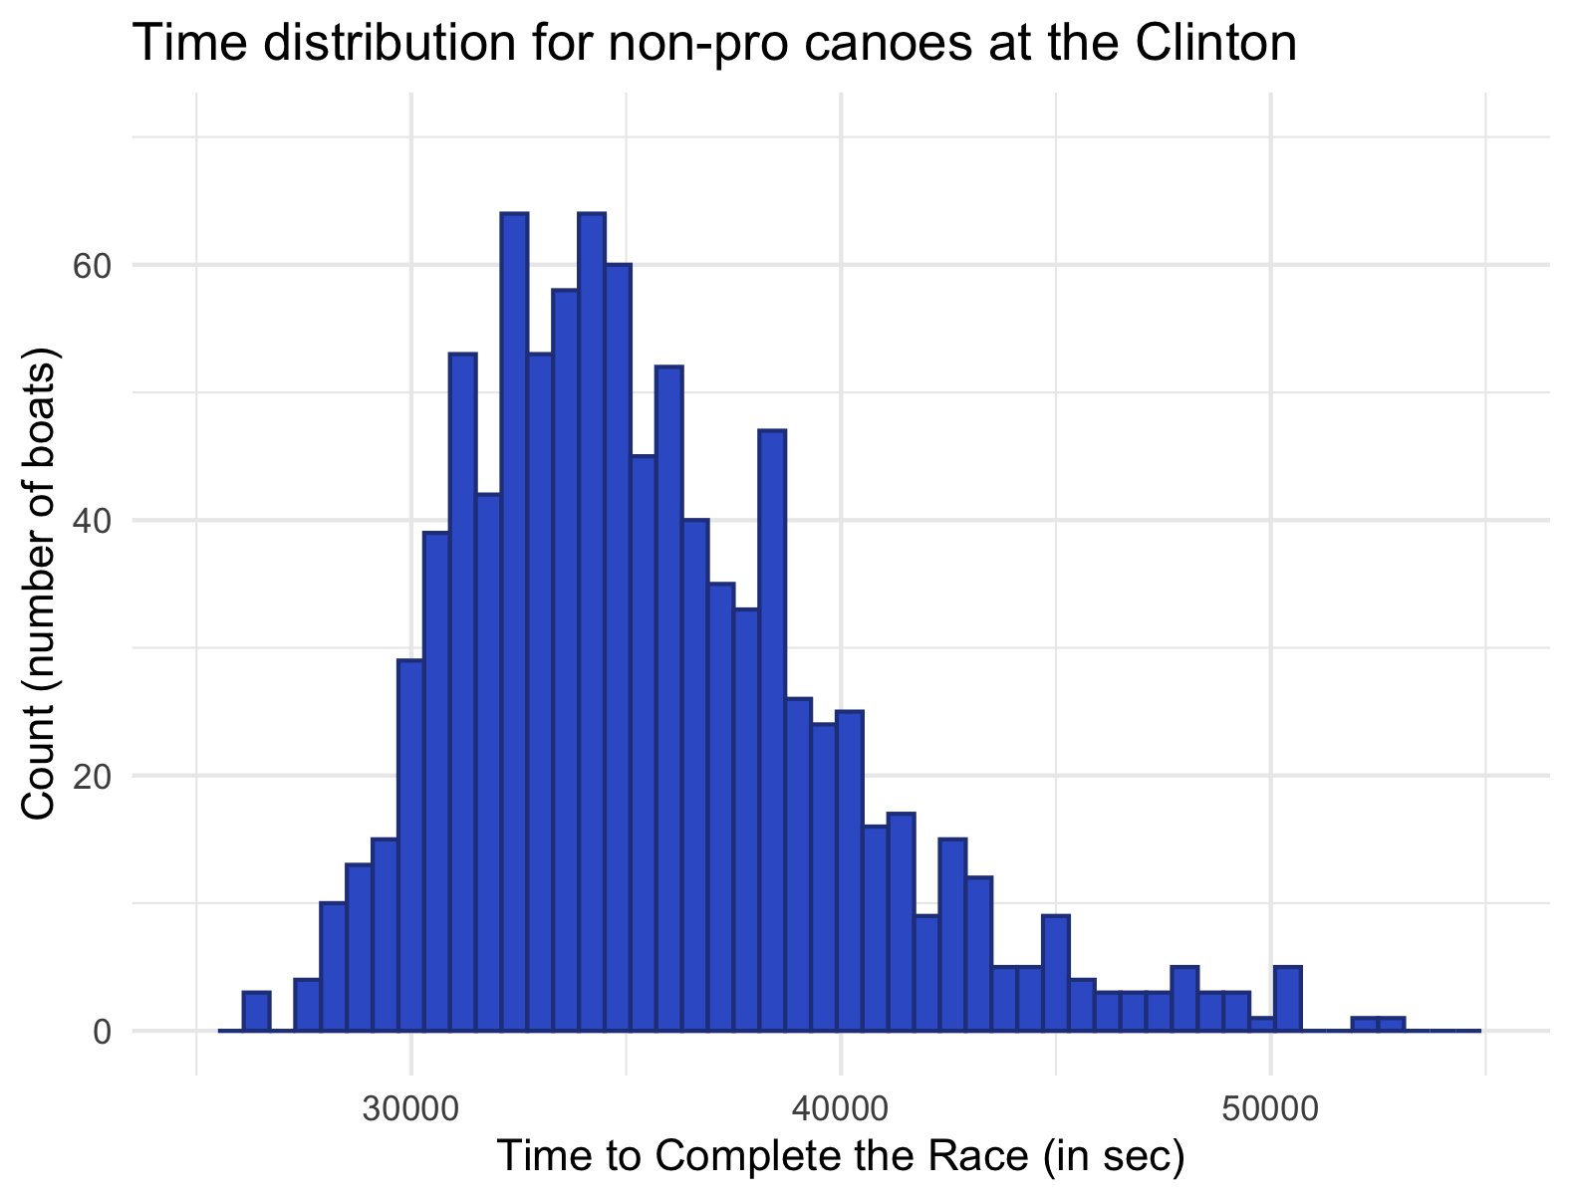
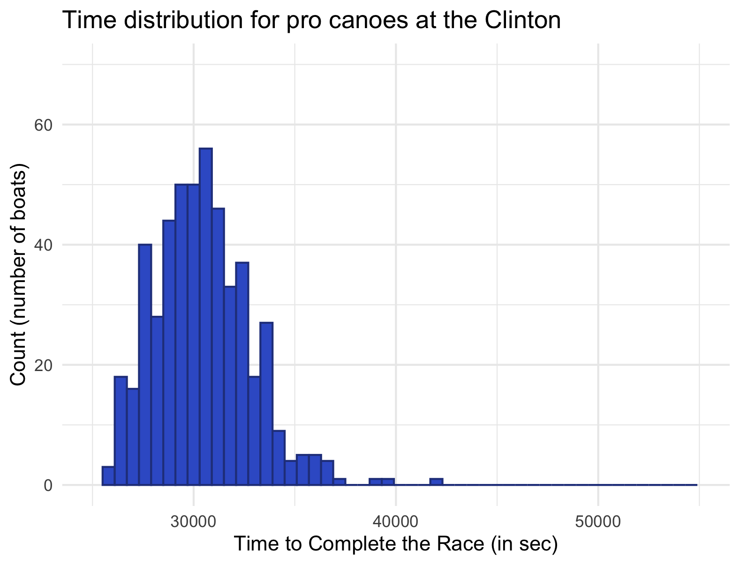
1. The histogram on the left shows the distribution of times on the Clinton from 2014-2025 for only the 497 pro canoes. The histogram on the right shows the distribution of times on the Clinton from 2014-2025 for all 954 canoes that are not pros. Use the histograms to complete the following activities.

- Describe the shape, spread, and center of the pro canoe data.

- Describe the shape, spread, and center of the non-pro canoe data.

- Based on the histograms, describe the differences between the distributions’ shapes. Use the context provided to propose a possible explanation of any differences you notice.

2. The following table shows the summary statistics for the pro and non-pro data. Use it to complete the following activities:
 | Pro | Non-Pro
Mean | 30420 | 35566
SD | 2362 | 4418
Min | 25899 | 26501
1Q | 28760 | 32404
Median | 30283 | 34817.5
3Q | 31840 | 38156.5
Max | 41761 | 52967

- Compare the measures of center and the spreads. Again, use the context provided to propose a possible explanation of any differences you notice.

- Sketch a boxplot (with no outliers) of the data with pro vs. non-pro as the boxes and completion time for the race on the y axis.

3. In 2025, Adam Blanchard and Rebecca Sutton placed first in the C2 Stock (not pro) Mixed class with a time of 8 hours, 32 minutes, and 21 seconds (30741 seconds). In the same year, Dean Brown & Chris Prater placed 40th in the pro class with a time of 8 hours, 3 minutes and 11 seconds (28991 seconds). Which of these times is better (relatively)? How did you draw your conclusion?

