Each year, the National Collegiate Athletics Association (NCAA) holds the championship tournament for women's gymnastics to crown the national champion. There are two semi-final meets that consist of four teams, and the top two teams from each semi-final meet square off in the championship finals.

This activity uses data from ncaa_gymnastics.csv which has information from the NCAA Women’s Gymnastics National Championships from the years 2008-2024 (except for 2020,as it was cancelled due to COVID-19). More specifically, we’ll be using the file beam_by_year.csv, pictured below, which takes the beam scores each year for the first, second, third, and fourth place teams. The file also contains the difference in beam score between the first-place team and the fourth-place team.

The balance beam is one of four events in the gymnastics meet (Beam, Vault, Uneven Bars, and Floor). It involves a gymnast who mounts onto an elevated balance beam, which is a long, firm, padded plank about four inches (10 cm) wide. As the name suggests, this event highlights the gymnast's balance, acrobatic skills, and leaps while they attempt multiple turns, jumps, and flips on the beam before an aerial dismount.

Women's college gymnastics uses Perfect 10 scoring, with each routine being judged out of ten points. Gymnasts are evaluated on execution, difficulty, as well as the composition of the routine, and must meet certain requirements for each.

Each team is allowed to have up to six people compete on each event, with the top five scores contributing to the combined score of that event for the team. After the entire rotation for each event, the combined scores for the four events are added together for a total score, and the team with the highest overall score is the champion.

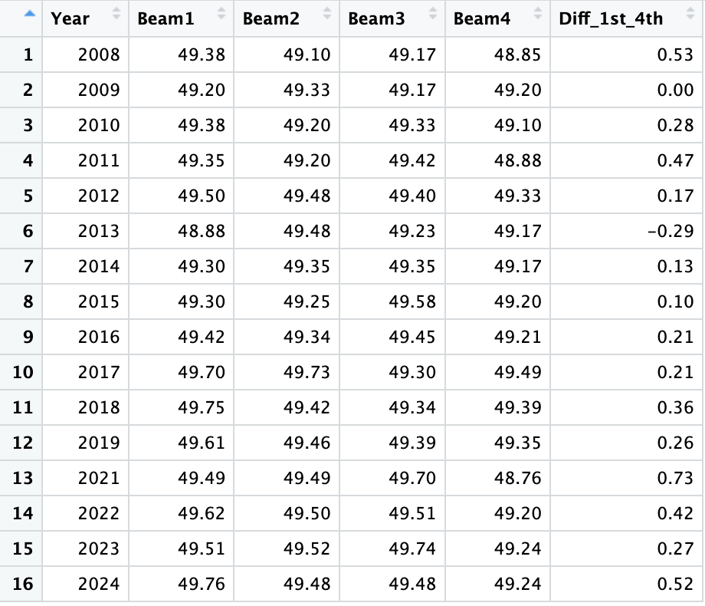

- Find the sample average beam score for teams that placed 1st in the national championship as well as those that placed 4th.

Rank = 1: $\overline{x}=49.45$
Rank = 4: $\overline{x}=49.17$

- Detail how you would use this data to calculate a bootstrap statistic by hand for the average beam score of the teams that place 1st in the national championship.

You could have a scrap of paper with each beam score of a team that placed 1st in the national championship. To calculate the bootstrap statistic (mean) you need to sample with replacement. So, you would randomly pick a piece of paper with a score, record the score, and then put that piece of paper back. You would do that 16 times in total as there are 16 observations and then you would calculate the mean of the scores you selected.

- Either using StatKey or by hand, create one bootstrap sample for the average beam score of teams that place 1st in the national championship. What is the bootstrap mean for this sample?

Any random combination of the 16 beam scores for the teams that placed first. An example below.

49.49, 49.30, 49.42, 49.62, 49.42, 48.88, 49.61, 49.42, 49.5, 49.42, 49.49, 49.38, 49.38, 49.75 49.35, 49.2

$$\overline{x}=49.41$$

- Using StatKey or another statistical software, create a bootstrap distribution for the mean beam scores of the teams that place first in the national championship. Describe the shape of the distribution. What is the standard error? Use at least 5000 samples.
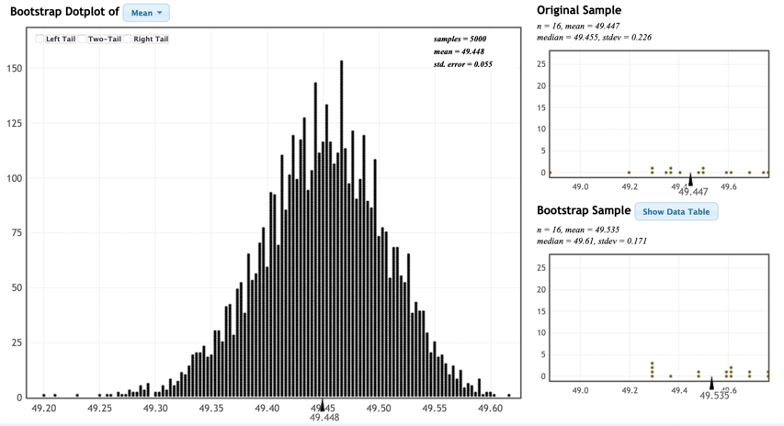

The distribution is normal shaped and centered around the sample statistic (49.45). From this distribution on StatKey, we can see that the standard error of the distribution is about 0.055 (could vary slightly based on random sampling)

- Using the standard error, create a 95% confidence interval for the average beam score of those teams that placed 1st. Interpret it in context.

95% CI:

= Statistic +- 2 * SE
= 49.45 +- 2* 0.055
=

(49.34, 49.55)

We can say with 95% confidence that the average beam score for teams that place first in the NCAA Women’s Gymnastics National Championship is between 49.34 and 49.55.

- Using StatKey or another statistical software, create a bootstrap distribution and a 95% confidence interval for the average beam score for teams that place 4th at the national championship.

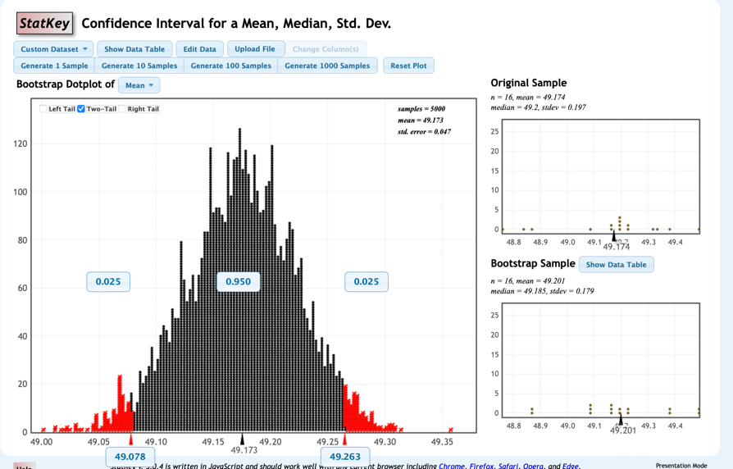
(49.078, 49.263)

Using the percentile method, we can say with 95% confidence that the average beam score for teams that place fourth in the NCAA Women’s Gymnastics National Championship is between 49.078 and 49.263.

- Let’s examine the difference in beam scores between 1st place teams and 4th place teams at the national championship.
  - What is the average distance between the balance beam scores of a team that places 1st and a team that places 4th?

Mean of diff_1st_4th column = 0.272

  - Create and interpret a 95% confidence interval for the mean difference between 1st and 4th place scores.
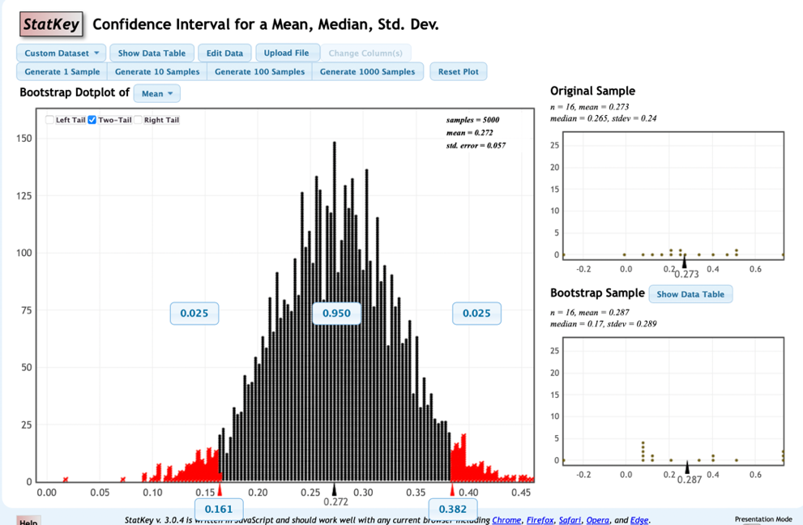
95% CI: (0.161, 0.382)

Using the percentile method, we can say with 95% confidence that on average, first place teams will have a beam score between 0.161 and 0.382 points higher than teams that place fourth in the national championship.

