- Make a histogram of total_penalties and describe the distribution.
```{r}
hist(handball_clean$total_penalties)
```
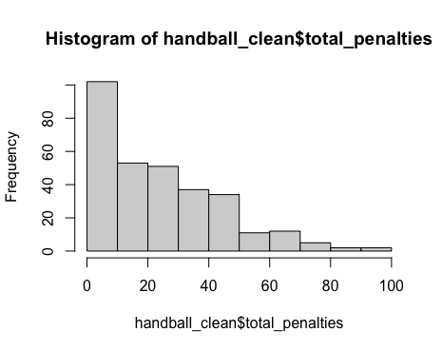
The distribution is heavily right skewed meaning its more common to have a lower amount of total_penalties.

  - Fit the model: $\hat{HPI} = β_{0}+β_{1}total_offense+β_{2} total_offense+ε$
```{r}
hpi_mod <- lm(HPI~total_offense+total_penalties, data=handball_clean)
summary(hpi_mod)
```
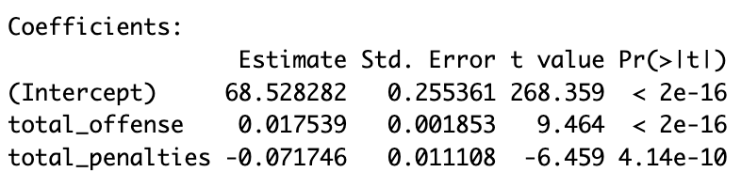

  - Interpret $β_{1}$ and $β_{2}$ in the context of HPI.
For every additional offensive play, a player’s HPI will increase by 0.017539, provided their total penalties stay constant.

For every additional penalty, a player’s HPI will decrease by 0.071746, provided their total offensive plays remain constant.

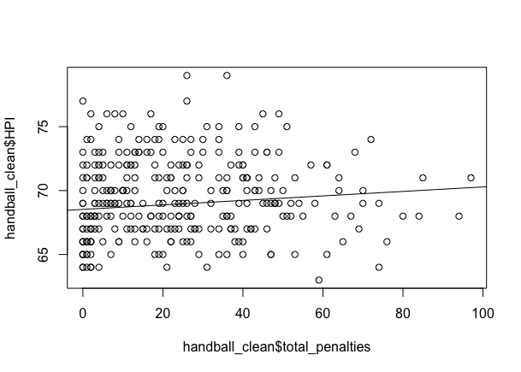
  - Create a scatterplot with a regression line, of HPI for against total_penalties. Comment on the slope.
```{r}
plot(handball_clean$HPI ~ handball_clean$total_penalties)
abline(hpi_mod)
```

The plot has a slightly positive slope. Note that the slope is positive even though the coefficient in the fitted model is negative, this is likely because the two variables are both heavily dependent on playing time

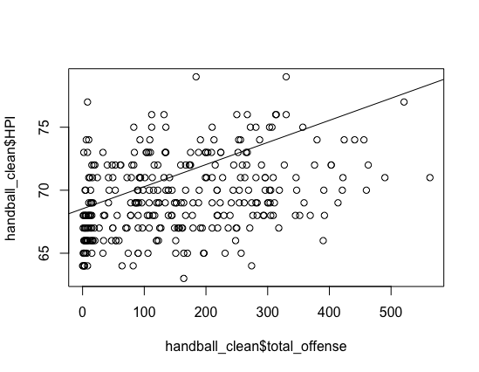
  - Create a scatterplot a regression line of HPI against total_offense. Comment on the slope.
```{r}
plot(handball_clean$HPI ~ handball_clean$total_offense)
abline(hpi_mod)
```

The plot has a steep positive slope.

- Find and interpret a 98% confidence interval for the mean HPI of players with 30 total_penalties.
```{r}
mod <- lm(HPI ~ total_penalties, data=handball_df)
newx <- data.frame(total_penalties=30)
predict(mod, newx,interval="confidence", level = 0.98)
```
(69.11, 69.97)
We are 98% confident that the mean HPI for all players with 30 total penalties for the season is between 69.11 and 69.97.
- Find and interpret a 98% prediction interval for the HPI of a player with 30 total_penalties.
```{r}
mod <- lm(HPI ~ total_penalties, data=handball_df)
newx <- data.frame(total_penalties=30)
predict(mod, newx,interval="prediction", level = 0.98)
```
(62.3, 76.78)
We are 98% confident that a player with 30 total penalties for the season will have an HPI between 62.3 and 76.78.

- Using R, perform an ANOVA test to assess the overall fit of the model:
$\hat{HPI} = β_{0}+β_{1}total_offense+β_{2} total_offense+ε.$
H₀: $β_{1}=β_{2}=0$H_{a}: $β_{1 } OR β_{2}≠0$
```{r}
summary(hpi_mod)
```
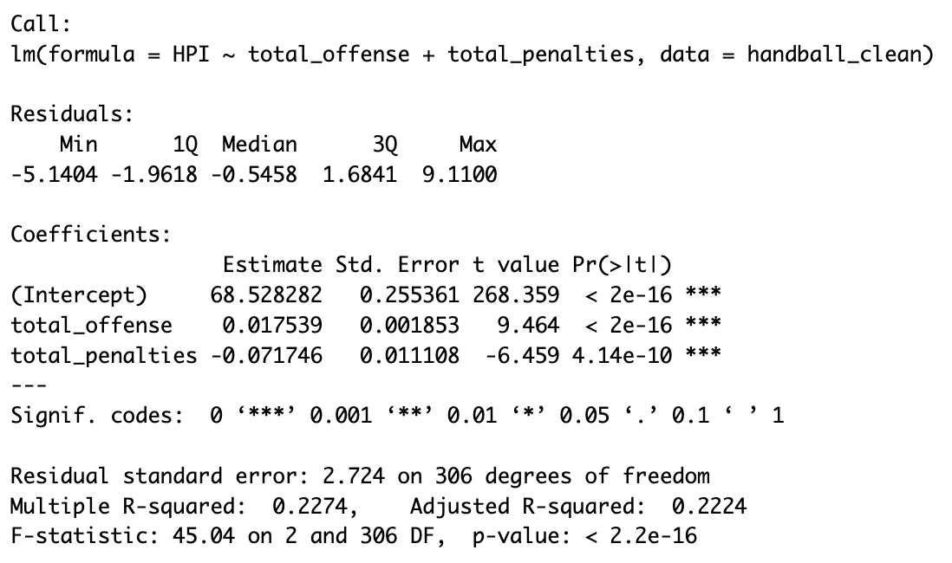
Conclusion: Reject H₀; p-value < 0.05, p-value < 0.05
We have significant evidence that both total_offense and total_penalties are effective predictors of HPI in handball.

- Total penalties vs. total offense
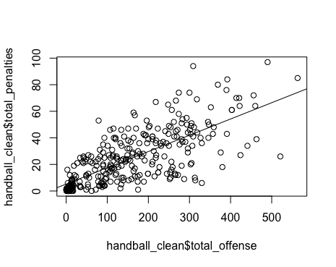
  - Create a scatterplot of total_penalties against total_offense with a regression line.
```{r}
mod <- lm(total_penalties ~ total_offense, data = handball_clean)
plot(handball_clean$total_penalties ~ handball_clean$total_offense)
abline(mod)
```

  - Based on the plot do you expect a strong correlation between total_penalties and total_offense, will it be positive or negative?

Given that the regression line shows total_penalties increasing with total_offense, I expect them to have a strong positive correlation.

- Find the correlation of total_penalties and total_offense.
```{r}
cor(handball_df$total_penalties, handball_df$total_offense)
```
r = 0.7341583
- Test the significance of the correlation between the total_offense and the total_penalties of a player. Provide an interpretation of the results.
H₀: $ρ=0$ H_{a}: $ρ ≠0$
```{r}
cor.test(handball_clean$total_offense, handball_clean$total_penalties)
```
P-value = < 2.2e-16
Conclusion:
r = 0.7341583
p-value < 0.05
Reject H₀
We have significant evidence of a strong positive correlation between total_penalties and total_offense, meaning they increase together.

- Could it be concluded that having more penalties impacts the success of a player in the form of HPI?
Having more penalties in some ways decreases a players success as they can detract from the playing time of a player. However, it seems that being a more aggressive player or a player with more penalties, tends to leads towards players being more offensively aggressive as well which does improve their success. Additionally if players play in more games they are likely to have more penalties and an overall higher HPI which could also be a reason for this trend.

