Pickleball is a fast-paced sport blending tennis, badminton, and ping-pong, played with paddles and a plastic ball on a small court. College tournaments feature singles, doubles, and mixed doubles in a best-of-three format, emphasizing strategy, teamwork, and precision. Player performance is often tracked using the DUPR (Dynamic Universal Pickleball Rating) system, which rates skill from 2.000 to 8.000 based on match results, opponent strength, and recent play. A Reliability Score (0–100%) reflects how accurate a rating is, with 60%+ considered dependable.
The file pickleBall.csv contains the ratings and reliability scores for players, based on collegiate matches from 2024. Each player in this dataset has both a doubles and singles score. Open this dataset in your statistical software of choice.
Research Question of Interest: We want to determine if there is a discernible difference between the mean singles and doubles reliability scores.
- Visualizing Reliability scores
- Create a boxplot comparing Singles and Doubles Reliability scores.
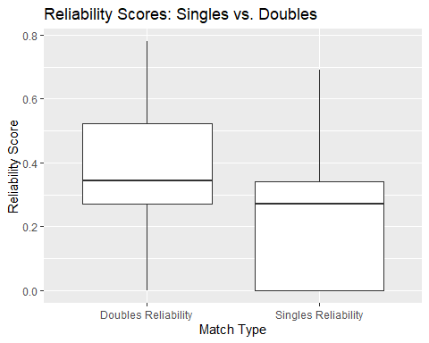
- What do you notice about the center, spread, and any outliers in the distributions? Which category appears to have a higher average reliability?
The mean for doubles reliability appears to be higher than for singles reliability, indicating that ratings tend to be more reliable for doubles matches. The spread (or variability) is larger for singles, which suggests that singles reliability scores vary more from player to player. There are no apparent outliers in either distribution based on the boxplot.
- Explain why a matched pairs t-test is likely a reasonable method to use to address the research question.
We want to perform a hypothesis test to test if there is a discernible difference between singles and doubles reliability. Because each player was measured twice (single and double reliability), we want to use a matched pairs t-test to perform the hypothesis test.
- Checking conditions
- Create a new column labeled Difference that consists of the Doubles Reliability minus Singles Reliability.
- State and evaluate the conditions needed for a paired t-test. You may assume that these players represent a representative sample of collegiate caliber pickleball athletes. Support your answers with appropriate graphical or numerical evidence as needed.
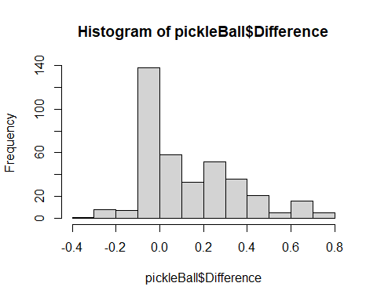
- Random Sample: We’re assuming that the observations are independent of one another. (Given that we don’t have more information about who each player was doubled with, this is likely a necessary assumption.)
- Normality: The differences between the pairs right skewed but since the sample size is 380 it should still be safe to use the t-distribution.
- No Extreme Outliers: The differences do not have any extreme outliers.
- Performing a matched pairs hypothesis test manually.
Let $μ$ be the true mean difference in rating reliability (Doubles - Singles). Use this order for convenience because doubles reliability mean is higher than singles reliability.
- State the null and alternative hypothesis.
- $H_{0}:μ=0$ (i..e The mean difference between the paired observations is zero.)
- $H_{A}:μ≠0$ (i..e, The mean difference is not zero.)
- Calculate the mean difference of the Difference column. Report your result.
0.1454211
- Calculate the standard deviation of the Difference column. Report your result.
0.212845
- Calculate the t-statistic. The formula is below in which you can do it by hand or using software as appropriate.
$$t=\frac{\overset{‾}{D}}{s_{D}/\sqrt{n}}$$
t_stat <- mean_difference / (sd_difference / sqrt(380))
t_stat
[1] 13.31851
- Calculate the degrees of freedom. Report your result.
$$df = n-1 = 379$$
- Calculate the p-value for test. Report your result.
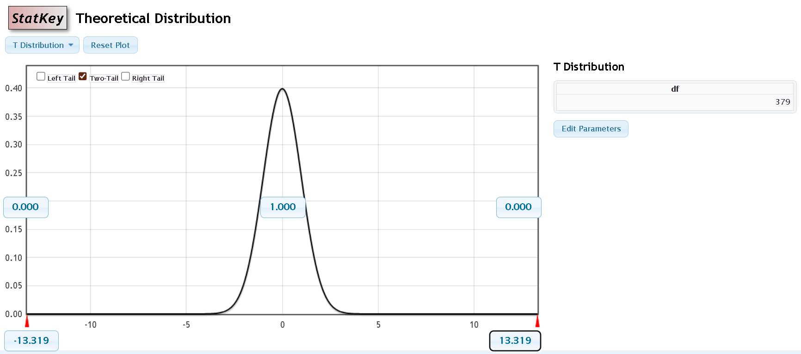
- Use the p-value to make a conclusion.
There is clear statistical evidence that the mean reliability score for doubles differs from that for singles (t = 13.319, df = 379, p-value < 0.0001).
- We can add more context to our conclusion from the hypothesis test by using a confidence interval to describe how large of a difference there is in the mean scores. Do so by constructing and interpreting a 95% confidence interval for the mean difference in reliability scores.

$$0.145±1.966*\frac{0.213}{\sqrt{379} }$$
$$0.145±0.022$$
$$(0.123, 0.165)$$
On average (and with 95% confidence), the mean doubles reliability score is 0.123 to 0.165 (12.3 to 16.5 percentage points) higher than the singles score.
- It turns out that doubles matches are more commonly played than single matches in pickleball. Why would this provide a feasible reason for seeing the results that we found?
Because doubles matches are more common in pickleball, players may have more experience playing in doubles formats. In contrast, players might have less practice or comfort in singles matches, where they are responsible for covering the entire court alone, leading to lower reliability scores on average. Therefore, the higher reliability seen in doubles matches may reflect the players’ increased experience and comfort with that format as well as the smaller amount of space they need to cover in singles.

