Model Description:

An explanation of the parameters, inputs and outputs of the TSSIM modeling code, what it does, and what functions are called. TSSIM aims to simulate the stacking patterns observed in distributary channel-lobe system using process-based statistics. It uses surface-based simulation, and grid deformation, and object-based simulation. For details see the MS dissertation by Alejandro Leiva, Stanford University, 2009.

https://pangea.stanford.edu/ERE/pdf/pereports/MS/Leiva09.pdf

Functions are in blue
Parameters are in red
Inputs (e.g. input files read into Matlab) are in green

Note: Names of directories for input CDFs of lobe parameters and output files may need to be changed to appropriate local directories if they are not located within the tssim\code directory.

After unzipping, navigate to the tssim\code directory and run ‘tssim’ from within Matlab.

Description of tssim:

tssim: This is the main program (script m-file) that calls everything else.

Parameters that can be specified in the script file (reference parameter values are shown):

ifgu_threshold = 12000;
Set the intermediate fine-grained unit (IFGU) threshold [years]. If the time between two events is longer than the threshold, the model simulates an IFGU.
int_dep_rate = 5e-5;
Average depositional rate [m/year] for time between lobes.
nlobe = 8;
Number of lobes
trend_map_range = 0.3;
Radius for the semicircular range for the trend map. It can go from 0 to 0.5. It is normalized by the length of the shorter side of the model.
s_source_windows = 60;
Total width (in pixels) of the sediment source window located in the middle of the northernmost boundary of the model.
max_lobe_thickness_allowed = 3;
Maximum thickness allowed for any lobe in the simulation[m].

Flags that have to be specified:

Show_plots;
Show all the intermediate altitude maps generated during a depositional event.
Keep_plots_after_iteration;
Keep all the plots after each depositional event. Only works if Show_plots is true.
consider_erosion; max_erosion_fraction = 0.2;
Add erosion to the simulation. max_erosion_fraction is the maximum erosion with respect to the maximum thickness allowed.
add_noise;
Add noise to the erosion and elevation map. Only used in non-conditional case.
add_noise_ifgu;
Adds noise to the IFGU simulation. Only in non-conditional case. Calls ‘sgsim’.Need to have ‘sgsim’ executable in the path.
smooth_surface; lmv_smoothing = 11;
Smooth out the surface before computing the Influence area using local moving window algorithm. lmv_smoothing is the size of the size of the window.
conditional; n_wells = 3;
Make the simulation conditional to hard data. Otherwise the simulation does not consider the data files. n_wells tells the model how many wells are to be considered.

Inputs:

base_topo: The base topography. This is currently taken from the process-based model by loading base_topo.mat.
well_data folder: hard data from wells. Files located in the folder \code\well_data\
lobe_width_cdf: the CDF of the maximum lobe widths.
lobe_length_cdf: the CDF of the maximum lobe lengths.
max_lobe_thick_cdf: CDF of maximum lobe thickness.
channel_width_cdf: CDF of maximum channel width.
intermediate_depositional_time_cdf: years of depositional time for IFGU.
chan_detrend_totL_over_W_cdf: the CDF of the variations around the trend in the ratio of length to width of the channels.

Outputs:

surface_cube: holds the top surface elevation of each layer, including the base_topo.
sim_thick_cube_strata: holds the simulated thickness if each layer.
sim_cat_cube_strata: holds the simulated category each layer.
sim_eros_cube_strata: holds the erosion thickness of each layer (negative)
tracklobe: tracks which of the layers are lobes and which are IFGUs. N-lobe for a simulated lobe layer, 0 for IFGUs, and -2 for non-simulated layers.

Visualization functions:

[model_facies model_sec_var model_facies_geoeas model_sec_var_geoeas] = get_model(surface_cube,tracklobe,ny,nz,write_file,file_name,c,max_lobe_thickness_allowed,h);
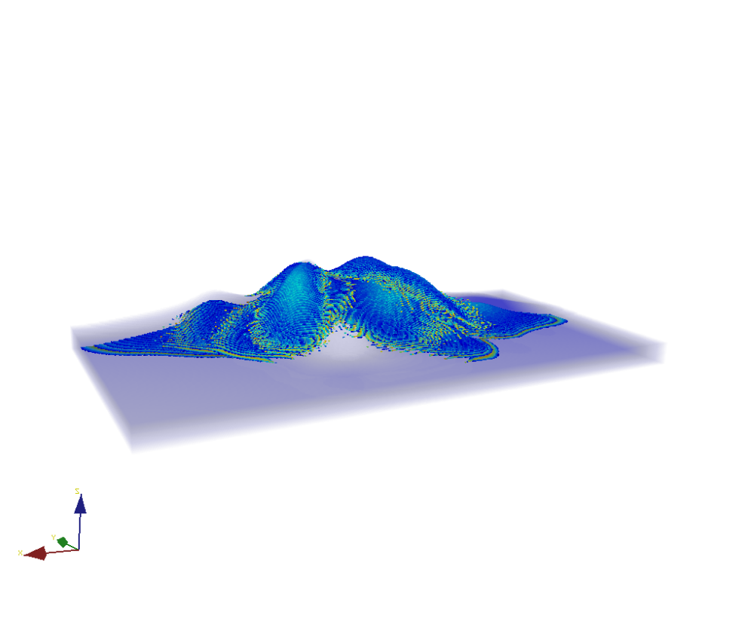

[log_facies log_sec_data zone_thickness]= get_model_slice(surface_cube,tracklobe,nz,nslice,grid_block,plot_figure,log_or_sec);

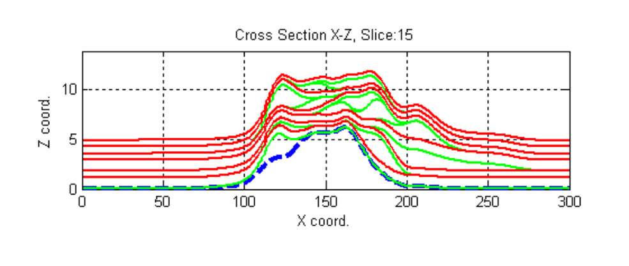

model_movie(surface_cube,tracklobe,n,code,delay,hold_image);
Shows a sequence of cross sections obtained using get_model_slice.

plot_model_slice(surface_cube,tracklobe,nslice,code,legend_flag);

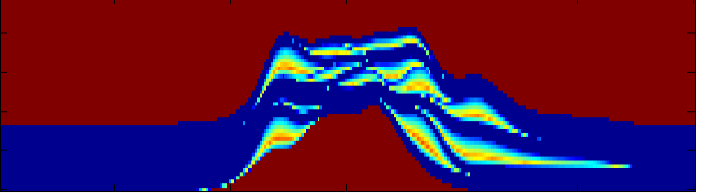

Example of how to run a simulation and get the output file 'ex1.txt'

>>tssim

>>[model_facies model_sec_var model_facies_geoeas model_sec_var_geoeas] = get_model(surface_cube,tracklobe,150,100,true,'ex1.txt',0.3,3,0.3);

Functions called by tssim:

- get_dirname;
- read_cdf_data(lobe_length_cdf_data,verbose);
- trend_map_maker(g,center_point,trend_map_range);
- make_pfield_for_startpoint_tau2(g,base_topo,trend_map_starting_point,[]);
- read_harddata(conditional,M,N,n_wells,dirname);
- lmv_surface(E,lmv.smoothing,g);
- get_core_data(hard_data_location,dirname,g);
- get_simulation_area_conditional(E,[dataj datai],pfield_startpoint,g);
- get_simulation_area(E,pfield_startpoint,show.plots,g,25);
- get_core_data_in_SA(map,hard_data_location,dirname,g);
- cont(sim_area);
- get_angle(fliplr(start_point),contour_map,85);
- get_source_location(prev_sim_elev,[pos_j pos_i],s_source_windows);
- lobe_generator(start_point,s_source_location,angles,lobe_max_thick,g, verbose,Input_path);
- centerline_generator(s_source_location1,start_point1,g);
- find_nearest_point(d_chan,g,verbose);
- channel_shape_generator(across_dist,chan_detrend_totalL_to_width_cdf, lobe_max_thick,d_chan,g);
- lobe_thickness_assignment(closeBW,start_point,g);
- noisy_data('hard_data_deposition.txt',thickness_map,0.5,g)
- write_dimension_parfile_depo('sgsim_deposition.txt',g.nx,g.ny);
- lobe_cond_thickness_assignment(closeBW,start_point,dataj,datai,pos_data,length_core,max_lobe_thickness_allowed,g);
- curvature(flipud(prev_sim_elev));
- gradient8(flipud(prev_sim_elev));
- river_direction(I,start_point);
- erosion(sim_layer,profc,G,cond_thickness_map,min_dir,center_point,g,4/5);
- get_fgu(prev_sim_elev,fines_thick,0.5);

Outline of workflow:

1.- Clear and close everything.

2.- Get the full file path.

3.- Simulation parameters and flags. Everything here is user defined.

4.- Load the surface. Might change if a different surface wants to be used.

5.- Make G-grid. Basically make a structure with the dimension of the model. It is easier to handle the dimensions by using this structure.

6.- Compute sediment source coordinates.

7.- Read in all input CDFs.

8.- Construct trend map.

9.- Initiate the matrices that will hold the model output.

10.- Assign first values to the previous matrices.

11.- Read hard data (only if conditional is true).

12.- Begin the simulation loop. Simulation continues until lobe_num <= nlobe.
- Smooth the surface
- Check if the lobe has to match the data necessarily. Case previous lobes did not go over the data location.
- Get the core data.
- Get conditional simulation area that allows the next lobe to match the data.
- Get non-conditional simulation area.
- Check if there is any data in this area.
- if not, the simulation continues as non-conditional. If there is data (conditional_thickness = true), the lobe has to meet thickness requirements.

13.- Generate lobe inside the simulation area.
- Get allowable angle range for lobe object-based simulation.
- Check is the thickness drawn from CDF is lower than the maximum thickness allowed.
- Iterate until generate a lobe in the simulation area. The tolerance can be added. No tolerance (ratio = 1), tolerance (1>ratio>0).
- Get the channel from the sediment source to the anchor point with channel width drawn from CDF.
- Perform morphological closing to avoid irregular boundaries in the lobe simulation (see Matlab help for more info).
- Check if the simulations is or not conditional.
- If not conditional, add noise in case it is required.
- If conditional, call lobe_conditional_thicknesss_assignment.

14.- Lobe thickness assignment. If not conditional noise can be added.

15.- Erosion calculation.
- Check if erosion max. value is lower than maximum fraction (e.g. 0.2) of max. lobe thickness allowed.
- Compute erosion components: Curvature, gradient (8 possible directions), and river-gradient direction relationship.
- Compute erosion map.
- Add noise in case the it is required and the simulation is non-conditional.
- Make sure that erosion does not go under the previous stacked layer.
- Save layers (surface_cube).

16.- Fine grained unit modeling.
- Compute fine grained unit thickness (average thickness for the unit).
- Check if depositional time drawn from CDF is larger than the threshold set by the user. In case it is, the IFGU simulation starts.
- Stack the layer just simulated (surface_cube) and assign flag (0) to tracklobe output.

17.- Re-start variables used in the loop. Simulation goes on until lobe_num > nlobe.

Functions description:

- get_dirname;
Very useful function that identifies where the files are and give the filepath correct to make the simulation able to run from anywhere the files are located.

- read_cdf_data(lobe_length_cdf_data,verbose);
Simple program that opens the CDF data file, scans it for the data, and then reports it in a 2-column matrix.

- trend_map_maker(g,center_point,trend_map_range);
Program generates trend map from sediment source until b, which is a fraction of the shortest model size dimension.

- make_pfield_for_startpoint_tau2(g,base_topo,trend_map_starting_point,[]);
Computes p-field for drawing anchor point location. The last parameter is a p-field that considers previous anchor point. At the first iteration it is []. Then it is computed using center_line_proxy.

- read_harddata(conditional,M,N,n_wells,dirname);
Reads hard data in case of conditional simulation.

- lmv_surface(E,lmv.smoothing,g);
Smoothes out the E surface using local varying windows. lmv.smoothing is the size of the windows.

- get_core_data(hard_data_location,dirname,g);
Get code data information of the well that is in the simulation area.

- get_simulation_area_conditional(E,[dataj datai],pfield_startpoint,g);
Gets conditional simulation area that matched the data in position: [dataj datai]. Considers pfield_startpoint in the anchor points drawing process.

- get_simulation_area(E,pfield_startpoint,show.plots,g,25);
Gets non-conditional simulation area. The last parameter is the constraint regarding the minimum length of the influence area.

- get_core_data_in_SA(map,hard_data_location,dirname,g);
Retrieves the core data in the simulation area.

- cont(sim_area);
Computes the contour of any binary image.

- get_angle(fliplr(start_point),contour_map,85);
Valid angle range used in the lobe simulation. The last input is the percentile of values considered in the distance calculation from the anchor point to the boundary that define the valid range of angles.

- get_source_location(prev_sim_elev,[pos_j pos_i],s_source_windows);
Gives the location of the sediment source inside the s_source_windows. This is located in the lowest half-space on the northern boundary of the model. The half-space is defined by the lobe position.

- lobe_generator(start_point,s_source_location,angles,lobe_max_thick,g, verbose,Input_path);
Generates lobe 2D simulation inside the simulation area defined by the dependence area.

- centerline_generator(s_source_location1,start_point1,g);
Computed the channel center-line from sediment source to anchor point.

- lobe_thickness_assignment(closeBW,start_point,g);
Assigns thickness to the closeBW binary image.

- noisy_data('hard_data_deposition.txt',thickness_map,0.5,g)
Generates file used in the GSSIM to add noise to the lobe simulations. Only used in case of non-conditional simulations. Third parameter indicates what portion (0-1) of the lobe data is used in the simulations.

- write_dimension_parfile_depo('sgsim_deposition.txt',g.nx,g.ny);
Writes .par file used in the noise simulation. There different files for deposition, erosion and fine-grained unit.

- lobe_cond_thickness_assignment(closeBW,start_point,dataj,datai,pos_data,length_core,max_lobe_thickness_allowed,g);
Assigns thickness to the closeBW binary image account for hard data in the [dataj,datai] location.

- curvature(flipud(prev_sim_elev));
Computes curvature of a digital elevation model.

- gradient8(flipud(prev_sim_elev));
Computes gradient of a digital elevation model in a 8-direction scheme.

- river_direction(I,start_point);
Computes influence area direction (river direction) in a 8-direction scheme. Value used in the erosion.

- erosion(sim_layer,profc,G,cond_thickness_map,min_dir,center_point,g,4/5);
Computes erosion considering gradient direction, gradient magnitude, influence area orientation and surface curvature profile. Function has to be adjusted in case of conditional simulations.

- get_fgu(prev_sim_elev,fines_thick,0.5);
Gets fine-grained unit thickness map considering underlying topography prev_sim_elev. The last parameter [0,1] indicates how much the topography is considered in the simulation.

