
Department of Computer Science

Software Design Description

Bursary-Bridge

Supervisor
Ms Zulu

Submitted by
Student Name | Student Number
1. CPP Mchunu | 202242486
2. A Nsibande | 240079346
3. KN Bikile | 202356797
4. SP Tshazi | 240103222
5.
6.

September 2026

Table of Contents

1.0. Introduction 4
1.1. Purpose 4
1.2. Scope 4
1.3. Glossary 5
1.4. References 6
1.5. Overview of document 6
2.0. Deployment diagram 7
3.0. Architecture design 9
3.1. Web System Architecture 9
Student Portal 10
Corporate Portal 11
Administration Portal 13
Bursary Ingestion Pipeline 15
Document Extraction Engine 16
Application Import Pipeline 17
Motivational Letter Composer 20
Authentication and Session Module 21
Matching Engine 23
Eligibility Service 25
Application Programming Interface 26
Document Storage Service 27
Notification and Email Service 30
Bursary-Bridge Database 31
4.0. Data structure design 32
4.1. Data field types and sizes. 33
5.0. Use case realizations 36
Use Case: Log In 36
Use Case: Complete Student Profile 37
Use Case: View Matched Opportunities 38
Use Case: Apply for Funding 39
Use Case: Browse All Bursaries 40
Use Case: Generate Motivational Letter 41
Use Case: Auto-Fill Application Forms 42
Use Case: Create Funding Programme 43
Use Case: Import Applications 44
Use Case: Review Imported Applications 45
Use Case: Review Applicant 46
Use Case: Shortlist Applicant 47
6.0. Interface design 48
7.0. Help system design 79
8.0. Index 80

Table of Figures

Figure 1 Deployment Diagram 7
Figure 2 Architecture Design 9
Figure 3 System Sequence Diagram 36
Figure 4 Log In Sequence Diagram 37
Figure 5 Complete Student Profile Sequence Diagram 38
Figure 6 View Matched Opportunities Sequence Diagram 39
Figure 7 Apply for Funding Sequence Diagram 40
Figure 8 Browse All Bursaries Sequence Diagram 41
Figure 9 Generate Motivational Letter Sequence Diagram 42
Figure 10 Auto-Fill Application Forms Sequence Diagram 43
Figure 11 Create Funding Programme Sequence Diagram 44
Figure 12 Import Applications Sequence Diagram 45
Figure 13 Review Imported Applications Sequence Diagram 46
Figure 14 Review Applicant Sequence Diagram 47
Figure 15 Shortlist Applicant Sequence Diagram 48
Figure 16 Landing page 49
Figure 17 Log in page 50
Figure 18 Registration, choice of account type 51
Figure 19 Student registration 52
Figure 20 Organisation registration 53
Figure 21 Student dashboard 54
Figure 22 Student profile 55
Figure 23 Opportunities, ranked by match 56
Figure 24 Opportunity detail, with the match explained 57
Figure 25 Application form 58
Figure 26 Student application tracker 59
Figure 27 Application detail 60
Figure 28 Student document library 61
Figure 29 Student notifications 62
Figure 30 Student account settings 63
Figure 31 Corporate dashboard 64
Figure 32 Funding programmes held by the Organisation 65
Figure 33 Funding programme editor 66
Figure 34 Applications received 67
Figure 35 Applicant review, with the eligibility verdict 68
Figure 36 Shortlists 69
Figure 37 Beneficiaries 70
Figure 38 Corporate reports 71
Figure 39 Organisation profile 72
Figure 40 Landing page at a tablet width of 834 pixels 73
Figure 41 Opportunities at a tablet width of 834 pixels 74
Figure 42 Applications received at a tablet width of 834 pixels 75
Figure 43 Landing page at a mobile width of 390 pixels 76
Figure 44 Student dashboard at a mobile width of 390 pixels 77
Figure 45 Opportunities at a mobile width of 390 pixels 78
Figure 46 Corporate dashboard at a mobile width of 390 pixels 79

1.0. Introduction

1.1. Purpose
This Software Design Description presents the design of Bursary-Bridge, a web application that connects South African students with bursaries, scholarships and other education funding, and gives the organisations that fund education a place to publish those opportunities and administer the applications they attract. It describes the design entities that make up the system, the responsibilities of each, the interfaces between them, the structure of the stored data and the way the use cases stated in the Software Requirements Specification are realised by those entities.
The expected audience is the Department of Computer Science at the University of Zululand, including the project supervisor and the studio committee, together with any developer who is asked to extend or maintain the system. The reader is assumed to be familiar with the Software Requirements Specification for Bursary-Bridge, to which this document is a companion; requirements are not restated here except where a design decision cannot be understood without them.

1.2. Scope
This document contains a complete description of the design of Bursary-Bridge as implemented in the prototype.
The architecture is a single web application served from one process. It is built on Next.js 15 using the App Router, with React 19 components rendered on the server by default, TypeScript throughout and Tailwind CSS for presentation. Persistent state is held in PostgreSQL and reached through Prisma. The application exposes two portals over one codebase and one database: a Student portal and a Corporate portal.
The system recognises exactly two roles, STUDENT and CORPORATE. A Student builds a profile, receives ranked funding opportunities with the reasons behind each score, and applies using the profile already captured. A Corporate User states an organisation's funding criteria as structured data, publishes funding programmes, and moves applicants through review, shortlisting and selection. No administrative, university or government role exists in the system.
The prototype does not disburse funds, does not verify submitted documents against any external authority, and does not integrate with the administration systems of universities or of government. Those lie outside the scope of this release and are not designed for in this document.

1.3. Glossary
Term | Definition
Applicant | A Student who has submitted an Application to a Funding Programme.
Application | A Student's formal request for funding under a specific Funding Programme, carrying a status, the match score recorded at submission, answers to programme questions and any attached Documents.
App Router | The Next.js routing model used by the system, in which the directory structure under app/ defines both the pages and the HTTP route handlers.
Corporate User | A representative of an Organisation who administers that Organisation's Funding Programmes. Also referred to as the Funder.
Design Entity | A named component of the design with a distinct responsibility, described in Section 3 by its type, attributes, resources and operations.
Eligibility Outcome | The verdict returned when an Applicant is evaluated against a programme's Eligibility Rule: ELIGIBLE, NOT_ELIGIBLE or PENDING_VERIFICATION.
Eligibility Rule | The machine-readable conditions attached to a Funding Programme, held as typed columns rather than free text.
Funding Programme | A bursary, scholarship or grant published by an Organisation, to which Students may apply.
Guard | A server-side function that establishes the caller's identity and role and returns the identifiers used to scope every subsequent database query.
Match Score | A percentage from 0 to 100 expressing how closely a Student's profile fits a Funding Programme, produced by the Matching Engine.
Matching Engine | The pure component that scores a Student profile against a Funding Programme across six weighted criteria and returns both the score and the reasons behind it.
Organisation | A corporation, foundation, non-governmental organisation or other body that funds education through the system.
Prisma | The type-safe object relational mapper through which all database access passes.
Programme | A standardised course of study held in the catalogue, distinct from a Funding Programme.
Route Handler | A server-side function under app/api that answers an HTTP request, validates its body and calls the service layer.
Server Component | A React component rendered on the server, able to query the database directly and never shipped to the browser.
Service Layer | The modules under services/ that hold the read and write logic shared by pages and route handlers.
Session | A server-side record identifying a signed-in user, addressed by an opaque token held in an httpOnly cookie.
Study Preference | A course paired with the institution at which the Student wishes to study it, held as one record.
Zod | The schema library used to validate every request body on the server.

1.4. References
[IEEE] The applicable IEEE standards are published in “IEEE Standards
Collection,” 2001 edition. IEEE 1016 Recommended Practice for Software
Design Descriptions provides the structure adopted by this document.

[SRS] “Software Requirements Specification: Bursary-Bridge, A Bursary and
Scholarship Matching Platform.” Department of Computer Science,
University of Zululand, 2026. All Section 3.2 cross references in Section 5
of this document refer to that specification.

[Next] Next.js 15 documentation, App Router. Vercel, 2025.

[Prisma] Prisma ORM documentation, version 6. Prisma Data, Inc., 2025.

[POPIA] Protection of Personal Information Act 4 of 2013, Republic of South
Africa.

1.5. Overview of document
The remaining chapters and their contents are listed below.
Section 2 is a Deployment Diagram showing the physical nodes on which the system runs and the artefacts placed on each, so that the location of every part of the system is unambiguous.
Section 3 is the Architecture Design. It identifies the design entities that collaborate to perform the functions of the system and describes each by its name, type, description, attributes, resources and operations, in the manner recommended by IEEE 1016.
Section 4 concerns the Data Structure Design, giving the logical structure of the stored data and the type and size of each field.
Section 5 contains the Use Case Realizations. Each use case is traced from the Software Requirements Specification to the design objects that carry it out, and is illustrated by a sequence diagram.
Section 6 discusses the User Interface Design and shows the implemented screens.
Section 7 covers the help system.
Section 8 is the index.

2.0. Deployment diagram
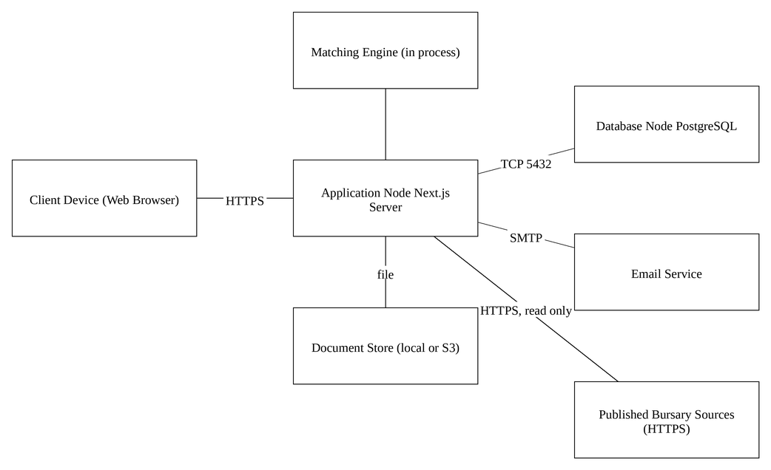
Figure 1 Deployment Diagram
Bursary-Bridge is deployed as a single Node.js process serving both portals, with PostgreSQL as the only persistent store. The browser is the sole client; no native application is distributed.
The application node runs the Next.js server, which renders the React server components, executes the route handlers under app/api and hosts the Matching Engine in process. The Matching Engine is not a separate service: it is a pure TypeScript module with no input or output of its own, which is what allows the same scoring code to run when a Student views their matches and when a Corporate User reviews an applicant.
The database node runs PostgreSQL and is reached only by the application node, over a connection string held in the environment rather than in source control. No client ever addresses the database directly.
Uploaded documents are held outside the public web root. In the prototype they are written to a directory on the application node; when STORAGE_DRIVER is set to s3 the same interface writes to S3-compatible object storage instead, and no calling code changes. Documents are never served as static files: every retrieval passes through an authorised route handler.
The one cooperating system is an electronic mail service, used for address verification and for notifications raised when an application changes status. The prototype's default driver writes these messages to the server console; the system takes no decision that depends on their delivery.

3.0. Architecture design

3.1. Web System Architecture
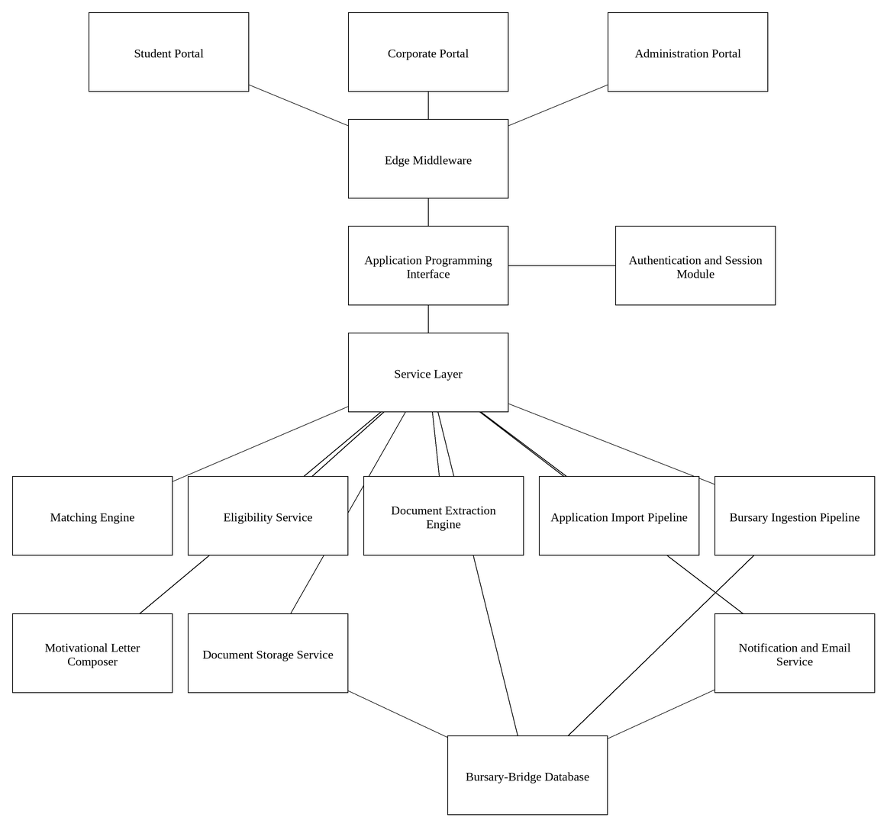
Figure 2 Architecture Design
The system is layered. The browser holds presentation only. The application node holds the pages, the route handlers, the service layer and the pure domain modules. The database holds all persistent state. Requests move downward through the layers and data moves upward; no layer reaches past the one beneath it.
Two properties of this arrangement carry most of the design. The first is that authorisation is established at the top of every server-side entry point by a guard, which returns the identifiers that then scope every query, so an authorisation failure is a missing identifier rather than a forgotten check. The second is that the Matching Engine is pure: it imports neither Prisma nor React, receives plain data structures and returns a score with its reasons, which makes it independently testable and prevents the score shown to a Student from diverging from the verdict shown to a Funder.
The design entities that follow are the components of the system. Each is described by its name, type, description, attributes, resources and operations.

Student Portal
Name: Student Portal
Type: Set of web pages
Description: The Student Portal is the set of screens presented to a user holding the STUDENT role. It comprises the dashboard, the opportunities list, the opportunity detail and application screens, the applications tracker, the document library, the notification list, the account settings and the seven-step onboarding sequence that builds the profile.
The pages are React server components. They query the service layer directly during rendering rather than fetching from the application's own HTTP interface, so the first paint carries real data and no loading state is shown for content the server already holds. Only the interactive parts, principally the forms, are client components.
Every page under /student and /onboarding calls a guard before it reads anything. A visitor without a session never reaches these pages: the edge middleware redirects them to the login screen and preserves the path they were heading for.
Attributes:
Route prefix: /student, /onboarding/student
Rendering: server components, with client components for forms
Guard: requireStudent(), requireOnboardedStudent()
Resources:
Service layer: matching, student-profile, student-summary, profile-strength, notifications
Authentication and Session Module
Operations:
Name: viewDashboard()
Arguments: None
Returns: Rendered page
Pre-condition: The Student holds a valid session
Post-condition: The dashboard is displayed with the profile strength, the strongest matches and the state of any open applications
Exceptions: No session: the user is redirected to the login page
Flow of Events:
The Student requests the dashboard.
The guard establishes the identity and returns the student profile identifier.
The page asks the service layer for the profile summary and the ranked opportunities.
The Matching Engine scores each published programme against the profile.
The page is rendered with the results and returned.

Name: completeOnboardingStep()
Arguments: Step name, submitted form values
Returns: Redirect to the next step
Pre-condition: The Student holds a valid session
Post-condition: The step is saved, the profile strength is recalculated and the Student is advanced to the next step
Exceptions: Validation failure: the step is redisplayed with messages against the offending fields and nothing is written
Flow of Events:
The Student completes the fields of the current step.
The values are submitted to the onboarding route handler.
The handler validates them against the step's schema.
The service layer writes the values and records the step reached, so an interrupted profile can be resumed.
The Student is advanced to the next step.

Corporate Portal
Name: Corporate Portal
Type: Set of web pages
Description: The Corporate Portal is the set of screens presented to a user holding the CORPORATE role. It comprises the dashboard, the funding programme list and editor, the applications table, the applicant review screen, the shortlists, the beneficiaries, the reports, the organisation profile and the four-step organisation onboarding sequence.
Every read performed by these pages is scoped to the organisation identifier returned by the guard. A Corporate User cannot address another organisation's programmes or applications, because no query in the portal is written without that identifier in its filter.
The applicant review screen presents the eligibility verdict and the reasons behind it alongside the applicant's profile. The verdict is produced by the same criteria that generated the Student's match score, so the two views of a single pairing cannot disagree.
Attributes:
Route prefix: /corporate, /onboarding/organisation
Rendering: server components, with client components for forms and filters
Guard: requireCorporate()
Resources:
Service layer: applicants, shortlists, corporate-stats, organisation-summary, notifications
Eligibility Service
Authentication and Session Module
Operations:
Name: reviewApplicant()
Arguments: Application identifier
Returns: Rendered page
Pre-condition: The Corporate User holds a valid session and the application belongs to their Organisation
Post-condition: The applicant's profile, eligibility verdict and reasons are displayed
Exceptions: The application belongs to another Organisation: the record is not found and the request is refused
Flow of Events:
The Corporate User selects an application.
The guard returns the organisation identifier.
The service layer loads the application, filtered by that identifier as well as by the application identifier.
The Eligibility Service evaluates the applicant against the programme's Eligibility Rule.
The page is rendered with the verdict and the reason for each criterion.

Name: publishProgramme()
Arguments: Funding programme identifier
Returns: Updated programme status
Pre-condition: The programme is in DRAFT and its eligibility criteria are complete
Post-condition: The programme status becomes PUBLISHED and it becomes visible to matching Students
Exceptions: Incomplete criteria: publication is refused and the missing items are named
Flow of Events:
The Corporate User opens a draft programme.
The system checks that the programme carries an Eligibility Rule and the fields a match requires.
The Corporate User confirms publication.
The status is set to PUBLISHED and the change is written to the audit log.
The programme enters the pool the Matching Engine scores.

Administration Portal
Name: Administration Portal
Type: Set of web pages
Description: The Administration Portal is the set of screens presented to a user holding the ADMIN role. It comprises the catalogue of institutions and courses, the user register, the organisation and funding programme registers, the bursary data sources and their run history, and the audit trail.
The portal maintains the platform rather than any one Organisation's funding. It holds no application data of its own: every screen acts on records owned elsewhere in the system, and every action it takes is written to the audit log with the acting administrator and a stated reason.
Every page under /admin calls requireAdmin() before it reads anything. The guard is applied in the layout, so a page added later inherits it rather than having to remember it.
Attributes:
Route prefix: /admin
Rendering: server components, with client components for forms
Guard: requireAdmin(), apiAdmin()
Resources:
Service layer: admin-catalogue, admin-users, admin-organisations, admin-programmes, admin-ingestion, admin-audit
Authentication and Session Module
Operations:
Name: setCatalogueEntryStatus()
Arguments: Entry identifier, target status, entry kind
Returns: The updated entry
Pre-condition: The administrator holds a valid session
Post-condition: The entry is active or retired; records already pointing at it are unaffected
Exceptions: Unknown entry: the request is refused and nothing is written
Flow of Events:
The administrator retires or restores an institution or course.
The service counts the student profiles and funding programmes that point at the entry.
The status is changed rather than the row deleted, so those records keep the institution or course they name.
The count is returned to the administrator with the result.

Name: runIngestion()
Arguments: None
Returns: The identifier and outcome of the run
Pre-condition: The administrator holds a valid session and at least one source is authorised
Post-condition: A run is recorded, with the opportunities it created, updated, merged and rejected
Exceptions: A source whose robots file disallows collection is recorded as not read; a source that cannot be reached makes the run BLOCKED rather than SUCCEEDED
Flow of Events:
The administrator starts a run.
The Bursary Ingestion Pipeline reads each authorised source's robots file and honours it.
Each listing and detail page is fetched at the rate the source asks for.
Each candidate is validated, deduplicated and stored with the address it was read from.
The run is closed with its counts and any note.

Bursary Ingestion Pipeline
Name: Bursary Ingestion Pipeline
Type: Server-side module
Description: The Bursary Ingestion Pipeline collects funding opportunities from published external sources. It is the only part of the system that creates an opportunity nobody has entered by hand, and it is constrained accordingly: a source is read only after an administrator has authorised it by name, its robots file is read first and honoured, and the rate it asks for is observed.
Extraction is deliberately literal. Each field is either found on the page or left unset; nothing is inferred from a neighbouring value. A candidate that cannot be shown to describe a real opportunity is rejected rather than stored with gaps, and every stored opportunity carries the address it was read from and the date it was last confirmed.
The module is written against a fetcher interface rather than the network directly, so the same pipeline runs over pages supplied offline. That is what allows it to be tested without reading a live site.
Attributes:
Location: lib/ingest, services/opportunity-ingest
Authorised sources: declared in the source registry, disabled by default
Provenance: source address, source name, source type and verification dates on every opportunity
Resources:
Bursary-Bridge Database
The published pages of the authorised sources, over HTTP
Operations:
Name: runSource()
Arguments: A registered source, and optionally a page limit
Returns: The candidates found and the rejections, with a status
Pre-condition: The source is authorised and has listing pages configured
Post-condition: Nothing is written; the outcome is returned for the caller to persist
Exceptions: Disallowed by robots: the source is reported as not read. Unreachable: the source is reported as blocked, which is distinct from having found nothing
Flow of Events:
The robots file for the source's host is read and parsed.
Each listing page permitted by that file is fetched.
The listing is parsed into candidates and links to detail pages.
Each detail page is fetched and parsed, waiting between requests for as long as the source asks.
Each candidate is validated, and those describing the same opportunity are merged.

Document Extraction Engine
Name: Document Extraction Engine
Type: Server-side module
Description: The Document Extraction Engine reads a completed application form and returns the values on it as canonical fields, each with the confidence of the reading and the label it was read from. It serves two features: the Student's auto-fill of blank forms, and the Organisation's import of applications received elsewhere.
Values are taken from a form's own field definitions where it has them and from the page text where it does not, and the two are not treated as equally reliable: a value read from a real form field is exact, while one recovered from the text layer was inferred from position and is trusted less.
A form that is encrypted, or that carries no readable text because it is a scan, is refused with a reason rather than guessed at. The engine never invents a value; a field it cannot establish is left unset and reported as needing attention.
Attributes:
Location: lib/pdf
Canonical fields: thirty-three, covering personal, contact, education and funding information
Confidence: HIGH, MEDIUM or LOW, recorded per field
Resources:
Document Storage Service
pdf-lib for writing forms, pdfjs-dist for reading them
Operations:
Name: readSourceForm()
Arguments: The bytes of a completed form, and its name
Returns: The canonical values, or a refusal with a reason
Pre-condition: The document is a PDF
Post-condition: Nothing is written; the values are returned to the caller
Exceptions: Encrypted, damaged, or a scan with no text layer: the form is refused and the reason is returned in words the user can act on
Flow of Events:
The document is opened and its fields and text are analysed.
Each field label is matched against the canonical field names and their recognised aliases.
Each matched value is normalised and recorded with its confidence and the label it came from.
Labels that matched nothing are returned separately rather than discarded.

Application Import Pipeline
Name: Application Import Pipeline
Type: Server-side module
Description: The Application Import Pipeline turns application forms an Organisation received outside the platform into scored, reviewable applicant records. It expands an upload, reads each form through the Document Extraction Engine, looks for an existing Student account, scores the applicant against the programme's own criteria, counts the supporting documents supplied and flags duplicates.
The pipeline creates nothing on its own. Extraction produces a batch for a person to review; the applications are created only when a Corporate User confirms it. Duplicates are flagged and never merged automatically, and a file that cannot be read is kept with the reason rather than discarded.
Duplicate detection runs as a single ordered pass after every file in the batch has been read. Deciding during extraction would be a race: two copies processed in the same window would each examine the other before either had been recorded, and both would pass.
Attributes:
Location: lib/import, services/application-import
Concurrency: four files at a time
Identity: matched on verified identifiers only, never on a name
Resources:
Document Extraction Engine
Matching Engine and Eligibility Service
Document Storage Service
Bursary-Bridge Database
Operations:
Name: createBatch()
Arguments: Organisation, funding programme, acting user, the uploaded files
Returns: The batch identifier and its reference
Pre-condition: The funding programme belongs to the acting Organisation
Post-condition: Every uploaded file is stored and recorded against the batch before any of it is read
Exceptions: A file that is not a PDF, or an archive that cannot be opened, is recorded as failed with the reason
Flow of Events:
The upload is expanded, each folder in an archive treated as one applicant.
Every file is written to Document Storage.
A row is created for each, so the batch survives an interruption.
Files that could not be used are recorded as failures rather than dropped, so the totals account for everything sent.

Name: processBatch()
Arguments: Batch identifier
Returns: Completion, with the counts held on the batch
Pre-condition: The batch exists and holds files awaiting processing
Post-condition: Every file has reached a conclusion and the batch is ready for review
Exceptions: A file that cannot be processed is marked failed with its reason; the remainder of the batch continues
Flow of Events:
Each pending file is read through the Document Extraction Engine.
The applicant is projected from the extracted values and matched against the catalogue.
An existing Student is looked for on verified identifiers.
The Matching Engine and the Eligibility Service score the applicant against this programme.
The supporting documents supplied are counted against those the programme requires.
Once every file has been read, one ordered pass flags duplicates within the batch and against the applications the programme already holds.

Name: confirmImport()
Arguments: Batch identifier, Organisation, acting user, the reviewer's decisions
Returns: The number imported and the number left out
Pre-condition: The batch belongs to the acting Organisation and has been processed
Post-condition: An application exists for each file marked for import, carrying its score, its eligibility verdict and a link to the document it came from
Exceptions: A file whose application cannot be created is reported and left for review; the rest are still created
Flow of Events:
Each file marked for import is taken in turn.
Where a Student was identified, the application is attached to that profile; where none was, an external applicant record is created.
The application is created with the source recorded as EXTERNAL, so it is never mistaken for one submitted here.
The file is marked imported and linked to the application, so confirming twice cannot create it again.

Motivational Letter Composer
Name: Motivational Letter Composer
Type: Pure domain module
Description: The Motivational Letter Composer assembles a draft letter from facts already held on a Student's profile and from sentences the Student wrote in answer to the questions put to them. There is no third source.
Where there is no material for a paragraph, the paragraph is omitted and the Student is told what to add, rather than a plausible substitute being written. The letter is sent under the Student's name to somebody deciding whether to fund them, and a sentence about an achievement they never mentioned would be a claim they never made.
The composer is deterministic and is reached through a provider interface, so a different writer can be substituted without the service, the interface or the stored letters changing.
Attributes:
Location: lib/letters
Questions: seven, all optional
Interface: LetterProvider
Resources:
The Student's profile, subject results and study preferences
The funding programme's stated requirements, where the letter names a programme the system holds
Operations:
Name: compose()
Arguments: The profile facts, the opportunity and the Student's answers
Returns: The letter, and the answers it used
Pre-condition: The Student holds a profile
Post-condition: Nothing is written; the text is returned to the service to store
Exceptions: None: a letter composed from nothing is short rather than an error
Flow of Events:
The salutation is addressed to the funder where one is named.
Each paragraph is assembled only where there is material for it.
A subject requirement the Student demonstrably meets is cited against the minimum the funder states.
The Student's own sentences are carried through unaltered rather than paraphrased.

Authentication and Session Module
Name: Authentication and Session Module
Type: Server-side module
Description: This module establishes and carries identity. It hashes and verifies passwords, issues and destroys sessions, resolves the current user from the request, and provides the guards that every protected entry point calls before it reads or writes anything.
A session token is a random 32-byte value encoded for transport and handed to the browser in a cookie marked httpOnly, SameSite=Lax and, outside development, Secure. Only the SHA-256 hash of the token, salted with the application secret, is stored, so a database dump cannot be replayed as a login. Tokens expire fourteen days after issue.
Passwords are hashed with bcrypt at a cost factor of 12. The password policy is declared once and used both by the client-side strength hint and by the server-side schema, so the two cannot drift apart.
The guards are the authorisation mechanism of the whole system. requireStudent() and requireCorporate() return the profile or organisation identifier of the caller, and that identifier is placed in the filter of every query the caller's request goes on to make. Authorisation is therefore not a check that can be omitted but a value without which no query can be written.
Attributes:
Session cookie name: bb_session
Session lifetime: 14 days
Token: 32 random bytes, stored as a salted SHA-256 hash
Password hash: bcrypt, cost factor 12
Roles: STUDENT, CORPORATE
Resources:
Bursary-Bridge Database (User, Session and VerificationToken tables)
AUTH_SECRET from the environment
Operations:
Name: createSession()
Arguments: User identifier, user agent, network address
Returns: No return value
Pre-condition: The credentials presented have been verified
Post-condition: A session record exists and the browser holds the cookie
Exceptions: None
Flow of Events:
A token of 32 random bytes is generated.
Its salted SHA-256 hash is written to the Session table with an expiry fourteen days ahead.
The token itself is set as an httpOnly cookie on the response.

Name: requireStudent()
Arguments: None
Returns: The signed-in user and their student profile identifier
Pre-condition: None
Post-condition: The caller holds an identifier that scopes its queries
Exceptions: No session, an expired session, or a user whose role is not STUDENT: the request is redirected to the login page, or answered 401 when it arrived at the application programming interface
Flow of Events:
The session cookie is read from the request.
Its hash is looked up in the Session table.
An expired or unknown session is rejected.
The user's role is checked.
The student profile identifier is returned to the caller.

Name: verifyPassword()
Arguments: Submitted password, stored hash
Returns: Boolean
Pre-condition: None
Post-condition: None
Exceptions: None
Flow of Events:
The submitted password is compared against the stored bcrypt hash.
The result is returned without revealing whether the address or the password was at fault.

Matching Engine
Name: Matching Engine
Type: Pure domain module
Description: The Matching Engine scores a Student profile against a Funding Programme and returns both a percentage and the reason for every criterion that contributed to it. It is the component that gives the system its purpose, and it is deliberately pure: it imports neither Prisma nor React, takes plain data structures as arguments and performs no input or output. It can therefore be tested in isolation and executed in any context.
Six criteria are evaluated, each carrying a fixed weight: course 30, institution 25, academic 20, qualification level 10, location 10 and financial 5, totalling 100. A criterion that cannot be evaluated because the profile does not yet carry the information earns half credit rather than zero, so an incomplete profile is not treated as a failed one, while the gap still lowers the score and is reported as needing verification. When more than 25 points of weight are unevaluable the result is reported as needing more information whatever the remaining criteria scored.
The score is classified as a strong match at 85 and above, a potential match from 60 to 84, and more information needed below 60. The reasons are returned with the score and are always displayed with it; a percentage is never shown on its own.
All tuning is held in a single configuration module so the weights and thresholds can be changed, or in future loaded per funder, without altering evaluation logic or the user interface.
Attributes:
Criterion weights: course 30, institution 25, academic 20, qualification 10, location 10, financial 5
Unknown credit ratio: 0.5
Maximum unknown weight: 25
Strong match threshold: 85
Potential match threshold: 60
Resources:
None. The engine performs no input or output and holds no state.
Operations:
Name: score()
Arguments: Student profile, funding programme with its eligibility rule
Returns: Score, classification and the reason for each criterion
Pre-condition: Both arguments have been adapted from database records into the engine's own data structures
Post-condition: None; the engine holds no state
Exceptions: None
Flow of Events:
Each of the six criteria is evaluated in turn.
A criterion that is met contributes its full weight; one that cannot be evaluated contributes half.
The contributions are summed and expressed as a percentage.
The unevaluable weight is compared against the maximum.
The score is classified and returned with its reasons.

Name: rank()
Arguments: Student profile, list of published funding programmes
Returns: The programmes ordered by descending score
Pre-condition: As for score()
Post-condition: None
Exceptions: None
Flow of Events:
Each programme is scored against the profile.
The results are ordered by score, highest first.
The ordered list is returned with each score's reasons intact.

Eligibility Service
Name: Eligibility Service
Type: Pure domain module
Description: The Eligibility Service answers the Funder's question, which is different from the Student's. Where the Matching Engine asks how well a profile fits and returns a percentage, the Eligibility Service asks whether the criteria are met and returns a verdict: ELIGIBLE, NOT_ELIGIBLE or PENDING_VERIFICATION.
The two share their criteria definitions, which is what guarantees that the score shown to a Student and the verdict shown to a Funder are two readings of the same evaluation rather than two independent calculations that may disagree.
The verdict is evaluated when an application is submitted and stored on the Application record. Recording it at submission rather than recomputing it on demand means a Funder reviewing an application sees the assessment as it stood when the Student applied, and that counts reported on the dashboard remain stable as profiles and programmes change afterwards.
Attributes:
Outcomes: ELIGIBLE, NOT_ELIGIBLE, PENDING_VERIFICATION
Criteria: shared with the Matching Engine
Resources:
None. The service performs no input or output.
Operations:
Name: evaluate()
Arguments: Student profile, eligibility rule
Returns: Outcome and the reason for each criterion
Pre-condition: The programme carries an eligibility rule
Post-condition: None
Exceptions: None
Flow of Events:
Each condition of the rule is tested against the profile.
A condition the profile contradicts yields NOT_ELIGIBLE.
A condition the profile cannot yet answer yields PENDING_VERIFICATION.
A profile that satisfies every condition yields ELIGIBLE.
The outcome is returned with the reason for each condition.

Application Programming Interface
Name: Application Programming Interface
Type: Set of HTTP route handlers
Description: The application exposes twenty-one route handlers under app/api. They serve the browser's write operations; reads performed during page rendering go to the service layer directly and do not pass through this interface.
Each handler follows the same shape. It calls a guard to establish identity and role; it parses the request body against a Zod schema and answers 400 with field-level messages if parsing fails; it calls the service layer with the identifiers the guard returned; and it answers with JSON. Validation is performed on the server in every case. The same schemas are used in the browser to give immediate feedback, but the browser's result is never trusted.
The handlers answer 401 rather than redirecting, because they are called by scripts rather than navigated to; the edge middleware excludes /api from its redirect rules for this reason.
The authentication handlers are rate limited by address and by account, as are registration, verification email requests, document uploads and application submissions.
Attributes:
Base path: /api
Handlers: 21
Groups: auth, student, corporate, documents, account, catalog
Validation: Zod schemas under lib/validation
Resources:
Authentication and Session Module
Service layer
Document Storage Service
Operations:
Name: POST /api/auth/login
Arguments: Email address, password
Returns: The signed-in user, or an error
Pre-condition: None
Post-condition: A session exists and the cookie is set
Exceptions: Unknown address or wrong password: 401 with a single message that does not reveal which was wrong. Too many attempts: 429 with the seconds to wait.
Flow of Events:
The body is validated against the login schema.
The rate limiter is consulted for the address and the account.
The user is looked up and the password compared against the stored hash.
A session is created and the cookie set.
The user's role determines the dashboard the browser is sent to.

Name: POST /api/student/applications
Arguments: Funding programme identifier, answers, attached document identifiers
Returns: The created application
Pre-condition: The Student holds a valid session and a completed profile
Post-condition: An application exists carrying the match score, classification, reasons and eligibility outcome recorded at submission
Exceptions: A second application to the same programme is refused. A closed or unpublished programme is refused. A missing required answer or document is refused with the field named.
Flow of Events:
The guard returns the student profile identifier.
The body is validated and the programme checked to be open.
The Matching Engine scores the profile against the programme.
The Eligibility Service evaluates the same pairing.
The application is written with the score, the reasons and the outcome, a notification is raised and the action is recorded in the audit log.

Document Storage Service
Name: Document Storage Service
Type: Server-side module
Description: This service holds the files Students upload in support of their applications: identity documents, academic records, proof of income and similar. It presents one interface with two implementations, selected by configuration: a local disk provider used by the prototype and an S3-compatible provider for deployment. No calling code touches the filesystem, so the change is to one environment variable.
Files are held outside the public web root and are never served as static assets. Every retrieval passes through a route handler that first establishes who is asking: the Student who owns the document, or an Organisation to which that document has been attached as part of an application. Any other request is refused.
Uploads are constrained on the server. The declared content type must be one of PDF, JPEG, PNG or WebP, and the file must not exceed five megabytes. Both checks are applied before anything is written.
Attributes:
Drivers: local, s3
Permitted types: application/pdf, image/jpeg, image/png, image/webp
Maximum size: 5 MB
Location: outside the public web root
Resources:
Local filesystem, or S3-compatible object storage
Bursary-Bridge Database (Document and ApplicationDocument tables)
Operations:
Name: put()
Arguments: File contents, declared content type, owning student profile
Returns: The stored object's key
Pre-condition: The Student holds a valid session
Post-condition: The file is stored and a Document record refers to it
Exceptions: A type that is not permitted, or a file above five megabytes, is rejected before any write occurs
Flow of Events:
The content type is checked against the permitted list.
The size is checked against the maximum.
The file is written through the configured provider.
A Document record is created against the owning profile.

Name: get()
Arguments: Object key, requesting user
Returns: The file contents
Pre-condition: The requester owns the document, or holds an application to which it is attached
Post-condition: None
Exceptions: A requester with neither relationship is refused and the document is reported as not found
Flow of Events:
The route handler establishes the requester's identity.
The document's ownership is checked, and the applications it is attached to are checked against the requester's organisation.
The file is streamed through the handler if either holds.

Notification and Email Service
Name: Notification and Email Service
Type: Server-side module
Description: This service raises the in-application notifications a user sees in their notification list and sends the corresponding electronic mail. Notifications are written to the database and are therefore durable; mail is a secondary channel and the system takes no decision that depends on its delivery.
The mail transport is a seam with two drivers. The prototype's driver writes each message to the server console, which makes address verification demonstrable without a mail server. Setting EMAIL_DRIVER to smtp directs the same messages to a development mail catcher or a transactional provider without altering any call site.
Notifications are raised when an address requires verification, when an application is submitted, when its status changes, when further information is requested and when an applicant is shortlisted or selected.
Attributes:
Drivers: console, smtp
Persistence: Notification table, read state per user
Resources:
Bursary-Bridge Database (Notification table)
Electronic mail service, when configured
Operations:
Name: notify()
Arguments: Recipient, subject, heading, body, optional action
Returns: No return value
Pre-condition: The recipient exists
Post-condition: A notification record exists and mail has been dispatched through the configured driver
Exceptions: A mail failure is logged and does not fail the operation that raised the notification
Flow of Events:
The notification is written to the database.
The message is passed to the configured mail driver.
The result of dispatch is logged and discarded.

Bursary-Bridge Database
Name: Bursary-Bridge Database
Type: Relational database
Description: The database is PostgreSQL and is reached only through Prisma. It holds twenty tables and thirty-five enumerated types. No component outside the application node addresses it, and no raw connection string appears in source control.
Two aspects of the structure carry most of the design. The first is the Study Preference, which pairs a course with the institution at which the Student wishes to study it and holds the two together as one record. Courses and institutions are not stored as unrelated lists, because a Student who wishes to read law at one university and engineering at another is stating two different things, and a matching engine given two flat lists cannot tell the difference.
The second is the Eligibility Rule, which holds a funder's conditions as typed columns rather than as prose. This is what allows the same conditions to drive both the Student's match score and the Funder's eligibility verdict.
Referential actions are stated explicitly. A profile's dependants cascade when it is deleted; catalogue references are restricted so that an institution in use cannot be removed; optional references are set to null.
Attributes:
Engine: PostgreSQL
Access: Prisma, version 6
Tables: 20
Enumerated types: 35
Migrations: applied from version-controlled files
Resources:
DATABASE_URL from the environment
Operations:
Name: query()
Arguments: A Prisma query carrying the identifier returned by a guard
Returns: Typed records
Pre-condition: The caller has passed a guard
Post-condition: None
Exceptions: A record outside the caller's scope is simply not returned, because the scope is part of the filter rather than a check applied afterwards
Flow of Events:
The service layer composes the query with the caller's identifier in its filter.
Prisma issues the statement.
Typed records are returned to the service layer.

Name: audit()
Arguments: Actor, action, subject
Returns: No return value
Pre-condition: A change has been made
Post-condition: An append-only audit record exists
Exceptions: None
Flow of Events:
The change to an application, programme, shortlist or account is written.
An audit record naming the actor, the action and the subject is appended.

4.0. Data structure design
The data is stored in a relational database managed by PostgreSQL and reached through Prisma. The schema is declared in one file and applied by version-controlled migrations, so the structure of a deployed database is always reproducible from source.
Identifiers are collision-resistant strings generated by the application rather than sequential integers, so that a record's identifier discloses neither the number of records held nor the order in which they were created. Textual fields are stored in PostgreSQL's text type, which is not fixed width; the sizes given below are therefore the limits imposed by the validation schemas on the server, which are the limits a user actually encounters. Fields whose type is an enumerated type are constrained by the database itself to the values listed in the schema.
The table below gives the fields of the principal entities. Relationship fields are shown by the entity they refer to rather than by their identifier column.

4.1. Data field types and sizes.
Attribute Name | Attribute Type | Attribute Size
User.email* | Text | 254
User.passwordHash* | Text | 60 (bcrypt)
User.role* | Enumerated | STUDENT, CORPORATE, ADMIN
User.firstName* | Text | 60
User.lastName* | Text | 60
User.mobile | Text | 20
User.emailVerifiedAt | Timestamp | 8 bytes
Session.tokenHash* | Text | 64 (SHA-256)
Session.expiresAt* | Timestamp | 8 bytes
StudentProfile.qualificationLevel | Enumerated | See schema
StudentProfile.academicAverage | Integer | 0 to 100
StudentProfile.yearOfStudy | Integer | 1 to 8
StudentProfile.householdIncome | Enumerated | Income bands
StudentProfile.citizenship | Enumerated | See schema
StudentProfile.province | Enumerated | 9 provinces
StudentProfile.city | Text | 80
StudentProfile.profileStrength | Integer | 0 to 100
StudyPreference.preferenceNumber* | Integer | 1 to 6
StudyPreference.programme* | Reference | Programme
StudyPreference.institution* | Reference | Institution
Organisation.name* | Text | 120
Organisation.type* | Enumerated | See schema
FundingProgramme.name* | Text | 120
FundingProgramme.fundingType* | Enumerated | Bursary, scholarship, grant
FundingProgramme.openDate* | Timestamp | 8 bytes
FundingProgramme.closingDate* | Timestamp | 8 bytes
FundingProgramme.status* | Enumerated | DRAFT, PUBLISHED, CLOSED
EligibilityRule.minAcademicAverage | Integer | 0 to 100
EligibilityRule.qualificationLevels | Enumerated list | See schema
EligibilityRule.yearsOfStudy | Integer list | 1 to 8
EligibilityRule.maxHouseholdIncome | Enumerated | Income bands
EligibilityRule.provinces | Enumerated list | 9 provinces
Application.status* | Enumerated | See Section 3
Application.matchScore | Integer | 0 to 100
Application.matchClassification | Enumerated | Strong, potential, more info
Application.eligibilityOutcome | Enumerated | ELIGIBLE, NOT_ELIGIBLE, PENDING_VERIFICATION
Document.mimeType* | Text | PDF, JPEG, PNG, WebP
Document.sizeBytes* | Integer | Maximum 5 242 880
StudentSubjectResult.subjectId* | Reference | SubjectCatalogue
StudentSubjectResult.percentage | Integer | 0 to 100; null when not yet known
StudentSubjectResult.year* | Integer | 4
StudentSubjectResult.level* | Enumerated | SCHOOL, TERTIARY
MotivationalLetter.opportunityName* | Text | 200
MotivationalLetter.content* | Text | Unbounded
MotivationalLetter.answers | Structured | The Student's own answers, as supplied
MotivationalLetter.status* | Enumerated | DRAFT, READY
MotivationalLetter.editedByStudent* | Boolean | 1
InformationRequest.message | Text | Unbounded; the Funder's own wording
InformationRequest.deadline | Date | Null when the Funder set none
InformationRequest.status* | Enumerated | OPEN, RESPONDED, CANCELLED
ApplicationImportBatch.reference* | Text | 40
ApplicationImportBatch.status* | Enumerated | See schema; UPLOADING to COMPLETED
ApplicationImportBatch.totalFiles* | Integer | Recomputed from the files
ApplicationImportFile.fileName* | Text | 255
ApplicationImportFile.storageKey* | Text | 255, unique
ApplicationImportFile.status* | Enumerated | See schema; PENDING to IMPORTED
ApplicationImportFile.failureReason | Text | Unbounded; null when the file was read
ApplicationImportFile.matchScore | Integer | 0 to 100; null when not eligible
ApplicationImportFile.duplicateReason | Text | Unbounded; why it was flagged
ImportExtractedField.canonicalKey* | Text | 60
ImportExtractedField.value* | Text | Unbounded
ImportExtractedField.confidence* | Enumerated | HIGH, MEDIUM, LOW
ImportExtractedField.correctedValue | Text | Unbounded; the extracted value is kept
ExternalApplicant.fullName* | Text | 200
ExternalApplicant.idNumber | Text | 20
ExternalApplicant.academicAverage | Integer | 0 to 100
Institution.canonicalName* | Text | 200, unique
Programme.canonicalName* | Text | 200, unique
OpportunitySource.url* | Text | 2048
OpportunitySource.lastVerifiedAt | Date | When the opportunity was last confirmed
ProgrammeCriterionWeight.criterion* | Text | 40
ProgrammeCriterionWeight.weight* | Integer | Relative, not a percentage

Fields marked with an asterisk are required. Fields shown as Reference are foreign keys to the named entity. Fields shown as Enumerated are constrained by the database to the values declared in the schema; where the set is long the schema is cited rather than reproduced.
Two uniqueness constraints carry business meaning rather than mere housekeeping. A Study Preference is unique on the profile and the preference number, so the ordering a Student expresses cannot contain duplicates or gaps in position; and it is unique on the profile, the course and the institution, so the same pairing cannot be entered twice under different numbers. An Application is unique on the profile and the funding programme, so a Student cannot apply twice to the same programme.
Two columns are deliberately nullable where a stricter schema might not allow it. An Application holds a student profile only when one exists: an application an Organisation imported stands behind an external applicant record instead, and requiring a profile would have meant creating an empty account for somebody who never asked for one. A subject result holds no percentage until the Student has the mark, because knowing which subject is being taken without yet knowing the result is a real state, and recording it as a zero would tell a Funder something false.

5.0. Use case realizations
The diagram below shows the interaction common to every request the system serves. A request from the browser reaches the application node, where the guard resolves the session before anything else occurs, the service layer composes a query already scoped to the caller, and the result is rendered and returned. The realizations that follow elaborate this pattern for individual use cases and omit the steps it has already established.
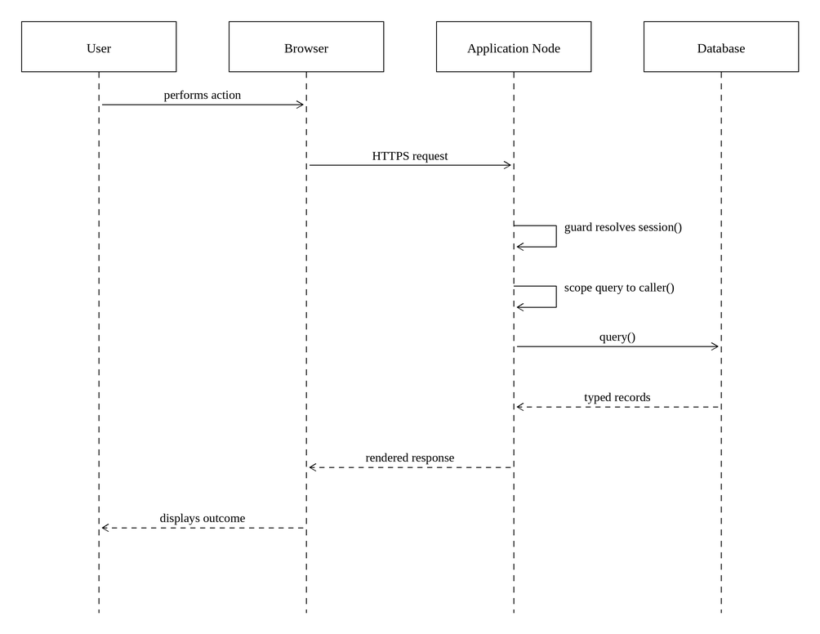
Figure 3 System Sequence Diagram

Use Case: Log In
See also Log In in Software Requirements Specification 3.2.1.
The Student or Corporate User presents their credentials. The password is compared against the stored bcrypt hash, a session is created and its token returned as an httpOnly cookie. The user's role determines the dashboard they are sent to. A failure names neither the address nor the password as the cause, and repeated failures are rate limited by address and by account.
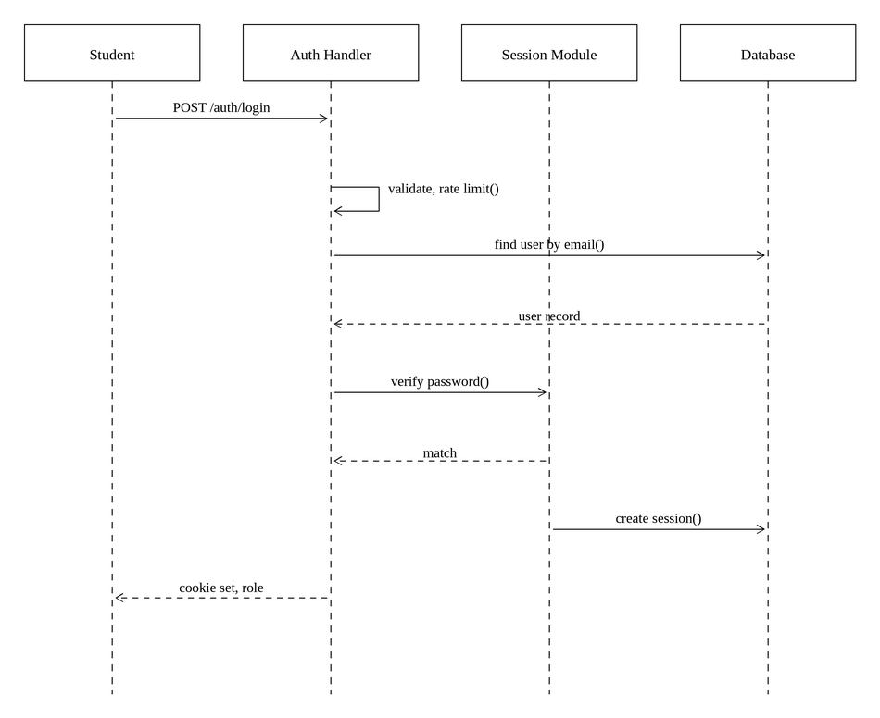
Figure 4 Log In Sequence Diagram

Use Case: Complete Student Profile
See also Complete Student Profile in Software Requirements Specification 3.2.7.
The Student advances through the onboarding steps. Each step is validated on the server against its own schema and written before the next is shown, and the step reached is recorded on the profile, so a Student who leaves part way through resumes where they stopped rather than starting again. The profile strength is recalculated after each step and is what prompts the Student to supply the information that would most improve their matches.
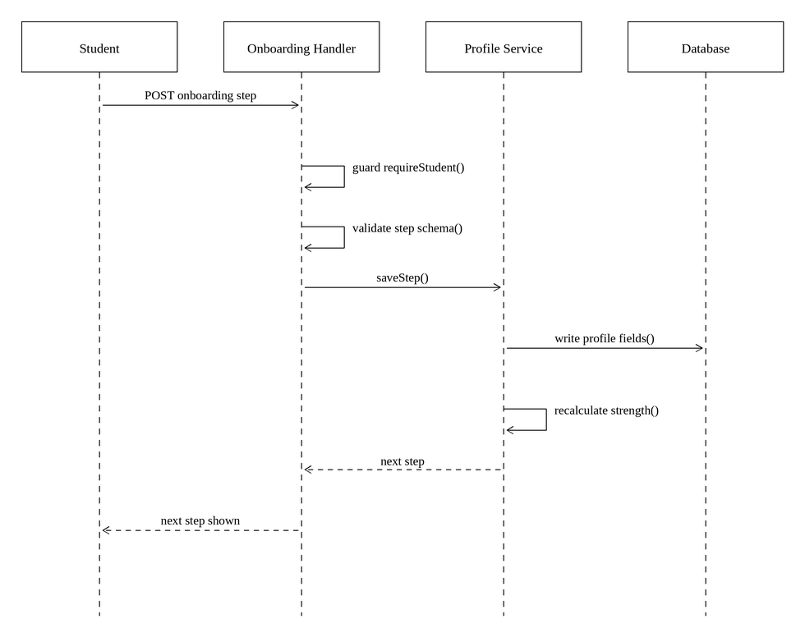
Figure 5 Complete Student Profile Sequence Diagram

Use Case: View Matched Opportunities
See also View Matched Opportunities in Software Requirements Specification 3.2.9.
The dashboard and the opportunities list both ask the service layer to rank the published programmes against the Student's profile. The Matching Engine scores each pairing across the six weighted criteria and returns the score with the reason for every criterion. The list is ordered by score, and each entry is displayed with its reasons; a percentage is never presented on its own.
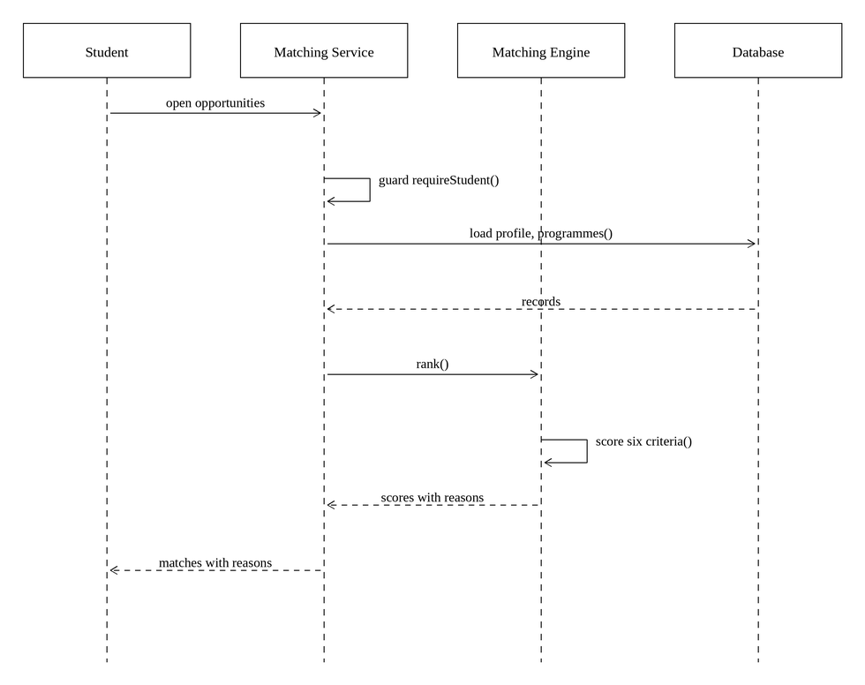
Figure 6 View Matched Opportunities Sequence Diagram

Use Case: Apply for Funding
See also Apply for Funding in Software Requirements Specification 3.2.12.
The Student submits an application against an open programme. The system scores the pairing and evaluates eligibility at that moment and stores both results on the application, so the Funder later reviews the assessment as it stood at submission. A notification is raised for the Student and the action is appended to the audit log. A second application to the same programme is refused by a uniqueness constraint rather than by a check that could be omitted.
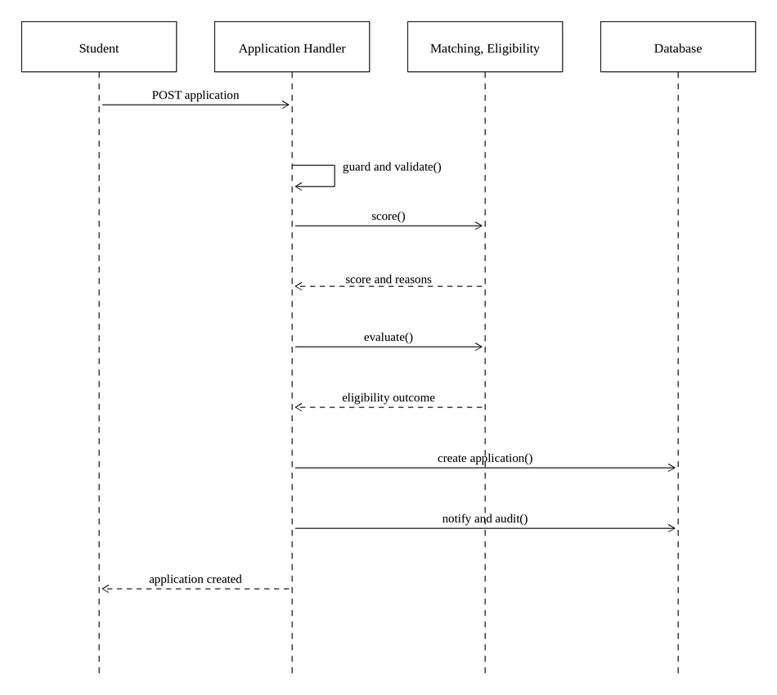
Figure 7 Apply for Funding Sequence Diagram

Use Case: Browse All Bursaries
See also Browse All Bursaries in Software Requirements Specification 3.2.16.
The Student opens the directory of every published opportunity the system holds. The service reads the published programmes, derives a display status for each from its dates and its recorded availability, and orders the list so that those accepting applications come first. The directory is never narrowed to the Student's own profile: it answers what exists, where the matched list answers what fits. A closed opportunity stays listed and is marked closed, so a Student can see who funds what and when to return.
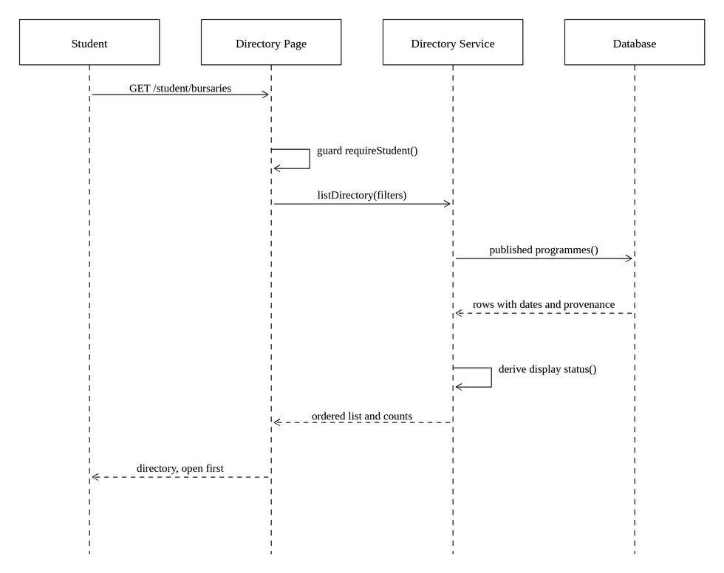
Figure 8 Browse All Bursaries Sequence Diagram

Use Case: Generate Motivational Letter
See also Generate Motivational Letter in Software Requirements Specification 3.2.17.
The Student chooses a programme and answers as many of the seven questions as they wish. The service gathers the facts held on their profile, the requirements the funder states, and the answers, and the Motivational Letter Composer assembles the draft from those alone. The letter is stored with the answers it was built from, so it can be traced to what the Student actually said and rewritten if they change it.
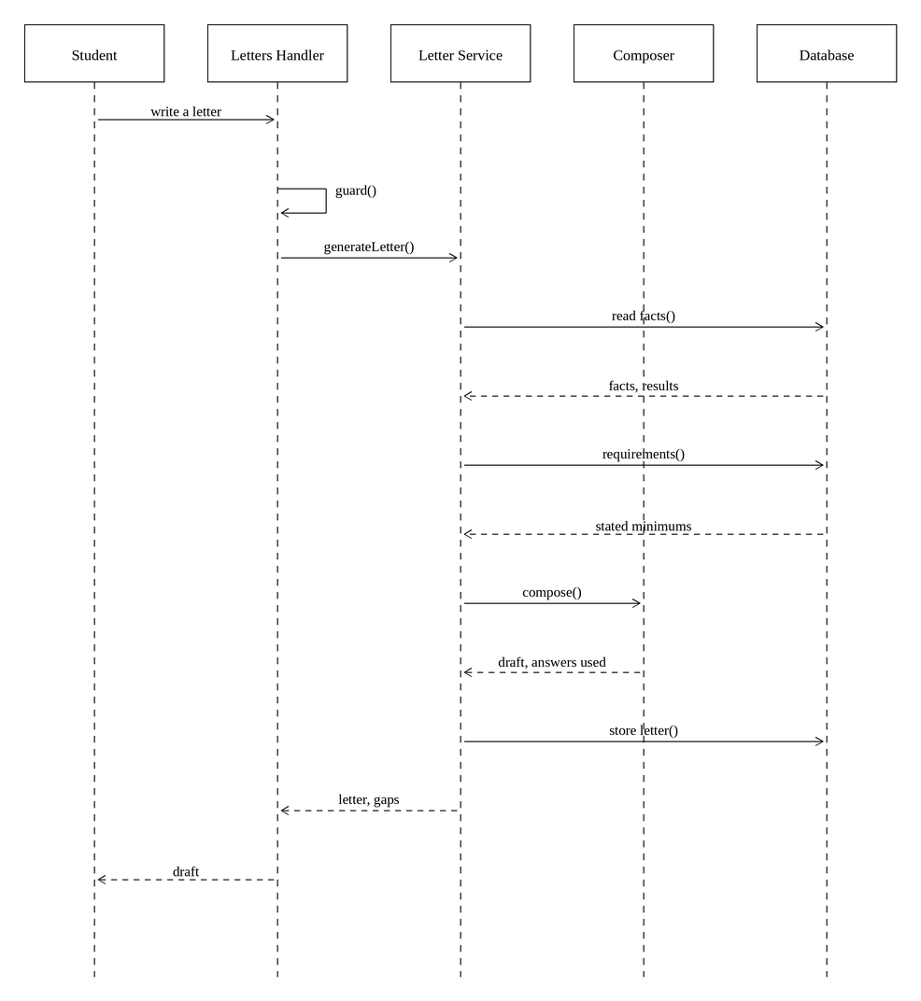
Figure 9 Generate Motivational Letter Sequence Diagram

Use Case: Auto-Fill Application Forms
See also Auto-Fill Application Forms in Software Requirements Specification 3.2.18.
The Student supplies one completed form and a number of blank ones. The Document Extraction Engine reads the completed form into canonical values, each carrying the confidence of the reading, then identifies the fields on each blank form and writes the values it can match. A field it cannot establish is left empty and flagged, because a blank a Student can complete is better than a populated field that is wrong. A form that cannot be read fails on its own without stopping the others.
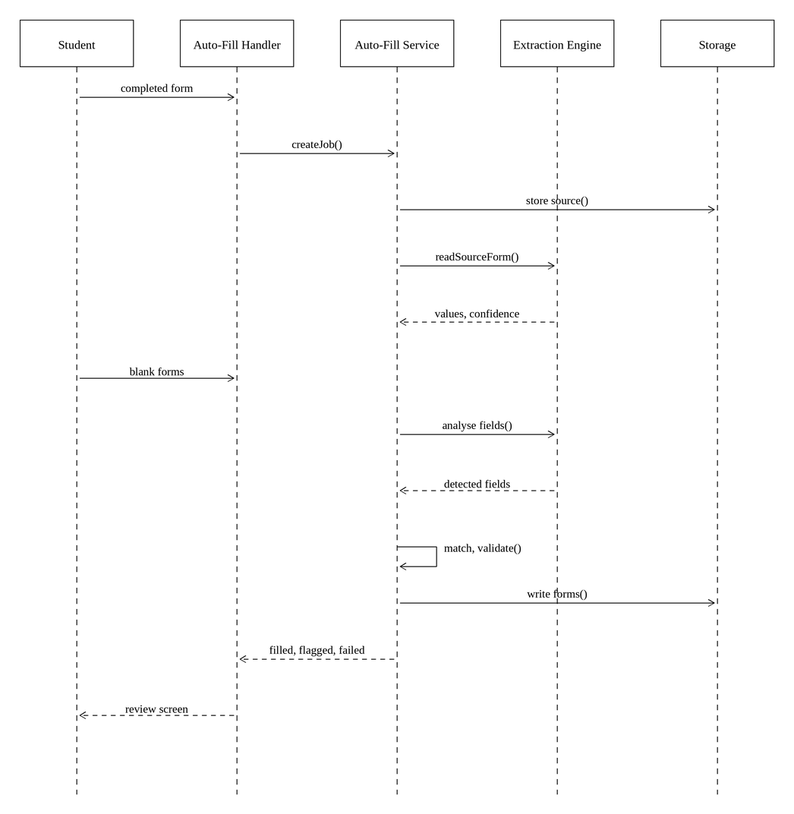
Figure 10 Auto-Fill Application Forms Sequence Diagram

Use Case: Create Funding Programme
See also Create Funding Programme in Software Requirements Specification 3.2.22.
The Corporate User describes a programme and states its eligibility criteria through ordinary form controls. The criteria are written to the Eligibility Rule as typed columns, not as prose, which is what allows the same conditions to drive both the Student's match score and the Funder's eligibility verdict. The programme is created in draft and is invisible to Students until it is published.
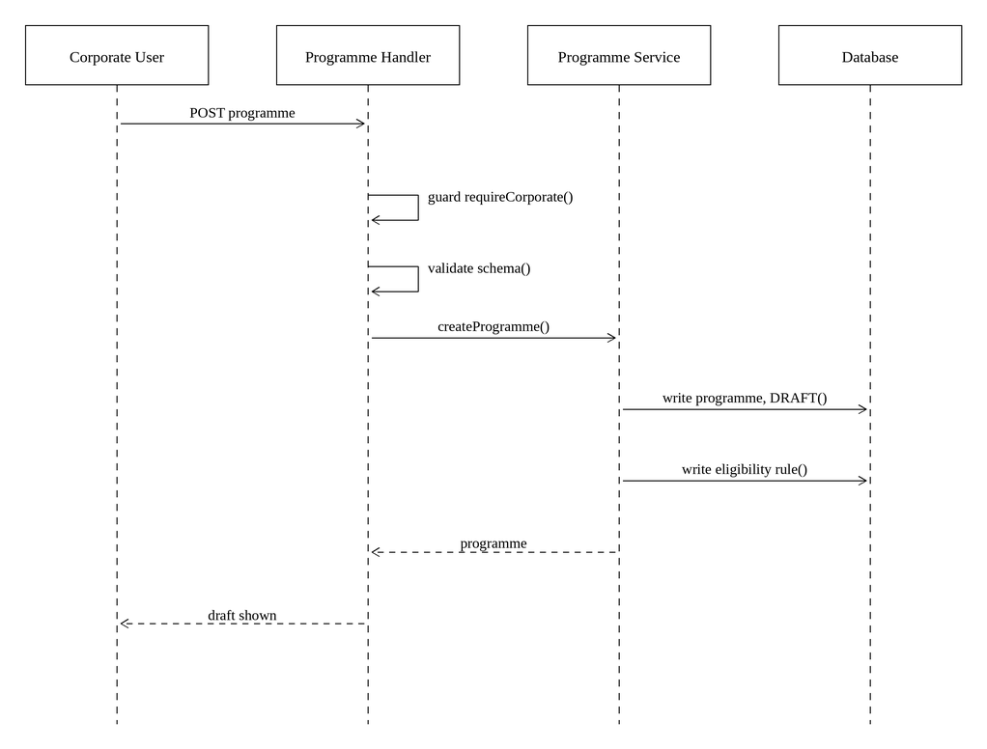
Figure 11 Create Funding Programme Sequence Diagram

Use Case: Import Applications
See also Import Applications in Software Requirements Specification 3.2.25.
The Corporate User uploads application forms the Organisation received elsewhere. Every file is stored before any of it is read, so the batch survives an interruption. Each form is read through the Document Extraction Engine, the applicant is looked for among existing Students on verified identifiers, the Matching Engine and the Eligibility Service score them against that programme's own criteria, and the supporting documents are counted against those the programme requires. Once every file has been read, one ordered pass flags duplicates. Nothing becomes an application until a Corporate User confirms the batch.
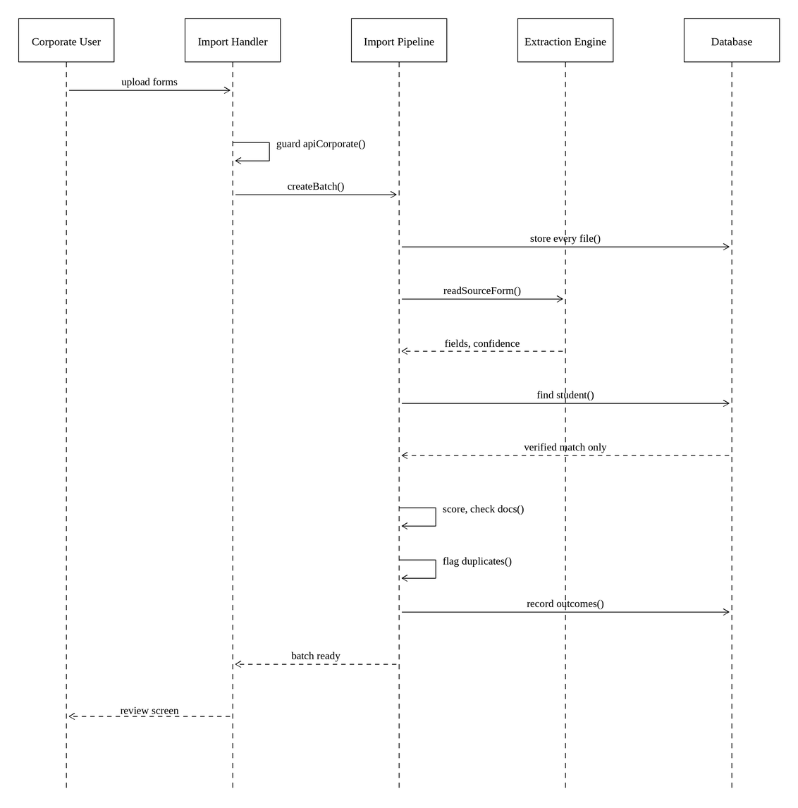
Figure 12 Import Applications Sequence Diagram

Use Case: Review Imported Applications
See also Review Imported Applications in Software Requirements Specification 3.2.26.
The Corporate User examines a processed batch. Each application is shown beside the document it was read from, with every extracted field, its confidence and the label it came from. A correction is stored alongside the extracted value rather than replacing it, so the record keeps both what the form said and what a person decided it meant. On confirmation an application is created for each file marked for import, attached to the identified Student where there was one and to a new external applicant record where there was not. The file is linked to the application it produced, so confirming twice cannot create it again.
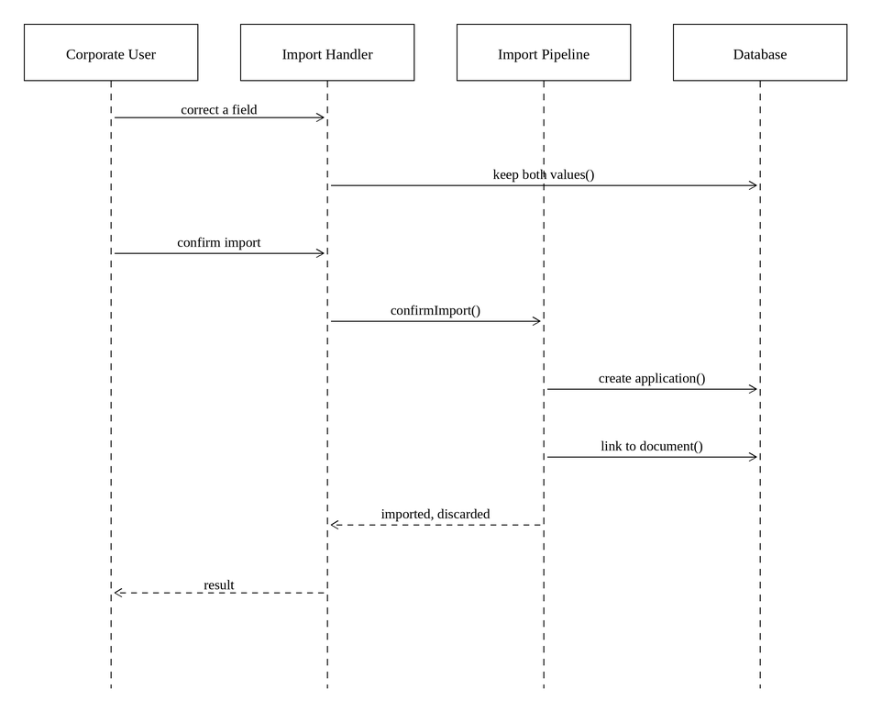
Figure 13 Review Imported Applications Sequence Diagram

Use Case: Review Applicant
See also Review Applicant in Software Requirements Specification 3.2.28.
The Corporate User opens an application belonging to their Organisation. The guard returns the organisation identifier and it forms part of the query, so an application belonging to another Organisation is not found rather than refused after being read. The Eligibility Service evaluates the applicant against the programme's rule and the verdict is displayed with the reason for each condition.
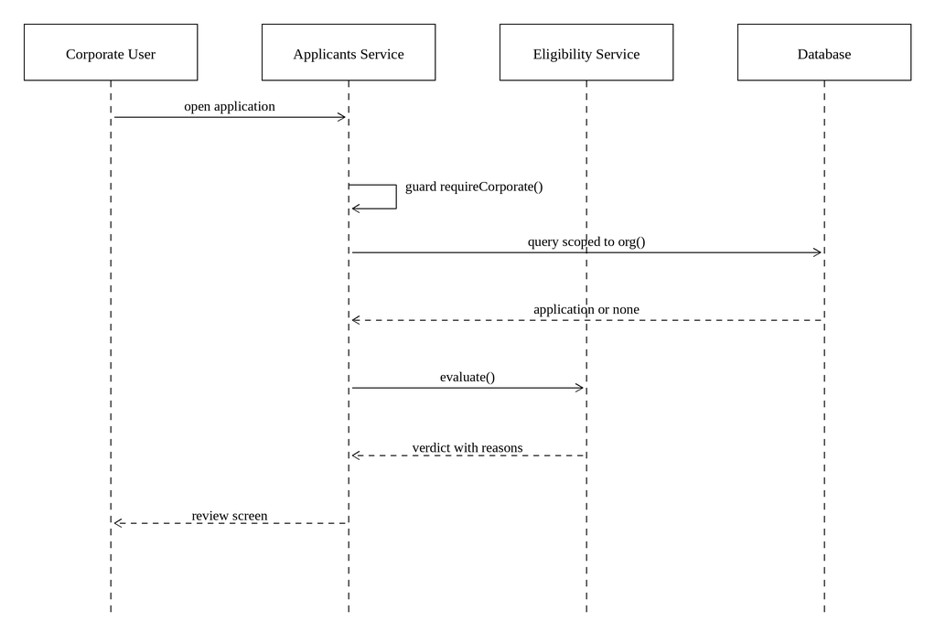
Figure 14 Review Applicant Sequence Diagram

Use Case: Shortlist Applicant
See also Shortlist Applicant in Software Requirements Specification 3.2.29.
The Corporate User adds an applicant to the shortlist for a programme. The application's status is advanced, a shortlist entry is created, the applicant is notified and the change is appended to the audit log. The operation is scoped to the Organisation throughout.
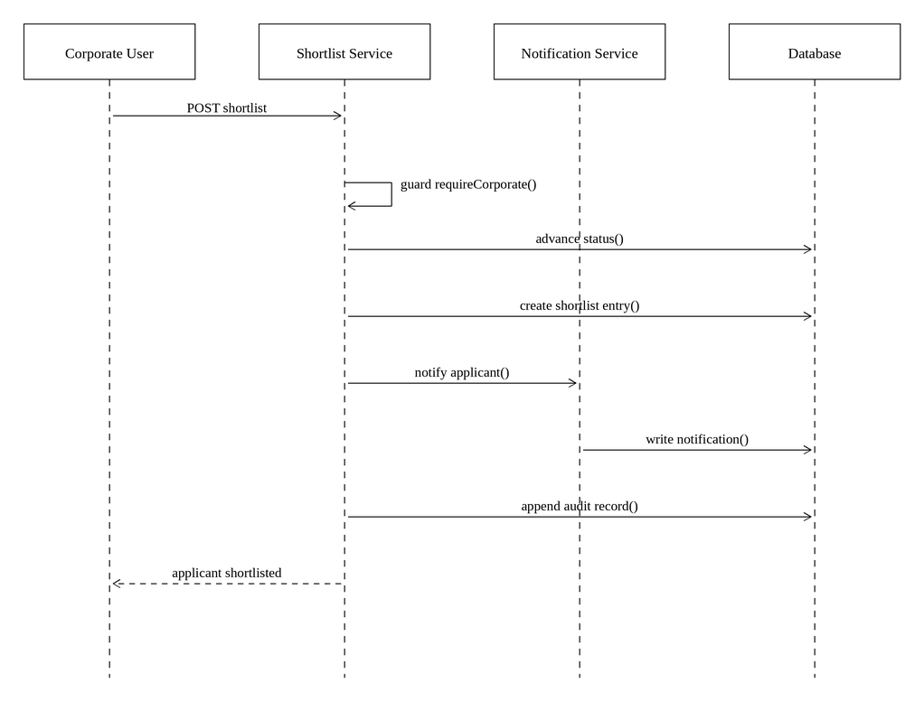
Figure 15 Shortlist Applicant Sequence Diagram

6.0. Interface design
The interface follows the approved reference designs, which are the visual source of truth for the system. It is laid out on a single palette and type scale expressed as Tailwind tokens, so that a change to a colour or a spacing step is made once and applies everywhere.
The layout is responsive rather than merely legible at small sizes. Many Students will reach the system on a mobile telephone, and some over a metered or intermittent connection, so the screens are laid out for narrow viewports as well as wide, wide content such as tables and reports scrolls within its own container rather than forcing the page sideways, and the profile is gathered in short steps that can be left and resumed.
Two principles govern the presentation of a match. The first is that a score is explained rather than merely asserted: the opportunity detail screen sets out every criterion, states whether it was met and names the weight it carried, so a Student can see why a programme scored as it did and what would improve it. The second is that a criterion the system could not evaluate is labelled as needing verification rather than being silently treated as a failure.
The screens reproduced below are captured from the running system rather than drawn, so they show the interface as implemented.
The Student-facing screens are captured against the real directory, whose bursaries were imported from published sources, so the programmes, funders and closing dates on them are the ones the system actually holds. The Organisation-facing screens are different: they show applications, shortlists and beneficiaries, and none of those exists until an Organisation has published a programme through the system and Students have applied to it, which has not yet happened. Those screens are therefore captured against a demonstration Organisation and demonstration Applicants created for the purpose, and the names, averages and figures on them are not real people or real awards. That data was removed from the database once the captures were taken.

Figure 16 Landing page
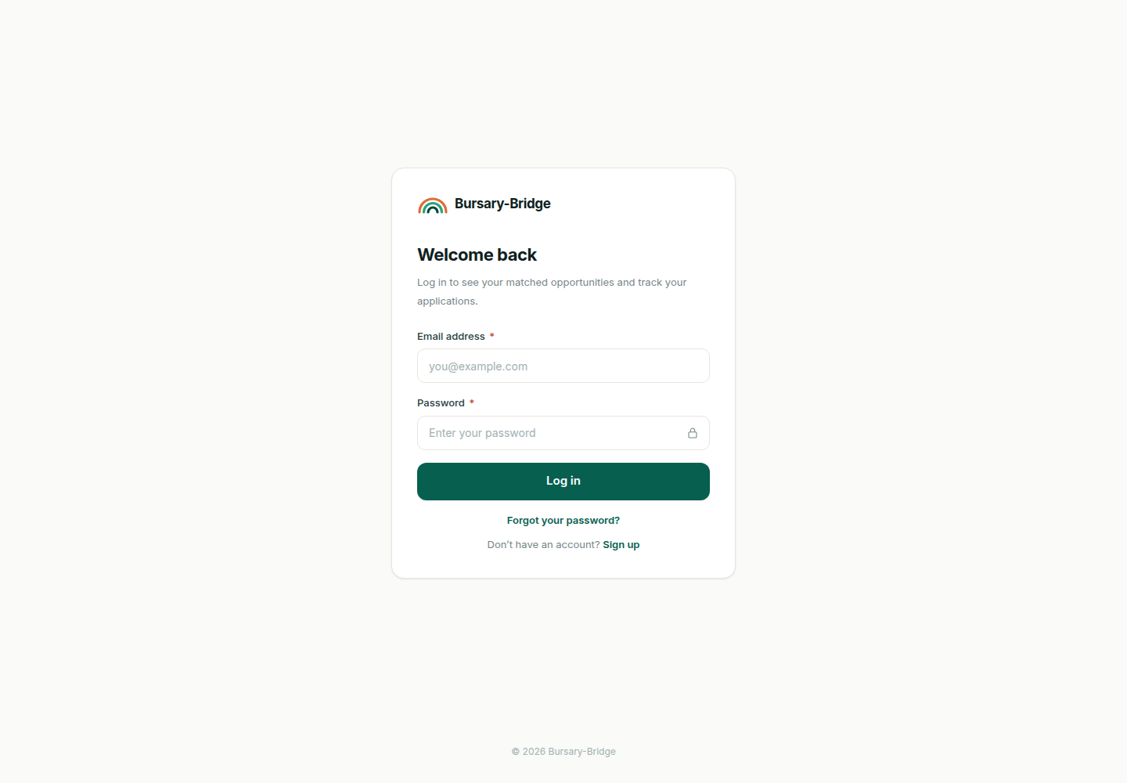
Figure 17 Log in page
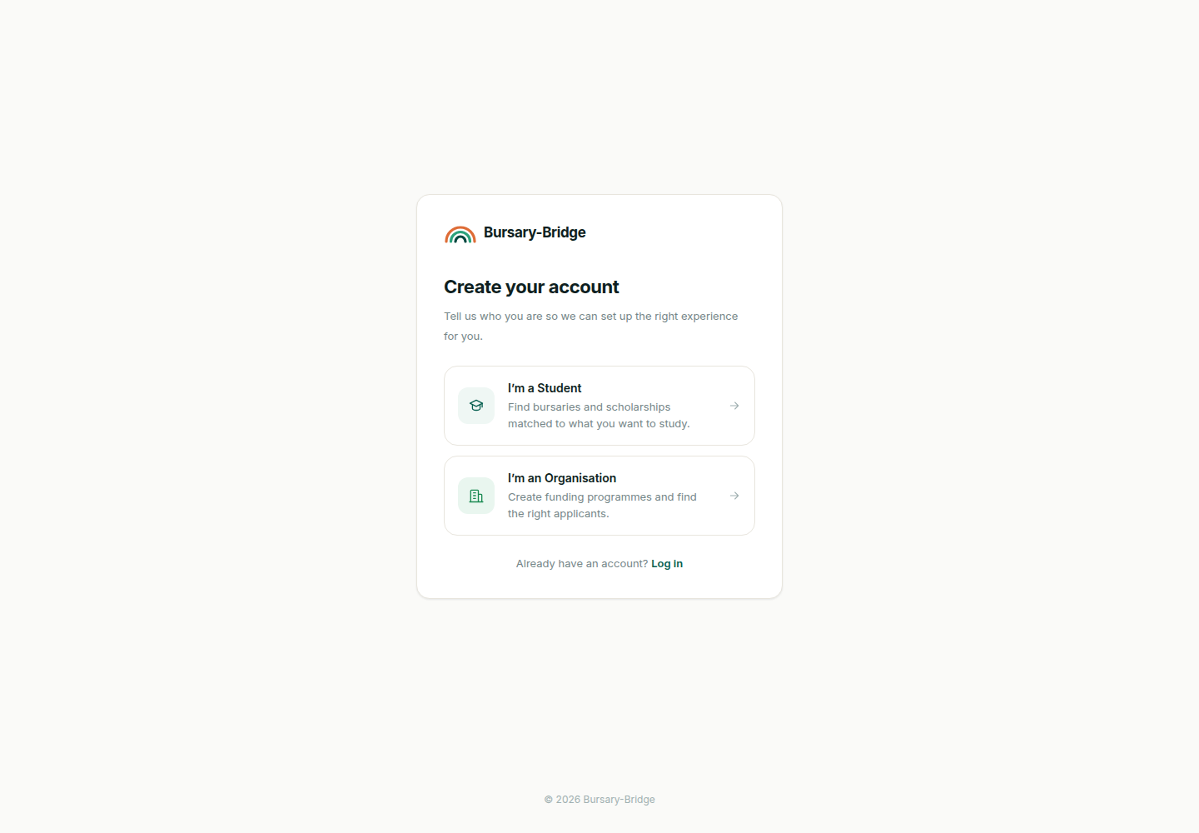
Figure 18 Registration, choice of account type
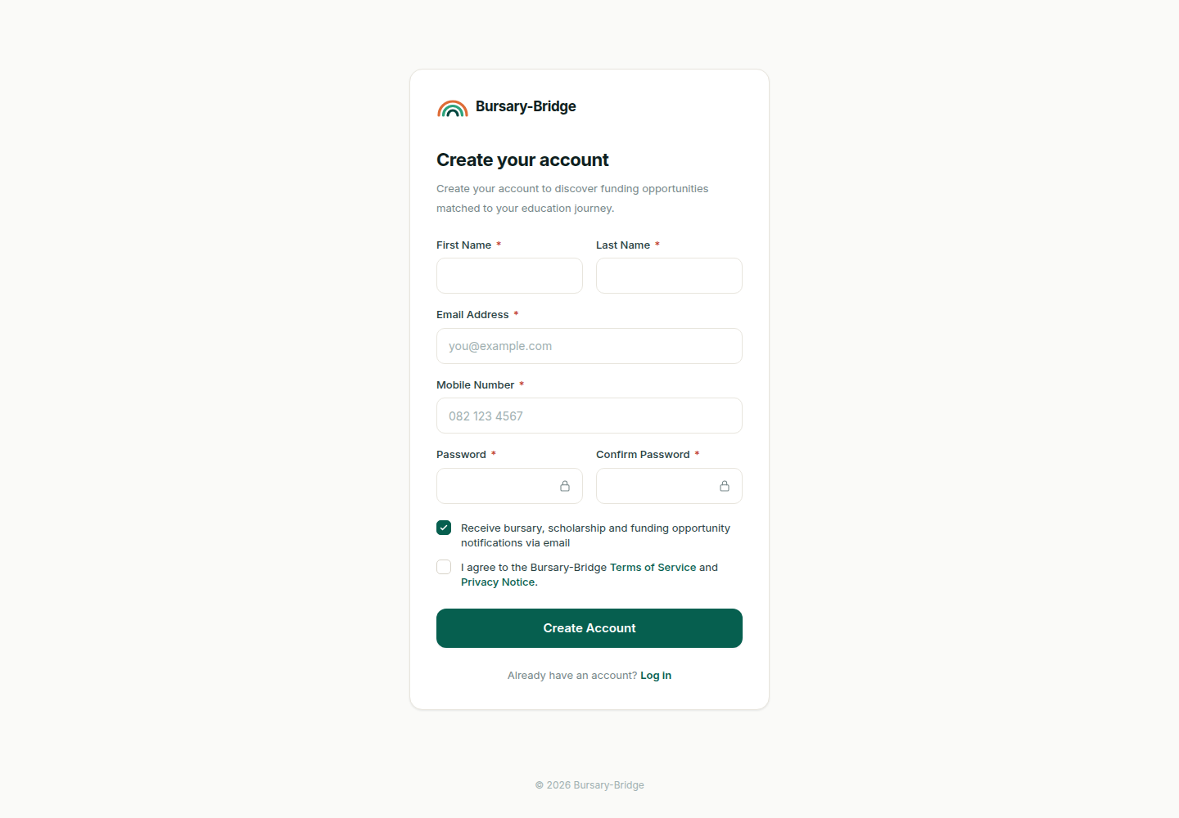
Figure 19 Student registration
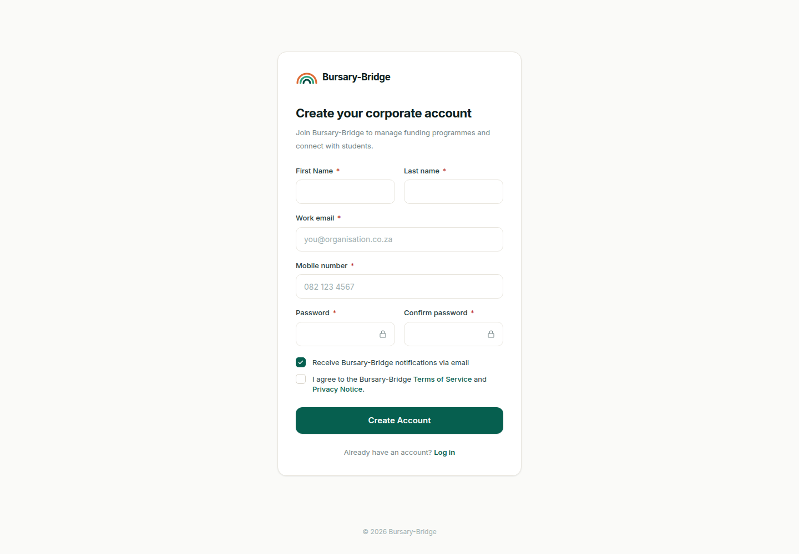
Figure 20 Organisation registration
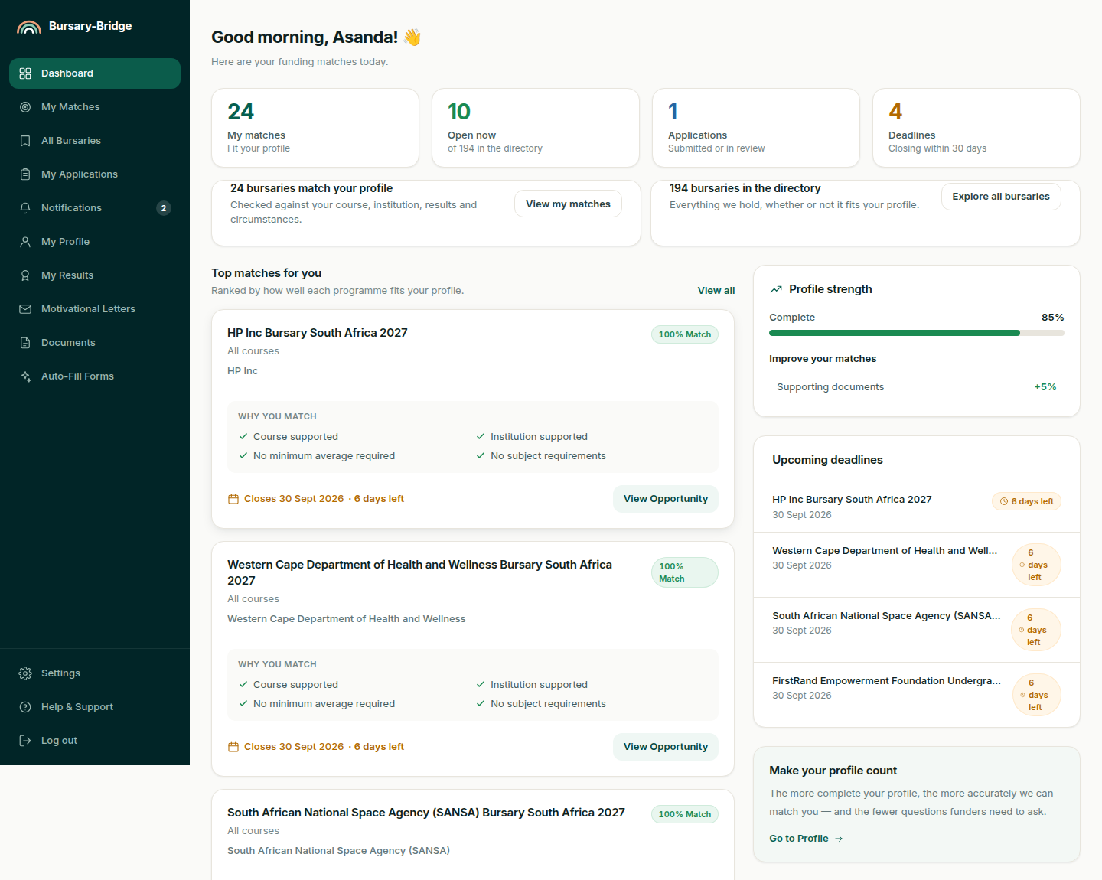
Figure 21 Student dashboard
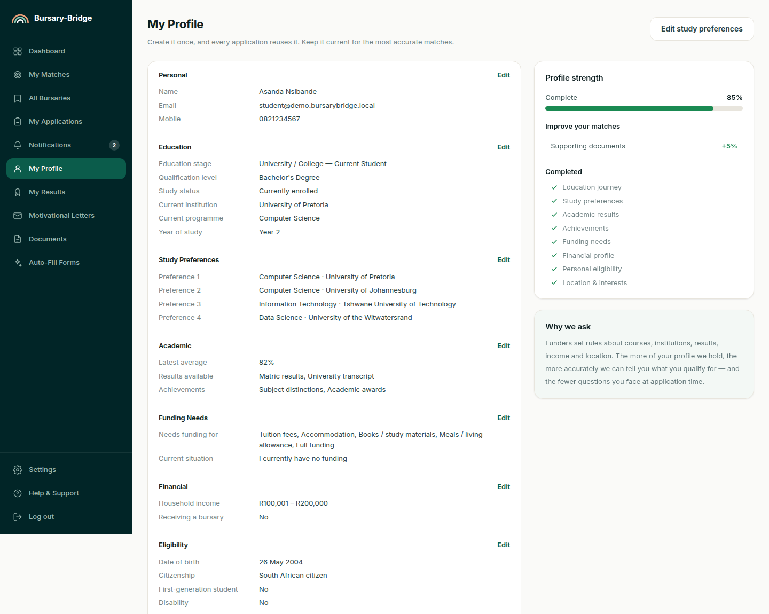
Figure 22 Student profile
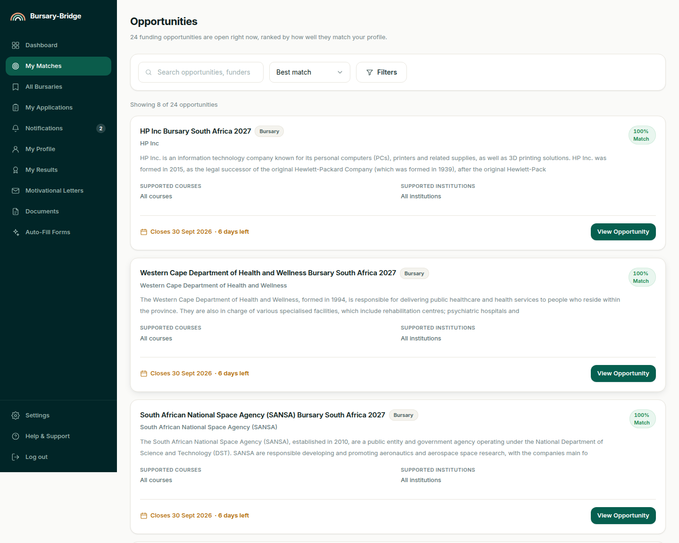
Figure 23 Opportunities, ranked by match
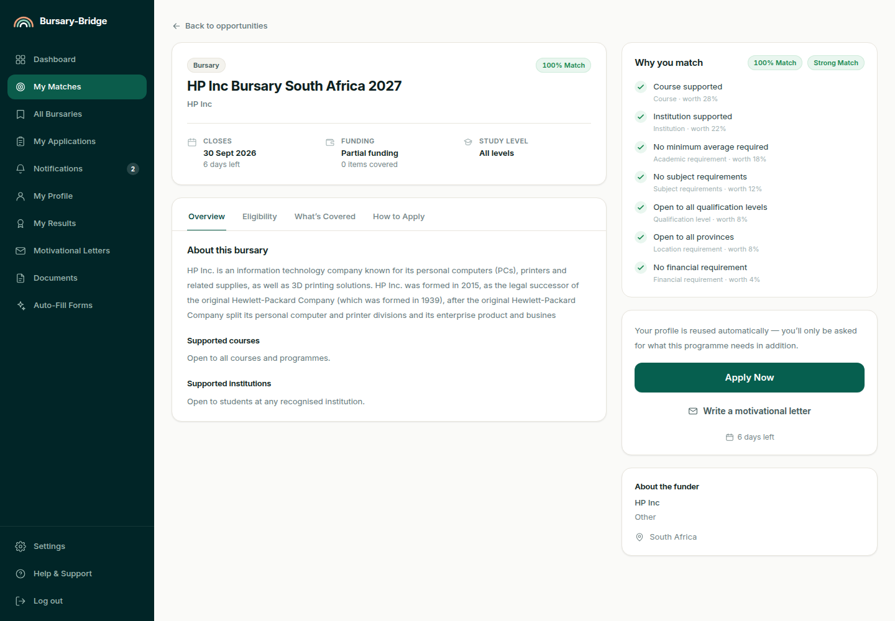
Figure 24 Opportunity detail, with the match explained
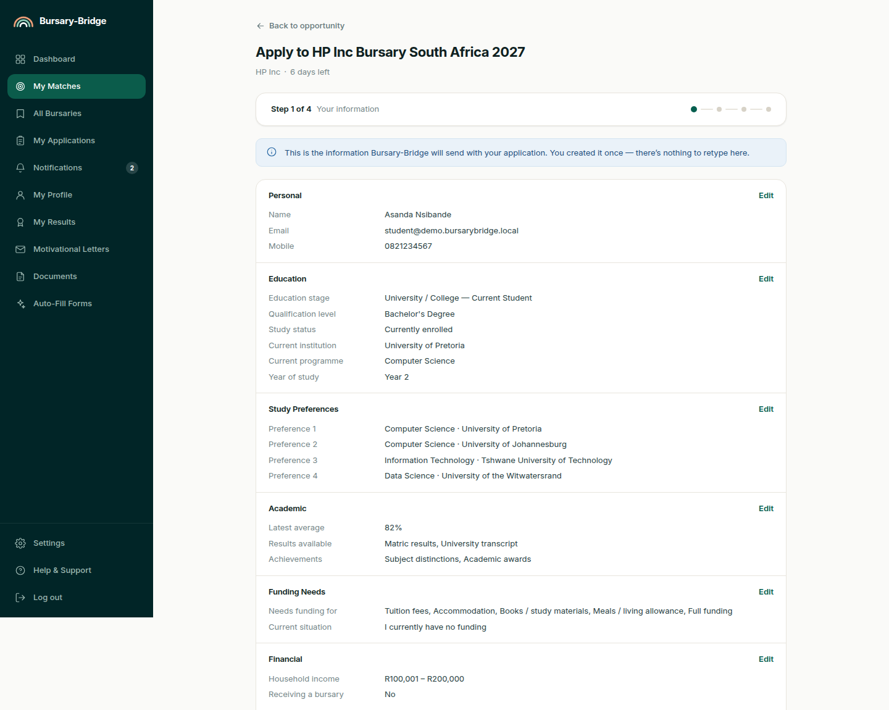
Figure 25 Application form
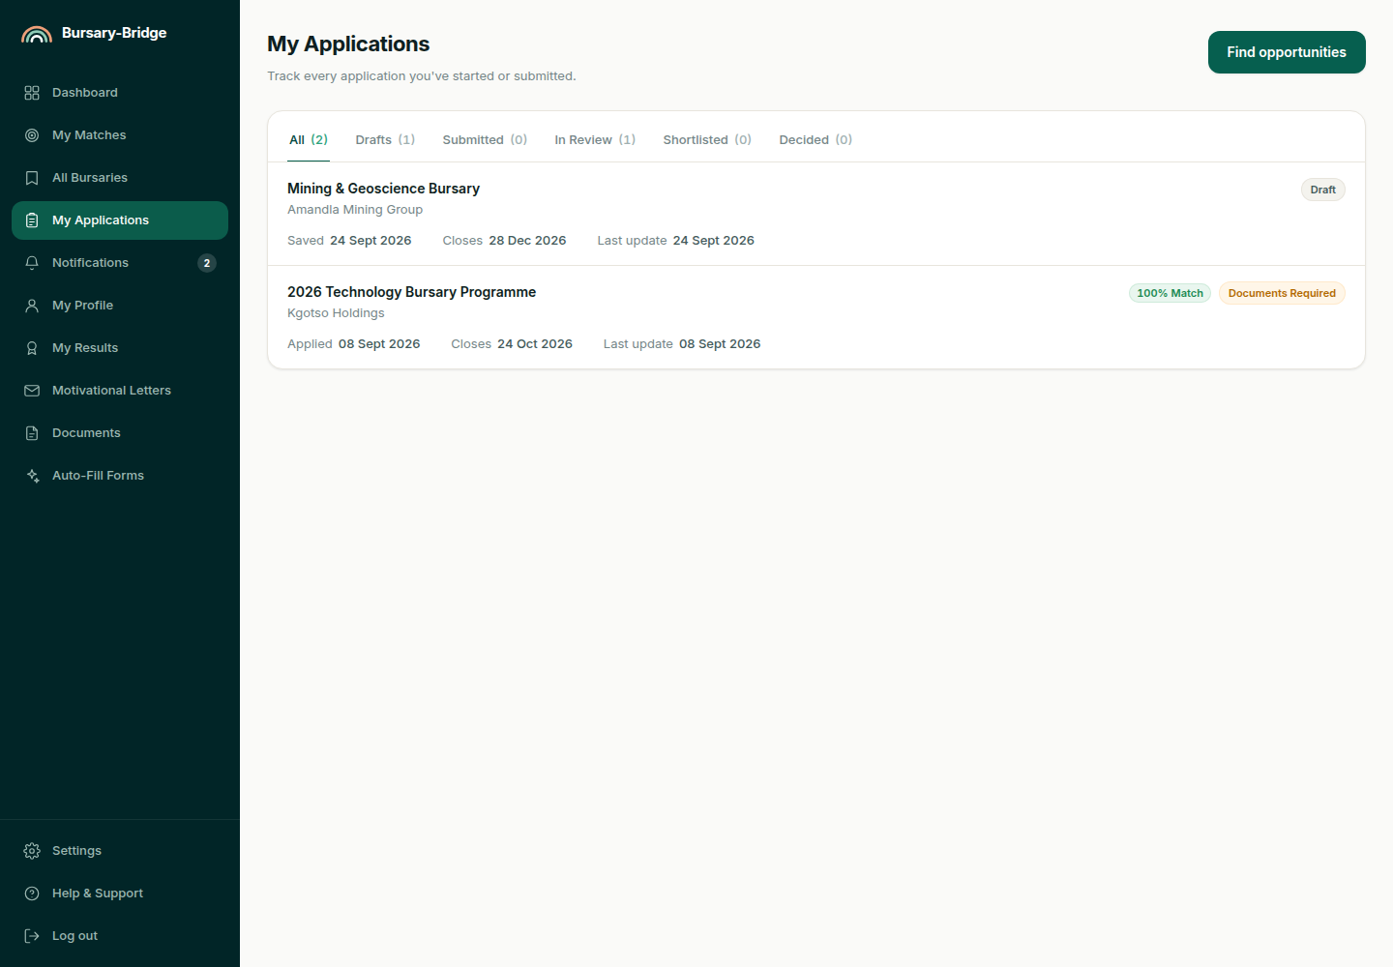
Figure 26 Student application tracker
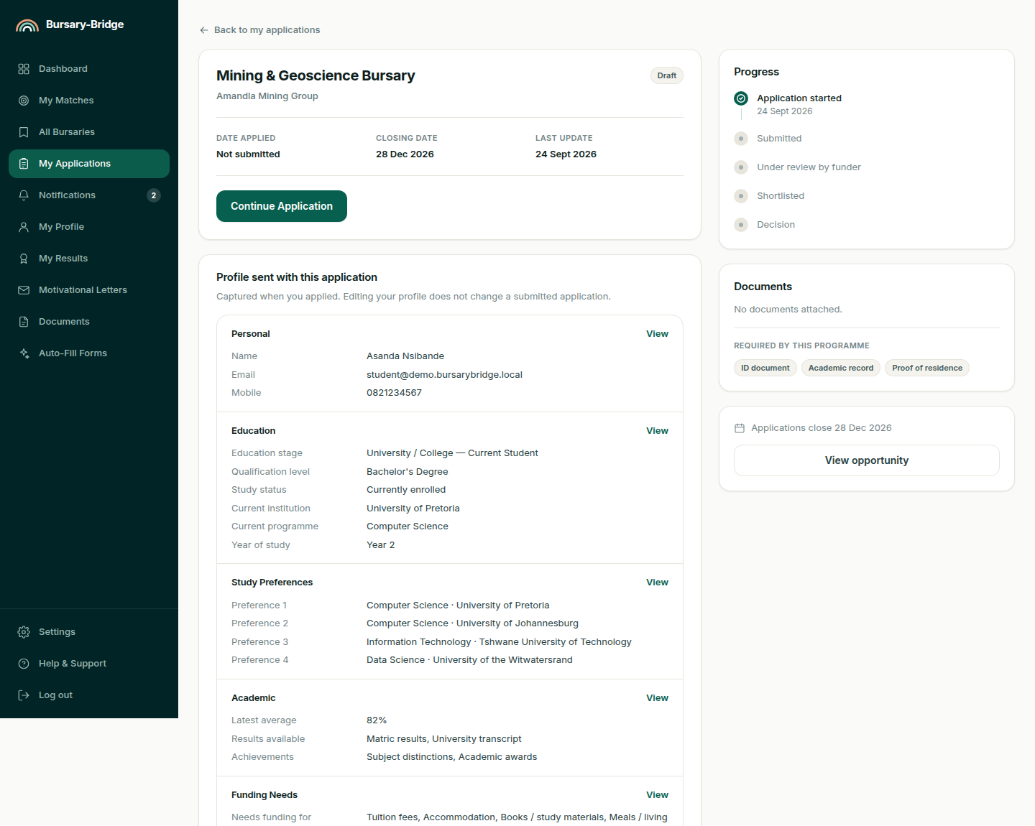
Figure 27 Application detail
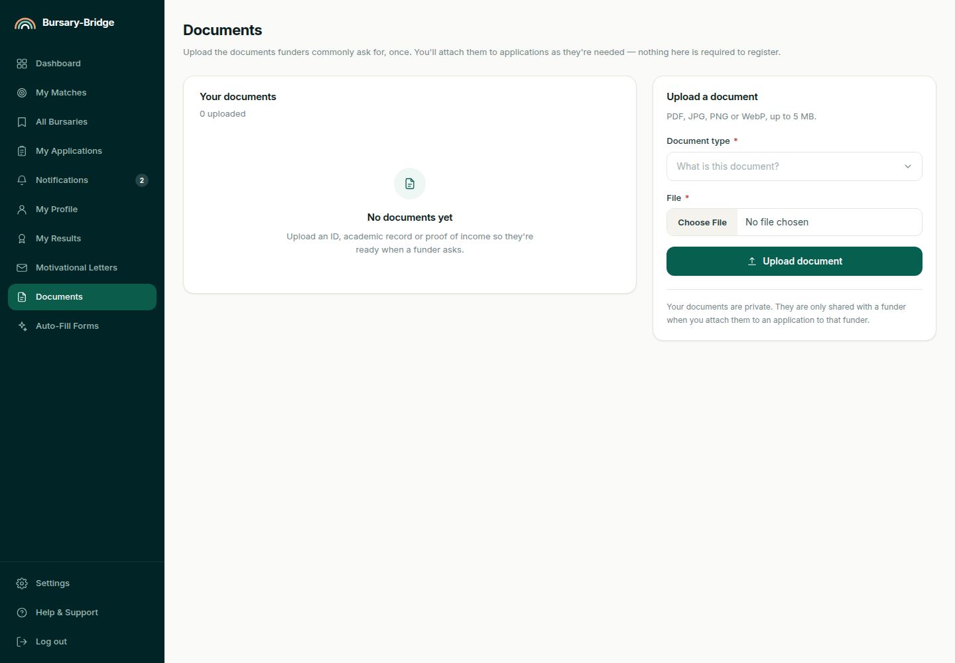
Figure 28 Student document library
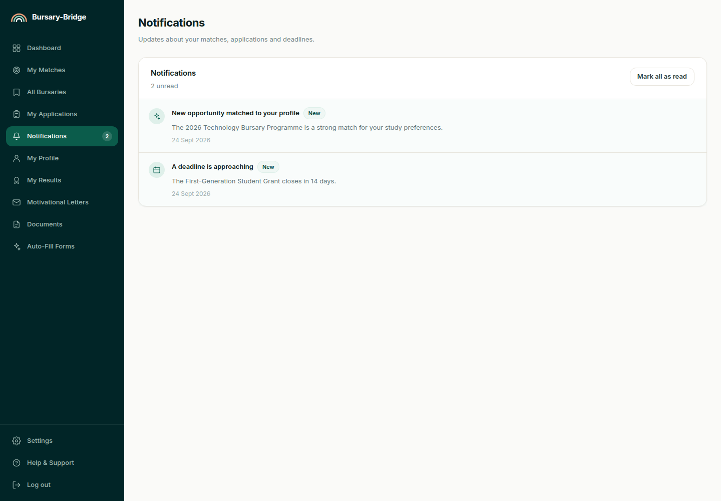
Figure 29 Student notifications
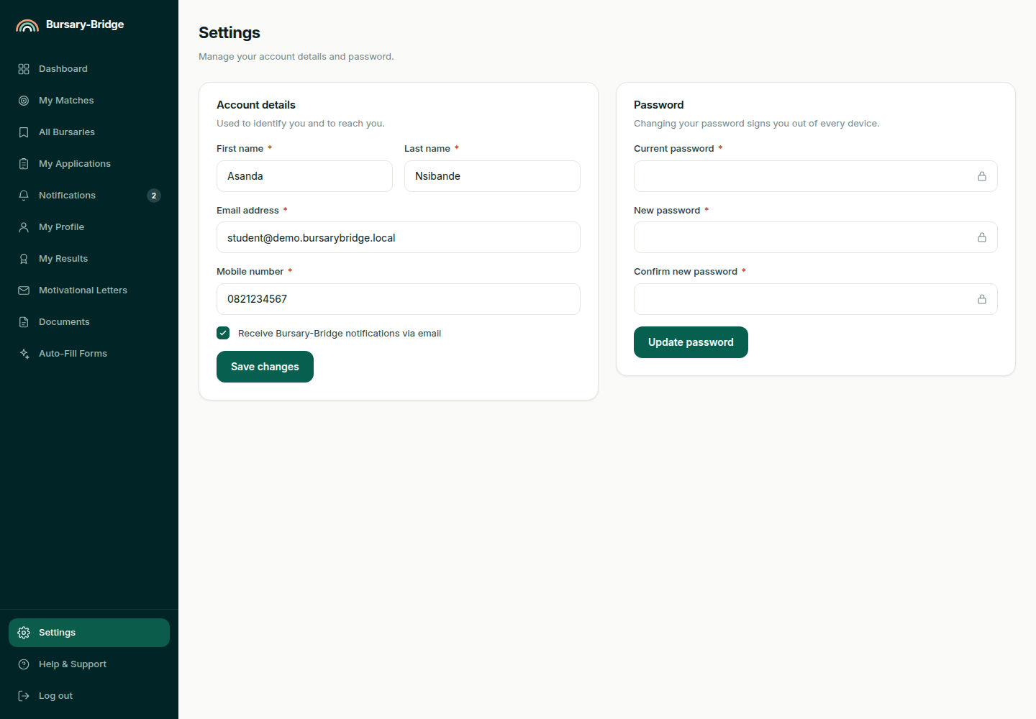
Figure 30 Student account settings
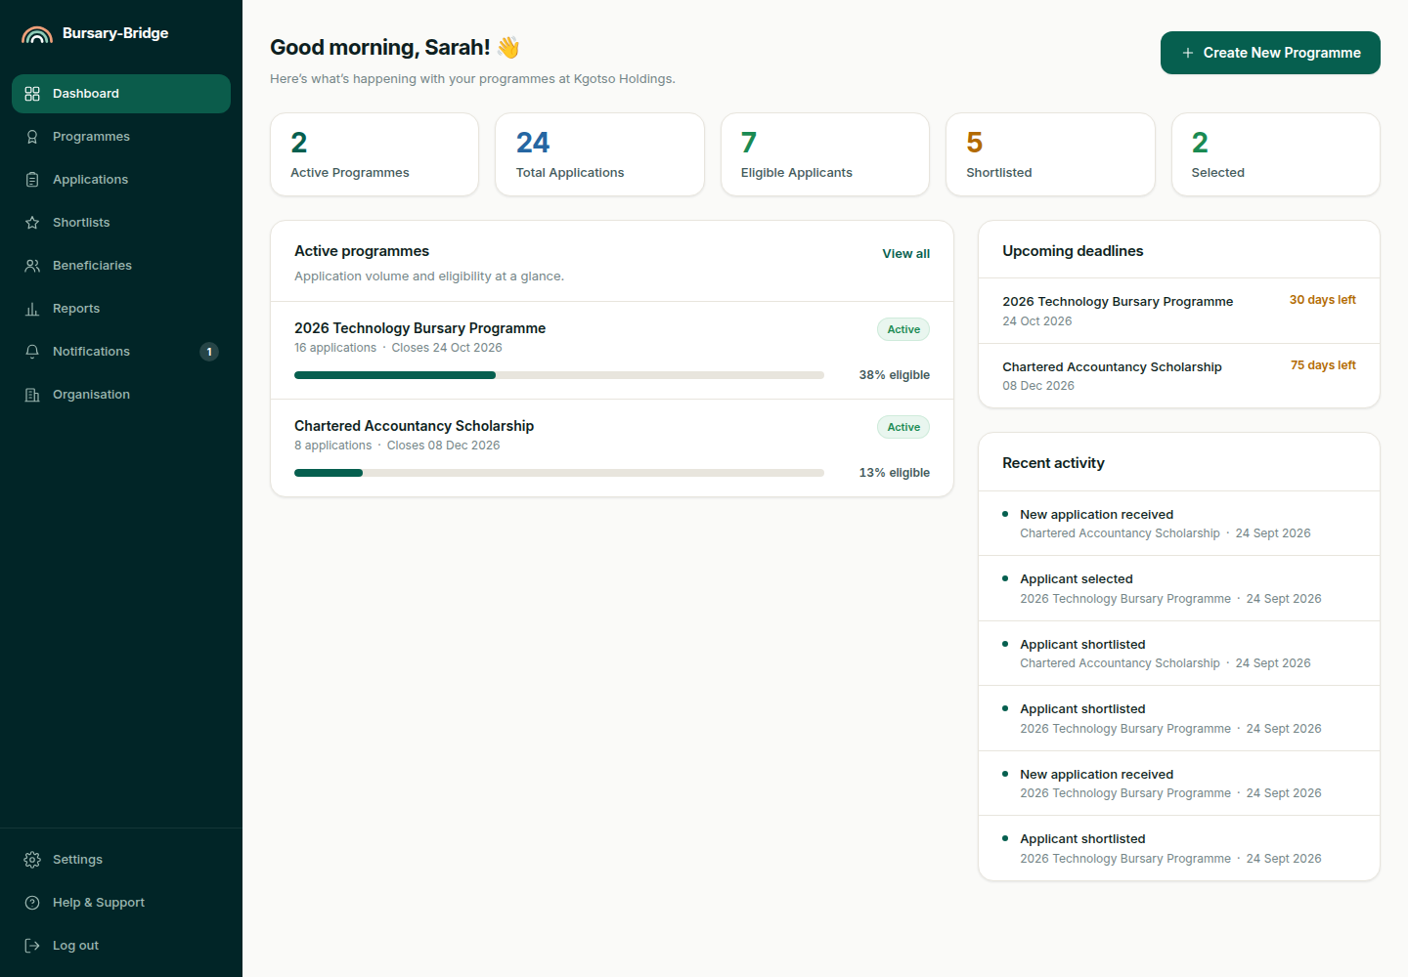
Figure 31 Corporate dashboard
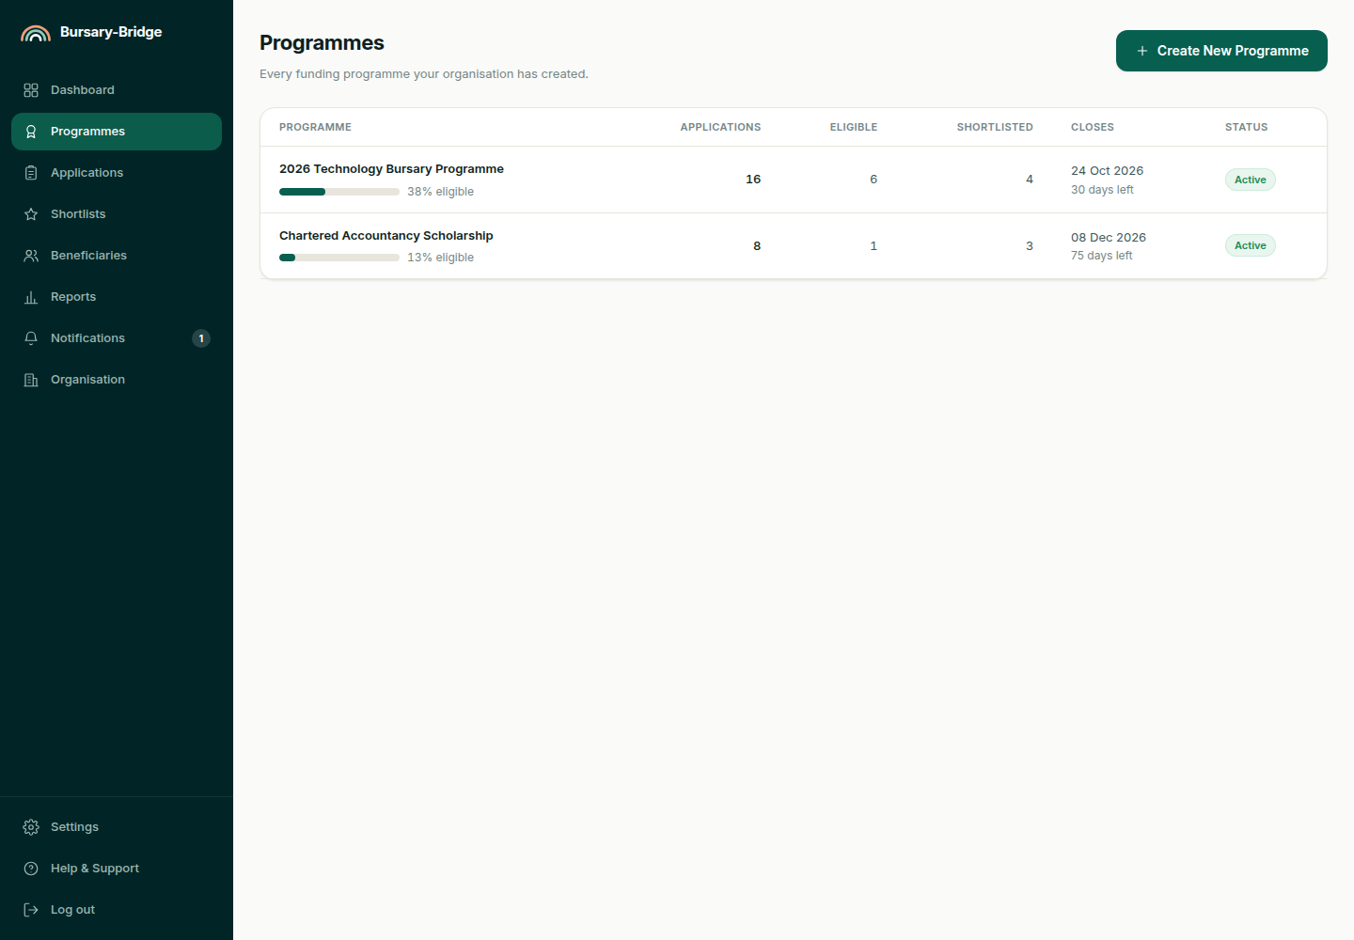
Figure 32 Funding programmes held by the Organisation
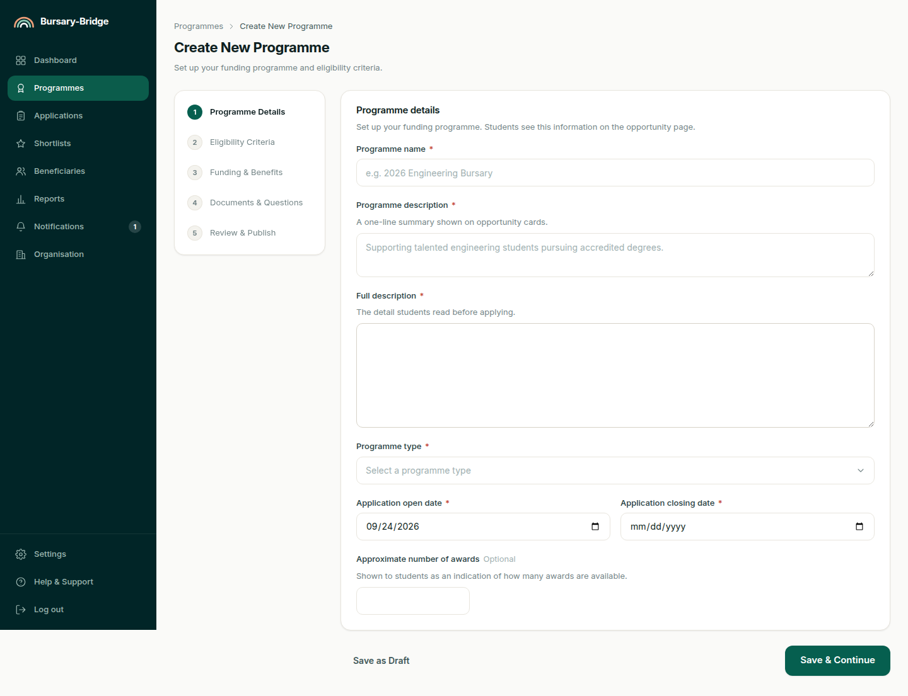
Figure 33 Funding programme editor
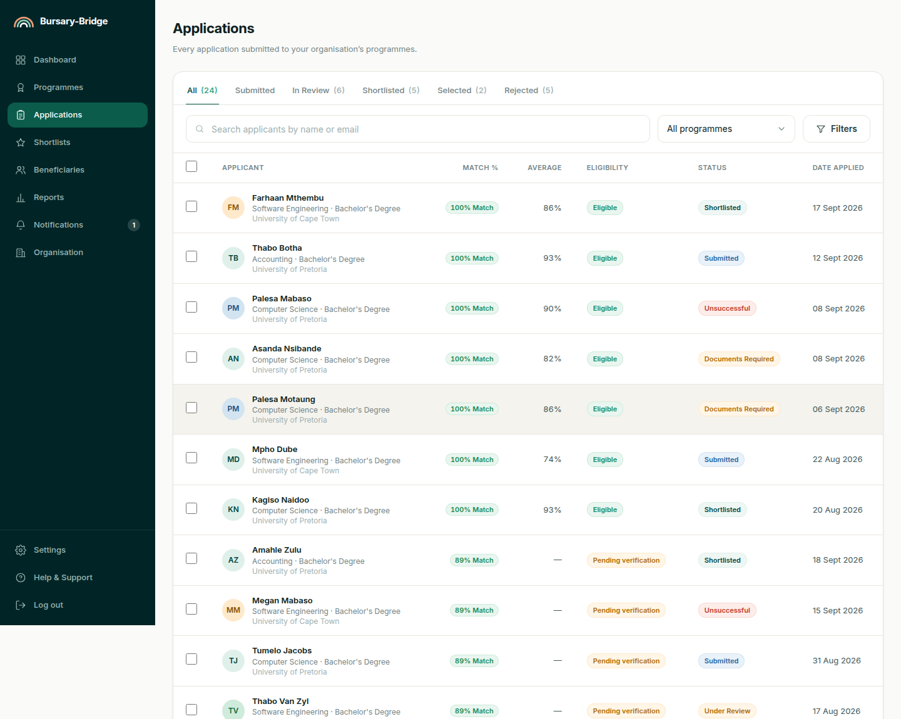
Figure 34 Applications received
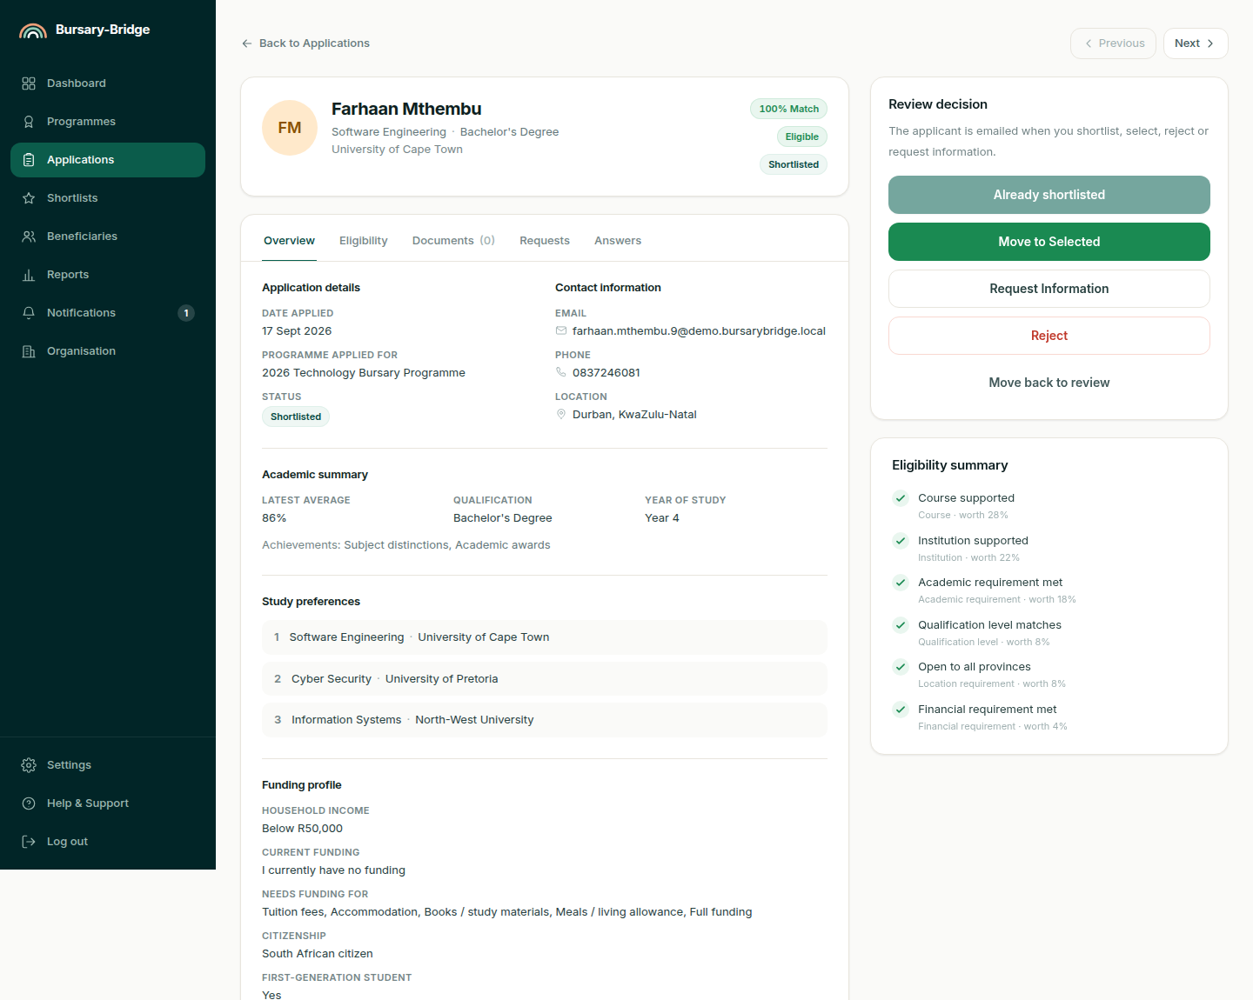
Figure 35 Applicant review, with the eligibility verdict
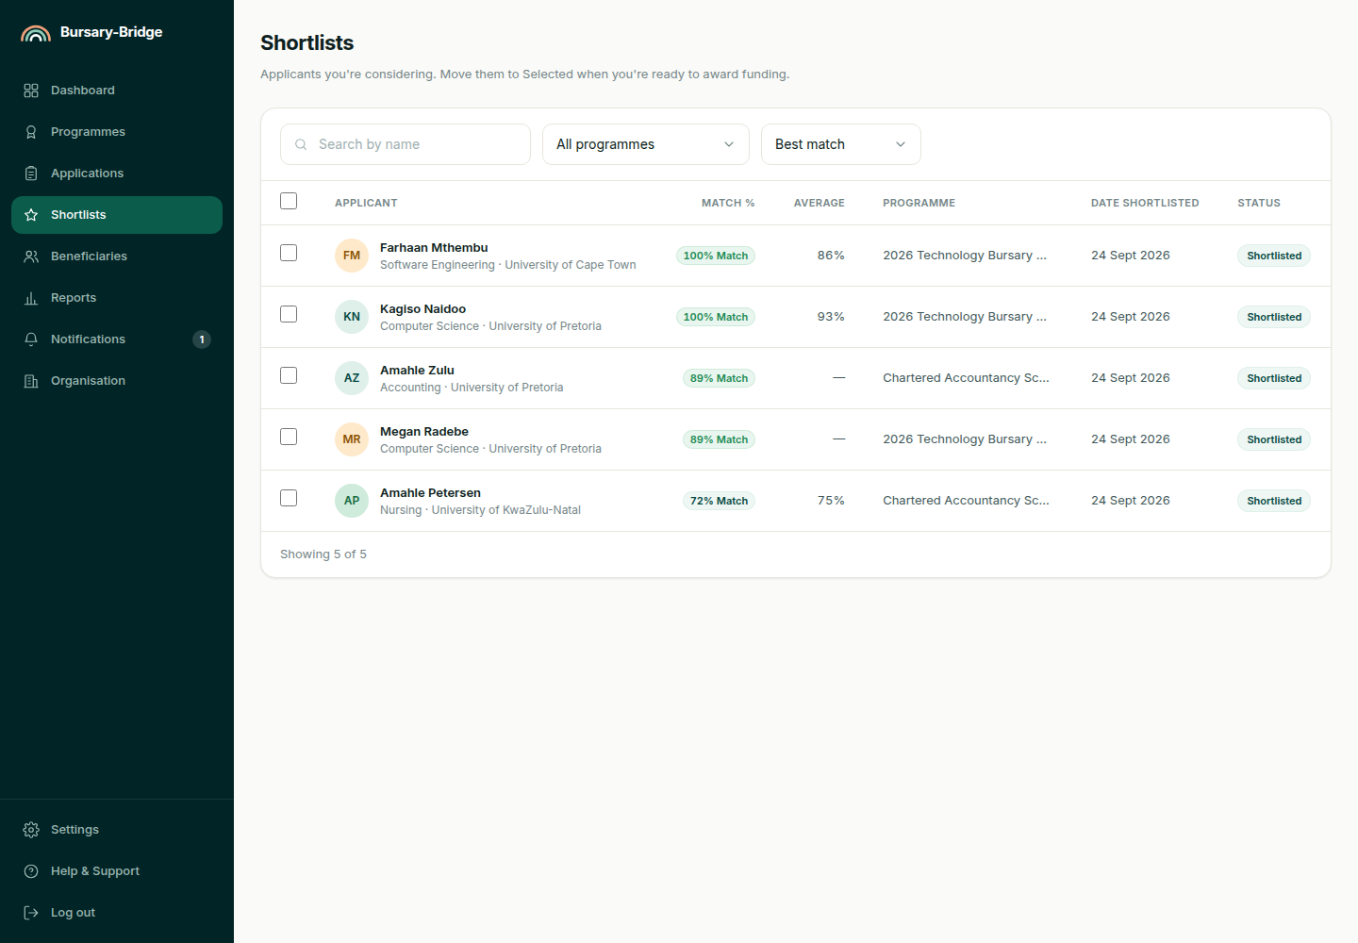
Figure 36 Shortlists
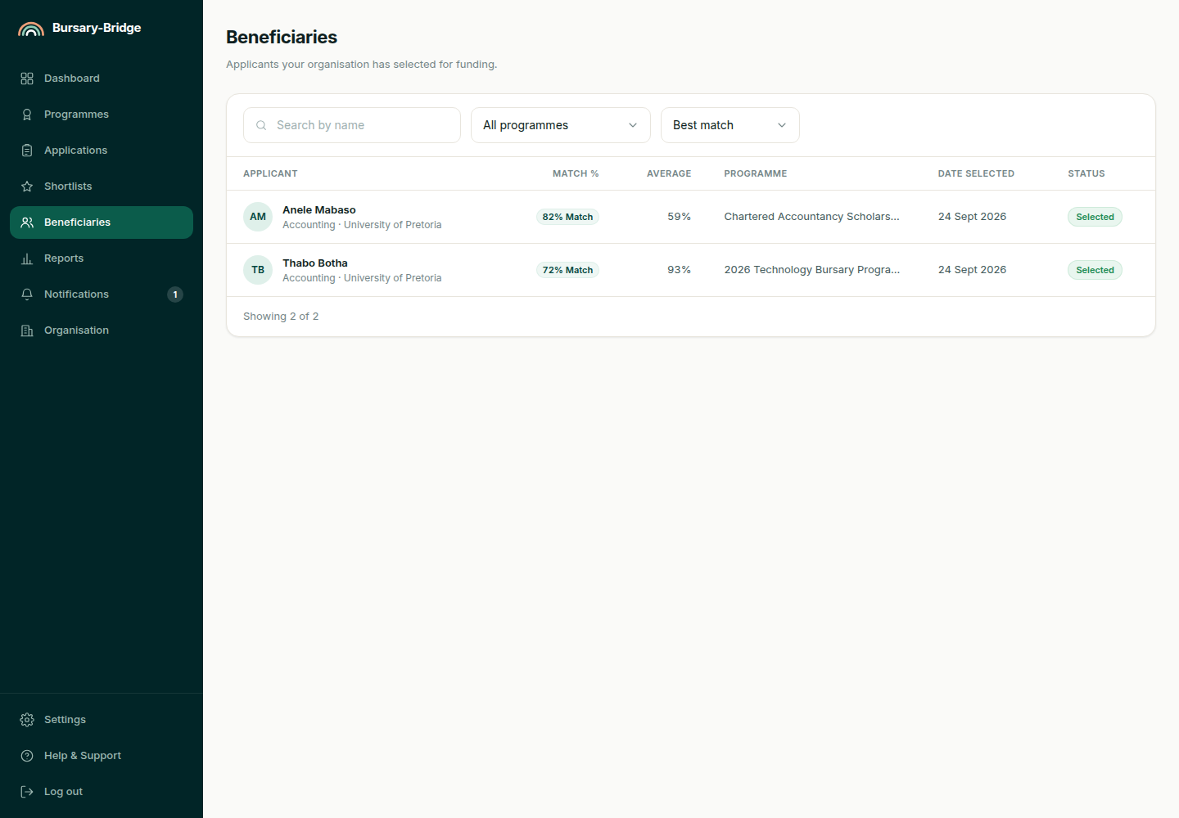
Figure 37 Beneficiaries
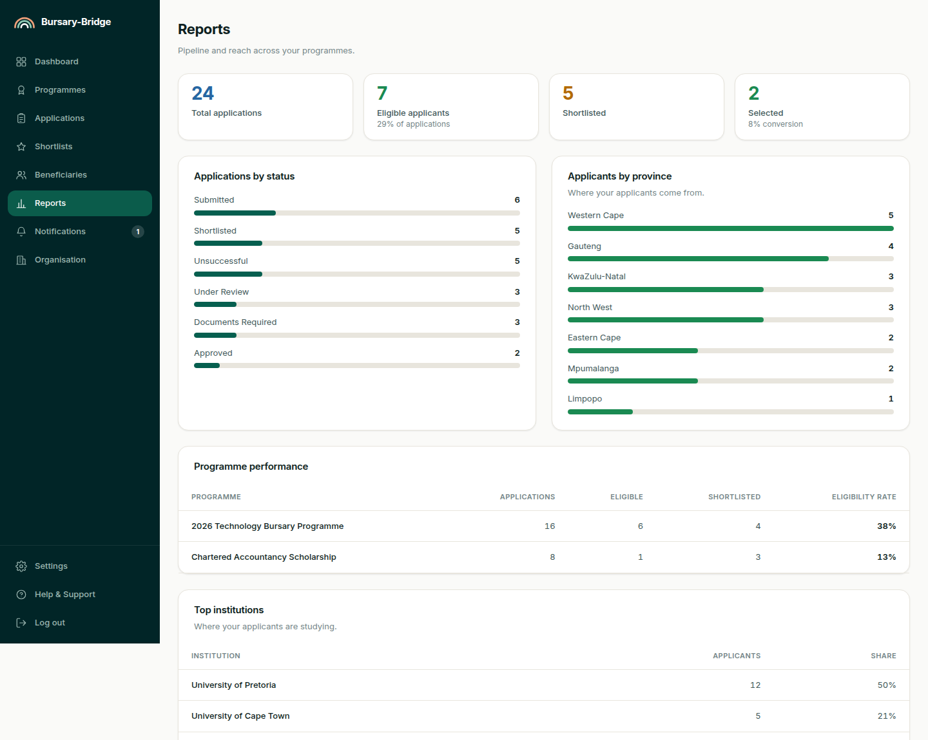
Figure 38 Corporate reports
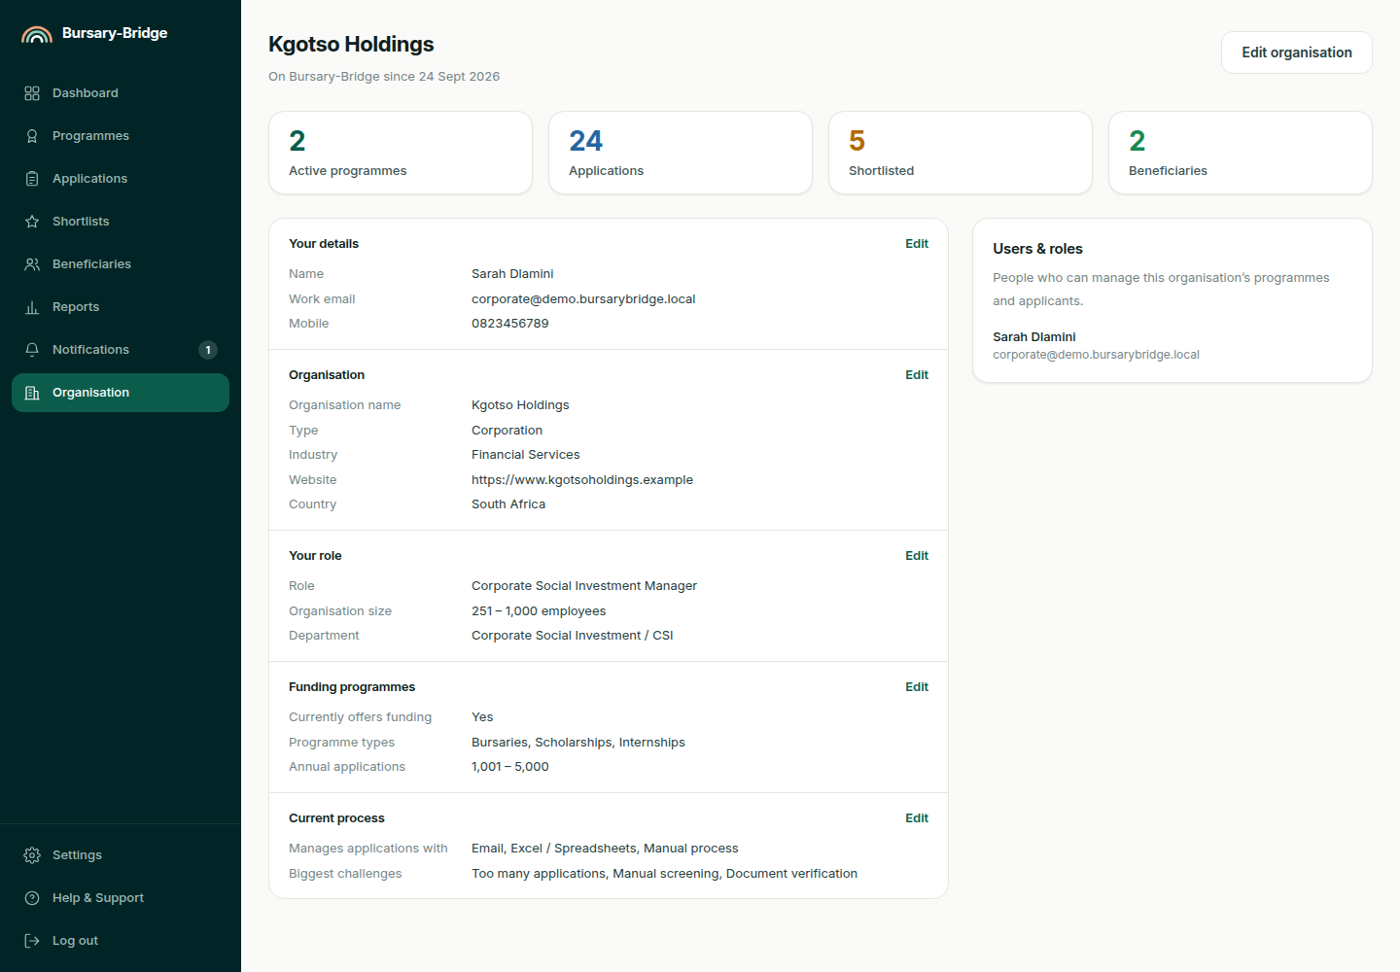
Figure 39 Organisation profile

Figure 40 Landing page at a tablet width of 834 pixels

Figure 41 Opportunities at a tablet width of 834 pixels
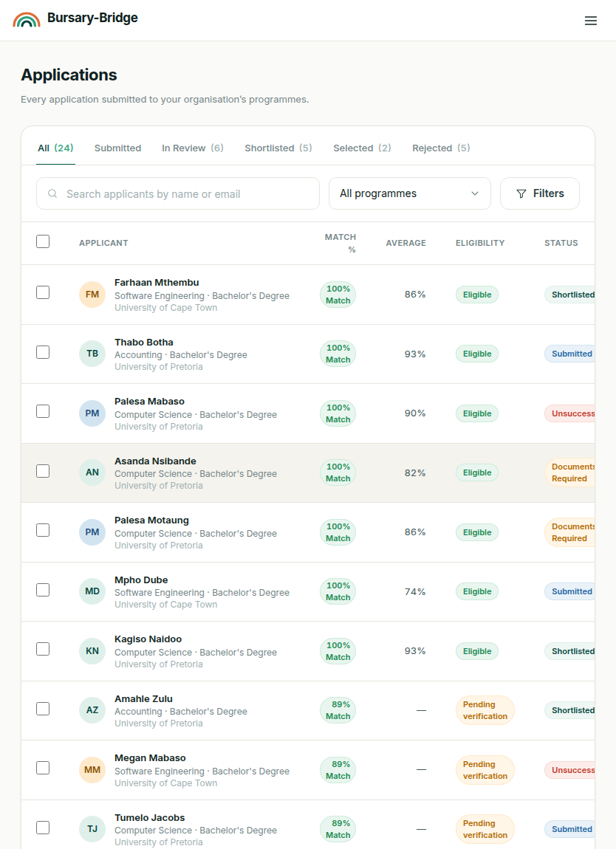
Figure 42 Applications received at a tablet width of 834 pixels

Figure 43 Landing page at a mobile width of 390 pixels
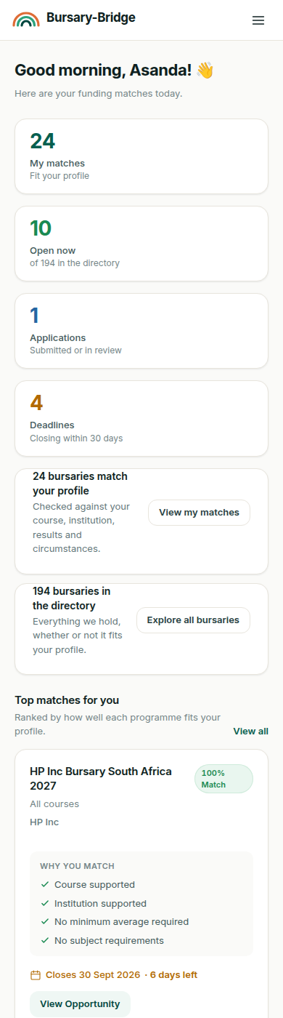
Figure 44 Student dashboard at a mobile width of 390 pixels
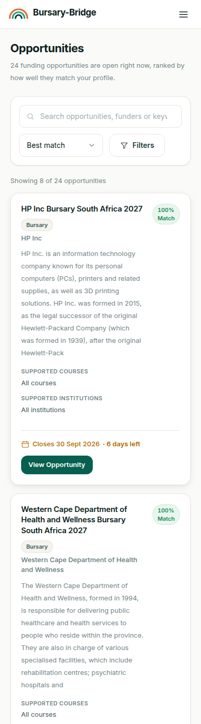
Figure 45 Opportunities at a mobile width of 390 pixels
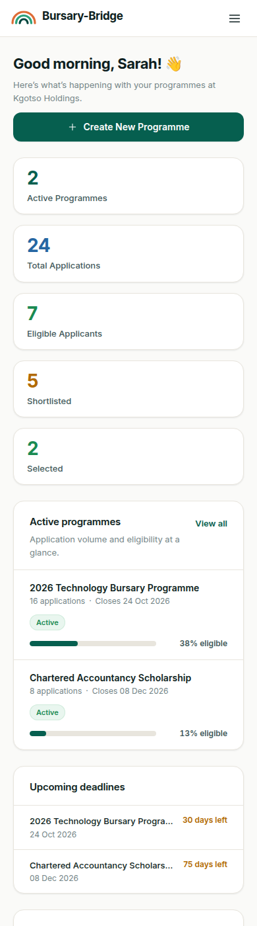
Figure 46 Corporate dashboard at a mobile width of 390 pixels

7.0. Help system design
The system carries contextual guidance rather than a separate help application. Wherever the system asks for something it says why it is being asked, each onboarding step carries a short explanation of how the information affects matching, and every match is accompanied by the reasons behind its score, which is the explanation a Student most often needs.
A help page is provided at /help, together with the terms of service and the privacy notice, which states what is collected and why. No indexed help system, guided tour or offline documentation is planned for this release.

8.0. Index
Administration Portal 13
Administrator 14–15
App Router 4–6
Applicant 5, 8, 12–13, 18–20, 30, 35, 44, 46–48, 68
Application 4–5, 8–10, 12–13, 16–21, 23, 25–36, 39, 42–47, 58–60, 79
Application Import Pipeline 17–18
Application Programming Interface 23, 26
ApplicationImportBatch 34
Audit Trail 13
Authentication and Session Module 10, 12, 14, 21, 27
Bursary Ingestion Pipeline 15
Bursary-Bridge Database 16, 18, 22, 29–31
Corporate Portal 4, 11–12
Corporate User 4–5, 8, 12–13, 18, 36, 43–47
Design Entity 5
Document Extraction Engine 16, 18–19, 42, 44
Document Storage Service 17–18, 27–28
Edge Middleware 10, 27
Eligibility Outcome 28
Eligibility Rule 5, 13, 24, 26, 31, 43
Eligibility Service 12–13, 18–19, 25, 28, 44, 46
Funding Programme 5–6, 12–13, 18, 20, 23–24, 28, 35, 43–44, 66
Guard 5, 9–12, 14, 26, 28, 32, 36, 46
Match Score 5, 12, 28, 31, 43
Matching Engine 5, 8, 10–11, 13, 18–19, 23, 25–26, 28, 31, 38, 44
Motivational Letter Composer 20, 41
Next.js 4–6, 8
Notification and Email Service 30
Organisation 4–5, 12–13, 16, 18–19, 21, 28, 30, 33, 35, 44, 46–47, 49, 53, 65, 72
PostgreSQL 4, 8, 31–33
Prisma 4–6, 10, 23, 31–32
Programme 5–6, 11–13, 18–20, 23–26, 28, 32–33, 35, 39, 41, 43–44, 46–49, 66
Route Handler 6, 8, 11, 28, 30
Server Component 6
Service Layer 6, 9–14, 26–27, 32, 36, 38
Session 6, 10–12, 14, 21–23, 27–29, 33, 36
Shortlist 32, 47–48
Student 4–6, 8, 10–12, 14, 16, 18–29, 31, 33–43, 45, 48–49, 52, 54–55, 59, 61–63, 77
Student Portal 4, 10
Study Preference 6, 31, 35
Zod 6, 26–27

