
Department of Computer Science

Software Requirements Specification

Bursary-Bridge
A Bursary and Scholarship Matching Platform

Supervisor
Ms Zulu

Submitted by
Student Name | Student Number
1. CPP Mchunu | 202242486
2. A Nsibande | 240079346
3. KN Bikile | 202356797
4. SP Tshazi | 240103222
5.
6.

September 2026

Table of Contents
1.0. Introduction 1
1.1. Purpose 1
1.2. Scope of Project 1
1.3. Glossary 2
1.4. References 4
1.5. Overview of Document 4
2.0. Overall Description 6
2.1 System Environment 6
2.2 Functional Requirements Specification 7
2.2.1 Common Use Cases 7
Use case: Log In 8
Use case: Log Out 9
Use case: Manage Account Settings 9
Use case: View Notifications 10
2.2.2 Student Use Cases 10
Use case: Register Student Account 13
Use case: Verify Email Address 14
Use case: Complete Student Profile 14
Use case: Manage Study Preferences 15
Use case: View Matched Opportunities 16
Use case: Search and Filter Opportunities 17
Use case: View Opportunity Details 17
Use case: Apply for Funding 18
Use case: Track Application 19
Use case: Manage Documents 19
Use case: Record Subject Results 20
Use case: Browse All Bursaries 21
Use case: Generate Motivational Letter 21
Use case: Auto-Fill Application Forms 22
Use case: Respond to Information Request 22
2.2.3 Corporate User Use Cases 23
Use case: Register Corporate Account 26
Use case: Complete Organisation Profile 27
Use case: Create Funding Programme 27
Use case: Define Eligibility Criteria 28
Use case: Publish Funding Programme 29
Use case: Import Applications 30
Use case: Review Imported Applications 30
Use case: View Applications 31
Use case: Review Applicant 32
Use case: Shortlist Applicant 32
Use case: Request Information from Applicant 33
Use case: Select Beneficiary 33
Use case: View Reports 34
2.2.4 Administrator Use Cases 35
Use case: Manage Institution and Course Catalogue 35
Use case: Manage User Accounts 36
Use case: Moderate Organisations and Programmes 37
Use case: Manage Bursary Data Sources 37
Use case: View Audit Trail 38
2.2.5 Complete Use Case Diagram 38
2.3 User Characteristics 41
2.4 Non-Functional Requirements 41
3.0. Requirements Specification 43
3.1 External Interface Requirements 43
3.2 Functional Requirements 43
3.2.1 Log In 44
3.2.2 Log Out 44
3.2.3 Manage Account Settings 44
3.2.4 View Notifications 45
3.2.5 Register Student Account 45
3.2.6 Verify Email Address 46
3.2.7 Complete Student Profile 47
3.2.8 Manage Study Preferences 48
3.2.9 View Matched Opportunities 48
3.2.10 Search and Filter Opportunities 49
3.2.11 View Opportunity Details 49
3.2.12 Apply for Funding 50
3.2.13 Track Application 51
3.2.14 Manage Documents 51
3.2.15 Record Subject Results 52
3.2.16 Browse All Bursaries 53
3.2.17 Generate Motivational Letter 53
3.2.18 Auto-Fill Application Forms 54
3.2.19 Respond to Information Request 55
3.2.20 Register Corporate Account 56
3.2.21 Complete Organisation Profile 56
3.2.22 Create Funding Programme 57
3.2.23 Define Eligibility Criteria 58
3.2.24 Publish Funding Programme 58
3.2.25 Import Applications 59
3.2.26 Review Imported Applications 60
3.2.27 View Applications 61
3.2.28 Review Applicant 61
3.2.29 Shortlist Applicant 62
3.2.30 Request Information from Applicant 62
3.2.31 Select Beneficiary 63
3.2.32 View Reports 63
3.2.33 Manage Institution and Course Catalogue 64
3.2.34 Manage User Accounts 64
3.2.35 Moderate Organisations and Programmes 65
3.2.36 Manage Bursary Data Sources 66
3.2.37 View Audit Trail 66
3.3 Detailed Non-Functional Requirements 67
3.3.1 Logical Structure of the Data 67
3.3.2 Security 73

List of Figures
Figure 1 - System Environment 6
Figure 2 - Application Status Lifecycle 7
Figure 3 - Common Use Cases 8
Figure 4 - Log In Use Case 8
Figure 5 - Log Out Use Case 9
Figure 6 - Manage Account Settings Use Case 9
Figure 7 - View Notifications Use Case 10
Figure 8 - Student Use Cases (1 of 3) 11
Figure 9 - Student Use Cases (2 of 3) 12
Figure 10 - Student Use Cases (3 of 3) 13
Figure 11 - Register Student Account Use Case 13
Figure 12 - Verify Email Address Use Case 14
Figure 13 - Complete Student Profile Use Case 15
Figure 14 - Manage Study Preferences Use Case 15
Figure 15 - View Matched Opportunities Use Case 16
Figure 16 - Search and Filter Opportunities Use Case 17
Figure 17 - View Opportunity Details Use Case 17
Figure 18 - Apply for Funding Use Case 18
Figure 19 - Track Application Use Case 19
Figure 20 - Manage Documents Use Case 19
Figure 21 - Record Subject Results Use Case 20
Figure 22 - Browse All Bursaries Use Case 21
Figure 23 - Generate Motivational Letter Use Case 21
Figure 24 - Auto-Fill Application Forms Use Case 22
Figure 25 - Respond to Information Request Use Case 23
Figure 26 - Corporate User Use Cases (1 of 3) 24
Figure 27 - Corporate User Use Cases (2 of 3) 25
Figure 28 - Corporate User Use Cases (3 of 3) 26
Figure 29 - Register Corporate Account Use Case 26
Figure 30 - Complete Organisation Profile Use Case 27
Figure 31 - Create Funding Programme Use Case 28
Figure 32 - Define Eligibility Criteria Use Case 28
Figure 33 - Publish Funding Programme Use Case 29
Figure 34 - Import Applications Use Case 30
Figure 35 - Review Imported Applications Use Case 30
Figure 36 - View Applications Use Case 31
Figure 37 - Review Applicant Use Case 32
Figure 38 - Shortlist Applicant Use Case 32
Figure 39 - Request Information from Applicant Use Case 33
Figure 40 - Select Beneficiary Use Case 34
Figure 41 - View Reports Use Case 34
Figure 42 - Administrator Use Cases 35
Figure 43 - Manage Institution and Course Catalogue Use Case 36
Figure 44 - Manage User Accounts Use Case 36
Figure 45 - Moderate Organisations and Programmes Use Case 37
Figure 46 - Manage Bursary Data Sources Use Case 37
Figure 47 - View Audit Trail Use Case 38
Figure 48 - Complete Use Case Diagram 40
Figure 49 - Logical Structure of the Bursary-Bridge Data 67

List of Tables
Table 1 - Glossary of Terms 2
Table 2 - User Data Entity 67
Table 3 - Student Profile Data Entity 68
Table 4 - Study Preference Data Entity 68
Table 5 - Organisation Data Entity 68
Table 6 - Funding Programme Data Entity 69
Table 7 - Eligibility Rule Data Entity 69
Table 8 - Application Data Entity 69
Table 9 - Subject Result Data Entity 70
Table 10 - Motivational Letter Data Entity 70
Table 11 - Information Request Data Entity 70
Table 12 - Application Import Batch Data Entity 71
Table 13 - Application Import File Data Entity 71
Table 14 - External Applicant Data Entity 72
Table 15 - Opportunity Source Data Entity 72
Table 16 - Shortlist Data Entity 72
Table 17 - Document Data Entity 72

1.0. Introduction

1.1. Purpose
The purpose of this document is to present a detailed description of Bursary-Bridge. It explains the purpose and the features of the system, what the system does, the constraints under which it must operate and how it reacts to the people who use it. This document is intended for the stakeholders who commissioned the system and for the developers who will build it.

1.2. Scope of Project
Bursary-Bridge is a web application that connects South African students with bursaries, scholarships and other education funding, and gives the organisations that fund education a place to publish those opportunities and administer the applications they attract.
Students who need funding face two related problems. Opportunities are scattered across many websites and are hard to find, and each one asks for the same information in a different form. Organisations that offer funding face the mirror of those problems. They receive large numbers of applications, many from students who do not meet the criteria, and they screen them by hand using email and spreadsheets.
Bursary-Bridge addresses both. A student builds one profile, which records what they want to study and where, what results they hold and what funding they need. The system compares that profile against every published funding programme and presents the opportunities that fit, each with a match score and, importantly, the reasons behind that score. The student applies using the profile they have already built rather than entering the same information again.
An organisation states its criteria once, as structured data rather than as prose. The same criteria then drive the matches shown to students and the eligibility verdict shown to the reviewer, so the two views cannot disagree. The organisation receives applications that are already scored and assessed, and moves applicants through review, shortlisting and selection.
The system serves three kinds of user: the Student, the Corporate User and the Administrator. The Administrator maintains the catalogue of institutions, qualifications and subjects that the other two select from, and suspends or restores accounts; the Administrator does not take part in matching or in selection. The system does not attempt to disburse funds, to verify documents against any external authority, or to integrate with the administration systems of universities or of government. Those lie outside the scope of this release.

1.3. Glossary
Table 1 defines the terms used throughout this specification. Each term carries the same meaning wherever it appears, in this document and in the Software Design Description and Test Plan that accompany it.
Table 1 - Glossary of Terms
Term | Definition
Administrator | A member of the Bursary-Bridge operating team who maintains the catalogue, the data sources and the accounts on the platform. An Administrator does not apply for funding and does not decide who receives it.
All Bursaries | The directory of every published Funding Programme held by the system, presented without regard to any Student's profile. Distinct from My Matches.
Applicant | A Student who has submitted an application to a Funding Programme, or an applicant whose application an Organisation imported.
Application | A Student's formal request for funding under a specific Funding Programme. An application carries a status, the profile the Student applied with, answers to programme questions and any attached documents.
Auto-Fill | The transfer of information from one application form a Student has already completed onto other, blank forms.
Beneficiary | An Applicant who has been selected to receive funding under a Funding Programme.
Corporate User | A representative of an Organisation who administers that Organisation's Funding Programmes on the system. Also referred to as the Funder.
Database | The collection of all information monitored by this system.
Eligibility Rule | The machine-readable set of conditions attached to a Funding Programme, covering supported institutions and courses, qualification level, minimum academic average, year of study, citizenship, household income and province.
Eligibility Outcome | The verdict returned when an Applicant is evaluated against a programme's Eligibility Rule: Eligible, Not Eligible, or Pending Verification.
Funding Programme | A bursary, scholarship or grant published by an Organisation, to which Students may apply.
Import Batch | One upload of application forms received outside Bursary-Bridge, processed together against a single Funding Programme.
Information Request | A Funder's request to an Applicant for specific documents or information in support of a submitted application.
Institution | A recognised South African university, university of technology or TVET college held in the standardised catalogue.
Match Score | A percentage from 0 to 100 expressing how closely a Student's profile fits a Funding Programme, produced by the Matching Engine.
Matching Engine | The component that scores a Student profile against a Funding Programme across six weighted criteria and returns both the score and the reasons behind it.
Motivational Letter | A letter a Student produces for a Funding Programme, composed from facts on their profile and sentences they wrote themselves.
My Matches | The Funding Programmes the Matching Engine has scored against a particular Student's profile. Distinct from All Bursaries.
Organisation | A corporation, foundation, NGO or other body that funds education through the system.
Programme | A standardised course of study, such as Computer Science, held in the catalogue. Distinct from a Funding Programme.
Profile Strength | A percentage indicating how complete a Student's profile is, used to prompt the Student to supply information that would improve their matches.
Provenance | The record of where an externally collected Funding Programme was read from: the address of the page, the name of the source, and the date it was last confirmed.
Shortlist | The set of Applicants an Organisation is actively considering for a Funding Programme.
Software Requirements Specification | A document that completely describes all of the functions of a proposed system and the constraints under which it must operate.
Stakeholder | Any person with an interest in the project who is not a developer.
Student | A learner seeking funding for tertiary study, who holds a profile on the system.
Subject Result | A subject or module a Student is taking, with the year and, where the Student knows it, the mark.
Study Preference | A course paired with the institution at which the Student intends to study it. A Student may hold a maximum of six.
User | A Student, a Corporate User or an Administrator.

1.4. References
The sources below are cited by bracketed number throughout this document. Each is cited at least once in the text, and every bracketed number in the text appears here.
[1] IEEE, IEEE Std 830-1998, IEEE Recommended Practice for Software Requirements Specifications. Los Alamitos, CA: IEEE Computer Society, 1998.
[2] Object Management Group, OMG Unified Modeling Language (OMG UML), Version 2.5.1. Needham, MA: Object Management Group, 2017. [Online]. Available: https://www.omg.org/spec/UML/2.5.1/.
[3] Republic of South Africa, Protection of Personal Information Act 4 of 2013. Pretoria: Government Printer, 2013. [Online]. Available: https://www.justice.gov.za/legislation/acts/2013-004.pdf.

1.5. Overview of Document
The next chapter, the Overall Description section, gives an overview of the functionality of the product. It describes the environment the system sits in, the actors who use it and the use cases each actor performs, in language intended for the stakeholders who commissioned it.
The third chapter, the Requirements Specification section, is written primarily for the developers. It describes each use case formally, with its trigger, its preconditions, the basic path through it, the alternative and exception paths and its postconditions, together with the logical structure of the data and the security requirements.
Both chapters describe the same software product in its entirety, but are intended for different audiences and so use different language. The division of the document between them, and the content of each section, follow the recommended practice for a software requirements specification set out in [1].
Four conventions are used throughout. Figures are numbered consecutively and listed in the List of Figures; every use case is accompanied by its own numbered diagram. Tables that present data in their own right are numbered and listed in the List of Tables; the formal requirement tables of Section 3.2 are not separately numbered, because each sits directly beneath the numbered heading of the use case it describes. Sources are cited by bracketed number against the list in Section 1.4. Cross references name the section, figure or table by its number rather than by its position on the page.

2.0. Overall Description

2.1 System Environment
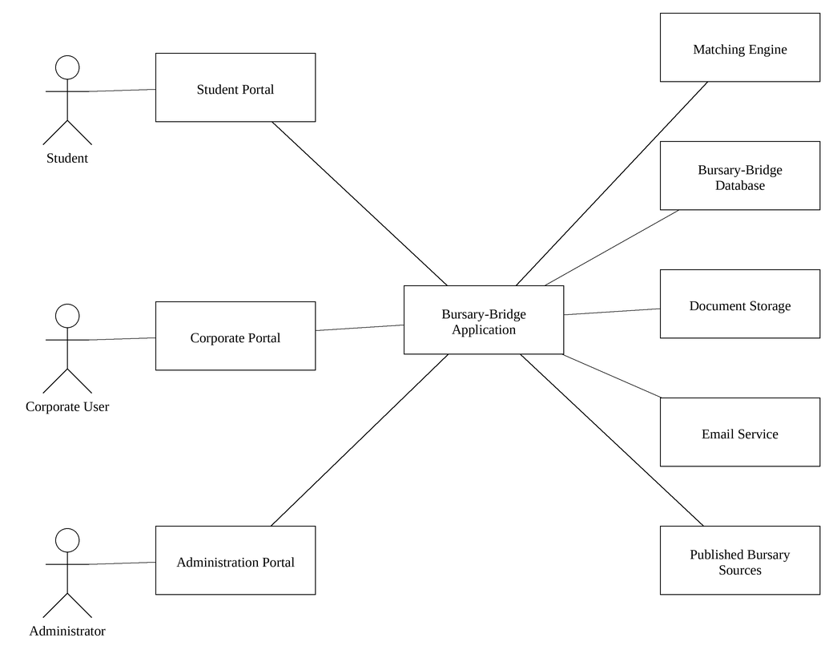
Figure 1 - System Environment
Figure 1 shows the environment in which Bursary-Bridge operates. The system has three active actors, the Student, the Corporate User and the Administrator, each reaching it through a portal of their own, and five cooperating components: the Matching Engine, the database, document storage, an email service and the published bursary sources from which the directory is collected.
The Student and the Corporate User both reach the system through a web browser over the Internet. Each is presented with a different portal, but both are served by one application and one database, so a funding programme published by an organisation is visible to a matching student immediately.
The Matching Engine is a component of the application rather than a separate system. It is drawn separately here because it is the part of the system that gives Bursary-Bridge its purpose: it compares a student profile against a funding programme and produces both a score and the reasons for that score.
Document Storage holds the files students upload. It is drawn separately because those files are held outside the web root and are released only through an authorised request, and because in a production deployment it would be an object store rather than part of the application server.
The Email Service is the one cooperating system. It delivers address verification messages and the notifications raised when an application changes status. The system does not depend on it for any decision; if a message cannot be delivered the user can still complete every journey through the interface.

2.2 Functional Requirements Specification
This section sets out the use cases for each actor. Use cases common to both actors are given first, followed by those belonging to the Student and then those belonging to the Corporate User. Each use case is presented with a diagram, a brief description, the steps that make it up and a cross reference to its formal description in Section 3.2.
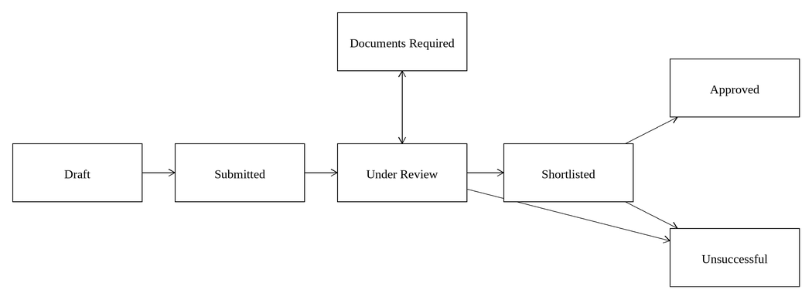
Figure 2 - Application Status Lifecycle
Figure 2 summarises the use cases that follow. A Student prepares an application as a draft and submits it. The Corporate User reviews it, may ask for further information, and either shortlists the applicant or records the application as unsuccessful. A shortlisted applicant is either selected as a beneficiary or, ultimately, unsuccessful.

2.2.1 Common Use Cases
Both kinds of user share a small number of use cases. They are described once here and are not repeated under each actor.
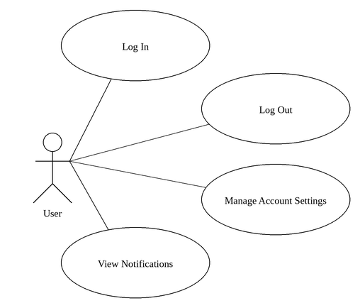
Figure 3 - Common Use Cases

Use case: Log In
Diagram:
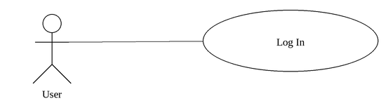
Figure 4 - Log In Use Case
Brief Description
A registered User authenticates and is taken to the part of the system that matches their role.
Initial Step-By-Step Description
Before this use case can be initiated, the User has already registered an account and has accessed the Bursary-Bridge login page.
1. The User enters their email address and password.
2. The System verifies the credentials against the stored password hash.
3. The System creates a session and issues a session cookie.
4. The System directs a Student to the Student Dashboard and a Corporate User to the Corporate Dashboard.
5. If the User has not finished their profile, the System returns them to the step at which they stopped.
Xref: Section 3.2.1, Log In

Use case: Log Out
Diagram:
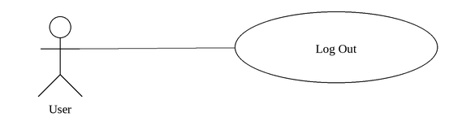
Figure 5 - Log Out Use Case
Brief Description
A User ends their session.
Initial Step-By-Step Description
Before this use case can be initiated, the User is signed in.
1. The User selects Log out from the navigation sidebar.
2. The System deletes the session record.
3. The System clears the session cookie and returns the User to the login page.
Xref: Section 3.2.2, Log Out

Use case: Manage Account Settings
Diagram:
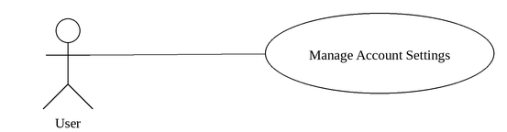
Figure 6 - Manage Account Settings Use Case
Brief Description
A User updates their contact details, notification preference or password.
Initial Step-By-Step Description
Before this use case can be initiated, the User has signed in and accessed the Settings page.
1. The User edits their first name, last name, email address, mobile number or email notification preference.
2. The System validates the submitted values and saves them.
3. If the email address changed, the System marks the address unverified and sends a new verification email.
4. The User may instead choose to change their password by supplying the current password and a new one twice.
5. The System verifies the current password, stores the new hash and ends every other session.
Xref: Section 3.2.3, Manage Account Settings

Use case: View Notifications
Diagram:
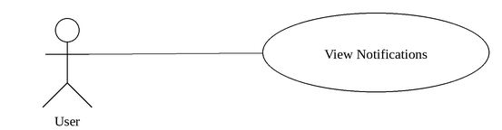
Figure 7 - View Notifications Use Case
Brief Description
A User reads the notifications the System has raised for them and marks them as read.
Initial Step-By-Step Description
Before this use case can be initiated, the User has signed in.
1. The User selects Notifications from the sidebar.
2. The System presents the User's notifications, newest first, with unread items highlighted.
3. The User selects a notification.
4. The System marks that notification read and follows its link.
5. The User may instead choose to mark every notification as read.
Xref: Section 3.2.4, View Notifications

2.2.2 Student Use Cases
The Student is the actor the system exists to serve. The use cases below carry the Student from registration through to tracking a submitted application.
This actor has more than one diagram. A fan of use cases grows wider with every use case on it, and every figure is set in the same text column, so beyond about five the labels become too small to read. The 3 diagrams below therefore divide this actor's use cases between them; together they show the complete set, and each use case also appears on its own diagram with its description.
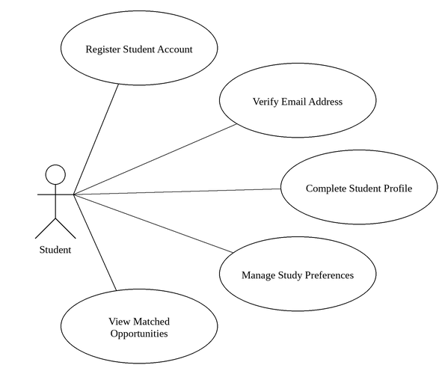
Figure 8 - Student Use Cases (1 of 3)
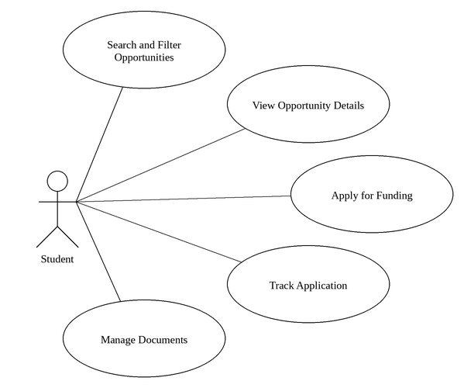
Figure 9 - Student Use Cases (2 of 3)
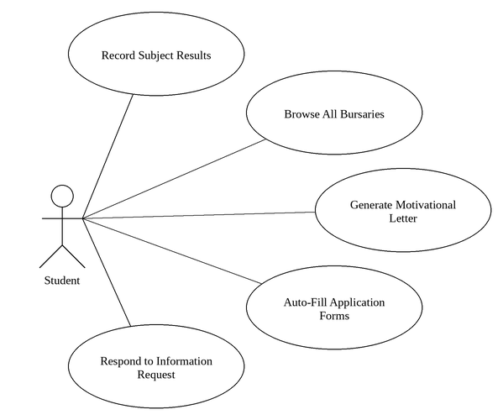
Figure 10 - Student Use Cases (3 of 3)

Use case: Register Student Account
Diagram:
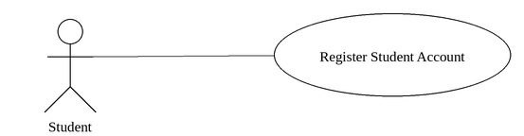
Figure 11 - Register Student Account Use Case
Brief Description
A prospective Student creates an account so that they can build a funding profile.
Initial Step-By-Step Description
Before this use case can be initiated, the visitor has accessed the Bursary-Bridge website and chosen to sign up as a Student.
1. The Student supplies a first name, last name, email address, mobile number and password, and confirms the password.
2. The Student indicates whether to receive funding opportunity notifications by email.
3. The Student accepts the Terms of Service and Privacy Notice.
4. The System validates every field and confirms that the email address is not already registered.
5. The System creates the account, an empty Student profile and a session, and sends a verification email.
6. The System presents the Check your email screen.
Xref: Section 3.2.5, Register Student Account

Use case: Verify Email Address
Diagram:
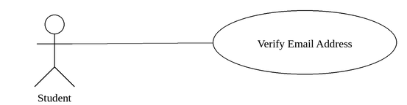
Figure 12 - Verify Email Address Use Case
Brief Description
The Student confirms ownership of the email address supplied at registration.
Initial Step-By-Step Description
Before this use case can be initiated, the Student has registered and the System has sent a verification email.
1. The Student opens the verification email and follows the link.
2. The System reads the token from the link and compares its hash against the stored token.
3. The System confirms that the token has not expired.
4. The System marks the email address verified and deletes the token.
5. The System takes the Student to the first step of the profile.
Xref: Section 3.2.6, Verify Email Address

Use case: Complete Student Profile
Diagram:
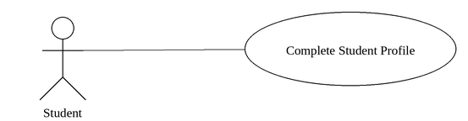
Figure 13 - Complete Student Profile Use Case
Brief Description
The Student supplies the information the Matching Engine needs, one step at a time.
Initial Step-By-Step Description
Before this use case can be initiated, the Student has registered and is signed in.
1. The Student states their education stage, the qualification level they intend to study and their study status. If they are already enrolled, the System also asks for their current institution, current programme and year of study.
2. The Student records their study preferences, as described in Section 2.2.2, Manage Study Preferences.
3. The Student gives their latest academic average, or indicates that they do not know it, and selects the results and achievements they hold.
4. The Student selects what they need funding for and describes their current funding situation.
5. The Student selects a household income band and, optionally, date of birth, citizenship and further eligibility information.
6. The Student selects their province, city or town, expected study location and up to five career interests.
7. The System presents the whole profile for review, with a link to edit any section.
8. The Student confirms, and the System opens the Student Dashboard.
Xref: Section 3.2.7, Complete Student Profile

Use case: Manage Study Preferences
Diagram:
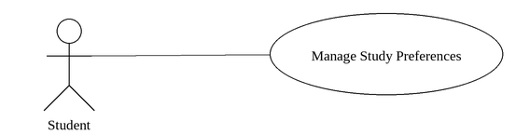
Figure 14 - Manage Study Preferences Use Case
Brief Description
The Student records up to six courses, each paired with the institution at which they intend to study it.
Initial Step-By-Step Description
Before this use case can be initiated, the Student has signed in and reached the Study Preferences step or opened it from their profile.
1. The System presents the Student's existing preferences, numbered in order.
2. The Student selects a course from the standardised catalogue.
3. The Student selects the institution at which they intend to study that course.
4. The Student repeats steps 2 and 3 for each combination they are considering, up to six.
5. The Student may remove a preference or change either half of a pair.
6. The System saves the list, renumbering the preferences so that they remain in order.
Xref: Section 3.2.8, Manage Study Preferences

Use case: View Matched Opportunities
Diagram:
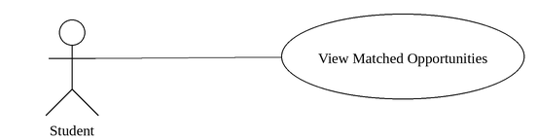
Figure 15 - View Matched Opportunities Use Case
Brief Description
The Student sees the funding programmes that best fit their profile, ranked, with the reasons behind each score.
Initial Step-By-Step Description
Before this use case can be initiated, the Student has completed their profile and accessed the Student Dashboard.
1. The System retrieves every published funding programme that is still open.
2. The System scores each programme against the Student's profile.
3. The System presents the number of matches, active applications and approaching deadlines.
4. The System presents the best matching programmes, each with its match percentage and the criteria that were met.
5. The System presents profile strength and the sections that would most improve the Student's matches.
Xref: Section 3.2.9, View Matched Opportunities

Use case: Search and Filter Opportunities
Diagram:
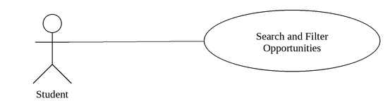
Figure 16 - Search and Filter Opportunities Use Case
Brief Description
The Student narrows the list of funding opportunities to those of interest.
Initial Step-By-Step Description
Before this use case can be initiated, the Student has completed their profile and accessed the Opportunities page.
1. The System presents every open opportunity, scored and ranked by match.
2. The Student enters search terms, or selects filters for course, institution, qualification, funding type, what the programme covers, province, minimum match score or closing date.
3. The Student may choose to hide opportunities already applied for.
4. The System applies the filters and presents the matching opportunities in pages.
5. The Student may reorder the results by match, closing date or name.
Xref: Section 3.2.10, Search and Filter Opportunities

Use case: View Opportunity Details
Diagram:

Figure 17 - View Opportunity Details Use Case
Brief Description
The Student reads the full terms of a funding programme and why they do or do not match it.
Initial Step-By-Step Description
Before this use case can be initiated, the Student has selected an opportunity from the Dashboard or the Opportunities page.
1. The System presents the programme name, the funding Organisation, the closing date and what the programme covers.
2. The System presents the full description, the supported courses and the supported institutions.
3. The System presents the eligibility requirements, including academic, qualification, year of study, citizenship, financial and geographic conditions.
4. The System presents the documents the programme requires and how to apply.
5. The System presents the Student's match score together with every criterion, showing which were met, which were not, and which could not be evaluated.
Xref: Section 3.2.11, View Opportunity Details

Use case: Apply for Funding
Diagram:
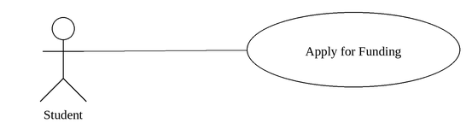
Figure 18 - Apply for Funding Use Case
Brief Description
The Student submits an application to a funding programme, reusing the profile they have already built.
Initial Step-By-Step Description
Before this use case can be initiated, the Student has completed their profile and has opened a published funding programme that is still open.
1. The System presents the profile that will be sent with the application, for review only, with links to edit any section.
2. The Student answers any questions specific to this programme.
3. The Student attaches the documents the programme requires from those already uploaded.
4. The System presents the application for review, together with the match score.
5. The Student confirms that the information is accurate and submits.
6. The System records the application, snapshots the match score and the eligibility verdict, and notifies the Student.
Xref: Section 3.2.12, Apply for Funding

Use case: Track Application
Diagram:
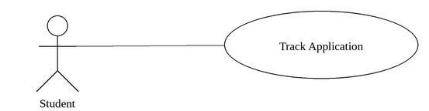
Figure 19 - Track Application Use Case
Brief Description
The Student follows the progress of an application through to a decision.
Initial Step-By-Step Description
Before this use case can be initiated, the Student has at least one application and has accessed My Applications.
1. The System presents the Student's applications grouped by status.
2. The Student selects an application.
3. The System presents the programme, the funder, the date applied, the closing date and the date of the last change.
4. The System presents a progress timeline from started through submitted, under review, shortlisted and decided.
5. The System presents the answers given, the documents attached and the match as it stood at submission.
Xref: Section 3.2.13, Track Application

Use case: Manage Documents
Diagram:
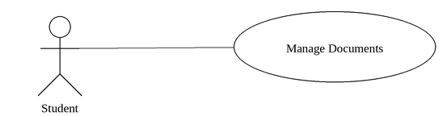
Figure 20 - Manage Documents Use Case
Brief Description
The Student uploads and maintains the supporting documents funders commonly ask for.
Initial Step-By-Step Description
Before this use case can be initiated, the Student has signed in and accessed the Documents page.
1. The System presents the documents the Student has already uploaded.
2. The Student selects the kind of document and chooses a file.
3. The System checks the file type and size, stores the file and records it against the Student.
4. The System recalculates profile strength.
5. The Student may view or permanently remove any document.
Xref: Section 3.2.14, Manage Documents

Use case: Record Subject Results
Diagram:
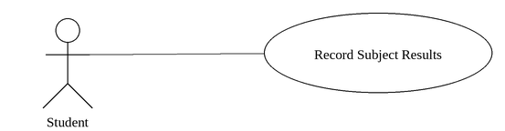
Figure 21 - Record Subject Results Use Case
Brief Description
A Student records the subjects or modules they are taking and the marks they have, so that funding programmes stating a subject minimum can be matched against them.
Initial Step-By-Step Description
Before this use case can be initiated, the Student has signed in and has accessed the My Results page.
1. The Student selects Add a result.
2. The Student chooses a subject from the standardised subject list, or types a subject the list does not carry.
3. The Student enters the year, and the mark if they have it.
4. The System stores the result against the Student's profile.
5. The System shows any funding programme requirement that the result now satisfies.
Xref: Section 3.2.15, Record Subject Results

Use case: Browse All Bursaries
Diagram:
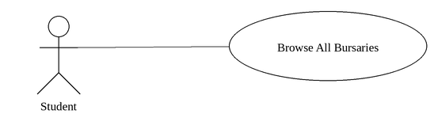
Figure 22 - Browse All Bursaries Use Case
Brief Description
A Student browses the complete directory of funding opportunities held by the system, whether or not they match the Student's own profile.
Initial Step-By-Step Description
Before this use case can be initiated, the Student has signed in and has accessed the All Bursaries page.
1. The Student opens All Bursaries.
2. The System lists every published opportunity, open ones first.
3. The Student searches by name, organisation, course or institution, or filters by status, funding type, field of study, institution, province or qualification.
4. The System shows the opportunities that satisfy the search and filters, with the status of each.
5. The Student opens an opportunity to read its full details and the source it was read from.
Xref: Section 3.2.16, Browse All Bursaries

Use case: Generate Motivational Letter
Diagram:
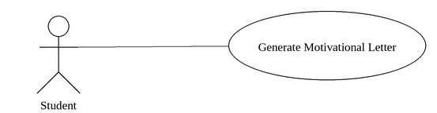
Figure 23 - Generate Motivational Letter Use Case
Brief Description
A Student produces a draft motivational letter for a chosen funding programme, assembled from their profile and from answers they write themselves.
Initial Step-By-Step Description
Before this use case can be initiated, the Student has signed in and has accessed the Motivational Letters page.
1. The Student selects the funding programme the letter is for.
2. The Student answers, in their own words, as many of the seven questions as they wish.
3. The System shows which facts from the Student's profile it will use.
4. The System composes a draft from those facts and those answers.
5. The Student edits the draft, saves it, and downloads it as a PDF.
Xref: Section 3.2.17, Generate Motivational Letter

Use case: Auto-Fill Application Forms
Diagram:
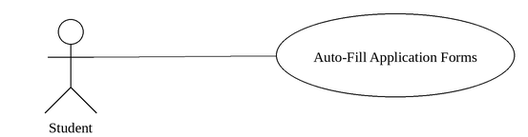
Figure 24 - Auto-Fill Application Forms Use Case
Brief Description
A Student supplies one completed application form and a number of blank ones, and the System transfers the information from the first onto the others.
Initial Step-By-Step Description
Before this use case can be initiated, the Student has signed in and has accessed the Auto-Fill Forms page.
1. The Student uploads one application form they have already completed.
2. The Student uploads one or more blank forms.
3. The System reads the completed form and identifies the fields on each blank form.
4. The System fills the fields it can match with confidence and leaves the rest blank for the Student.
5. The Student reviews each field, corrects anything wrong, and downloads the completed forms.
Xref: Section 3.2.18, Auto-Fill Application Forms

Use case: Respond to Information Request
Diagram:
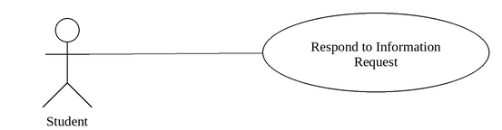
Figure 25 - Respond to Information Request Use Case
Brief Description
A Student supplies documents or information that a Funder has asked for in support of a submitted application.
Initial Step-By-Step Description
Before this use case can be initiated, the Funder has requested information and the Student has opened the application.
1. The Student opens the application the request belongs to.
2. The System shows exactly what the Funder asked for, in the Funder's own words.
3. The Student attaches a document to each item requested.
4. The Student submits the response.
5. The System notifies the Funder and records the response against the application.
Xref: Section 3.2.19, Respond to Information Request

2.2.3 Corporate User Use Cases
The Corporate User administers an Organisation's funding programmes and decides who receives funding.
This actor has more than one diagram. A fan of use cases grows wider with every use case on it, and every figure is set in the same text column, so beyond about five the labels become too small to read. The 3 diagrams below therefore divide this actor's use cases between them; together they show the complete set, and each use case also appears on its own diagram with its description.
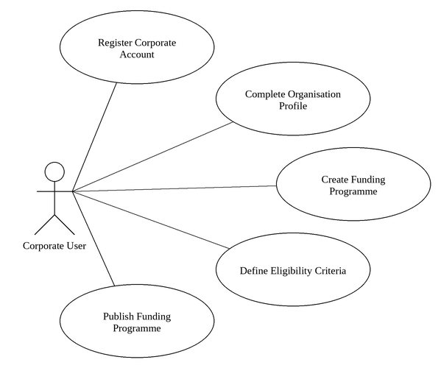
Figure 26 - Corporate User Use Cases (1 of 3)
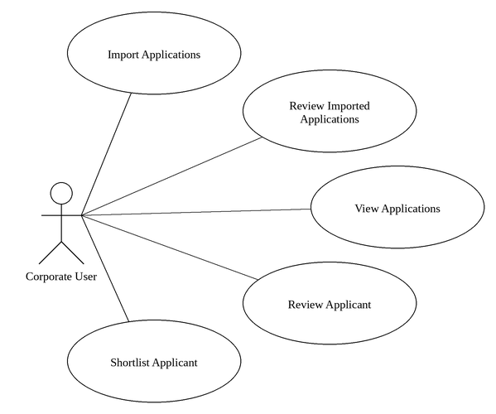
Figure 27 - Corporate User Use Cases (2 of 3)
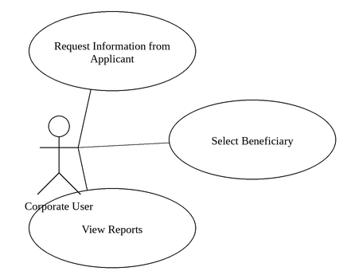
Figure 28 - Corporate User Use Cases (3 of 3)

Use case: Register Corporate Account
Diagram:
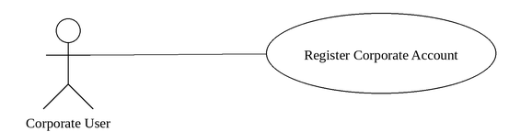
Figure 29 - Register Corporate Account Use Case
Brief Description
A representative of a funding Organisation creates an account so that the Organisation can publish programmes.
Initial Step-By-Step Description
Before this use case can be initiated, the visitor has accessed the Bursary-Bridge website and chosen to sign up as an Organisation.
1. The Corporate User supplies a first name, last name, work email address, mobile number and password, and confirms the password.
2. The Corporate User indicates whether to receive notifications by email.
3. The Corporate User accepts the Terms of Service and Privacy Notice.
4. The System validates every field and confirms the email address is not already registered.
5. The System creates the account, an Organisation record and a session, and sends a verification email.
6. The System opens the first step of the Organisation profile.
Xref: Section 3.2.20, Register Corporate Account

Use case: Complete Organisation Profile
Diagram:
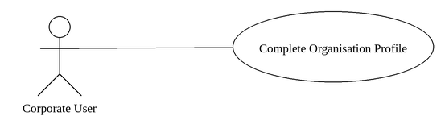
Figure 30 - Complete Organisation Profile Use Case
Brief Description
The Corporate User describes the Organisation, their role within it, and how it funds education.
Initial Step-By-Step Description
Before this use case can be initiated, the Corporate User has registered and is signed in.
1. The Corporate User gives the Organisation's name, type, industry, website and country.
2. The Corporate User states their own role, the size of the Organisation and their department.
3. The Corporate User states whether the Organisation currently funds education, which kinds of programme it runs and roughly how many applications it receives each year.
4. The Corporate User describes, optionally, how applications are managed today and the three biggest challenges faced.
5. The System presents the whole profile for review, with a link to edit any section.
6. The Corporate User confirms, and the System opens the Corporate Dashboard.
Xref: Section 3.2.21, Complete Organisation Profile

Use case: Create Funding Programme
Diagram:
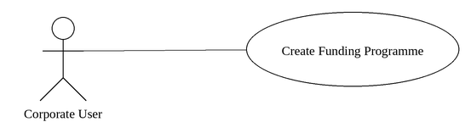
Figure 31 - Create Funding Programme Use Case
Brief Description
The Corporate User sets up a bursary, scholarship or grant for students to apply to.
Initial Step-By-Step Description
Before this use case can be initiated, the Corporate User has completed the Organisation profile and accessed the Programmes page.
1. The Corporate User gives the programme name, a short description, a full description and the programme type.
2. The Corporate User gives the date applications open and the date they close, and optionally the number of awards available.
3. The Corporate User defines the eligibility criteria, as described in Section 2.2.3, Define Eligibility Criteria.
4. The Corporate User selects what the programme pays for.
5. The Corporate User selects the documents applicants must provide and adds any questions specific to this programme.
6. The System presents the programme for review.
7. The Corporate User saves the programme as a draft, or publishes it.
Xref: Section 3.2.22, Create Funding Programme

Use case: Define Eligibility Criteria
This use case is part of the Create Funding Programme use case.
Diagram:
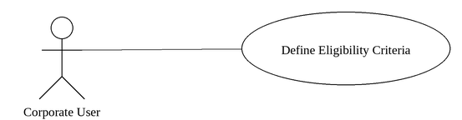
Figure 32 - Define Eligibility Criteria Use Case
Brief Description
The Corporate User states precisely who may apply to a funding programme.
Initial Step-By-Step Description
Before it can be initiated, the Corporate User has reached the Eligibility Criteria step of the programme builder.
1. The Corporate User selects the institutions the programme supports, or leaves the list empty to accept any institution.
2. The Corporate User selects the courses the programme supports, or leaves the list empty to accept any course.
3. The Corporate User selects the qualification levels and years of study that qualify.
4. The Corporate User sets a minimum academic average, if one applies.
5. The Corporate User sets the citizenship, household income and provincial conditions, if any apply.
6. The Corporate User records any further requirements in their own words.
Xref: Section 3.2.23, Define Eligibility Criteria

Use case: Publish Funding Programme
This use case extends the Create Funding Programme use case.
Diagram:
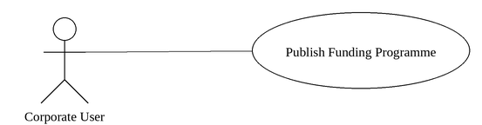
Figure 33 - Publish Funding Programme Use Case
Brief Description
The Corporate User makes a programme visible to students, or closes it again.
Initial Step-By-Step Description
Before it can be initiated, the Corporate User has opened a programme belonging to their Organisation.
1. The Corporate User selects to publish the programme.
2. The System confirms that the closing date has not already passed.
3. The System sets the programme status to published.
4. The programme immediately appears among the matches of every student whose profile fits it.
5. The Corporate User may later close the programme, or reopen a closed programme.
Xref: Section 3.2.24, Publish Funding Programme

Use case: Import Applications
Diagram:
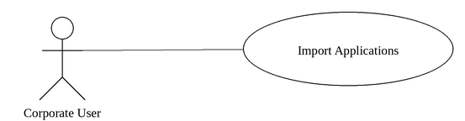
Figure 34 - Import Applications Use Case
Brief Description
A Corporate User uploads application forms the Organisation received outside Bursary-Bridge and has the System turn them into applicant records against one of its funding programmes.
Initial Step-By-Step Description
Before this use case can be initiated, the Corporate User has signed in and has opened a funding programme belonging to their Organisation.
1. The Corporate User selects Import Applications against a funding programme.
2. The Corporate User uploads the application forms, individually or as an archive.
3. The System reads each form and extracts the applicant's details.
4. The System scores each applicant against that programme and checks for duplicates.
5. The System presents the batch for review.
Xref: Section 3.2.25, Import Applications

Use case: Review Imported Applications
Diagram:
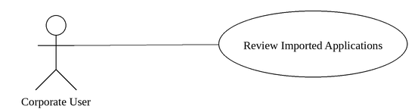
Figure 35 - Review Imported Applications Use Case
Brief Description
A Corporate User examines a processed import batch, corrects what was read wrongly, decides what to do about duplicates, and confirms which applications to bring into the programme.
Initial Step-By-Step Description
Before this use case can be initiated, an import batch has finished processing.
1. The Corporate User opens the batch.
2. The System shows the applications grouped as ready, needing review, duplicates and failures.
3. The Corporate User inspects an application beside the form it was read from.
4. The Corporate User corrects any field that was read wrongly.
5. The Corporate User confirms the import.
Xref: Section 3.2.26, Review Imported Applications

Use case: View Applications
Diagram:
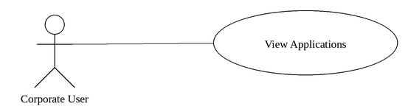
Figure 36 - View Applications Use Case
Brief Description
The Corporate User examines the applications submitted to the Organisation's programmes.
Initial Step-By-Step Description
Before this use case can be initiated, the Corporate User has signed in and accessed the Applications page.
1. The System presents the applications submitted to this Organisation's programmes, best match first.
2. The System presents counts by status across the top.
3. The Corporate User may search by applicant name or email, or filter by programme, status, institution, course, match score or eligibility verdict.
4. The System applies the filters and presents one page of results.
5. The Corporate User may select several applicants and act on them together.
Xref: Section 3.2.27, View Applications

Use case: Review Applicant
Diagram:
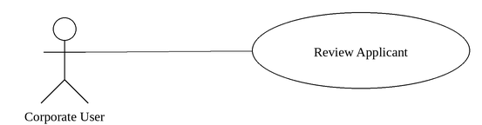
Figure 37 - Review Applicant Use Case
Brief Description
The Corporate User examines one applicant in detail and assesses them against the programme's criteria.
Initial Step-By-Step Description
Before this use case can be initiated, the Corporate User has selected an applicant from the Applications list.
1. The System presents the applicant's name, course, institution, match score, eligibility verdict and application status.
2. The System presents the application details, contact information and academic summary.
3. The System presents the applicant's study preferences and funding profile.
4. The System evaluates the applicant against the programme's current criteria and presents every criterion.
5. The System presents the documents attached and the answers given.
6. The Corporate User may move to the previous or next applicant without returning to the list.
Xref: Section 3.2.28, Review Applicant

Use case: Shortlist Applicant
This use case extends the Review Applicant use case.
Diagram:
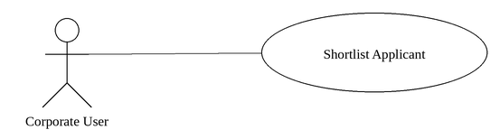
Figure 38 - Shortlist Applicant Use Case
Brief Description
The Corporate User marks an applicant as being under active consideration.
Initial Step-By-Step Description
Before it can be initiated, the Corporate User has opened an applicant or selected applicants from the list.
1. The Corporate User selects Add to Shortlist.
2. The System sets the application status to Shortlisted and records a shortlist entry.
3. The System notifies the applicant.
4. The applicant appears on the Shortlists page for the programme.
5. The Corporate User may later remove the applicant from the shortlist.
Xref: Section 3.2.29, Shortlist Applicant

Use case: Request Information from Applicant
This use case extends the Review Applicant use case.
Diagram:
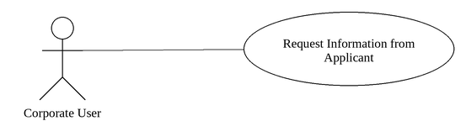
Figure 39 - Request Information from Applicant Use Case
Brief Description
The Corporate User asks an applicant for information or a document that is missing.
Initial Step-By-Step Description
Before it can be initiated, the Corporate User has opened an applicant.
1. The Corporate User selects Request Information.
2. The Corporate User writes what is required.
3. The System sets the application status to Documents Required and stores the message.
4. The System notifies the applicant, quoting the message.
5. The applicant sees the request on their application tracking page.
Xref: Section 3.2.30, Request Information from Applicant

Use case: Select Beneficiary
This use case extends the Review Applicant use case.
Diagram:
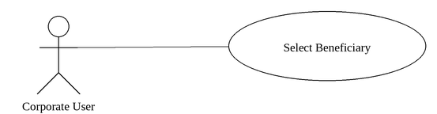
Figure 40 - Select Beneficiary Use Case
Brief Description
The Corporate User awards funding to an applicant, or records that an application was unsuccessful.
Initial Step-By-Step Description
Before it can be initiated, the Corporate User has opened an applicant or selected applicants from the shortlist.
1. The Corporate User selects Move to Selected.
2. The System sets the application status to Approved and records the applicant as a beneficiary.
3. The System notifies the applicant.
4. The applicant appears on the Beneficiaries page.
5. The Corporate User may instead reject an applicant, optionally giving a reason.
Xref: Section 3.2.31, Select Beneficiary

Use case: View Reports
Diagram:
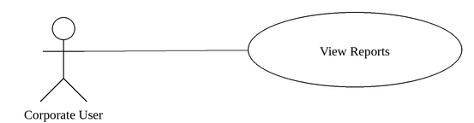
Figure 41 - View Reports Use Case
Brief Description
The Corporate User reviews the Organisation's application pipeline and reach.
Initial Step-By-Step Description
Before this use case can be initiated, the Corporate User has signed in and accessed the Reports page.
1. The System presents the totals for applications received, applicants found eligible, applicants shortlisted and beneficiaries selected.
2. The System presents the breakdown of applications by status.
3. The System presents the breakdown of applicants by province.
4. The System presents each programme with its application volume, eligible count and eligibility rate.
5. The System presents the institutions the Organisation's applicants come from.
Xref: Section 3.2.32, View Reports

2.2.4 Administrator Use Cases
The Administrator maintains the platform itself rather than any one Organisation's funding. The Administrator does not apply for funding and does not decide who receives it.
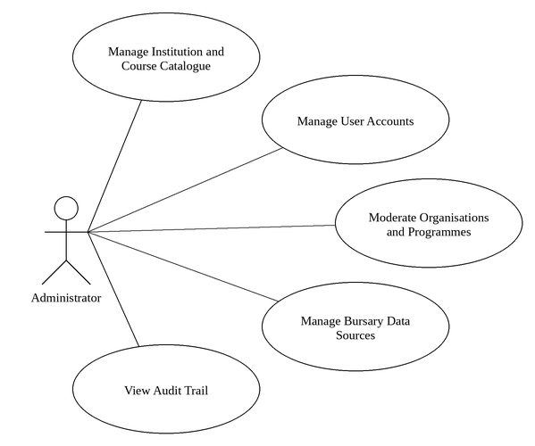
Figure 42 - Administrator Use Cases

Use case: Manage Institution and Course Catalogue
Diagram:
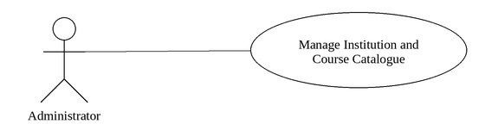
Figure 43 - Manage Institution and Course Catalogue Use Case
Brief Description
An Administrator maintains the standardised list of institutions and courses that Students and Funders choose from, and the links between them.
Initial Step-By-Step Description
Before this use case can be initiated, the Administrator has signed in and has accessed the Catalogue page.
1. The Administrator adds an institution or a course, or edits an existing one.
2. The System checks the name against the catalogue to prevent a second entry for the same thing.
3. The Administrator records which courses an institution offers.
4. The Administrator retires an entry that is no longer offered.
Xref: Section 3.2.33, Manage Institution and Course Catalogue

Use case: Manage User Accounts
Diagram:
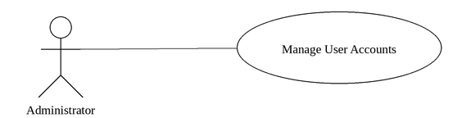
Figure 44 - Manage User Accounts Use Case
Brief Description
An Administrator suspends, restores or forces a password reset on an account, and may change the role an account holds.
Initial Step-By-Step Description
Before this use case can be initiated, the Administrator has signed in and has accessed the Users page.
1. The Administrator searches for an account.
2. The Administrator selects an action against it.
3. The System requires a reason.
4. The System applies the action and records it in the audit log.
Xref: Section 3.2.34, Manage User Accounts

Use case: Moderate Organisations and Programmes
Diagram:
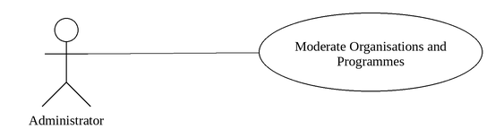
Figure 45 - Moderate Organisations and Programmes Use Case
Brief Description
An Administrator withdraws an Organisation or a published funding programme that breaches the platform's rules, and restores it if the matter is resolved.
Initial Step-By-Step Description
Before this use case can be initiated, the Administrator has signed in and has accessed the Organisations or Programmes page.
1. The Administrator opens the Organisation or funding programme.
2. The Administrator suspends it, giving a reason.
3. The System withdraws it from the Student-facing directory.
4. The Administrator restores it if the matter is resolved.
Xref: Section 3.2.35, Moderate Organisations and Programmes

Use case: Manage Bursary Data Sources
Diagram:
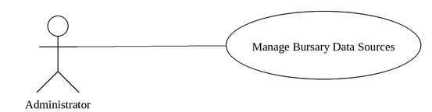
Figure 46 - Manage Bursary Data Sources Use Case
Brief Description
An Administrator runs and inspects the collection of funding opportunities from published external sources.
Initial Step-By-Step Description
Before this use case can be initiated, the Administrator has signed in and has accessed the Data Sources page.
1. The Administrator sees which sources are authorised and when each was last read.
2. The Administrator starts a collection run.
3. The System reads the authorised sources and records what it found.
4. The Administrator inspects the run and the opportunities it produced.
Xref: Section 3.2.36, Manage Bursary Data Sources

Use case: View Audit Trail
Diagram:
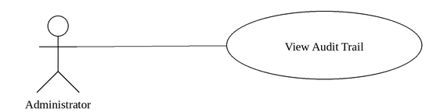
Figure 47 - View Audit Trail Use Case
Brief Description
An Administrator inspects the record of consequential actions taken across the system.
Initial Step-By-Step Description
Before this use case can be initiated, the Administrator has signed in and has accessed the Audit page.
1. The Administrator opens the audit trail.
2. The System lists the recorded actions, most recent first.
3. The Administrator filters by action, by the user who took it, or by date.
Xref: Section 3.2.37, View Audit Trail

2.2.5 Complete Use Case Diagram
Figure 48 brings together every actor and every use case described in this section. The Student, the Corporate User and the Administrator are all specialisations of a User, which is why the four use cases they share are attached once to the User actor rather than drawn three times. The diagram is set sideways on the page overleaf because it carries thirty-seven use cases; each of them is also shown, at a larger size, on the per-actor diagrams above and on its own diagram beside its description.

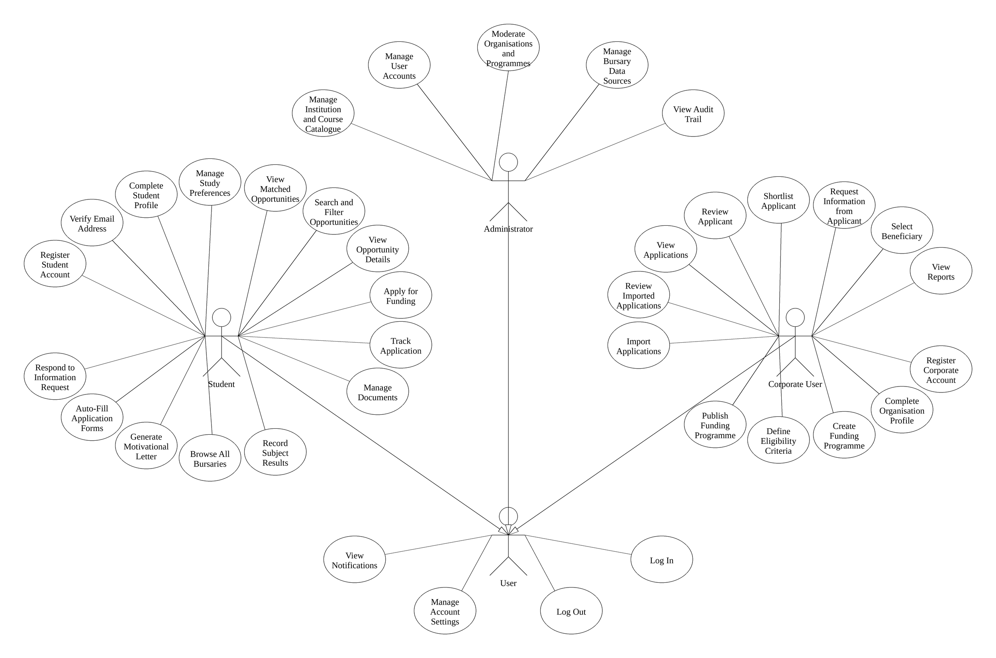
Figure 48 - Complete Use Case Diagram

2.3 User Characteristics
The Student is expected to be able to use a web browser and to complete an online form. Many students will reach the system on a mobile telephone, and some over a metered or intermittent connection, so the interface is laid out for small screens as well as large and the profile is gathered in short steps that can be left and resumed. No knowledge of bursary administration is assumed; wherever the system asks for something, it says why it is being asked.
The Corporate User is expected to be comfortable with an administrative web application of the kind used in an office, including tables, filters and forms. They are assumed to understand their own organisation's funding criteria, but not to have any technical knowledge, so the eligibility criteria are captured through ordinary form controls rather than through any rule language.
The Administrator is a member of the Bursary-Bridge operating team and is expected to understand the platform itself: the standardised catalogue of institutions and courses, the sources from which funding opportunities are collected, and the circumstances in which an account or a published programme should be withdrawn. The Administrator is not assumed to be a developer, and every administrative action is carried out through the interface rather than against the database.
No actor is expected to receive training. The detailed appearance of the screens is discussed in Section 3.1 below.

2.4 Non-Functional Requirements
Platform. Bursary-Bridge is a responsive web application. It is reached through a current web browser on a desktop computer, a laptop, a tablet or a mobile telephone, and requires no installation.
Server. The application runs on a Node.js server and stores its data in a PostgreSQL database. Both may run on a single machine for the prototype, and may be separated as demand grows.
Responsiveness. The interface is laid out for desktop, laptop, tablet and mobile widths. On a narrow screen the navigation collapses behind a menu and the layout reflows; no page requires horizontal scrolling.
Performance. Lists that may grow large, in particular the applicant list, are filtered and paged in the database so that the browser never receives more than one page of results.
Availability. The application is intended to be available at all times, subject to the hosting arrangements of the deploying institution.
Accessibility. The interface uses semantic HTML, labelled form controls, visible keyboard focus and sufficient colour contrast, so that it can be used with a keyboard alone and with a screen reader.
Usability. Each screen states where the User is, what is required of them and why it is required. Every list presents a meaningful empty state, and every operation presents a loading, success and error state. Users are never shown a technical error message.

3.0. Requirements Specification

3.1 External Interface Requirements
The system depends on two external systems. The first is the Email Service, which delivers address verification messages and status notifications. The system passes a recipient address, a subject and a body, and treats delivery as advisory: no decision anywhere in the system depends on a message having been delivered, and every journey can be completed through the interface alone.
The second is the set of published bursary sources from which funding opportunities are collected, described in Section 2.2.4, Manage Bursary Data Sources. The system reads pages published by those sources over HTTP and passes nothing to them beyond the request itself and an identifying user agent. It reads each source's robots file first and does not fetch any page that file disallows, and it waits between requests for as long as the source asks. What it takes from a page is the description of the opportunity and the address the page was read from; that address is stored against the opportunity and shown to Students, so that any statement the system makes about a bursary can be checked against its source.
Documents are written to Document Storage through an interface that names only a folder, a file name, a content type and the bytes. The prototype writes to the local file system; an object storage service may be substituted without any change to the code that calls it.
The user interface is delivered as web pages. The Student portal presents a dashboard, the matched opportunities, the complete bursary directory, the detail of a single opportunity, an application form, an application tracker, a profile, a results page, a motivational letter editor, an auto-fill workspace and a document library. The Corporate portal presents a dashboard, a programme builder, an application import workspace, an applicant list, an applicant detail screen, a shortlist, a beneficiary register and a report. The Administration portal presents the catalogue, the user register, the organisation and programme registers, the data sources and the audit trail. All three portals share a navigation sidebar which collapses behind a menu on a narrow screen.

3.2 Functional Requirements
The Logical Structure of the Data is contained in Section 3.3.1.

3.2.1 Log In
Use Case Name | Log In
XRef | Section 2.2.1, Log In
Trigger | The User submits the login form.
Precondition | The User has a registered account and is not currently signed in.
Basic Path | 1. The User enters an email address and password.  2. The System looks up the account by email address.  3. The System compares the supplied password against the stored bcrypt hash.  4. The System creates a session record and returns a signed, HTTP-only session cookie.  5. The System redirects the User according to their role and onboarding state.
Alternative Paths | In step 5, if the User has not completed onboarding, the System redirects to the outstanding step rather than the dashboard.
Postcondition | The User is authenticated and holds a valid session.
Exception Paths | If the email address is not registered, or the password does not match, the System returns the same message in both cases so that the endpoint cannot be used to discover which email addresses hold accounts. After ten failed attempts from one address, or six against one account, further attempts are refused for five minutes.
Other | Sessions expire after fourteen days. Only a hash of the session token is stored, so a copy of the database cannot be replayed as a login.

3.2.2 Log Out
Use Case Name | Log Out
XRef | Section 2.2.1, Log Out
Trigger | The User selects Log out.
Precondition | The User holds a valid session.
Basic Path | 1. The System deletes the session record from the database.  2. The System clears the session cookie in the browser.  3. The System returns the User to the login page.
Alternative Paths | None.
Postcondition | The session no longer exists and the cookie cannot be reused.
Exception Paths | If the session has already expired, the System still clears the cookie and returns the User to the login page.
Other | Because the session is deleted on the server, logging out invalidates the cookie immediately rather than relying on its expiry.

3.2.3 Manage Account Settings
Use Case Name | Manage Account Settings
XRef | Section 2.2.1, Manage Account Settings
Trigger | The User submits the account details form or the change password form.
Precondition | The User holds a valid session.
Basic Path | 1. The System validates the submitted values on the server.  2. For a details change, the System writes the new values to the User record.  3. For a password change, the System verifies the current password, hashes the new password and stores it.  4. The System confirms the change to the User.
Alternative Paths | In step 2, if the email address has changed, the verified flag is cleared and a fresh verification email is sent.
Postcondition | The account record reflects the change. After a password change every other session has been invalidated.
Exception Paths | If the new email address already belongs to another account, the change is refused. If the current password is incorrect, the password change is refused.
Other | Changing a password deliberately signs the User out of every device, so that a stolen session cannot survive the change.

3.2.4 View Notifications
Use Case Name | View Notifications
XRef | Section 2.2.1, View Notifications
Trigger | The User opens the Notifications page.
Precondition | The User holds a valid session.
Basic Path | 1. The System retrieves the fifty most recent notifications belonging to this User.  2. The System presents them newest first, showing the unread count.  3. The User selects a notification, or selects to mark all as read.  4. The System records the read timestamp and, where the notification carries a link, navigates to it.
Alternative Paths | The User may mark every unread notification as read in a single action.
Postcondition | The selected notifications are marked read and the unread badge is updated.
Exception Paths | A User can only ever read notifications addressed to their own account; a request for another User's notification affects nothing.
Other | Notifications are also mirrored to email when the User has left email notifications enabled.

3.2.5 Register Student Account
Use Case Name | Register Student Account
XRef | Section 2.2.2, Register Student Account
Trigger | The Student submits the student registration form.
Precondition | The visitor is not signed in and does not hold an account under the supplied email address.
Basic Path | 1. The System validates the name fields, the email address, the South African mobile number and the password.  2. The System confirms that the two password entries match and that the terms have been accepted.  3. The System confirms that no account already exists for the email address.  4. The System hashes the password using bcrypt and creates the User record with the role Student.  5. The System creates an empty Student profile positioned at the first onboarding step.  6. The System creates a session, sends a verification email and presents the verification screen.
Alternative Paths | None.
Postcondition | A Student account and an empty profile exist, the Student is signed in, and a verification email has been sent.
Exception Paths | If the email address is already registered the System refuses the registration and invites the visitor to sign in instead. If any field fails validation the System returns the specific field errors and creates nothing. More than five registration attempts from one address within ten minutes are refused.
Other | The password must be at least eight characters and contain an upper case letter, a lower case letter and a digit. The same rules are enforced on the server and shown as a live checklist beneath the field.

3.2.6 Verify Email Address
Use Case Name | Verify Email Address
XRef | Section 2.2.2, Verify Email Address
Trigger | The Student follows the verification link, or requests that the email be sent again.
Precondition | A verification token exists for the account and has not yet been used.
Basic Path | 1. The System hashes the token from the link and looks up the matching record.  2. The System confirms the token has not expired.  3. The System sets the verified timestamp on the User record.  4. The System deletes the token so that the link cannot be used twice.  5. The System redirects the Student to the first profile step.
Alternative Paths | The Student may request a fresh verification email, which replaces any existing token. No more than three such requests are accepted in five minutes.
Postcondition | The email address is recorded as verified and the token has been consumed.
Exception Paths | An unrecognised token is rejected. A token older than twenty-four hours is rejected and deleted, and the Student is invited to request a new one.
Other | Verification is not enforced before the Student may continue, so an email delivery problem never blocks the journey. Only the hash of the token is stored.

3.2.7 Complete Student Profile
Use Case Name | Complete Student Profile
XRef | Section 2.2.2, Complete Student Profile
Trigger | The Student submits any step of the profile.
Precondition | The Student holds a valid session and a Student profile record exists.
Basic Path | 1. The System presents the current step with any previously saved values filled in.  2. The Student completes the step and submits it.  3. The System validates the step against the schema that governs that step alone.  4. The System saves the values, recalculates profile strength and advances the stored position.  5. The System presents the next step, and after the last step presents the review screen.  6. On confirmation the System marks the profile complete and opens the Dashboard.
Alternative Paths | A learner in Grade 10 or Grade 11 is not asked for a tertiary qualification level. A Student who is not currently enrolled is not asked for a current institution, programme or year of study. The Student may leave at any point using Save and Exit and resume later at the same step.
Postcondition | The profile holds the supplied information, profile strength has been recalculated, and once the review step is confirmed the Student may see matched opportunities.
Exception Paths | A step that fails validation is redisplayed with the specific field errors and nothing is saved. The review step is refused if no education stage has been recorded or no study preference exists.
Other | Each step is validated on the server against its own schema, so a request cannot write a field belonging to a different step. Registration deliberately does not ask for a residential address, identity number, banking details or financial records; such information is requested only when a specific application needs it.

3.2.8 Manage Study Preferences
Use Case Name | Manage Study Preferences
XRef | Section 2.2.2, Manage Study Preferences
Trigger | The Student submits the study preferences form.
Precondition | The Student holds a valid session and a Student profile exists.
Basic Path | 1. The System presents the current preferences and the catalogue of courses and institutions.  2. The Student adds, edits, removes or reorders preferences.  3. The System confirms that every course and institution exists in the catalogue.  4. The System confirms that no two preferences name the same course and institution pair.  5. The System replaces the stored list in a single transaction and renumbers it from one.  6. The System recalculates profile strength.
Alternative Paths | A preference that is missing either its course or its institution is not saved; the System tells the Student that the incomplete rows will be discarded.
Postcondition | The Student holds between one and six numbered study preferences, each a valid course and institution pair.
Exception Paths | A seventh preference is refused. A duplicate course and institution pair is refused. A course or institution that is not in the catalogue is refused.
Other | A study preference is stored as a pair, never as two unrelated lists, because a bursary that funds a course at one institution is not necessarily open to the same course elsewhere. The Matching Engine scores both halves of the same pair, so a supported course at an unsupported institution does not count as a full match. The limit of six is enforced on the server.

3.2.9 View Matched Opportunities
Use Case Name | View Matched Opportunities
XRef | Section 2.2.2, View Matched Opportunities
Trigger | The Student opens the Student Dashboard.
Precondition | The Student has completed onboarding and holds at least one study preference.
Basic Path | 1. The System loads the Student's profile projection.  2. The System loads every funding programme whose status is published and whose closing date has not passed.  3. The Matching Engine scores each programme across the six weighted criteria.  4. The System orders the results by score, highest first.  5. The System presents the leading matches together with the reasons that produced each score.
Alternative Paths | If the Student has already applied to a programme it is marked as applied and excluded from the leading matches.
Postcondition | The Student has been shown their ranked matches and the reasons behind them.
Exception Paths | If no programme is currently open, or the profile is too sparse to score, the System explains this and directs the Student to complete the sections that would produce matches.
Other | A percentage is never presented on its own. Every score is accompanied by the criteria that were met, failed, or could not be evaluated.

3.2.10 Search and Filter Opportunities
Use Case Name | Search and Filter Opportunities
XRef | Section 2.2.2, Search and Filter Opportunities
Trigger | The Student enters a search term or changes a filter on the Opportunities page.
Precondition | The Student has completed onboarding.
Basic Path | 1. The System presents the scored opportunities together with the filter controls.  2. The Student sets one or more filters.  3. The System applies the filters to the scored set.  4. The System presents the result count and the first page of results.  5. The Student pages through the results or changes the ordering.
Alternative Paths | The Student may clear all filters and return to the full list at any point.
Postcondition | The Student is presented with the opportunities that satisfy the chosen filters.
Exception Paths | If no opportunity satisfies the filters, the System says so and offers to clear them.
Other | Scoring is performed on the server and results are paged, so the browser never receives the whole catalogue at once.

3.2.11 View Opportunity Details
Use Case Name | View Opportunity Details
XRef | Section 2.2.2, View Opportunity Details
Trigger | The Student selects an opportunity.
Precondition | The programme is published and the Student has completed onboarding.
Basic Path | 1. The System retrieves the programme with its eligibility rule, supported courses and supported institutions.  2. The Matching Engine scores the Student against that programme.  3. The System presents the programme detail with the score and the per-criterion explanation.  4. The System offers to start an application, or shows the existing application if one has been submitted.
Alternative Paths | If the Student has already submitted an application, the System offers to view that application instead of starting a new one. If a draft exists, the System offers to continue it.
Postcondition | The Student understands what the programme funds, who is eligible and how well they match.
Exception Paths | A programme that is still a draft, or that belongs to no published set, cannot be opened by a Student and returns a not found response.
Other | The explanation shown to the Student is produced by the same engine that produces the eligibility verdict shown to the funder, so the two can never contradict one another.

3.2.12 Apply for Funding
Use Case Name | Apply for Funding
XRef | Section 2.2.2, Apply for Funding
Trigger | The Student selects Apply Now on an opportunity.
Precondition | The programme is published, its closing date has not passed, and the Student has not already submitted an application to it.
Basic Path | 1. The System presents the Student's stored profile without asking for it again.  2. The Student answers the programme's questions and attaches documents.  3. The Student confirms the declaration and submits.  4. The System validates the payload, including every required question.  5. The Matching Engine scores the Student and the Eligibility Service returns a verdict.  6. The System stores the application with the score, the verdict and the reasons, and sets the status to Submitted.  7. The System notifies the Student and opens the application tracking page.
Alternative Paths | The Student may save a draft at any point and return to it later. A draft may be edited freely until it is submitted.
Postcondition | An application exists with the status Submitted, carrying the match score and eligibility verdict as they stood at submission.
Exception Paths | An application to a closed programme is refused. A second application to the same programme is refused. Submission without confirming the declaration, or with a required question unanswered, is refused and the offending fields are named. A document that does not belong to the Student cannot be attached.
Other | The score is stored at submission so that the funder always sees the match as it stood when the Student applied, even if the Student later edits their profile.

3.2.13 Track Application
Use Case Name | Track Application
XRef | Section 2.2.2, Track Application
Trigger | The Student opens My Applications or selects an application.
Precondition | The application belongs to this Student.
Basic Path | 1. The System retrieves the applications belonging to this Student.  2. The System presents them with their statuses and key dates.  3. The Student selects one.  4. The System presents the full application, its timeline and the recorded match.
Alternative Paths | If the application is still a draft, the System offers to continue it. If the funder has asked for more information, the System presents the request prominently.
Postcondition | The Student knows the current status of the application and what, if anything, is expected of them.
Exception Paths | A request for an application that belongs to another Student returns a not found response.
Other | The statuses are Draft, Submitted, Under Review, Documents Required, Shortlisted, Approved and Unsuccessful.

3.2.14 Manage Documents
Use Case Name | Manage Documents
XRef | Section 2.2.2, Manage Documents
Trigger | The Student submits the upload form, or selects to remove a document.
Precondition | The Student holds a valid session.
Basic Path | 1. The Student selects a document type and a file.  2. The System confirms the file is a PDF or an image and is no larger than five megabytes.  3. The System writes the file to storage under a key belonging to this Student.  4. The System records the document and recalculates profile strength.
Alternative Paths | The Student may remove a document, which deletes both the record and the stored file. Applications already submitted keep the copy that was attached to them.
Postcondition | The document is stored against the Student's profile and is available to attach to applications.
Exception Paths | A file of an unsupported type, an empty file, or a file larger than five megabytes is refused. More than twenty uploads in ten minutes are refused.
Other | Documents are not required in order to register. They are stored outside the public web root and are released only to the Student who owns them, or to a funder that has received an application the document is attached to.

3.2.15 Record Subject Results
Use Case Name | Record Subject Results
XRef | Section 2.2.2, Record Subject Results
Trigger | The Student adds, edits, reorders or deletes a result on the My Results page.
Precondition | The Student has signed in and has completed onboarding.
Basic Path | 1. The Student selects Add a result.  2. The System presents the subject list appropriate to the Student's education stage, school subjects for a school learner and modules for a tertiary student.  3. The Student selects a subject, or types one that the list does not hold.  4. The Student enters the academic year, and optionally the mark and the term.  5. The System validates that the mark, if given, is a whole percentage between 0 and 100.  6. The System stores the result and adds any typed subject to the catalogue as a custom entry attributed to the Student.  7. The System lists, beneath the result, any published funding programme whose stated subject minimum this result meets.
Alternative Paths | In step 4 the Student may leave the mark empty. Knowing which subject is being taken, without yet knowing the mark, is a real state and is stored as such; it is not recorded as a zero.
Postcondition | The result is stored against the Student's profile and is available to the Matching Engine.
Exception Paths | If the Student records a second result for the same subject and year, the System refuses the duplicate and offers to edit the existing result instead. If a typed subject name is too short or contains no letters, the System refuses it.
Other | The page uses the vocabulary of the Student's education stage: a Grade 12 learner records subjects, a university student records modules. Where two results exist for one subject in different years, the Matching Engine uses the later one.

3.2.16 Browse All Bursaries
Use Case Name | Browse All Bursaries
XRef | Section 2.2.2, Browse All Bursaries
Trigger | The Student selects All Bursaries from the navigation.
Precondition | The Student has signed in.
Basic Path | 1. The System retrieves every funding programme with the status Published.  2. The System determines the display status of each from its dates and its recorded availability: Open, Closing Soon, Upcoming, Closed or Status Unknown.  3. The System orders the list with opportunities accepting applications first and closed ones last.  4. The System shows the count against each status so the Student can see how much of the directory each represents.  5. The Student applies a search term or a filter, and the System reduces the list accordingly.
Alternative Paths | If the Student applies filters that nothing satisfies, the System says so and offers to clear the filters, rather than presenting an empty page.
Postcondition | The Student has seen the directory as it stands, and the directory is unchanged.
Exception Paths | If the directory holds no opportunities at all, the System says that none have been collected yet and explains where they come from. It does not present example opportunities in their place.
Other | This use case is deliberately distinct from View Matched Opportunities. All Bursaries answers the question of what exists and is never narrowed to the Student's own profile; View Matched Opportunities answers what fits this Student. A closed opportunity remains listed and is marked Closed, so that a Student can see who funds what and when to return.

3.2.17 Generate Motivational Letter
Use Case Name | Generate Motivational Letter
XRef | Section 2.2.2, Generate Motivational Letter
Trigger | The Student selects Write a letter.
Precondition | The Student has signed in and has completed onboarding.
Basic Path | 1. The Student chooses a published funding programme, or names a bursary the system does not hold.  2. The System presents seven optional questions covering motivation, field of study, goals, circumstances, achievements, suitability and the effect of the funding.  3. The Student answers any number of them.  4. The System shows the profile facts that will appear in the letter, and lists anything missing that would strengthen it.  5. The System composes the letter from the stated facts and the Student's own sentences.  6. The System stores the draft together with the answers it was built from.  7. The Student edits the text, marks the letter ready, copies it, or downloads it as a PDF.
Alternative Paths | The Student may rewrite the letter from changed answers. Where the Student has already edited the text, the System warns that rewriting replaces those edits and requires confirmation.
Postcondition | A letter is stored against the Student's profile, carrying the answers it was composed from.
Exception Paths | If the Student names a bursary the system does not hold but supplies no organisation, the System refuses to proceed. If the Student's profile carries nothing usable, the System says so and composes from the answers alone.
Other | Every sentence in a generated letter comes either from a fact already on the Student's profile or from a sentence the Student wrote. Where there is no material for a paragraph, the paragraph is omitted and the Student is told what to add; the System does not compose a plausible substitute. The letter is the Student's own statement and is never sent anywhere by the System.

3.2.18 Auto-Fill Application Forms
Use Case Name | Auto-Fill Application Forms
XRef | Section 2.2.2, Auto-Fill Application Forms
Trigger | The Student starts an auto-fill job.
Precondition | The Student holds a completed application form as a PDF.
Basic Path | 1. The Student uploads a completed form.  2. The System reads the form's fields, taking their values from the form's own field definitions where it has them and from the page text where it does not.  3. The Student uploads the blank forms to be filled.  4. The System identifies the fields on each blank form and matches them against what it read.  5. The System writes the matched values into each form and records, for every field, the value, its confidence and the label it came from.  6. The System presents each filled form for review beside the fields it wrote.  7. The Student corrects any field, and the System rewrites that form.  8. The Student downloads the completed forms individually or together.
Alternative Paths | A form the System cannot match confidently is left blank and flagged for the Student's attention rather than filled with a guess.
Postcondition | Each blank form has been written with the values the System could establish, and the Student has been shown every value it wrote.
Exception Paths | If the completed form is password protected, or is a scan with no readable text, the System refuses the job and says why. If one blank form cannot be read, the remaining forms are still filled; the failure is reported against that form alone.
Other | The System never invents a value. A field it cannot establish is left empty and marked as needing attention, because a blank field a Student can complete is better than a populated field that is wrong. Signatures are never produced.

3.2.19 Respond to Information Request
Use Case Name | Respond to Information Request
XRef | Section 2.2.2, Respond to Information Request
Trigger | The Student opens an application against which a Funder has raised a request.
Precondition | An open information request exists against one of the Student's submitted applications.
Basic Path | 1. The System presents the request above everything else on the application page, because it is the only item the Student can act on.  2. The System lists each thing asked for, and the deadline if the Funder set one.  3. The Student attaches one of their existing documents to an item, or uploads a new one.  4. The System records the attachment against that item and marks it supplied.  5. The Student submits the response once every item has been answered.  6. The System marks the request responded, notifies the Funder, and records the event in the audit log.
Alternative Paths | The Student may detach a document before submitting and attach a different one. The Student may respond to a request after its deadline; the System records the date and leaves the decision to the Funder.
Postcondition | The request is marked as responded and the attached documents are readable by the requesting Organisation.
Exception Paths | If the Student submits with nothing attached, the System refuses and says which items are outstanding. If the Funder has withdrawn the request, the System says so and does not accept a response.
Other | A document attached to a request becomes readable by that Organisation alone, and only for the application the request belongs to.

3.2.20 Register Corporate Account
Use Case Name | Register Corporate Account
XRef | Section 2.2.3, Register Corporate Account
Trigger | The Corporate User submits the organisation registration form.
Precondition | The visitor is not signed in and does not hold an account under the supplied email address.
Basic Path | 1. The System validates the name fields, the work email address, the mobile number and the password.  2. The System confirms that no account exists for the email address.  3. The System hashes the password and creates the User record with the role Corporate.  4. The System creates an Organisation record and links a Corporate profile to it.  5. The System creates a session, sends a verification email and opens the Organisation Details step.
Alternative Paths | None.
Postcondition | A Corporate account, an Organisation record and a linked Corporate profile exist, and the Corporate User is signed in.
Exception Paths | If the email address is already registered the registration is refused. Any field that fails validation is returned with a specific message and nothing is created.
Other | The Organisation record is created immediately, so that every later action can be scoped to it. The Organisation is named properly in the next step.

3.2.21 Complete Organisation Profile
Use Case Name | Complete Organisation Profile
XRef | Section 2.2.3, Complete Organisation Profile
Trigger | The Corporate User submits any step of the Organisation profile.
Precondition | The Corporate User holds a valid session and a Corporate profile exists.
Basic Path | 1. The System presents the current step with any saved values filled in.  2. The Corporate User completes the step and submits it.  3. The System validates the step and writes the values against this Organisation only.  4. The System advances the stored position and presents the next step.  5. On confirmation the System marks the profile complete and opens the Dashboard.
Alternative Paths | The Current Process step is optional and may be submitted empty.
Postcondition | The Organisation profile is complete and the Corporate User may create funding programmes.
Exception Paths | An Organisation name already used by another Organisation is refused. A step that fails validation is redisplayed with field errors. No more than three challenges may be selected.
Other | Every write is scoped to the Organisation attached to the signed-in Corporate User, so one Organisation can never modify another's record.

3.2.22 Create Funding Programme
Use Case Name | Create Funding Programme
XRef | Section 2.2.3, Create Funding Programme
Trigger | The Corporate User selects Create New Programme.
Precondition | The Corporate User holds a valid session and the Organisation profile is complete.
Basic Path | 1. The System presents the programme builder at the first of its five steps.  2. The Corporate User completes each step in turn.  3. The System validates the whole programme, including that the closing date falls after the opening date.  4. The System confirms that every selected institution and course exists in the catalogue.  5. The System creates the programme, its eligibility rule, its supported lists and its questions in a single transaction.  6. The System opens the new programme.
Alternative Paths | The Corporate User may save the programme as a draft at any point and complete it later. A draft is not visible to students.
Postcondition | A funding programme exists, together with its eligibility rule, supported courses and institutions, required documents and questions.
Exception Paths | A closing date on or before the opening date is refused. A programme with no funding coverage selected is refused. A selected institution or course that is no longer in the catalogue is refused. The programme is written as one transaction, so it can never exist without its eligibility rule.
Other | What the Corporate User configures here is exactly what the Matching Engine and the Eligibility Service evaluate; the criteria are stored as structured data rather than as prose.

3.2.23 Define Eligibility Criteria
Use Case Name | Define Eligibility Criteria
XRef | Section 2.2.3, Define Eligibility Criteria
Trigger | The Corporate User reaches the Eligibility Criteria step of the programme builder.
Precondition | A funding programme is being created or edited by a Corporate User of the owning Organisation.
Basic Path | 1. The System presents each criterion with the catalogue values available for it.  2. The Corporate User sets the criteria that apply and leaves the rest empty.  3. The System validates the values, including that any minimum average lies between zero and one hundred.  4. The System stores the criteria as an eligibility rule attached to the programme.
Alternative Paths | Any criterion left empty places no restriction on that dimension, and the System states this beneath each control.
Postcondition | The programme carries an eligibility rule that the Matching Engine and the Eligibility Service can evaluate.
Exception Paths | A minimum average outside the range zero to one hundred is refused.
Other | This use case is part of Section 3.2.17, Create Funding Programme. The criteria drive both the match score shown to students and the eligibility verdict shown to the funder.

3.2.24 Publish Funding Programme
Use Case Name | Publish Funding Programme
XRef | Section 2.2.3, Publish Funding Programme
Trigger | The Corporate User selects to publish, close or reopen a programme.
Precondition | The programme belongs to the Corporate User's Organisation.
Basic Path | 1. The System confirms the programme belongs to this Organisation.  2. The System confirms that a programme being published still has a future closing date.  3. The System updates the programme status.  4. The System records the change in the audit log.
Alternative Paths | Closing a programme withdraws it from student view but leaves applications already received untouched. A closed programme may be reopened.
Postcondition | The programme status reflects the change, and student visibility follows from it.
Exception Paths | Publishing a programme whose closing date has passed is refused, and the Corporate User is asked to set a future date first. A programme belonging to another Organisation returns a not found response.
Other | This use case extends Section 3.2.17, Create Funding Programme.

3.2.25 Import Applications
Use Case Name | Import Applications
XRef | Section 2.2.3, Import Applications
Trigger | The Corporate User uploads one or more application forms against a funding programme.
Precondition | The Corporate User's Organisation owns the funding programme the applications are being imported into.
Basic Path | 1. The System stores every uploaded file before reading any of it, so that the batch survives an interruption.  2. The System expands any archive, treating each folder as one applicant and the documents filed beside a form as that applicant's supporting documents.  3. The System reads each application form and records every field it extracts, with the confidence of the reading and the label it was read from.  4. The System looks for an existing Student account matching the applicant on a verified identifier.  5. The System evaluates eligibility and calculates a match score against that programme's own criteria.  6. The System counts the supporting documents supplied against those the programme requires.  7. The System compares each applicant against the rest of the batch and against the applications the programme already holds, and flags any duplicate.  8. The System reports the batch as ready for review, giving the number ready, the number needing review, the number flagged as duplicates and the number that could not be read.
Alternative Paths | The Corporate User may leave the page while the batch is processing and return to it later; the progress is held against the batch rather than in the browser.
Postcondition | Every uploaded file has reached a conclusion and is held against the batch. No applicant record has yet been created.
Exception Paths | A file that is password protected, damaged, or a scan with no readable text is kept and reported with the reason rather than discarded. A file that is not a PDF is refused with the reason. One unreadable file does not stop the remainder of the batch.
Other | Importing creates nothing on its own: the applications are created only when a Corporate User confirms the batch, in Review Imported Applications. Applications created this way are marked as externally imported wherever they appear, so an imported application is never mistaken for one a Student submitted here.

3.2.26 Review Imported Applications
Use Case Name | Review Imported Applications
XRef | Section 2.2.3, Review Imported Applications
Trigger | The Corporate User opens a batch that has finished processing.
Precondition | The batch belongs to the Corporate User's own Organisation and has been processed.
Basic Path | 1. The System lists the files in the batch by outcome.  2. The Corporate User opens one and sees every extracted field with its confidence, the label it was read from, and the original document.  3. The Corporate User corrects a field where the reading was wrong; the System keeps both the extracted value and the correction.  4. The Corporate User decides, for each flagged duplicate, whether to import it anyway or to leave it out.  5. The Corporate User confirms the import.  6. The System creates one application for each file marked for import, attaching it to the existing Student where one was identified and creating an external applicant record where one was not.  7. The System records how many were imported and how many were left out, and writes the confirmation to the audit log.
Alternative Paths | The Corporate User may confirm a batch in which some files remain unreviewed; those flagged as needing review or as duplicates are left out unless explicitly marked for import.
Postcondition | Applications exist in the programme for the files the Corporate User chose to import, each carrying its match score, its eligibility verdict and a link to the document it came from.
Exception Paths | If an application cannot be created, the remaining ones are still created and the failure is reported against that file. Confirming a batch a second time does not create the applications again.
Other | The original document is never replaced. The uploaded form, the values extracted from it and any correction a reviewer made are all retained, so a funding decision can be traced back to what the applicant actually submitted.

3.2.27 View Applications
Use Case Name | View Applications
XRef | Section 2.2.3, View Applications
Trigger | The Corporate User opens the Applications page or changes a filter.
Precondition | The Corporate User holds a valid session and belongs to an Organisation.
Basic Path | 1. The System retrieves the applications belonging to this Organisation only.  2. The System applies any search terms and filters in the database.  3. The System counts the matching applications and retrieves one page of them.  4. The System presents each applicant with their match score, eligibility verdict and status.
Alternative Paths | The Corporate User may select applicants and shortlist, select or remove them in a single action.
Postcondition | The Corporate User is presented with the applications that satisfy the chosen filters.
Exception Paths | If no application satisfies the filters the System says so. An Organisation is never shown an application submitted to another Organisation's programme.
Other | Filtering and paging are performed in the database, so a programme with several thousand applicants loads in constant time.

3.2.28 Review Applicant
Use Case Name | Review Applicant
XRef | Section 2.2.3, Review Applicant
Trigger | The Corporate User selects an applicant.
Precondition | The application was submitted to a programme belonging to this Organisation.
Basic Path | 1. The System retrieves the application, confirming it belongs to this Organisation.  2. The Eligibility Service evaluates the applicant against the programme's criteria as they stand now.  3. The System presents the applicant across the overview, eligibility, documents and answers views.  4. The System offers the review decisions available for this applicant.
Alternative Paths | The Corporate User may open a document the applicant attached, which the System releases only because this Organisation received the application.
Postcondition | The Corporate User has the information needed to make a decision on the applicant.
Exception Paths | An application belonging to another Organisation returns a not found response.
Other | Eligibility is recalculated when the applicant is opened, so a reviewer always sees an assessment against the programme's current criteria rather than a stale snapshot. Information the applicant has not supplied is reported as pending verification rather than counted as a failure.

3.2.29 Shortlist Applicant
Use Case Name | Shortlist Applicant
XRef | Section 2.2.3, Shortlist Applicant
Trigger | The Corporate User selects Add to Shortlist, on one applicant or on several at once.
Precondition | The application was submitted to a programme belonging to this Organisation.
Basic Path | 1. The System confirms every named application belongs to this Organisation.  2. The System records a shortlist entry for each and sets the application status to Shortlisted.  3. The System notifies each applicant.  4. The System records the action in the audit log.
Alternative Paths | Removing an applicant from the shortlist returns the application to Under Review and withdraws the shortlist entry.
Postcondition | The applicant holds the status Shortlisted and appears on the Organisation's shortlist.
Exception Paths | An application belonging to another Organisation is refused. Selecting no applicant is refused.
Other | This use case extends Section 3.2.21, Review Applicant. Applicants may be shortlisted individually or in bulk from the applications list.

3.2.30 Request Information from Applicant
Use Case Name | Request Information from Applicant
XRef | Section 2.2.3, Request Information from Applicant
Trigger | The Corporate User selects Request Information.
Precondition | The application was submitted to a programme belonging to this Organisation.
Basic Path | 1. The System presents a field for the reviewer's message.  2. The Corporate User writes the message and confirms.  3. The System sets the status to Documents Required and stores the message against the application.  4. The System notifies the applicant.
Alternative Paths | None.
Postcondition | The application holds the status Documents Required and the applicant has been told what is needed.
Exception Paths | A request with no message is refused. An application belonging to another Organisation is refused.
Other | This use case extends Section 3.2.21, Review Applicant.

3.2.31 Select Beneficiary
Use Case Name | Select Beneficiary
XRef | Section 2.2.3, Select Beneficiary
Trigger | The Corporate User selects Move to Selected, or selects Reject.
Precondition | The application was submitted to a programme belonging to this Organisation.
Basic Path | 1. The System confirms every named application belongs to this Organisation.  2. The System sets the status to Approved and records the decision date.  3. The System records or updates the shortlist entry as selected.  4. The System notifies each applicant.
Alternative Paths | Rejecting an applicant sets the status to Unsuccessful, records any reason given and notifies the applicant. An applicant may also be returned to Under Review.
Postcondition | The applicant holds a final status of Approved or Unsuccessful and has been notified.
Exception Paths | An application belonging to another Organisation is refused.
Other | This use case extends Section 3.2.21, Review Applicant. Selection may be performed on one applicant or on several at once from the shortlist.

3.2.32 View Reports
Use Case Name | View Reports
XRef | Section 2.2.3, View Reports
Trigger | The Corporate User opens the Reports page.
Precondition | The Corporate User holds a valid session and belongs to an Organisation.
Basic Path | 1. The System groups this Organisation's applications by status, by province and by institution.  2. The System computes the eligibility rate and conversion rate for each programme.  3. The System presents the figures as totals, proportions and tables.
Alternative Paths | None.
Postcondition | The Corporate User is presented with the Organisation's pipeline and reach.
Exception Paths | If the Organisation has received no applications, the System says so rather than presenting empty charts.
Other | Every figure is computed from this Organisation's own applications. Eligibility counts read the verdict recorded when each application was submitted.

3.2.33 Manage Institution and Course Catalogue
Use Case Name | Manage Institution and Course Catalogue
XRef | Section 2.2.4, Manage Institution and Course Catalogue
Trigger | The Administrator creates, edits, links or retires a catalogue entry.
Precondition | The Administrator has signed in.
Basic Path | 1. The Administrator enters the name of an institution or course, with its type or field.  2. The System reduces the name to a canonical form, ignoring case, punctuation and spacing, and compares it against the catalogue.  3. The System refuses an entry that would duplicate an existing one, naming the entry it matched.  4. The System stores the entry with both the name as typed and its canonical form.  5. The Administrator records the courses offered at an institution, so that a Student choosing that institution is offered the courses it actually teaches.
Alternative Paths | The Administrator may retire an entry instead of deleting it. A retired entry is no longer offered for new selections but continues to describe the Students and programmes already pointing at it.
Postcondition | The catalogue reflects the change, and no two entries describe the same institution or course.
Exception Paths | If the Administrator attempts to retire an institution or course that Students or funding programmes currently point at, the System completes the retirement but states how many records are affected, since deleting it outright would leave those records without an institution or course.
Other | Canonical matching is what stops the same university appearing twice under two spellings, which would split its Students across two entries and weaken every match calculated for them.

3.2.34 Manage User Accounts
Use Case Name | Manage User Accounts
XRef | Section 2.2.4, Manage User Accounts
Trigger | The Administrator applies an action to a user account.
Precondition | The Administrator has signed in, and the account is not the Administrator's own.
Basic Path | 1. The Administrator searches by name or email address.  2. The Administrator chooses to suspend, restore, or require a password reset.  3. The System requires a reason of at least ten characters.  4. The System applies the change, ends every session the account holds, and writes the action, the reason and the Administrator to the audit log.
Alternative Paths | An account required to reset its password may sign in only to set a new one, and is returned to the reset page until it does.
Postcondition | The account's status reflects the action, and the action is recorded against the Administrator who took it.
Exception Paths | The System refuses an action against the Administrator's own account, so that the last administrator cannot lock themselves out. It refuses an action with no reason.
Other | A suspended account cannot sign in and is told to contact support. Suspension does not delete the account or anything belonging to it.

3.2.35 Moderate Organisations and Programmes
Use Case Name | Moderate Organisations and Programmes
XRef | Section 2.2.4, Moderate Organisations and Programmes
Trigger | The Administrator suspends or restores an Organisation or a funding programme.
Precondition | The Administrator has signed in.
Basic Path | 1. The Administrator selects the Organisation or funding programme.  2. The Administrator suspends it and states the reason.  3. The System sets the status to Suspended and removes it from everything a Student sees.  4. The System records the action, the reason and the Administrator in the audit log.
Alternative Paths | The Administrator may restore a suspended programme, which returns it to the status it held before.
Postcondition | The Organisation or programme is withdrawn from the Student-facing system and the action is recorded.
Exception Paths | The owning Corporate User cannot publish a suspended programme back out of that state; an attempt is refused and explained, since otherwise the suspension could be undone by the party it was applied to.
Other | Applications already submitted to a suspended programme are retained. Suspension withdraws the programme from view; it does not erase what has happened under it.

3.2.36 Manage Bursary Data Sources
Use Case Name | Manage Bursary Data Sources
XRef | Section 2.2.4, Manage Bursary Data Sources
Trigger | The Administrator starts a collection run, or opens a previous one.
Precondition | The Administrator has signed in, and at least one source has been authorised.
Basic Path | 1. The System lists each registered source, whether it is authorised, and the outcome of the last run against it.  2. The Administrator starts a run.  3. The System reads each authorised source's robots file and does not fetch any page that file disallows.  4. The System reads the source's pages at the rate the source asks for, extracts each opportunity, and records the address it was read from.  5. The System rejects anything that does not describe a real opportunity, merges entries that describe the same opportunity, and stores the remainder.  6. The System records the run with the number found, created, updated, merged and rejected.
Alternative Paths | The Administrator may inspect a run that found nothing, which is recorded distinctly from a run that could not reach its sources.
Postcondition | The directory reflects what the authorised sources carried at the time of the run, and every opportunity records the address it was read from and the date it was last confirmed.
Exception Paths | If a source's robots file disallows collection, the run records the source as not read rather than reading it anyway. If a source cannot be reached, the run is recorded as blocked, which is distinct from a run that succeeded and found nothing.
Other | A source is read only after an Administrator has authorised it by name. Registering a source in the system does not authorise reading it.

3.2.37 View Audit Trail
Use Case Name | View Audit Trail
XRef | Section 2.2.4, View Audit Trail
Trigger | The Administrator opens the audit trail.
Precondition | The Administrator has signed in.
Basic Path | 1. The System lists each recorded action with the time, the user, the entity affected and any recorded reason.  2. The Administrator narrows the list by action, user or period.
Alternative Paths | None.
Postcondition | The audit trail is unchanged; it can be read but not edited.
Exception Paths | If no actions match the filters, the System says so rather than presenting an empty table.
Other | The audit log is append-only. Account actions, programme suspensions, application decisions, information requests and import confirmations are all recorded, so that a decision affecting a Student can be accounted for afterwards.

3.3 Detailed Non-Functional Requirements

3.3.1 Logical Structure of the Data
Figure 49 presents the logical structure of the data stored by Bursary-Bridge, drawn as a Unified Modeling Language class diagram in accordance with [2].
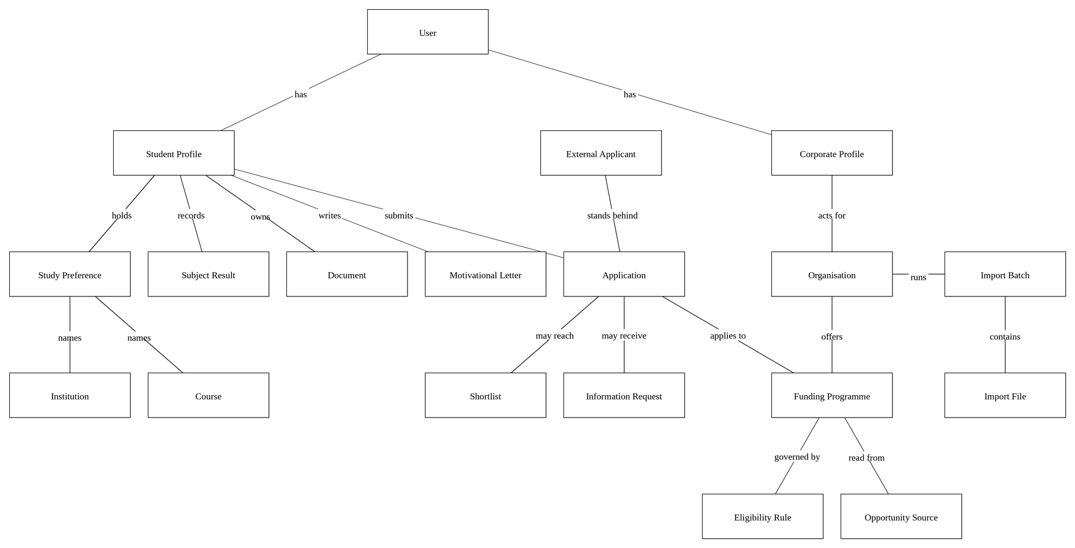
Figure 49 - Logical Structure of the Bursary-Bridge Data
Tables 2 to 17 describe each of the entities in Figure 49 in turn, giving the data items it holds, the type of each and the constraints that apply.
Table 2 - User Data Entity
Data Item | Type | Description | Comment
Email Address | Text | The address used to sign in | Unique across the system
Password Hash | Text | The bcrypt hash of the password | The password itself is never stored
Role | Enumeration | Student, Corporate or Administrator | Determines which part of the system is reachable
First Name | Text | Given name
Last Name | Text | Family name
Mobile Number | Text | South African mobile number
Email Verified | Date | When the address was confirmed; null if not
Table 3 - Student Profile Data Entity
Data Item | Type | Description | Comment
User | Pointer | The User entity | One profile per User
Education Stage | Enumeration | Grade 10 through postgraduate, or planning to study
Qualification Level | Enumeration | Certificate through doctoral degree | Not asked of school learners
Study Status | Enumeration | Enrolled, accepted, applied, planning or returning
Academic Average | Integer | Latest average as a percentage | Null if the Student does not know it
Household Income | Enumeration | Annual household income band | A band, never an exact figure
Citizenship | Enumeration | Citizen, permanent resident or other
Province | Enumeration | One of the nine South African provinces
Profile Strength | Integer | Completeness as a percentage | Recalculated after every change
Table 4 - Study Preference Data Entity
Data Item | Type | Description | Comment
Student Profile | Pointer | The Student entity
Preference Number | Integer | Position in the Student's ordered list | One to six
Programme | Pointer | The course entity | Paired with the institution below
Institution | Pointer | The institution entity | Paired with the course above
Table 5 - Organisation Data Entity
Data Item | Type | Description | Comment
Name | Text | Registered name of the Organisation | Unique across the system
Type | Enumeration | Corporation, foundation, NGO or other
Industry | Enumeration | Sector in which the Organisation operates
Website | Text | Public web address | Optional
Application Volume | Enumeration | Applications received each year
Table 6 - Funding Programme Data Entity
Data Item | Type | Description | Comment
Organisation | Pointer | The owning Organisation | Scopes every access to the programme
Name | Text | Name of the programme
Funding Type | Enumeration | Bursary, scholarship, grant or other
Coverage | Enumeration | What the programme pays for | May be several
Open Date | Date | When applications open
Closing Date | Date | When applications close
Status | Enumeration | Draft, published or closed | Only published programmes are visible to students
Table 7 - Eligibility Rule Data Entity
Data Item | Type | Description | Comment
Funding Programme | Pointer | The programme the rule governs | One rule per programme
Minimum Academic Average | Integer | Lowest acceptable average | Null if no minimum applies
Qualification Levels | Enumeration | Levels that qualify | Empty means all levels
Years of Study | Integer | Years that qualify | Empty means any year
Citizenship | Enumeration | Citizenship conditions | Empty means no condition
Maximum Household Income | Enumeration | Highest acceptable income band | Null if no condition
Provinces | Enumeration | Provinces that qualify | Empty means all provinces
Required Documents | Enumeration | Documents applicants must provide
Table 8 - Application Data Entity
Data Item | Type | Description | Comment
Student Profile | Pointer | The applying Student
Funding Programme | Pointer | The programme applied to | One application per Student per programme
Organisation | Pointer | The Organisation that receives it | Scopes funder access
Status | Enumeration | Draft through to approved or unsuccessful
Match Score | Integer | The score at the moment of submission | Held so the funder sees a stable figure
Eligibility Outcome | Enumeration | Eligible, not eligible or pending verification | Recorded at submission
Answers | Text | Answers to the programme's questions
Submitted | Date | When the application was submitted | Null while it remains a draft
Table 9 - Subject Result Data Entity
Data Item | Type | Description | Comment
Student Profile | Pointer | The Student the result belongs to
Subject | Pointer | The catalogue subject or module | May be an entry the Student typed
Percentage | Integer | The mark, as a whole percentage | Null when the Student does not yet have it
Year | Integer | The academic year the result belongs to
Level | Enumeration | School or tertiary | Follows the Student's education stage
Table 10 - Motivational Letter Data Entity
Data Item | Type | Description | Comment
Student Profile | Pointer | The Student who wrote it
Funding Programme | Pointer | The programme the letter is for | Null for a bursary the system does not hold
Content | Text | The letter as it stands | Editable by the Student
Answers | Structured | The Student's answers the letter was composed from | Retained so the letter can be traced to what the Student said
Status | Enumeration | Draft or Ready
Edited by Student | Boolean | Whether the Student has changed the text | Governs the warning shown before a rewrite
Table 11 - Information Request Data Entity
Data Item | Type | Description | Comment
Application | Pointer | The application the request concerns
Organisation | Pointer | The Organisation that raised it
Message | Text | The Funder's own wording | Shown to the Applicant unaltered
Deadline | Date | When the Funder needs a response | Optional
Status | Enumeration | Open, Responded or Cancelled
Items | Collection | Each thing asked for, and the document supplied against it
Table 12 - Application Import Batch Data Entity
Data Item | Type | Description | Comment
Organisation | Pointer | The Organisation importing
Funding Programme | Pointer | The programme the applications are imported into
Reference | Text | The batch's reference, shown in the import history
Status | Enumeration | Uploading, Extracting, Ready for Review, Importing, Completed or Failed
Counts | Integers | Files uploaded, processed, ready, needing review, duplicate, failed and imported | Recomputed from the files, never tracked alongside them
Table 13 - Application Import File Data Entity
Data Item | Type | Description | Comment
Batch | Pointer | The batch the file arrived in
File Name | Text | The name the Organisation gave the file
Storage Key | Text | Where the original document is held | The original is never replaced
Status | Enumeration | Pending, Processing, Ready, Needs Review, Duplicate, Failed, Imported or Discarded
Failure Reason | Text | Why it could not be read, in words a reviewer can act on | Null when it was read
Match Score | Integer | The score against this batch's programme | Null when the applicant is not eligible
Eligibility Outcome | Enumeration | Eligible, Not Eligible or Pending Verification
Duplicate Of | Pointer | The file or application it appears to duplicate | A flag for a reviewer, never acted on automatically
Extracted Fields | Collection | Each field read from the form, with its confidence, the label it came from and any correction
Application | Pointer | The application created from this file | Set when a reviewer confirms the batch; null until then
Table 14 - External Applicant Data Entity
Data Item | Type | Description | Comment
Organisation | Pointer | The Organisation that imported the application | An applicant record belongs to one Organisation
Full Name | Text | The applicant's name as the form gave it
Identity Number | Text | The identity number, where the form stated one | Held because Funders deduplicate on it
Institution | Pointer | The catalogue institution, where the name matched one | Null when it did not
Course | Pointer | The catalogue course, where the name matched one | Null when it did not
Academic Average | Integer | The average the form stated | Null when the form did not state one
Table 15 - Opportunity Source Data Entity
Data Item | Type | Description | Comment
Funding Programme | Pointer | The opportunity this source describes
Address | Text | The page the opportunity was read from | Shown to Students
Name | Text | The name of the publication or funder
Official | Boolean | Whether this is the funder's own site | An official source outranks a listing
Last Verified | Date | When the opportunity was last confirmed against this page
Table 16 - Shortlist Data Entity
Data Item | Type | Description | Comment
Application | Pointer | The application concerned | One entry per application
Organisation | Pointer | The Organisation shortlisting
Status | Enumeration | Shortlisted, selected or withdrawn
Added | Date | When the applicant was shortlisted
Selected | Date | When the applicant was selected | Null unless selected
Table 17 - Document Data Entity
Data Item | Type | Description | Comment
Student Profile | Pointer | The owning Student | Governs who may read the file
Type | Enumeration | Identity document, academic record, proof of income and so on
File Name | Text | Name of the uploaded file
Size | Integer | Size of the file in bytes | Limited to five megabytes
Storage Key | Text | Where the file is held in storage | Outside the public web root
Two aspects of this structure carry the weight of the design. A Study Preference holds a course and an institution together as one record, never as two unrelated lists, because a bursary that funds a course at one institution is not necessarily open to that course elsewhere. An Eligibility Rule holds a funder's criteria as typed columns rather than as prose, because those columns are exactly what the Matching Engine evaluates.

3.3.2 Security
The system holds personal information about students, including their academic results and an indication of their household income, and it holds funding criteria that organisations may regard as commercially sensitive. The following requirements apply.
• Passwords are hashed with bcrypt at cost twelve and are never written to logs.
• Sessions are random values held in an HTTP-only cookie. Only a hash of the session token is stored, so a copy of the database cannot be replayed as a login. Logging out deletes the session, and changing a password ends every other session.
• An unknown email address and an incorrect password produce identical responses, so the login endpoint cannot be used to discover which addresses hold accounts.
• Registration, login, verification email requests, document uploads and application submissions are rate limited, per address and per account.
• Every request is authorised on the server before any data is read. A Student may read only their own profile, applications and documents. A Corporate User may read only the programmes and applications belonging to their own Organisation. These rules are applied in the database query rather than in the interface.
• Uploaded documents are stored outside the public web root and are released only through an authorised handler, which admits the Student who owns the document and any Organisation that has received an application the document is attached to.
• Every field is validated on the server. The rules shown in the browser are generated from the same definitions, so the two cannot diverge.
• Changes to applications, programmes, shortlists and accounts are written to an append-only audit log.
Registration deliberately does not ask for a residential address, an identity number, a passport number, banking details, a parent's identity number or detailed financial records. Registration establishes identity and the matching profile; an application collects what a specific programme requires. Collecting less reduces both the value of the database to an attacker and the obligations of the operator under the Protection of Personal Information Act [3].

