# Bildergebnis für pro flight switch panelQuick Guide for the Pro Flight Panel Client program

Program V 1.0

🡺 Supports the Logitech (Saitek) Pro Flight Switch Panel

* This program intends to send commands to a running SCJoyServer.

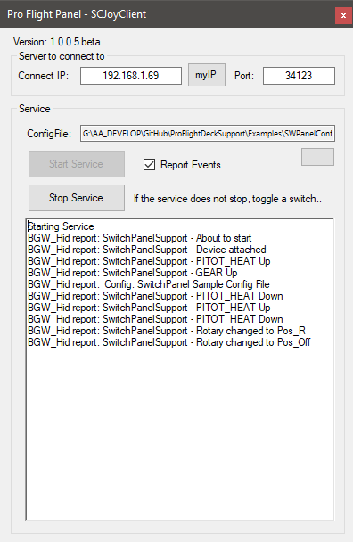

SCJoyServer to connect (IP and Port number)

Load a Configuration file to control the output

Hit **Start** Service to process Switches.

Hit **Stop** Service to stop processing   
(sometimes it will not stop immediately and the Start and Stop buttons remain disabled, toggle just a switch and it should end)

Check **Report Events** to see the switches/rotary detection.

Note:

When the service starts the LEDs are shut off.  
When the service stops warning LEDs are enabled 🡪  
When the program ends the LEDs will go off.

The Configuration File contains the commands to be sent with each Switch or the Rotary Knob   
(look for Doc/Examples folder of this project for specification and examples)

**SCJoyServer** can integrate multiple clients sending joystick and keyboard commands.

It then forwards such activation to the local vJoy (virtual Joystick) device and/or keyboard.

Clients can be anything from this Panel to Tablets, RaspBerry PI etc.

*See: https://github.com/SCToolsfactory/SCJoyServer*

Panel Client connected to Server – some Switches and Rotary actuated…

