# Quick Guide for the Pro Flight Panel Support program

Program V 1.0.0

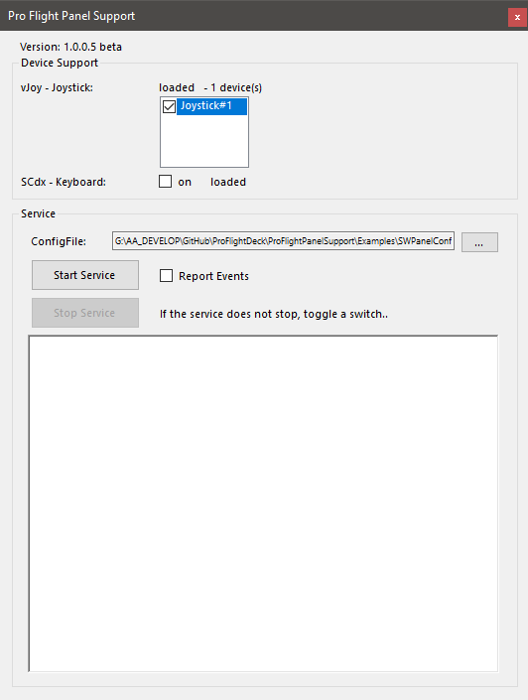

Shows available vJoy devices (here just one)  
Check the one to use

The keyboard driver is loaded  
🡪 Enable (check **On**) the keyboard output when ready.  
Note: the program send keys to the window with focus – any window that has the focus …

Load a Configuration file to control the output

Hit **Start** Service to process Switches.

Hit **Stop** Service to stop processing   
(sometimes it will not stop immediately and the Start and Stop buttons remain disabled, toggle just a switch and it should end)

Check **Report Events** to see the switches/rotary detection.

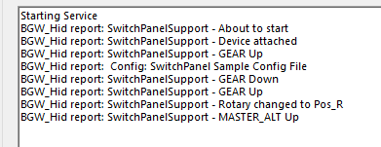

Note:

When the service starts the LEDs are shut off  
When the service stops warning LEDs are enabled 🡪  
When the program ends the LEDs will go off