Booking Travel Mobile App
Software Requirements Specification

Project Name: Booking Travel Mobile App
Document Type: Software Requirements Specification
Applicable Stage: Week 5 Project Requirements Analysis and Report

1 Introduction 3
1.1 Purpose 3
1.2 Background 3
1.3 Definition 4
1.4 References 4
2 Overview of the Task 4
2.1 Objectives 4
2.2 User Characteristics 5
2.3 Assumptions and Constraints 5
3 Requirements Specification 6
3.1 Functional Specifications 6
3.2 Performance Specifications 8
3.2.1 Accuracy 8
3.2.2 Time Characteristics Requirements 8
3.2.3 Flexibility 8
3.3 Input/Output Requirements 9
3.4 Data Management Capability Requirements 9
3.5 Fault Handling Requirements 10
3.6 Other Specific Requirements 10
4 Operating Environment Specifications 11
4.1 Equipment 11
4.2 Supporting Software 11
4.3 Interfaces 11
4.4 Control 12

1 Introduction

1.1 Purpose
This document provides a formal specification of the requirements for the Booking Travel Mobile App and serves as a unified basis for the requirements analysis phase of the course project in Week 5. It is intended for project team members, instructors, and other stakeholders who will later participate in design, implementation, and evaluation. The document mainly describes the project background, target users, functional scope, quality requirements, operating environment, and constraints. Through this specification, the project team can clearly define what problems the system needs to solve at the current stage, which users it serves, what capabilities it should provide, and what content is temporarily excluded, thereby establishing a clear requirements baseline for the interface design work in Week 10 and system implementation in Week 16.

1.2 Background
The software to be developed is named Booking Travel Mobile App, a travel planning support application for mobile users. At present, many travelers need to use multiple tools simultaneously during trip preparation, such as search engines, map tools, social platforms, and note-taking applications, to collect destination information, compare attraction arrangements, plan travel sequences, and record travel plans. This leads to scattered information sources, low decision-making efficiency, and unclear itinerary organization. Especially for weekend travelers, holiday vacationers, and independent travelers, completing destination discovery, preference filtering, itinerary arrangement, and information management within limited time is a common real-world pain point.
This project is based on the principle of making travel planning simpler, more centralized, and easier to execute. It aims to integrate destination discovery, personalized recommendations, itinerary creation, map exploration, and travel information management into a single mobile application. The project is initiated by the course project team, developed by student group members, and intended for ordinary users who are familiar with smartphones and wish to complete travel planning on mobile devices. The system is expected to operate mainly on mainstream mobile devices under Internet-connected environments and, when necessary, interact with map services, SMS verification services, and third-party social login services.
From the perspective of system positioning, Booking Travel Mobile App can be regarded in this course project as a relatively independent mobile application product. It is not a complete online travel transaction platform and does not undertake complex commercial transaction functions such as hotel or flight booking and payment. Its core positioning is a one-stop travel planning tool defined at the requirements analysis stage, focusing on four key problems: finding destinations, making plans, viewing maps, and managing itineraries.

1.3 Definition
Term | Definition
Booking Travel Mobile App | The travel planning mobile application to be developed for this course project, integrating destination discovery, itinerary planning, recommendations, map exploration, and trip information management.
Destination | A city, region, or tourist site that the user intends to visit and evaluate as part of travel planning.
Attraction | A specific point of interest, scenic spot, landmark, or visitable place associated with a destination.
Itinerary | The chronological travel arrangement created by the user for a particular trip, including dates, places, and planned activities.
Personalized Recommendation | Candidate destination or attraction suggestions generated by the system based on user preferences, browsing behavior, saved content, or historical records.
Interactive Map | A map-based interface through which users can browse destinations and attractions by viewing markers, locations, and spatial relationships.
Phone Number Verification Login | A login method in which users complete identity verification through a phone number and an SMS verification code.
Social Account Login | A login method in which users authenticate through an authorized third-party social platform account.

1.4 References
1. “Material You design,” Android Open Source Project. https://source.android.google.cn/docs/core/display/material
2. Software Requirements Specification Template, provided by the course.
3. “ISO/IEC/IEEE 29148:2018,” ISO. https://www.iso.org/standard/72089.html
4. “Data Security Law of the People's Republic of China,” http://www.npc.gov.cn/c2/c30834/202106/t20210610_311888.html
5. “Personal Information Protection Law of the People's Republic of China.” http://www.npc.gov.cn/npc/c2/c30834/202108/t20210820_313088.html

2 Overview of the Task

2.1 Objectives
This section describes the overall intent, application objectives, scope of use, and background of the Booking Travel Mobile App. The software is intended to serve as an independent and self-contained mobile application for travel planning, supporting users in destination discovery, itinerary creation, recommendation-based decision making, map exploration, and trip information management. Within the scope of this course project, the product is not defined as a subsystem of a larger commercial travel platform, but it may reasonably interact with external supporting services such as map services, phone verification services, and third-party social login services. These external services act as auxiliary interfaces rather than core system components, while the main software product remains a standalone travel planning application oriented toward ordinary mobile users.

Primary Objectives
1. Simplify the travel planning process by integrating destination discovery, recommendation, itinerary organization, and map-based exploration into one mobile application, thereby reducing the need for users to switch repeatedly between different tools.
2. Improve decision-making efficiency before travel by allowing users to browse destinations, compare attraction-related information, and obtain relevant suggestions based on preferences and historical behavior.
3. Support users in building structured and adjustable itineraries by enabling the creation, editing, deletion, and sequencing of trip items such as dates, places, and planned activities.
4. Provide intuitive spatial understanding during planning and travel through basic interactive map functions that help users view destination locations, attraction distribution, and route-related context.
5. Establish a one-stop mobile travel planning foundation through basic account access and trip information management, forming a complete requirement basis for later interface design and implementation stages.

2.2 User Characteristics

Primary User Groups
1. University students and young travelers who are familiar with smartphone applications, prefer lightweight mobile interaction, and often need efficient support for short trips, holidays, or independent travel planning.
2. Ordinary users planning weekend trips or vacation travel who need centralized destination information, simple comparison of attractions, and clear itinerary organization without relying on professional planning experience.
3. Free independent travelers who prefer making decisions according to personal interests, schedules, and location conditions, and therefore require recommendation, map viewing, and flexible plan adjustment capabilities.
4. Mobile-first users who expect low learning cost, clear navigation paths, and convenient access to saved plans while traveling, especially when they need to review or modify arrangements in a short time.

User Behavior Characteristics
1. Most target users use the system intensively during two stages: pre-trip planning and in-trip consultation. Before departure, they focus on information discovery, attraction comparison, and itinerary generation; during travel, they focus on quick viewing, location confirmation, and minor plan adjustments.
2. These users usually have basic information-search ability but are sensitive to fragmented content and repeated operations. As a result, the system should emphasize centralized information presentation, clear task flow, and low-barrier interaction.
3. Different user frequencies lead to different expectations: first-time users need understandable core paths and easy onboarding, while more experienced travelers need efficient search, recommendation relevance, and convenient management of saved travel content.

2.3 Assumptions and Constraints

Assumptions
1. The system will mainly operate on mainstream Android and iOS smartphones, and target users possess basic mobile Internet usage ability and can complete common interactions such as login, browsing, searching, and plan editing on their devices.
2. Users are assumed to have basic network connectivity during major usage scenarios, enabling the system to obtain destination information and, when necessary, connect to map services, SMS verification services, or third-party social authorization services.
3. At the current course-project stage, the development team can focus on a manageable set of core functions, including login, destination discovery, personalized recommendation, itinerary planning, interactive map support, and basic trip information management.

Constraints
1. The project follows fixed academic milestones, with requirements analysis completed in Week 5, interface design in Week 10, and implementation plus presentation in Week 16. Therefore, the current deliverable must remain focused on requirement definition rather than implementation details or high-fidelity interface output.
2. Available time, manpower, and technical resources are limited, so the functional scope must stay within a feasible course-project boundary and avoid expansion into complex commercial travel-platform functions.
3. The current scope excludes online payment, real-time hotel or flight transaction services, deep third-party merchant integration, large-scale travel community interaction, and highly complex recommendation mechanisms comparable to commercial platforms.
4. Recommendation capability at this stage should adopt interpretable and achievable approaches, such as rule-based or simple preference-based logic, instead of depending on large-scale data models or advanced algorithmic infrastructure.

3 Requirements Specification

3.1 Functional Specifications
The functional specification of Booking Travel Mobile App is aligned with the current UML design, including the use case, activity, sequence, communication, and state machine diagrams. The system forms a continuous task flow from authentication, to destination discovery, to itinerary creation, to saved trip management and in-trip adjustment. The Input-Processing-Output Table is as below.
Functional Module | Input | Processing | Output
Registration and Login | Phone number, verification code, or social account authorization information | Perform identity verification, establish user sessions, and save basic account information | Login result, account status, and entry to the system home page
Destination Discovery | User-entered keywords, categories, or browsing selections | Retrieve destination information, organize list content, and provide detail displays | Destination list, destination details, and related attraction information
Personalized Recommendation | User preferences, browsing history, or saved content | Perform rule matching and content filtering based on interest characteristics | Recommended destinations, recommended attractions, or suggested itinerary directions
Itinerary Planning | Travel dates, locations, activity arrangements, and notes | Create, edit, delete, and sort itinerary items | Structured itinerary lists and date-organized plan content
Interactive Map | Destination selection, current location, or map browsing operations | Display spatial locations, mark related places, and support basic exploration | Map view, attraction distribution, and location reference information
Travel Information Management | User-saved itineraries, favorited content, and basic profile data | Centralize, display, and support subsequent viewing and adjustment | Saved itineraries, personal preference information, and centralized travel materials

Functional Modules
1. Registration and Login: The system shall support user access through phone number verification login and social account login. It shall create and maintain a valid user session after successful authentication and shall support active log out.
2. Destination Browsing and Search: The system shall allow users to browse recommended destinations and destination categories, search destinations by keyword, and view matching result lists for further selection.
3. Destination Detail Viewing: The system shall allow users to open a destination detail page and view destination information, related attractions, and associated location content needed for planning decisions.
4. Personalized Recommendation: The system shall provide personalized destination suggestions based on user preferences, browsing behavior, or saved travel content, and present recommendation results on the mobile interface.
5. Interactive Map Viewing: The system shall request and display destination and attraction map markers, support basic map-based location viewing, and help users understand spatial relationships before and during travel.
6. Itinerary Planning and Editing: The system shall support creating itineraries, adding attractions or activities by date, editing itinerary items, deleting itinerary items, reordering itinerary content, and saving updated plans.
7. Saved Trip Management: The system shall allow users to view saved trips, open existing itineraries, review daily plans, and manage itinerary content through a centralized trip management entry.
8. In-Trip Adjustment Support: The system shall support quick viewing of the current trip plan during travel and allow users to update itinerary items when actual travel conditions change.

Functional Relationship with UML Design
1. The activity diagram confirms the end-to-end business flow: open app, authenticate, browse or search destinations, view destination details and map content, add items to itinerary, save the plan, and manage saved trips.
2. The sequence and communication diagrams confirm the main service interactions with Auth Service, Recommendation Service, Destination Service, Map Service, and Itinerary Service.
3. The use case diagram confirms the core user-visible functions: Register / Log In, Browse Destinations, Search Destinations, View Destination Details, Get Personalized Recommendations, Create Itinerary, Edit Itinerary, Delete Itinerary Item, View Interactive Map, Manage Saved Trips, and Log Out.
4. The state machine diagram confirms the major usage states of the product, including Unauthenticated, Authenticating, Authenticated, Browsing, ViewingDestination, ViewingMap, Planning, DraftSaved, Traveling, Completed, and Archived. The functional scope in this specification remains consistent with these state transitions.

3.2 Performance Specifications

3.2.1 Accuracy
1. The software shall validate the accuracy and completeness of key input data, including phone numbers, verification codes, destination keywords, dates, and itinerary entries, before processing or saving.
2. The software shall ensure that output data shown to users remains consistent with processed input data, retrieved destination content, saved itinerary data, and returned map information.
3. Where data is transmitted between the mobile application and external services, the software shall preserve basic data correctness and avoid mismatches, truncation, or invalid status presentation during transmission.

3.2.2 Time Characteristics Requirements
1. Response time: Common user operations such as login result display, destination search result display, destination detail loading, and itinerary save feedback should be returned within an acceptable mobile interaction time under normal network conditions.
2. Update processing time: Editing, deleting, or reordering itinerary items should be processed promptly, and the updated result should be reflected without unnecessary delay.
3. Data conversion and transmission time: Data exchange with authentication, destination, recommendation, and map-related services should complete within a reasonable time and should provide visible status feedback when waiting is required.
4. Solution computation time: Recommendation generation and basic itinerary-related processing should complete fast enough to maintain a smooth planning experience for ordinary users.

3.2.3 Flexibility
1. Changes in operation modes: The software should support future adjustment of user operation flows, such as simplified guest entry, richer trip review flows, or extended in-trip usage modes.
2. Changes in the operating environment: The software should remain adaptable to mainstream Android and iOS mobile environments and reasonable changes in device resolution or network conditions.
3. Changes in interfaces with other software: The software should allow replacement or extension of external interfaces such as SMS verification, social login, map service, or recommendation service without requiring a full redesign of core functions.
4. Changes in accuracy and validity timeframes: The software should allow future adjustment of validation rules, data freshness expectations, and timing rules for itinerary or recommendation-related content.
5. Changes or improvements in planning: The software should support future expansion of itinerary fields, recommendation logic, and trip management rules. Modular separation between authentication, destination, map, recommendation, and itinerary functions should be maintained to support such changes.

3.3 Input/Output Requirements

Input Data Specifications
ID | Input Type | Media/Source | Format | Range & Constraints | Accuracy & Validation | Description & Example
IN-01 | Phone login data | Touch input / User | Phone number + verification code | Valid phone format; code required; mandatory for phone login | Validated for completeness, format, and code correctness before authentication | Phone-based account access | 13800138000 + 6-digit code
IN-02 | Social login request | App action / User + Social provider | Authorization selection and callback token | Requires supported social provider and successful authorization | Token/status must be verified before session creation | Third-party login entry | Select social login and receive callback token
IN-03 | Destination search query | Touch/keyboard input / User | Keyword and optional filters | Keyword length within reasonable input range; filters optional | Validated for empty input, unsupported characters, and filter validity | Search destinations or attractions | Keyword: 'Suzhou', filter: weekend trip
IN-04 | Destination selection | Tap selection / User | Destination ID or selected list item | Must reference an existing destination item | Selection must match a valid destination record | Open destination details | Tap destination card from result list
IN-05 | Itinerary item data | Touch input / User | Date, place, attraction/activity, optional notes | Date required; at least one itinerary content field required | Validated for required fields, date format, and editable item consistency | Create or edit itinerary content | 2026-05-01, attraction visit, morning activity
IN-06 | Map interaction input | Tap/location action / User | Marker selection or map area request | Depends on available map data and permission status | Selected marker must correspond to returned map content | View location-related information | Tap attraction marker on destination map

Output Data Specifications
ID | Output Type | Medium | Format | Accuracy | Description | Example
OUT-01 | Authentication result | Mobile UI | Status message / page transition | Must accurately reflect authentication success or failure | Login result and session status | 'Login successful' and home page displayed
OUT-02 | Recommendation list | Mobile UI | Card list / destination list | Should remain basically relevant to user preference input or history | Personalized destination suggestions | Recommended weekend destinations list
OUT-03 | Destination search results | Mobile UI | List view | Must correspond to submitted keyword/filter conditions | Matched destination options | Search results for 'Hangzhou'
OUT-04 | Destination details | Mobile UI | Detail page with text and attraction | Must match selected destination record | Destination and attraction content for planning | Detail page for selected destination
OUT-05 | Map display | Mobile UI / Map view | Map markers and location display | Markers should correspond to returned destination or attraction locations | Spatial view of destination-related places | Map with attraction markers around selected city
OUT-06 | Itinerary output | Mobile UI | Chronological trip list / daily plan view | Must reflect latest saved itinerary state | Saved trip plan and daily arrangements | Day 1 to Day 3 itinerary overview
OUT-07 | Error or status prompt | Mobile UI | Popup / inline message / empty state | Must accurately reflect the current system or request status | User guidance in exception or empty-result scenarios | 'Network unavailable, please try again'

3.4 Data Management Capability Requirements
1. The software shall manage user account records, basic profile data, destination and attraction data references, itinerary records, and saved trip records.
2. Within the course-project scope, the data volume should support hundreds of user records and a reasonable number of itinerary and saved-trip records, with allowance for foreseeable growth during later project stages.
3. Stored data should remain organized by user and by trip so that users can create, update, retrieve, and review travel plans efficiently.
4. Storage planning should consider future expansion of itinerary content, recommendation-related data, and trip history without changing the core data-management logic.

3.5 Fault Handling Requirements
1. The software shall detect and report common faults, including invalid input, network timeout, login failure, destination query failure, map service unavailability, and itinerary save or update failure.
2. The software shall provide clear and understandable fault messages so that users know the cause of failure and the next available action.
3. The software shall preserve user-entered data where reasonable when a request fails, especially for login input, search input, and itinerary editing content.
4. The software shall allow recovery actions such as retrying the request, returning to the previous step, or continuing with unaffected functions when partial service faults occur.

3.6 Other Specific Requirements
1. Security and confidentiality: The software shall provide basic protection for user phone numbers, login status, and saved trip information, and shall avoid unnecessary exposure of personal travel data during normal use.
2. Ease of use: The software should maintain clear navigation, understandable prompts, and low learning cost so that ordinary mobile users can complete core tasks with limited guidance.
3. Maintainability and extensibility: The software should keep major functions such as authentication, destination services, recommendation, map interaction, and itinerary management sufficiently modular to support later updates and feature expansion.
4. Readability and consistency: System feedback, labels, and core information presentation should remain concise, consistent, and easy to interpret on mobile devices.
5. Reliability and portability: The software should operate stably in mainstream mobile environments and maintain basic functional consistency across common Android and iOS devices under normal operating conditions.

4 Operating Environment Specifications

4.1 Equipment
1. The software is intended to run on mainstream Android and iOS smartphones with standard mobile processors and sufficient memory to support login, destination browsing, map display, and itinerary management functions.
2. No specialized hardware is required. A touchscreen mobile device, routine internal storage, and basic online network access are sufficient for normal operation in the course-project scope.
3. Input and output are mainly handled through the mobile screen and touch interaction, including text entry, tapping, scrolling, filtering, and map selection.
4. Data communication depends on ordinary mobile network or Wi-Fi connectivity for interaction with authentication, destination, recommendation, map, and itinerary-related services.
5. No dedicated external storage devices, special communication terminals, or specialized function keys are required for this software.

4.2 Supporting Software
Supporting software mainly includes the mobile operating system environment, map-related service support, SMS verification support, social login authorization support, and routine development or testing tools used during the course project.

4.3 Interfaces
1. External interfaces: The software shall interact with SMS verification services for phone login, social login providers for third-party authentication, map services for location and marker display, and destination or recommendation-related services for travel content retrieval.
2. Internal interfaces: Internal module interaction shall remain centered on the task flow confirmed by the UML diagrams, including authentication, destination browsing, destination detail viewing, recommendation display, itinerary editing, map viewing, and saved trip management.
3. Interface communication should support clear request and response behavior suitable for mobile operation, and abnormal interface results should be returned with understandable status feedback.

4.4 Control
1. User controls: Control signals mainly come from mobile user actions such as tapping, text input, swiping, selecting filters, requesting verification codes, opening map views, and saving or editing itinerary items.
2. System controls: The software shall generate internal control actions for session management, page navigation, request submission, result display, status prompts, and exception handling during the execution of core functions.
3. External control sources: Some control-related responses originate from external supporting services, such as authentication return status, map data return status, and recommendation or destination data response status.

Appendix
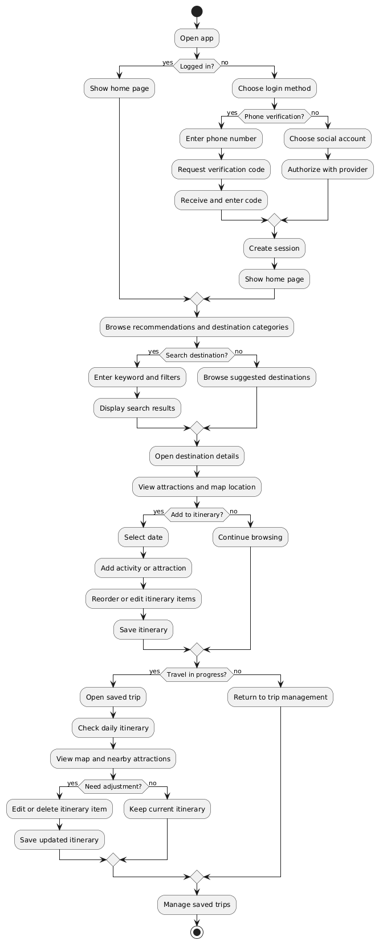
Figure 1: Activity Diagram
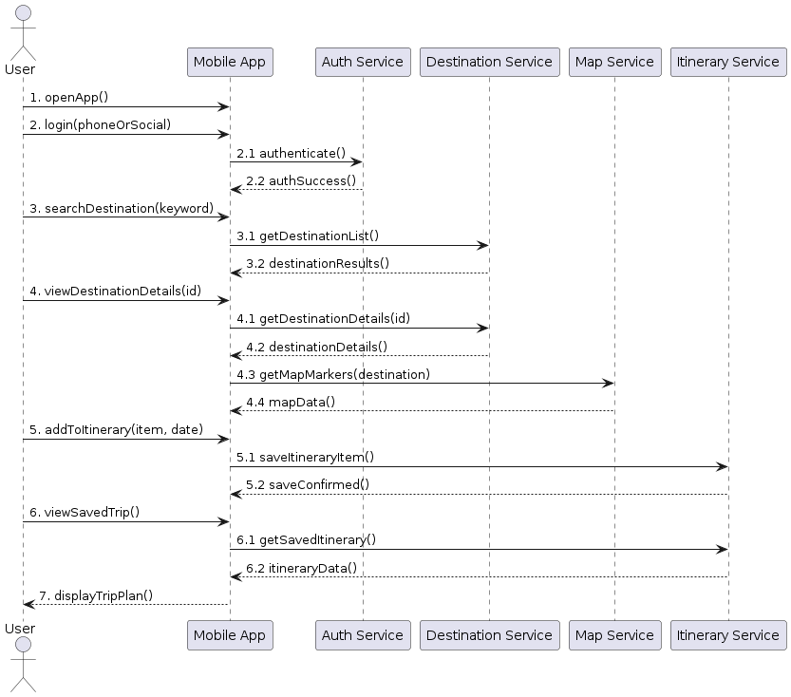
Figure 2: Communication Diagram

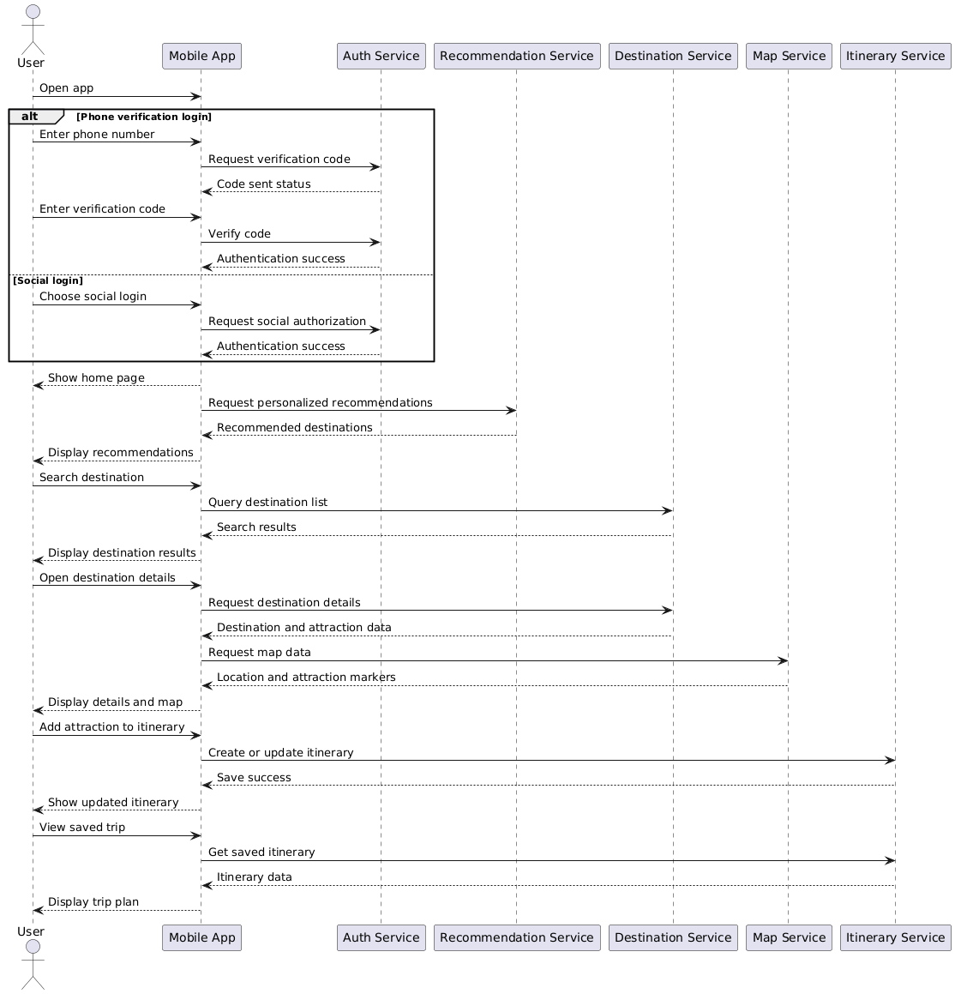
Figure 3: Sequence Diagram

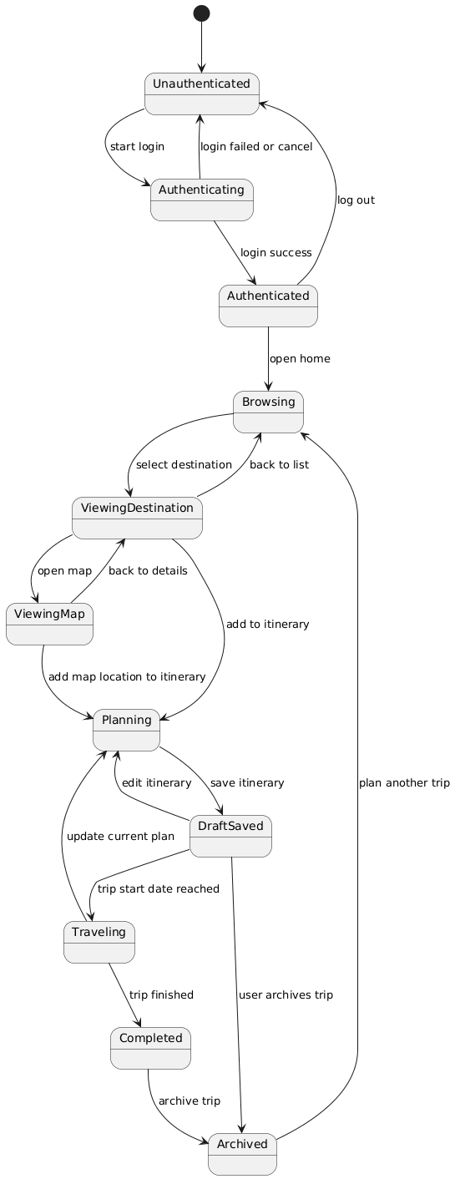
Figure 4: State Machine Diagram

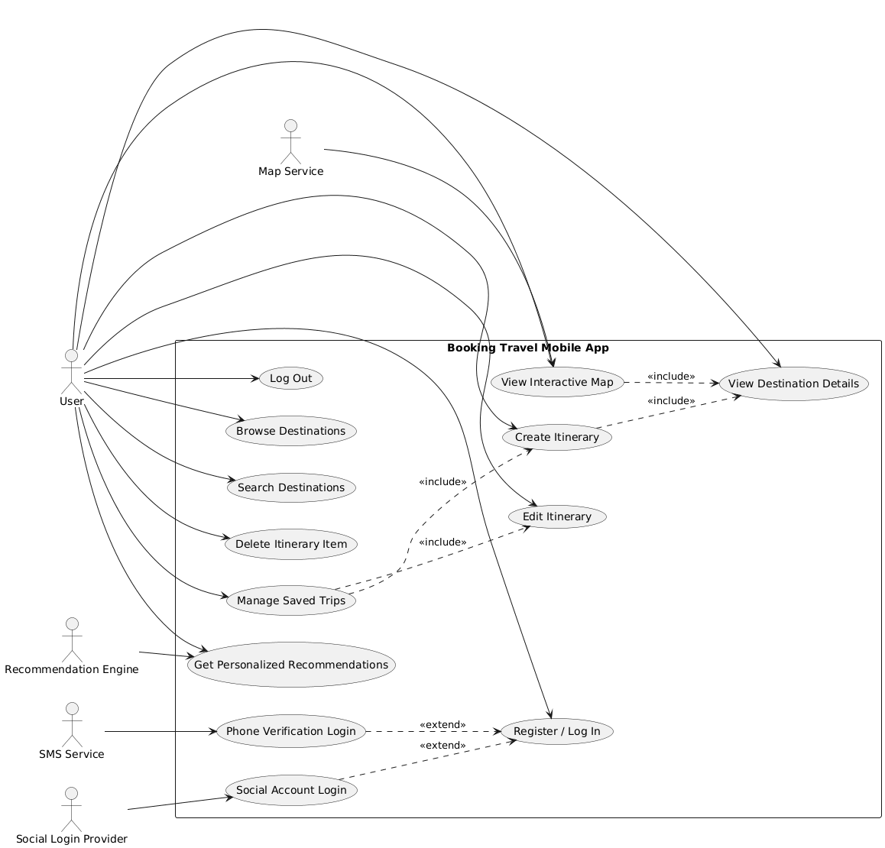
Figure 5: Use Case Diagram

