Advanced Signal Processing
for
Wireless Communications

Contents

1. Introduction

2. Wireless Channel Characteristics

3. Digital Modulation Techniques

4. Spread-Spectrum System

5. Adaptive Filtering, Equalization,
and RAKE Reception

6. Smart Antennas Technology

7. Space-Time Diversity

1. Introduction

1.1 Overview
This text is to provide the knowledge in advanced techniques for modern wireless communications, particularly CDMA (code division multiple Access) wireless communications. CDMA is a wireless technology that allows multiple mobile users to share the same frequency band at the same time by assigning each user a unique code. The CDMA system achieves high bandwidth efficiency and it is adopted in the third-generation wireless communications systems, namely, CDMA 2000,WCDMA, and TD-SCDMA.
Several advanced techniques are used or are considered to be used in the new generation CDMA wireless communications systems. They include RAKE receiver, Turbo codes, smart antennas, multiuser detection, power control, and space-time diversity. This text will start with basics of wireless communications and then give detailed descriptions for above techniques. The contents of this text are primarily from the books listed on the back of the text.

1.2 Applications and Developments

1. Application of wireless communications: personal communications, satellite
communications, moving vehicle communications,……..

2. User population and data Rates.

(Million) user population
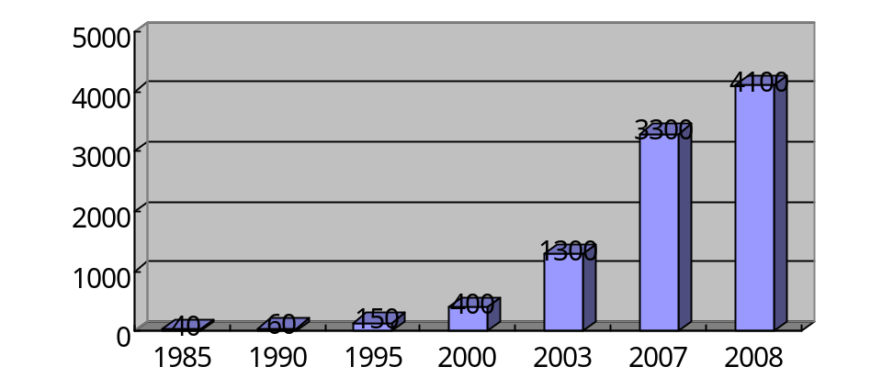
Fig. 1.1: World user population growth

(Million) user population
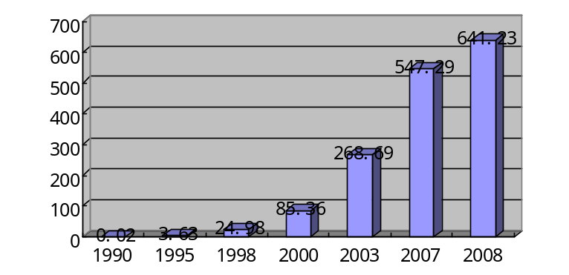
Fig. 1.2: User population growth in China

(Mbps) 9.6K 14.4K 2M 20M 3.6G
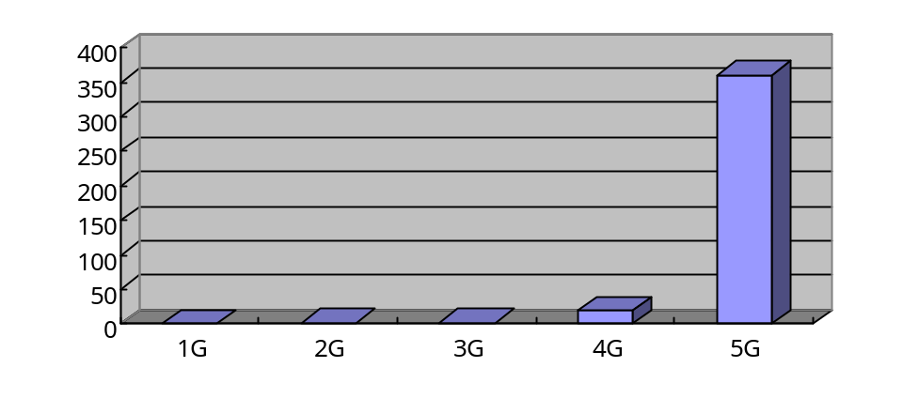
Fig. 1.3: Progress in data rate
1.3 Existing Problems

(1) Link quality
(2) Battery consumption
(3) Radiation and health issues
(4) System capacity
(5) Base station density
(6) Data rate

1.4 Advanced Techniques for the 3G Wireless Communications and Beyond
(1) Smart antennas
(2) Adaptive equalization
(3) Optimized RAKE reception
(4) Space-time coding and diversity
(5) Advanced modulation and coding techniques:
OFDM, Turbo code, new coding method,-----
(6) Multiuser detection
(7) Power Control

2. Wireless Channel Characteristics
2.1 Path Loss
- Free Space

Friis free space equation
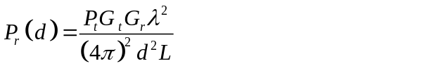 (2.1)
where d is the T-R separation distance is meters, Pr is received signal power, P_{t} is the transmitted signal power, L is the system loss factor, 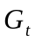 is the transmitter antenna gain, 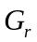 is the receive antenna gain, is the wavelength
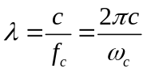 (2.2)
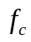,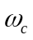—carrier frequency in Hertz and in radians per second.

- Log-Distance Path Loss Model

Both theoretic and measurement-based average received signal power decreases by the logarithm of the distance between the transmitter and the receiver, whether in outdoor or indoor radio channels. Such models have been used extensively in the literature. The average path loss for an arbitrary T-R separation is expressed as a function of distance by using a path loss exponent, n.
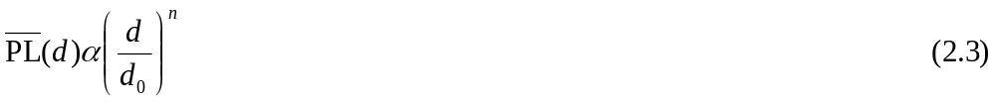
or
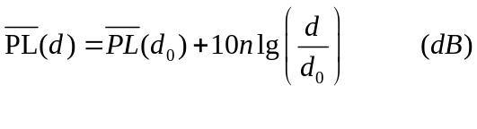 (2.4)
where 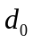 is the close-in reference distance which is close to the transmitter. The value of n depends on specific propagation environment. For example, in free space, n=2, and when obstructions are present, n will have a large value. The model (2. 4) does not consider the fact that the surrounding environments may be very different at two different locations having the same T-R separation. This leads to the measured signals to be much different than the average value predicated by the equation (2.4).
Measurement have shown that at any value of d, the path loss PL(d) at a particular location is random and distributed log-normally (normal in db) about the mean distance-dependent value. We can therefore express the path loss as

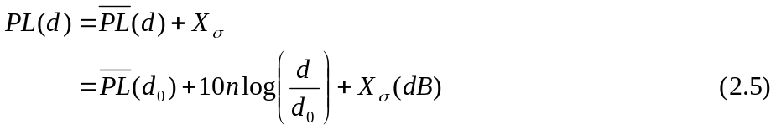
and
where X_{σ} is a zero-mean Gaussian distributed random variable (in dB) with standard deviation (also in dB).

The log-normal distribution (2.5) describes the random shadowing effects which occur over a large number of measurement locations with the same T-R separation. This phenomenon is referred to as log-normal shadowing.
Suppose that is the standard deviation of 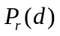. The probability that the received signal level will exceed a certain value γ can be calculated from
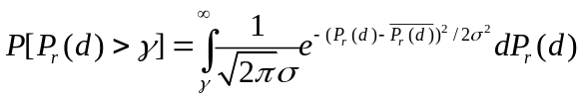 (2.7)

Use the substitution
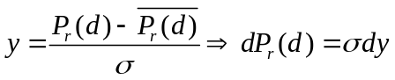 (2.8)
to yield
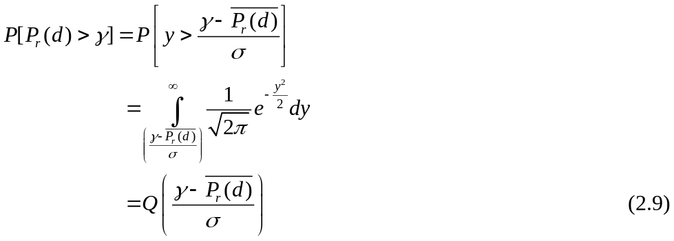

Similarly, the probability that the received signal level will be below γ is given by

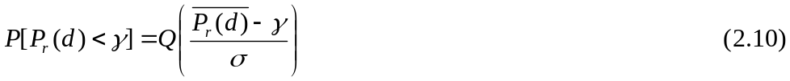

2. 2 Doppler Shift

Consider a mobile moving at a speed v, along a path segment with a length d between points X and Y, while it receives signal from a remote source S, as illustrated in Fig 2.1.

S

△L θ
θ
X d Y
V

Fig. 2.1

The distance in path lengths traveled by the wave from the source S to the mobile

at points X and Y is △L =d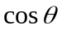=v where is the time required for the mobile to travel from X to Y, and is assumed to be the same at points X and Y since the source is assumed to be very far away.

The phase change in the received signal due to the difference in path length is therefore

where is the wavelength of the carrier frequency. Hence the change in frequency, or Doppler shift, is given by,

If the mobile is moving toward the direction if arrived of the wave, the Doppler shift is positive, and if the mobile is moving away from the direction of arrival of the wave, the Doppler shift is negative.

Example 2. 1
Consider a transmitter which radiates a sinusoidal carrier frequency of 1850MHz. For a vehicle moving 60mph, compute the received carrier frequency if the mobile is moving (a) directly towards the transmitter, (b) directly away from the transmitter, (c) in a direction which is perpendicular to the direction of arrival of the transmitted signal.

Solution:
Given: 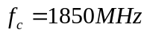
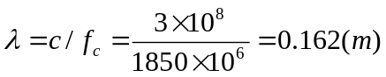

Vehicle speed v=60mph
=26.82m/s

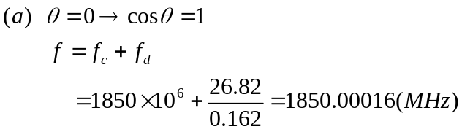
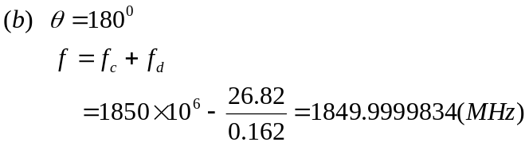
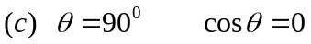
no Doppler shift
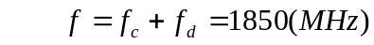.

2. 3 Impulse Response Model of a Multipath Channel

2. 3. 1 Fading Channel

The fluctuation in a received signal level is known as fading. The fading is typically composed of two multiplicative components as
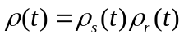 (real) (2.13)

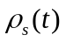-------slow fading or long term fading
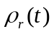-------fast fading or short term fading

The signal through radio propagation also experiences phase variation. The channel gain for the lth signal path can be modeled as a complex number as

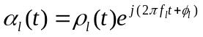 (2.14)
where 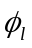 is the phase and 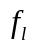 is the Doppler shift, of the lth path. The amplitude 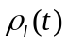 is often modeled as a fixed, Rayleigh, Ricean or log-normal distributed random variable while the phase can be considered to be uniformly distributed.

- Rayleigh fading

The received signal level has a distribution (pdf)

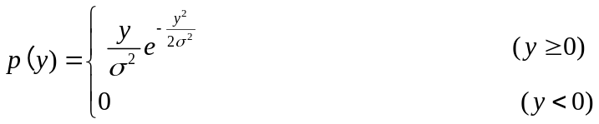 (2.15)

(pdf –probability density function)

where  is the time–average power of the random variable y.

The mean value of y is

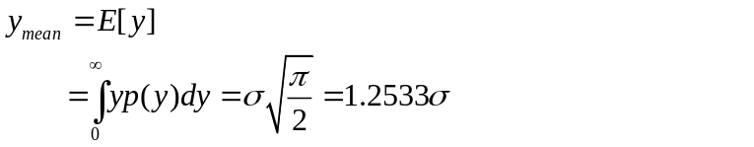 (2.16)

0.6065
p(y)

0 4 y

Fig. 2.2

- Ricean Fading

when there is a line-of-sight propagation path, Ricean fading occurs.

The Racean distribution is given by
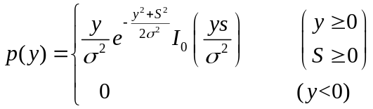 (2.17)

where S is the amplitude of the dominant signal, I₀(.) is the modified Bassel function of zero-order,

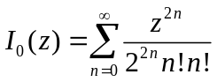 (2.18)

and is the time-averaged power of random variable y. The Ricean distribution is often described in terms of a parameter K.

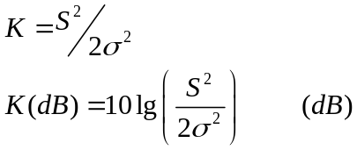

K=-dB(Rayleigh)

p(y)
K=6dB

Y

Fig. 2.3

2. 3. 2 Coherence Bandwidth and Coherence Time

Coherence bandwidth Bc is the range of frequencies over which two frequency components have a strong potential for amplitude correlation. Two sinusoids with frequency separation greater than Bc are affected quite differently by the channel.
The coherence Bandwidth can be expressed as
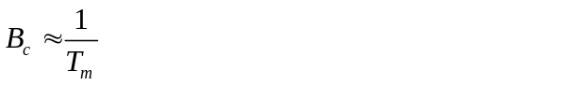 (2.19)

where 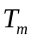 is the multipath delay spread. If the signal bandwidth B is larger than the coherence bandwidth, i.e.

B>Bc

the channel is the frequency selective fading channel (multipath with different delays). If the signal band width B is smaller than the coherence bandwidth, i.e.

B<Bc

the channel is the flat fading channel (same delay but maybe multipath).

Coherence time Tc is to characterize the time varying nature of the channel.
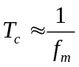 (2.20)
where 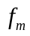 is the maximum Doppler shift. Coherence time is a statistical measure of the time duration over which the channel impulse response is essentially invariant.

Impulse
Response T1 T2
Tc

Fig. 2.4

When the channel impulse response changes at a rate much slower than the transmitted base band signal, the channel is a slow fading channel, i.e.
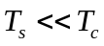. (2.21)

Here Ts is the base band signal pulse duration. When
(2.22)
the Channel is a fast fading channel. It should be noted that when a channel is specified as a fast on slow fading channel, it does not specify whether the channel is flat fading o r frequency selective fading in nature. Fast or slow fading only deals with the rate of change of the channel due to motion.

2.3.3 Channel Models

(a) Delay Power Profile

Received Power (dB)
10
0

-10
-20

-30
Delay Time

Fig.2.5

(b) Saleh-Valenzuela’s Model
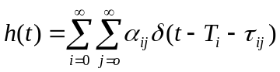 (2.23)

It is based on cluster phenomenon. This model is in time domain and the signal direction is not considered. A more simplified model is shown as

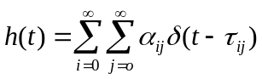 (2.24)
(c) In reality the propagation signals are directional and the directions are reflected in array response when receiver employs an antenna away. The propagation wave is shown as

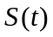
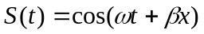
where 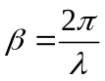 is the wavenumber. When the signal impinges on a linear array from a direction

Y

θ

X

Fig. 2.5
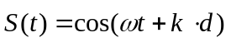 where is the wavenumber vector, is the position vector.
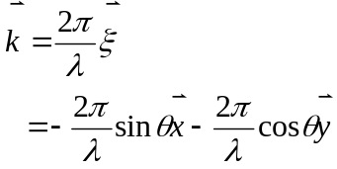
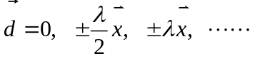

It is a uniform linear array with half wavelength spacing. Express in complex form

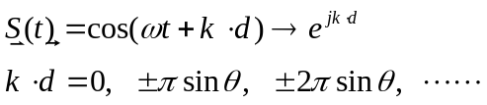

Array response vector:
. (2.25)

We can obtain a vector channel impulse response as

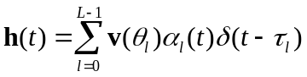 (2.26)

where L is the number of paths corresponding to different directions. Raleigh’s model is the result of the convolution as

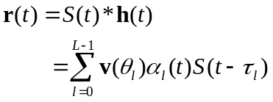 (2.27)

