3. Digital Modulation Techniques

3.1 Channel Capacity
Modern wireless communication systems use digital modulation techniques. The advancement in very large-scale integration (VLSI) circuits and digital signal processing technology has made digital modulation more cost effective than analog modulation. The advantages of digital modulation include greater noise immunity, easier multiplexing of various forms of information (e.g., voice, data, and video), and more security. The performance of a modulation scheme is often measured in terms of its bandwidth efficiency which describes the ability of a modulation scheme to accommodate date within a limited bandwidth. In general increasing the date rate implies decreasing the pulse width of a digital symbol, which increases the bandwidth of the signal. There is an unavoidable relationship between data rate and bandwidth occupancy. However, some modulation schemes perform batter than others in making this tradeoff. Bandwidth efficiency reflects how efficiently the allocated bandwidth is utilized and is defined as the ratio of the data rate per Hertz in a given bandwidth. If R is the data rate in bits per second, and B is the bandwidth occupancy by the modulated signal, then bandwidth efficiency 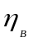 is expressed as
The system capacity of a digital communication system is directly related to the bandwidth efficiency of the modulation scheme, since a modulation with a greater value of will transmit more date in a given spectrum allocation.

There is a fundamental upper bound on an achievable bandwidth efficiency. Shannon’s channel capacity theorem states that for an arbitrarily small probability of error, the maximum possible bandwidth efficiently is limited by the noise in the channel, and is given by
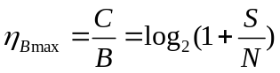 (3.2)
where C is the channel capacity in bps, B is the signal bandwidth, and 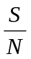 is the signal-to-noise ratio.

Example

Given S/N=20dB=100
Signal bandwidth
B=30,000 Hz
The maximum possible data rate
Rate
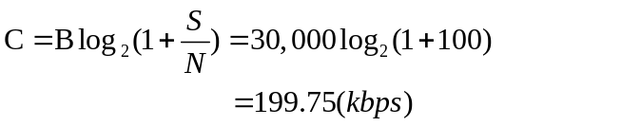

3.2 Nyquist Criterion for ISI Cancellation

When rectangular pulse case passed through a band limited channel, the pulse will spread in time, and the pulse for each symbol will smear into the time intervals of succeeding symbols. This causes intersymbol interference (ISI) and leads to an increased probability of error in detecting a symbol. The pulse shaping techniques are used to reduce the inter symbol interference. Consider a digital transmission system as shown in following figure.

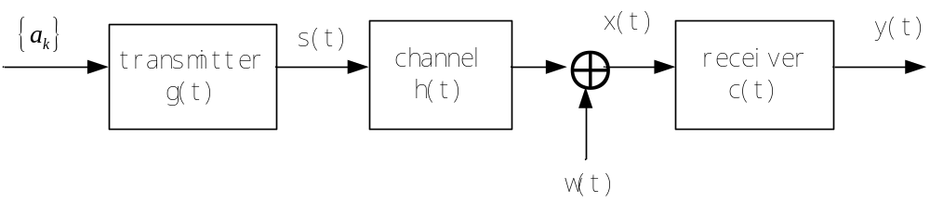

Fig. 3.1

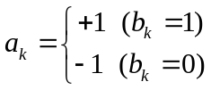

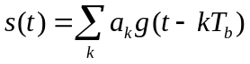 (3.3)

where g (t) is the impulse response of the transmit filter, 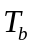 is the pulse duration. The pulse-amplitude modulator transforms the input binary sequences into a new sequence of short pulses (approximating a unit impulse), whose amplitude is 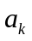. The signal s(t) is distorted as a result of the channel impulse response h (t). At the receiver

filter output .

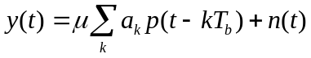 (3.4)
where  is a scaling factor, and 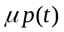 is the overall impulse response
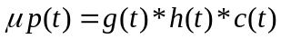 (3.5)

where c(t) is the impulse response of the receiver filter. We assume p(0)=1,
y(t) is sampled at 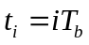,
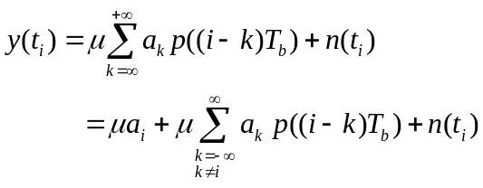 (3.6)
Here 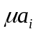 represents the contribution of the ith bit, the second term represents ISI since 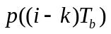may not be zero, and 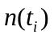 is the noise sampled at time . In the absence of both ISI and noise, we have y()= which shows that, under these ideal conditions, the ith transmitted bit is decoded correctly.

From (3.6), in order to be free of ISI, it requires that
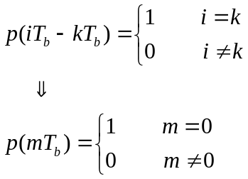
If p(t) satisfies above condition, the receiver output y(t_{i}) simplifies to (ignoring noise )
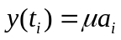 (for all i) which implies zero ISI.

Now consider the ideal sampled signal which has a Fourier transform pair as
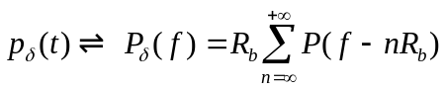 (3.7)
where 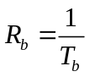 is the bit rate in bits per second.
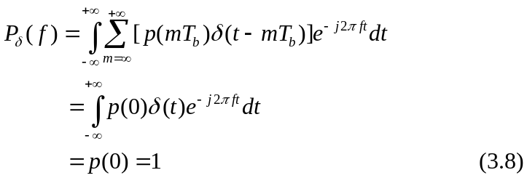

The Nyquist criterion is stated as

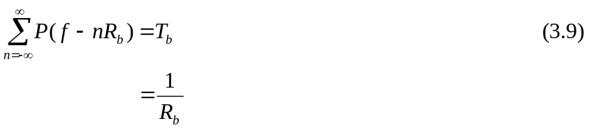

The simplest way to satisfy (3.9) is shown as follows

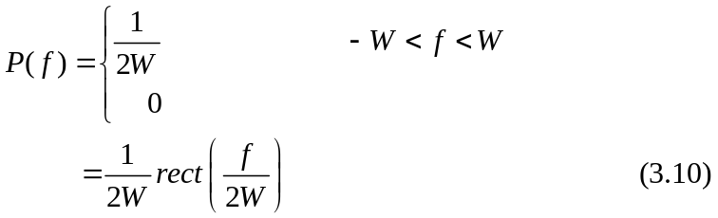

where the bandwidth W is defined by
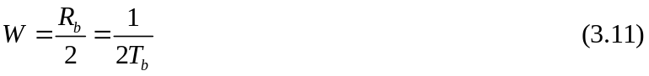
and is called Nyquest bandwidth. Then one signal waveform that produces zero ISI is given by
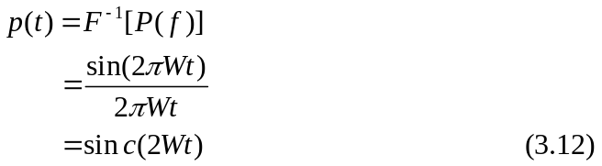

3.3 Raised cosine Spectrum 升余弦频谱

We may overcome the practical difficulties encountered with the ideal Nyquest channel by extending the bandwidth from W=R_{b} /2 to an adjustable value between W and 2W. A particular form of P(f) that embodies many desirable features is provided by a raised cosine spectrum as
我们可以克服的理想奈奎斯特通道遇到的实际困难，通过扩展带宽从W= RB/2值W和2W之间可调。提供一种特殊形式的P（f）该体现了许多很好的特性由一个上升的余弦频谱
P(f)=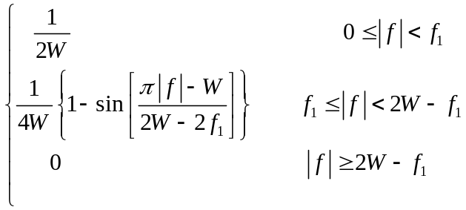 (3.13)
where 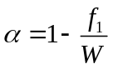, is called the roll off factor.(滚降系数）

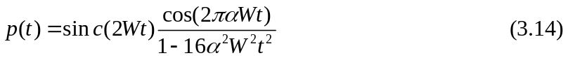

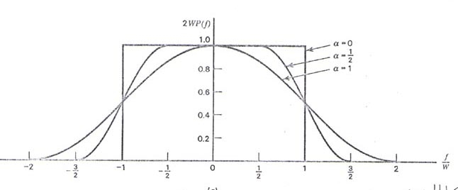

Fig. 3.2

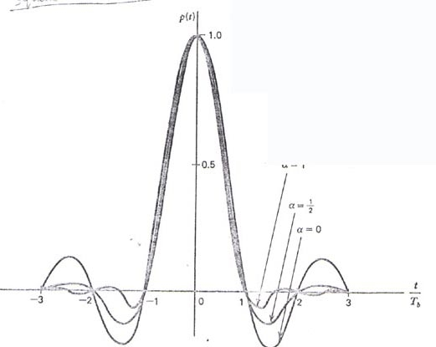

Fig. 3.3

3.4 Gaussian Pulse-Shaping Filter高斯脉冲整形滤波器

It is also possible to use other non-Nyquist technique for pulse shaping. One of such techniques is Gaussian pulse-shaping filter. Unlike Nyquist filters which have zero crossings at adjacent symbol peaks, the Gaussian filter has a smooth transfer function with no zero-crossings. Its transfer function is shown as
另外，也可以使用其他非奈奎斯特脉冲整形技术。对这样的技术是高斯脉冲整形滤波器。高斯滤波器与奈奎斯特滤波器在相邻符号峰有过零点，有一个平稳的传递函数没有过零点。它的传递函数示出作为
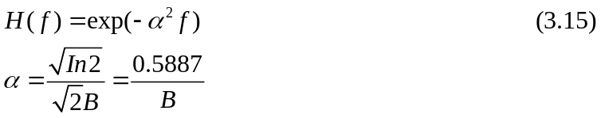

where B is the 3-dB bandwidth of the Gaussian filter. The impulse response of the Gaussian filter is given by

其中B是高斯滤波器的3分贝带宽。高斯滤波器的脉冲响应由下式给出
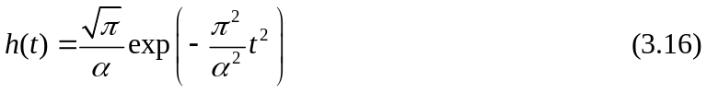

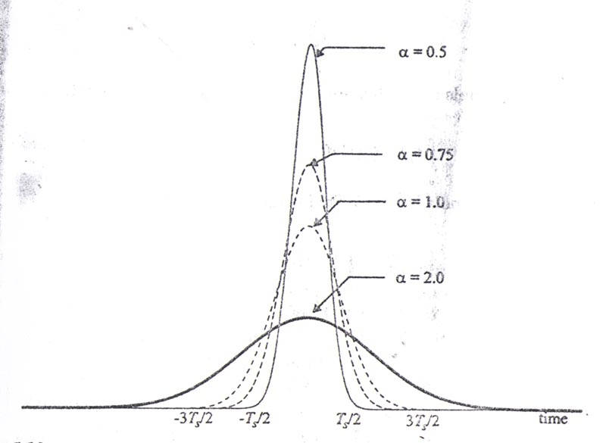

Fig. 3.4

3.5 Matched Filter

A basic problem that often arises in communication systems is that of detecting pulse transmitted over a channel that is corrupted by additive noise at the input of the receiver. Consider then the receiver model shown in following.

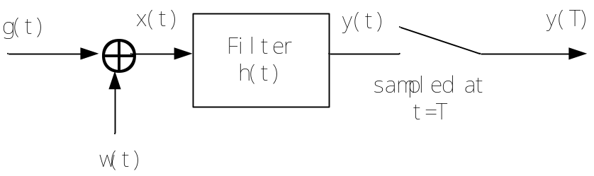

Fig. 3.5

where T is an arbitrary observation time interval. g (t) may represent a binary symbol 1 or 0. w(t) is AWGN of zero mean and power spectral density 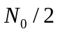. The resulting output y(t) may be expressed as

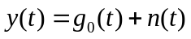 (3.18)

where 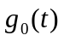and n(t) are produced by the signal and noise components of the input x(t). It is desirable that the signal component is considerably greater than the noise component n(t). Thus we want to maximize the peak pulse signal-to-noise ratio defined as
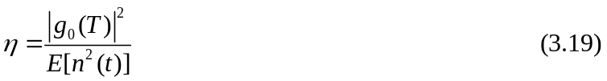
where 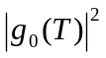 is the instantaneous power in the output signal, and 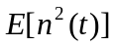 is a measure of average output noise power. We want to specify the impulse response h(t) of fitter such that is maximized. Let G(f) denote the Fourier transform of the known signal g (t), and H (f) denote the transfer function of the filer. Then

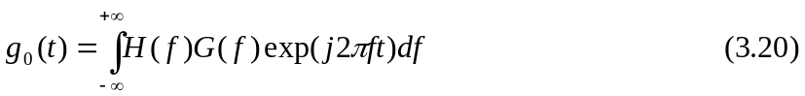

Hence, when the filter output is sampled at t=T, we have

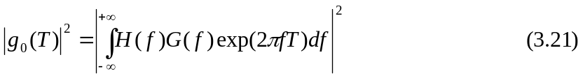

The power spectral density S_{N} (f) of n(t) is equal to the power spectral density of the input noise w(t) times the squared magnitude of the transfer function H(f). It follows that
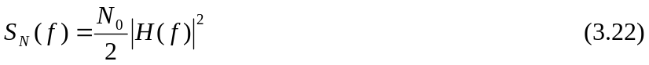

The average power of n(t) is

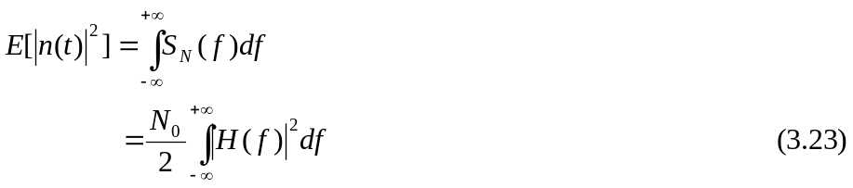

Then
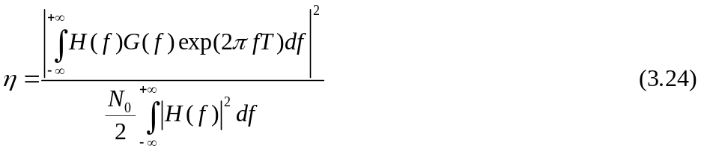

The problem is to find, for a given G(f), the particular form of transfer function H(f) that makes a maximum.

To find the solution, we apply Schwarz inequality. Schwarz inequality shows that if we have two complex functions 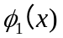 and 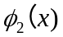 in the real variable x satisfying the condition
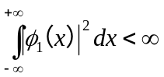
and
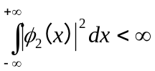,
then we may write

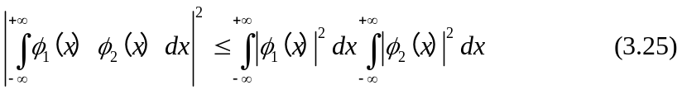

The equality holds if, and only if, we have
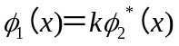 (3.26)

where k is an arbitrary constant, and asterisk denotes complex conjugation. Setting

(3.27)

We have

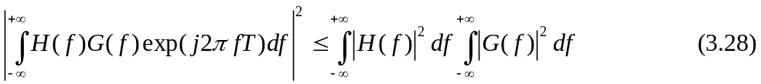

From (3.24) and (3.28), we have

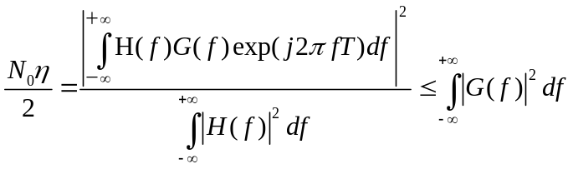 . (3.29)

Then
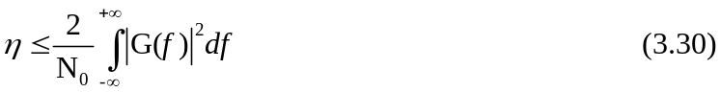
Therefore,
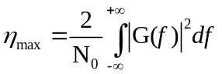
Correspondingly, with (3.27), H(f) assumes its optimum value denoted by 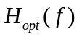,
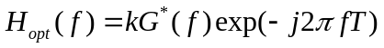. 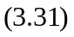

The impulse response of this optimum filter is
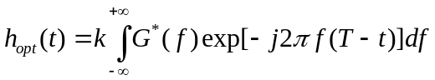 (3.32)

For a real signal g (t), we have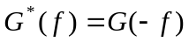, then

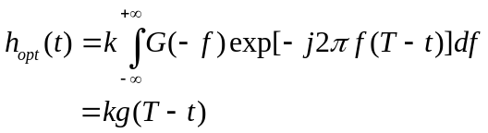 (3.33)

The impulse response of the optimum filer is matched to the input signal. The most important result in the calculation of the performance of signal processing systems using matched filters is the following: the peak pulse signal-to-noise ratio of a matched filter depends only on the ratio of the signal energy to the power spectral density of the white noise at the filter input. To demonstrate this property, consider a filter matched to a known input signal g (t).

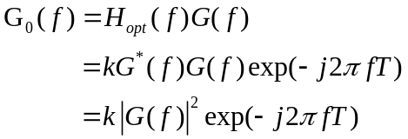 (3.34)

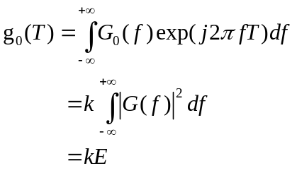 (3.35)

where E is the energy of g(t). According to (3.22), the average output noise power should be

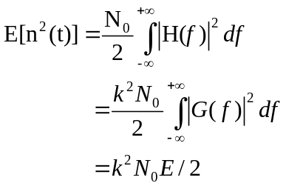 (3.36)
Therefore,

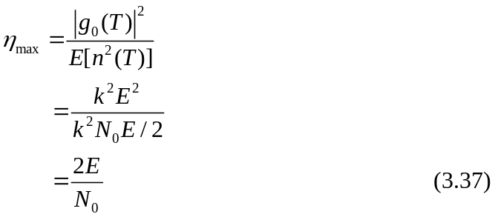

Example:
g(t)
A

0 T t

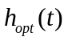 A

0 T t

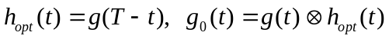
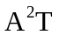

0 T t

The matched filter may be implemented using an integrate-and-dump circuit as

AT

0 T t
3.6 Bit Error Rate Due to Noise

Consider the received signal as follows

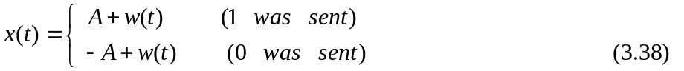
where 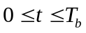, 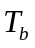 is the bit duration, and A is the transmitted pulse amplitude. Consider following system.

s(t) x(t) y 1 if y>λ
Matched
Filter
Decision
Device

0 if y<λ
Sample
w(t)

To determine the average probability of error, suppose that the symbol 0 was sent. Then the received signal is
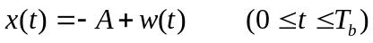 (3.39)

The matched filter output, sampled at t=T_{b}, is given by

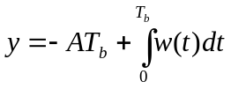

For the purpose of computing the error probability, we consider

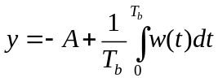 (3.40)

We may characterize the random variable Y as follows:

- The random variable Y is Gaussian distributed with a mean of －A.

- The variance of Y is
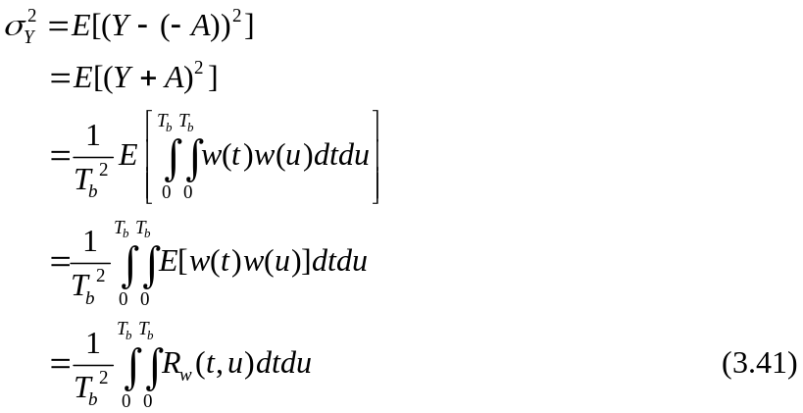

where 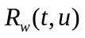 is the autocorrelation function of the white noise w(t). Since w(t) has a power spectral density 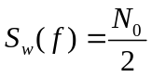, and
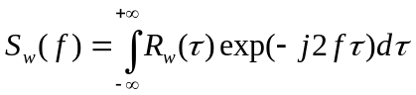,
then we have
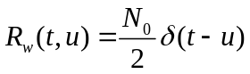 (3.42)

Hence,
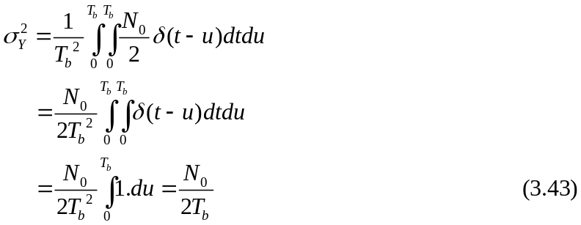

Therefore, the probability density function of random variable Y, given that symbol 0
was sent, is

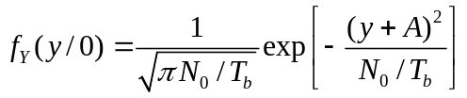. (3.44)

This function is plotted in following figure. Let 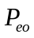 denote the conditional probability of error, given that symbol 0 was sent.

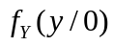
Peo

y
-A
Threshold

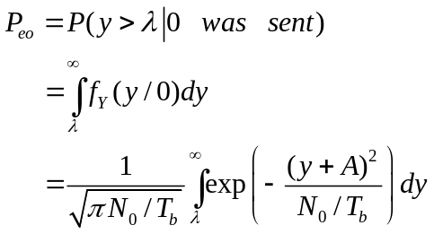 (3.45)

It is reasonable to set 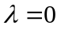，then

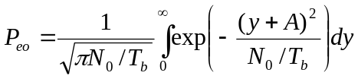

Define
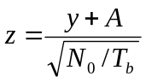
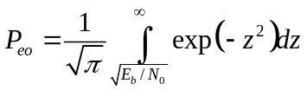
where 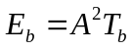. At this point it is convenient to introduce the definition of complementary error function

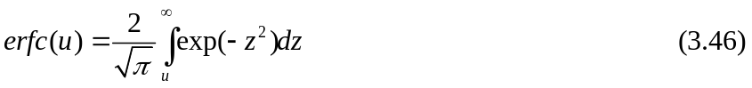

Therefore,
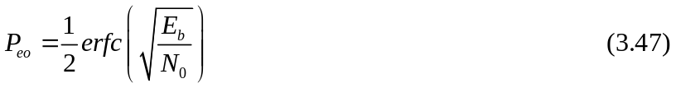
When symbol 1 was transmitted, we have the conditional probability density function of Y, given that symbol 1 was sent, as
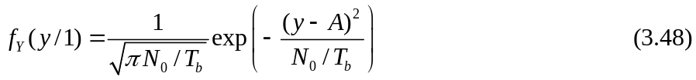

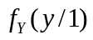
Peo

Y
A

Let P_{e1} denote the conditional probability of error, given that symbol 1 was sent.

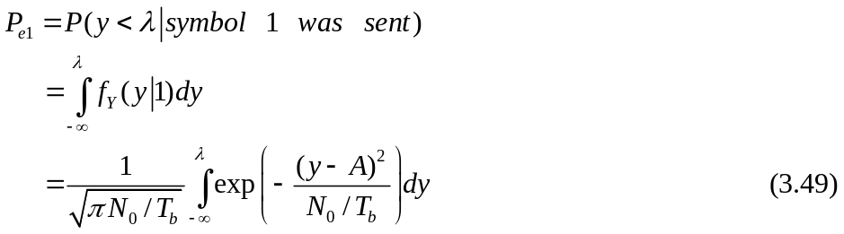

We readily find that 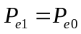. The average probability of symbol error 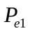 in the receiver is given by

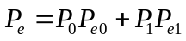
where P₀ and P₁ are the a priori probabilities of binary symbols 0 and 1, respectively. Since and 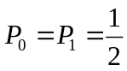, we obtain

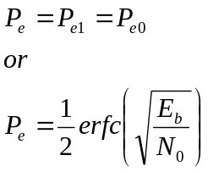

3.7 Geometric Interpretation of Signals

We can adopt a convenient set of orthonormal basis functions 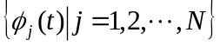, then each signal in the set 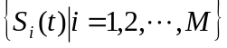, may be expanded as
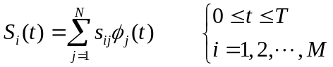
Accordingly, we may state that each signal in the set 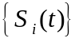 is completely determined by the vector of its coefficients

The vector 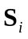 is called signal vector. The idea of visualizing a set of energy signals geometrically is of profound importance. It provides the mathematical bass for the geometric representation of signals, thereby paving the way for noise analysis in a conceptually satisfying manner.

Example:

N=2, M=3

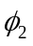
3
2 S2
1 S1
-1 1 2 3
-2 S3
-3
3
1
S1=

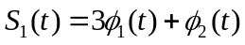

The cosine of the angle between two vectors is defined by

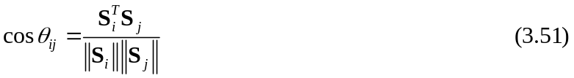
The two vectors and 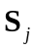 are the orthogonal to each other if their inner product is zero, in which case 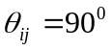. The norm square of the vector is expressed as
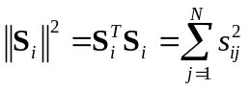

By definition, the energy of a signal S_{i}(t) of duration T is equal to

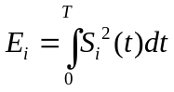

Therefore, we have
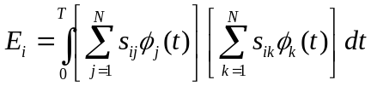

Interchanging the order of summation and integration, and rearrange terms

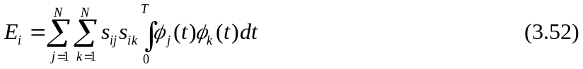

After derivation, (3.52) reduces to
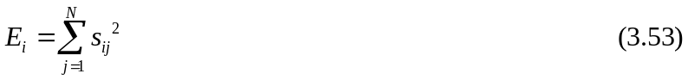
Thus it shows that the energy of a signal S_{i}(t) is equal to the squared-length of the signal vector S_{i}. In the case of a pair of signals, the Euclidean distance is

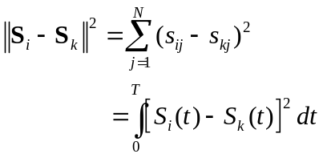

3.8 Response of Bank of Correlators to Noisy Input

Suppose that the input to the bank of N correlators is

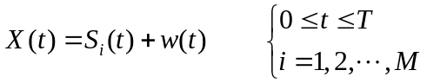
where w(t) is a sample function of a white Gaussian noise process of zero mean and power special density N₀/2. Correspondingly, we find that the output of correlator j, say, is the sample value of the random variable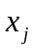, as shown by
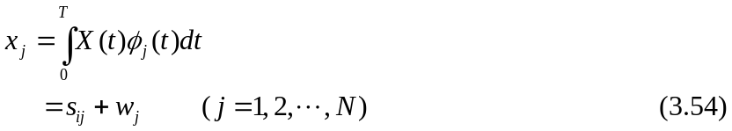
The first component, 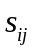, is a quantity contributed by the transmitted signal 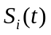; it is defined by
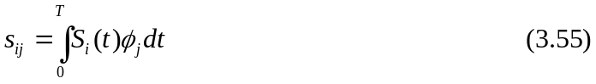

The second component, 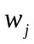, is defined by
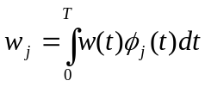.
Consider next a new random process 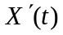 whose sample function is related to the received signal 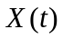 as
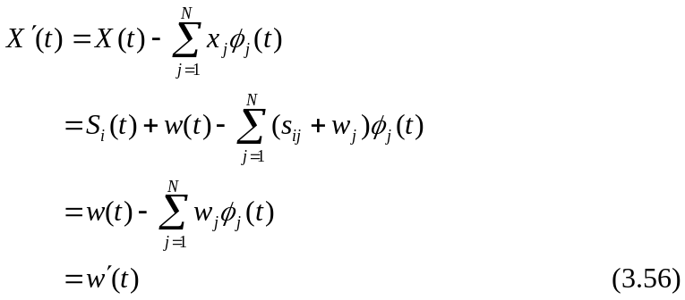
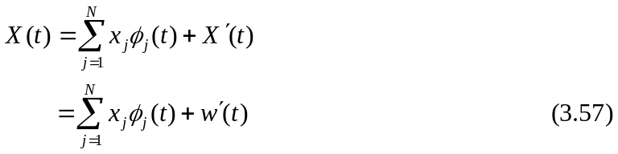

We now wish to develop a statistical characterization of the set of N correlator outputs.
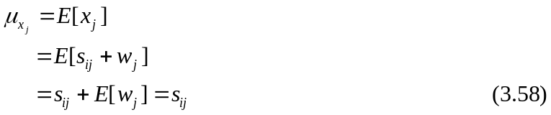

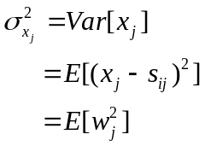
is defined by

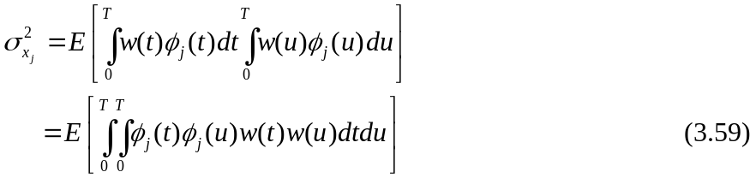

Interchanging the order of integration and expectation

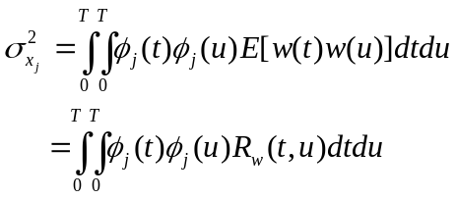
where is the autocorrelation function of the noise process w(t). Since the noise w(t) has a power special density N₀/2, we may express as

Then
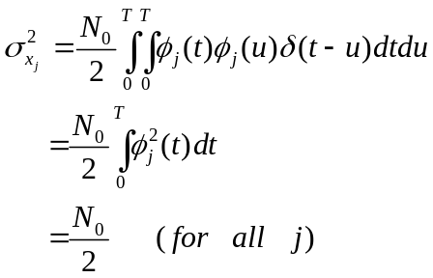

Thus all the correlator outputs x_{j} (j=1,2,…N) have a variance equal to the power spectral density N₀/2 of the noise process w(t). Moreover, since the 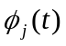 forms an orthogonal set, we find that the X_{j} are mutually uncorrelated, as shown by

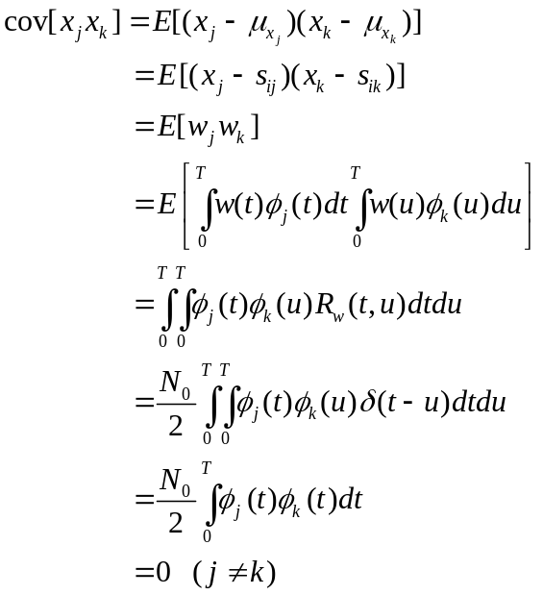

Define the vector of N random variables

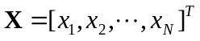
whose elements are independent Gaussian random variables with mean values equal to and variance equal to N₀/2. Since 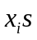 are statistically independent we may express the conditional probability density function of the vector X, given that the signal S_{i}(t) or the symbol 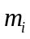 was transmitted, as the product of the conditional probability density function of its individual elements as

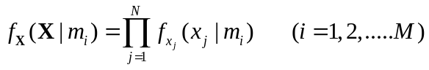 (3.60)
The vector X is called observation vector and is called an observation element. The conditional probability density functions, 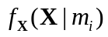, for each transmitted message are called likelihood functions. Since each is a Gaussian random variable with mean and variance , we have

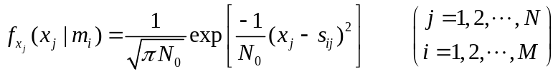 (3.61)

Therefore, the likelihood functions of an AWGN channel are given by

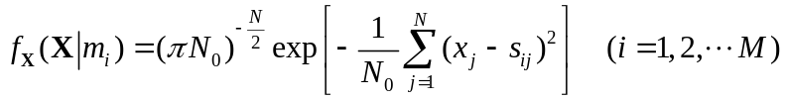 (3.62)

