3.9 Coherent Detection of Signals in Noise
When the transmitted signal S_{i}(t) 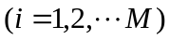 is applied to a bank of correlators, the resulting correlator outputs define the signal vector S_{i}. Since knowledge of the vector S_{i} is as good as knowing S_{i}(t) itself, we may represent S_{i}(t) by a point in a N-dimensional space. We refer to this point as the message point. The set of message points corresponding to the set of transmitted signals 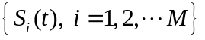 is called a signal constellation. However, the representation of the received signal X(t) is complicated by the presence of the additive noise w(t). When the received signal X(t) is applied to the bank of N correlators, the correlator outputs define the observation vector X.
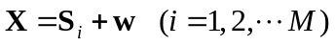 (3.63)

The detection problem is stated as; Given the observation vector X, we have to perform a mapping from X to an estimate 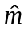 of the transmitted symbol, 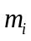, in a way that would minimize the probability of error in the decision-making process.

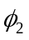

0
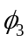

Fig. 3.6

Received signal point
Observation vector
Noise vector

Message point
Signal vector

0

Fig. 3.7

Maximum-likelihood Decoder
Suppose that given the observation vector X, we make the decision 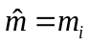. The probability of error in this decision, which we denote by Pe(m_{i}, X), is

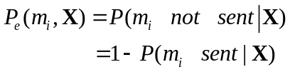 (3.64)

The decisions-making criterion is to minimize the probability of error in mapping each given observation vector X into a decision. We may therefore state the optimum decision rule as:
set if
(3.65)
where k=1,2,…….M. This decision rule is referred to as the maximum a posterior probability (MAP) rule.

Using Baye’s rule, we may restate the MAP rule as
set if
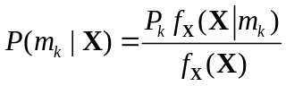 is maximum for k=i (3.66)
where P_{k} is the a prior probability of occurrence of symbol m_{k}, 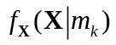 is the likelihood function that results when symbol m_{k} is transmitted, and 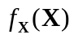 is the unconditional joint probability density function of the random vector X.

Baye’s rule
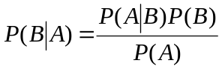
Since (1) is independent of the transmitted signal.
(2) P_{k}=constant because all signals are transmitted with equal probability.
Therefore, we may simplify the decision rule as
set if
is maximum for k=i (3.67)

It is more convenient to work with the nature logarithm of the likelihood function rather than the likelihood function itself. Then we may restate the decision rule as
set if
In[] is maximum for k=i (3.68)

This decision rule is referred to as the maximum-likelihood rule, and the device for its implementation is correspondingly referred to as the maximum likelihood decoder.
It is useful to have a graphical interpretation -+of the maximum-likelihood decision rule. Let I denote the N-dimensional space of all possible observation vectors X. we refer to this space as the observation space. Because we have assumed that the decision rule must say (i=1,2,…M) the total observation space I is partitioned into M decision regions, denoted by Z₁, Z₂,…Z_{m}. Accordingly, we my restate the decision rule as follows.

Observation vector X lies in region Z_{i} if
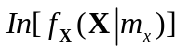 is maximum for k=i (3.69)

Consider an AWGN channel for which the likelihood function is defined by

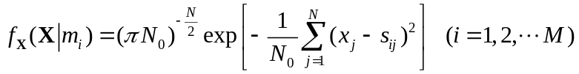 (3.70)

The corresponding value of the metric is therefore

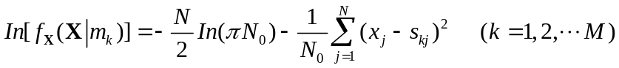 (3.71)

We may formulate the maximum-likelihood decision rule for an AWGN Channel as follows.

Observation vector 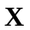 lies in region Z_{i} if

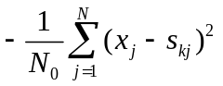 is maximum for k=i (3.72)

Equivalently, we may state that the observation vector lies in the region Z_{i} if

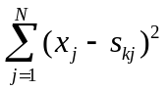 is minimum for k=i (3.73)
Note that
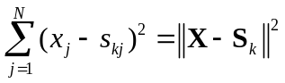 (3.74)

Then we may say,

Observation vector lies in the region Z_{i} if

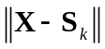 is minimum for k=i. (3.75)

(3.75) states that the maximum likelihood decision rule is simply to choose the message point closest to the received signal point, which is intuitively satisfying.
Expand the terms
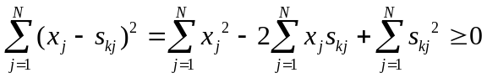

Accordingly, we may formulate a decision rule as follows.

Observation vector X lies in region Z_{i} if

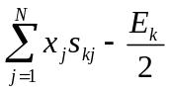 is maximum for k=i (3.76)
where 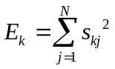.

Bit Versus Symbol Error Probabilities

Assume each symbol has m bits. There would be 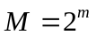 possible symbols (m=log₂M). The average probability of symbol error is related to the bit error rate as follows

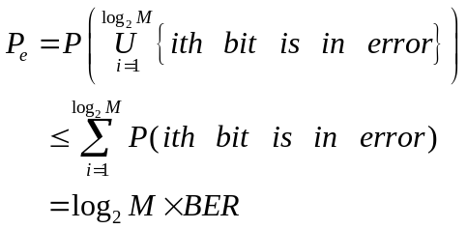
Note:
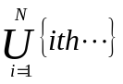 means one of the N events occurs.
We certainly have
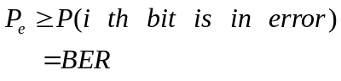

Therefore,
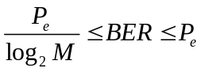. (3.77)

3.10 Correlation Receiver


∫(.)dt

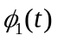

x(t)
∫(.)dt

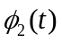
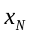

∫(.)dt

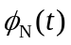.

X^{T}S₁
∑

Select
largest

X 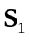 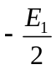
X^{T}S₂
∑
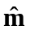
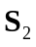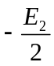

X^{T}S_{M}
∑

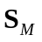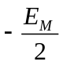

Fig. 3.8

Equivalence of Correlation and Matched Filter Receivers

Consider a linear time-invariant filter with impulse response h_{j}(t). With x(t) as input, the output
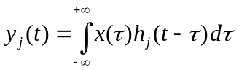 (3.78)
we set
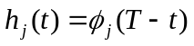

Then
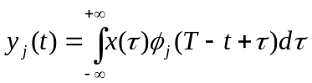

Sampling this output at t=T

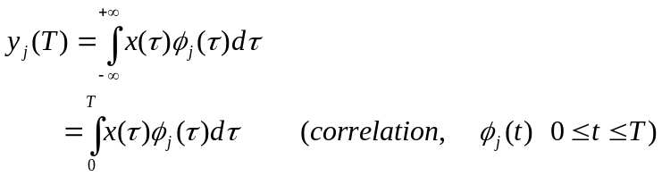

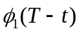
x₁

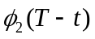
x(t) x₂
X

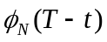
x_{N}

Fig. 3.9

3.11 Detection of Signals with Unknown Phase

Consider a transmitted signal
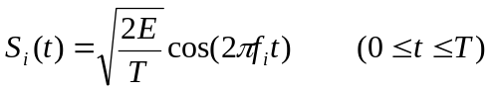

where E is the signal energy and T is the donation of the signal interval. The received signed is
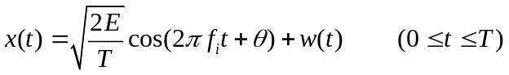 (3.79)

where the phase θ is a random variable that is uniformly distributed between 0 and 2π. This assumption implies a lack of knowledge of phase. A digital communication system characterized in this way is said to be noncoherent. Here we assume that 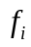 is an integral multiple of 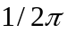. Expand (3.79), we have

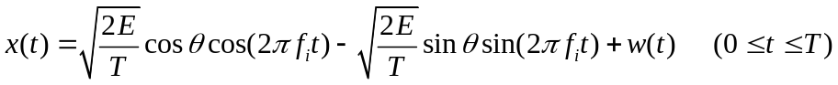 (3.80)

- Quadrature receiver using correlators

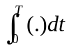
y_{I}
(.)²

x(t) 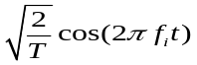

y_{Q}
(.)²
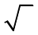

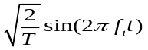
Output

Fig. 3.10

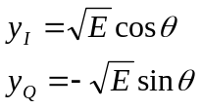

The output
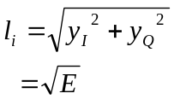

In the case of
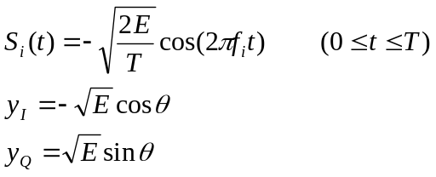

(b) Quadrature receiver using matched filters

t=T
Filter Matched to
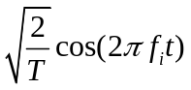
y_{I}
(.)²

x(t)

Filter Matched to
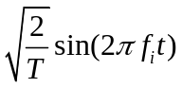
t=T
y_{Q}
(.)²

l_{i}

Fig. 3.11

Both matched filters are defined for the time interval 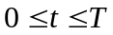. Then we have the impulse response of the first matched filter as

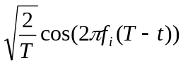
and the impulse response of the second matched filter as

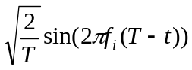.

3.12 Coherent Binary Phase Shift Keying (BPSK)

In a BPSK modulation scheme, the pair of signals 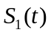 and 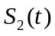 are used to represent binary symbols, l and 0, defined by
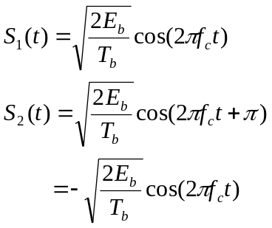
where 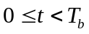, and E_{b} is the transmitted signal energy per bit. To ensure that each transmitted bit contains integral number of cycles of the carrier wave, the carrier frequency 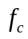 is chosen to be equal to 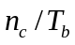 for some fixed integer 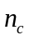. A pair of sinusoidal signals that differ only in a relative phase shift of 180degees, are referred to as antipodal signals. It is clear that in BPSK, these is only one basis function of unit energy , namely
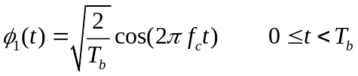 (3.81)

Then we may express the transmitted signals as follows,

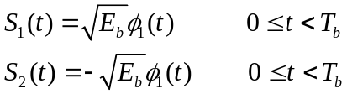

A BPSK systems in therefore characterized by having a signal space that is
one–dimensional (N=1), with a signal constellation consisting of two message points (M=2).

Decision boundary

Z₂ Z₁

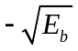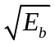

Fig. 3.12

The coordinates of the message points are

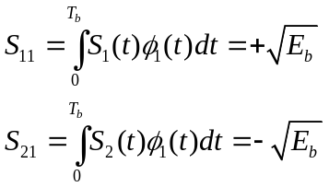

To realize a rule for making a decision in favor of symbol 1 or symbol 0 ,we partition the signal space into two regions by constructing the midpoint of the line joining these two message points, and then marking off the appropriate decision regions , i.e. 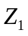 and 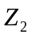. The decision rule is now simply to decide that signal , i.e. the binary symbol 1, was transmitted if the received signal point falls in region , and decide that signal , i.e. the binary symbol 0, was transmitted if the received signal if the received signal point falls in region . The observable element is related to the received signal 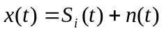 by

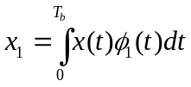 (3.82)

The PDF (probability density function) when symbol is transmitted is defined by

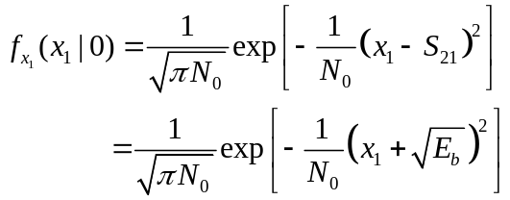 (3.83)

The probability of error for deciding in favor of symbol 1 given that symbol 0 was transmitted, is therefore
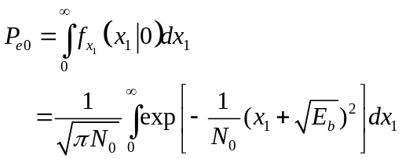 (3.84)

Putting z =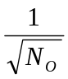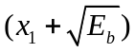 and changing the variable of integration from x₁ to z, we may rewrite
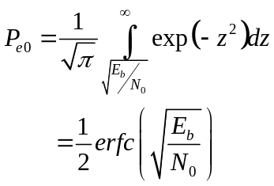 (3.85)
Similarly, 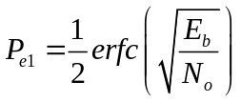. Thus averaging the error probability, we have the bit error rate for coherent BPSK is

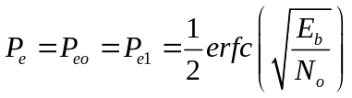 (3.86)

3.13 Coherent Binary Frequency Shift Keying (BFSK)

In a BFSK system, symbols 1 and 0 are distinguished from each other by transmitting one of two sinusoidal waves that differ in frequency by a fixed amount. A typical pair of sinusoidal wave is described by

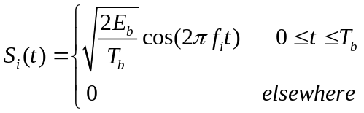
where i=1,2, and 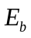 is the transmitted signal energy per bit; the transmitted frequency is
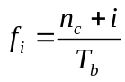
where is an integer. It is observed that the signal and are orthogonal. We therefore deduce that the most useful form for the set of orthonormal basis function is

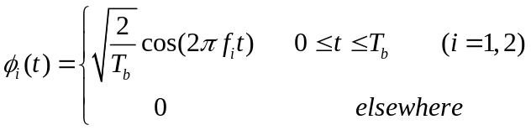

Correspondingly, the coefficient 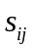 (i=1,2, j=1,2 ) is defined by
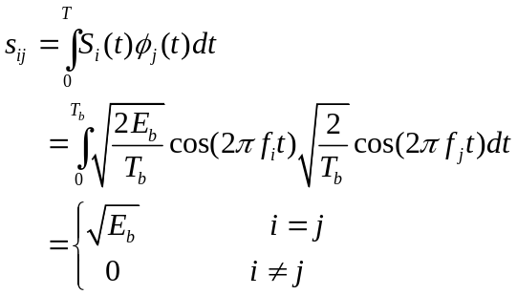

A coherent BFSK system is characterized by having a signal space that is two-dimensional with two message points.

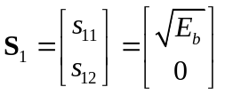
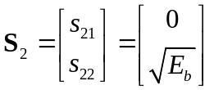

The Euclidean distance between this two message points is

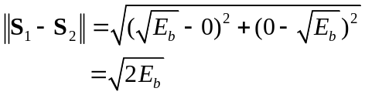

The observation vector X has two elements x₁ and x₂ that are defined by
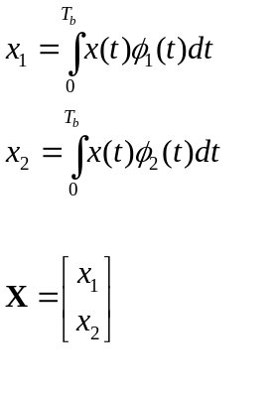
where 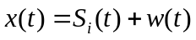

Region Z₂ m₂
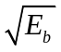

m₁
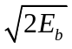
Region Z₁

Decision boundary

Fig. 3.13

The observation space is partitioned into two decision regions ,Z₁ and Z_{2.} The receiver decides in favor of symbol 1 if the received signal point represented by the observation vector X falls inside the region Z_{1.} This occurs when 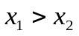. If , on the other hand, we have 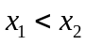 , the received signal point falls inside the region Z₂ , the receiver decides in favor of symbol 0. On the decision boundary, we have =, in which case the receiver makes a random guess. Define a new Gaussian random variable L whose sample value is equal to the difference between x₁ and x₂ ; that is
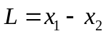 (3.87)
The mean value of random variable L depends on which binary symbol was transmitted. Given that symbol 1 was transmitted, the Gaussian random variables x₁ and x₂ have mean values equal to 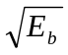 and 0, respectively. Correspondingly, the conditional mean of the random variable L, given that symbol 1 was transmitted is

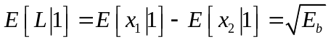 (3.88)

On the other hand, given that symbol 0 was transmitted, we have

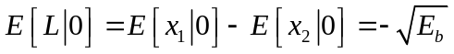

Suppose that we know that symbol 0 was transmitted. The conditional probability density function of the random variable L is then given by

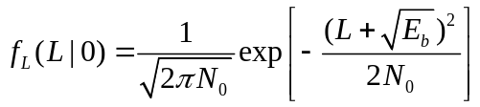 (3.89)

Note the variance of L is independent of which symbol was transmitted . Since x₁ and x₂ are statistically independent, we have

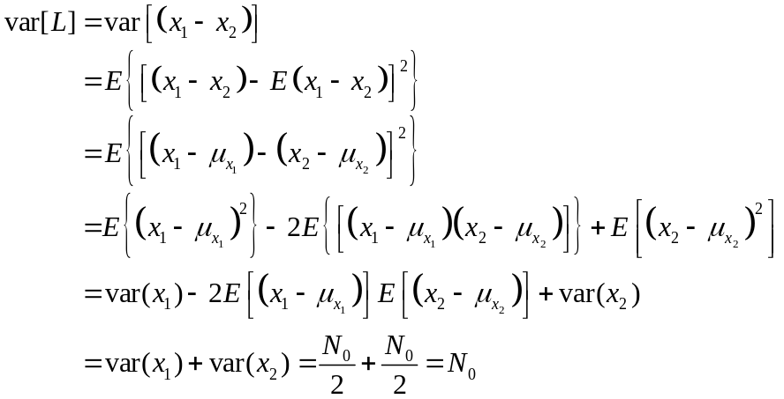

where 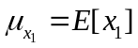. Since the condition 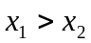, or L>0 corresponds to the receiver making a decision in favor of symbol 1, we deduce that the conditional probability of error, given that symbol 0 was transmitted, is
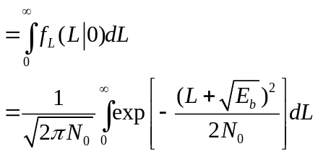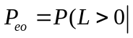symbol 0 was sent)

Put 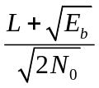=z
Then
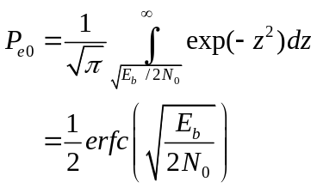 (3.90)
similarly, we can show
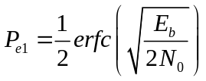 (3.91)

Accordingly, averaging P_{e0} and P_{e1}, we have the bit error rate for coherent BFSK is

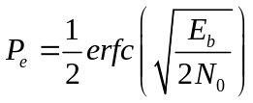 (3.92)

In comparison to BPSK system where we have

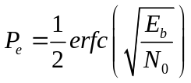.

We see that in order to maintain the same bit error rate, we have to double the bit energy-to-noise density ratio, E_{b}/N₀. This result is in perfect accord with the signal-space diagrams, where in a BPSK system, the distance between two message points is equal to 2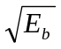, whereas in a BFSK system the corresponding distance is . This result clearly illustrates that, in an AWGN channel, the detection performance of equal energy binary signals depends only on the distance between two message points in the signal space. The larger we have this distance, the smaller will be the average probability of error.

Generation and Detection of Coherent BFSK Signals

If the binary symbol 1 is transmitted, then volts are on, and 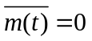, only the signal at upper branch is transmitted. If the binary symbol 0 is transmitted, then 0 volt is on, and 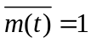, only the signal at lower branch is transmitted.

m(t)

Data in 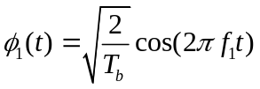
On-off level encoder
m(t)
Inverter
BFSK signal
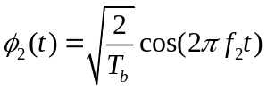

Fig. 3.14 (a) BFSK transmitter

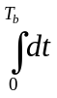

+ L Choose 1 if L>0
Decision
device

Input -
Chose 0 if L<0

Fig. 3.14 (b) BFSK receiver

3.14 Coherent Quadriphase-Shift keying (QPSK)

In QPSK system information carried by the transmitted signal is contained in the phase. In particular, the phase of the carrier takes one of four equally spaced values, 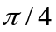, 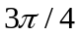, 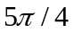, and 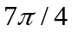. Then we may define the transmitted signal as

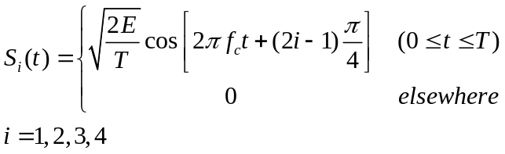 (3.93)

Here the carries frequency f_{c} equals 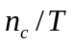 where 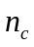 is an integer. Expanding (3.93), we have the transmitted signal in the equivalent form:

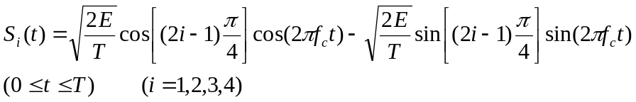

Based on this representation we can make the following observations:

① There are two orthonormal basis functions, 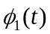 and 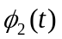
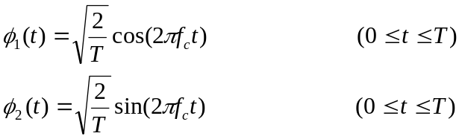

② There are four message points, and the associated signal vector are defined by
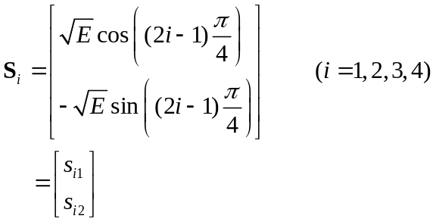 (3.94)

The elements of the signal vectors have their values as follows

Input bits | Phase | s_{i1} | s_{i2}
1 0 |  | 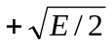 | 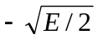
0 0
0 1
1 1

The signal constellation:

(0,1) (1,1)

(0,0) (1,0)

Fig. 3.15

In a coherent QPSK system, the received signal x(t) is given by

The observation vector X has two elements x₁ and x₂ defined by
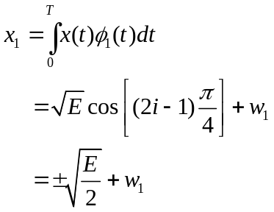 (3.95)
and

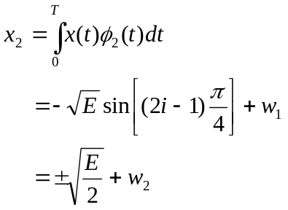 (3.96)

To calculate the average probability of symbol error, we note that a coherent QPSK system is in fact equivalent to two coherent BPSK system working in parallel and using two carriers that are in phase quadrature. The in-phase channel output x₁ and the quadrature channel output x₂ may be viewed as the individual outputs of two coherent BPSK systems. The coordinates of QPSK message points are 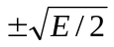. Recall that in a coherent BPSK system the coordinates of the message points are 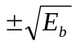 and

Then we may state that the average probability of bit error in each channel of the coherent QPSK system is
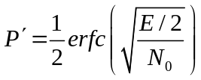. (3.97)

Another important point to note is that the bit errors in the in-phase and quadrature channels of the coherent QPSK system are statistically independent. The in-phase channel makes a decision on one of two bits constituting a symbol of QPSK signal, and the quadrature channel takes care of the other bit. Accordingly, the average probability of a correct decision resulting from the combined action of the two channels working together is

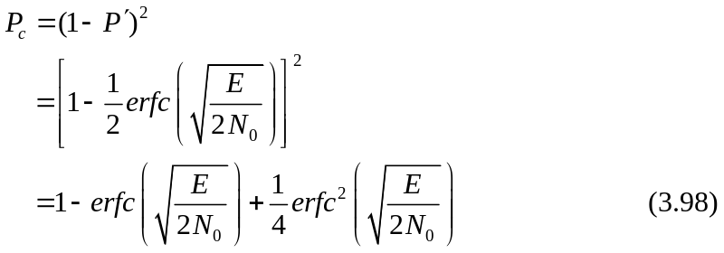

The average probability of symbol error for coherent QPSK is therefore

