4. Spread-Spectrum System
4.1 Introduction
In some cases, the system may be required to provide form of secure communication in a hostile environment such that the transmitted signals are not easily detected or recognized by unwanted listeners. This requirement can be met by a class of signaling techniques known as spread-spectrum modulation.
The primary advantage of a spread-spectrum communication system is its ability to reject interference whether is the unintentional interference by another user or the intentional interference by a hostile transmitters attempting to jam the transmission. Spread spectrum is a means of transmission in which the date sequence occupies a bandwidth in excess of the minimum bandwidth necessary to send it. The spectrum spreading is accomplished before transmission through the use of a code that is independent of the date sequence. The same code is used in the receiver to dispread the received signal so that the original date sequence may be recovered.

4.2 Pseudo-Noise Sequences
A pseudo-noise (PN) sequence is a periodic binary sequence with a noise like waveform that is usually generated by a feedback shift register shown as Fig 4.1.

Logic
1
2
m

… … output sequence

clock

Fig. 4.1

Let S_{j}(k) denote the state of the jth flip-flop after the kth clock pulse; this state may be represented by symbol 0 or 1. S_{j}(k) is a Boolean function. The state of the shift register after the kth clock pulse is then defined by the set
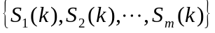 where 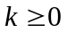.

For the initial state, 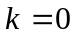

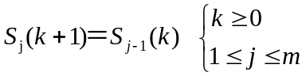 (4.1)

where S_{o}(k) is the input applied to the first flip-flop after the kth clock pulse. For a specific length m, this Boolean function S_{o}(k) uniquely determines the subsequent sequence of states and therefore the PN sequence produced at the output of the final flip-flap in the shift register. With a total umber of m flip-flop, the number of possible states of the shift register is at most 2^{m} . It follows therefore that the PN sequence generated by a feedback shift register must eventually become periodic with a period of at most 2^{m} . A feedback shift register is said to be liner when the feedback logic consists of medulo-2 adders. In such a case the zero state (the states of flip-flops are all zeros) is not permitted. This is because for a zero state the input So(k) produced by the feedback logic would be 0 and the output would therefore consist entirely 0’s . Consequently , the period of a PN sequence produced by a liner feedback shift register with m flip-flops cannot exceed 2^{m}-1. When the period is exactly 2^{m}-1 the PN sequence is called maximum-length-sequence (m-sequence).

Module – 2
1 1 0
0 1 1
1 0 1
0 0 0
Example 4.1
Modulo-2 adder

Flip-flop

1
2
3
c(t)
S₃

clock
m=3
Fig 4.2

Here c(t) is the output of the M-sequence generator. The succession of states is as follows: 100,110,111,011,101,010,001,100,……………The output sequence is therefore 00111010………which repeats itself with period of 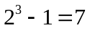.

Rc() is the autocorrelation function of the period signal c(t), which indicates the ability for a M-sequence to resist interference due to multipath signals. The period of c(t) is T_{b}=NT_{c} (N=2^{m}-1) where T_{c} is the duration assigned to bit 1 or 0 in the M-sequence. The autocorrelation function of c(t) with the period T_{b} is

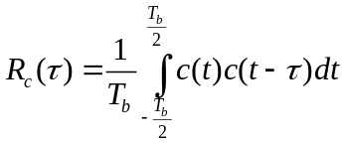 (4.2)
where the lag lies in the interval (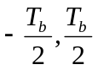).

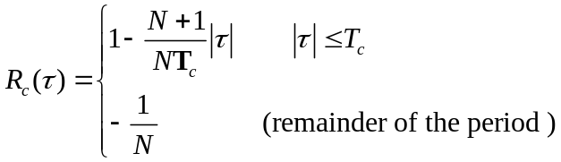 (4.3)

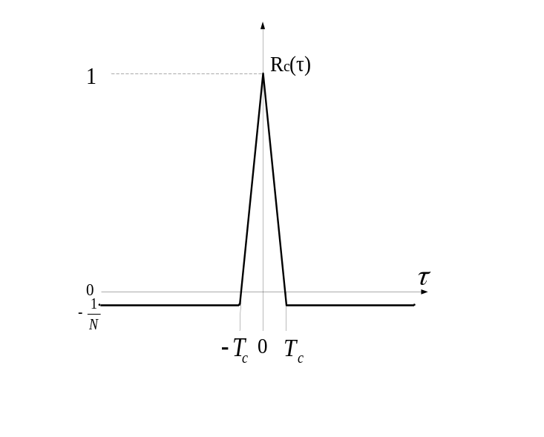
Fig. 4.3

4.3 Walsh code
Walsh codes are usually used along with PN codes in spread spectrums systems. The generation of Walsh code is done through a matrix expansion method which gives a Walsh matrix. Each row of a Walsh matrix is a Walsh code that is exactly orthogonal to other Walsh codes in the matrix. A Walsh matrix of order 2^{N+1} is determined by the Walsh matrix of order 2^{N} as

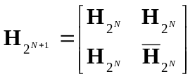 (4.4)
Example 4.2

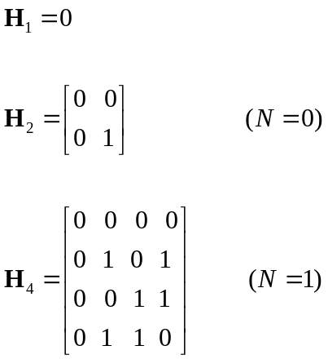

4.4 OVSF code
Another important code for spread spectrum systems is the orthogonal variable spreading factor (OVSF) code that insures orthogonality between Walsh codes of different length. Application of OVSF codes can be found in high speed data transmission systems. The OVSF code tree is shown in Fig. 4.4.

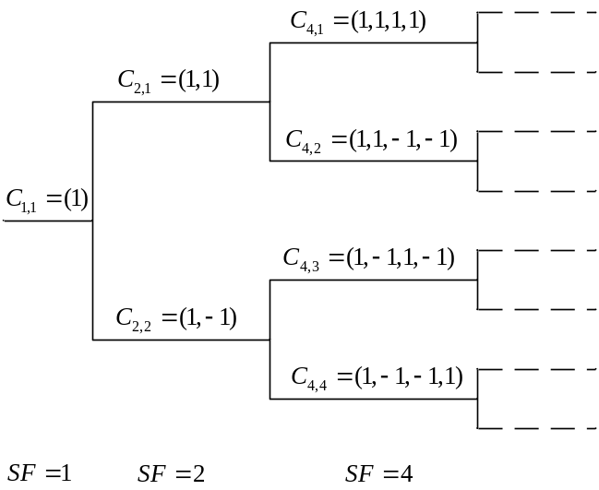

Fig. 4.4

A code from a tree branch is orthogonal with another code from different tree branch. OVSF code can be generated as

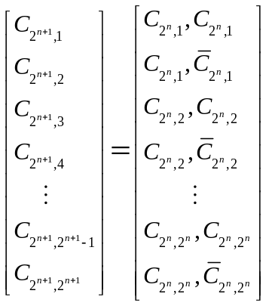 (4.5)

In (4.5), 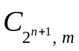 denotes the mth OVSF code with a spreading factor of 2^{n+1}.
Example 4.3

n=0 C_{1,1}=1

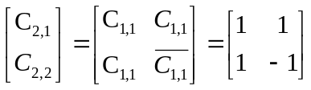

n=1
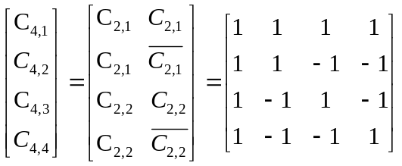

4.5 Spread Spectrum Communication System

By multiplying the information-bearing signal b(t) by the PN signal c(t), each information bit is “chopped” up into a number of small time increments as

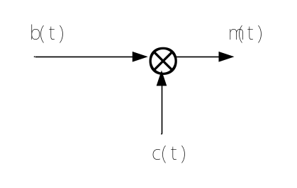
m(t)=c(t)b(t)
(a)

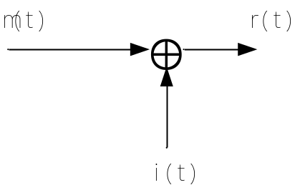

r(t)=m(t)+i(t)=c(t)b(t)+i(t)

( i(t) is interference )

(b)

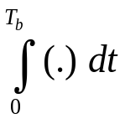
z(t)
Decision Device
1,if V>0
0,if V<0
c(t)
Threshold=0
r(t)

(c)

Fig.4.5: (a) Transmitted signal; (b) Received signal; (c) Receiver structure

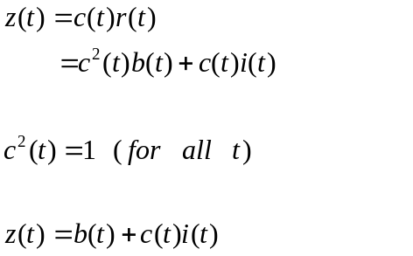 (4.6)

The system described above is referred to as direct sequence spread spectrum system.

4.6 Direct-Sequence Spread Spectrum with Coherent
BPSK Modulation

To provide for the use of the direct – sequence spread spectrum systems, we may incorporate BPSK into the transmitter and receiver, as shown in follow figure.
+1
-1
Encoder
modulator
1
0
Binary data
b_{k}
PN generator
carrier
x(t)

Fig. 4.6: Transmitter

Demodulator
Low pass
∫(.)dt
decision
y(t)
Local carrier
Local PN generator
output

Fig. 4.7: Receiver
For the purpose of analysis, it is more convenient to interchange the order of these operations as shown in following.
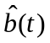
u(t)
data
s(t)
x(t)
y(t)
Modulator
Coherent detector
b(t)
c(t)
i(t)
c(t)

PN generator
Local PN generator
carrier
Local carrier

Transmitter
Receiver

Channel

Fig. 4.8
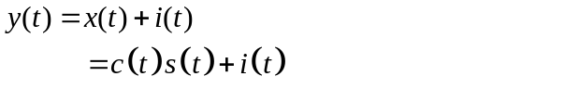 (4.7)

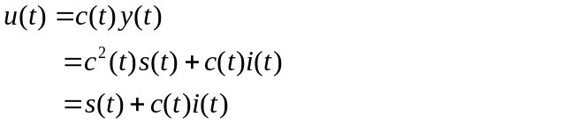 (4.8)

4.7 The Performance of the Direct – Sequence Spread
Spectrum System

Consider the set of orthonormal basis functions.

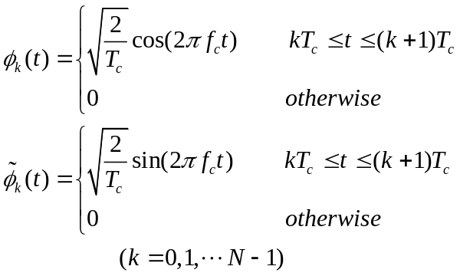 (4.9)

where T_{c} is the chip duration and N is the number of chips per bit. The chip energy here is equal to 1. Accordingly, we may decide the transmitted signal x(t) for the interval of an information bit as

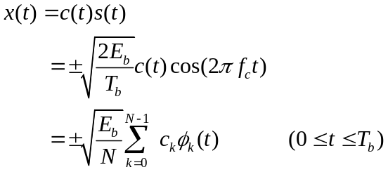 (4.10)

where E_{b} is the signal energy per bit. The sequence {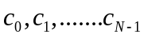}denotes the PN sequence, with c_{k}=±1. The transmitted signal x(t) is therefore N – dimensional.

Interference can be represented by a general form as

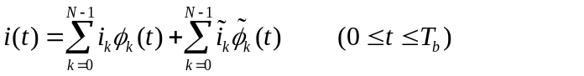 (4.11)
where
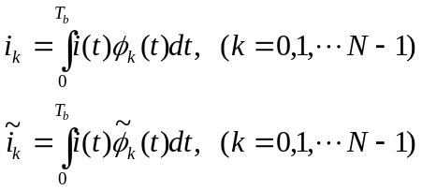 (4.12)

Thus i(t) is 2N– dimensional. The average power of the interference is expressed as follows
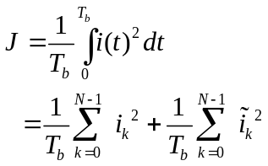 (4.13)

Note that the interference on each chip interval is assumed to have a form as

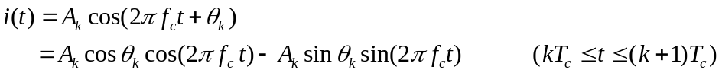
(4.14)

This explains why i(t) is represented with the equation (4.11). We can also assume there is an equal power in the cosine and sine coordinates defined in (4.11); hence, we have

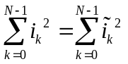 (4.15)

Therefore, we may simplify (4.13) as

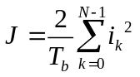 (4.16)

From Fig 4.8 and Eq. 4.8, at the output of the coherent detector, we have

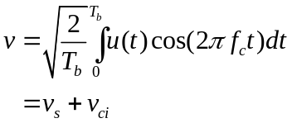 (4.17)
where 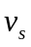 and 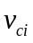 are due to the dispread BPSK signal s(t) and the spread interference, c(t)i(t), respectively.

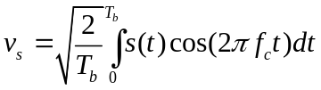 (4.18)

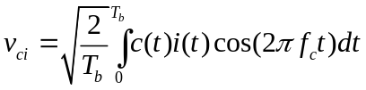 (4.19)

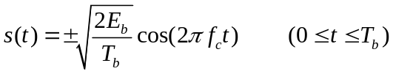

where the plus sign corresponds to the bit 1 and the minus sign corresponds to the bit 0. Assuming that fc is an integer multiple of 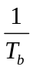, we have
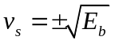 (4.20)

We may rewrite (4.19) in following form

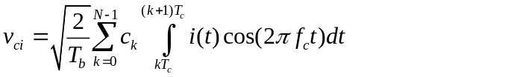 (4.21)

Further more, we have

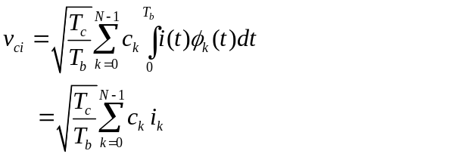 (4.22)

The coherent detection eliminates the sine components. We next approximate the PN sequence as an independent and identically distributed (i.i.d) binary sequence. Thus, the probability of the event 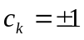 is
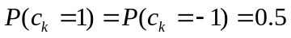
Accordingly, we have

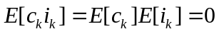
where 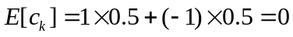. Therefore, E [v_{ci}]=0. The variance of v_{ci} is given by
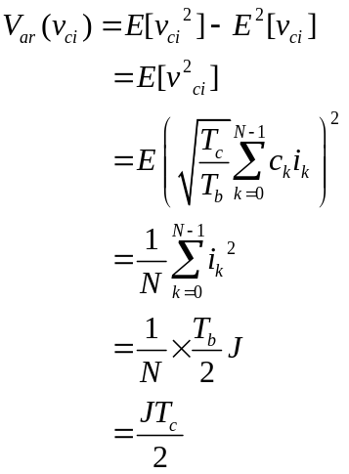

We may define the output signal-to-noise radio as
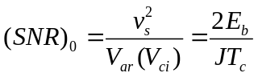 (4.23)

The average signal power at the receiver input equals 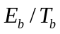. We thus define an input signal-to-noise radio as

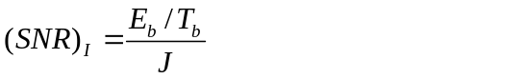 (4.24)

From (4.20) and (4.21), we obtain

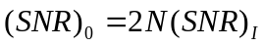 (4.25)

Note that 2 in (4.25) accounts for an additional gain that is obtained through the use of coherent detection (which presumes exact knowledge of signal phase by the receiver). N in (4.25) accounts for the gain in SNR obtained by the use of spread spectrum. N here is refereed to as the processing gain.

4. 8 Code-Division Multiple Access System
We may support multiple users over a common communication channel in a spread spectrum environment by using a technique known as code-division multiple access (CDMA), which relies on the use of different spreading codes for the individual users.

Consider the signal transmitted by a mobile user to a base station

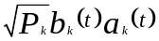

where 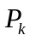 is the signal power transmitted by the kth user, 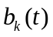 is the information bit for the kth user, and 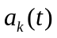 is the spreading sequence. At the base station, the received signal is

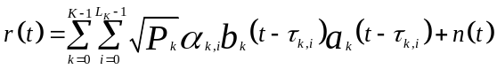
(4.26)

where 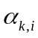 is the complex channel gain for the ith path of the kth user, 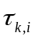 is the delay for the ith path of the kth user , and n(t) is AWGN. Compute the decision variable for user 0 at path 0 for the jth symbol and assume 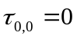.
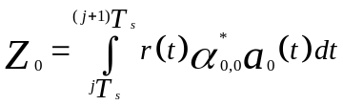
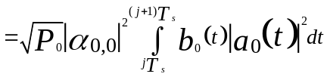
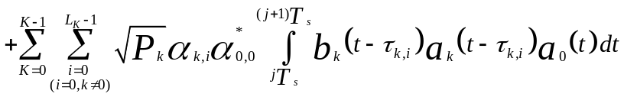

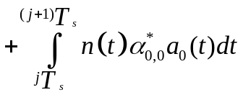 (4.27)

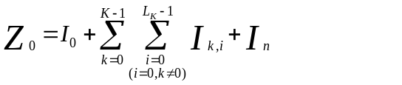
(4.28)
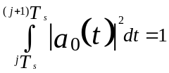
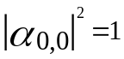Here assume and . The desired signal
component:
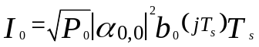

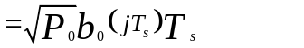 (4.29)

The component of the multiple access interference (MAI):
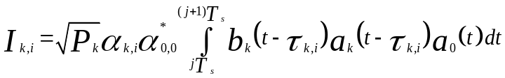
(4.30)

The component of AWGN:
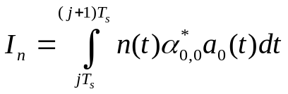
(4.31)

In (4.28), the components of MAI and AWGN are assumed to be zero-mean random variables with Gaussian distribution . Therefore the decision variable in (4.28) may be expressed as

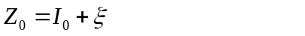 (4.32)

where is a random variable representing both MAI and AWGN.

The probability density function of
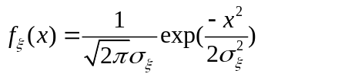 (4.33)

where 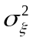 is the variance of the random variable .

The decision variable determines what information bits were originally sent out. For example, in a BPSK modulation, if 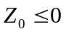 the original information bit is determined as –1; if 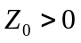 the original information bit is determined as +1. With (4.32), in determining the value of the received bit, the probability of error is equal to the probability that 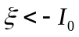 when 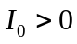 and 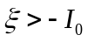 when 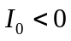. The bit error probability is (symmetry of pdf)
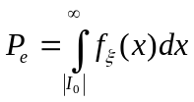 (4.34) Then
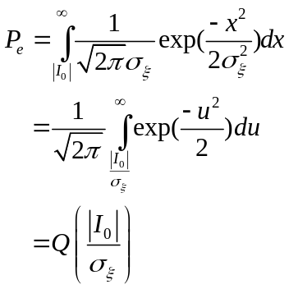 (4.35)
(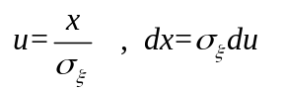)

The signal-to-noise ratio is

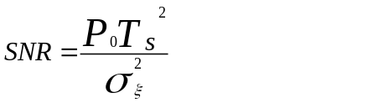 (4.36)

According to (4.29), the desired signal power is 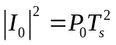 assuming 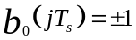. The bit error probability is

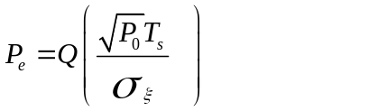 (4.37)

It is desirable to achieve a low bit error rate (BER) which requires low MAI, i.e., small value of 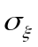.
If every user transmits the same level of signal power, the received powers from users closer to the base station will be higher than that of the users farther away from the base station. Further more, a user close to the base station may contribute too much MAI to make a high BER. This prevents other user signals from being received successfully. This is known as near-far effect. To reduce the near-far effect, the technique of power control is employed in CDMA wireless systems. With power control, the signal power transmitted by a mobile user is automatically adjusted and only the minimum power needed to achieve the acceptable signal quality is transmitted.

4. 9 Power Control
Power control forces all users to transmit the minimum amount of power needed to achieve acceptable signal quantity at the base station. Power control reduces the powers transmitted by mobile users close to the base station, and increases the powers of users farther away from the base station.

4. 9. 1 Signal-to-Interference Ratio (SIR)

      - Uplink

For the mth user at the kth base station, its SIR at the uplink receiver input is

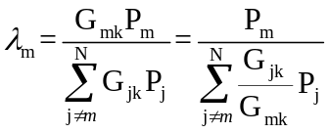 (4.38)

where 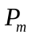 is the transmit power of the mth user, 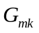 is the path gain between the mth user (may include the user from another cell) and the kth base station, N is the total number of mobile users.

4.9.1.2 Downlink

In a CDMA wireless communication system, downlink multi-user signals are usually synchronized, therefore, there is no MAI between any two users in the same cell. In this case, only the user signals from different cells are considered as interference. For mth user of kth base station, the SIR at the input of the downlink receiver is

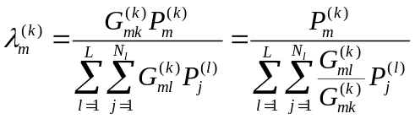 (4.39)

where 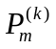 is the transmitted signal power by kth base station (BS) to mth user in kth base station, 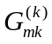 is the gain of the path between kth BS and mth user of kth BS, 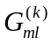 is the gain of the path between mth user of the kth BS and the lth BS, L is the number of BS in consideration (the base stations different from the kth one), and 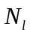 is the number of users of the lth BS.

4. 9. 2 Uplink and Downlink Power Control

4.9.2.1 Uplink Power control

The uplink power control is to minimize the transmit power of each mobile users in the cell, and overcome the “near-far problem”. It can also extend the battery lift of a handset.

4.9.2.2 Downlink Power Control

When a mobile user is located at the edge of a cell, the SIR of the receiver is greatly
reduced since signals transmitted by other base stations in neighboring cells may cause serious interference. This is so called “edge problem”. The downlink power control overcomes the “edge problem” and minimizes the BS transmit power while it achieves an acceptable signal quality for every mobile receiver in the cell at downlink.

4. 9. 3 Types of Power Control

4.9.3.1 Open-Loop Power Control

Signal
BS
power amp.

Wireless channel
MS
Signal power
measurement

Uplink open-loop
power control
Signal
Data
processing
MS
power amp.

Fig. 4.9

The open-loop power control can be expressed as

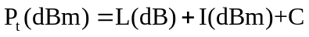 (4.40)

Pt is the mobile transmit power in dBm( 10log₁₀ 1(mw)=0(dBm)), L(dB) is the path loss measured by the mobile unit , C is a constant, and I(dBm) is the interference power. Usually a mobile unit expects a received signal power level. By making comparison between this power level and the actually received power, the path loss can be estimated.
In a real FDD CDMA wireless system, the carrier frequency difference between downlink and uplink is greater than 45 MHz which exceeds the coherent bandwidth. Therefore the path loss of fading channel estimated for downlink may not be good for uplink. Then open-loop control can only provide a rough power adjustment.

4.9.3.2 Closed-Loop Power Control

The closed-loop power control provides a more accurate power adjustment so that the system can track the fast fading channel. The closed-loop power control can be expressed as
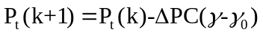 (4.41)

where Pt(k) is the transmit power at the kth iteration, 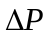 is the step size, C is a constant, is the measured signal-to-noise ration (SNR), and 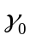 is the threshold value for SNR.

Fig 4.10 shows an uplink closed-loop power control scheme for WCDMA systems.

Uplink signal
MS
Transmitter
BS receiver

Measure SIRi

Outer-loop
Change transmit power
Comparison
SIRo

Determine TPC

MS
receiver

Downlink signal
BS transmitter
(Including TPC)

Fig 4.10

In every 0.625ms, a TPC (Transmit Power Control) is generated and it is sent to the mobile unit. When SIRi<SIR0, TPC=1, mobile unit increases its transmit power by 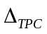(dB); when SIRi>SIR0, TPC=0, mobile unit decreases its transmit power by (dB). Here SIR0 is determined by outer loop frame error rate (FER).

Fig 4.11 shows a downlink closed-loop power control scheme for WCDM system.

Downlink signal
MS
receiver
BS transmitter

Measure SIRi

Outer-loop
Change transmit power
Comparison
SIRo

Determine TPC

BS
receiver

Uplink signal
MS transmitter
(Including TPC)

Fig 4.11
In every 0.625ms, a TPC is generated by mobile and it is sent to the BS receiver. When SIRi<SIR0, TPC=1, BS increases its transmit power by (dB); when SIRi>SIR0, TPC=0, BS decreases its transmit power by (dB).

4. 10 Multiuser Detection
Multiuser detection intends to suppress the multiple access interference (MAI) in uplink and achieve an improved SIR.
4. 10. 1 Multiuser Adaptive MMSE Detector

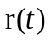

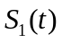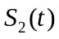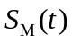
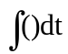

Ck,1 Ck,2 Ck,M
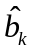
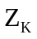 Output
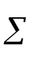
Adaptive weight update
Training sequence

_

＋

Fig 4.12
Here M is the number of users, 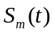 is the spreading sequence for the mth user, 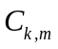 is the mth weight of the kth user, 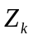 is the decision variable for the kth user, and is the symbol estimate for the kth user. The main drawbacks: (1) needs to know other user’s spreading sequence, (2) requires a training sequence.

4. 10. 2 Successive Interference Cancellation (SIC) Detector

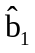
Matched
Filter
Decision
r(t)

Regeneration

T

+ 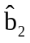
Matched
Filter
Decision

T
Regeneration

Fig. 4.13

- The detector makes a list for the users arrived according to their signal powers. The one with the highest power is listed first and the one with the lowest power is listed last.
- It detects only one user at each time. The strongest one goes first.
- After the first detection it regenerates the signal using the result. Then subtract the regenerated signal from the input signal.
- Continue above regeneration-subtraction process as shown in Fig 4.13.
- The performance of SIC detector largely depends on the accuracy of channel estimates as well as the user signal power distribution. If user signal powers deviate largely, it would give a significant performance improvement.
- SIC detector has a long processing delay time, in particular when there are a large number of users. The processing delay can make the application of SIC detector impractical.

4. 10. 3 Parallel Interference Cancellation (PIC) Detector

v
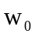

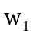
User 0
Matched
Filter

+
Delay
- - 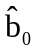
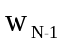
User 1
Matched
Filter
Regenerate
User 1
Q1

User k-1
Matched
Filter
Regenerate
User k-1
Qk-1

Weight update

Fig. 4.14
PIC can be combined with SIC as follows

T
r(t)

+
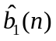 _ 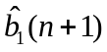

Multi-user signal gene-
ration

Detection
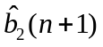
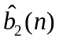

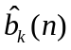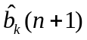

Fig 4.15

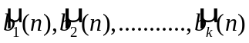 are results from SIC detector.

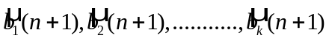are the bit decision after parallel interference cancellation.

At each summer, the regenerated signals of other users are subtracted from the input signal and the resulting signal is sent for detection. For example, when the user #1 signal (corresponding to 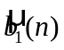) is to be detected, the regenerated signals from 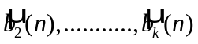 are subtracted from the input signal and then it is sent to the detection stage which gives an output 

