5. 7 RAK Receiver

From sampling theorem, a band-limited signal 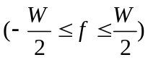 can be represented as
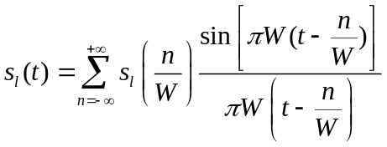 (5.113)

(reconstruction formula) where W is the bandwidth of the signal.

Its Fourier transform is

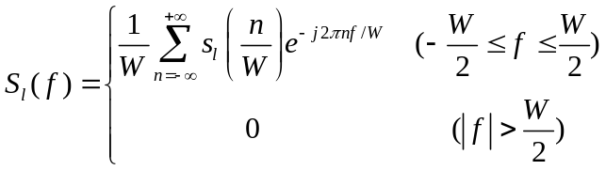 (5.114)

(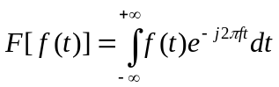, sampling at 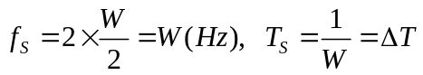)

The noiseless received signal from a frequency selective channel is

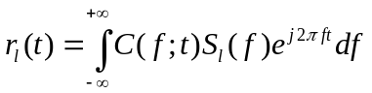 (5.115)
where 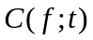 is the time variant Fourier transform representation of the channel, then

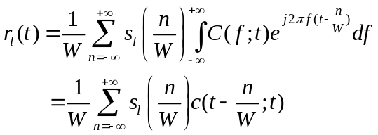 (5.116)

where 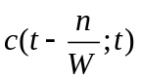 is the time variant channel impulse response. It is observed that (5.116)
has a convolution sum. Hence it can be expressed in an alternative form.

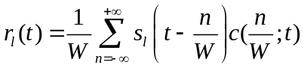. (5117)

It is convenient to define a set of time variant channel coefficients as

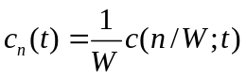 (5.118)

Then Eq (5.117) can be written as
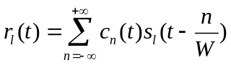 (5.119)
which is the noiseless received signal with a tapped delay line channel model to represent a time variant frequency selective channel. Here the tap spacing is 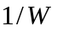 and the tap weight is 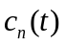.
Assume the multipath delay spread is Tm. For practical purpose, this channel model can be truncated at
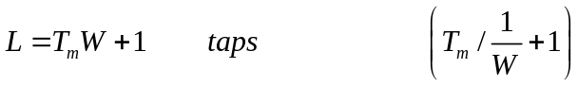.

Then the noiseless received signal can be written as

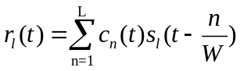.

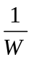
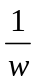
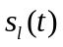
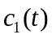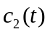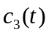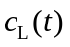
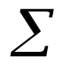

Additive
Noise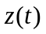

Suppose there are two antipodal signals transmitted through a frequency selective channel, the signal at the receiver input is
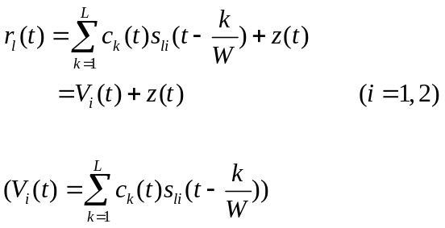 (5.120)

where z(t) is a complex-valued zero-mean AWGN. The decision variable can be expressed as

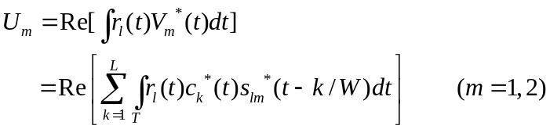. (5.121)

The RAKE receiver

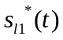

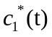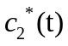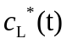

U1=Re()
Summer and integrator
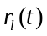

U2=Re()
Summer and integrator

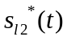

Fig. 5.6

For a slow fading channel. The channel coefficients can be treated as constants in certain time duration, then
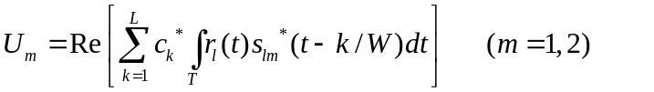 (5.122)

Suppose the transmitted signal is 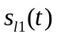, then the received signal is

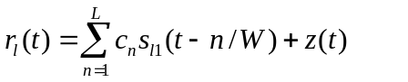 (5.123)

Combining Eqs (5.122) and (5.123), we obtain

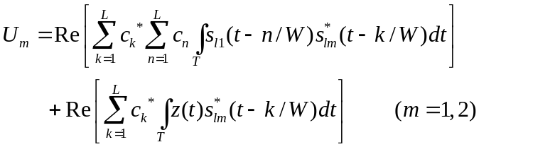 (5.124)

If two antipodal signals and 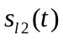 are generated from PN sequences, we can have following property,

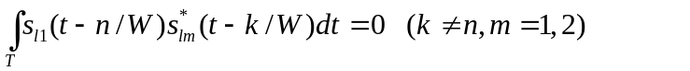 (5.125)

Then Eq (5.124) simplifies to

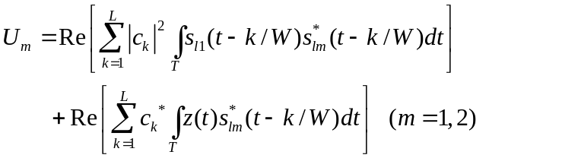 (5.126)

Assume following property is held true

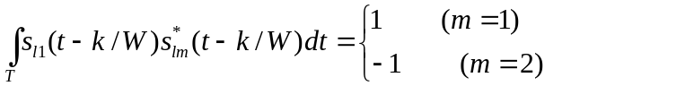 (5.127)

Then Eq.(5.83-5.126) becomes
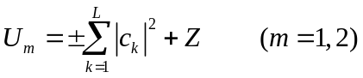 (5.128)
where
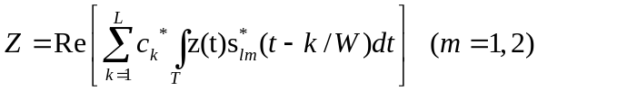 (5.129)

RAKE receiver can also be implemented in an alternative form.

Received
signal

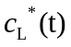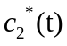

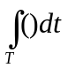

sample to decision
circuit

In a RAKE receiver, the coherent combining is implemented to increase the signal-to- interference-plus-noise ratio (SINR)

Q Q C

A B
C A

I I
B

6. Smart Antennas Technology
6.1 Array Pattern
Recall from form Chapter 2 that an array response vector is written as

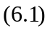

A steering vector is the complex conjugate of an array response vector, i.e.

An array pattern is defined as

An array pattern is the away response to a unit input signal over a range of directions of arrival (DOA).

Gain (dB)

(deg.)

Fig 6.1

6. 2 Adaptive Beamforming

6. 2. 1 Minimum Variance Beamforming

With adaptive beamforming, array response levels vary according to the nature of incident

signals.

Interference
Desired signal

Interference

Fig. 6.2

Suppose there is an antenna array with M elements. The array input vector whose elements are samples of the array input signals at different elements is written as

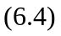

where s_{m}(n) is the input signal sample on the mth array element at the time index n. The array output is
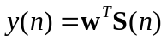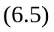
where is the array beamformer weight vector,

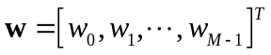. 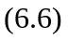

The average array beamformer output power is

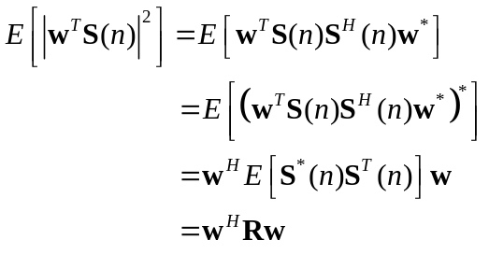 (6.7)
where
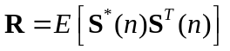. (6.8)

The problem of the adaptive beamforming can be formulated as (minimum variance

beamforming)

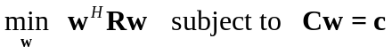 (6.9)

which suppress all output signals except the one in the desired direction specified by the constraint row vector C.

To solve the optimization problem in (6.9), we form the lagnagian (real) as

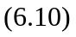

where λ is a Kx1 vector with K constraints assumed. Compute 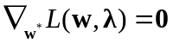 and obtain
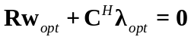. (6.11)

Note: 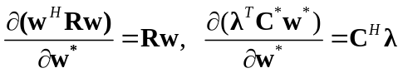

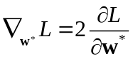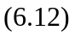

Then, we have

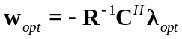. (6.13)

According to the constraint, we have

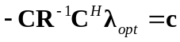. 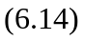

Then
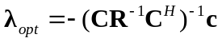. 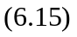

Form (6.13), (6.15), the optimal weight vector is computed as

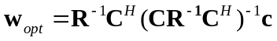. 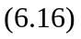

When there is only one desired signal directional, C is a 1xM row vector and c is a 1x1 scalar, for convenience we set c=1. Then the solution becomes
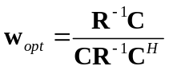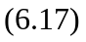
where 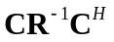 is a 1x1 real number.

6. 2. 2 Frost Beamformer

Computing a matrix and its inverse to obtain the beamforming weight vector is computationally intense and it is an undesirable operation in reality. Frost beamformer gives a solution that does not require such computation. The weight vector is iteratively updated through a simple recursive algorithm as

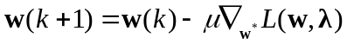 (6.18)

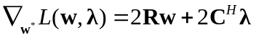. (6.19)

Then
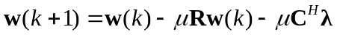. (6.20)

Impose the constraint condition
. (6.21)

Then solve for λ
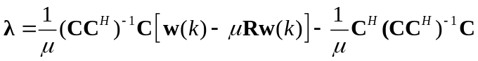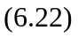
From (6.20) and (6.22),

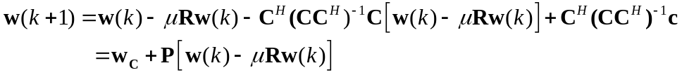(6.23)

where
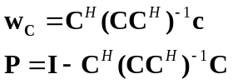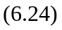

To simplify the computation for correlation matrix R, use an instant sample for approximation, i.e.

Then, we have
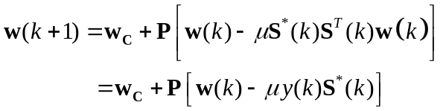 (6.26)

where y (k) is the output of the beamformer

(6.26) is called Frost beamforming.

6. 2. 3 Generalized Sidelobe Canceller (GSC)

GSC is a type of adaptive beamformer, its structure is shown as following.

Input + Z
Non-Adaptive
Wc
_

B
Blocking Matrix
Adaptive
Wa

Fig 6.3

- The non-adaptive weight vector allows the signal of the desired direction to pass.
- The blocking matrix B prevents the signal of the desired direction from going through.
- The adaptive weight vector combines signals from other directions in an attempt to cancel them. The weight vector is optimized in favor of a minimum output power.

A GSC system is shown as

+ Output
Wa(0)
Wc(0)
Wc(1)
B
Input
-

Wc(M-1)
Algorithm
Wa(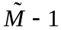)
Fig. 6.4

The mathematical formwork for the GSC relies on unconstrained optimization. The problem is stated as
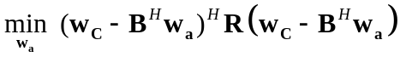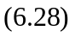

where 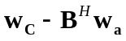 can be interpreted as the overall weight vector w. The block matrix B prevents the signal of the desired direction from going through and its rows are orthogonal to the weight vector 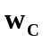. To find the adaptive weight vector in this problem, we demand that
this beamformer has the same solution as that of the previous one from the minimum variance beamformer. Then we have

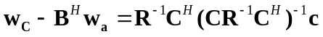. 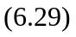

Multiply by BR
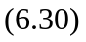

For a M element antenna array, the size of the matrix B is (M-1) xM. Since all the rows of B are orthogonal to where
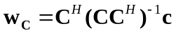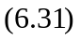

we have 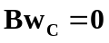, then

Therefore, we obtain the solution

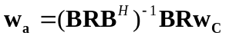. 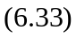

By merging the ideas in the generalized sidelobe canceller and the LMS algorithm, dynamic adaptive algorithm can be derived

Wc(0)

Zc(k) Z(k)
y(k)
Wc(1)
Za(k)

Wc(M-1)

B
Wa,o(k)

Wa,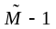(k)

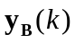

LMS

Fig 6.5

y(k) is the input signal vector

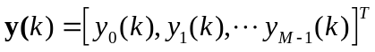 (6.34)

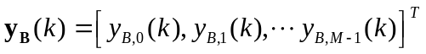
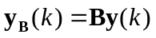 (6.35)
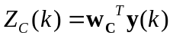 (6.36)
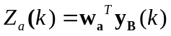 (6.37)
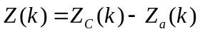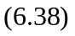

The next weight vector is updated as

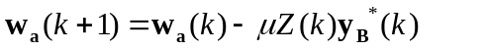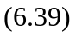

In all above adaptive beamformers, the direction of arrival (DOA) is a necessary condition which may not be easily available in some applications.

The MMSE (Minimum Mean squares Error) beamformer obviates this need and it only requires a training signal or reference sequence in the received signals.

6. 2. 4 MMSE Beamformer

The received signal is expressed as

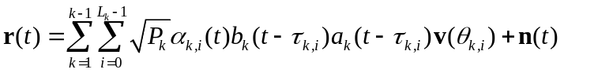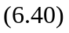
where 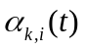 is the complex channel gain for the ith path of the kth user, 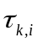 is the delay time, 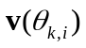 is the array response vector, b_{k}(t) is the transmitted data, 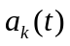 is the spreading sequence, and n(t) is the noise vector.

The optimization criterion for a MMSE beamformer is to minimize the difference between the array output and a reference signal, i.e.

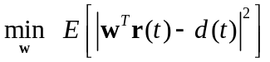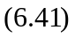

Expand (6.41)

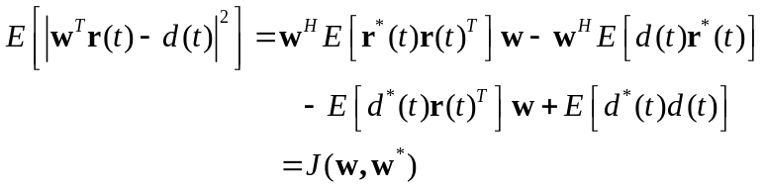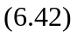

Computer the gradient vector and set it to zero

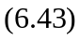

The optimal solution is

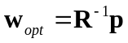 (6.44)

where
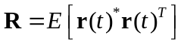 (6.45)
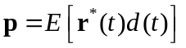. (6.46)

Rather than soloing (6.44) directly, the LMS algorithm can greatly reduce the computational complexity.

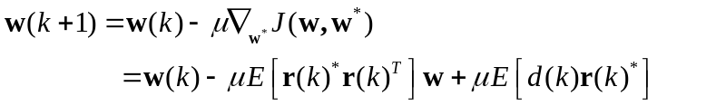(6.47)

Remove expectation operation

(6.48)
where 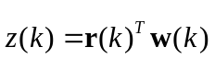 is the beam former output .

Input

Output
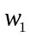

Generate
Error
Signal

d(k)
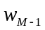

Adaptive
Algorithm

Fig 6.6

Adaptive beampatterns resulted from a MMSE beamforming algorithm for different environments are shown in following figures.

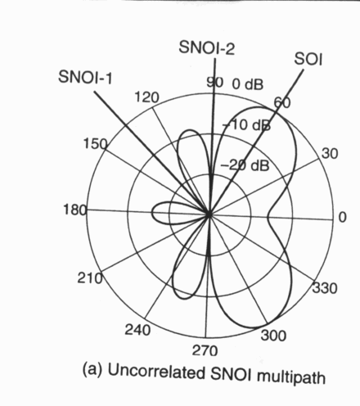
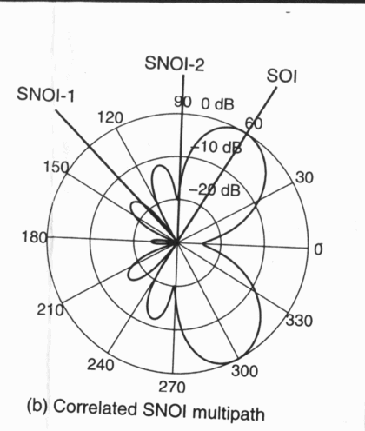

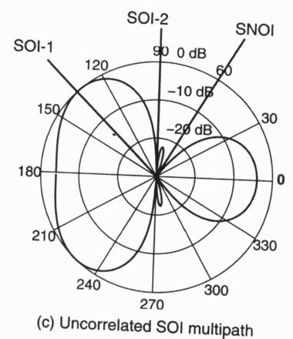

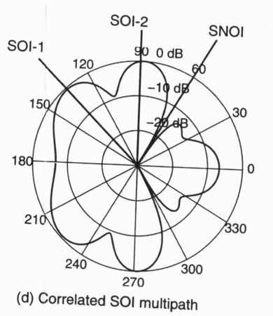

Fig. 6.7

