6. 3 Direction of Arrival (DOA) Estimation

6.3.1 Minimum Variance Method

The problem formulation

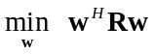 subject to Cw=1.
From previous analysis, we have the optimal weight vector as

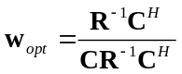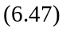

The average beamformer output power is

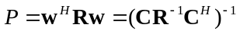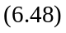

Replace C with the array response vector

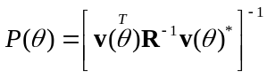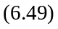
As θ changes over a range of DOAs, a peak response of the spatial power spectrum 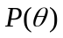 indicates the DOA of an incident signal. Is also called steered response.

6. 3. 2 The Conventional Method

Consider a steered response defined as
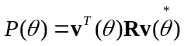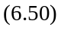

which is beamformer output power with steering vector as its weight vector. The maximum response corresponds to the DOA of the incident signal.

Power (dB)

Conventional

Minimum variance

6. 3. 3 Multiple Signal Classification (MUSIC) Algorithm

This algorithm provides a high-resolution technique for DOA estimation. Suppose there are D signals incident on an array. The received signals are expressed as

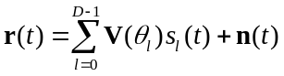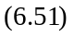

Write (6.51) in a matrix form

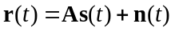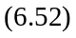

where

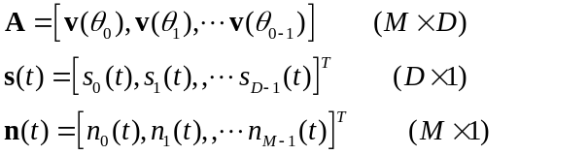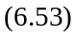

The input correlation matrix is

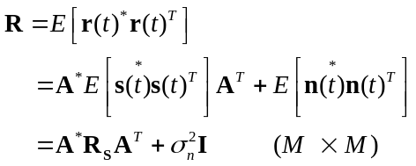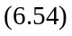
where 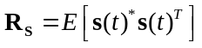 (DxD) is the correlation matrix for incident signals and 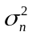 is the noise power. Performing eigen decomposition, we have

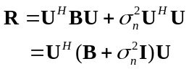 (6.55)
where U is the matrix with its columns being the eigen vectors of the matrix 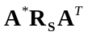 and B is a diagonal matrix whose diagonal elements are eigen values of . Note that from the basic property of the eigen decomposition, 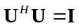. The ith eigen value of the matrix R is

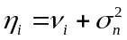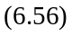
where is the ith eigen value of the matrix . Assume that these D signals are uncorrelated. Then the M×M matrix has a rank D (D<M) which implies that M-D eigen values of the matrix R are equal to , i.e.,

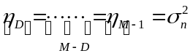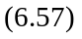
where the eigen values are assumed to be in a descending order. We can first determine the number of the smallest of eigen values of the correlation matrix R, say K, and then obtain the estimated number of incident signals by
These K smallest eigen values should be approximately equal to each other and approach to .
Let 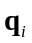 denote the ith eigenvector of the correlation matrix R corresponding to the eigen value 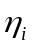, then following relationship holds
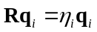 (6.59)
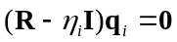 (6.60)

For eigenvectors corresponding to the K (K=M-D) smallest eigen values (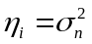), we have

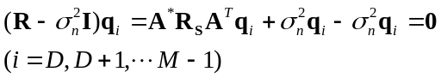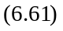

which gives
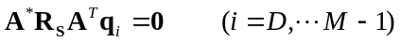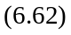

Then we have
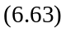

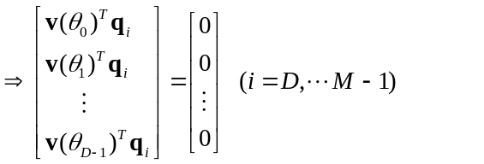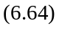

which indicates that the eigenvectors associated with the K smallest eigen values are orthogonal to the D vectors in the matrix A, i.e.

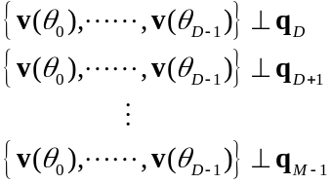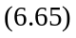
or
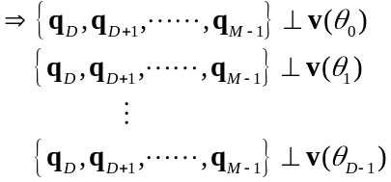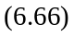

Form a matrix V_{N} as
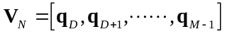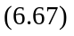
which is a matrix for noise subspace since these eigenvectors (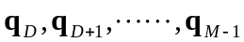) correspond to K smallest eigen values equal to . We have
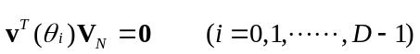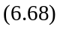

Then we obtain the MUSIC spatial spectrum as

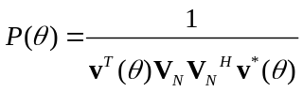
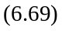
The result 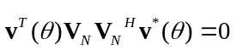 occurs when DOA corresponds to a 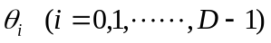. Then a peak response appears when is equal to the DOA of an incident signal. Thus, the DOA can be estimated by locating the peaks in MUSIC spectrum. MUSIC algorithm generates very sharp peaks in its spatial spectrum and gives a high resolution in DOA estimation.
The performance comparison is shown in following figure.

MUSIC

Minimum variance

-90 0 +90 (deg.)

7． Space-Time Diversity

7. 1 One Transmitter and Two Receivers

Space-time Diversity is a very effective technique that exploits the principle of providing the receiver with multiple faded replicas of the same information-bearing signal from uncorrelated space-time channels. The fig. 7.1 shows a system of one transmitter and two receivers for maximum ratio receiver combining (MRRC).

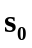
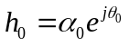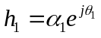

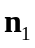
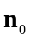

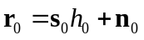
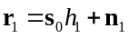

Channel
Estimator
Channel
Estimator

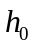 * 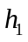*
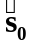
Maximum likelihood
detector

Output

Fig. 7.1

The channel between the transmit antenna and receiver antenna 0 is denoted by

and the channel between the transmit antenna and the receive antenna 1 is denoted by

The received signal is
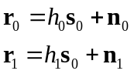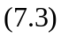
where 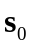, , and 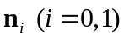 are vectors for transmitted signal, received signal, and AWGN noise.

The receiver needs to decide which symbol was sent out by transmitter. The maximum likelihood decision rule at the receiver is to select a symbol that has a minimum distance, i.e.

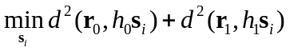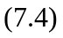
where
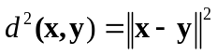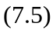

OR equivalently

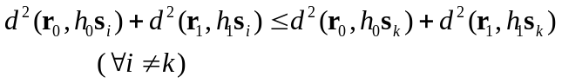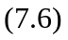

The combining scheme for the receiver to generate an output is

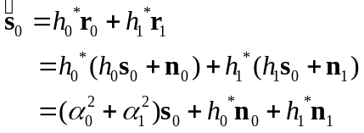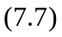

Since the channel estimates are usually available, we can test each data symbol as

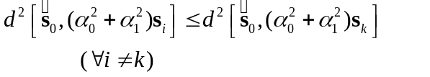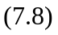
i.e., choose such that its corresponding distance square is the smallest among all possible ones.

From (7.8)

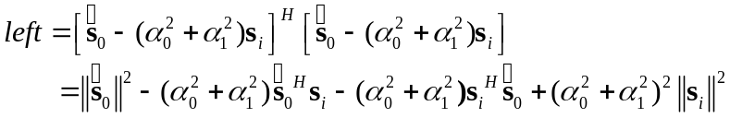

Since each symbol has an equal power, i.e. 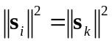, we have

. Then (7.8) can be expressed as

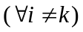

or

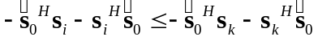 .

Adding 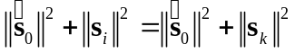 on both sides leads to

(7.9)

which is equivalent to

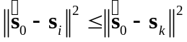
or
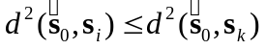 . 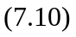

Therefore, the symbol decision from (7.8) is equivalent to that of (7.10).

7. 2 Two Transmitters and One Receiver
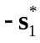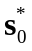

Tx ant .0 Tx ant. 1
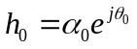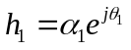

Rx ant.
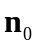
interference & noise
Channel
Estimator
Combiner
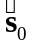
Maximum likelihood detector

Output
Fig. 7.2
Transmission scheme (Table I)

 | ant.0 | ant.1
t
t+T

Table I: the transmission sequence

Consider a slow fading wireless channel

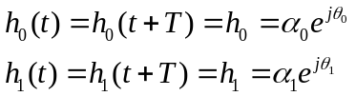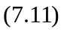

where T is the symbol duration. The received signal can be expressed as

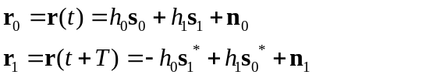 (7.12)

where 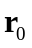 and are the received signals at the time t and t+T. The combined signals after r₀ and r₁ received are:
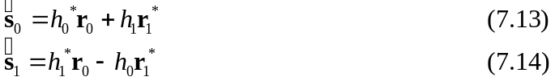

Here is an estimate of the transmitted symbol and is an estimate of the transmitted symbol . Furthermore it can be shown from (7.12), (7.13), and (7.14) that
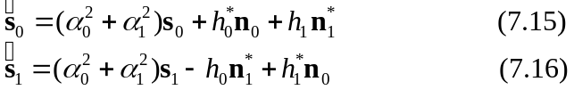

These combined signals are sent to the maximum likelihood detector. The symbol decision is made based on following result.

1. To detect the symbol , apply
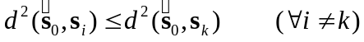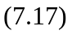
(find the minimum distance)

2. To detect the symbol , apply
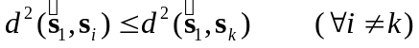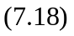

7. 3 Two Transmitters and Two Receivers

-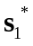 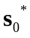
Tx ant 0 Tx ant 1

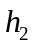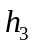

Rx ant 0 Rx ant 1
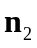

interference & noise interference & noise
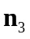

h0 h2
Channel
Estimator
Combiner
Channel
Estimator

h1 h3
h0 h1 h2 h3
Maximum likelihood detector

Output

Fig. 7.3

 | Rx ant. 0 | Rx ant. 1
Tx ant. 0 | h₀ | h₂
Tx ant. 1 | h₁ | h₃

Table Ⅱ: the definition of channels between the transmit and receive antennas.

 | Rx ant. 0 | Rx ant. 1
t | r₀ | r₂
t+T | r₁ | r₃

Table Ⅲ: the notation for the received signals at the two receive antennas

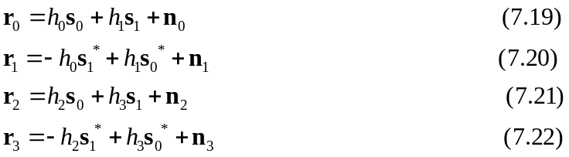

The combiner gives two outputs that are sent to the maximum likelihood detector, i.e.

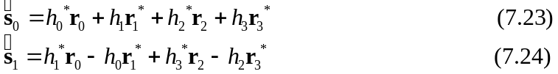

Substituting appropriate equations, we obtain

The maximum likelihood detection is achieved by performing following procedure

Space-time diversity can be obtained by transmitting data symbols at different time and different locations. Both transmitter and receiver can employ multiple antennas to increase the order of diversity and achieve the improved performance.

References

1. J. C. Liberti, Jr. and T. S. Rappaport, Smart Antennas For Wireless Communications: IS-95 and Third Generation CDMA Applications, Prentice Hall PTR Upper saddle River, NJ07458, 1999.
2. G. L. Stuber, Principles of Mobile Communication, 2nd Edition, Kluwer Academic Publishers, 2001.
3. John G. Proakis, Digital Communications, 4th Edition, McGraw-Hill, NY10020, 2001.
4. D. H. Johnson and D.E. Dudgeon, Array Signal Processing: Concepts and Techniques, PTR Prentice Hall, Englewood cliffs, NJ07632, 1993.
5. Simon Haykin, Communication systems, 3 rd Edition, John Wiley&Sons, Inc, 1994.
6. T. S. Rappaport, Wireless Communications Principles and Practice, Prentice Hall, Inc., 1996.
7．吴文陵. 移动通信中的关键技术. 北京: 北京邮电大学出版社, 2000.
8．邱玲，朱近康，孙葆根，张磊. 第三代移动通信技术. 北京: 人民邮电出版社, 2001.
9. S. M. Alamouti, “A simple transmit diversity technique for wireless communications,” IEEE J. Selec. Areas Comm., Vol. 16, pp. 1451-1458, Oct. 1998.

