South China University of Technology
《Principles of Compiler》Experiment Report
Experiment Title： Lexical Analysis
Name： 王育之 Student ID： 202030170238
Class： 20计联 Group：
Collaborator： 宋大可（202030040111）
Teacher： 董敏
Description
【Objective and Requirement】
Objective：
Use flex and python to implement lexical analysis by programs designed by ourselves. Describe the two implementation processes, give a comparative analysis, give a regular expression or regular grammar description, draw FA, describe the data structure used, such as how the symbol table is designed, and give the experimental results.
Requirement：
a) After starting the program, first output the author's name, class and student number (available in Chinese, English or Pinyin);
b) Request to input the name of the test program, and automatically start lexical analysis and output the results after entering the program name;
c) The output result is a binary sequence of words;
d) It is required to find the following lexical errors and point out the nature and location of the errors: for example:
Illegal character, that is, it is not a symbol of the sysy language character set;
Illegal numbers; Illegal identifier, etc
The comment part is missing the delimiter * / (the comment requires that the left and right sides be defined by / * and * / respectively, and cannot cross lines).
【Environment】
OS:Windows 10,
Software:pycharm,flex
Content and Procedure
The word encoding and definition:

word | code | word | code
const | 1 | > | 19
int | 2 | <= | 20
float | 3 | >= | 21
void | 4 | ! | 22
if | 5 | && | 23
else | 6 | || | 24
while | 7 | = | 25
break | 8 | { | 26
continue | 9 | } | 27
return | 10 | [ | 28
+ | 11 | ] | 29
- | 12 | ( | 30
* | 13 | ) | 31
/ | 14 | , | 32
% | 15 | ; | 33
== | 16 | literal | 34
!= | 17 | identifier | 35
< | 18
The definition of each words:

identifier → identifier-nondigit | identifier identifier-nondigit | identifier digit
identifier-nondigit →a|b|c|...z|A|B|C...Z|_
identifier digit→0|1|2|....9

literal→int|float

int→decimal-const | octal-const
| hexadecimal-const

decimal-const → nonzero-digit | decimal-const digit

octal-const → 0 | octal-const octal-digit
hexadecimal-const→ hexadecimal-prefix hexadecimal-digit
| hexadecimal-const hexadecimal-digit

hexadecimal-prefix → 0x | 0X
nonzero-digit →1|2|3....9
octal-digit→0|1|2......7
hexadecimal-digit→0|1|2......9|a|A|b|B|......f|F
digit→0|1|2....9

keyword=”const”|”int”|”float”|”void”|”if”|”else”|”while”|”break”|”continue”|”return”
operation='+' | '-' | '*' | '/' | '%' |"==" |"!=" |'<' | '>' | '<='| '>=' | '!' | '&&' | '||' | '='
delimiter='{' | '}' | '[' | ']' |'(' | ')' | ',' | ';'

Here we just take identifier as an example to draw its DFA:
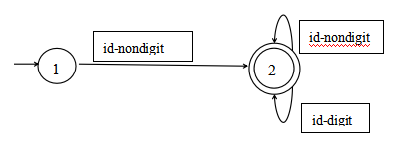
Similarly we draw other words’ DFA.

The procedure of the python program:
1.Lists setting and classification:we set these lists: keyword_list, operation_list, delimiter_list, to store the element and signal_list to store “ ”and “\n”, and comment_list to store “//”,”/*”, ”*/”

2.Comment checking and deletion, word division.We read the source code as text and delete the comment.Meanwhile we check if the signal of comment is correct. Then we try to divide the words. Initially we set a list to store the word and a variable”new_word” to store the current word.
If we read the word in signal_list, we skip it, move “new_word” into the list and initialize the new_word to blank.
If we read the operation with length 2, we move the “new_word”into the list, and initialize it. Also move the recognized operation into the list.
If we read the operation or delimiter with length 1, we also do it the same as 4.
Else if we read char or number, we add it to the “new_word”and than read the next char.

- Tuple generating.We write several functions to decide their type: keyword, operation, delimiter, identifier and literal. Then transfer each word into a 2-tuple according to the code table.

Here’s some main functions and codes:
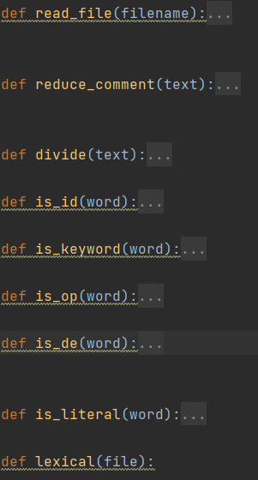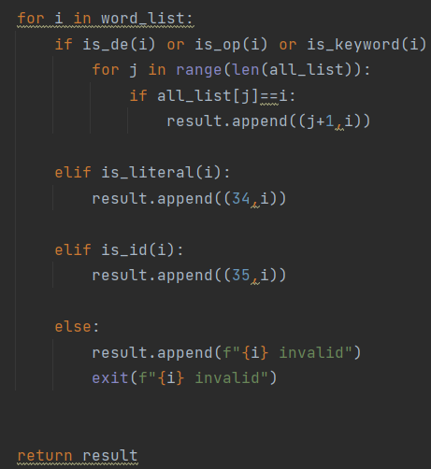

The result of one example:
Here’s the input
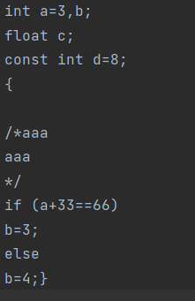
Here’s the output
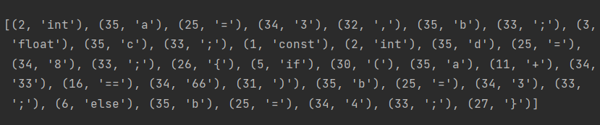
The realization of Flex:
Firstly, generates a C source file as output. By default, the text library defines a routine yylex (). You can compile this file and link it to the flex runtime library to generate an executable. When you run the executable, it parses its input for the occurrence of regular expressions. Whenever it finds one, it executes the corresponding C code.
The differences is that the pattern is usually a regular expression, or can be replaced by the pattern name defined in the defined part; The behavior is generally c code and can be empty.
Begin, the initial state of flex is initial, begin (start STAT) means to enter a new state After entering this state, only the rules with the corresponding state defined can be matched. For example, after calling begin (XC) above, that is, after matching xcstart, it enters the XC state, so only <xc>{xcstart} {...} The agent with <xc> at the beginning will be matched. Any other rules will not be matched.
The return values of yylval and yylex (called in the bison yyparse function) can be understood to be divided into two parts. One is the return value in the rule, which is the returned token, and the other is the one-to-one corresponding yylval. The type of yylval is yystype, which can be redefined according to user needs
It is generally defined as a union type, and the token is bound to a variable in the Union in bison. Then in scan L directly set the corresponding value to yylval-> (member variable of Union). You can get the token and its corresponding value in yyparse.
Yytext, which is a character array containing matching strings.
Yylloc, which is the location information, that is, the location of the matching token in the entire input stream. This value is fed back to yyparse
Yyalloc is malloc by default. It is masked by%opiton noyylloc, and its own version is defined as palloc.
Yyrealloc, the default realloc, is masked by%option noyyrealloc, and has its own version of realloc defined.
Yyfree, which is free by default, is masked by%option noyyfree and defines its own version of pfree.
YYleng is the length of the string corresponding to the matching token.

Last about the result presentation:
The source code：
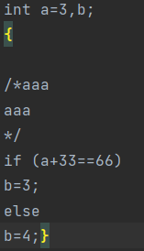
The output:
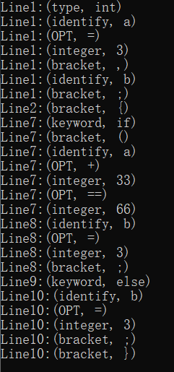

Conclusion
The comparison of the 2 methods:
We find that the flex method can show the position(line) of the scanned word and the 2-tuple is consists of a alias of itself and its real-name(or value).
But in my program, it is consists of the species code and the real-name(or value).
Besides, the flex program is actually more perfect. It already has the code for scanning. We can just input specific code of the grammar. But in our program, we just input the species code as several list or dict. Then using our own algorithm to do the scanning.
Our reflection:
Through this assignment, I understood my shortcomings and could not easily understand the source program. Although I finally understood the principle through the students' explanation and reference to their code, it was not so clear. In the process of tapping the code, we encountered some problems that could not be solved, but we solved them through Baidu search and reading textbooks. I began to understand the working principle of compilation and the structure of compilation language. I have understood the problems that should be paid attention to in the compilation of the compiler, and have a better understanding of the compilation process of the compiler, which provides me with some essential experience for programming later. we understand that we need to digest textbook knowledge in combination with practice.
Besides, I have learnt how to do scanning by programming, which not only help me understand better to the compiler’s principle but also improve my programming capacities.
Teacher’s Comments and Score
Comment：

Score： Signature：
Date：

