South China University of Technology
《Principles of Compiler》Experiment Report
Experiment Title： SDT
Name： 王育之 Student ID： 202030170238
Class： 20计联 Group：
Collaborator： 宋大可（202030040111）
Teacher： 董敏
Description
【Objective and Requirement】
Objective：
Use automatic tools to complete syntax analysis, semantic analysis and intermediate code generation
Manually implement syntax analysis, semantic analysis, intermediate code generation design grammar, attribute grammar and SDT.
The experiment contents are described and compared in the experiment report.
Requirement：
a) After starting the program, first output the author's name, class and student number (available in Chinese, English or Pinyin).
b) Request to enter the name of the test program, and automatically start compiling after typing the program name.
c) Output the quaternion intermediate code (see template output 3 and 4 for the style).
d) The syntax error of the program can be found and the error information can be output.

【Environment】
Operating System：Windows 10
Software:yacc,pycharm
Content and Procedure
1.Firstly we write the origin grammar into SDT.The tasks are:
- Rewrite the origin grammar into LL(1) grammar, including combining the same left-most items, eliminate left recursion.
- We eliminate some unnecessary expression, such as the expression about arrays and functions.
- Except for the variable and const declaration, the expression should within the block”{}”to replace the “main”function.
The result is:
源程序
Program→CompUnit|Block|CompUnit Program|Block Program
{Program.place=CompUnit.place}
{Program.place=Block.place}
{Program.place=CompUnit Program.place}
{Program.place=Block Program.place}

编译单元
CompUnit → Decl CompUnit’
{CompUnit.place= Decl CompUnit.place}

声明
Decl → ConstDecl | VarDecl
{Decl.place=ConstDecl.place}
{Decl.place=VarDecl.place}

常量声明
ConstDecl → 'const' BType ConstDef { ',' ConstDef } ';'
{ConstDecl.type=BType.type}
{ConstDecl.val=ConstDef.val}

基本类型
BType → 'int' | 'float'
常数定义
ConstDef → Ident '=' ConstInitVal
{ConstDef.type=Ident.type}
{ConstDef.type=ConstInitVal.type}

常量初值
ConstInitVal → ConstExp |
{ConstInitVal.val=ConstExp.val}

变量声明
VarDecl → BType VarDef { ',' VarDef } ';'
{VarDecl.type=Btype.type}
{VarDecl.val=VarDef.val}

变量定义
VarDef → Ident | Ident '=' InitVal
{VarDef.type=Ident.type}
{VarDef.val=InitVal.val}

变量初值
InitVal → Exp
{InitVal.val=Exp.val}

语句块
Block → '{' { BlockItem } '}'
{Block.place=BlockItem.place}

语句块项
BlockItem → Decl | Stmt
{BlockItem.place=Decl.place}
{BlockItem.place=Stmt.place}

语句
Stmt → LVal '=' Exp ';' | [Exp] ';' | Block | 'if' '( Cond ')' Stmt [ 'else' Stmt ]
| 'while' '(' Cond ')' Stmt | 'break' ';' | 'continue' ';' | 'return' [Exp] ';'
{Stmt.val=LVAl.val}
{Stmt.place=Exp.place}
{ Stmt.place :＝newtemp ;
emit (jrop , Cond.place , Stmt1.place , nextstat+3 ) ;
emit ( :＝, 0 ,－,Stmt.place ) ;
emit ( jump ,―,―, nextstat+2 ) ;
emit ( :＝, 1 ,－, Stmt.place ) }

表达式
Exp→AddExp
{Exp.val:=AddExp.val}

条件表达式
Cond → LOrExp
{Cond.place:=LOrExp.place}

左值表达式
LVal → Ident
{LVal.val:=Ident.val}
{LVal.name:=Ident.name}

基本表达式
PrimaryExp → '(' Exp ')' | LVal | Number
{PrimaryExp.val:=Exp.val}
{PrimaryExp.val:= LVal.val}
{PrimaryExp.val:=Number.val}

数值
Number → IntConst
{Number.val:=IntConst.val}
Number →floatConst
{Number.val:=floatConst.val}

一元表达式
UnaryExp → PrimaryExp{
UnaryExp.val :=PrimaryExp.val;}

UnaryExp → UnaryOp UnaryExp1
{if UnaryOp.type==plus UnaryExp.val:=UnaryExp1.val;
Elseif UnaryOp.type==minus UnaryExp.val:=-UnaryExp1.val;
Else UnaryExp.val:=!UnaryExp1.val;
}

单目运算符
UnaryOp → '+' | '−' | '!’
{UnaryOp.type:=plus}
{UnaryOp.type:=minus}
{UnaryOp.type:=not}

乘除模表达式
MulExp → UnaryExp MulExp’
{MulExp.val := UnaryExp.val '*' | '/' | '%'MulExp’.val;
emit('*' | '/' | '%',UnaryExp.place, MulExp’
.place, MulExp .place }

MulExp’ →('*' | '/' | '%') UnaryExp MulExp’1
{MulExp’.val := UnaryExp.val '*' | '/' | '%'MulExp’1.val;
emit('*' | '/' | '%',UnaryExp.place, MulExp’1
.place, MulExp’ .place}

MulExp’→ε

加减表达式
AddExp → MulExp AddExp’
{AddExp.val := MulExp.val +/- AddExp’.val;
emit(+/-,MulExp.place, AddExp’.place, AddExp.place }

AddExp’→ ('+' | '−') MulExp AddExp’1
{AddExp’.val:=MulExp.val +/- AddExp’1.val;
emit(+/-,MulExp’1.place, AddExp’.place, AddExp’.place }

AddExp’→ε

关系表达式
RelExp → AddExp RelExp’
{ RelExp.place :＝newtemp ;
emit (jrop , AddExp.place , RelExp’ .place , nextstat+3 ) ;
emit ( :＝, 0 ,－, RelExp.place ) ;
emit ( jump ,―,―, nextstat+2 ) ;
emit ( :＝, 1 ,－, RelExp.place ) }

RelExp’→ ('<' | '>' | '<=' | '>=') AddExp RelExp’1
{ RelExp’.place :＝newtemp ;
emit (jrop , AddExp.place , RelExp’1.place , nextstat+3 ) ;
emit ( :＝, 0 ,－, RelExp’.place ) ;
emit ( jump ,―,―, nextstat+2 ) ;
emit ( :＝, 1 ,－, RelExp’.place ) }

RelExp’→ε

相等性表达式
EqExp → RelExp EqExp’ { EqExp.place :＝newtemp ;
emit (jrop , RelExp.place ,EqExp’ .place , nextstat+3 ) ;
emit ( :＝, 0 ,－, EqExp.place ) ;
emit ( jump ,―,―, nextstat+2 ) ;
emit ( :＝, 1 ,－, EqExp.place ) }

EqExp’ → '==' RelExp EqExp’1
{ EqExp’.place :＝newtemp ;
emit (“==” , RelExp.place ,EqExp’ 1.place , nextstat+3 ) ;
emit ( :＝, 0 ,－, EqExp’.place ) ;
emit ( jump ,―,―, nextstat+2 ) ;
emit ( :＝, 1 ,－, EqExp’.place ) }

EqExp’ → '!=' RelExp EqExp’1
{ EqExp’.place :＝newtemp ;
emit (“!=” , RelExp.place ,EqExp’ 1.place , nextstat+3 ) ;
emit ( :＝, 0 ,－, EqExp’.place ) ;
emit ( jump ,―,―, nextstat+2 ) ;
emit ( :＝, 1 ,－, EqExp’.place ) }

EqExp’ →ε
逻辑与表达式
LAndExp → EqExp LAndExp’
{LAndExp.place :＝newtemp ;
emit ( and , EqExp.place , LAndExp’.place , LAndExp.place ) }

LAndExp’ → '&&' EqExp LAndExp’1
{LAndExp’.place :＝newtemp ;
emit ( and , EqExp.place , LAndExp’1.place , LAndExp’.place ) }

LAndExp’ →ε

逻辑或表达式
LOrExp → LAndExp LOrExp’
{ LOrExp.place :＝newtemp ; emit ( or , LAndExp.place ,LOrExp’
.place , LOrExp.place ) }

LOrExp’→'||' LAndExp LOrExp’1{ LOrExp’.place :＝newtemp ; emit ( or , LAndExp.place ,LOrExp’1.place , LOrExp’.place ) }

LOrExp’→ε

常量表达式
ConstExp → AddExp {ConstExp.val=AddExp.val}

2.The part about the flex-yacc:

Then about the code:
Code for Flex input:
[a-zA-Z_][a-zA-Z_0-9]* {return ID;}
[0-9]+\.[0-9]+ {return REAL;}
[0-9]+ {return NUM;}
"||" {return OR;}
"&&" {return AND;}
"|" {return &apos;|&apos;;}
"&" {return &apos;&&apos;;}
"<=" {return LE;}
"<" { return &apos;<&apos;;}
">=" {return GE;}
">" {return &apos;>&apos;;}
"!=" {return NE;}
"=" { return &apos;=&apos;;}
"==" {return EQ;}
"\+" {return &apos;+&apos;;}
"\-" {return &apos;-&apos;;}
"\*" {return &apos;*&apos;;}
"\/" {return &apos;/&apos;;}
"(" {return &apos;(&apos;;}
")" {return &apos;)&apos;;}
";" {return &apos;;&apos;;}
"{" {return &apos;{&apos;;}
"}" {return &apos;}&apos;;}
"[" {return &apos;[&apos;; }
"]" {return &apos;]&apos;;}
Test.y:rel : expr &apos;<&apos; expr { printf("rel-->expr<expr\n"); }
| expr LE expr { printf("rel-->expr<=expr\n"); }
| expr GE expr { printf("rel-->expr>=expr\n"); }
| expr &apos;>&apos; expr { printf("rel-->expr>expr\n"); }
| expr { printf("rel-->expr\n"); }
;
expr : expr &apos;+&apos; term { printf("expr-->expr+term\n"); }
| expr &apos;-&apos; term { printf("expr-->expr-term\n"); }
| term { printf("expr-->term\n"); }
;
term : term &apos;*&apos; unary { printf("term-->term*unary\n");
| term &apos;/&apos; unary { printf("term-->term/unary\n"); }
| unary { printf("term-->unary\n"); }
;
unary : &apos;!&apos; unary { printf("unary-->!unary\n"); }
| &apos;-&apos; unary %prec UMINUS{ printf("unary-->-unary\n"); }
| factor { printf("unary-->factor\n"); }
factor : &apos;(&apos; bol &apos;)&apos; { printf("factor-->(bool)\n"); }
| loc { printf("factor-->loc\n");
| NUM { printf("factor-->num\n"); }
| REAL { printf("factor-->real\n"); }
| TRUE { printf("factor-->true\n"); }
| FALSE { printf("factor-->false\n"); }
Code for Flex output:
Test.l:[a-zA-Z_][a-zA-Z_0-9]* {return ID;}
[0-9]+\.[0-9]+ {return REAL;}
[0-9]+ {return NUM;}
"||" {return OR;}
"&&" {return AND;}
"|" {return &apos;|&apos;;}
"&" {return &aps;&&apos;;}
"<=" {return LE;}
"<" { return &apos;<&apos;;}
">=" {return GE;}
">" {return &apos;>&apos;;}
"!=" {return NE;}
"=" { return &apos;=&apos;;}
"==" {return EQ;}
"\+" {return &apos;+&apos;;}
"\-" {return &apos;-&apos;;}
"\*" {return &apos;*&apos;;}
"\/" {return &apos;/&apos;;}
"(" {return &apos;(&apos;;}
")" {return &apos;)&apos;;}
";" {return &apos;;&apos;;}
"{" {return &apos;{&apos;;}
"}" {return &apos;}&apos;;}
"[" {return &apos;[&apos;; }
"]" {return &apos;]&apos;;}
Test.y:rel : expr &apos;<&apos; expr { printf("rel-->expr<expr\n"); }
| expr LE expr { printf("rel-->expr<=expr\n"); }
| expr GE expr { printf("rel-->expr>=expr\n"); }
| expr &apos;>&apos; expr { printf("rel-->expr>expr\n"); }
| expr { printf("rel-->expr\n"); }
;
expr : expr &apos;+&apos; term { printf("expr-->expr+term\n"); }
| expr &apos;-&apos; term { printf("expr-->expr-term\n"); }
| term { printf("expr-->term\n"); }
;
term : term &apos;*&apos; unary { printf("term-->term*unary\n"); }
| term &apos;/&apos; unary { printf("term-->term/unary\n"); }
| unary { printf("term-->unary\n"); }
;
unary : &apos;!&apos; unary { printf("unary-->!unary\n"); }
| &apos;-&apos; unary %prec UMINUS{ printf("unary-->-unary\n"); }
| factor { printf("unary-->factor\n"); }
;
factor : &apos;(&apos; bool &apos;)&apos; { printf("factor-->(bool)\n"); }
| loc { printf("factor-->loc\n"); }
| NUM { printf("factor-->num\n");
| REAL { printf("factor-->real\n"); }
| TRUE { printf("factor-->true\n"); }
| FALSE { printf("factor-->false\n"); }

Code for yacc:
%{
#include <ctype.h>
#include <stdio.h>
int yylex();
int yyerror(char* s);
#define YYDEBUG 1
%}

%union {
int i;
float f;
char* id;
}

%token LT LE GT GE EQ NE WHILE DO PROGRAM BEGIN0 END VAR INTEGER REAL ASSIGNMENT IF THEN ELSE PLUS MINUS TIMES DIVIDE SEMI COLON COMMA DOT LPAREN RPAREN
%token <id> ID
%token <i> INT
%token <f> FLOAT
%%

prog : PROGRAM ID SEMI subprog {printf("语法分析成功！\n");}
;
subprog : varExplain BEGIN0 stateTab END DOT
;
varExplain : VAR varExpTab
;
varExpTab : varTab COLON type SEMI
| varTab COLON type SEMI varExpTab
;
type : INTEGER
| REAL
;
varTab : ID
| ID COMMA varTab
;
stateTab : statement
| statement SEMI stateTab
;
statement : assignState
| condiState
| whileState
| complexState
;
assignState : ID ASSIGNMENT algoriExpe
;
condiState : IF realExpe THEN statement ELSE statement
;
whileState : WHILE realExpe DO statement
;
complexState : BEGIN0 stateTab END
;
algoriExpe : item
| algoriExpe PLUS item
| algoriExpe MINUS item
;
item : factor
| item TIMES factor
| item DIVIDE factor
;
factor : ID
| constNum
| LPAREN algoriExpe RPAREN
;
realExpe : algoriExpe realOp algoriExpe
;
constNum : INT
| FLOAT
;
realOp : LT
| LE
| EQ
| GT
| GE
| NE
;

%%

int main(int argc, char ** argv){
//yydebug = 1;
extern FILE* yyin;
if (argc == 2){
if ((yyin = fopen(argv[1], "r")) == NULL){
printf("Can't open file %s\n", argv[1]);
return 1;
}
}

yyparse();

if(argc == 2){
fclose(yyin);
}

return 0;
}

The test txt is:
A=M;
B=N;
if (A<B)C=N;
else C=M;

The result is:
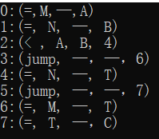

Because the token names are defined in the parser, the lexical analyzer only needs to contain the corresponding header files to use these token names. When writing the parser, it should be noted that the token names of the same token should be consistent with the lexical analyzer, otherwise the lexical analyzer and the parser cannot be linked. Delete the main function and output function in the lexical analyzer, and write the main function to the parser. Because the parser is dominant, it calls the lexical analyzer when necessary.

3.The procedure of the python program:
A.For each production, we set a function to check whether the input tokens satisfy it or not. Then we use LL(1) grammar and recursive descent method to finish the syntax analysis. If the current tokens don’t match any production, the program will display a syntax error.Else it will display the information of analyze successfully.

- We use dictionary container to maintain the symbol table to store all the variable and const’s name and value. Which can find the value of each item and check if the variable or const has declared.

- In each production’s syntax analysis, we do semantic analysis to check if their types are correct and store the value of each production’s items to produce the Quadruples.

D.We mainly classify the quadruple production into these classes: Declaration, while-loop and if-sentence. In declaration, we just emit the (:=,val,_,id) directly and add it into symbol table. In other 2 sentence, we mainly do it on the function of “LOR””LAND”sentence.When it match a sentence firstly generating it. After all the quadruples are generated, we do the chaining and backpatch.

Here’s some example of codes:
The codes about the SDT of “if”sentence:
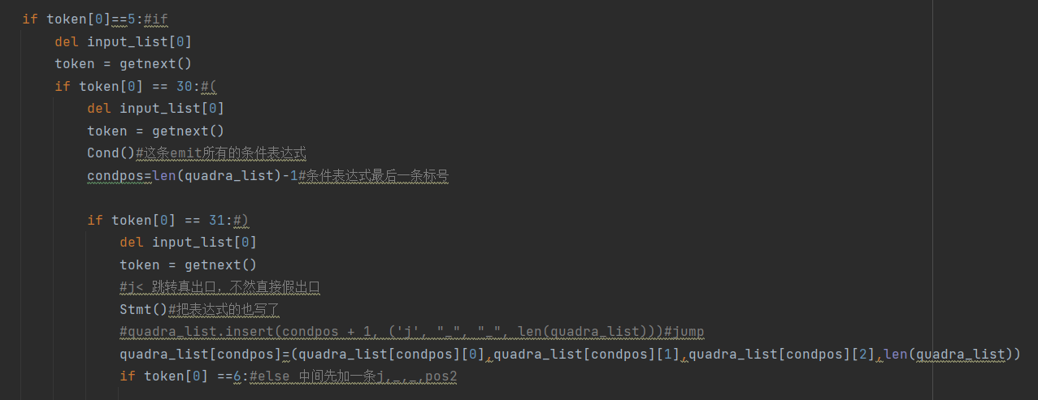
The codes about the quadruple emitting in logic expression:
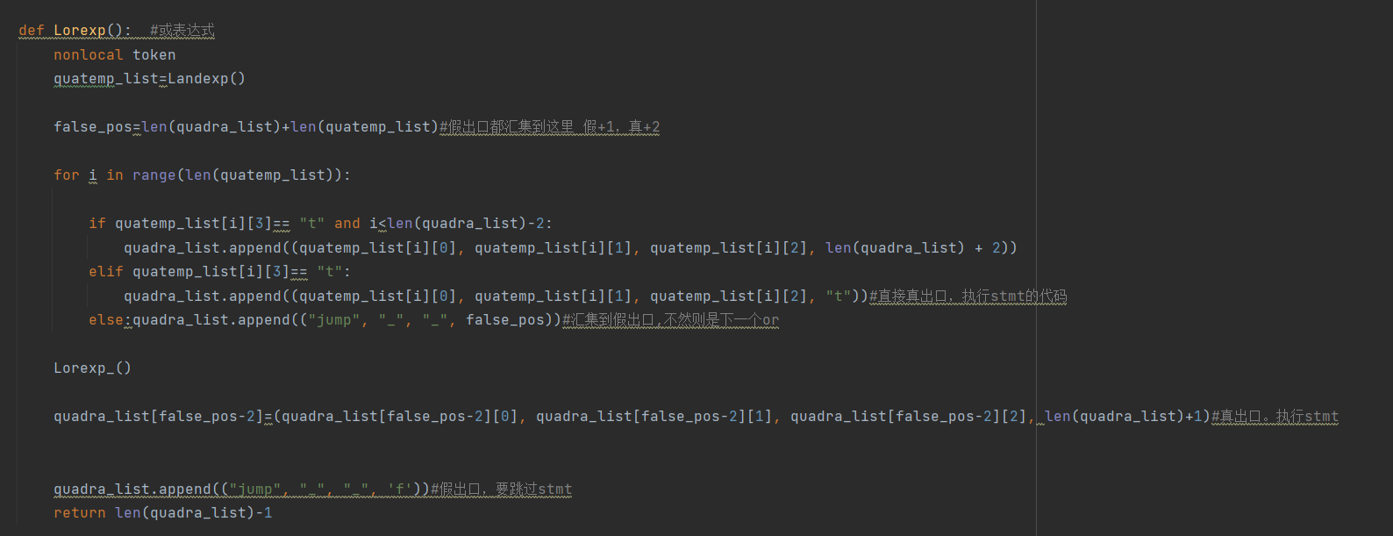

Here’s some result corresponding the input:
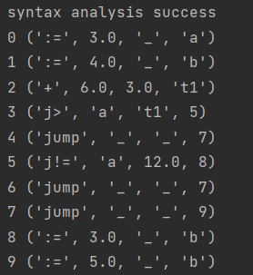
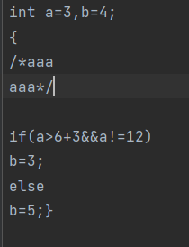

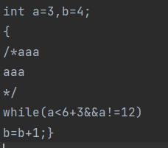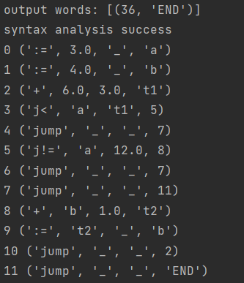

Conclusion
From the experiment, I have deep understanding about the procedure of SDT. Firstly, I learn better for the recursive-descending method to do LL(1) parsing about the syntax. Secondly, I can design the attribute grammar according to the CFG. Thirdly, I also learn more about using programming method to do the quadruple generating. It is really a hard work for me, especially in the part of logic statement. But I finally finish it. I learned a lot from the experiment.
Teacher’s Comments and Score
Comment：

Score： Signature：
Date：

