Dots and boxes User manual

Object of the game Take more boxes than your opponent. You move by connecting two dots with a line. When you place the last wall of a single square (1x1 grid), the box is yours. The players move in turn, but whenever a player takes a box (s)he gets one more move. The game ends when all boxes have been taken. The player with the most boxes wins.

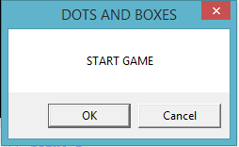

Connecting dots One can connect two dots by clicking on the line between them. The illustration below shows the first move of the game.

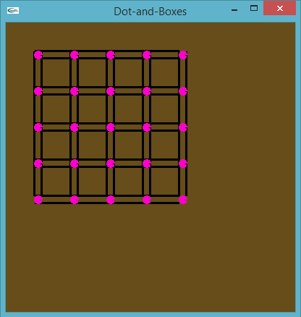

Taking boxes

When all four of the lines around a single box(1x1grid) are in place, the player who made the last line or move owns the box. The box is marked in that player’s color and (s)he must move again. Player one gets green color and player 2 gets light blue shade.

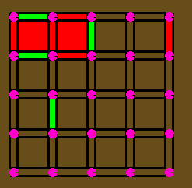

Strategy

On the surface this doesn’t look like a very strategic board game. In the beginning connections are made in more or less random fashion, and no boxes are taken.

Only in the endgame one of the players is usually forced to give away boxes, and after that the players take turns in giving away ever-larger ‘chains’ of boxes; the one who gets the last and largest chain usually wins. However, there are ways to force your opponent to give away the long chains at the end.

End of the board game

The game is finished when all connections have been made and all boxes have been taken. The player who owns most boxes wins.

