Security Part 2 : Enable or Disable Services

Services are a collection of programs and scripts that can run automatically when starting/booting a virtual machine. Having control over services and other programs is vital for any system administrator as it allows them to control and secure the environment providing access to users or programs as needed. As a result there are many reasons why you would want the ability to control when processes start if at all. The purpose of this document is to guide you through the steps needed to view the processes running on your virtual machine and how to enable or disable services.

1. Linux uses Systemd to manage services. To view these services we will use the systemctl command. To list all of the services on your virtual machine, you may enter the following:

# systemctl list

1. We can also view things by type, for example we can view all of the services on the system, along with the current status and a brief description. To do so you may enter the following:

# systemctl list-units –type=service

1. You may view any service on its own by entering the following:

# systemctl status “service name”

Example: # systemctl status sshd

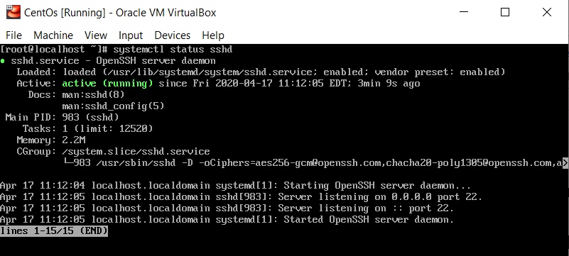

In the image above we can see that the sshd service is in a “Loaded” state. In the same line, at the end we can see that the service shows enabled. This means the service will automatically start when the virtual machine boots. Just below that we can see the service is “Active” and the start time of the service is also displayed.

1. If we wish to prevent sshd from starting at boot we can simply disable the service. To do so, you may enter the following:

# systemctl disable sshd

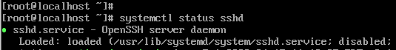

1. This will persist across reboots and prevent any service you want from starting at boot. Be cautious when disabling services as some are dependent on others. Disabling the wrong service or one that is a dependency for others could have unintended consequences.

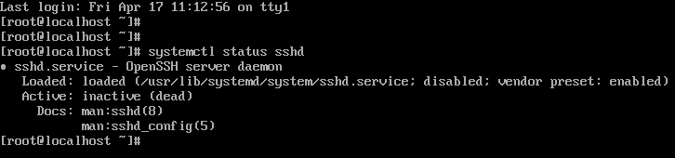

1. If you wish to have the service start at boot simply re-enable or enable the service.

# systemctl enable “service name”

Example: # systemctl enable sshd