**How to Install and Configure Fail2ban, VIM, EMACS for CentOS**

1. Install the repository required for fail2ban.

$ yum install epel-release

2. Install fail2ban

$ yum install fail2ban fail2ban-systemd

3. Now that fail2ban is installed, we need to enable and start the service.

$ system enable fail2ban

$ system start fail2ban

4. Now, we will make a copy of the configuration file, this way we can safely make changes while retaining a copy of the original. The jail.conf file can be modified when package upgrades and updates are done. This is another reason we do not want to edit this file.

$ cp /etc/fail2ban/jail.conf /etc/fail2ban/jail.local

5. Open the created copy of the configuration file so we can make our configuration changes. Use the editor you are most comfortable with, VI, EMACS, or NANO.

- Locate the section the [DEFAULT] section of the file and set the following values:

bantime = 15m

findtime = 5m

maxretry = 3

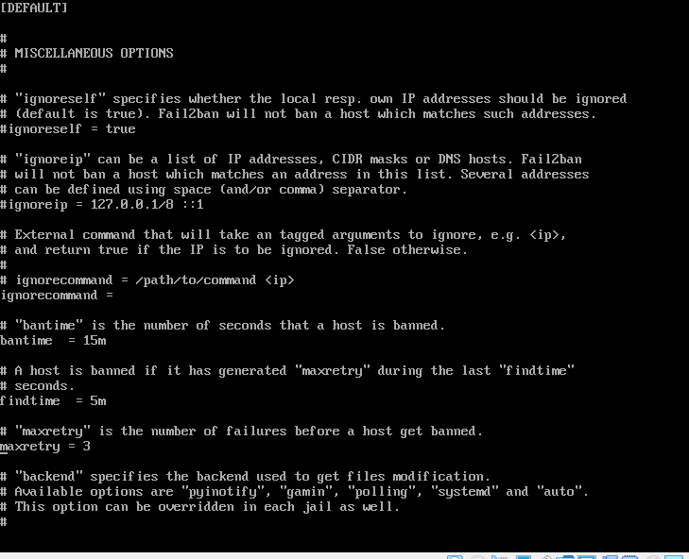

bantime defines how long an IP Address will be banned for failed login attempts.

maxretry defines the number of failed login attempts before the IP Address is banned.

findtime defines the length or span of time in which the maxretries occur.

6. Add the following to the [SSHD] section of the file and add/set the following values:

enabled = true

port = 22

filter = sshd

logpath = /var/log/auth.log

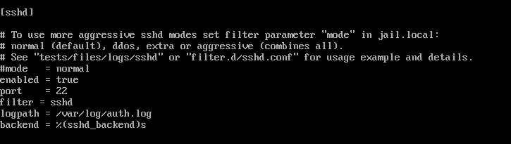

**Install TMUX**

TMUX is part of the same epel-release repository that we installed previously.

1. If tmux is not already installed on your CentOS VM, run the following:

$ yum install tmux

**Install Emacs and VIM**

1. To install the EMACS editor, run the following:

$ yum install emacs

2. When prompted, answer "Y" to proceed with the installation.

**Install VIM**

VIM editor should already be installed by default in your CentOS VM.

1. Should VIM not be installed, you may do so by running the following:

$ yum install vim

Congratulations, you have completed the required installations and setup.