How to install Docker on your CentOS and Ubuntu VM

Docker is a virtualization software that will allow us to implement containers on our virtual machines. This document will guide you through the process of installation process.

Install Docker in CentOS:

1. First, we will need to add the necessary repository to our system using the config-manager utility. This will allow us to download the packages needed to run Docker. To do so, enter the following:

# dnf config-manager --add-repo=https://download.docker.com/linux/centos/docker-ce.repo

1. You can list the versions of docker-ce that are available to us by running the following:

# dnf list docker-ce –showduplicates |sort –r

Normally, you would select or specify the version of Docker that you want to install, however there may you may encounter dependency issues depending on your CentOS version and/or version of Docker selected.

1. Install Docker using the --nobest option, which will install compatible versions that will allow us to avoid dependency issues. Do so using the following:

# yum install –nobest docker-ce

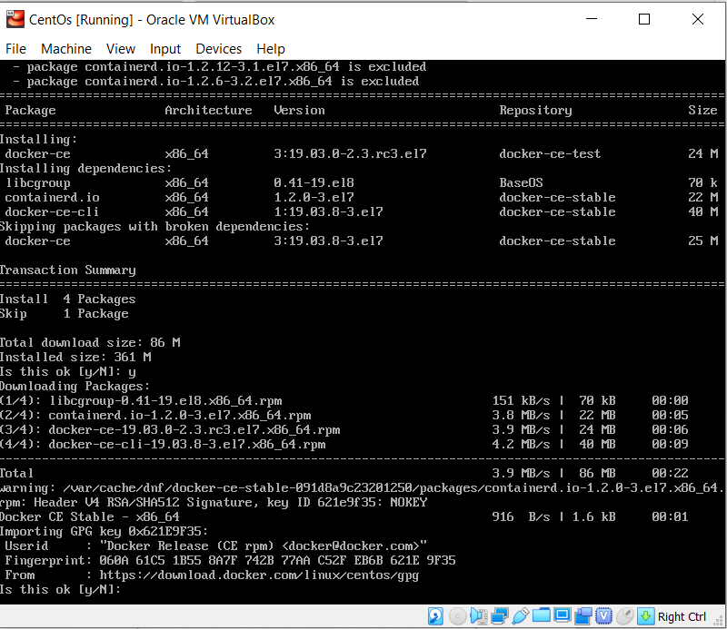

1. DNS resolution may fail with docker, a workaround is to disable firewalld. You may do so using the following:

# systemctl disable firewalld

1. Docker has now been installed. We will check Docker to ensure we are able to enable and activate the service. You may do so using the following:

# systemctl enable –now docker

# systemctl is-active docker

or

# systemctl is-enabled docker

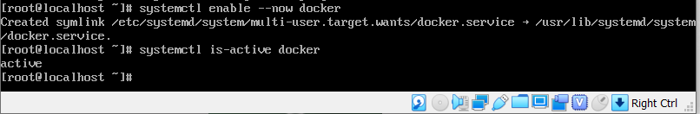

1. Start Docker. You may do so by using the following:

# systemctl docker start

1. Test Docker by running the Hello World program. You may do so by using the following:

# docker run hello-world

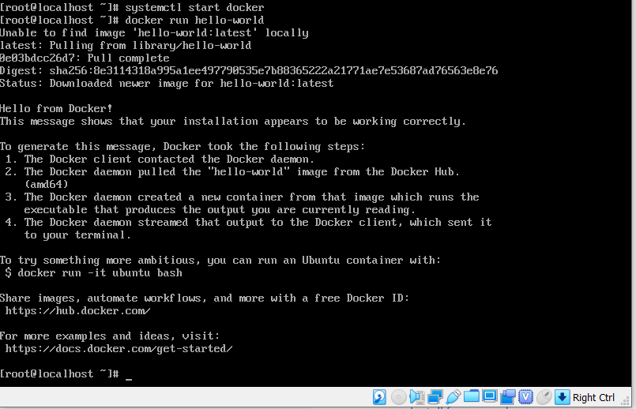

Install Docker for Ubuntu:

For installation of Docker on the Ubuntu VM, we will follow the instructions provided on the Docker website: <https://docs.docker.com/engine/install/ubuntu/>

1. First we need to update various packages which will allow us to update the repository over HTTPS.

# apt-get install apt-transport-https ca-certificates curl gnupg-agent software-properties-common

1. Next, we will need to add the official GPG key to our system. If this step is skipped we will be unable to add the required repository to our system. You may do so by issuing the following:

# curl –fsSL <https://download.docker.com/linux/ubuntu/gpg> |apt-key add -

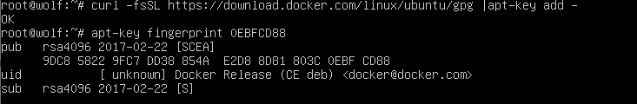

Check the fingerprint by issuing the command: # apt-key fingerprint 0EBFCD88

Ensure the key reported matches the image above.

1. Now we are ready to add the repository to our system. You may add the repo by issuing the following:

# add-apt-repository “deb [arch=amd64] <https://download.docker.com/linux/ubuntu> $(lsb_release -cs) stable”

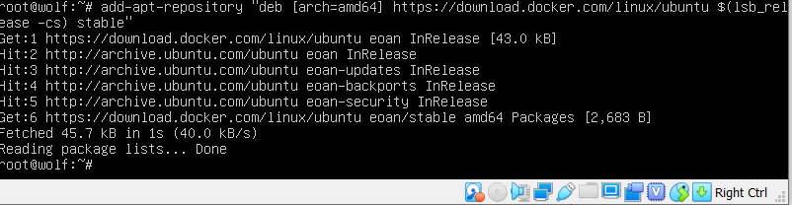

1. Install Docker Engine:

# apt-get install docker-ce docker-cd-cli containerd.io

1. Verify docker is installed successfully. You may do so by issuing the following:

# docker run hello-world

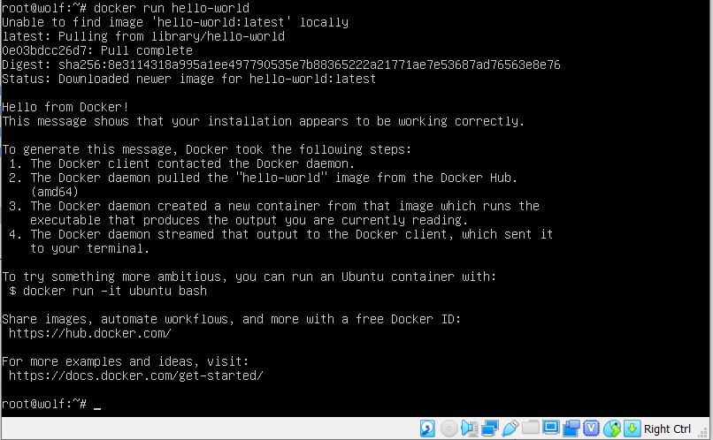

1. You have completed the installation of Docker on your virtual machines.