Virtual Machine Emergency Modes

Emergency mode, is a minimal boot environment. This means, the OS boots starting the absolute minimum amount of processes and programs needed to run. There are several reasons one might want to boot into this mode, you may have lost your password or perhaps the file system has become corrupted and you need to do some repairs. This document will guide you through the process of entering “Emergency Mode” on your both your CentOS and Ubuntu Server virtual machines.

Emergency Mode CentOS:

1. At the start up menu, press the ‘e’ key. This will place the VM into edit mode, at which point you will see the following:

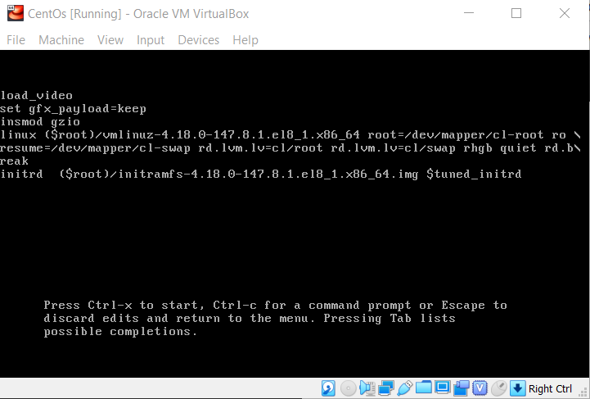

1. On the line that begins with ‘resume=’ I have added ‘rd.break’.
2. Press Ctrl-x to start the VM.
3. The VM will start in ‘emergency mode’ which will be indicated by the ‘switch_root’ prompt.

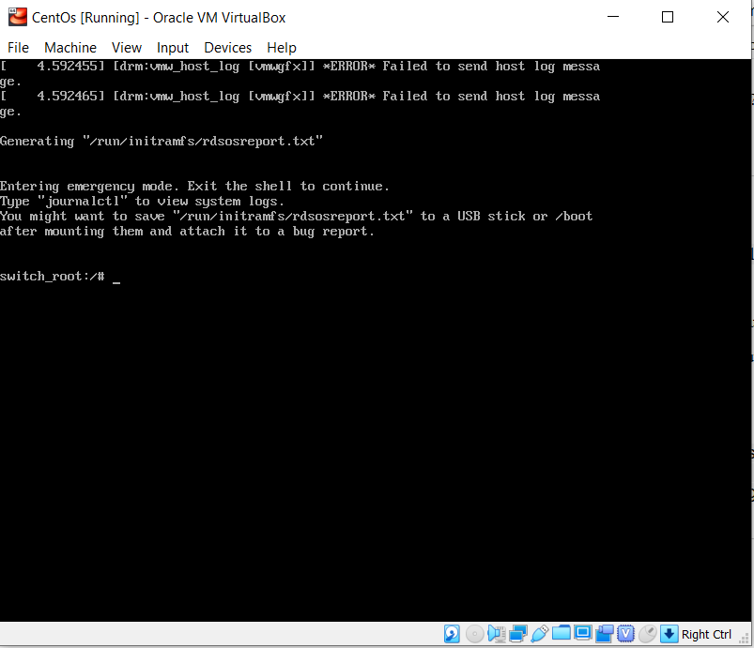

1. You are now in emergency mode.
2. To exit and restart the VM you can issue the command ‘ reboot –f ‘.

Emergency Mode Ubuntu Server:

1. After starting the virtual machine, press and hold down the “Shift” key. This will present you with the GRUB menu.

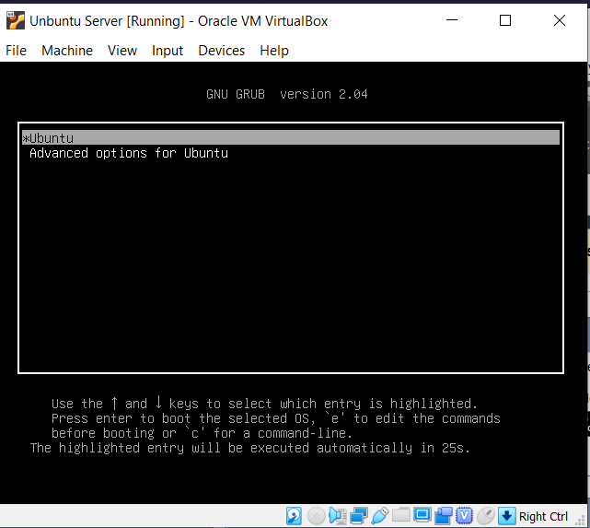

1. From the GRUB menu, press the ‘e’ key to enter edit mode.
2. Press the down arrow key, and locate the line ending in ‘maybe-ubiquity’
3. Add systemd.unit=emergency.target to the line ending in ‘maybe-ubiquity’

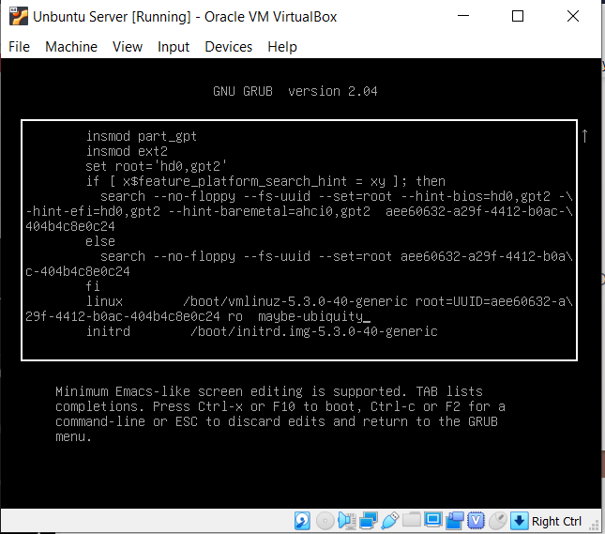

1. Once you have edited the line, you can press Ctrl-x or F10 to boot the virtual machine.
2. After the VM resets, you will be prompted to enter the root password to enter emergency mode.

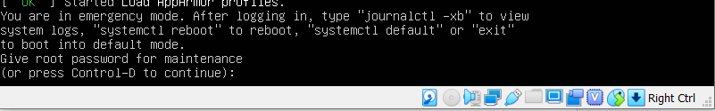

1. From here you can make the edits or repairs needed.
2. Once complete, you can exit emergency mode by issuing “systemctl reboot” command, “systemctl default” or “exit” to boot in default mode. This is noted when presented with the login prompt for emergency mode.