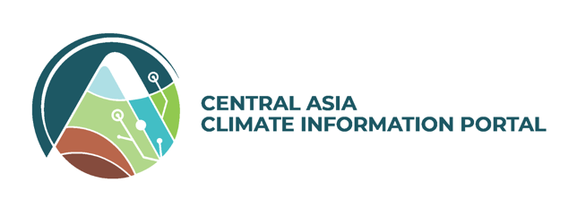

**Theory of Change**

**Tool**

*TOC Knowledge Base Data Model*

**TOC KNOWLEDGE BASE DATA MODEL**

**TABLE OF CONTENTS**

1 GENERAL INFORMATION 4

1.1 System Summary 4

1.2 Scope and Organisation of the Report 4

2 TOC Conceptualisation 6

2.1 Basic Definitions 6

2.2 Tool Workflow 6

3 External Semantic Resources 7

**General Information**

# GENERAL INFORMATION

## System Summary

The Theory of Change Tool (TOC Tool) is a web application aiming to help research teams to define and constitute evaluable the impact of their activities and initiatives. Towards this, users visually build *Nested Theories of Change*, i.e., diagrammatic representations of the causal links between different outputs and outcomes towards specific impact targets.

The aforementioned information is preserved in a semantics-enabled knowledge base, where the associations between different entities (outputs, outcomes, actors, impacts) is stored and through which this information can be analysed and aggregated.

## Scope and Organisation of the Report

The document presents the basic principles and design of the data model informing the TOC Tool knowledge base. It summarises the overall conceptualisation of the TOC and highlights the relations between the different entities involved in the TOC creation process as well as the core elements of the Nested TOC itself.

**TOC Conceptualisation**

# TOC Conceptualisation

The section lays out the basic concepts and core design principles informing the semantic model over which the TOC Tool is built. The model is expressed using the OWL W3C specification and will be uploaded in the Graph Database that is part of the TOC Tool backend, along with the corresponding tests for data integrity and conformance to the model.

## Basic Definitions

The tool is organized under the notion of *TOC Flows*. A TOC Flow encapsulates all different levels of a nested TOC, along with procedural characteristics of the TOC creation workflow.

In more detail, a TOC Flow comprises the following elements:

1. The TOC creation team, consisting of one or more *TOC Users* with different roles.
2. Information on the *Programme* to which the TOC Flow refers. Covered types are CGIAR Initiatives, CGIAR Projects, Proposals, and other
3. The different levels of the produced *TOC*, namely: Initiative-level TOC, WP-level TOC, and Sub-level TOCs, either Country-level TOCs or InnoP-level TOCs.
4. The *Review* associated with the specific TOC.

## Modelling the TOC Tool Workflow

Access to the tool is granted via a Login with MEL screen. All user information remains on MEL, except for the user’s email, name, and identifier, which are replicated in the TOC knowledge base for ensuring the proper presentation of the corresponding information and maintain the links with the user’s MEL profile.

The first user, defined manually when setting up the system, is the *TOC Tool Admin*. The user is responsible for taking care of the tool’s cold start configuration and processing requests for new TOC Flows.

# External Semantic Resources

|  |  |
| --- | --- |
| **TOC Concept** | **Source** |
| Country |  |
| Programme | CLARISSA |
|  |  |
|  |  |
|  |  |
|  |  |
|  |  |