Week 5 Workshop Task – PHP Basics (Part 2)

Git hub link :
Student Portfolio Manager
PART 1 — Homepage (index.php)

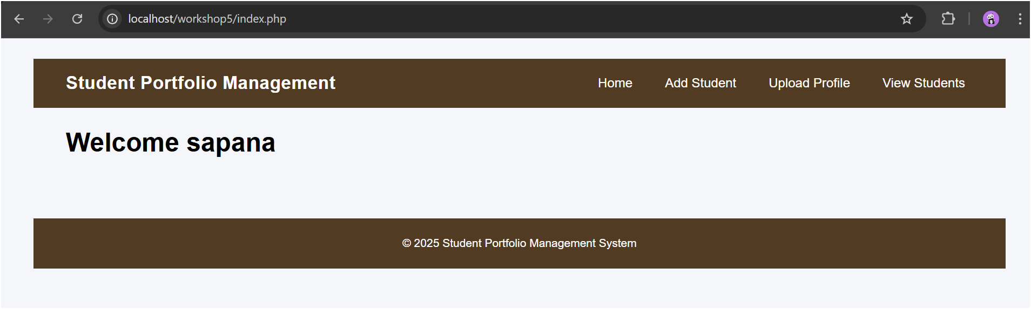
PART 2 — Add Student Info Page (add_student.php)

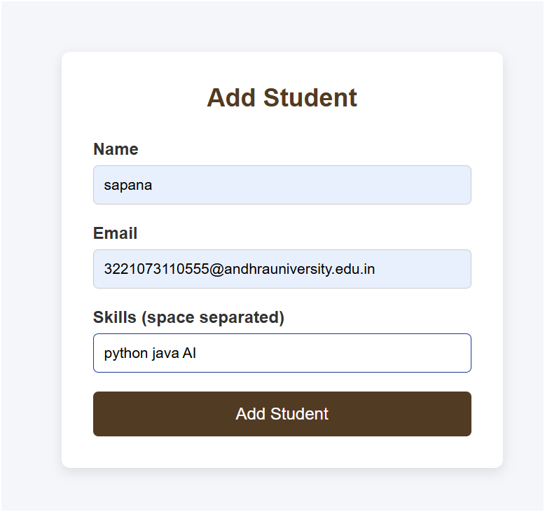
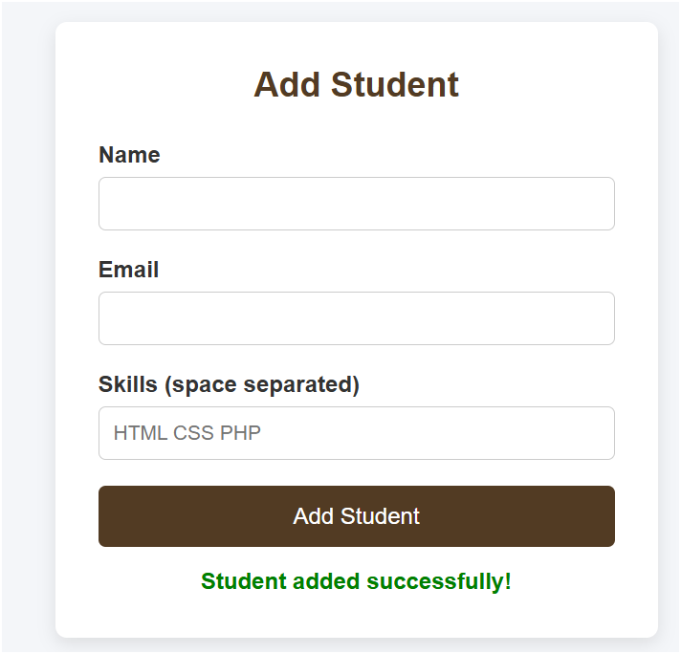
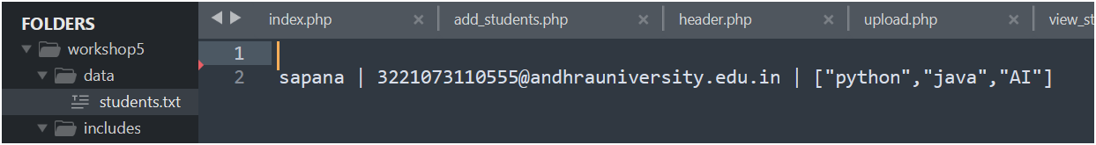

PART 3 — Upload Portfolio File (upload.php)
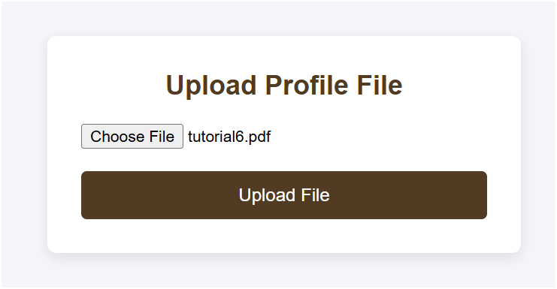
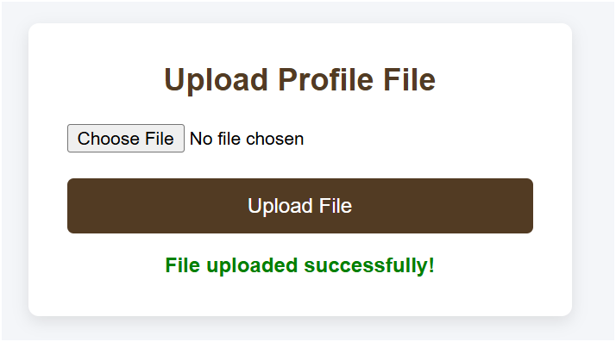
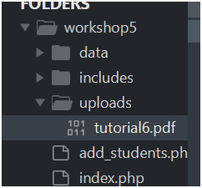

PART 4 — View Students Page (students.php)

