Data Analytics for Immersive Environments, Pair Project Descriptive & Inferential Analysis of a Jungian Sandplay VR Project

Shane Cunningham, Student No.D00262648

2022-11-25

# Table of Contents

### 1. Abstract

#### 1.1 Aim and rationale

#### 1.2 Participants and setting

#### 1.3 Experiment design

#### 1.4 Results gathering

#### 1.5 Major findings

#### 1.6 Findings/implications

### 2. Introduction

#### 2.1 Topic and context

#### 2.2 Rationale

#### 2.3 Hypothesis

### 3. Method

#### 3.1 Participants

#### 3.2 Design, Materials, Procedure

### 4. Results

#### 4.1 Descriptive statistics

#### 4.2 Inferential statistics

#### 4.3 Statistical tests

### 5. Discussion

#### 5.1 Outline findings and relation to the hypothesis

### 6. References

# Abstract

### Aim and rationale

The aim and rationale of this study is to determine if Virtual Reality technology provides a viable alternative solution for treating post-traumatic stress disorder patients. The hypothesis of this report is to explore if the gender of the patient is affecting the post-trial observer rated results.

### Participants and setting

The Study consists of 150 participants suffering from PTSD, of which, there were 75 male, and 75 female participants. The participants were aged from 18 – 25 years old.

### Experiment design

The participants were divided into three groups, control, static, animated, and were tested using observer rated and self-report mechanisms.

### Results gathering

The data was tested by studying the effects of the different variables and the data structure. Inferential testing was applied using the t-student test to explore the difference in the means of both genders in the post-trial observer rated results.

### Major findings

The major findings of the study reject the null hypothesis.

# Introduction

### Topic and context

This is a study to determine whether Virtual Reality technology provides a viable alternative solution for treating post-traumatic stress disorder patients. The VR applications used for this study are based on the concept of Jungian sandplay, a therapeutic method stemming from philosophical beliefs of Carl Jung who emphasized that through collective unconsciousness, the human psyche is pre-conditioned as a result of evolution. Jung states that ancestral memories through archetypes represent themes from various cultures and are expressed throughout art, literature, and sub-conscious thought (McLeod, 2018). Sandplay therapy was developed in the 1950’s by Dora Klaff who based the practice on the work of child psychologist Margaret Lowenfeld (Psychology Today, 2022). Sandplay therapy helps the patient to express through creating their own scene using different artifacts of their own choosing, the patients’ actions are then analyzed by a therapist or a counselor (Psychology Today, 2022).

### Rationale

The purpose of this report is to put into practice the formulation of a hypothesis, to create statistical and inferential tests, and to generate descriptive statistics, visual graphs, all using the R programming language and R markdown to generate a notebook of the findings.

### Hypothesis

Null Hypothesis

* Ho: Gender does not make any difference to the post-trial observer rated results, any issues that occur will only happen by chance.

Alternative Hypothesis

* Ha: Gender is affecting the post-trial observer rated results.

# Method

### Participants

The Study consists of 150 participants suffering from PTSD, of which, there were 75 male, and 75 female participants. The participants were aged from 18 – 25 years old. The study examines if virtual reality technology can be used to aid in the treatment of post-traumatic stress disorder.

### Design, Materials, Procedure

The participants were divided into three numerically equal groups,

* ***Control***
  + Traditional Cognitive Behavioral Therapy, no VR technology, 12 weeks of treatment. 50 minutes per week with a therapist using traditional CBT
* ***Static***
  + Non-Animated version of a VR Application
* ***Animated***
  + Animated version of a VR Application.
* ***Age range***: 18 - 25 years
* ***Gender*** was recorded
* All ***groups*** were of ***equal*** size
* PTSD measurements for All groups using:
  + ***observer - rated*** (therapist rated)
  + ***self – report*** (Child PTSD Symptom Scale Self-Report Version (CPSS-SR)) mechanisms.
* Measurements were taken from the participants at the ***start and end*** of the study
* Measurements of the study for all groups were scaled to range from ***0 – 10***

# Results

### Descriptive statistics

#### **Dimensions**

# dim() calls for the dimensions of the data frame  
dim(jung)

## [1] 150 7

The results of the dimensions check verifies that there is 150 rows and 7 columns in the data frame. The first column, test_number, which was included in order for r to read the csv file, is not important for this study.

#### **Variables**

names(jung)

## [1] "test_number" "gender" "test_group" "pre_trial_cpss"   
## [5] "post_trial_cpss" "pre_trial_or" "post_trial_or"

R’s names() function displays the variable names used in the data set. The variable types are:

* test_number: numerical, non - continuous
* gender: categorical, blocking
* test_group: categorical, blocking (explanatory)
* pre_trial_cpss: numerical, continuous (response variable)
* post_trial_cpss: numerical, continuous (response variable)
* pre_trial_or: numerical, continuous (response variable)
* post_trial_or: numerical, continuous (response variable)

#### **Structure**

str(jung)

## 'data.frame': 150 obs. of 7 variables:  
## $ test_number : int 1 2 3 4 5 6 7 8 9 10 ...  
## $ gender : chr "Male" "Male" "Male" "Male" ...  
## $ test_group : chr "Static" "Static" "Static" "Static" ...  
## $ pre_trial_cpss : num 7.04 6.93 6.07 6.22 6.85 5.47 6.63 5.71 8.11 6.94 ...  
## $ post_trial_cpss: num 5.67 6.23 5.91 5.8 6.02 6.7 4.54 4.45 5.58 5.32 ...  
## $ pre_trial_or : num 7.57 6.42 5.52 6.26 7.1 5.6 6.22 5.68 8.45 6.74 ...  
## $ post_trial_or : num 5.5 6.45 5.97 5.82 5.95 6.46 4.4 4.35 5.53 5.22 ...

The R programming language str() function displays the structure of the data set. The example illustrates the data types involved, integers, chars and num or float data types.

### Inferential statistics

stripchart(pre_trial_or, main = "Strip Chart of pre_trial_or", col="red" , pch = 21)

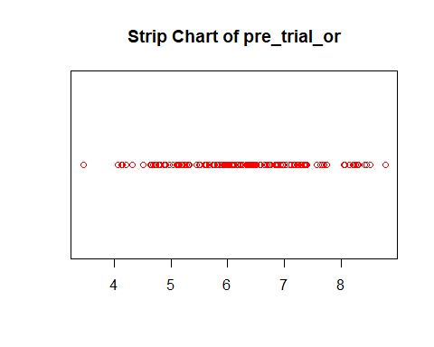

mean(pre_trial_or)

## [1] 6.222267

The mean of the pre-trial observer reported results were 6.222267.

stripchart(post_trial_or, main = "Strip Chart of post_trial_or", col="red", pch = 21)

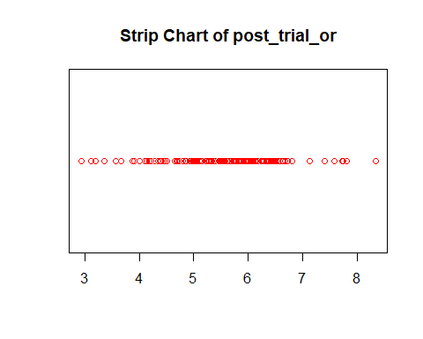

mean(post_trial_or)

## [1] 5.476467

6.222267 - 5.476467

## [1] 0.7458

The mean of the post-trial observer reported results were 5.476467, 0.7458 less than the pre-trial mean.

boxplot(pre_trial_or ~ test_group)

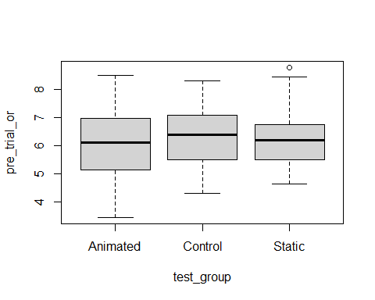

boxplot(post_trial_or ~ test_group)

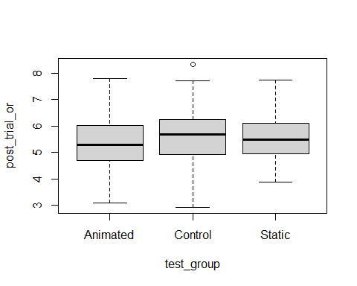

The pre-trial observer reported results with a mean of 5.476467, produced an outlier in the control group.

boxplot(pre_trial_or ~ gender)

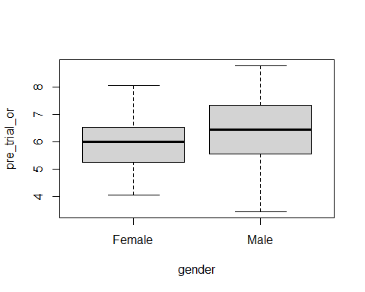

boxplot(post_trial_or ~ gender)

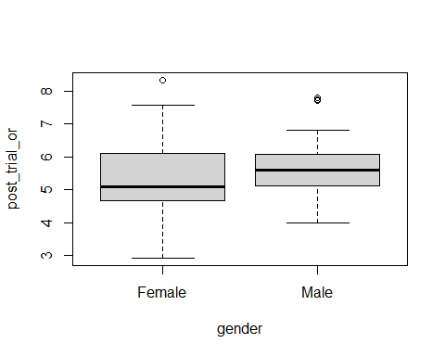

The box plot above shows a more condensed data plot for the Males compared to the pre-trial. The Males also have a small number of outliers of which were not evident in the pre-trial. The Female plot has also produced an outlier of a higher value than any findings in the pre-trial results.

jung%>%  
 filter(pre_trial_or < 10) %>%  
 ggplot(aes(x=pre_trial_or, y=test_group, col=gender))+  
 geom_point(alpha=0.5)

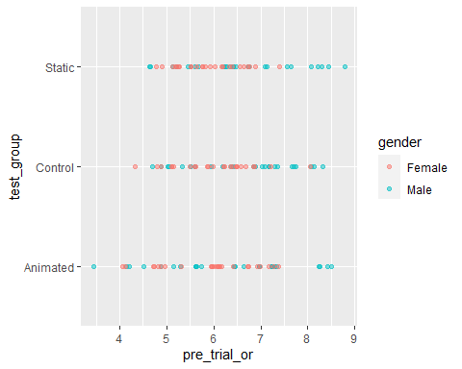

jung%>%  
 filter(post_trial_or < 10) %>%  
 ggplot(aes(x=post_trial_or, y=test_group, col=gender))+  
 geom_point(alpha=0.5)

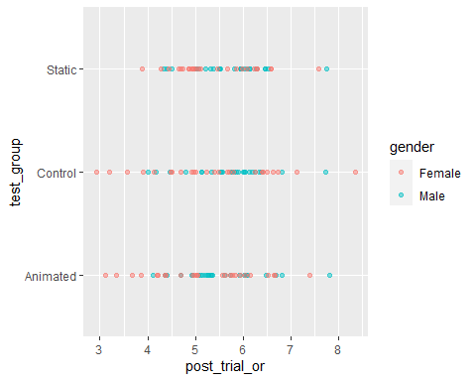

The dot plots above illustrate how the different genders performed in each test group for the pre-trial and post-trial or.

# query data looking for post trial observer rated for Female and Male genders  
df1 <- jung %>%  
 select(gender, post_trial_or) %>%  
 filter(gender == "Female" |  
 gender =="Male")  
  
t.test(data = df1, post_trial_or ~ gender)

##   
## Welch Two Sample t-test  
##   
## data: post_trial_or by gender  
## t = -2.0345, df = 135.28, p-value = 0.04386  
## alternative hypothesis: true difference in means between group Female and group Male is not equal to 0  
## 95 percent confidence interval:  
## -0.629225689 -0.008907645  
## sample estimates:  
## mean in group Female mean in group Male   
## 5.316933 5.636000

T-test results to test whether the post_trial_or results have been effected by the gender of the participants.

### Statistical tests

From the result of the t-test we can reject the null hypothesis. This is due to the difference in means between the two groups is not equal to 0. The alternative hypothesis is also verified by the 95 percent confidence interval where the difference will be between -0.629225689 -0.008907645.

# Discussion

### Outline findings and relation to the hypothesis

Due to acceptance of the alternative hypothesis, the data are showing a difference in the means for the male and female results from the post-trial observer reported study and rejecting a false null hypothesis (p(rejecting a false H0)= 1 - B). The overall findings prove that the patients did not respond positively to the study, as the study shows, the average results from the post-trial observer reported, control, and post-trial cpss declined in all tests. The result from the study also revealed outliers which could be useful in further studies of the data.

# References

Aron, E.N. and Aron, A. (1997) ‘Sensory-processing sensitivity and its relation to introversion and emotionality’, Journal of Personality and Social Psychology, 73(2), pp. 345–368. Available at: <https://doi.org/10.1037//0022-3514.73.2.345>. Best Practices in Preparing Data Files for Importing into R - Easy Guides - Wiki - STHDA (no date). Available at: <http://www.sthda.com/english/wiki/best-practices-in-preparing-data-files-for-importing-into-r#prepare-your-file> (Accessed: 10 December 2022).

Bhalla, D. (no date) ‘dplyr Tutorial : Data Manipulation (50 Examples)’, ListenData. Available at: <https://www.listendata.com/2016/08/dplyr-tutorial.html> (Accessed: 10 December 2022).

Foundations for Inference: Point Estimates (2019). Available at: <https://www.youtube.com/watch?v=oLW_uzkPZGA> (Accessed: 12 December 2022).

Hypothesis Testing Fundamentals (2015). Available at: <https://www.youtube.com/watch?v=NVbPE1_Cbx8> (Accessed: 11 December 2022).

Independent-samples t-test using R, Excel and RStudio (page 2) | Setting up your data (no date). Available at: <https://statistics.laerd.com/r-tutorials/independent-samples-t-test-using-r-excel-and-rstudio-2.php> (Accessed: 10 December 2022).

Inference for Estimators Other Than the Mean (2014). Available at: <https://www.youtube.com/watch?v=PUMBNtVKr_g> (Accessed: 12 December 2022).

Inferential Statistics - an overview | ScienceDirect Topics (no date). Available at: <https://www.sciencedirect.com/topics/medicine-and-dentistry/inferential-statistics> (Accessed: 23 December 2022).

Intro to Confidence Intervals via Proportions (2019). Available at: <https://www.youtube.com/watch?v=A6_W8qY8zJo> (Accessed: 12 December 2022).

Learn dplyr: Learn R: Data Cleaning Cheatsheet (no date) Codecademy. Available at: <https://www.codecademy.com/learn/learn-dplyr/modules/learn-r-data-cleaning/cheatsheet> (Accessed: 10 December 2022).

Markdown Cheat Sheet | Markdown Guide (no date). Available at: <https://www.markdownguide.org/cheat-sheet/> (Accessed: 10 December 2022).

McCombes, S. (2022) How to Write a Strong Hypothesis | Steps & Examples, Scribbr. Available at: <https://www.scribbr.com/methodology/hypothesis/> (Accessed: 10 December 2022).

McLeod, Dr.S. (2018) Carl Jung’s Theories: Archetypes, & The Collective Unconscious, SimplyPsychology. Available at: <https://www.simplypsychology.org/carl-jung.html>. Post-traumatic stress disorder (PTSD) - Symptoms and causes (no date) Mayo Clinic. Available at: <https://www.mayoclinic.org/diseases-conditions/post-traumatic-stress-disorder/symptoms-causes/syc-20355967> (Accessed: 23 December 2022).

post-traumatic-stress-disorder-ptsd-treatment (no date) HSE.ie. Available at: <https://www2.hse.ie/conditions/ptsd/treatment/> (Accessed: 23 December 2022). Psychology Today (2022) Sandplay Therapy | Psychology Today Ireland, Psychology Today. Available at: <https://www.psychologytoday.com/ie/therapy-types/sandplay-therapy> (Accessed: 7 December 2022).

PTSD Symptom Scale-Interview Version - PsycNET (no date). Available at: <https://psycnet.apa.org/doiLanding?doi=10.1037%2Ft05176-000> (Accessed: 23 December 2022).

R Markdown for a Data Analysis Report (2016). Available at: <https://www.youtube.com/watch?v=0bxa7rkur9o> (Accessed: 7 December 2022).

R programming for beginners – statistic with R (t-test and linear regression) and dplyr and ggplot (2017). Available at: <https://www.youtube.com/watch?v=ANMuuq502rE> (Accessed: 20 December 2022).

Riederer, Y.X., Christophe Dervieux, Emily (no date a) How to read this book | R Markdown Cookbook. Available at: <https://bookdown.org/yihui/rmarkdown-cookbook/how-to-read-this-book.html> (Accessed: 10 December 2022).

Riederer, Y.X., Christophe Dervieux, Emily (no date b) R Markdown Cookbook. Available at: <https://bookdown.org/yihui/rmarkdown-cookbook/> (Accessed: 10 December 2022).