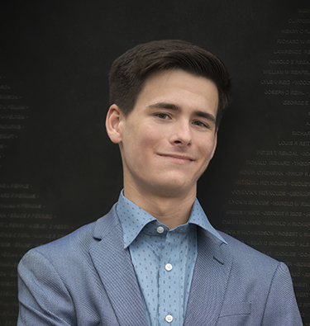
Brandon Huyck
LinkedIn: linkedin.com/in/brandon-huyck

SKILLS
- Python, C/C++, Java, MySQL, R, Jupyter, Git, GitHub, Linux, Splunk, OOP, unit testing
- Problem solving, critical thinking, attention to detail, organization, big-picture thinking, brainstorming, teamwork, leadership, written and verbal communication, flexibility
- Interests include Software Engineering, Testing, Databases, and Data Analysis

WORK EXPERIENCE
- Starbucks, Software Engineering Intern in Tech Ops, Seattle, WA, May-August 2023
  - Workplace meetings, adaptability, solution design
  - Created a workflow using Microsoft Suite that increased automation and ease for team leadership, reducing fallibility of system; generated research report on technical transition for management; integrated into, and adapted, team culture.
- Mastercard, Technical Intern in BizOps, St. Louis, MO, June-August 2022
  - Big data, data analytics, data visualization
  - Created dashboards in Splunk that displayed the health of various applications using KPIs, determined the extent of impact of issues, and communicated to executives.
- Gonzaga University, Teaching Assistant, Spokane, WA, September 2022 – Present
  - Code review, explaining technical concepts
  - Data Structures and Algorithms, Introduction to Data Science, and Operating Systems

PROJECTS AND COURSEWORK
- MyPL Interpreted Programming Language
  - Lexer, syntax parser, semantic checker, code generator, virtual machine, AST, visitor pattern
- GUI Yahtzee Application
  - OOP, Model-View-Controller, class and method design, SOLID, team project
- Computer Science Coursework
  - Software Engineering Capstone, Databases, Computing Ethics, Theory of Computation, Programming Language Design, Machine Learning, Operating Systems, Computer Security, Introduction to Data Science
- Mathematics Coursework
  - Linear Algebra, Number Theory, Combinatorics, Statistics, Proofs, Calculus

EDUCATION, INVOLVEMENT, AND HOBBIES
- B.S. Computer Science, GPA 3.98, Gonzaga University, Spokane, WA, graduating May 2024
- Math tutor for K-12 students, foodie and cook, coffee nerd, card and board game player

