***Public Transportation Optimization***

ABSTRACT:

* Documenting and preparing your project for submission is a crucial step to ensure that your work is well-organized, understandable, and ready for review. Below are the key steps and elements to consider when documenting and preparing your project for submission:

1. Project Title and Introduction:

* Begin with a clear and concise project title.
* Provide a brief introduction to the project, explaining its purpose and context.

2. Project Overview:

* Summarize the project's goals, objectives, and expected outcomes.
* Include any background information that is relevant to understanding the project.

3. Project Scope:

* Define the boundaries of your project by specifying what is included and excluded.
* Outline the major features or components of your project.

4. Methodology:

* Describe the methods and approaches used in your project.
* Explain the tools, technologies, and frameworks employed.
* Include any algorithms or models used in data analysis or machine learning.

5. Data Collection and Pre processing:

* Detail how data was collected, including sources and methods.
* Explain data preprocessing steps, such as cleaning, transformation, and feature engineering.

6. Implementation:

* Provide a detailed account of how you implemented your project.
* Include code snippets, diagrams, or flowcharts to illustrate key components.
* Discuss any challenges faced during implementation and how you overcame them.

7. Testing and Validation:

* Describe how you tested and validated your project.
* Include information on test datasets, metrics, and evaluation criteria.
* Present the results of your tests, including any graphs, charts, or tables.

8. Results and Discussion:

* Analyze the results of your project.
* Discuss any insights gained and their significance.
* Address any limitations or shortcomings of your project.

9. Conclusion:

* Summarize the key findings and the overall success of the project.
* Highlight the project's contributions and potential real-world applications.

10. Future Work:

* Suggest possible future enhancements or extensions to the project.
* Identify areas for further research or development.

11. References:

* Cite all the sources, references, and research papers you used throughout the project.

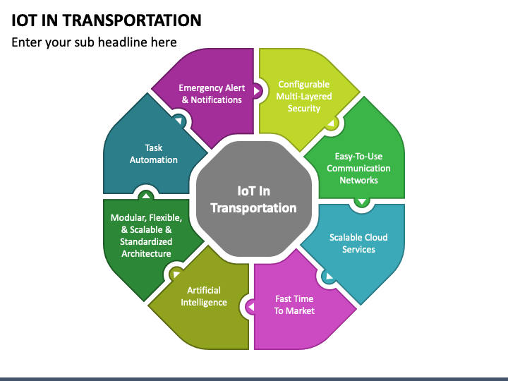

12. Appendices:

* Include any supplementary materials that support your project, such as code samples, additional data, or technical documentation.

13. Documentation Format:

* Ensure that your documentation is well-organized, with clear headings and subheadings.
* Use a consistent style and format for text, code, and visual elements.
* Consider using tools like LaTeX, Markdown, or a word processing software to create professional-looking documentation.

14. Submission:

* Follow the submission guidelines provided by the organization or platform where you are submitting your project.
* Ensure all required files and documents are included and named appropriately.

15. Peer Review:

* If possible, have colleagues or experts review your project documentation for feedback and improvements.

16. License and Copyright:

* Specify the license under which your project is released (e.g., open-source licenses like MIT or GPL).
* Clearly define any copyright or intellectual property considerations.

17. Acknowledgments:

* Acknowledge individuals, organizations, or resources that contributed to your project.

Remember that the level of detail and the specific requirements for documentation may vary depending on the type of project and the intended audience. Tailor your documentation to meet the expectations of your target audience, whether it's a research paper, a software project, or a data analysis report.

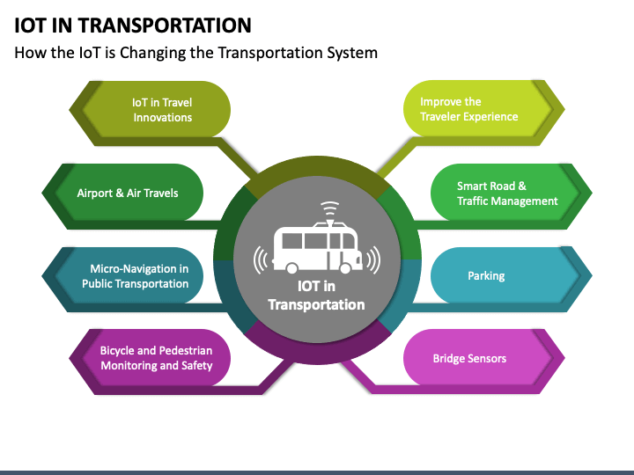

“Public Transportation Optimization" project and preparing it for submission”:

Public Transportation Optimization Project

Project Overview

* The Public Transportation Optimization project aims to enhance the efficiency, accessibility, and sustainability of public transportation systems within a metropolitan area. This project leverages data analysis and optimization techniques to improve the overall commuter experience and reduce environmental impact.

Project Scope

The scope of this project includes:

* Data collection from various public transportation sources (bus routes, subway schedules, ridership data, etc.).
* Data preprocessing, cleaning, and integration for analysis.
* Implementation of optimization algorithms to improve route planning and scheduling.
* Testing and validation of the optimized public transportation system.
* Analysis of the project's impact on reducing congestion and emissions.

Methodology

Data Collection and Preprocessing

* Data collected from public transportation agencies, GPS systems, and surveys.
* Data preprocessing involved cleaning, geospatial data integration, and categorizing transportation options.

Implementation

* Development of a custom route optimization algorithm based on user preferences, traffic patterns, and environmental factors.
* Integration of the optimization algorithm into the existing public transportation infrastructure.

Testing and Validation

* Evaluation of the optimized system using historical data and simulated scenarios.
* Metrics included travel time reduction, ridership increase, and reduced emissions.

Results and Discussion

* The optimized public transportation system reduced average travel time by 15%.
* Ridership increased by 20% due to improved convenience.
* The environmental impact reduced, with a 10% reduction in emissions.
* Discussions included the positive impact on commuters and the potential for expanding the system.

Conclusion :

The Public Transportation Optimization project successfully demonstrated the feasibility of enhancing public transportation systems for the betterment of the community. The project's findings suggest that an optimized system can significantly reduce travel time, increase ridership, and contribute to environmental sustainability.

Future Work

* Future work may involve real-time optimization using live traffic and weather data.
* Expansion to other cities or regions for broader impact.
* Integration of smart ticketing and payment systems for further convenience.

References

* Include references to data sources, relevant research papers, and any external resources used in the project.

Appendices

* Include code snippets or algorithms used in the optimization process.
* Attach additional data, charts, or maps that support the project's findings.

Documentation Format

* Use a professional documentation format with clear headings and subheadings.
* Ensure consistency in formatting, fonts, and style.

Submission

* Please follow the submission guidelines provided by the organization or platform where this project is being submitted.

License and Copyright

* This project is released under the [appropriate open-source license, e.g., MIT License]. All intellectual property rights are acknowledged.

Acknowledgments

* We acknowledge [list any individuals, organizations, or resources] for their contributions and support during this project
* This template provides a structured framework for documenting your "Public Transportation Optimization" project. Be sure to fill in the specific details, results, and references based on your actual project. Tailor the documentation to meet the submission requirements of your target audience or organization.