**PUBLIC TRANSPORT OPTIMIZATION**

**Abstract:**

* Consider incorporating machine learning algorithms to improve arrival time prediction accuracy based on historical data and traffic conditions.

**Introduction:**

Incorporating machine learning algorithms to improve arrival time prediction accuracy based on historical data and traffic conditions is a great idea and a common application of machine learning in transportation and logistics. Here's a high-level overview of the steps you can take to implement such a system.

1. **Data Collection:**

* Gather historical data on routes, including timestamps of previous trips, traffic conditions, weather conditions, road closures, and any other relevant information.
* You can collect this data from various sources, including GPS sensors , traffic conditions, weather conditions, road closures, and any other relevant Gather historical data on routes, including timestamps of previous trips, traffic cameras, weather APIs, and historical trip records.

**2. Data Pre processing:**

* Clean and pre process the collected data. This may involve handling missing values, outlier detection, and feature engineering.
* For example, you can derive features like average speed, time of day, day of the week, and holiday indicators from timestamps.

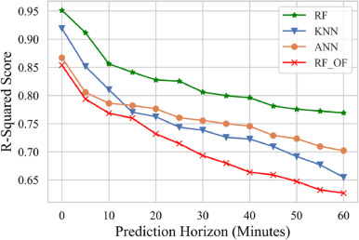

**3. Feature Selection:**

* Identify the most relevant features for your prediction task. This may involve using techniques like feature importance analysis and correlation analysis to select the best predictors for arrival time.

**4. Model Selection:**

* Choose a machine learning model that is suitable for regression tasks, such as Random Forests, Gradient Boosting, Support Vector Machines, or Neural Networks. You can also experiment with various algorithms to find the best-performing one for your specific dataset.

**5. Model Training:**

* Split your dataset into training and testing sets to evaluate model performance. Train the selected machine learning model on the training data and tune hyper parameters to optimize performance. You may also consider techniques like cross-validation

**6. Traffic Data integration:**

* Incorporate real-time traffic data into your model. This can be achieved by using APIs from services like Google Maps or Ways by collecting traffic data from sensors.
* Real-time traffic data helps your model adapt to current road conditions.

**7. Prediction and Feedback Loop:**

* Deploy your trained model in a production environment where it can make real-time predictions for arrival times.
* Continuously update the model with new data to improve accuracy. Implement a feedback loop to capture the accuracy of predictions and use it for model retraining.

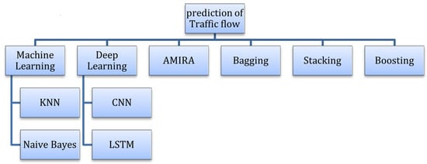

**8. User Interface:**

* Develop a user-friendly interface, such as a mobile app or website, where users can input their starting and ending locations to get estimated arrival times. Make the interface easy to use and visually informative.

**9. Monitoring and Maintenance:**

* Regularly monitor the model's performance and retrain it as needed to adapt to changing traffic patterns, road closures, and other factors. Maintenance is crucial to ensure the accuracy of predictions over time.

**10. Privacy and Data Security:**

* Ensure that you handle user data and location information with care, following privacy regulations and best practices to protect user privacy and data security.
* Remember that the success of your arrival time prediction system will depend on the quality and quantity of data, the choice of machine learning algorithms, and the accuracy of real-time traffic updates.

**11. Model Development:**

* Split your data into training, validation, and test sets to evaluate your model's performance.
* Train and fine-tune your machine learning model using the training data. Hyper parameter tuning and cross-validation can be used to optimize model performance. Maintain accuracy and user satisfaction.

12. Continuous Learning**:**

* Machine learning models can become obsolete as data patterns change. Implement mechanisms for continuous learning, retraining, and model updates.

13. Select Appropriate Algorithms:

* Choose machine learning algorithms that are well-suited to your problem. The choice depends on the nature of your data (e.g., structured or unstructured) and the problem type (e.g., classification, regression, clustering).

**14.** **Deployment:**

* Once satisfied with your model's performance, deploy it into a production environment. This may involve integrating it with existing systems or creating a new application.
* Implement necessary monitoring and maintenance processes to ensure the model's continued effectiveness**.**

**15. Continuous Learning:**

* Machine learning models can become obsolete as data patterns change. Implement mechanisms for continuous learning, retraining, and model updates.

**16. Historical data and traffic conditions:**

* Arrival time prediction accuracy depends on several factors, including the quality and quantity of historical data, the sophistication of the prediction model, and the real-time availability and accuracy of traffic conditions. Here are some key considerations for improving the accuracy of arrival time predictions:

**17. High-Quality Historical Data:**

* The accuracy of arrival time predictions heavily relies on historical data. Ensure that your historical data is reliable, up-to-date, and covers a wide range of scenarios, including different times of day, days of the week, and weather conditions

**18. Real-Time Traffic Data:**

* Access to real-time traffic data is crucial for accurate predictions. Use data from traffic monitoring systems, GPS devices, or mobile apps to continuously update your predictions based on the current traffic conditions.

**19. Machine Learning Models:**

* Advanced machine learning algorithms, such as neural networks, random forests, or gradient boosting, can help improve prediction accuracy. These models can learn complex patterns in historical data and adjust predictions based on real-time information.

**20. Feature Engineering:**

* Carefully select and engineer relevant features that can affect travel times. Factors like road type, historical traffic patterns, weather conditions, and events (e.g., accidents, road closures) should be considered in your model.

**21. Data Pre processing:**

* Clean and pre process your data to handle missing values, outliers, and anomalies. Normalization and scaling may also be necessary to ensure that all features are on a similar scale.

**22. Validation and Testing:**

* Divide your historical data into training, validation, and testing sets to evaluate the performance of your prediction model. Use appropriate metrics, such as Mean Absolute Error (MAE) or Root Mean Squared Error (RMSE), to assess accuracy.

**23. Real-Time Updates:**

* Continuously update your predictions as new data becomes available. Real-time updates based on current traffic conditions can significantly enhance accuracy.

**24. User Feedback:**

* Incorporate user feedback and reports to improve the accuracy of predictions. Users can provide valuable insights into unexpected delays or issues that may not be present in historical data.

25. Integration with Navigation Systems:

* If your arrival time predictions are intended for navigation systems, ensure seamless integration to provide users with real-time guidance and updates.

* Machine Learning Maintenance:

* Regularly retrain and update your prediction models to account for changing traffic patterns, road construction, and other factors that can impact travel times.
* It's important to note that no prediction system can be 100% accurate due to the inherent uncertainty in traffic conditions and unforeseen events.
* However, by implementing the above strategies and leveraging advanced technologies, you can significantly improve the accuracy of arrival time predictions based on historical data and traffic conditions.